**Authentication of the API**

To generate an API key, you have to be an admin user.

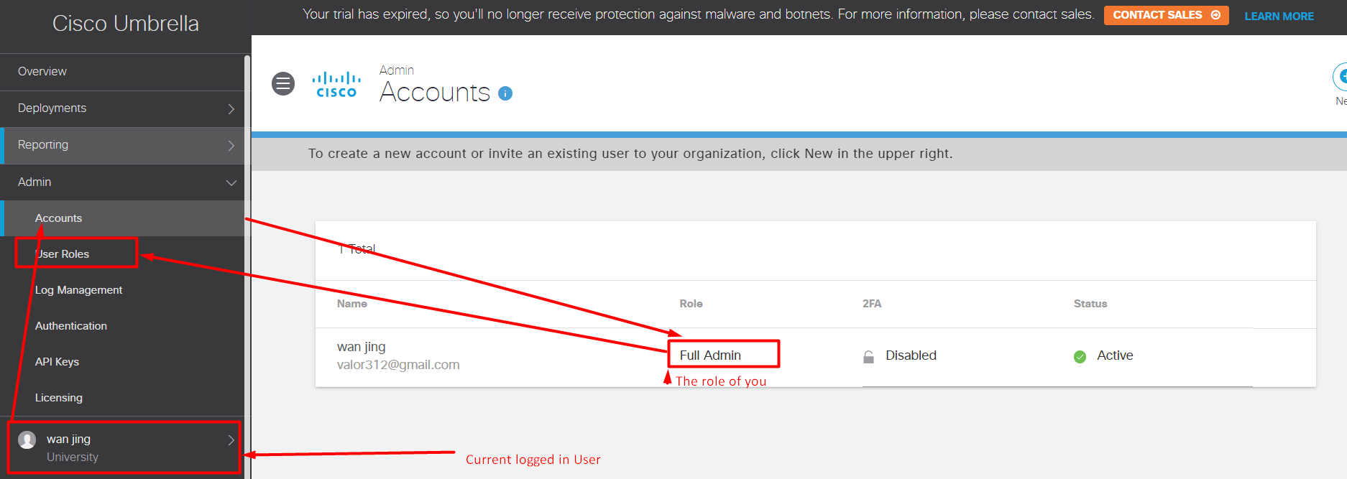

Generate an API key.

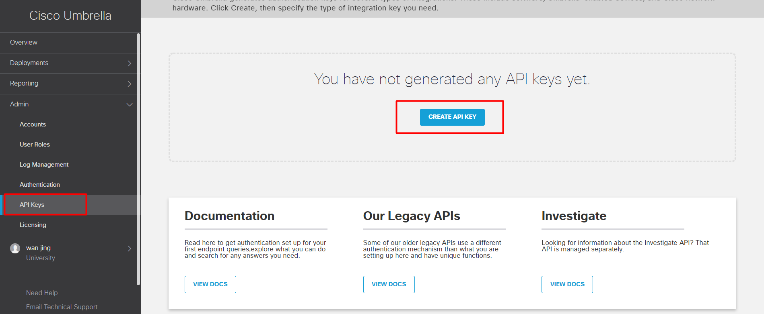

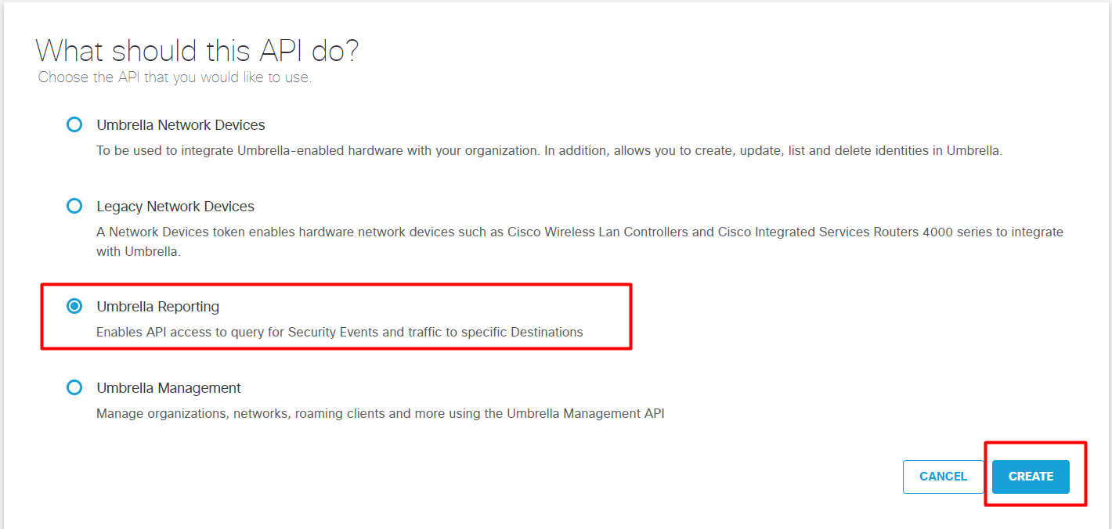

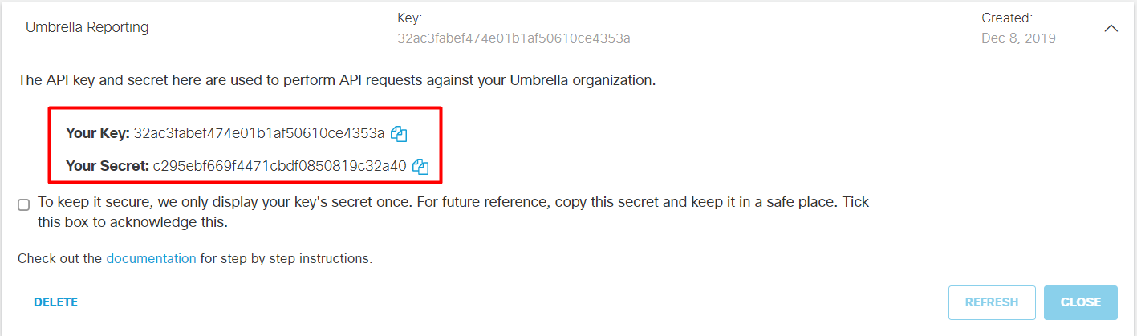

**Set the authentication information to the PostMan collection.**

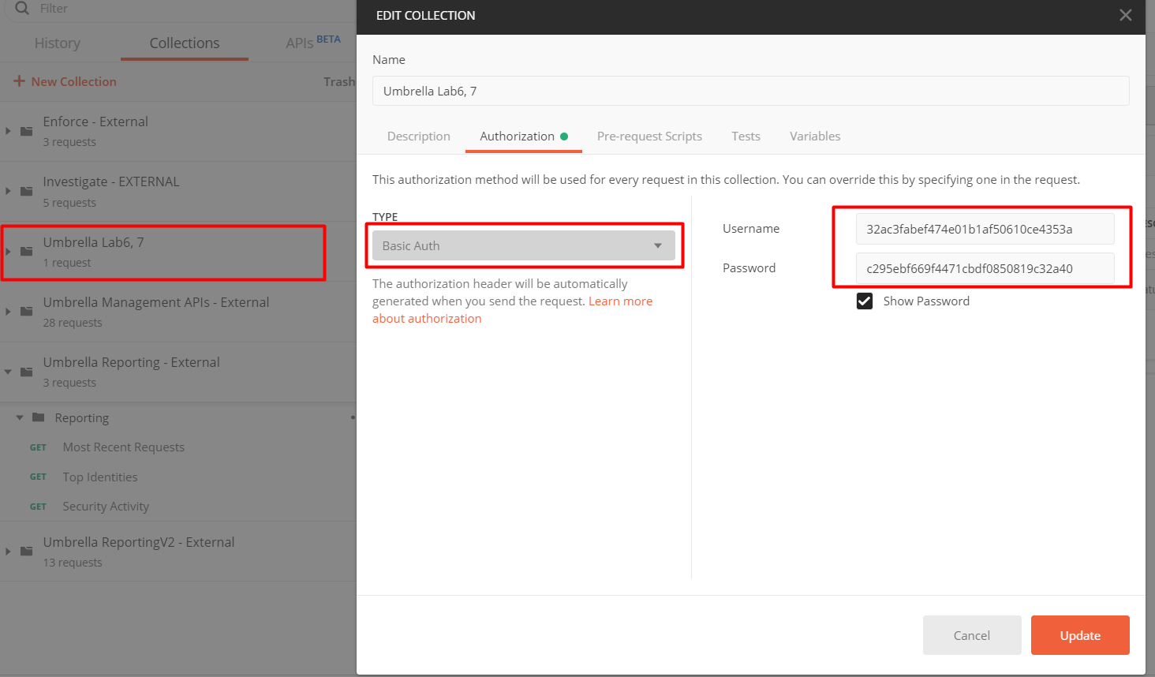

**How to get the Origin ID in the API URL?**

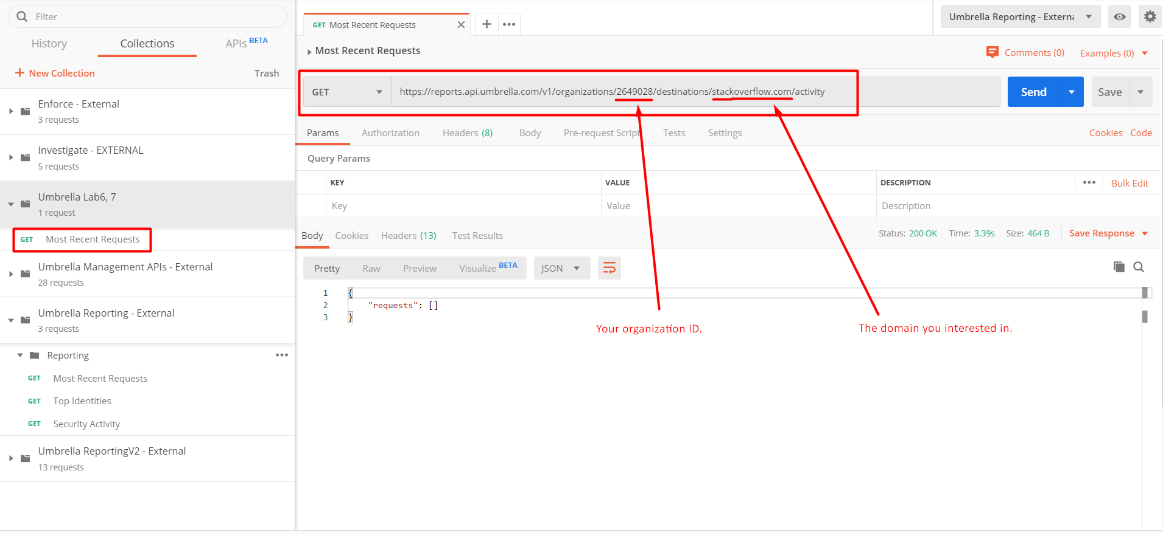

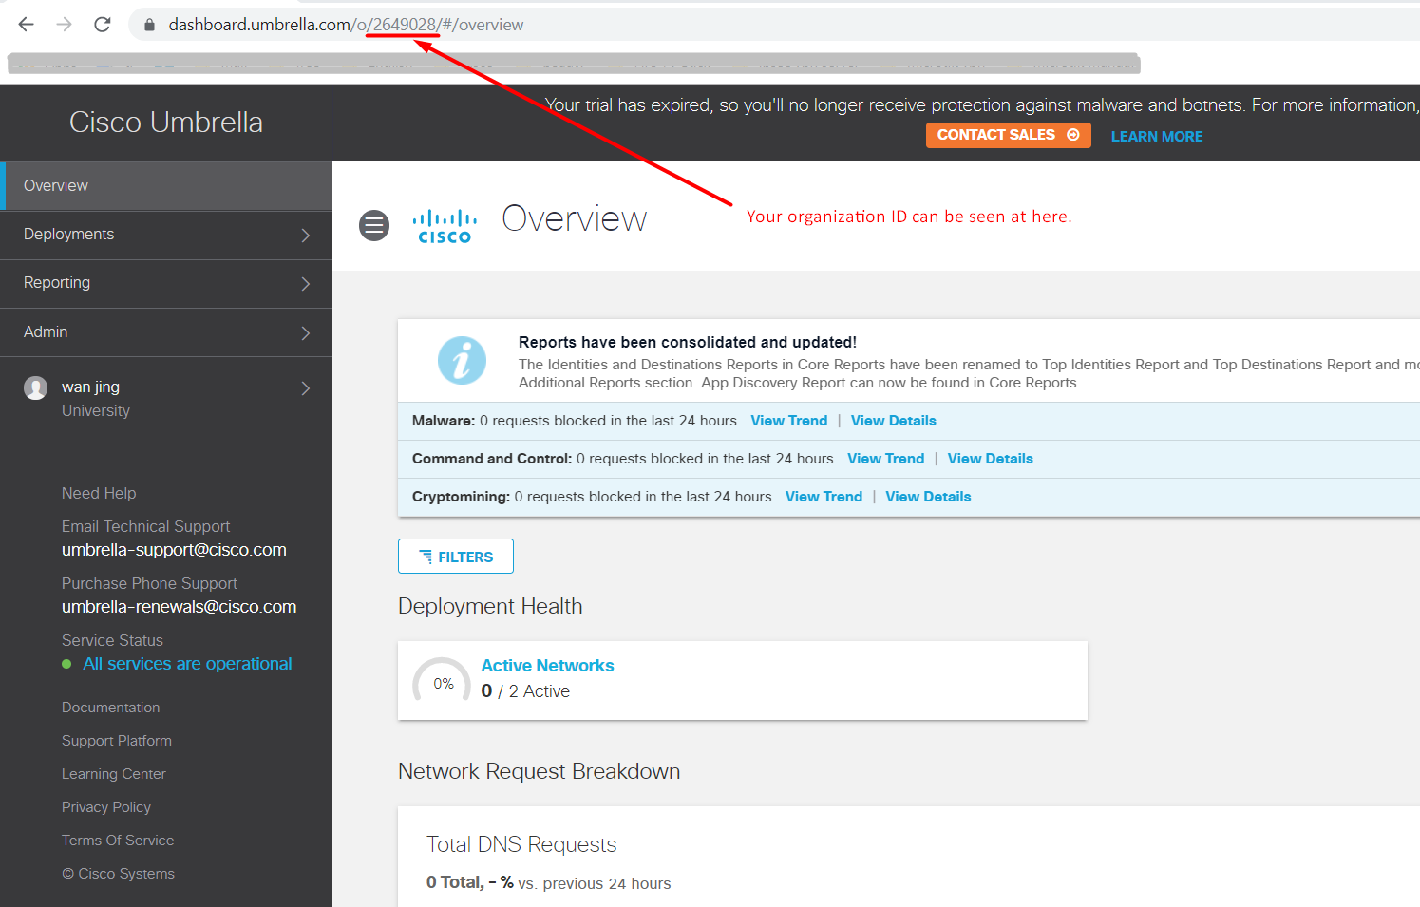

31) Umbrella - Retrieve Destinations: Most Recent Requests Report

<https://reports.api.umbrella.com/v1/organizations/2353515/destinations/update.googleapis.com/activity>

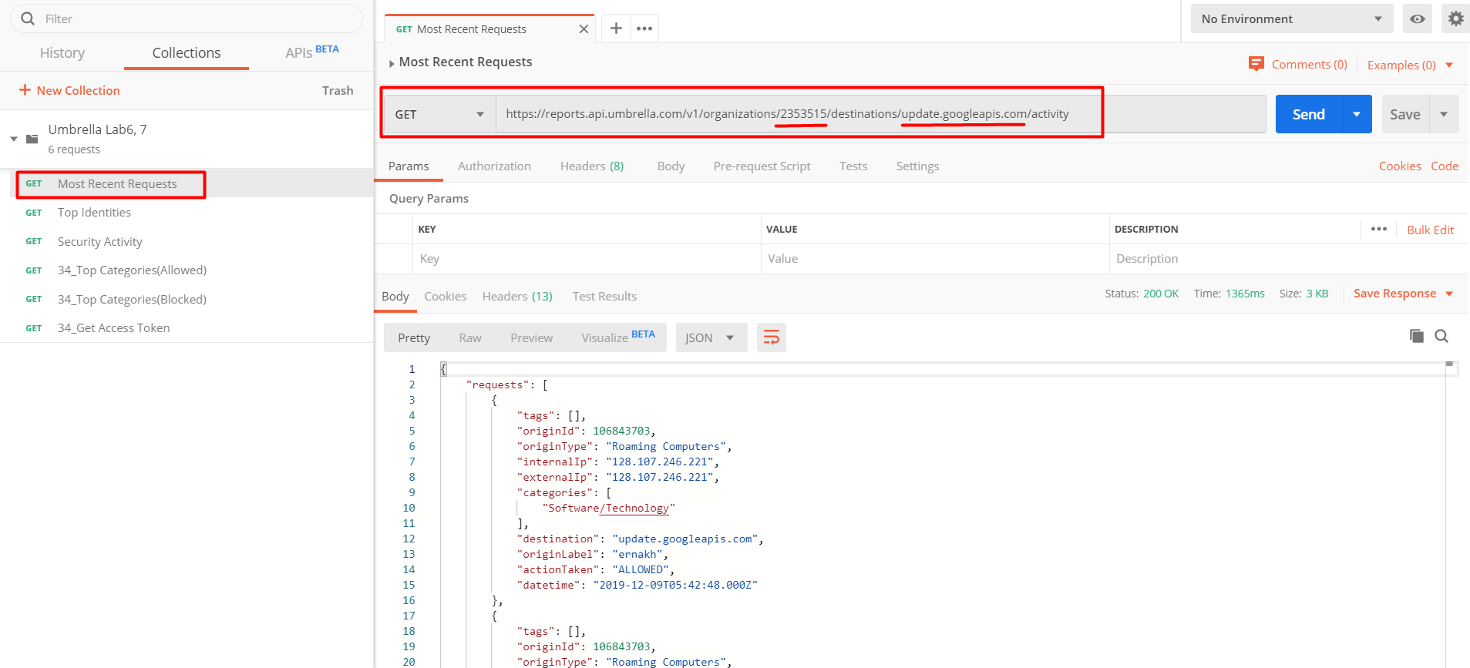

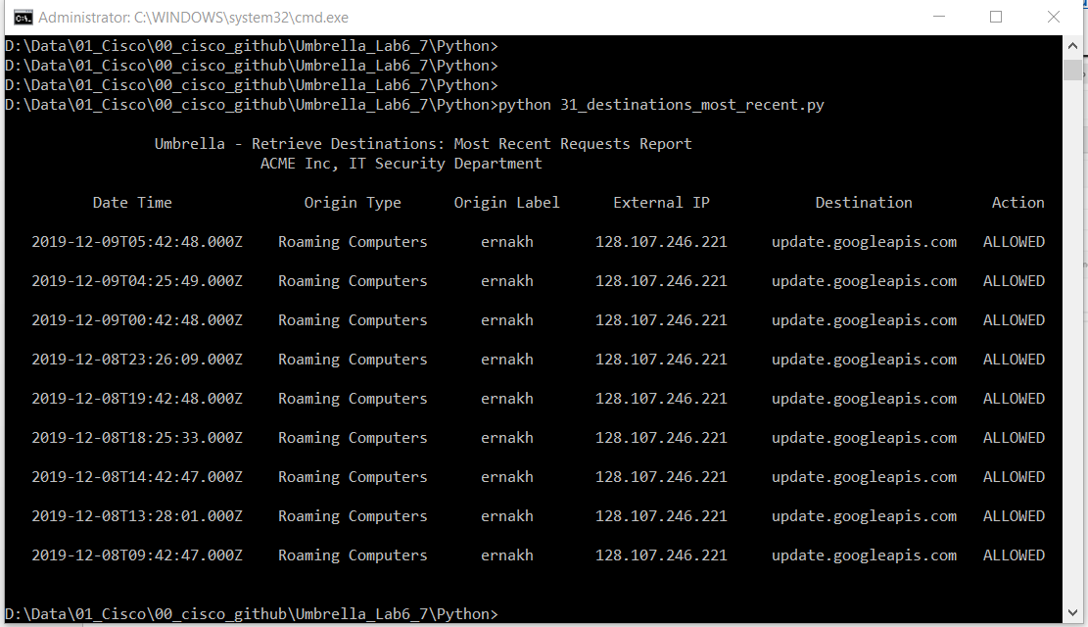

32) Umbrella - Retrieve Destinations: Top Identities Report

<https://reports.api.umbrella.com/v1/organizations/2353515/destinations/update.googleapis.com/identities>

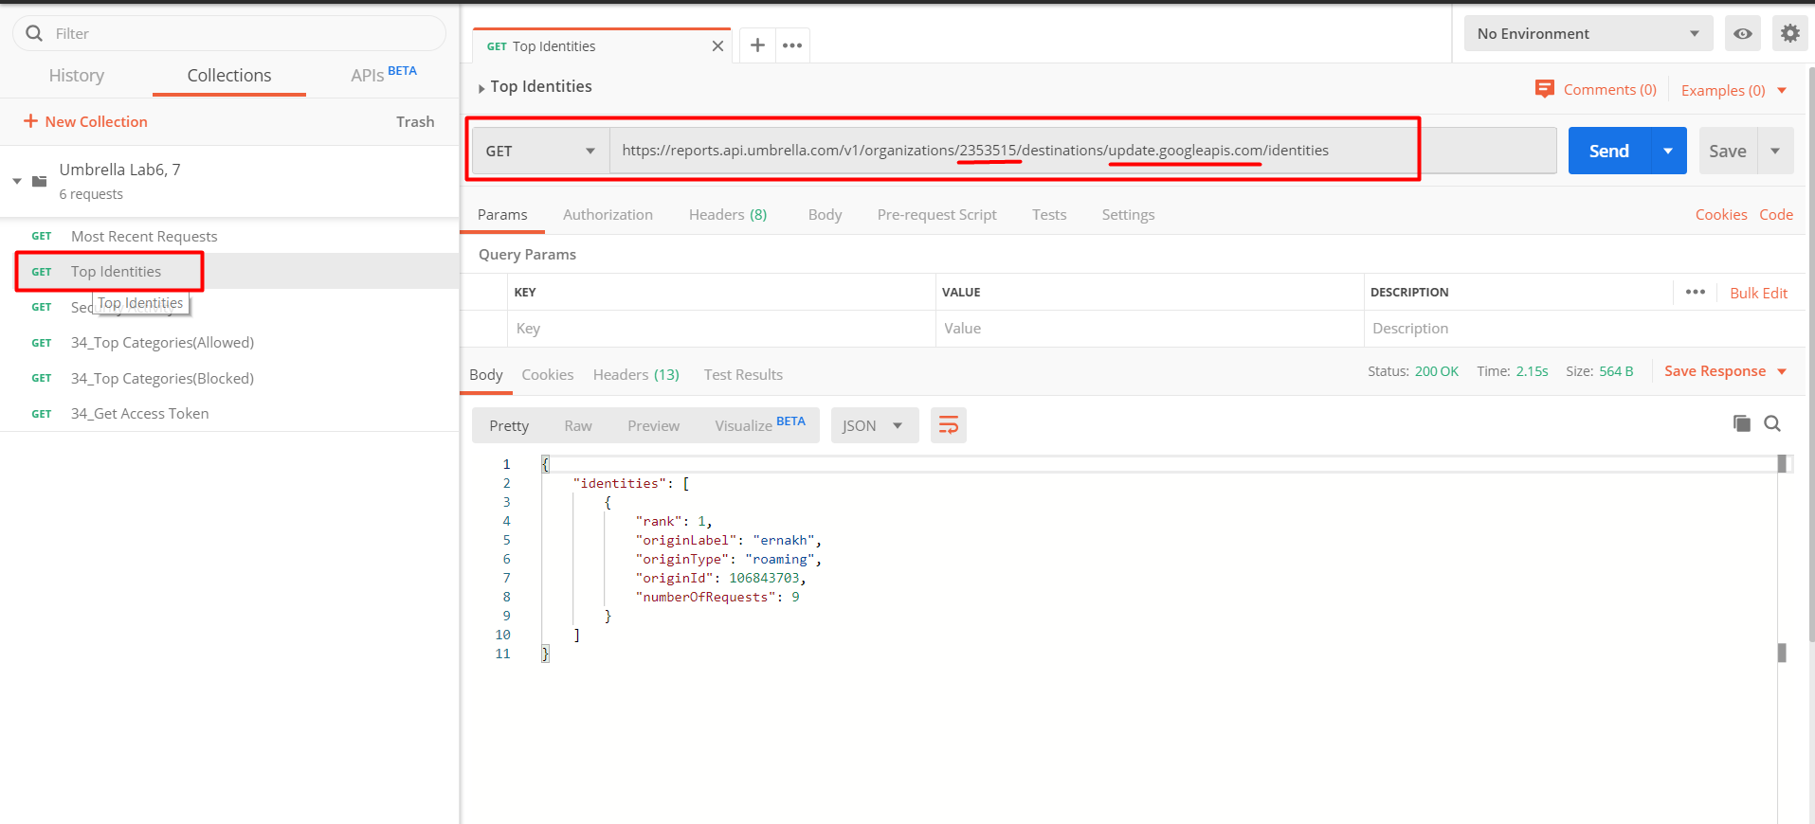

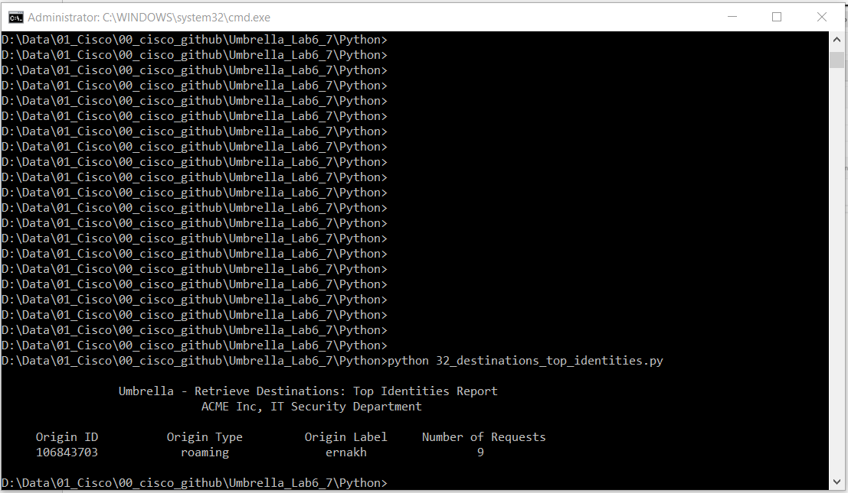

33) Umbrella - Retrieve Security Activity Report

<https://reports.api.umbrella.com/v1/organizations/2353515/security-activity?start=0>

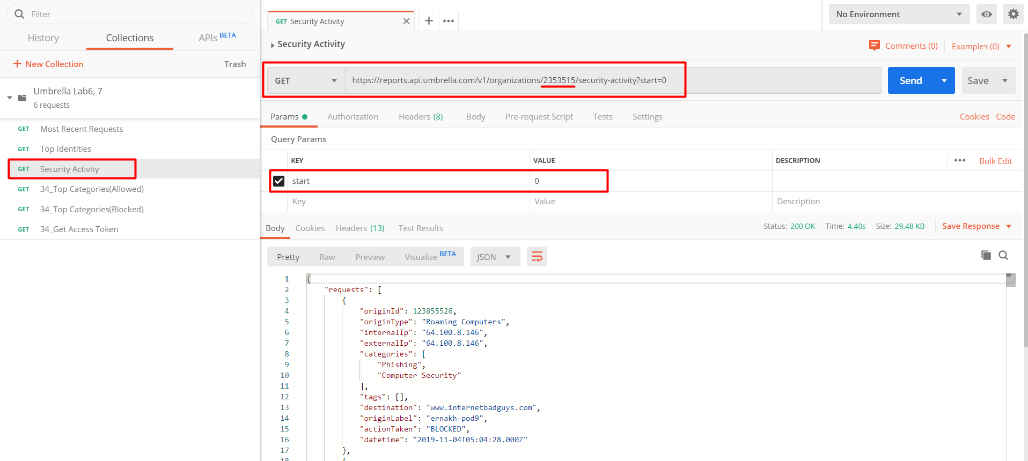

We can get the human time stamp to Epoch timestamp on this URL.

<https://www.epochconverter.com/>

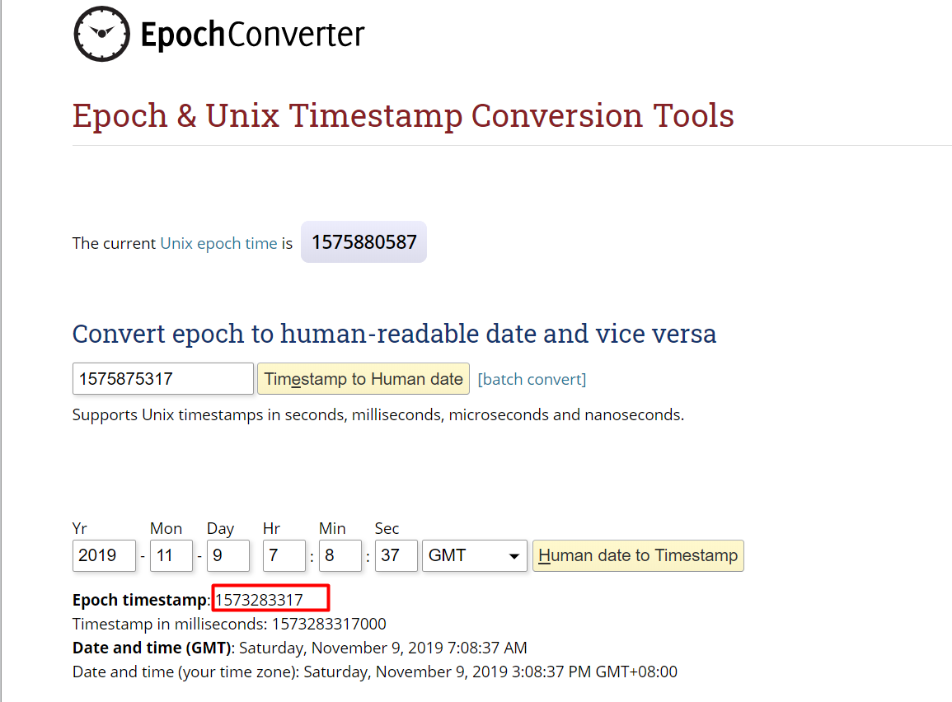

Python result.

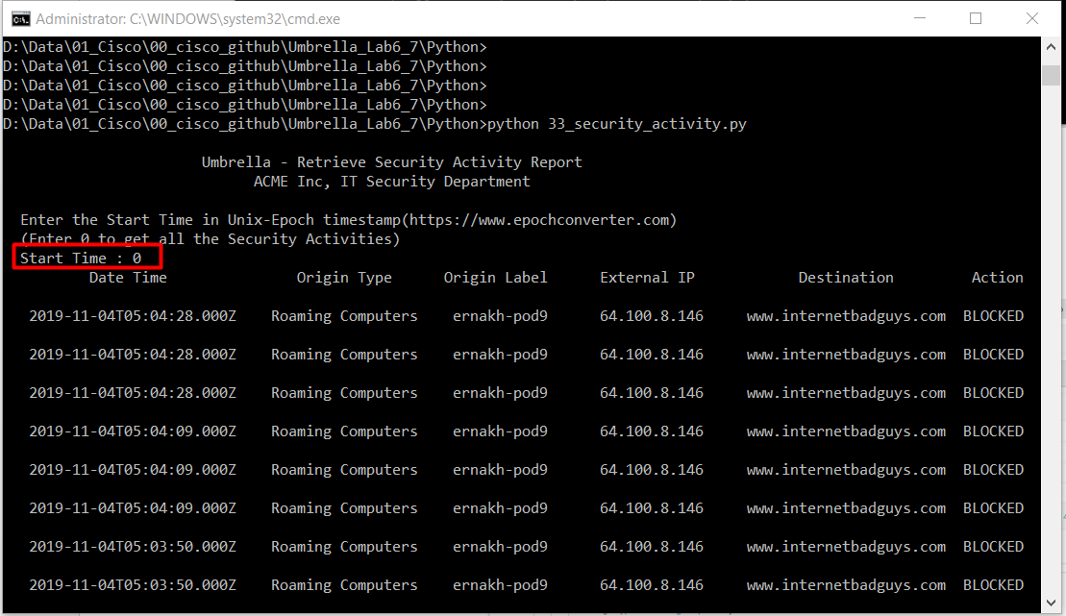

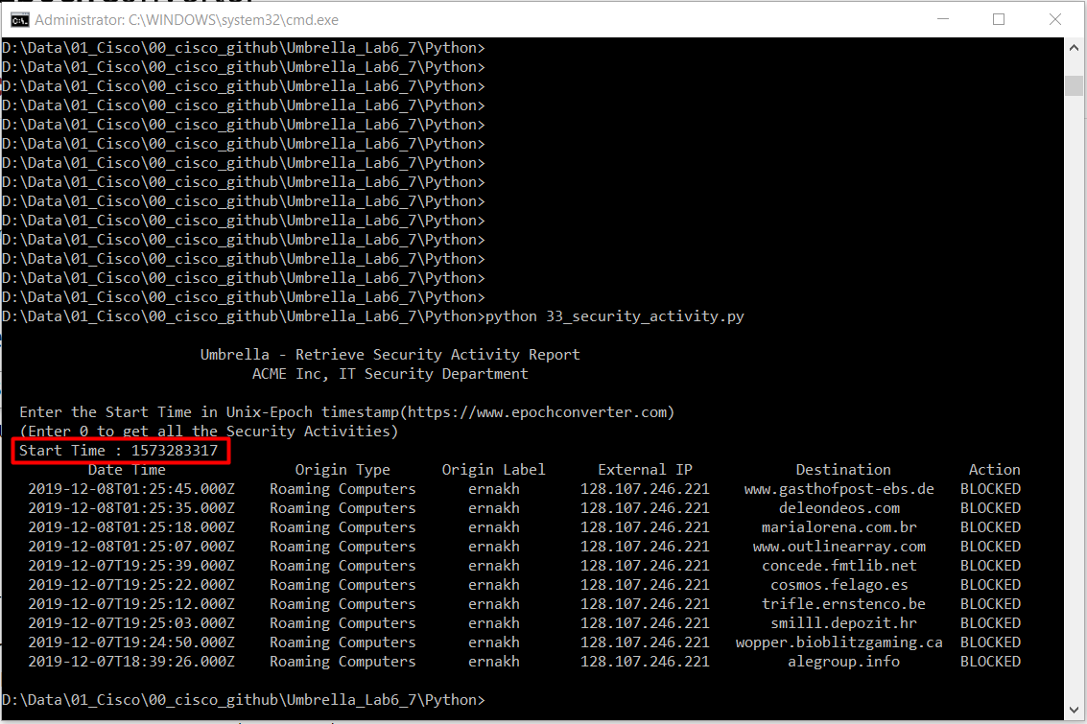

34) Umbrella - Build a Compiled Report from the Other Reports

35) Umbrella - Send Security Events to the Cisco Umbrella Cloud for Enforcement

36) Umbrella - List Domains and Delete Individual Domains

37) Umbrella - Add a Domain to a Domain List