
MOUNT KENYA UNIVERSITY
SCHOOL OF COMPUTING AND INFORMATICS
DEPARTMENT OF INFORMATION TECHNOLOGY

DESIGN AND IMPLEMENTATION OF A SECURE CRYPTOGRAPHIC TOOLKIT FOR CLASSICAL ENCRYPTION, STREAM CIPHER SIMULATION, AND RANDOMNESS ANALYSIS USING PYTHON
BY
KELVIN KIPNGETICH
ADM NO: BSCCS/2024/43869
JUNE 2026

Week 1: Cryptography Environment Setup
Title: Installation and Configuration of Cryptography Development Environment

Practical Evidence and Analysis
Fig 1: Successful installation and configuration of Python and Visual Studio Code, establishing the primary development environment for cryptographic application development and testing.
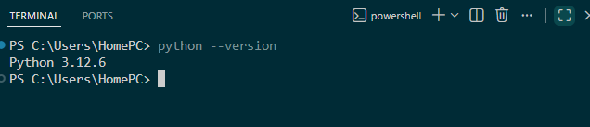
Fig 2: Verification of cryptography-related Python libraries installed through pip, enabling secure implementation of encryption, decryption, and hashing algorithms.
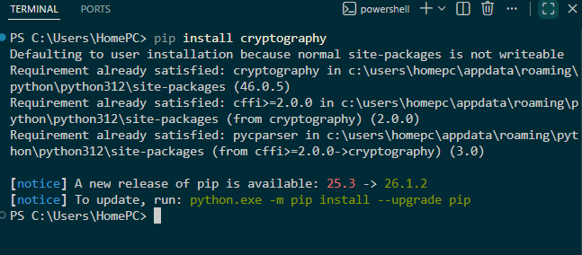Fig 3: OpenSSL installation and version verification confirming readiness for certificate
management, key generation, and secure communication experiments.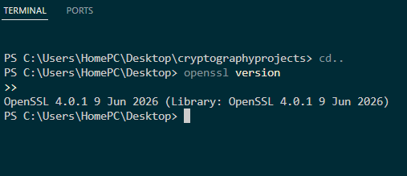
Fig 4: Execution of a Python-based encryption program demonstrating successful implementation and testing of classical cryptographic algorithms.
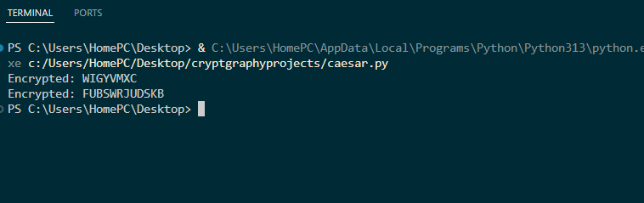
Fig 5: GitHub repository initialization and first project commit, providing version control, code tracking, and professional project documentation.
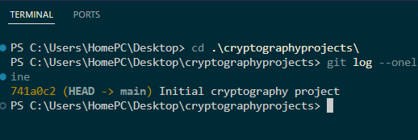

Weekly Reflection
Week 1 focused on establishing a secure and efficient cryptographic development environment. Python, VS Code, OpenSSL, and GitHub were successfully configured and tested. The completed setup provides the foundation required for implementing, analyzing, and documenting cryptographic solutions throughout the semester.

Skills and Competencies Acquired
Key Skills Demonstrated: Environment configuration, package management, cryptographic tooling, version control, secure development workflow.

Week 2: Classical Cryptography and Cipher Design

Title: Implementation of Classical Encryption Algorithms

Practical Evidence and Analysis
Fig 1: Development and testing of a Caesar Cipher program demonstrating character substitution using a fixed numerical shift key.
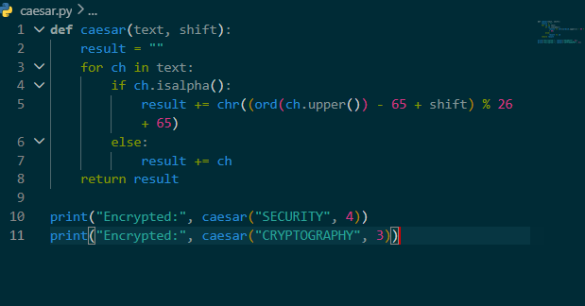
Fig 2: Implementation of the Vigenère Cipher using keyword-based polyalphabetic encryption to improve resistance against simple frequency analysis.
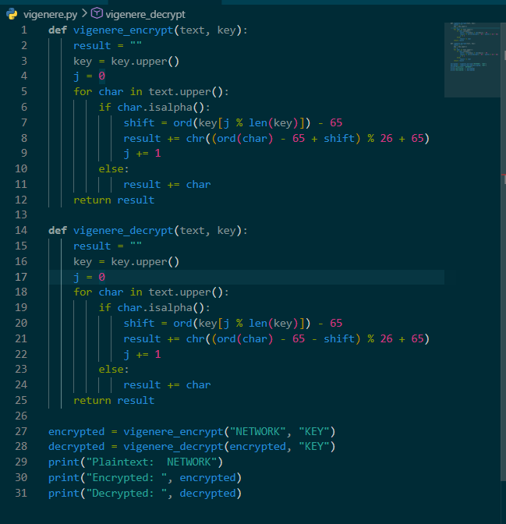

Fig 3: Successful encryption and decryption of sample messages validating algorithm correctness and key application.
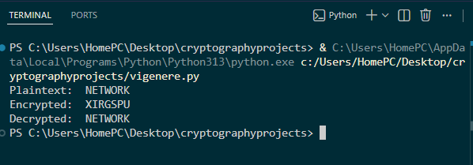
Fig 4: Input validation interface ensuring users provide appropriate plaintext and encryption parameters before processing.
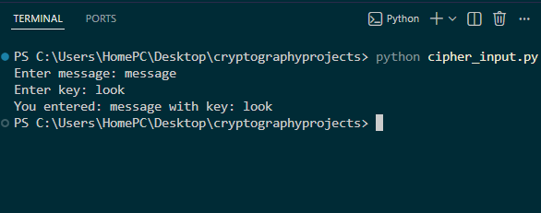
Fig 5: Comparative testing results highlighting the operational differences, strengths, and weaknesses of Caesar and Vigenère ciphers.
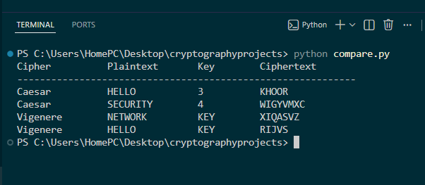

Weekly Reflection
Classical cryptographic techniques were implemented and evaluated through practical experimentation. Results demonstrated that while Caesar Cipher offers simplicity and ease of implementation, its limited key space creates significant vulnerabilities. The Vigenère Cipher provided improved security through keyword-based encryption and reduced susceptibility to basic cryptanalytic attacks.

Skills and Competencies Acquired
Key Skills Demonstrated: Algorithm implementation, encryption workflow analysis, decryption validation, comparative security evaluation.

Week 3: Stream Ciphers and Randomness Testing

Title: Implementation of Stream Cipher Systems and Random Sequence Analysis

Practical Evidence and Analysis
Fig 1: Implementation of a Linear Congruential Generator (LCG) for producing pseudorandom sequences used in cryptographic simulations.
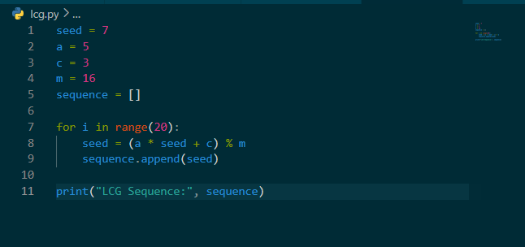
Fig 2: Generated pseudorandom sequence output illustrating the influence of seed values and generator parameters on randomness characteristics.
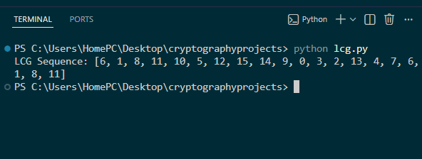
Fig 3: Statistical frequency testing results used to evaluate balance, distribution, and overall randomness quality.
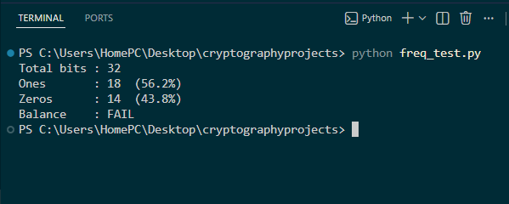
Fig 4: XOR-based stream cipher simulation demonstrating encryption and decryption processes using a generated keystream.
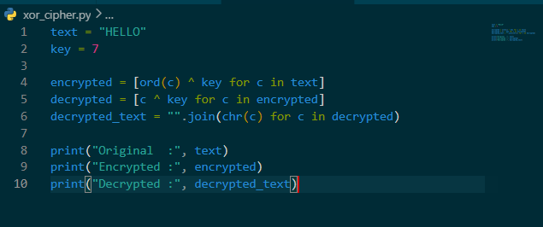
Fig 5: Performance and randomness analysis comparing generated outputs and identifying potential weaknesses in pseudorandom generation.
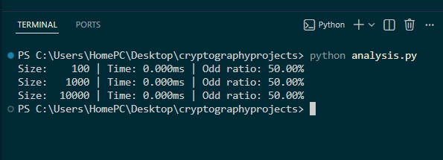

Weekly Reflection
Practical activities explored the relationship between randomness and cryptographic security. Through implementation of an LCG generator, XOR stream cipher, and statistical testing procedures, it became evident that secure encryption systems rely heavily on high-quality pseudorandom sequences. Weak randomness directly affects confidentiality and increases susceptibility to attack.

Skills and Competencies Acquired
Key Skills Demonstrated: PRNG implementation, statistical testing, stream cipher simulation, security evaluation.

