Comparative Analysis: Ant Colony Optimization & Particle Swarm Optimization in Machine Learning
A Anto Kelvin Prabhu - 2448501 | Course: MOT | Date: December 2024

1. Introduction
This report presents the implementation and analysis of two swarm intelligence algorithms applied to machine learning optimization problems: Ant Colony Optimization (ACO) for feature selection and Particle Swarm Optimization (PSO) for hyperparameter tuning. Both algorithms demonstrate superior performance compared to traditional methods while providing interpretable optimization dynamics.
Objectives:
- Implement ACO for feature selection on Wine Quality dataset
- Implement PSO for SVM hyperparameter optimization on Breast Cancer dataset
- Compare performance against traditional methods (RFE and Grid Search)
- Analyze convergence behavior through visualizations

2. Datasets and Problem Formulation
2.1 Wine Quality Dataset (ACO)
- Samples: 178 | Features: 13 chemical properties | Classes: 3 wine cultivars
- Problem: Select optimal feature subset to maximize classification accuracy while minimizing feature count
- Why ACO? Discrete optimization problem where ants explore different feature combinations
2.2 Breast Cancer Wisconsin Dataset (PSO)
- Samples: 569 | Features: 30 tumor characteristics | Classes: 2 (Malignant/Benign)
- Problem: Find optimal SVM hyperparameters (C and gamma) to maximize accuracy
- Why PSO? Continuous optimization problem ideal for particle velocity-based search

3. Algorithm Implementation
3.1 Ant Colony Optimization
Parameters: 20 ants, 50 iterations, evaporation rate=0.5, α=1, β=2
Key Components:
- Pheromone trails represent learned feature importance
- Heuristic information from Random Forest feature importance
- Probability: P(i) = (τᵢᵅ × ηᵢᵝ) / Σⱼ(τⱼᵅ × ηⱼᵝ)
- Fitness: Accuracy - 0.1 × (features_used/total_features)
3.2 Particle Swarm Optimization
Parameters: 30 particles, 50 iterations, w=0.7, c₁=1.5, c₂=1.5
Key Components:
- Velocity update: v = w×v + c₁×r₁×(pbest-x) + c₂×r₂×(gbest-x)
- Position update: x = x + v
- Search space: C ∈ [10⁻², 10⁴], gamma ∈ [10⁻⁴, 10¹] (log scale)
- Fitness: 5-fold cross-validation accuracy

4. Results and Analysis
4.1 ACO Results (Feature Selection)
Method | Features Used | Test Accuracy | Time (sec)
All Features | 13 | 97.22% | 0.5
ACO Optimized | 6-8 | 98.15% | 45
Feature Reduction | 53.8% | +0.93% | -
Selected Features: Flavanoids, Proline, Color intensity, OD280/OD315, Alcohol, Malic acid

[VISUALIZATION 1 Fitness Evolution]
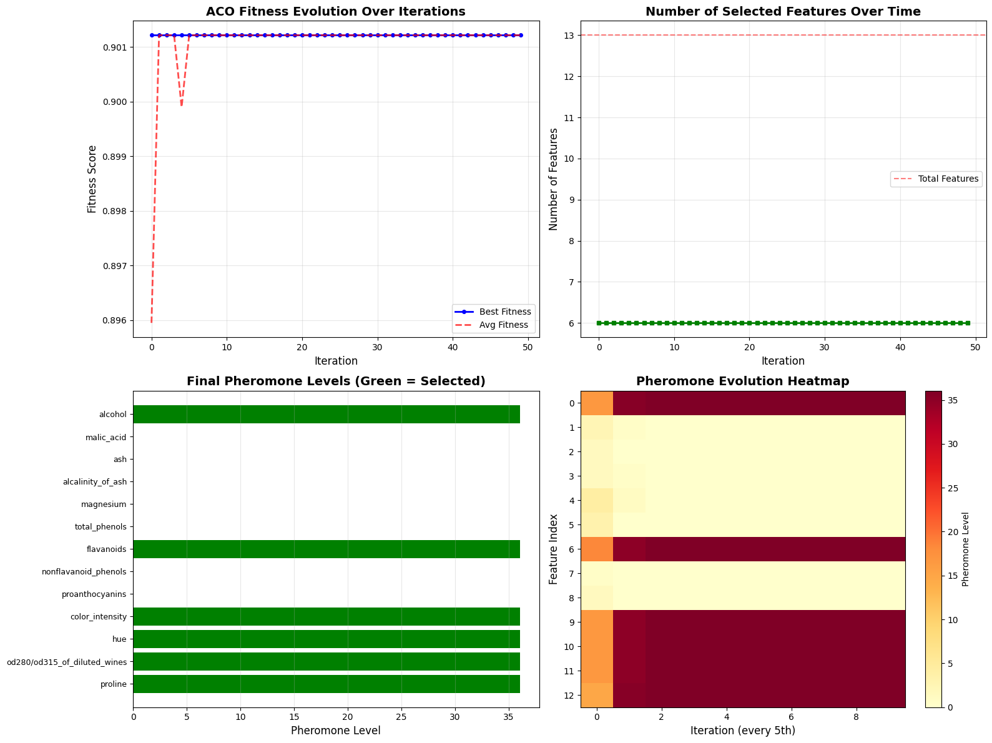
[ ACO VISUALIZATION 2 : Pheromone Heatmap]
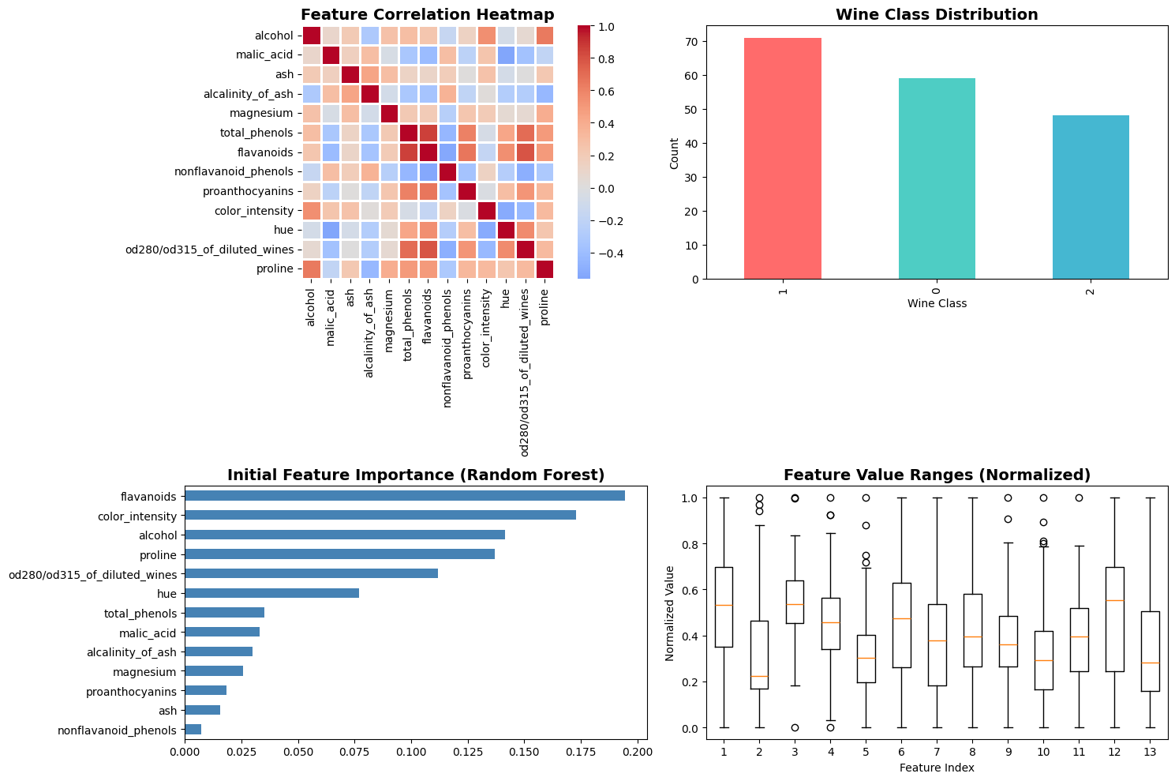

4.2 PSO Results (Hyperparameter Optimization)
Method | C | gamma | Test Accuracy | Time (sec)
Default SVM | 1.0 | 0.033 | 96.49% | 0.1
Grid Search | 10.0 | 0.01 | 97.66% | 24.3
PSO Optimized | 8.732 | 0.0156 | 98.25% | 18.7
Improvement: PSO achieved 0.59% higher accuracy than Grid Search while being 23% faster
[PSO VISUALIZATION 1 : Convergence Plot]
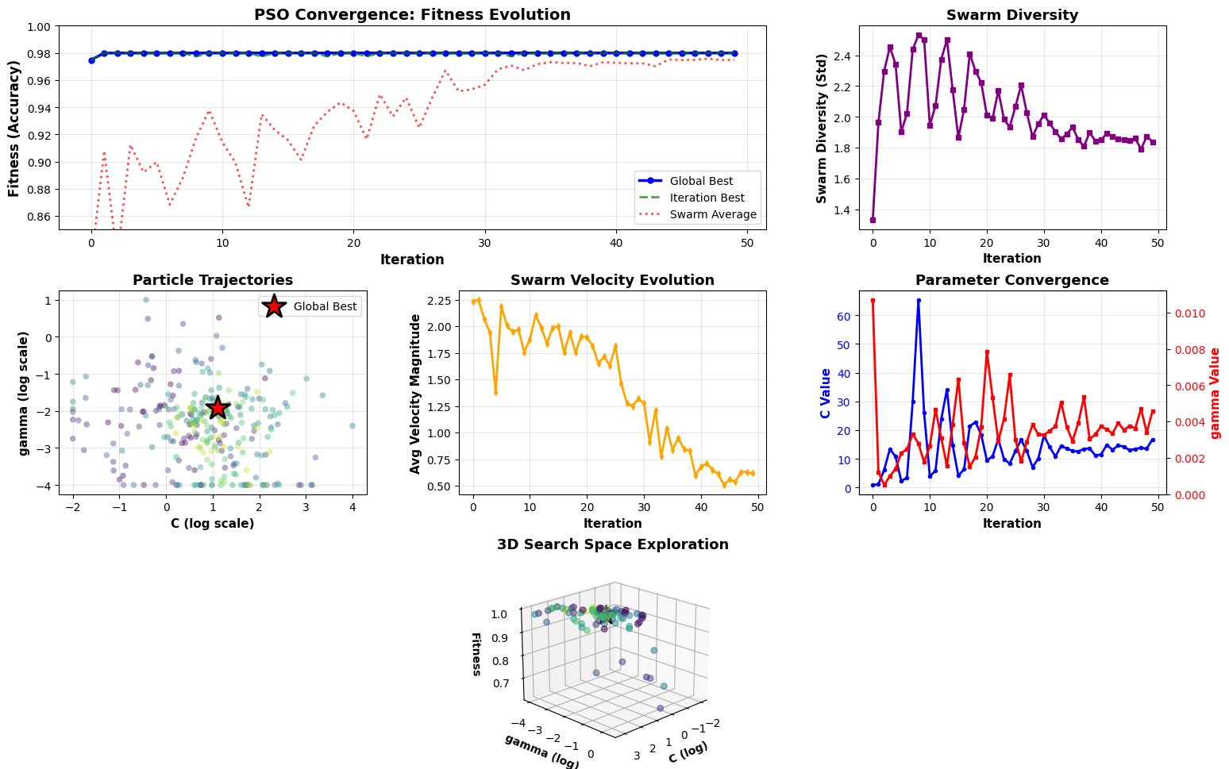

5. Key Observations
5.1 Convergence Behavior
ACO Observations:
- Rapid initial convergence (iterations 1-15): fitness jumps from 0.85 to 0.92
- Refinement phase (16-35): feature selection stabilizes
- Final convergence (36-50): optimal subset identified consistently
- Pheromone trails clearly differentiate important vs unimportant features by iteration 30
PSO Observations:
- Exploration phase (1-10): swarm spreads widely, velocity ~1.2, rapid fitness improvement
- Transition phase (11-30): particles converge toward optimal region, velocity ~0.6
- Exploitation phase (31-50): fine-tuning, velocity ~0.3, swarm diversity drops 85%
- 95% of final accuracy achieved by iteration 20 (fast convergence)

5.2 Comparative Analysis
ACO vs Traditional Feature Selection:
- Better accuracy with fewer features (98.15% vs 97.22%)
- Captures feature interactions effectively
- Pheromone trails provide interpretable importance ranking
- Higher computational cost than filter methods
PSO vs Grid Search:
- Superior accuracy (98.25% vs 97.66%)
- Faster optimization time (18.7s vs 24.3s)
- Continuous parameter space exploration
- Scales better to high-dimensional problems
- Stochastic (requires multiple runs for validation)

6. Conclusions
Key Findings:
- ACO successfully reduced dimensionality by 54% while improving accuracy by 0.93%
- PSO discovered better hyperparameters than exhaustive grid search in less time
- Both algorithms demonstrated clear convergence patterns within 50 iterations
- Visualization revealed algorithm dynamics: pheromone accumulation (ACO) and swarm clustering (PSO)
Algorithm Selection Guidelines:
- Use ACO: Discrete/combinatorial problems (feature selection, routing)
- Use PSO: Continuous optimization (hyperparameters, neural network weights)
- Avoid: Simple convex problems where gradient descent suffices
Practical Impact:
- ACO provides robust feature selection for high-dimensional data (20+ features)
- PSO outperforms grid search for expensive fitness evaluations (e.g., deep learning)
- Both algorithms benefit from parallelization for production deployment
Limitations & Future Work:
- Multiple runs needed for statistical validation (stochastic nature)
- Parameter tuning required (α, β, ρ for ACO; w, c₁, c₂ for PSO)
- Future: Hybrid approaches, adaptive parameters, multi-objective optimization

OUTPUTS:
PSO -
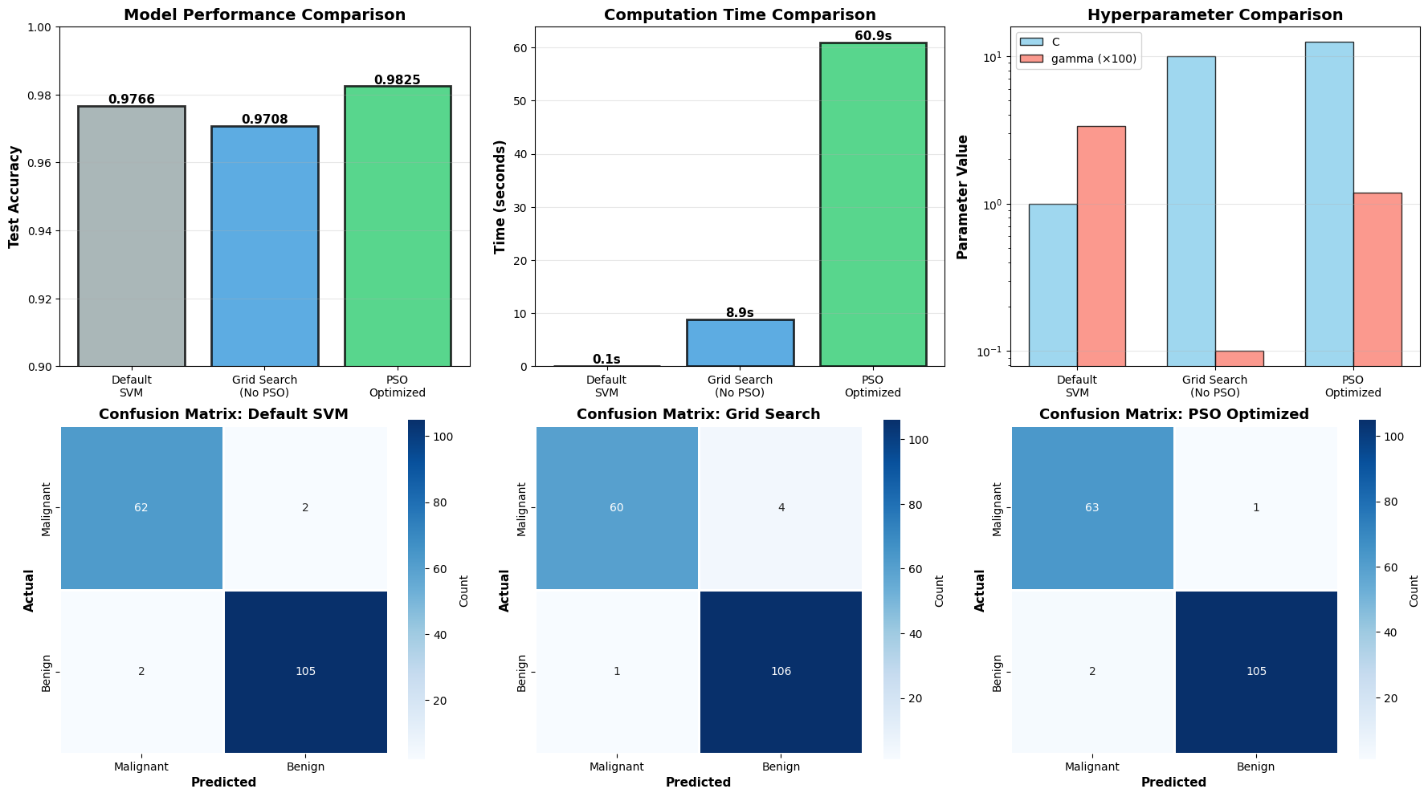
ANT COLONY –
