COSC 219 – M1 Game Explorer Proposal.
Project Name: Game Explorer
Team Members: Kudakwashe Kelvin Sibanda and Tanatswa Mashumba
Project Description:
Game Explorer is an interactive website that helps users discover video games and identify which devices they are available on, including PC, PlayStation, Xbox, Nintendo, Android, and iPhone (iOS). Users can search for games, filter by platform or genre, view game details such as release dates, and save their favourite games for future visits.
Intended Audience:
Game Explorer is designed for gamers of all ages who play on PC, PlayStation, Xbox, Nintendo, Android, or iPhone. It helps users discover new games and identify which devices support them, making it easier to find games they can play.
API Used: Wikipedia (MediaWiki Action API)
API Documentation: https://www.mediawiki.org/wiki/API:Main_page
We will use JavaScript fetch() to retrieve live video game information from Wikipedia, including game titles, supported platforms, genres, and release information. The API works directly in the browser without requiring an API key.
API Test Evidence:
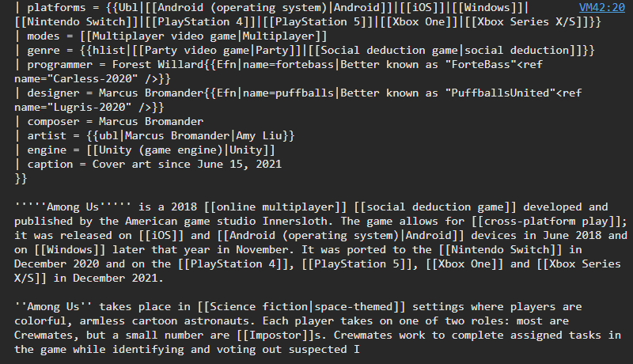
API Test: We successfully used JavaScript fetch() to retrieve live video game information from the Wikipedia API. The response included supported platforms for Among Us, such as Android, iOS, Windows, PlayStation, Xbox and Nintendo Switch.

🎮 GAME EXPLORER | ♡ My Favourites
🔍 Search for a game... | Search
Platform: All Devices ▼ | Genre: All Genres ▼
🎮 Minecraft PC • Xbox • PlayStation • Mobile ♡ Save Favourite | 🎮 Among Us PC • Nintendo • Android • iOS ♡ Save Favourite

Hardest Requirement:
The hardest requirement will be handling API loading, empty, loaded, and error states. Since Game Explorer retrieves live data from Wikipedia, we must ensure users receive clear messages when games are loading, no results are found, or the API request fails.

Division of Work:
Kudakwashe Kelvin Sibanda: Responsible for implementing the game search feature, connecting the Wikipedia API using JavaScript fetch(), and displaying game information and platform filters.
Tanatswa Mashumba: Responsible for implementing the favourites feature using localStorage, designing the responsive website layout, and styling the interface with CSS.
Both Team Members: Responsible for accessibility, testing, debugging, documentation, and the final presentation.

