Kelvin Silva
Cs 2 Barkeshli
Project Tree
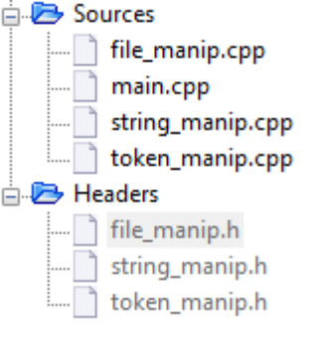
main.cpp //Main function
string_manip.cpp //String manipulation low level functions
token_manip.cpp //Token manipulation high level functions
file_manip.cpp //File manipulation side level functions
string_manip.h //String manipulation low level functions definition
token_manip.h //Token manipulation high level functions definition, global variables definitions
file_manip.cpp //File manipulation side level functions definition
This program requires an input from the user to be a file name of an existing .txt file. The program reads blocks from the file (BLOCK_MAX_SIZE) and tokenizes the block. Each token is inserted into its own row of 2 dimensional array char char_set[][] and token count held in int statistics[].
The end result of the program is to display each token on screen and the content of statistics on screen.
Summary
Given filename of text file, the textfile is opened and associated with an istream object. The istream object is passed to extract_block_file. Extract_block_file calls istream::read function to obtain data of BLOCK_MAX_SIZE bytes. This data is then inserted into char block[]. Main then calls TokenizeBlock, passing char block[].
TokenizeBlock calls GetNextToken in many successions to extract all the tokens from block[] and inserts each token into char_set[][]. Each token is held in its own row.
GetNextToken() first probes using Find() at start_pos of block[]. Depending on the ascii value from Find, baby_grep /*zorg*/ is called to search for the rest of the token. Probing is necessary so we can give the correct character set to search for.
From GetNextToken, baby_grep /*zorg*/ () calls FindAny, and FindNotAny functions. A full description of baby_grep and FindAny and FindNotAny functions are detailed below.
After TokenizeBlock is finished with the current block, extract_block_file is called again by main to extract another block from the text file. The block is then inserted into char block[] and passed to TokenizeBlock. This process happens until extract_block_file reaches EOF. In the case of EOF, all tokens are displayed on screen followed by the statistics retrieved.
Once all tokenization and the file has been completely read, the stream is closed. Main calls cin.get() and awaits the user to press enter to exit the program
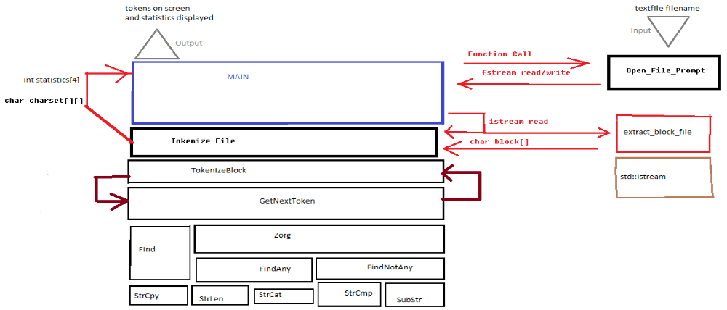
Main.cpp
Main sets up fstream read and write objects and calls Prompt_Open_File (described below) for valid streams. Main then calls TokenizeFile which takes a 2d character array for tokens and a valid stream. TokenizeFile returns with tokens in character set.
Main then calls Print2d to output all tokens separated by newlines in an outfile, and also outputs all data to console screen via cout object.
Main then calls cin.get to prompt user to exit the program.

High Level Functions (token_manip.h)
int Find(char key, char str[], int startpos)
Returns the index of the first occurrence of key in str starting from startpos.
int FindAny(char key[], char str[], int startpos)
Returns the index of the first occurrence of any value of key in str starting from startpos. When Find returns true, return the index Found.
int FindNotAny(char key[], char str[], int startpos)
Returns the index of the first non-occurrence of any value of key in str starting from startpos. When Find returns false, return the index not Found.
int baby_grep /*zorg*/( char source[],
char destination[],
char char_set[],
int start_pos)

Obtains the substring of the first occurrence of char_set[] from start_pos in source. baby_grep /*zorg*/() calls FindAny to find the first occurrence of char_set[] and then calls FindNotAny() to find the first disoccurence of the char_set[]. The two indexes returned by FindAny and FindNotAny denote the substring indexes for the item baby_grep /*zorg*/ () was called to search for.
baby_grep /*Zorg*/() then calls SubStr to extract the string and insert into destination[]. The return value of baby_grep /*zorg*/() is the position of the last index of SubStr. [That is, the index returned by FindNotAny]

bool GetNextToken(char block[], char token[], int &pos, int &type)

Obtains the next token in block[] and stores it in token[]. Based on the type of token found, &type will be an integer modified by GetNextToken. If an alphanumeric token is found, then type will be 1, if a punctuation is found, then type will be 2, and type will be 3 for whitespaces. Newlines will be of type = 4.

&pos is the position of the index that is being scanned. It is important for the functioning of GetNextToken.

Successive calls to GetNextToken will retrieve all tokens in a block. &pos is the variable that determines how GetNextToken will work.

int TokenizeBlock(char block[], char char_table[][TOKEN_MAX_SIZE], int statistics[])

TokenizeBlock is an encapsulation of GetNextToken. It successively calls GetNextToken until the end of block is reached. It inserts each token in a row in char_table.

Int statistics[type] is the statistic count for each token, e.g how many aplhanumeric characters there are.

For example if statistics[type] holds the value of 4, and type is 1, then
statistics[1] == 4. Meaning that there are 4 alphanumeric tokens in char_table.

int TokenizeFile(std::fstream &read_file, char char_table[][TOKEN_MAX_SIZE], int statistics[])

Tokenize file calls extract_block_file in rapid succession to feed extracted blocks into tokenizeblock. The buffer is cleared for safety. After loop ends, all tokens are stored in each row on a 2 dimensional array. Return value is the number of tokens (that is, the row count), which is equal to statistics[0].

Low Level Functions (string_manip.h)
void StrCpy(char dest[], char source[])
Copy characters from source to destination. Places data of source into dest.
Int StrLen(char A[])
Counts the number of positions of the string excluding null character
void StrCat(char str1[], char str2[])
Appends str2 to str1. Results are stored in str1
Int StrCmp(char A[], char B[])
Compares the two strings for ascii value. If the value of A[i] > B[i] then return 1, if A[i] < B[i] then return -1, if A[i] == B[i] then i++, if all chars in A and B are equal then return 0;
void SubStr(char source[], char sub[], int start, int stop)
Copies contents in between source[start] and source[stop] into sub.

File Manipulation Functions (file_manip.h)

bool /*getblock*/ extract_block_file(ifstream &read_file,
char block[],
int size_read = BLOCK_MAX_SIZE)

Obtains a block of data from read_file stream that is the size of size_read. Inserts the result into block[]. Heavy usage of ifstream::read

void Print2d(std::ostream &stream, char print_char[][TOKEN_MAX_SIZE], int row_ct);

Streams all contents of print_char into the outstream.

void Open_File_Prompt(std::fstream &ofn);

Polls for filename until stream is valid. Only accepts a valid filename. If filename is invalid, prompt user again.

