AN EXPLAINABLE DECISION-SUPPORT FRAMEWORK FOR FORECASTING DAILY CUSTOMER DEMAND AND SUPPORTING FOOD-WASTE REDUCTION IN SMALL FOOD-SERVICE BUSINESSES (DEMANDIQ)

Bachelor of Software Engineering (Machine Learning)

Kelvin Tawe
Student ID: 148709872

Course: Capstone Project
Supervisor: Marvin Muyonga O.

African Leadership University, Kigali, Rwanda
2026

DECLARATION
This capstone report is my original work, unless stated otherwise, and all external sources have been referenced or cited. This work has not been presented for the award of a degree or for any similar purpose in any other university.
Signature………………………………………… Date…………………………………
Kelvin Tawe

CERTIFICATION
The undersigned certifies that he has read and hereby recommends for acceptance by African Leadership University a report entitled “An Explainable Machine-Learning Decision-Support Framework for Forecasting Daily Customer Demand and Supporting Food-Waste Reduction Decisions in Small Food-Service Businesses (DemandIQ)”, submitted in partial fulfilment of the requirements for the degree of Bachelor of Software Engineering.
Signature………………………………………… Date…………………………………
Marvin Muyonga O.
Supervisor
Faculty, Bachelor of Software Engineering
African Leadership University

DEDICATION AND ACKNOWLEDGEMENT
Dedication
To my supervisor, Marvin Muyonga O., whose feedback kept pulling this work back to what the numbers could actually support; to the African Leadership University, where I carried it out; and to the problem I could not stop returning to. A kitchen must decide how much to cook before it knows who will come. I wrote this in the belief that such a decision deserves a range, not a guess dressed up as certainty.
Acknowledgement
I thank my supervisor, Marvin Muyonga O., for his guidance on the proposal and on this report. I thank African Leadership University and my lecturers for the teaching that made this work possible.

ABSTRACT
Small food businesses must decide how much food to prepare before they know how many customers will come. Preparing too much creates waste; preparing too little loses sales. Earlier evidence used confidential data, gave no reliability range and explained nothing. The aim was to design, build and test such a system, with seven objectives: the literature, a reproducible pipeline, forecasting, ranges, policies, explanations and the application. It built DemandIQ, an explainable system on a checkpointed, rerunnable pipeline. It forecast next-day visitors with LightGBM and CatBoost on the public Recruit Restaurant Visitor Forecasting data (829 Japanese restaurants, 252,108 restaurant-days), added stratified adaptive conformal ranges, compared four preparation policies by shortage and surplus cost, and explained each forecast with SHAP. A reviewed intake layer turned manual entries, spreadsheets, paper-log photos, till devices and point-of-sale links into one daily row. On the held-out test window, LightGBM’s mean absolute error of 6.695 visitors beat the best baseline by 12.7%. The ranges covered 89.98% of days against a 90% target, but only 56.1% of days with 60 or more visitors. A buffer built from the ranges lowered total cost only when a shortage cost about 4.7 times a surplus. Every applicable channel check passed, while local handwriting reading stayed weak. The models were not tested on Rwandan data, so the method needs local evidence before it guides vendors. The study concludes that a boosted forecast with calibrated ranges is a workable basis for the preparation decision, and recommends presenting the range rather than a single number, setting the cost ratio from the business’s records, and piloting the intake layer on local data before real use.
Keywords: demand forecasting, food waste, conformal prediction, newsvendor, explainable machine learning, reproducibility

TABLE OF CONTENTS
Declaration i
Certification ii
Dedication and Acknowledgement iii
Abstract iv
List of Tables vii
List of Figures viii
List of Acronyms and Abbreviations ix
CHAPTER ONE: INTRODUCTION 1
1.1 Background to the Study 1
1.2 Statement of the Problem 2
1.3 Aim and Objectives of the Study 3
1.3.1 Aim 3
1.3.2 Specific Objectives 3
1.4 Research Questions 4
1.5 Project Scope 5
1.6 Significance and Justification 6
1.7 Research Budget 6
1.8 Research Timeline 6
1.9 Definition of Terms 7
CHAPTER TWO: LITERATURE REVIEW 8
2.1 Introduction 8
2.2 Conceptual Review 8
2.3 Historical Background of the Research Topic 9
2.3.1 Origins and Early Context of the Research Problem 9
2.3.2 Foundational Theories 9
2.3.3 Key Milestones 9
2.3.4 Historical Gaps and Transition to the Current Study 10
2.4 Theoretical Review 10
2.4.1 Foundational Theories 10
2.5 Overview of Existing Systems 11
2.5.1 Strengths and Weaknesses of the Existing Systems 11
2.6 Review of Related Works 12
2.6.1 Summary of Reviewed Literature 13
2.7 General Comments 14
CHAPTER THREE: SYSTEM ANALYSIS AND DESIGN 15
3.1 Introduction 15
3.2 Research Design 15
3.2.1 Dataset and Dataset Description 15
3.2.2 Baseline Model Description 17
3.2.3 Proposed Model Description 17
3.2.4 Metrics for Evaluation 18
3.3 System Analysis 19
3.3.1 Functional Requirements of the System 19
3.3.2 Non-functional Requirements of the System 19
3.3.3 Proposed Model Diagram 20
3.4 System Design 20
3.4.1 Architecture, Database, Flow, Class, Use Case and Sequence Diagrams 20
3.5 Development Tools 25
3.6 Ethical and Legal Considerations 25
CHAPTER FOUR: SYSTEM IMPLEMENTATION, RESULTS AND DISCUSSION OF FINDINGS 26
4.1 System Implementation 26
4.1.1 Introduction 26
4.1.2 Model Pipeline 26
4.1.3 Intake Layer 26
4.1.4 Backend and Web Application 28
4.1.5 Privacy and Access Controls 28
4.2 Graphical View of the Project 28
4.2.1 Screenshots with Description 28
4.3 Results 34
4.3.1 Forecast Accuracy (RQ1) 34
4.3.2 Prediction Ranges (RQ2) 35
4.3.3 Preparation Policies (RQ3) 36
4.3.4 Explanations (RQ4) 37
4.3.5 Statistical Comparison, Sparse Restaurants and Cost-ratio Sweep 38
4.4 Discussion of Findings 38
4.5 Testing 39
4.5.1 Introduction 39
4.5.2 Objective of Testing 40
4.5.3 Unit Testing Outputs 40
4.5.4 Validation Testing Outputs 41
4.5.5 Integration Testing Outputs 42
4.5.6 Functional and System Testing Results 43
4.5.7 Acceptance Testing Report 45
CHAPTER FIVE: SUMMARY, CONCLUSION AND RECOMMENDATIONS 46
5.1 Summary 46
5.2 Conclusion 46
5.3 Recommendations 47
5.4 Future Implementations 47
5.5 Contributions to the Body of Knowledge 48
REFERENCES 50
APPENDIX A: HOW SUPERVISOR FEEDBACK WAS ADDRESSED 55

LIST OF TABLES
Table 1. Alignment of Problems, Research Questions, Objectives, Data and Measures 5
Table 2. Comparative Summary of Reviewed Literature 13
Table 3. Functional Requirements 19
Table 4. Non-functional Requirements 19
Table 5. Development Tools and Versions 25
Table 6. Test-Window Forecast Accuracy 35
Table 7. Feature-Group Ablation 35
Table 8. Range Coverage at a 90% Target 36
Table 9. Preparation Policies at Equal Shortage and Surplus Cost 37
Table 10. Paired Per-restaurant Comparison (Wilcoxon Signed-rank Test) 38
Table 11. Total Cost by Policy and Cost Ratio 38
Table 12. Environment Configuration 40
Table 13. Unit Test Summary 41
Table 14. Requirements Traceability 41
Table 15. Behaviour Checks by Channel 42
Table 16. Photo Reading Before and After Preprocessing 43
Table 17. Pipeline Stage Durations 43
Table 18. Response Time and Compatibility Results 45
Table 19. Response to Supervisor Feedback 55

LIST OF FIGURES
Figure 1. Framework and Evaluation Boundaries 11
Figure 2. Chronological Split of the Recruit Data 16
Figure 3. Model Pipeline in 12 Checkpointed Stages 20
Figure 4. System Architecture 21
Figure 5. Use Case Diagram 22
Figure 6. Database Design 23
Figure 7. Class Diagram of the Photo-Reading Module 24
Figure 8. Sequence Diagram of Photo Intake 24
Figure 9. Sign-in Page (FR1) 29
Figure 10. Workspace Page: Five Members, Two Locations, 102 Forecasts (FR2, FR3) 29
Figure 11. Security Page: Two-factor Sign-in an Administrator Seat Cannot Switch Off (FR1) 30
Figure 12. Data Ingestion Page, Image Tab with the Consent Box (FR5, FR6) 30
Figure 13. Consent Box Before a Photo Upload (FR6) 31
Figure 14. Review Screen: Photo Beside the Rows the Reader Found (FR6) 31
Figure 15. Demand Forecast Page with the Range and the Japan Notice (FR9) 32
Figure 16. “Why This Forecast?” Panel with SHAP Drivers (FR9) 32
Figure 17. Analytics Page with the Assistant Panel (FR10) 32
Figure 18. Privacy Policy and Terms of Use Reader (FR12) 33
Figure 19. Rights Section of the Privacy Policy (FR12) 33
Figure 20. A Second Workspace Signed In on Its Own Seat: Only Its Own Member, and None of the First Workspace’s Locations or Forecasts (FR2) 34
Figure 21. Dataset Record for the Recruit Data: 252,108 Records, 829 Restaurants, 1 January 2016 to 22 April 2017 34
Figure 22. Range Coverage by Demand Level, Two Ways of Conditioning 36
Figure 23. Surplus and Unmet Demand by Preparation Policy 37

LIST OF ACRONYMS AND ABBREVIATIONS
Abbreviation | Meaning
2FA | Two-factor authentication
ACI | Adaptive conformal inference
ALU | African Leadership University
API | Application programming interface
CSV | Comma-separated values
FAO | Food and Agriculture Organization of the United Nations
FR | Functional requirement
GDP | Gross domestic product
LSTM | Long short-term memory
MAE | Mean absolute error
MASE | Mean absolute scaled error
MoMo | Mobile money
NISR | National Institute of Statistics of Rwanda
OCR | Optical character recognition
POS | Point of sale
PS | Potential surplus
REC | Research Ethics Committee
REST | Representational state transfer
RMSE | Root mean squared error
RMSLE | Root mean squared log error
RQ | Research question
SDLC | Software development life cycle
SHAP | SHapley Additive exPlanations
SO | Specific objective
SR | Forecast-based surplus
UD | Unmet demand
UNEP | United Nations Environment Programme
XLSX | Excel workbook format

CHAPTER ONE: INTRODUCTION

1.1 Background to the Study
Food loss and waste were large and measurable. The United Nations Environment Programme (UNEP, 2024) estimated that about 1.05 billion tonnes of food were wasted in 2022 at household, food-service and retail level, almost one-fifth of the food available to consumers, with food service alone accounting for about 290 million tonnes. Wasted food also wastes the land, water, energy, labour and capital that produced it. In Rwanda, an estimated 40% of food production was lost or wasted each year, roughly 12% of GDP (Ruzigamanzi et al., 2026; World Bank, 2020). Food security improved, with food-secure households rising from 79% in 2021 to 83% in 2024 (National Institute of Statistics of Rwanda [NISR], 2025), and in 2026 the Food and Agriculture Organization of the United Nations (FAO, 2026) and the City of Kigali supported an initiative on organic and food-waste management.
These figures showed how much was lost, not who carried the loss. In Rwanda, small operators were the most exposed: the informal sector held 82.7% of total employment in 2023 (NISR, 2024), and in August 2026 annual inflation was 16.3% for food and non-alcoholic beverages and 15.6% for restaurants and hotels (NISR, 2026). The figures did not show that inflation caused waste, but each wasted portion cost a small operator more than it had a year earlier.
A restaurant, cafeteria or street vendor had to choose how much to buy and cook before knowing how many customers would come. Too much created surplus that might be thrown away; too little lost sales. Two studies linked this decision to waste. A review of 63 studies on hospitality food waste named inaccurate prediction of customer numbers as a recognised cause in buffet operations (Dhir et al., 2020), and AI waste-tracking at five hospitality sites in Germany, Switzerland and Greece found that avoidable waste, meaning overproduction and consumer leftovers, made up a substantial share of what was measured (Sigala et al., 2025). Neither gave the share of waste that came from purchasing at small operators, and this study did not measure waste. It forecast demand and evaluated the preparation decision that followed.
Machine-learning forecasts were a candidate tool. Rodrigues et al. (2024) compared models on several years of daily demand from three catering services and, under their planning assumptions, estimated reductions in wasted meals of 14% to 52%. Malefors et al. (2022) forecast guest attendance in public catering, and Hübner et al. (2024) reported an average 30% reduction in bakery returns. Most of this evidence came from confidential or proprietary data, so others could not rerun it.
This study therefore used public data: the Recruit Restaurant Visitor Forecasting dataset (Recruit Holdings, 2018), which recorded daily visitor counts for 829 restaurants in Japan from 1 January 2016 to 22 April 2017. Japanese data could not show how the method worked in Kigali, but it could show how a pipeline behaved when every step, from data audit to decision cost, was open to inspection.

1.2 Statement of the Problem
Operators of small food-service businesses in Rwanda kept demand records in different forms: paper logbooks, mobile-money (MoMo) statements and, in some places, point-of-sale (POS) exports (Malauri et al., 2021; NISR, 2016, 2024). That setting motivated the work and shaped the software, but the evaluation could not test it, because the forecasting data came from Japan. Three problems were addressed with the data that was available.
Problem 1: the evidence could not be reproduced. Studies that estimated waste reductions from forecasting mostly used confidential data (Hübner et al., 2024; Malefors et al., 2022; Rodrigues et al., 2024), so readers could not check the preprocessing, the split between training and test data, or the baselines. Public-data studies reported accuracy or a single decision cost (An et al., 2025; Bojer & Meldgaard, 2021) and published no pipeline a second person could rerun from end to end.
Problem 2: uncertainty was hidden from the preparation decision. A point forecast did not say how reliable it was. The best quantity depended on the relative cost of a shortage and a surplus, which a single number could not express (An et al., 2025; Ban & Rudin, 2019). Prediction ranges could show the spread, but only if their coverage held at the demand levels where operators needed them, busy days included.
Problem 3: forecasts were not interpretable. Gradient-boosted models were accurate but opaque. SHAP attributions described which features moved a prediction (Lundberg & Lee, 2017), and demand-planning work argued that explanations had to fit the user (Zhu et al., 2025). Evidence that they helped operators was thin: the retail study tested explanations of large errors with analysts in a large organisation (Lucic et al., 2019), not with small food businesses.
Taken together, no open, rerunnable pipeline forecast daily restaurant demand, reported whether its ranges held at different demand levels, priced shortage against surplus and explained its forecasts. A practical constraint added to this: the models needed history in one form, while operators kept it in several. DemandIQ therefore included an intake layer, built and tested for function but not evaluated for forecasting accuracy.

1.3 Aim and Objectives of the Study

1.3.1 Aim
The study aimed to develop and evaluate an explainable, reproducible machine-learning decision-support system that forecast next-day restaurant demand on public data, reported prediction ranges, compared preparation policies by shortage and surplus cost, and accepted operator records through a reviewed intake layer.

1.3.2 Specific Objectives
The first objective was to review and synthesise at least 20 peer-reviewed and institutional sources on restaurant demand forecasting, forecast uncertainty, newsvendor-type preparation decisions, explainability and small-business data practices, using the documented protocol in Section 2.1. The second was to publish a reproducible pipeline with pinned versions, recorded source-file hashes and one command to regenerate the results tables, with an independent rerun targeting reproduction within 0.05 visitors for mean absolute error and 0.5 percentage points for coverage. The third was to train LightGBM and CatBoost on Recruit, compare them with defined baselines on the held-out period from 1 February to 22 April 2017, and test the comparison by restaurant; these forecasting results also supplied the inputs for the prediction-range and preparation-policy objectives.
The remaining objectives were to build stratified adaptive conformal prediction ranges and report their coverage and width overall and by demand level, aiming for overall coverage within two percentage points of 90%; compare four preparation policies across shortage-to-surplus cost ratios and identify where an uncertainty buffer began to pay off; assess SHAP explanations and their stability; and build the DemandIQ backend and web application, including an intake layer evaluated through automated behaviour checks and photo-reading accuracy on pages with known content. Together, these objectives addressed the three research problems and made the path from business records to decisions inspectable.

1.4 Research Questions
Each research question mapped to one problem and one objective. Table 1 shows the alignment, including the data and measures used.
The study asked four related questions: how accurately explainable gradient-boosted models forecast next-day restaurant demand on public data against defined baselines under chronological validation; how reliable stratified adaptive conformal prediction ranges were overall and at different demand levels; how preparation policies compared when shortage and surplus were priced, and at what cost ratio an uncertainty buffer lowered total cost; and how stable and plausible SHAP attributions were across folds, random seeds and demand levels.
Table 1. Alignment of Problems, Research Questions, Objectives, Data and Measures
Problem | Research question | Objective | Data | Main measures
1. Evidence could not be reproduced | RQ1 (accuracy). Reproducibility was a deliverable, not a question. | SO2, SO3 | Recruit visit, store, calendar and reservation files | MAE, RMSE, RMSLE, MASE against baselines; per-restaurant paired test; independent rerun within tolerance
2. Uncertainty was hidden | RQ2 (range reliability); RQ3 (policy cost) | SO4, SO5 | Recruit test window; validation tail for calibration | Coverage and width by group; shortage plus surplus cost across cost ratios; break-even ratio
3. Forecasts were not interpretable | RQ4 (explanation stability) | SO6 | Primary model on the test window and backtest folds | Rank correlation of top features across folds and seeds; plausibility checks
Setting: records were fragmented | None (functional evaluation) | SO7 | Synthetic files and pages built from Recruit rows; one handwritten page | Behaviour checks passed; photo-reading accuracy against known content
Note. SO = specific objective. MAE = mean absolute error; RMSE = root mean squared error; RMSLE = root mean squared log error; MASE = mean absolute scaled error.

1.5 Project Scope
In scope. The study forecast next-day visitor demand for 829 restaurants using the four Recruit files (visit counts, store attributes, holiday calendar and partial reservation logs). One global model served all restaurants, each entering through lagged and rolling features. The study built prediction ranges, four preparation policies, a cost comparison, SHAP explanations, a feature-group ablation and a rolling-origin backtest. It also built an intake layer for manual entries, CSV and XLSX files, photographed pages, POS-style connector pulls and till-device posts, plus a backend and web application with sign-in, roles, forecasts and privacy controls. The intake layer was evaluated on synthetic files and pages generated from Recruit rows and on one handwritten page.
Out of scope. The study made no claim about forecast accuracy, waste reduction or cost savings for restaurants or vendors in Rwanda, because the empirical data were Japanese. It did not test the MoMo connector against a real provider, and no webhook route existed. It did not measure waste, and it did not apply the framework to fresh-food vendors or retailers. The URBAN-WASTE dataset (Eriksson & Lindgren, 2019) was reviewed and set aside, because its units were kilograms of waste, not visitors, and it had no paired preparation data. Acceptance testing with operators was not carried out, because research ethics approval was still pending (Section 4.5.7).

1.6 Significance and Justification
For research, the study offered an open pipeline whose results another person could regenerate, and reported three things that point-forecast studies on public data usually left out: interval coverage at different demand levels, the cost ratio at which a buffer paid off, and the stability of explanations. For software engineering, DemandIQ showed one path from mixed operator records to a forecast, a range, a policy comparison and an explanation, with a human review step before any row was saved. For practice, it gave groundwork that a later local study could build on; it did not show that the method worked in Kigali, and no such claim was made.

1.7 Research Budget
The research used free tools: Python, LightGBM, CatBoost, scikit-learn and SHAP; Tesseract for local photo reading; PostgreSQL; GitHub for version control; and Google Colab for compute. The Recruit data were free under Kaggle’s competition terms. The only possible cost was a hosting slot for the demonstration, and none was paid: the demonstration was hosted on Railway’s free trial tier, and the system otherwise ran locally in Docker on a laptop.

1.8 Research Timeline
The work followed ALU’s 13-week capstone schedule. Weeks 1 and 2 covered the proposal chapters and the documented literature search; Weeks 3 and 4 the defence, revisions and data audit; Week 5 the leakage-safe feature frame and baselines; Week 6 model training and comparison; Week 7 prediction ranges; Week 8 preparation policies, explanations, the backtest and the intake evaluation; Weeks 9 to 11 the application, testing and report drafting; and Weeks 12 and 13 final submission and the defence.

1.9 Definition of Terms
Term | Definition
Demand | The number of visitors recorded for one restaurant on one day. Preparation was expressed in visitor-equivalents, not kilograms of food.
Unmet demand (UD) | For each restaurant-day, the visitors above the prepared quantity, summed over the test window.
Potential surplus (PS) | For each restaurant-day, the prepared quantity above realized demand, summed over the test window.
Forecast-based surplus (SR) | The surplus a policy created above its own point forecast. It was zero by construction for the point-forecast policy, so it was reported but not used to rank policies.
Cost ratio | The cost of one unit of unmet demand divided by the cost of one unit of surplus.
Coverage | The share of test restaurant-days whose realized demand fell inside the prediction range.
Canonical daily row | The record the models read: location, date, demand quantity and a note of the channel that produced it.
Reproducible | Rerunning the published code on the same source files, in a clean environment, regenerated the reported results within the tolerances in Objective 2.

CHAPTER TWO: LITERATURE REVIEW

2.1 Introduction
This chapter reviewed literature bearing on the three problems in Section 1.2: restaurant and catering demand forecasting, work that used public restaurant data, gradient boosting, newsvendor-type preparation decisions, prediction ranges, explanations for forecast users, and the data practices of small businesses.
The search followed a fixed protocol. ScienceDirect, Scopus, IEEE Xplore, the ACM Digital Library, arXiv and Google Scholar were searched, and the Kaggle documentation was read for dataset descriptions. Each theme had its own query group, for example: (restaurant OR canteen OR catering) AND (visitors OR demand OR "customer flow") AND (forecast OR predict); "Recruit Restaurant Visitor Forecasting"; (newsvendor OR "quantile forecast") AND (restaurant OR food); "conformal prediction" AND ("time series" OR demand); (explainab OR SHAP) AND ("demand forecast*" OR planner); and ("mobile money" OR "paper records" OR bookkeeping) AND ("small business" OR micro-enterprise) AND (Africa OR Rwanda). Sources were included if they were in English, peer-reviewed or institutional, reported a method and data, and were published from 2015 onward, except for foundational methods. Opinion pieces, duplicates and sources with no description of data or method were excluded. Titles and abstracts were screened first, then full texts; hit counts were not logged, so the section reports the protocol and the sources that survived screening.
This report cited 36 references: 24 research papers, 11 institutional, legal and dataset sources, and 1 research-methods book, which met the target of at least 20 sources in Objective 1.

2.2 Conceptual Review
Five concepts organised the study. The dependent variables were forecast error, interval coverage and total preparation cost. The independent variables were the model, the feature groups, the preparation policy and the cost ratio.
Demand forecasting meant predicting the visitors a restaurant would receive on a future day from its own history, the calendar and, where available, reservations. Forecast uncertainty meant how far the real value could stray, expressed as a range with a stated coverage. The preparation decision meant choosing a quantity to prepare, with two costs: surplus when the quantity was too high and unmet demand when it was too low. Explainability meant showing which inputs moved a forecast. Record consolidation meant turning records kept in different forms into one daily row, with a person checking anything read from a photo.

2.3 Historical Background of the Research Topic

2.3.1 Origins and Early Context of the Research Problem
Food waste became a measured global problem once national and global indices existed (UNEP, 2024). Research on hospitality waste grew from this, but Dhir et al. (2020) noted that much of it concentrated on developed countries. Early restaurant forecasting studies drew on point-of-sale data; Tanizaki et al. (2019), for example, forecast daily customers from sales data enriched with weather and events.

2.3.2 Foundational Theories
Four bodies of work formed the base. The newsvendor model framed the choice of a quantity before demand is known, with one cost per unit short and another per unit left over (An et al., 2025; Ban & Rudin, 2019). Gradient boosting supplied the forecasting methods (Chen & Guestrin, 2016; Ke et al., 2017; Prokhorenkova et al., 2018). Conformal prediction supplied ranges with a coverage guarantee, examined by Vovk (2013) for conditional validity and extended by Gibbs and Candès (2021) to data that shift over time. Shapley-value attribution supplied explanations (Lundberg & Lee, 2017).

2.3.3 Key Milestones
Gradient-boosting libraries appeared between 2016 and 2018 (Chen & Guestrin, 2016; Ke et al., 2017; Prokhorenkova et al., 2018), and SHAP in 2017 (Lundberg & Lee, 2017). Tesseract, the open-source reader used here, was described in 2007 (Smith, 2007). The Recruit competition produced a public dataset (Recruit Holdings, 2018), which Bojer and Meldgaard (2021) later reviewed with five other Kaggle competitions. Ban and Rudin (2019) joined machine learning and the newsvendor decision, adaptive conformal inference arrived in 2021 (Gibbs & Candès, 2021), and restaurant and catering studies followed (Malefors et al., 2022; Posch et al., 2022; Rodrigues et al., 2024; Hübner et al., 2024; Shah et al., 2025; Sigala et al., 2025). An et al. (2025) then tested newsvendor policies on Recruit data.

2.3.4 Historical Gaps and Transition to the Current Study
Across this history, the strongest food-service evidence rested on confidential or commercial data. The public-data studies reported accuracy or one decision cost. The study moved from there to one open pipeline that joined accuracy, range reliability, cost-ratio sensitivity and explanation stability.

2.4 Theoretical Review

2.4.1 Foundational Theories
Newsvendor theory. When the demand distribution is known, the best quantity is the quantile equal to the underage cost divided by the sum of the underage and overage costs (An et al., 2025). When both costs are equal, that quantile is the median. Two points followed. A decision needed an explicit cost ratio, and a hypothesis such as “a higher quantile reduces unmet demand” was true by construction and told a reader little. A useful test priced both sides and asked at what ratio a buffer started to pay.
Conformal prediction. Restaurant demand is a non-stationary series, not an exchangeable sample, so standard coverage guarantees did not apply directly. Adaptive conformal inference (ACI) updated the miscoverage level over time so that long-run coverage held under shift (Gibbs & Candès, 2021), and conditional validity could be controlled within groups, not only on average (Vovk, 2013). Coverage could be judged two ways. Conditioning on predicted demand, known at forecast time, tested whether a range was reliable for the decision an operator faced. Conditioning on realized demand, known only afterwards, showed under-coverage on the busiest days almost by construction. Reporting both was more honest than reporting either alone.
Shapley attribution. SHAP gave each feature a share of the difference between a prediction and the model’s base value (Lundberg & Lee, 2017). It described the model and not the world, so a strong attribution was not a causal claim.
Theoretical framework. The framework had four layers, shown in Figure 1. The intake layer turned operator records into one daily row; the forecasting layer built leakage-safe features and produced a point forecast and a range; the decision layer turned these into preparation quantities and priced shortage against surplus; and the explanation layer attributed each forecast to its features.
Figure 1. Framework and Evaluation Boundaries
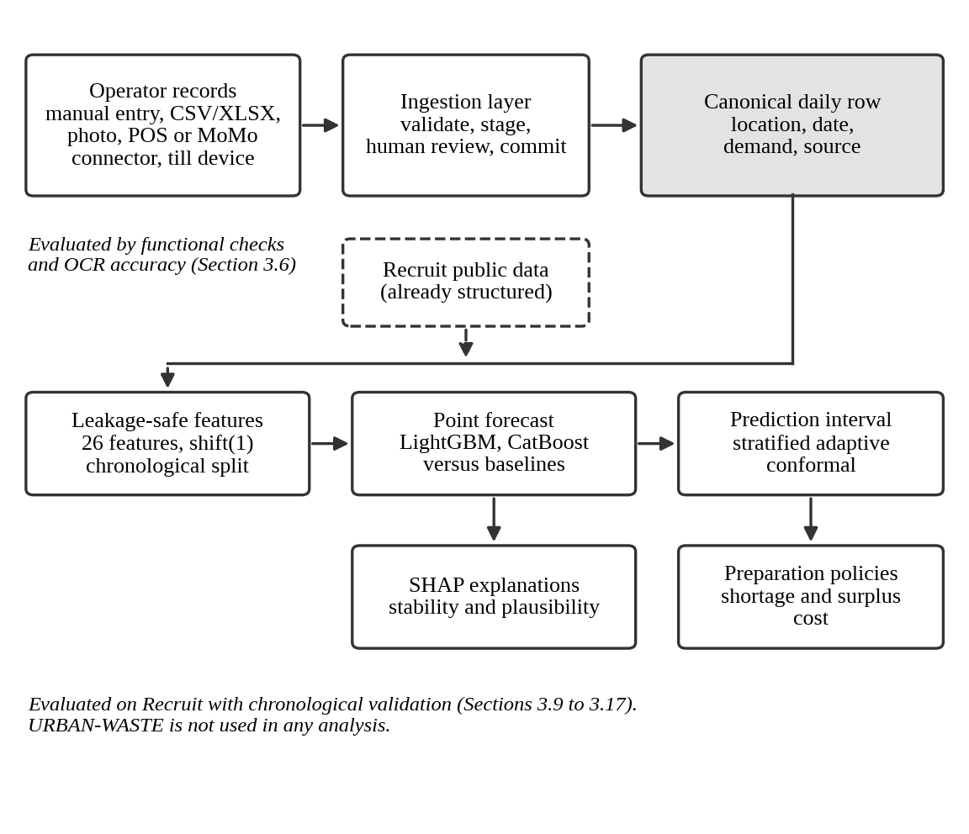
Note. Dashed lines mark Recruit data entering the pipeline in already structured form. The intake layer was evaluated by functional checks and photo-reading accuracy, and the forecasting layers by chronological validation on Recruit.

2.5 Overview of Existing Systems
Several kinds of software addressed food-service demand and waste. AI-enabled waste-tracking devices, such as those Sigala et al. (2025) evaluated, used computer vision and automated weighing to classify waste in hotels, restaurants and catering. Foodforecast, the commercial platform Hübner et al. (2024) evaluated, applied machine learning to bakery sales to reduce returns. Academic systems such as those of Rodrigues et al. (2024) and Malefors et al. (2022) applied Random Forest, LSTM and neural-network models to catering demand.

2.5.1 Strengths and Weaknesses of the Existing Systems
The strength of these systems was that they showed forecasting could reduce waste or returns in real operations. Their weakness, for this study, was access. The waste-tracking devices and Foodforecast were commercial products with proprietary data, and the academic studies used confidential catering data. None offered an openly rerunnable workflow, and none were designed for operators who kept records on paper or in mobile-money statements. Filimonau and De Coteau (2019) named in-house skills, training needs, investment cost and potential savings as the factors that decided whether waste measures worked, which implied that a tool for small operators had to be low-cost and understandable without specialist skills.

2.6 Review of Related Works
Restaurant demand varied with recent demand, day of week, holidays, location, restaurant type, reservations and weather. Malefors et al. (2022) forecast guest attendance in Swedish public catering during the Covid-19 pandemic and found that Random Forest could outperform a simple neural network. Rodrigues et al. (2024) compared Random Forest, long short-term memory (LSTM) networks, LightGBM and a neural network with the planning methods of three catering services; Random Forest and LSTM gave the strongest forecasts, and the authors estimated reductions in wasted meals of 14% to 52% on confidential data. Posch et al. (2022) forecast daily sales of menu items from point-of-sale data using interpretable Bayesian generalized additive models. Shah et al. (2025) compared linear regression, Random Forest, XGBoost and LSTM on sensor-collected customer-flow data from a university restaurant, and XGBoost had the lowest error. Hossain and Parvin (2025) compared two statistical models with three machine-learning models on one restaurant in Bangladesh: Multilayer Perceptron and Random Forest ranked first and second, but both statistical models beat XGBoost. Rankings therefore depended on setting and data volume, which was why every model here was benchmarked against simple baselines.
Public Recruit data had been used before. Bojer and Meldgaard (2021) found that gradient-boosted trees did well across six Kaggle competitions, that global models tended to beat local single-series models, and that all top Recruit solutions used rolling statistics and lagged reservations; the Recruit test period was hard because it included Golden Week with only one earlier holiday period to learn from. An et al. (2025) used Recruit visitors and reservations from 185 restaurants with Prophet to test newsvendor policies, with a restaurant critical quantile of 50%. Neither reported range coverage at different demand levels, a range of cost ratios and explanation stability together in a pipeline someone else could rerun.
On decisions, Ban and Rudin (2019) solved a feature-based newsvendor problem with machine learning for emergency-room nurse staffing and reported out-of-sample cost 23% lower than the best-practice benchmark. On explanations, Lucic et al. (2019) tested contrastive explanations of large forecast errors with retail forecasters and found that users understood the model’s errors better with them. Zhu et al. (2025) argued that explanations for demand planners should be designed around the planner’s goals and noted that user-specific research was sparse.
On data practices, the informal sector accounted for 82.7% of total employment and 70.1% of non-agricultural employment in Rwanda in 2023, mostly in services (NISR, 2024), and its definition centred on unregistered enterprises that did not keep written accounts (NISR, 2016). In a survey of 245 owner-managers of micro and small businesses in Tanzania, Malauri et al. (2021) found that some kept records only occasionally and others not at all, and that inventories and purchases were recorded more often than sales. Reading handwritten pages needed OCR; Tesseract (Smith, 2007) was built for printed text, so its output was treated as a draft for a person to review. No source reviewed evaluated consolidating mobile-money, POS and paper records for demand forecasting.

2.6.1 Summary of Reviewed Literature
Table 2. Comparative Summary of Reviewed Literature
Study | Target and data | Decision layer | Limit for this study
Rodrigues et al. (2024) | Meal demand, three catering services; confidential | Planning comparison; waste estimated | Could not be rerun independently
Malefors et al. (2022) | Guest attendance, Swedish public catering | Meal planning | No ranges or cost ratio reported in the study as read
Hübner et al. (2024) | Bakery sales and returns; commercial system | Returns reduction | Proprietary system and data
Sigala et al. (2025) | Measured waste at five hospitality sites | Feedback to operators | Not a forecasting dataset
Bojer & Meldgaard (2021) | Review of six Kaggle competitions, including Recruit | None | Competition results, not ranges or cost analysis
An et al. (2025) | Newsvendor policies on Recruit, Rossmann and Wikipedia data | Newsvendor cost | Restaurant experiments used one critical quantile (50%)
Ban & Rudin (2019) | Emergency-room nurse staffing | Feature-based newsvendor | Not food service
Posch et al. (2022) | Menu-item sales from POS data | Forecasts motivated by waste reduction | No cost-ratio analysis described
Shah et al. (2025) | University restaurant customer flow, sensors, 2019 to 2024 | None | No decision or range layer
This study | Recruit visitors and reservations, 829 restaurants | Four policies priced over a cost-ratio range | Japanese data; no Kigali validation
Note. POS = point of sale. Entries summarise what the cited studies reported and left out for the purposes of this study.

2.7 General Comments
The literature supported three points. Machine-learning forecasting was an established approach to food-service planning. Waste measurement and commercial forecasting products showed the area was already active, so the study could not claim novelty on that basis. The strongest evidence rested on data nobody else could obtain, and the public-data studies stopped before ranges, cost ratios and explanations.
Two gaps followed. Gap 1 was an open pipeline joining accuracy against defined baselines, range coverage at different demand levels, cost-ratio sensitivity and explanation stability. This was a narrower claim than “no one has used public data” and would have weakened if a study had done all four. Gap 2 was the setting: the forecasting evidence came from organisations that recorded sales in structured form, while small Rwandan operators often kept fragmented records. No source reviewed studied how a consolidated, explainable forecasting workflow could be built for such records. The study built an intake layer and tested it for function, but evaluated forecasting on Recruit only.

CHAPTER THREE: SYSTEM ANALYSIS AND DESIGN

3.1 Introduction
This chapter described how each research question was answered and how the system was analysed and designed. Sections 3.2 to 3.2.4 covered the empirical design; 3.3 to 3.5 covered the requirements, design and tools; and 3.6 covered the ethical and legal considerations. The order followed the usual structure of a research report (Denscombe, 2025): what was studied, with what data, by what methods, and how results were judged.

3.2 Research Design
The study combined a quantitative, comparative experiment on secondary data with a software development project. The experiment compared models and decision policies under chronological validation; the software project built the intake layer, backend and web application and evaluated them by functional testing. The two parts had different standards of evidence and were kept apart: forecasting claims rested on the Recruit experiment, and claims about record consolidation on functional checks and photo-reading accuracy only.
SDLC model. The project followed an iterative incremental model with weekly increments. The model pipeline and the intake layer could be built and tested separately and were joined at the canonical daily row. Each increment ended with a test run, and defects returned to the next increment. The pipeline was developed in one notebook that drove the same package the backend loaded, so experiment code and production code could not drift apart.

3.2.1 Dataset and Dataset Description
Recruit was the only dataset used in the forecasting experiment (Recruit Holdings, 2018). It was available under Kaggle’s competition-specific academic and research conditions, not as an unrestricted public dataset. The audited visit file held 252,108 restaurant-day observations from 829 restaurants between 1 January 2016 and 22 April 2017, with no missing values and no duplicate restaurant-date pairs. The target was the recorded number of visitors (mean 20.97, median 17, standard deviation 16.76, range 1 to 877, no zero-visitor days). Companion files gave restaurant characteristics (14 genres, 103 areas), Japanese holidays, and reservation logs (92,378 records covering 314 of the 829 restaurants).
Coverage was uneven. Restaurants were observed on 85.0% of the days in their observed span on average, and 210 fell below 80%; 209 of those appeared in the test window. Observed days per restaurant ranged from 20 to 477, with a median of 284. Because reservations existed for only 314 restaurants, the models had to work when they were missing.
Two details mattered for interpretation. Bojer and Meldgaard (2021) described the competition as covering 821 restaurants, while the visit file held 829; all 829 were used, and no comparison with the competition leaderboard was claimed. The competition’s own forecast period, the last week of April and May 2017 including Golden Week, was not used. The test window was carved out of the training file, so scores here did not match competition scores.
Split. The split was chronological and never shuffled (Figure 2). Training ran from 1 January 2016 to 2 January 2017 (174,059 rows for fitting), the validation tail from 3 to 31 January 2017 (19,354 restaurant-days) and was the only data used to choose hyperparameters and calibrate the policy, and the held-out test window from 1 February to 22 April 2017: 81 days and 57,866 restaurant-days, used once for final evaluation. These counts are 829 below the 252,108 observed restaurant-days because each restaurant’s first observation had no earlier day to lag from and was dropped when features were built.
Figure 2. Chronological Split of the Recruit Data
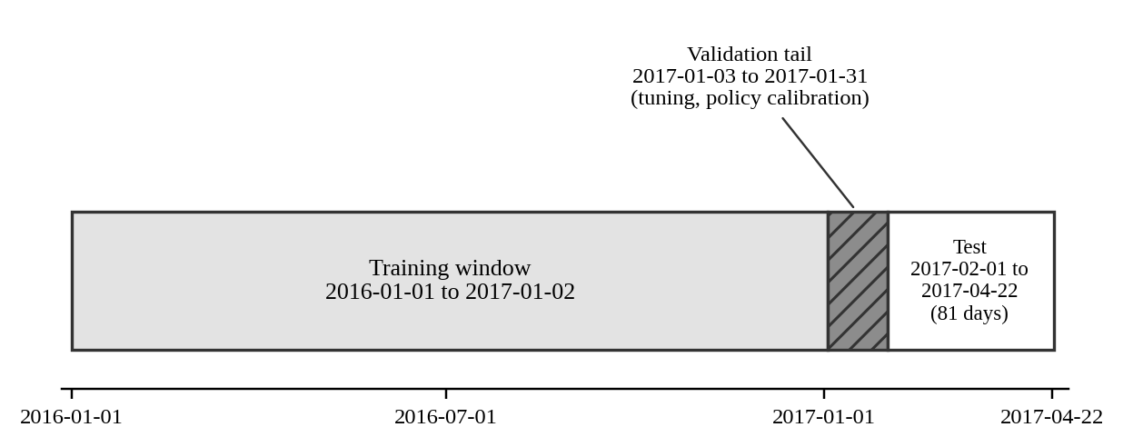
Note. The training, validation and test windows did not overlap.
Features and target. The target was next-day visitor demand, modelled as log(1 + visitors) so that a few very busy days did not dominate the error, then converted back and clipped at zero. There were 26 features in three declared groups: 12 historical-demand (including rolling means over 7 and 28 days and an eight-week same-weekday mean), 11 calendar (including day of week and holiday indicators) and 3 reservation features. Rolling windows used a one-day shift so they never included the target day. An audit ran before any model stage and blocked on hard failures; it checked scale, duplicate pairs, date parsing, value ranges, identifier consistency, temporal span, restaurant coverage and reservation coverage. All eight checks passed, and source files were verified with SHA-256 hashes.
Data selection. The URBAN-WASTE dataset (Eriksson & Lindgren, 2019) held 3,321 records from 34 establishments, with waste in kilograms. Only nine observations carried both waste weight and ordered portions, and its units differed from visitor counts, so it could not supply labels for a surplus model. It was reviewed and not used. No waste labels were simulated for Recruit, because a simulated label would only restate the policy that produced it.

3.2.2 Baseline Model Description
Five simple baselines were scored on the test window: previous day, same weekday a week earlier, the restaurant’s recent mean, the restaurant’s mean for that weekday and the mean across all restaurants. XGBoost (Chen & Guestrin, 2016), Random Forest and linear regression served as comparison models, so the study could show whether the boosted trees earned their complexity. The baselines were scored on 57,873 restaurant-days and the models on 57,866; the final comparison used the rows the two had in common.

3.2.3 Proposed Model Description
LightGBM (Ke et al., 2017) was the primary model and CatBoost (Prokhorenkova et al., 2018) the second. One global model served all 829 restaurants. Hyperparameters came from a bounded search of eight trials scored on the validation tail only, with trial 0 as the documented default, so the reported gain was measured against what would otherwise have shipped. Everything was trained with seed 42.
Prediction ranges. Ranges used split conformal prediction with two changes. Calibration was done within groups of predicted demand (0 to 15, 15 to 30, 30 to 60 and over 60 visitors), following the idea of conditional validity (Vovk, 2013), and the miscoverage level was updated over time in the manner of adaptive conformal inference (Gibbs & Candès, 2021). The main target was 90% coverage, with 80% and 95% as sensitivity checks, and a single global quantile as the comparison.
Preparation policies. Four policies were compared. The historical-average policy prepared the restaurant’s recent 28-day average; the point-forecast policy prepared the forecast; the uncertainty-buffer policy prepared the forecast plus a scaled buffer built from the ranges, with the scale chosen on the validation tail; and the risk-aware policy traded surplus against unmet demand with a weight on unmet demand. For preparation quantity P and realized demand D, potential surplus was PS = max(0, P − D) and unmet demand was UD = max(0, D − P). Total cost was c_o × PS + c_u × UD, and only the ratio r = c_u / c_o changed the ranking. For a known demand distribution, the best quantity was the quantile r / (1 + r) (An et al., 2025).
Explanations. TreeSHAP attributions (Lundberg & Lee, 2017) were computed once for each test forecast and stored. The web application showed the main drivers with a reminder that they described the model and not causes.

3.2.4 Metrics for Evaluation
Forecast accuracy was measured by mean absolute error (MAE), root mean squared error (RMSE), root mean squared log error (RMSLE), mean absolute scaled error (MASE) and bias, with R-squared as a descriptive statistic. MAE was the main metric because it was in visitors. MASE scaled error by the in-sample error of a naive benchmark (Hyndman & Koehler, 2006), so a value below 1 beat that benchmark. For restaurant i on day t, with actual demand y and forecast ŷ:
MAE = (1 / n) × Σ |y(i,t) − ŷ(i,t)| RMSE = √[(1 / n) × Σ (y(i,t) − ŷ(i,t))²]
RMSLE = √[(1 / n) × Σ (log(1 + y(i,t)) − log(1 + ŷ(i,t)))²]
Ranges were judged by coverage and mean width overall, by predicted-demand group and by realized-demand level. Policies were judged by PS, UD and total cost across cost ratios 0.5, 1, 2, 3, 5 and 10. Explanations were judged by the rank correlation of mean absolute attributions across folds and seeds, and by plausibility. A rolling-origin backtest refit LightGBM on six folds, each with a 30-day test window and origins advancing 14 days; the folds overlapped by 16 days, and the earliest two also overlapped the validation tail, so the backtest checked stability rather than giving an independent accuracy estimate. For each model and the best baseline, a paired Wilcoxon signed-rank test compared per-restaurant MAE across the 829 restaurants.

3.3 System Analysis

3.3.1 Functional Requirements of the System
Table 3. Functional Requirements
ID | Requirement | Objective
FR1 | A user signs in with email and password. Two-factor sign-in can be enabled on any seat; once it is on, an Administrator seat cannot turn it off. | SO7
FR2 | Each member of a workspace holds one of five roles: Owner, Administrator, Data Clerk, Analyst or Viewer. A seat sees only its own workspace. | SO7
FR3 | A new sign-up creates the workspace and its owner seat. An Owner or Administrator adds locations to it. | SO7
FR4 | A user enters daily demand manually. | SO7
FR5 | A user uploads a CSV or XLSX file, maps its columns, previews the rows and commits them. | SO7
FR6 | A user uploads a photo only after ticking a consent box. The system reads it, shows the rows beside the photo, and saves nothing until the user confirms. | SO7
FR7 | The system pulls demand from a POS or MoMo connector and accepts posts from an enrolled till device. | SO7
FR8 | A user undoes an import, which removes the rows it wrote. | SO7
FR9 | The system shows a forecast, a likely range and the main reasons for a chosen restaurant and dates. | SO3 to SO6
FR10 | The system shows analytics and lets a user download forecast and analytics reports. | SO7
FR11 | The system scores data quality after each commit against five rules — gaps, spikes, duplicate days, stale connectors and schema drift — and shows the score with its open issues. | SO7
FR12 | The system shows the Privacy Policy and Terms, and lets a user delete their account. | SO7
FR13 | The model pipeline compares four preparation policies by shortage and surplus cost. | SO5
Note. SO = specific objective.

3.3.2 Non-functional Requirements of the System
Table 4. Non-functional Requirements
Quality | Requirement
Security | Two-factor sign-in that an Administrator seat cannot switch off; one credential per device; workspace isolation; a single checked write path.
Privacy | Photos read on the application’s own server and not stored; a consent box before any photo upload; only date, quantity and channel kept from tills and connectors.
Reliability | Writes idempotent on location and date; atomic checkpoints in the pipeline so a stopped run resumes.
Reproducibility | Pinned versions, hashed inputs, one command to regenerate every results table.
Performance | Full pipeline within about 17 minutes in the test container; page and request times in Section 4.5.6.
Usability | Plain-language notices, including a warning that the model was trained on Japanese data.
Maintainability | Separate adapters, one writer, small value objects, named thresholds and docstrings.
Compatibility | Tested environments in Section 4.5.1.

3.3.3 Proposed Model Diagram
Figure 3 shows the model pipeline. It ran in 12 stages, and each stage saved an atomic checkpoint. The last step exported one serving file that the backend loaded.
Figure 3. Model Pipeline in 12 Checkpointed Stages
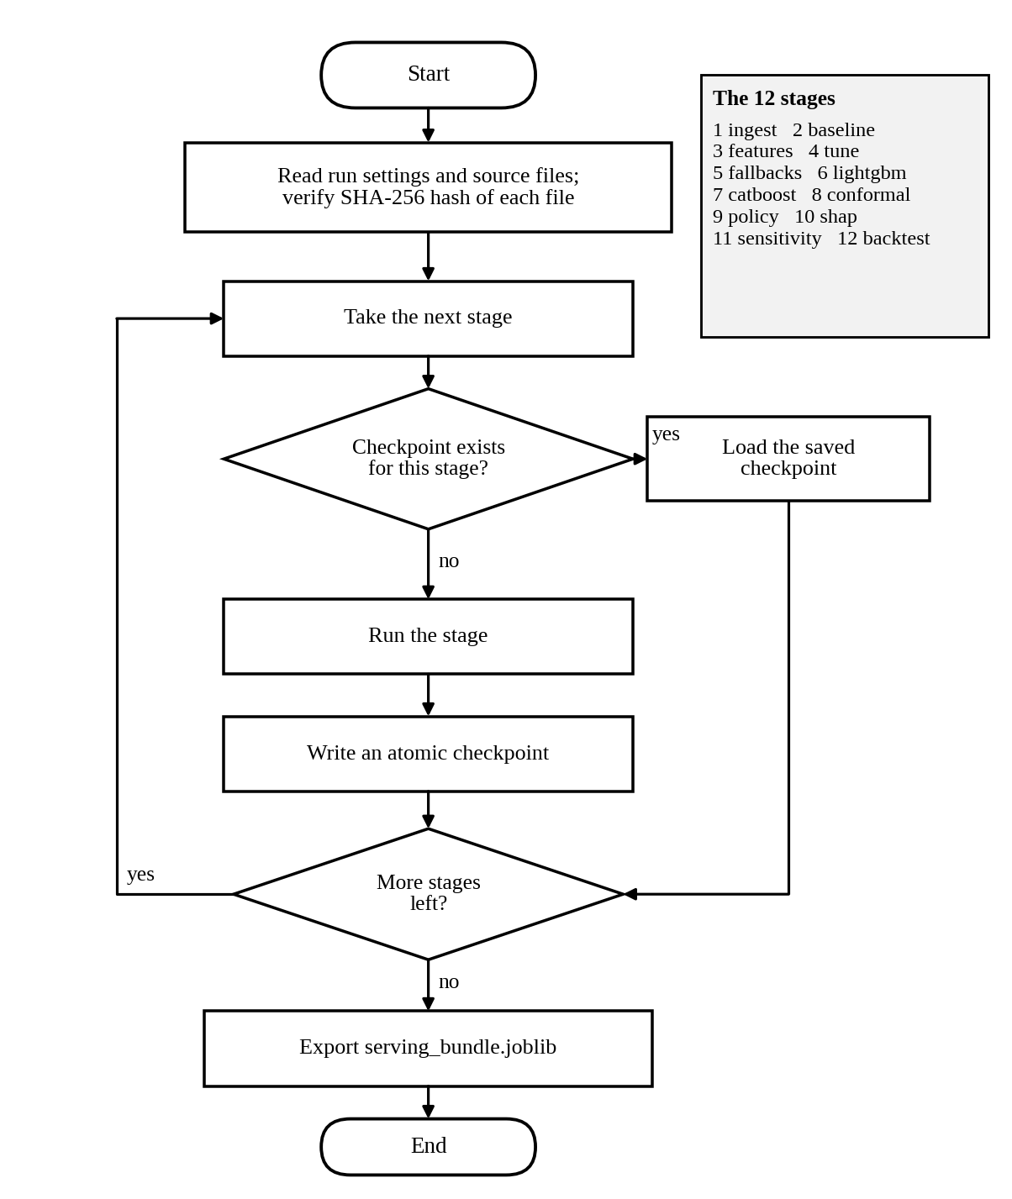
Note. Grey boxes mark the stages that changed the data, the features and the ranges.

3.4 System Design

3.4.1 Architecture, Database, Flow, Class, Use Case and Sequence Diagrams
Figure 4 shows the architecture. The React web application talked to a FastAPI backend, which held all demand data in PostgreSQL and wrote it through one function, commit_demand. A forecasting service loaded the serving file made by the offline model package. Photos were read by local OCR on the same server and were not kept: the page was read, the rows were staged, and nothing of the image was written to the database.
Figure 4. System Architecture
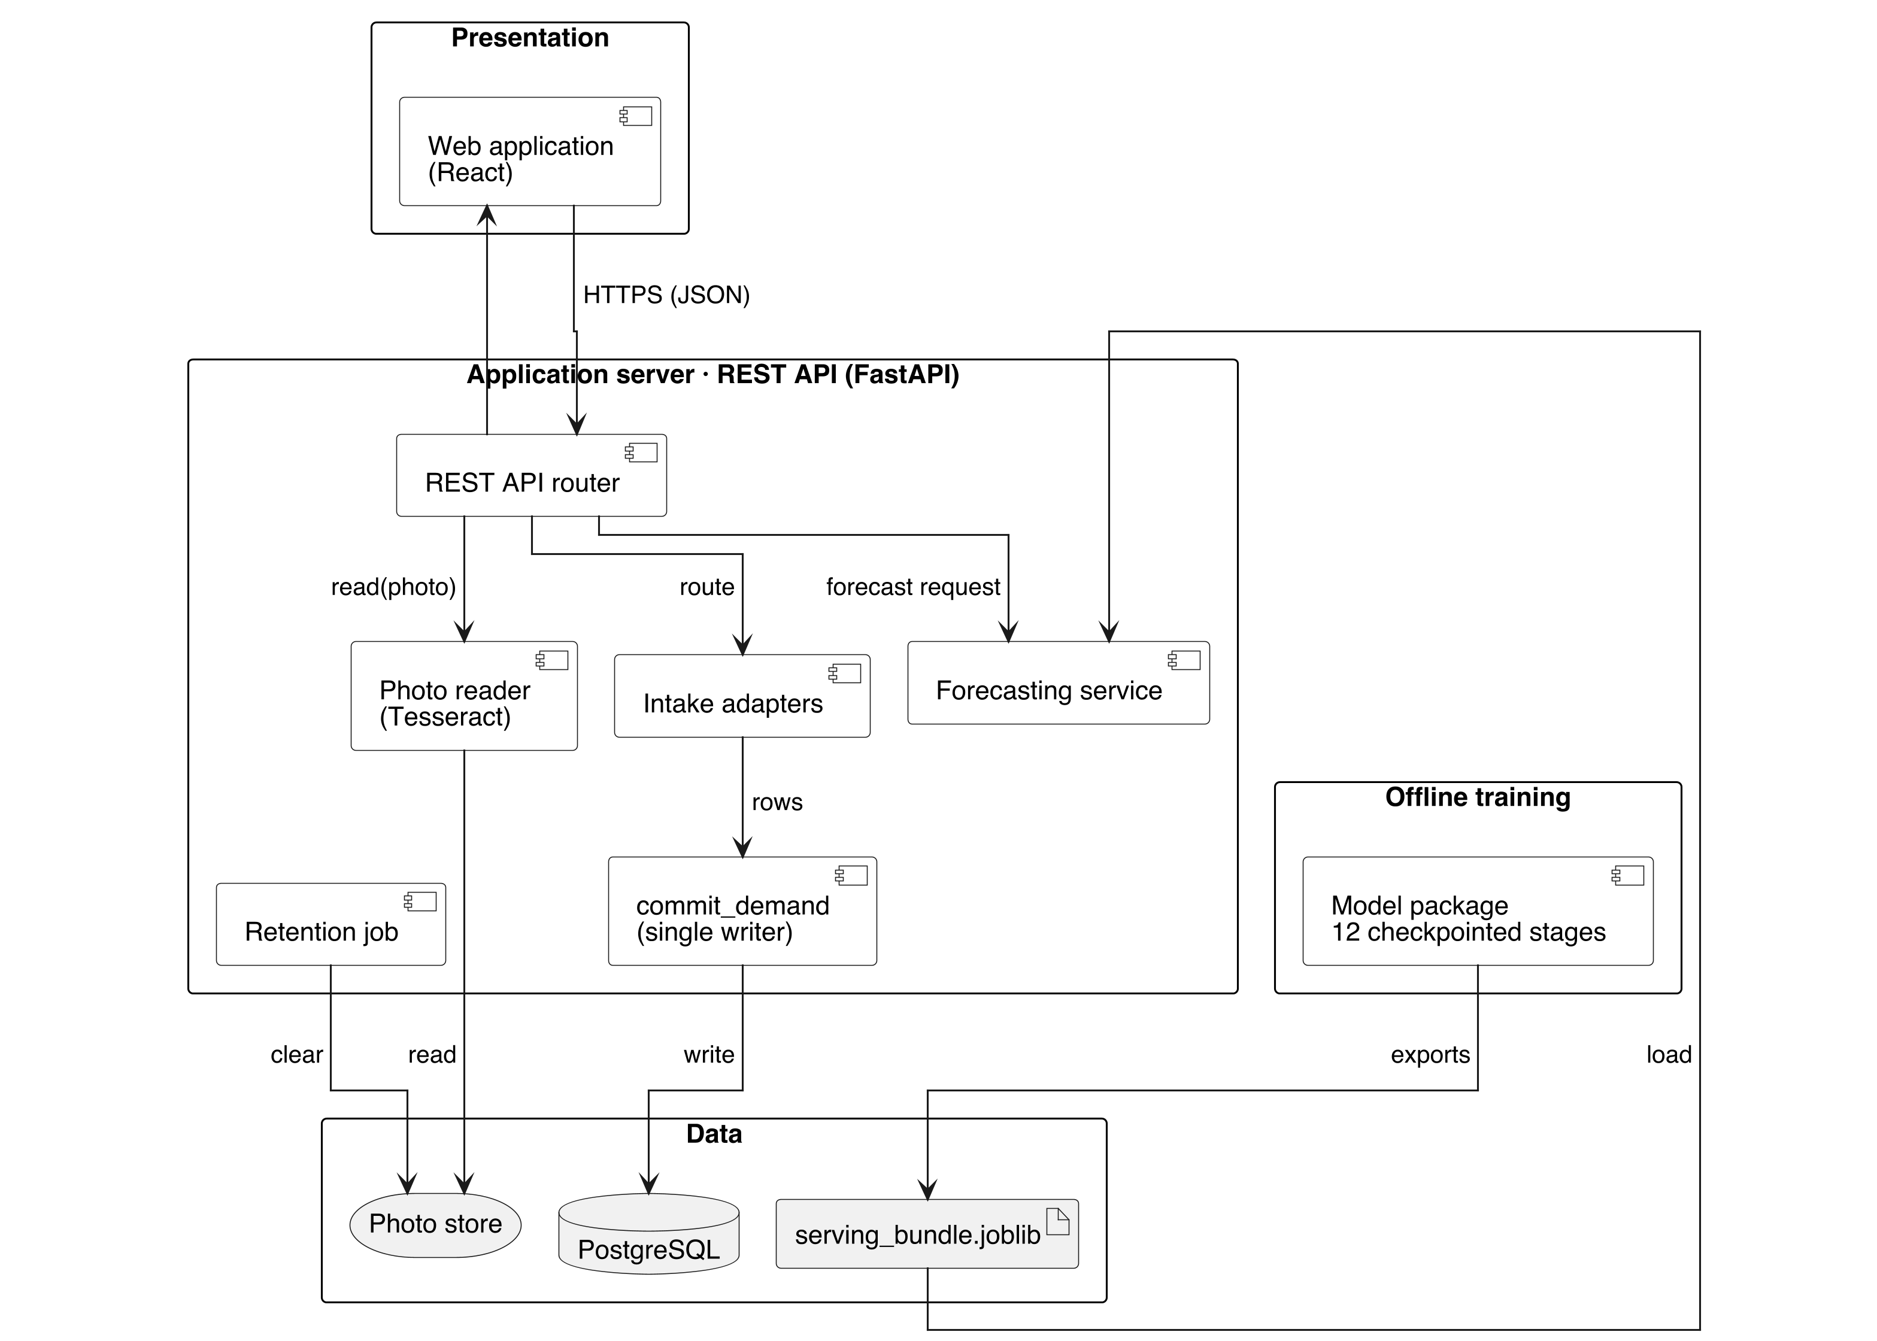

Figure 5 shows the use cases. Members of a workspace signed in, managed data, reviewed photo rows and read forecasts. Till devices and connectors sent demand into the system.
Figure 5. Use Case Diagram
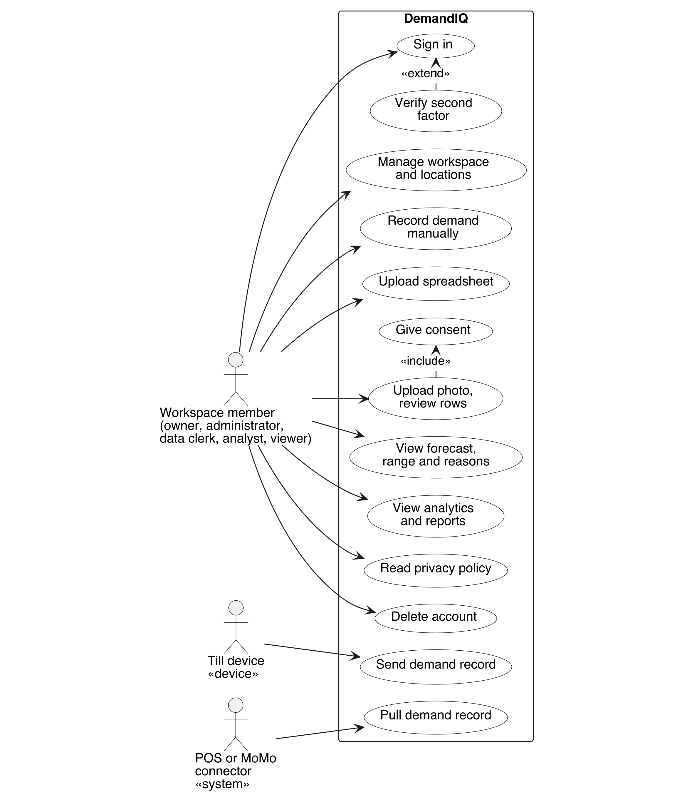
Note. The actor “workspace member” stands for the five roles. Till devices and POS or MoMo connectors reach the system without a person signing in, which is why they appear as actors of their own.
Figure 6 shows the main tables. A workspace held members, stored in users, and locations. Uploads and connectors belonged to the workspace rather than a single location, while demand observations and devices pointed at a location; a device’s location could be empty until assigned. Demand was unique by location and date, a constraint the database enforced rather than the application.
Figure 6. Database Design
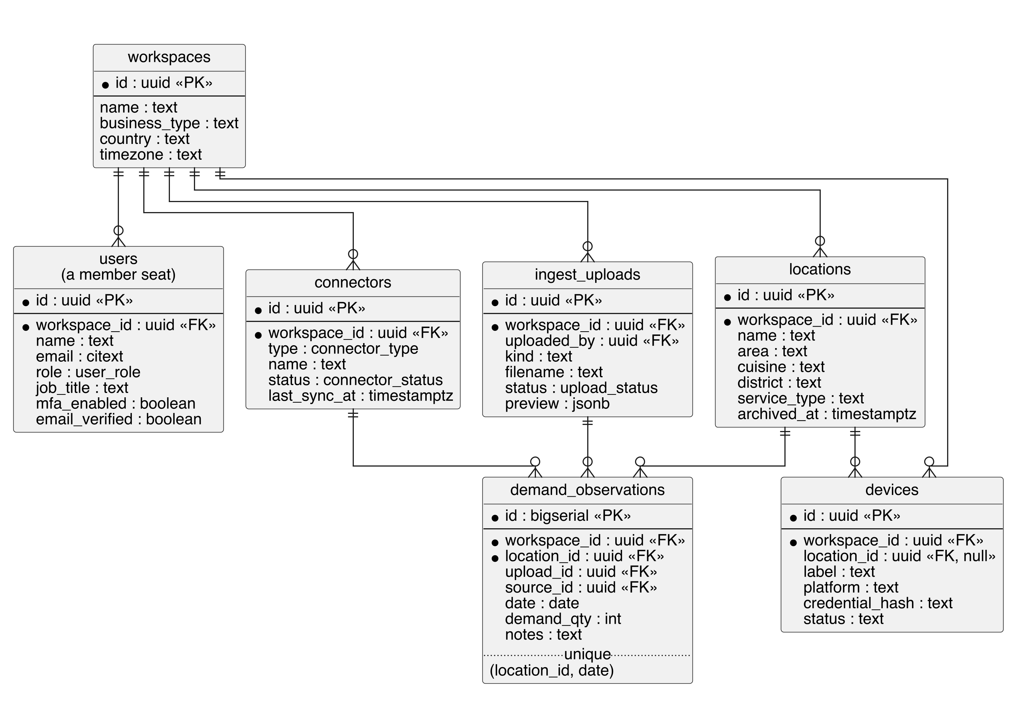
Note. Table and column names are those of the deployed schema (PostgreSQL 15.19, 54 tables). The member seat is stored in users rather than in a separate member table, and ingest_uploads records the workspace and the uploading member rather than a location. Only devices carries a nullable location_id. Figure 6 is drawn by model/scripts/render_figure6.py, which checks every name against the schema.
Figure 7 shows the classes used in photo reading. Small frozen dataclasses carried each result between steps, and a dedicated error type kept a bad upload apart from an engine failure.
Figure 7. Class Diagram of the Photo-Reading Module
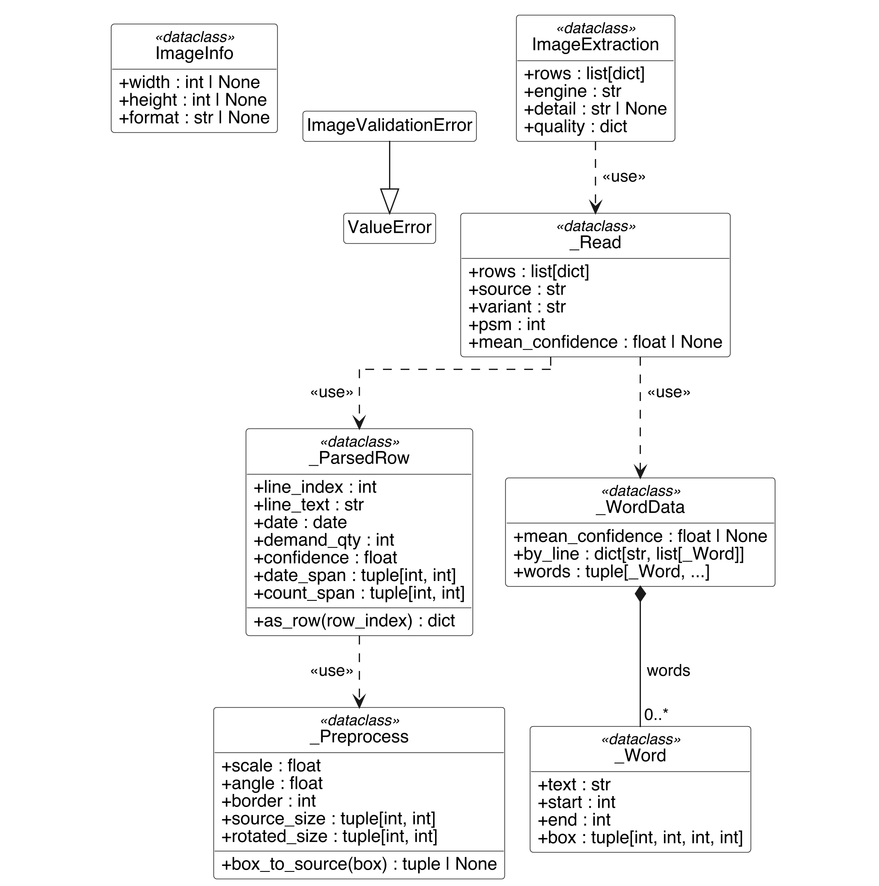

Figure 8 shows the order of events when an operator uploaded a photo. The consent step came first, and rows reached the database only after the operator confirmed them.
Figure 8. Sequence Diagram of Photo Intake
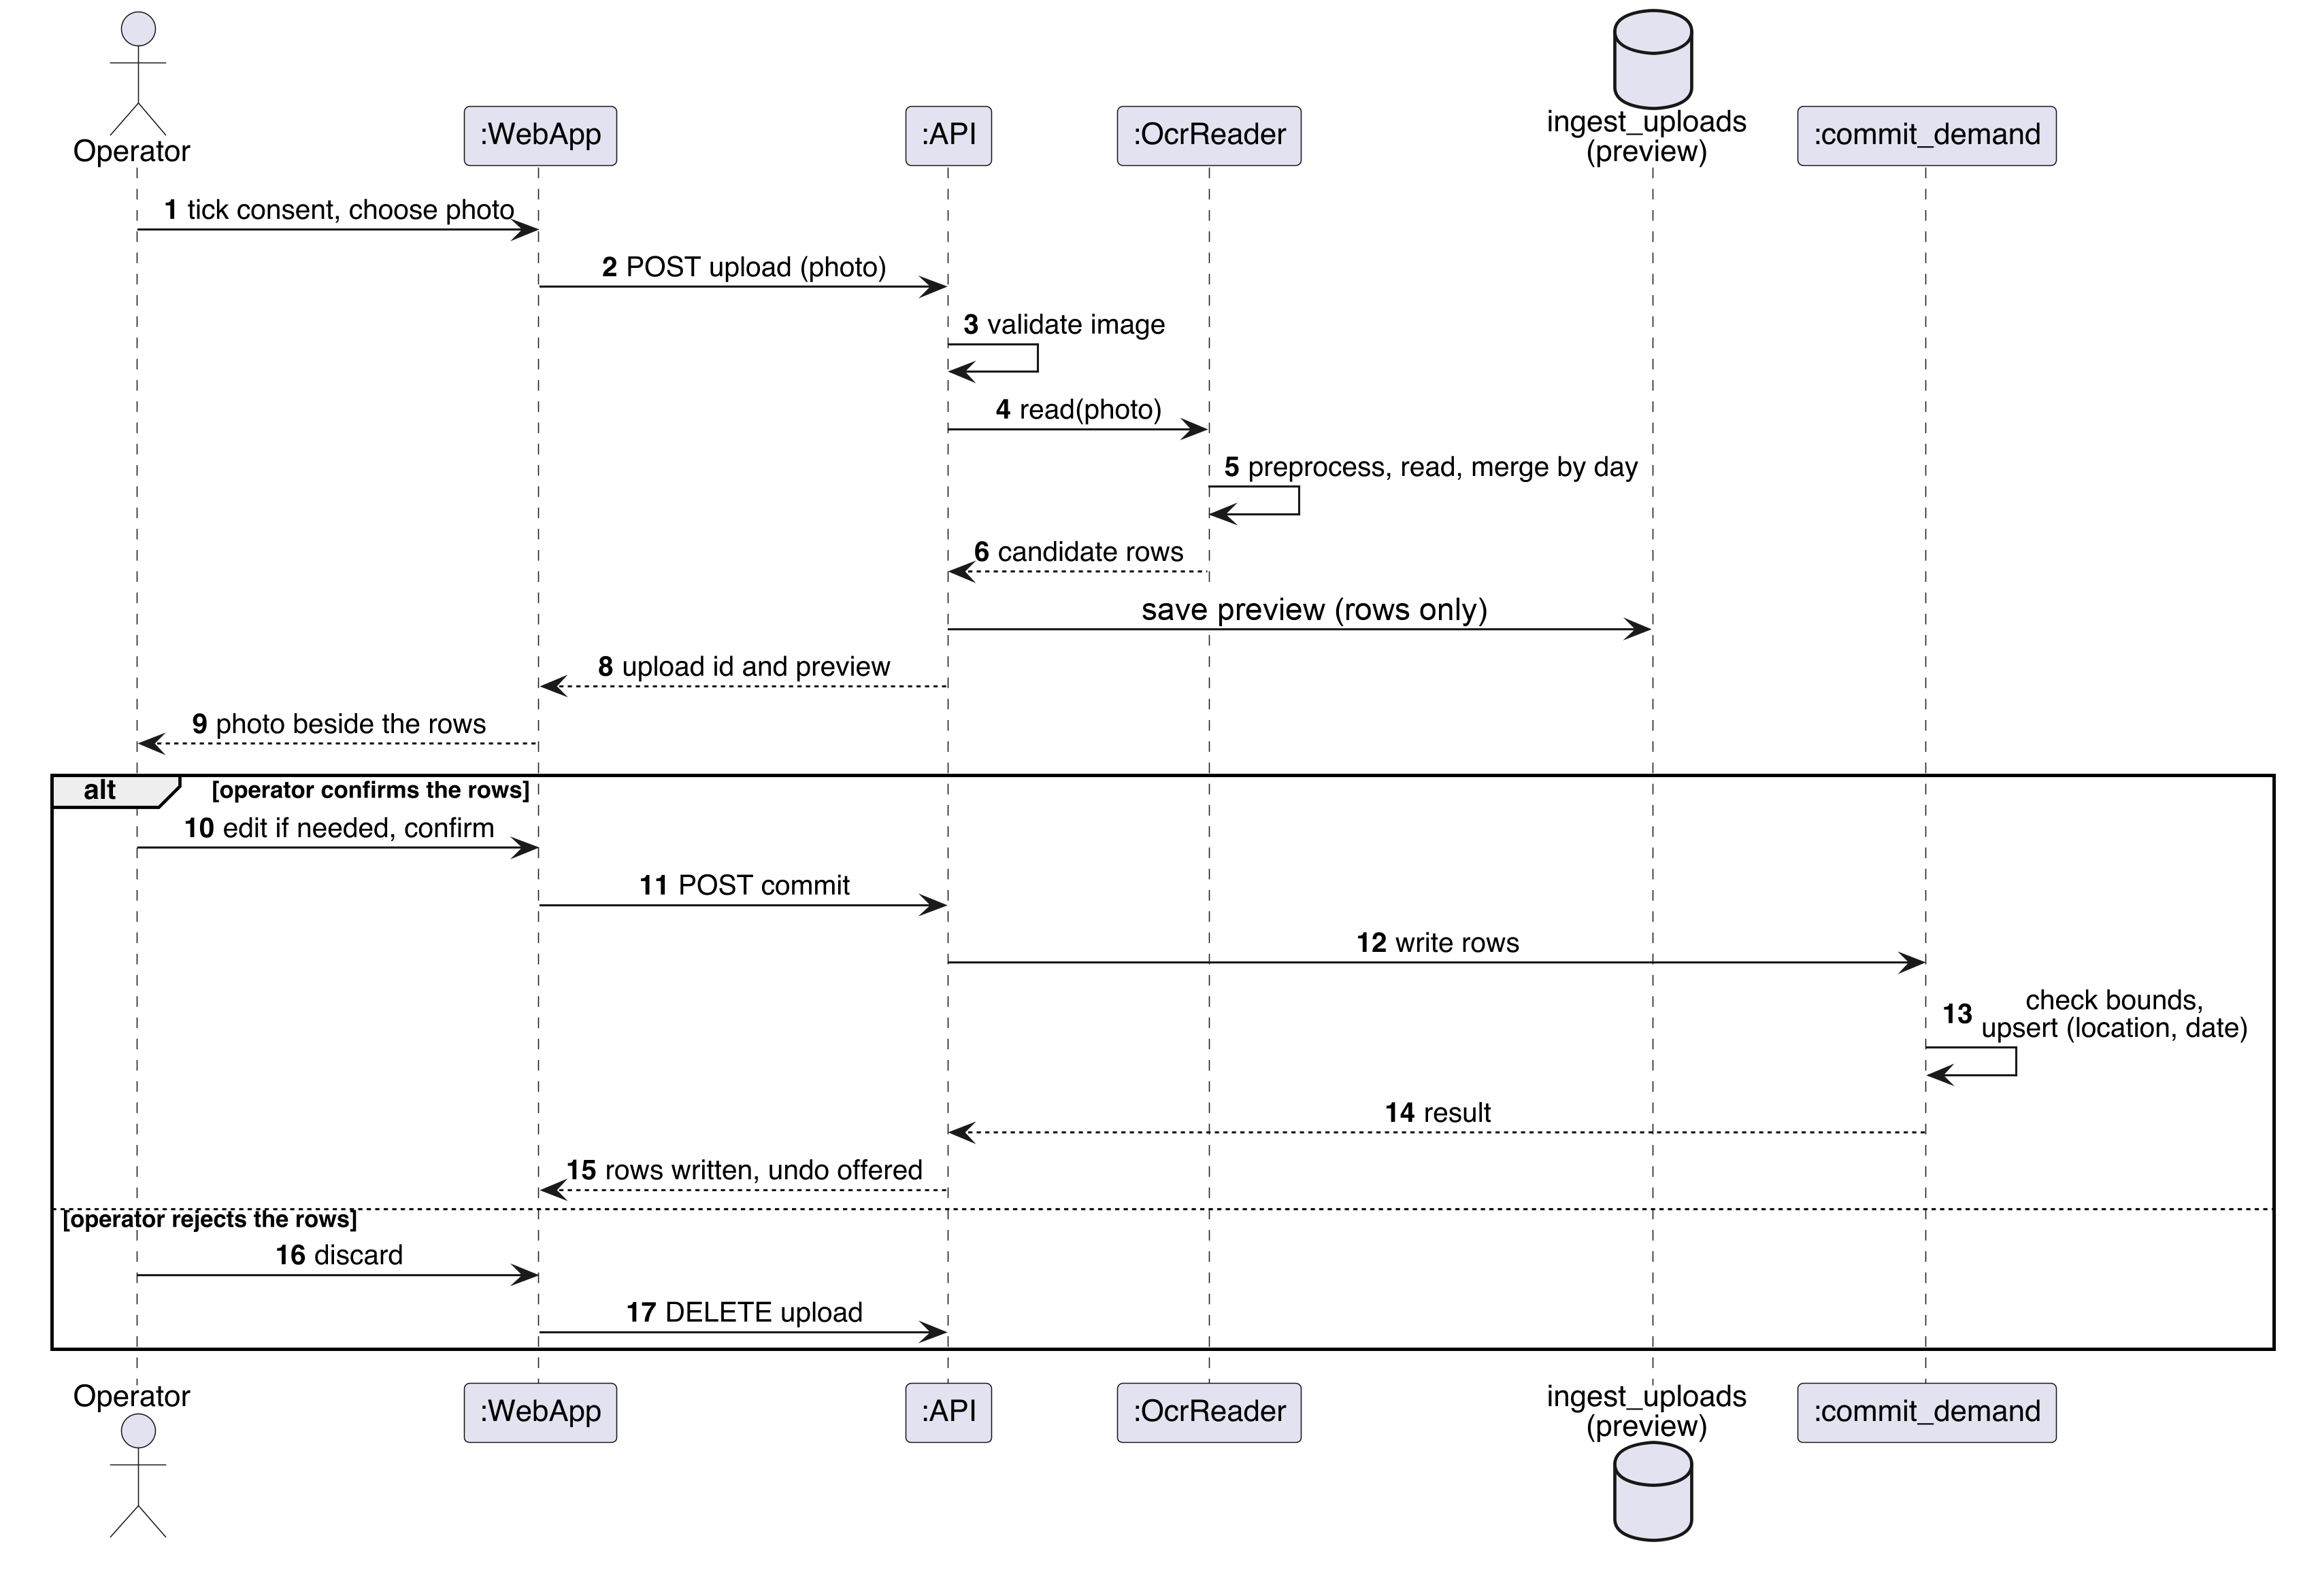

3.5 Development Tools
Table 5. Development Tools and Versions
Area | Tool | Use
Language and data | Python 3.11.17; pandas 3.1.0; NumPy 2.4.6; PyArrow | Pipeline, data handling, Parquet checkpoints
Modelling | LightGBM 4.7.0; CatBoost 1.2.10; XGBoost 3.2.0; scikit-learn 1.9.1; joblib | Models, baselines, metrics, serving file
Explanation | SHAP | Forecast explanations
Photo reading | Tesseract; pytesseract; Pillow; httpx | Local OCR, preprocessing, optional service calls
Backend | FastAPI; PostgreSQL | REST API and database
Front end | React | Web application
Operations | Docker Compose; Git and GitHub; Google Colab | Packaging, version control, compute
Note. Versions are those the project installed.

3.6 Ethical and Legal Considerations
The forecasting experiment used secondary, anonymised restaurant counts, so it involved no personal data and no human participants. The intake layer could receive personal data by accident, such as a name on a photographed page. The system therefore read photos on its own server, asked for confirmation of permission before any upload, stored no photo at all, and published a Privacy Policy and Terms page. Rwanda’s Law No. 058/2021 on personal data and privacy shaped these choices (Republic of Rwanda, 2021). Approval from the Research Ethics Committee (REC) for testing with real operators was applied for and was pending at the time of writing, so no real operator data was collected.

CHAPTER FOUR: SYSTEM IMPLEMENTATION,
RESULTS AND DISCUSSION OF FINDINGS

4.1 System Implementation

4.1.1 Introduction
This section explained how the designs in Chapter 3 were built and shown running: the model pipeline, the intake layer, the backend and web application, and the privacy and access controls. Sample source code was given for the main modules, and Section 4.2 showed the matching screens.

4.1.2 Model Pipeline
The model package ran 12 stages from one notebook: ingest, baseline, features, tune, fallbacks, LightGBM, CatBoost, conformal, policy, SHAP, sensitivity and backtest. Each stage saved an atomic checkpoint, so a stopped run resumed at the last finished stage. A final script exported one serving file, serving_bundle.joblib, holding the booster, the feature columns, the range calibration, the metrics and the run provenance, which the backend loaded to make forecasts. Leakage was controlled inside the pipeline: rolling windows used a one-day shift, a probe rejected any feature built from the target, and the split was chronological. The repository, with the notebook, the pipeline scripts and the pinned environment, is public at https://github.com/kelvintawe13/DemandIQ.

4.1.3 Intake Layer
Five adapters (manual entry, CSV or XLSX, photo, till device and POS connector) each translated their own input and passed rows to one writer, commit_demand. The writer made imports idempotent on location and date, refused future dates, limited quantities to between 0 and 10,000,000, and recorded the channel on every row. Rows read from photos waited in a staging table until a person confirmed them, with the operator's own copy of the image shown beside them in the browser.
The photo reader solved four problems with custom logic. It flattened uneven lighting by subtracting a blurred copy of the page. It found the page tilt by testing angles up to 6 degrees either way on a small copy and keeping the angle that lined the text up best (Code Sample 1). It read the page in three Tesseract layout modes (Smith, 2007) and merged the reads by date with a vote. It chose the demand count on each line by skipping numbers inside the date and numbers that followed a label such as “Table” or “tips” (Code Sample 3), and Code Sample 2 shows how the reader decided whether a sheet wrote dates day-first or month-first, using only dates that could be read one way.
Code Sample 1. Scoring how straight a page is, used by the tilt search (backend/app/services/ingestion/image.py).
def _row_projection_score(image):
"""How strongly the ink lines up in horizontal bands (higher is straighter)."""
from PIL import ImageOps

raw = ImageOps.invert(image).tobytes()
width, height = image.size
rows = [sum(raw[y * width : (y + 1) * width]) for y in range(height)]
mean = sum(rows) / max(1, height)
return sum((row - mean) ** 2 for row in rows)

Code Sample 2. Deciding whether a sheet writes dates day-first or month-first (backend/app/services/ingestion/image.py).
def _infer_day_first(text: str) -> bool:
day_first_votes = 0
month_first_votes = 0
for match in _NUMERIC_DATE.finditer(text):
first, second = int(match.group(1)), int(match.group(2))
year = _normalise_year(match.group(3))
day_first_date, month_first_date = _numeric_dates(first, second, year)
if day_first_date and not month_first_date:
day_first_votes += 1
elif month_first_date and not day_first_date:
month_first_votes += 1
return day_first_votes >= month_first_votes

Code Sample 3. Choosing the demand count on a line, an excerpt from _count_candidates (backend/app/services/ingestion/image.py).
for match in _INT.finditer(line):
start, end = match.span()
if date_span[0] <= start < date_span[1]:
continue
if _preceding_word(line, start) in _ANNOTATION_LABELS:
continue
value = int(match.group(1))

If no engine was set up, the reader returned no rows and a note. It never made up a row, because a wrong row that an operator committed without reading would damage the history the models learned from.

4.1.4 Backend and Web Application
The backend was a FastAPI service over PostgreSQL. It exposed routes for manual entry, file upload with column mapping and commit, connector pulls (POST /connectors/{id}/pull), till-device posts (POST /devices/{id}/demand with a key in X-Device-Key), undoing and retrying uploads (FR8), and account deletion (DELETE /me/account). The React front end gave each user a sidebar with Overview, Analytics, Demand Forecast, Data Ingestion, Sources, Quality Monitor, Alerts, Reports and Settings. Every commit was scored against five rules — gaps, spikes, duplicate days, stale connectors and schema drift — and the score was shown with its open issues (GET /quality/score, FR11).

4.1.5 Privacy and Access Controls
Users signed in to a workspace with one of five roles: Owner, Administrator, Data Clerk, Analyst or Viewer. Two-factor authentication (2FA) could be enabled on any seat, and the server refused to let an Administrator seat turn it off. A required consent box gated every photo upload. The policy reader opened from sign-up, the landing-page footer and Settings. The application kept no photo: the review screen held the operator's own copy in the browser, and the upload and its demand rows stayed. This deployment read photos on its own server and did not use an outside vision service. The repository carried a LICENSE, a THIRD_PARTY_NOTICES.md file and docs/PROCESSING_RECORD.md.

4.2 Graphical View of the Project

4.2.1 Screenshots with Description
Each screenshot below matched a functional requirement from Section 3.3.1. Figure 9 showed sign-in (FR1), Figure 10 a workspace with its members and locations (FR2, FR3), Figure 11 the two-factor setting, and Figure 20 a second workspace that held none of the first one’s data. Every screenshot came from a demonstration workspace: its daily visitor counts are a two-month slice of the public Recruit dataset, rebased onto recent dates and attached to demonstration location names, and its forecasts are output of the trained model. No record from a Kigali business and no data from a real operator appears in any screenshot.
Figure 9. Sign-in Page (FR1)

Note. Demo accounts were seeded one per role in the demo workspace.
Figure 10. Workspace Page: Five Members, Two Locations, 102 Forecasts (FR2, FR3)
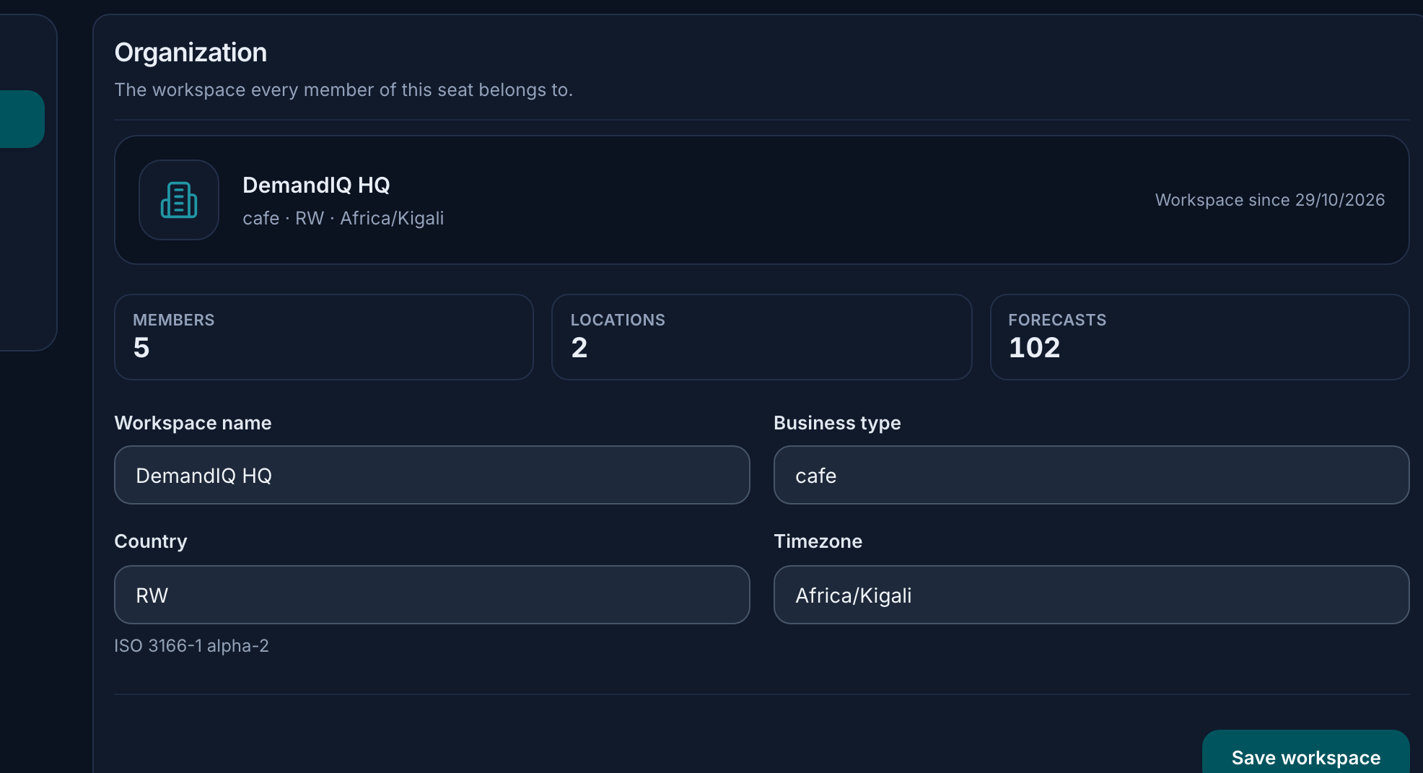
Note. The five seats and two locations were created for testing, and the counts belong to the demonstration workspace. Kigali Heights and Remera Grill are demonstration names, not customer records.

Figure 11. Security Page: Two-factor Sign-in an Administrator Seat Cannot Switch Off (FR1)


Figure 12 showed the Data Ingestion page. Its tabs covered Excel or CSV, Image (handwritten), Manual Form and POS or MoMo (FR4 to FR7). Figure 13 showed the consent box, which disabled the upload control until it was ticked, and Figure 14 the review screen, where the photo sat beside the rows the reader found and nothing was saved until the user confirmed.
Figure 12. Data Ingestion Page, Image Tab with the Consent Box (FR5, FR6)
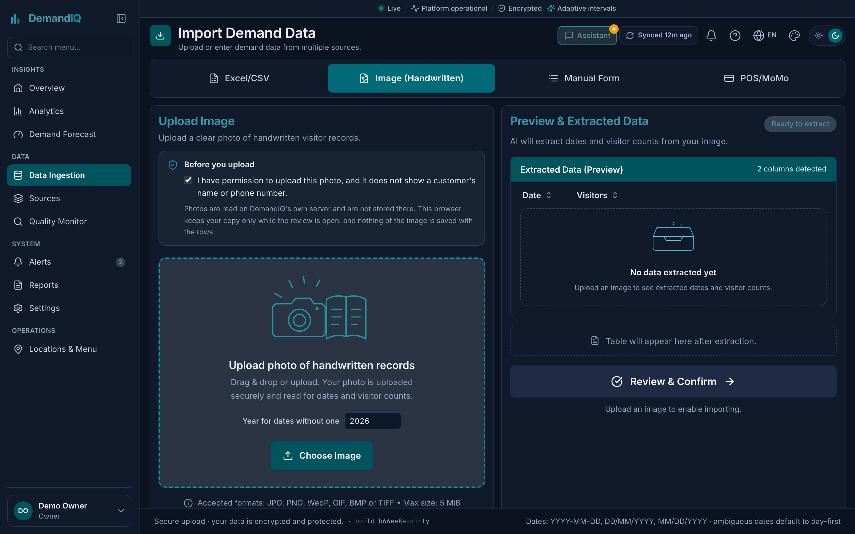

Figure 13. Consent Box Before a Photo Upload (FR6)

Note. The text asked the user to confirm permission and that the photo showed no customer name or phone number. It also said photos were read on the application’s own server and not stored.
Figure 14. Review Screen: Photo Beside the Rows the Reader Found (FR6)
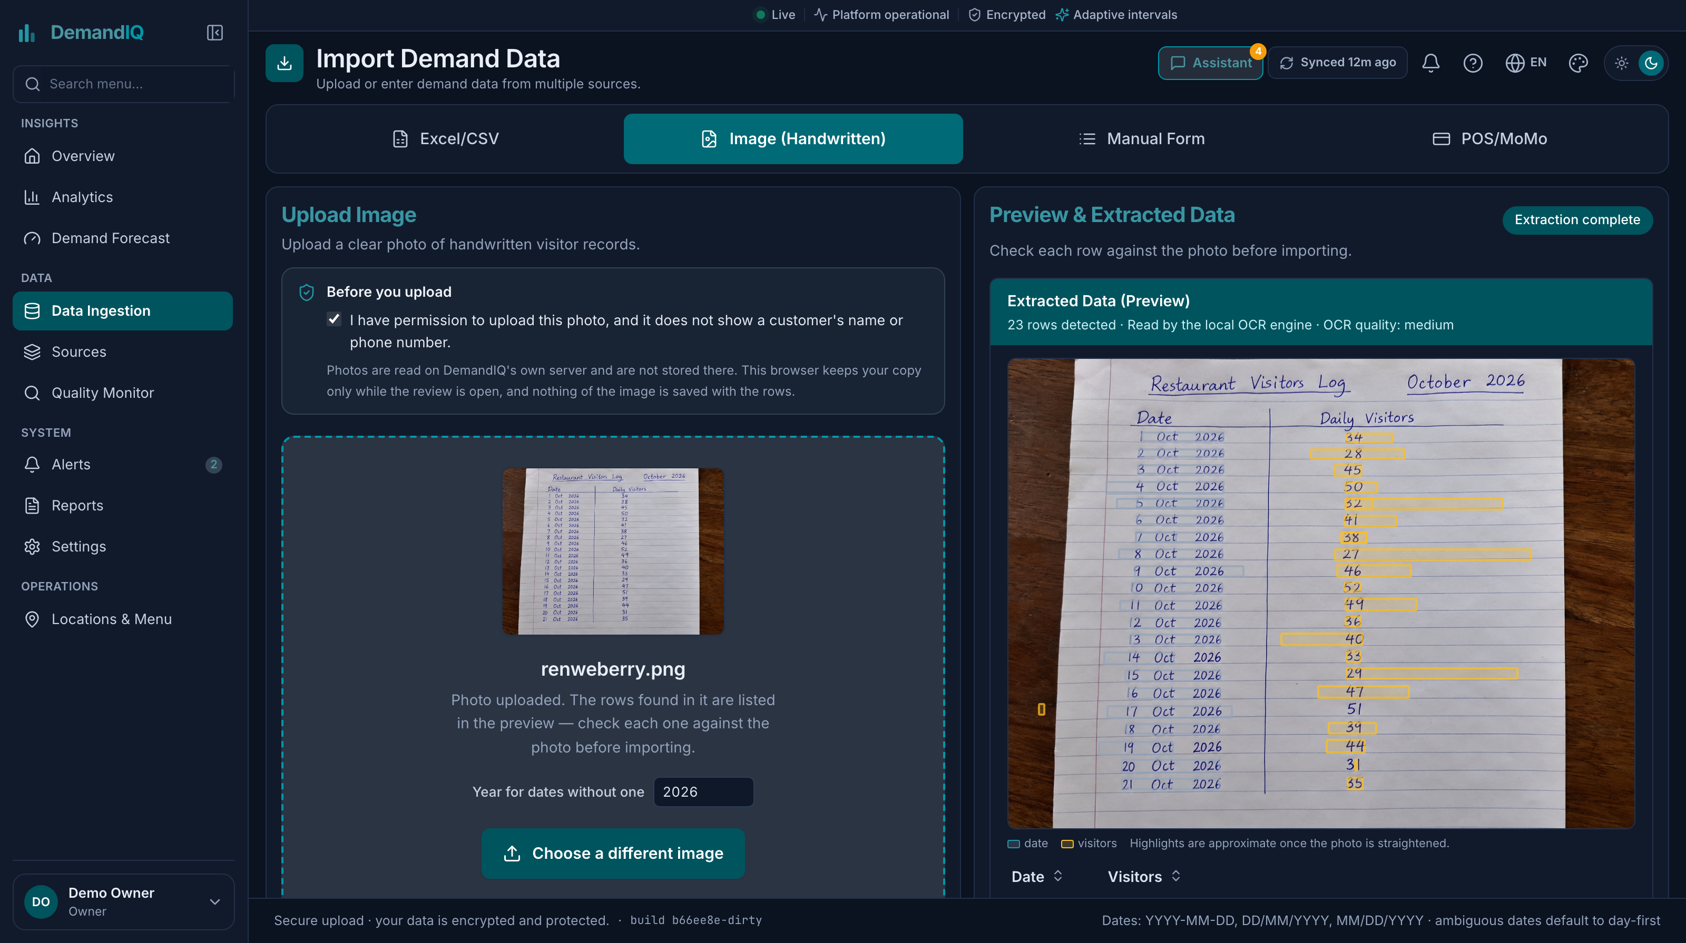
Note. Nothing was saved until the user clicked Review and Confirm.
Figure 15 showed the Demand Forecast page (FR9). The user picked a restaurant, dates and a view, and the page showed the expected customers, how sure the model was, the busiest day ahead and the likely range, with a notice that the model was trained on restaurant data from Japan and could be wrong on busy days. Figure 16 showed the reasons behind one forecast, marked as predictive attribution and not cause.
Figure 15. Demand Forecast Page with the Range and the Japan Notice (FR9)
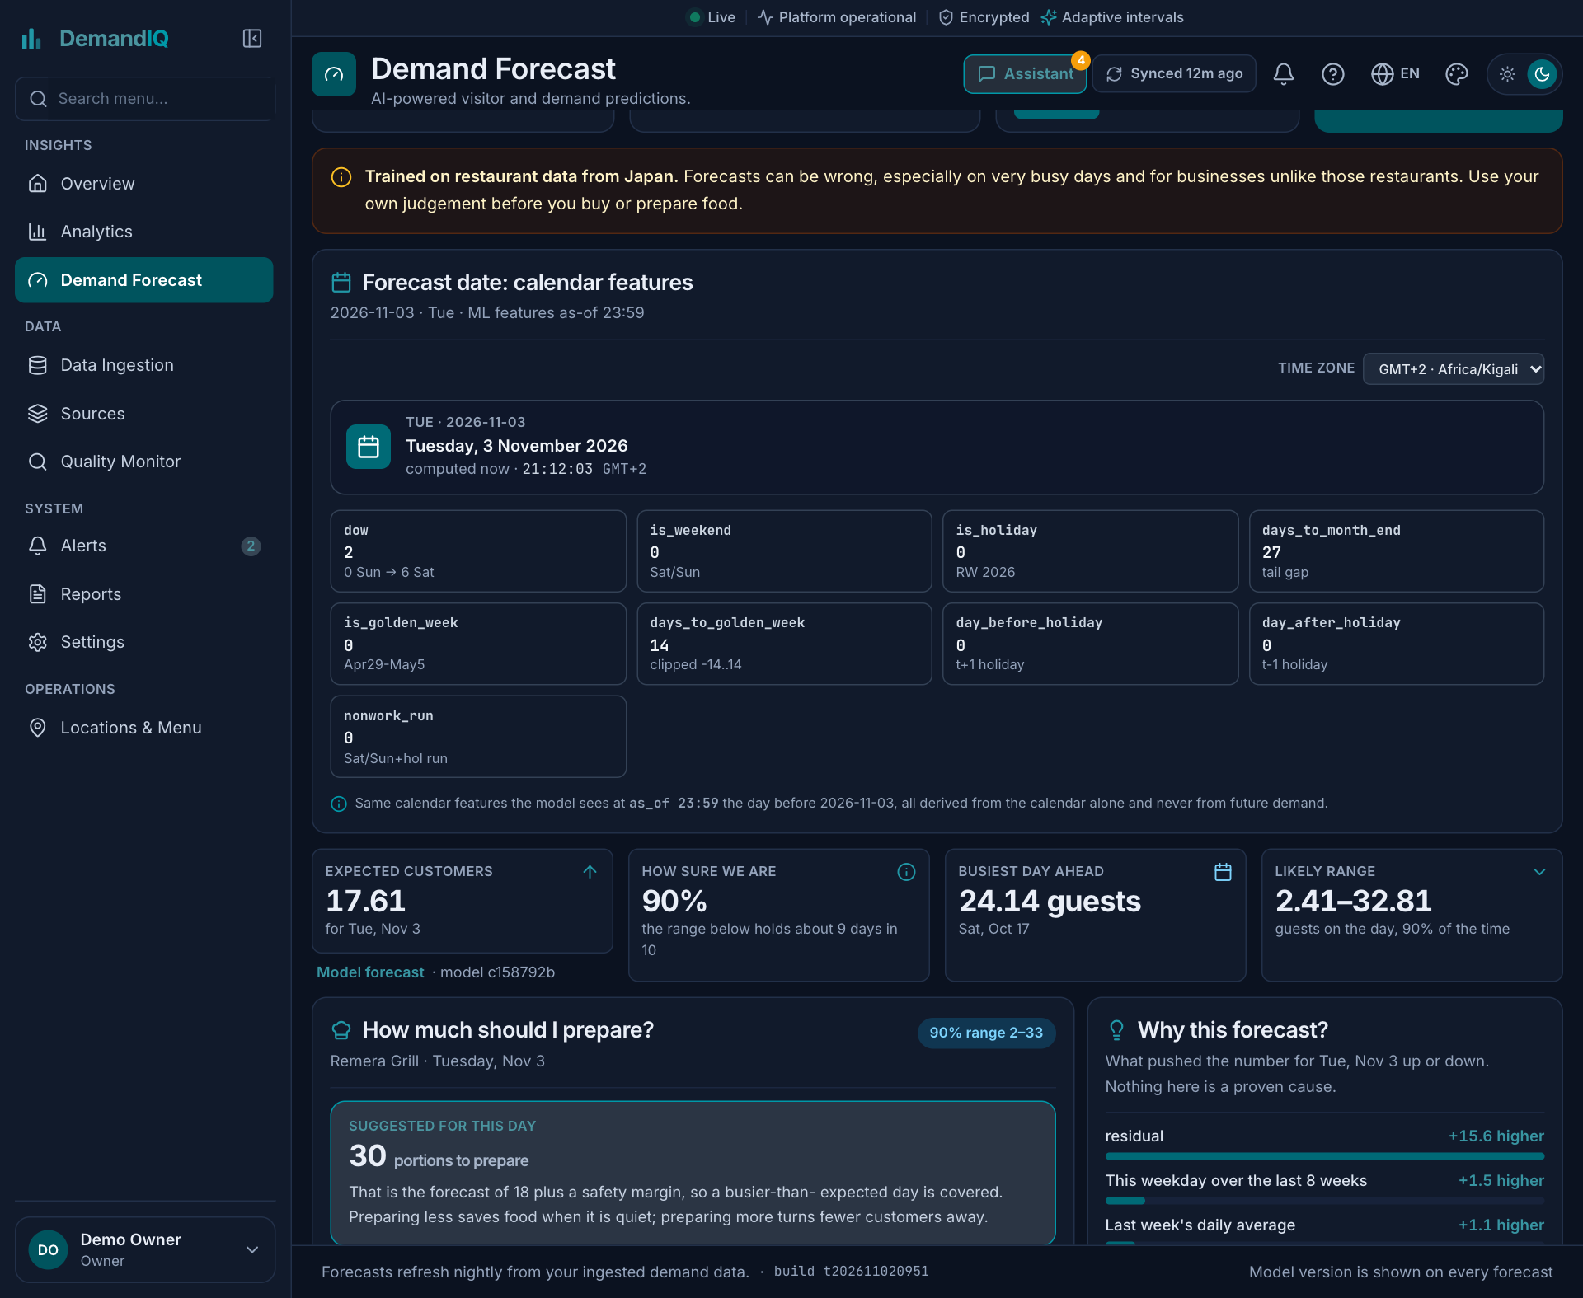

Figure 16. “Why This Forecast?” Panel with SHAP Drivers (FR9)
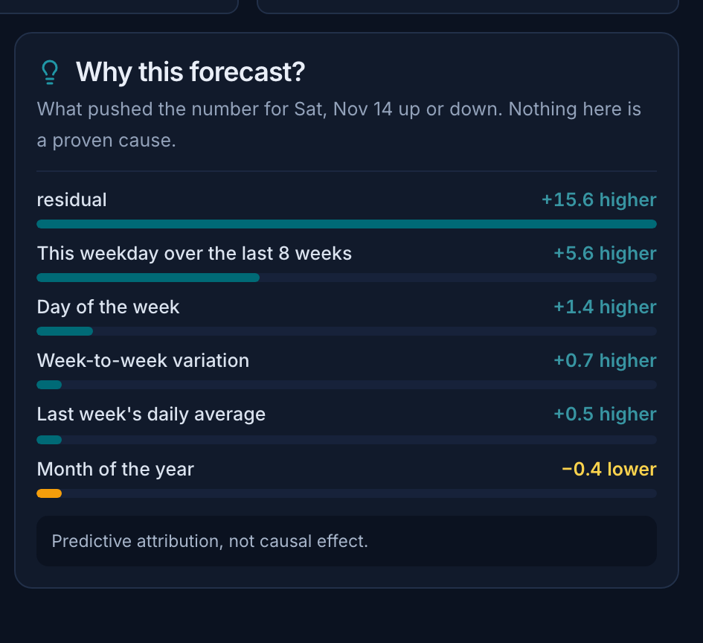

Figure 17. Analytics Page with the Assistant Panel (FR10)
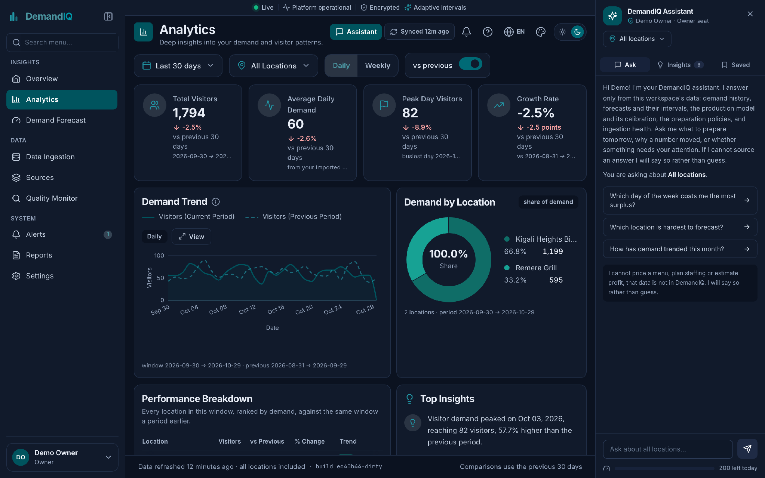
Note. The visitor counts, the assistant and the forecast behind them come from the demonstration workspace, which replays part of the public Recruit dataset through the trained model. They are not the records of a Kigali restaurant, and no operator supplied them.

Figure 18 showed the Privacy Policy and Terms reader as last updated 29 October 2026; the current policy was updated 7 November 2026. Figure 19 showed its rights section, which named Rwanda’s Law No. 058/2021 (FR12), and Figure 21 the dataset record for the Recruit data inside the application.
Figure 18. Privacy Policy and Terms of Use Reader (FR12)


Figure 19. Rights Section of the Privacy Policy (FR12)


Figure 20. A Second Workspace Signed In on Its Own Seat: Only Its Own Member, and None of the First Workspace’s Locations or Forecasts (FR2)
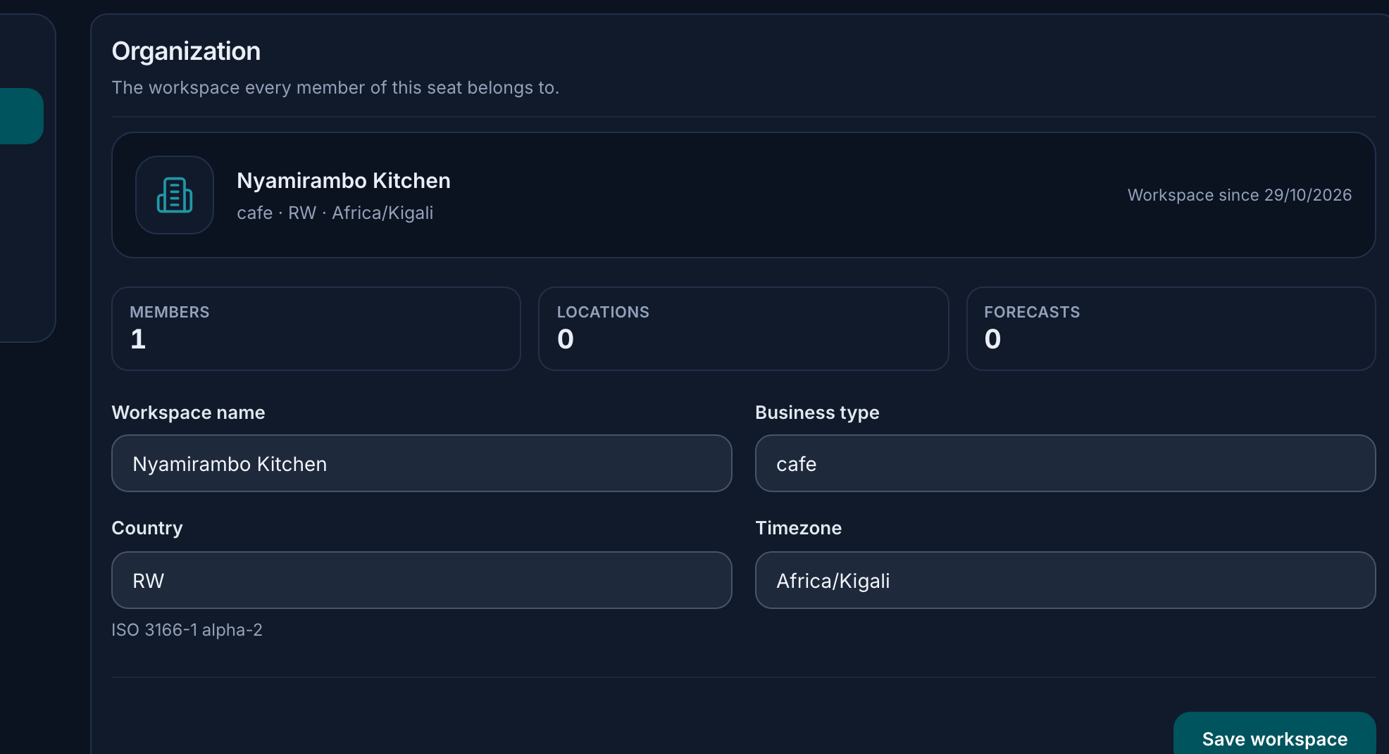

Figure 21. Dataset Record for the Recruit Data: 252,108 Records, 829 Restaurants,
1 January 2016 to 22 April 2017
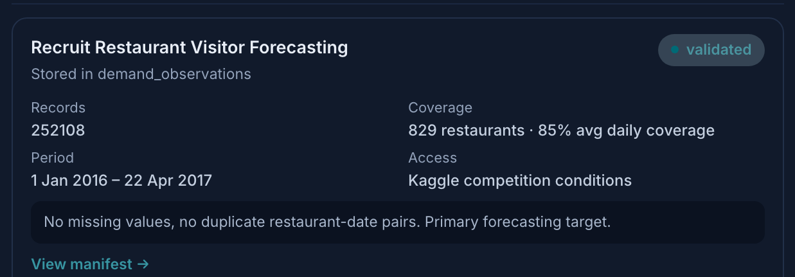

4.3 Results
All results came from one run with seed 42 and one test window (1 February to 22 April 2017). They were evidence for the design, not final statistics, and Section 4.4 discussed them against the research questions.

4.3.1 Forecast Accuracy (RQ1)
Table 6 gave test-window accuracy. The boosted models beat every simple baseline and linear regression. LightGBM’s MAE of 6.695 was 12.7% below the best baseline, weekday mean (7.667). The three boosters were within 0.007 MAE of each other and Random Forest was within about 0.07. LightGBM was chosen as the primary model for its range and attribution support, not because it won.
Table 6. Test-Window Forecast Accuracy
Model | MAE | RMSE | RMSLE | MASE | Bias | R² | Gain vs weekday mean (%)
XGBoost | 6.688 | 11.382 | 0.4935 | 0.6327 | −1.658 | 0.5793 | −12.8
CatBoost | 6.690 | 11.371 | 0.4937 | 0.6329 | −1.719 | 0.5802 | −12.7
LightGBM (primary) | 6.695 | 11.362 | 0.4935 | 0.6334 | −1.643 | 0.5808 | −12.7
Random Forest | 6.764 | 11.514 | 0.4957 | 0.6399 | −2.329 | 0.5695 | −11.8
Weekday mean (best baseline) | 7.667 | 12.757 | 0.5728 | 0.7259 | −0.410 | 0.4716 | 0.0
Historical average | 8.846 | 14.242 | 0.6297 | 0.8375 | −1.412 | 0.3415 | +15.4
Linear regression | 8.921 | 25.450 | 0.5503 | 0.8440 | −1.146 | −1.1030 | +16.4
Seasonal naive | 9.874 | 15.840 | 0.7282 | 0.9349 | −0.130 | 0.1854 | +28.8
Naive | 10.650 | 17.125 | 0.7733 | 1.0083 | −0.091 | 0.0480 | +38.9
Global average | 12.759 | 17.557 | 0.8630 | 1.2080 | −0.479 | −0.0007 | +66.4
Note. Models were scored on 57,866 restaurant-days and baselines on 57,873. Tuning moved LightGBM validation MAE from 6.466 to 6.454. The last column is the MAE difference from the weekday mean, negative meaning a lower error.
The six-fold backtest gave a mean MAE of 6.66 (SD 0.335) and a mean RMSLE of 0.4922 (SD 0.0071); because the folds overlapped, that spread was not an independent standard error. In the feature ablation (Table 7), removing historical features raised MAE by 4.535, removing reservations by 0.196 and removing calendar features by 0.142. Reservations existed for only 314 restaurants, so the model relied mostly on a restaurant’s own recent demand.
Table 7. Feature-Group Ablation
Feature set | Features | MAE | Change in MAE
Full model | 26 | 6.695 | 0.000
Without calendar | 15 | 6.837 | +0.142
Without reservation | 23 | 6.891 | +0.196
Without historical | 14 | 11.230 | +4.535
Note. Same model, seed, split and rows, with one feature group removed at a time. This showed marginal contribution on this data, not cause.

4.3.2 Prediction Ranges (RQ2)
Overall coverage was 89.98% at the 90% target, with a mean width of 29.55 visitors (Table 8). At the 80% and 95% targets, coverage was 80.03% and 94.87%. By predicted-demand group, coverage was close to 90% in every group. By realized demand it fell to 84.9% for 30 to 60 visitors and 56.1% for 60 or more (Figure 22). A single global quantile gave similar overall coverage (89.96%), a wider mean range (31.42 visitors) and 52.5% on the busiest days. The realized-demand shortfall was partly the selection effect described in Section 2.4.1, but on a very busy day the range was still the thing to trust least. Backtest fold coverage ran from 87.6% to 94.7%, with a mean of 90.1%.
Table 8. Range Coverage at a 90% Target
Demand level (visitors) | By predicted demand | By realized demand | Global quantile, by realized demand
0 to 15 | 90.00% | 94.58% | 95.16%
15 to 30 | 89.96% | 90.72% | 92.12%
30 to 60 | 89.97% | 84.85% | 82.11%
60 or more | 90.44% | 56.13% | 52.45%
Overall | 89.98% | 89.98% | 89.96%
Note. Mean width was 29.55 visitors for the grouped method and 31.42 for the global quantile.
Figure 22. Range Coverage by Demand Level, Two Ways of Conditioning
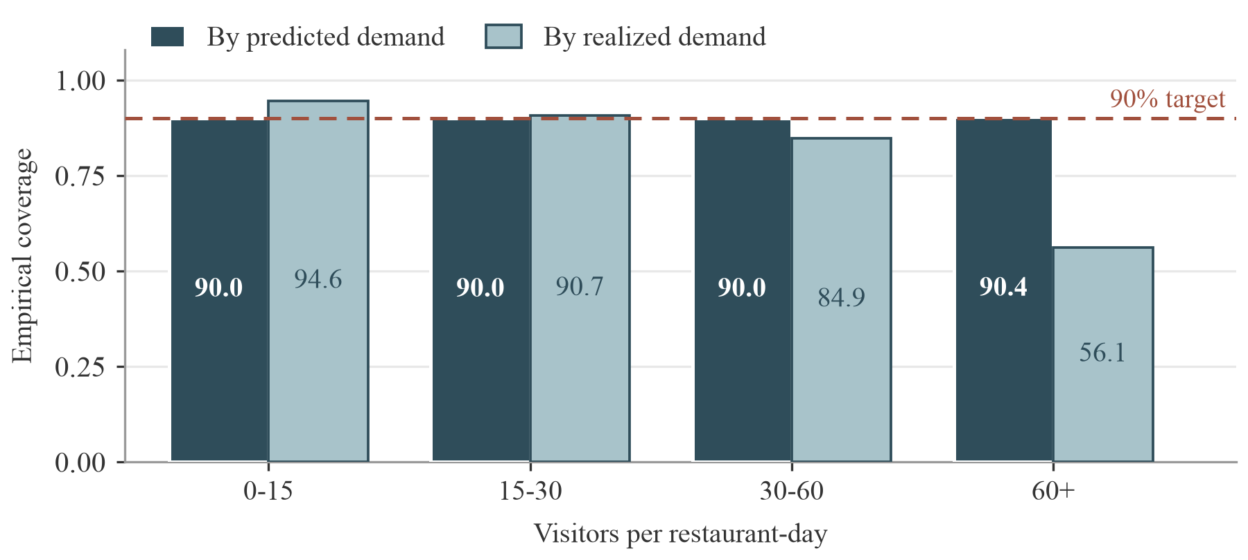
Note. The dashed line marks the 90% target. Left bars condition on predicted demand and right bars on realized demand. Bands are half-open, so a day with 15 visitors falls in the second band, not the first.

4.3.3 Preparation Policies (RQ3)
Table 9 and Figure 23 showed the four policies of FR13 at equal costs (r = 1). The point-forecast policy had the lowest total (387,416 visitor-equivalents). The risk-aware policy was 0.4% higher (388,943) and the uncertainty buffer was 9.6% higher (424,483). The historical average was worst (510,901). The buffer cut unmet demand by 9,943 units, a 4.1% reduction, and added 47,010 units of surplus. Each unit of unmet demand avoided therefore cost about 4.7 units of surplus, so the buffer lowered total cost only if a shortage cost more than about 4.7 times a surplus.
Table 9. Preparation Policies at Equal Shortage and Surplus Cost
Policy | Surplus (PS) | Unmet demand (UD) | Total (PS + UD) | Forecast-based surplus (SR)
Historical average (28 days) | 214,765 | 296,136 | 510,901 | 163,721
Point forecast | 146,182 | 241,235 | 387,416 | 0
Uncertainty buffer (scale 0.6) | 193,192 | 231,292 | 424,483 | 114,015
Risk-aware (weight 1) | 136,914 | 252,029 | 388,943 | 0
Note. Units were visitor-equivalents summed over 57,866 restaurant-days. The buffer scale 0.6 was the lowest value in the validation grid.
Figure 23. Surplus and Unmet Demand by Preparation Policy
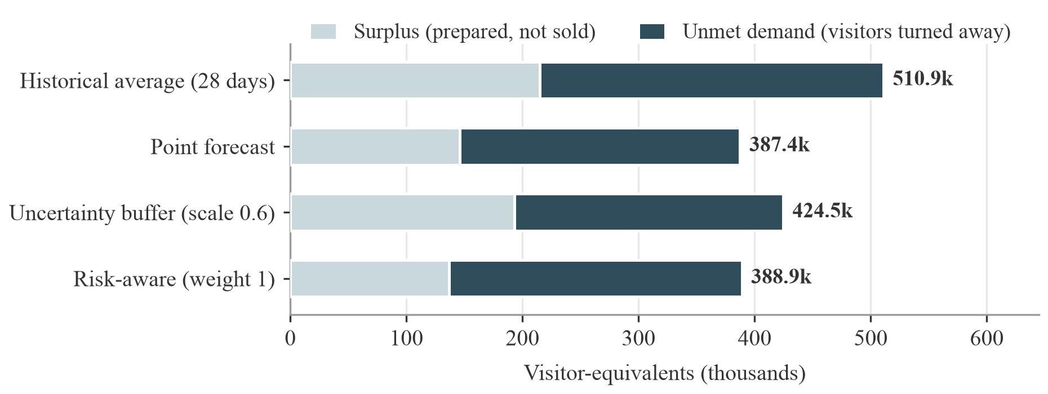
Note. Totals are labelled at the end of each bar. Equal costs (r = 1).

4.3.4 Explanations (RQ4)
The strongest feature by mean absolute SHAP value was the eight-week same-weekday mean (8.81 visitors), far ahead of the seven-day rolling mean (2.16), reservation visitors (1.35), the 28-day rolling mean (1.10) and day of week (1.01). The base value was 15.56 visitors. The ordering was plausible: the model mostly forecast a restaurant’s typical level for that weekday and adjusted it. In visitor units, the median relative reconstruction error was 12.7%. Stability was checked by splitting the test window into six consecutive blocks and ranking features by mean absolute attribution inside each: the mean and minimum Spearman coefficient between block rankings were both 1.000, and the five leading features appeared in a block’s top five 29 times out of 30. The saved run holds one attribution pass rather than one per fold or per seed, so this measured stability over time, not across random seeds; Section 5.4 states that limit.

4.3.5 Statistical Comparison, Sparse Restaurants and Cost-ratio Sweep
Three analyses answered the supervisor’s feedback. Table 10 compared models restaurant by restaurant with a paired Wilcoxon signed-rank test on per-restaurant MAE, and Table 11 priced the policies across cost ratios. The third was the sparse-restaurant check: the 209 restaurants observed on fewer than 80% of their days were kept in the sample, and their paired difference is reported as its own row so the main comparison can be read with and without them. All three came from model/scripts/extra_analyses.py on the saved run artifacts. XGBoost and Random Forest predictions were not saved, so their rows are marked not run.
Table 10. Paired Per-restaurant Comparison (Wilcoxon Signed-rank Test)
Comparison | Median MAE difference | Share of restaurants better | p-value
LightGBM vs weekday mean | −0.239 | 62.5% | 3.6e-33
LightGBM vs CatBoost | +0.001 | 49.7% | 0.64
LightGBM vs XGBoost | Not run | Not run | Not run
LightGBM vs Random Forest | Not run | Not run | Not run
LightGBM vs weekday mean, 209 restaurants below 80% observed-day coverage | −0.307 | 64.1% | 2.9e-09

Table 11. Total Cost by Policy and Cost Ratio
Cost ratio r | Historical average | Point forecast | Uncertainty buffer | Risk-aware
0.5 | 362,833 | 266,799 | 308,837 | 262,928
1 | 510,901 | 387,416 | 424,483 | 388,943
2 | 807,036 | 628,651 | 655,775 | 640,972
3 | 1,103,172 | 869,886 | 887,066 | 893,002
5 | 1,695,444 | 1,352,356 | 1,349,649 | 1,397,060
10 | 3,176,123 | 2,558,530 | 2,506,107 | 2,657,206
Note. Total cost = surplus + r × unmet demand, in visitor-equivalents. It was computed from the same saved policy results as Table 9, so the r = 1 column equals Table 9's totals.

4.4 Discussion of Findings
RQ1: accuracy. Boosted trees beat all simple baselines, agreeing with Bojer and Meldgaard (2021), who found gradient-boosted trees strong across Kaggle competitions. The three boosters and Random Forest were nearly tied, agreeing with Hossain and Parvin (2025) and Rodrigues et al. (2024) that the ranking of tree models depended on the data. The 12.7% gain over the weekday mean also showed that a simple baseline was hard to beat by much, because most of the signal was a restaurant’s own weekday pattern; the ablation confirmed it, since history mattered far more than calendar or reservations.
RQ2: ranges. Grouped calibration held coverage near 90% at forecast time in every group. The gap appeared only when busy days were selected after the fact. That limit mattered in practice, because busy days were the days operators most needed a reliable range, and it was why the application carried a visible notice instead of a bare number.
RQ3: policies. A buffer reduced unmet demand but cost far more surplus than it saved, so at equal costs the point forecast won. This fitted newsvendor theory: at equal costs the best quantity is the median, and a model trained on log demand sits close to it (An et al., 2025). An et al. tested only a critical quantile of 50% in their restaurant experiments, so the break-even ratio added something their setup did not show, and a hypothesis such as “a higher quantile reduces unmet demand” would have been true and uninformative, which was why cost was priced.
RQ4: explanations. The drivers were plausible and dominated by history, and the reminder that they were not causal followed Lundberg and Lee (2017). No evidence was collected that explanations helped operators, which left the question Zhu et al. (2025) raised open for small food businesses.
Intake layer. The behaviour checks showed that mixed records could pass through one checked path. Photo reading was the weak link: local Tesseract recovered 9 of 21 days at best on a handwritten page, agreeing with Smith (2007) that the engine was built for printed text, which justified the human review step.
Limitations and impact. All forecasting results came from Japanese restaurants. They showed how the method behaved, not its impact in Kigali, where vendors worked differently and the busy-day weakness would matter most.

4.5 Testing

4.5.1 Introduction
This section described the testing strategies, environments and error logging. Table 12 listed the environments. Errors were tracked through typed exceptions (for example ImageValidationError for a bad upload), Python logging with stack traces for engine failures, preview notes telling the operator what went wrong, and row-level warnings for duplicate or conflicting dates.
Table 12. Environment Configuration
Item | Configuration
Pipeline runtime | Linux container; Python 3.11.17; seed 42; library versions in Table 5
Deployment server | Docker Desktop on macOS 15.8.1, Intel Core i7-8569U at 2.80 GHz, 16 GB RAM. Containers: python:3.11-slim (API and jobs), Node (web), PostgreSQL 15.19 Alpine. The demonstration was hosted on Railway’s free trial tier; every measurement in this table was taken on the local containers, so no hosting region applies.
Database | PostgreSQL 15.19 (Alpine build), 54 tables after migrations.
Browsers tested | Chrome 156.0.8078.79 on macOS 15.8.1, driven headless over the DevTools protocol. Firefox was not installed in the test environment and was therefore not tested; no compatibility claim is made for it.
Devices tested | No physical mobile device was available. One x86_64 laptop as above at 1440 x 900. A low-end phone was approximated by emulation (4x CPU throttle, Slow 4G), not measured on real hardware.

4.5.2 Objective of Testing
Testing assessed whether the software ran correctly and remained stable across unit, integration and system levels; whether each intake channel and the photo reader behaved correctly on normal and difficult inputs; how the models compared with simple empirical baselines; and whether the system was compatible and responsive across the environments listed in Table 12.

4.5.3 Unit Testing Outputs
Unit tests checked single functions in isolation. The parsing functions took text and returned rows with no side effects, which made them direct to test. A drift test (test_drift_ocr_jobs.py) checked that limits copied between two modules agreed, for example the 10,000,000 quantity ceiling. The backend suite currently collects 883 tests in the Linux container with the repository mounted (27 more than the earlier collection of 856, from parametrized cases in test_remote_bundle.py; test_upload_source.py remains at six tests). The previous completed backend run recorded 804 passed, 0 failed and 52 skipped, with 79% statement coverage of the application package; those execution and coverage figures have not been refreshed against the current collection. The model suite ran 169 tests and all passed, in 2,424 s on the laptop described in Table 13. Table 13 records the available results. The skips are the suite's own skip markers, not failures, and are counted here.
Table 13. Unit Test Summary
Measure | Result
Tests collected | 1,052 total: 883 backend and 169 model. Collection counts; the current backend cases were not all rerun.
Passed / failed | Previously completed runs: 973 passed / 0 failed (52 skipped). Backend: 804 passed, 0 failed, 52 skipped from the earlier 856-test collection; these counts have not been refreshed against the current 883-test collection. Model: 169 passed, 0 failed.
Code coverage | Earlier backend run: 79% of the app/ package (12,755 statements, 2,635 missed), measured with pytest-cov. Model coverage was not measured. Backend coverage has not been refreshed for the current collection.
Test runner output | Earlier completed backend run: 804 passed, 52 skipped in 1,290 s. The current backend collection is 883 tests; a refreshed full run and coverage measurement did not complete. Model: 169 passed, 0 failed in 2,424 s. Both recorded runs followed removal of two environmental obstacles: the missing OpenMP runtime that caused 19 model tests to fail at import, and a migration test pinned to an old head name; it now checks for one head and that migration 020 is applied by it.

4.5.4 Validation Testing Outputs
Table 14 mapped Objectives 2 to 7 to a test and its result; Objective 1 is reported in Section 5.2.
Table 14. Requirements Traceability
Objective | Test | Expected | Actual | Result
SO2 Reproducible pipeline | Independent rerun in a clean environment | MAE within 0.05; coverage within 0.5 points | Passed: an independent rerun from a fresh virtual environment and an empty checkpoint directory reproduced the test-window MAE of 6.695 as 6.695 (difference 0.000) and overall coverage of 89.98% as 89.98% (difference 0.00 percentage points), inside the 0.05-visitor and 0.5-point tolerances. The rerun regenerated every stage of the training pipeline except the feature-group ablation (Table 7), from the same raw files. | Pass
SO3 Forecasting | Test-window MAE against best baseline | Lower MAE | 6.695 against 7.667 | Pass (paired test: see Table 10)
SO4 Ranges | Overall coverage at 90% target | Within 2 points of 90% | 89.98% | Pass; weakest group reported (56.1%)
SO5 Policies | Total cost across cost ratios | Ranking and break-even ratio reported | Equal-cost ranking and 4.73 break-even | Pass: ranking in Table 9, sweep in Table 11, break-even 4.73
SO6 Explanations | Top-feature stability across folds and seeds | Rank correlation of at least 0.8 | Mean rank correlation 1.000 across six test-window blocks (minimum 1.000); the five leading features stayed in a block’s top five 29 times in 30 | Pass
SO7 Intake and system | Behaviour checks on six channels | Every applicable check passes | Table 15: no failures on any channel; the connector was run against a stub | Pass

4.5.5 Integration Testing Outputs
Integration tests drove every channel through the running API with a real input: a JSON batch, a logbook CSV with a title line and a TOTAL footer, an Excel workbook, a phone photo of a handwritten page, a till posting and a pull from a test POS provider. Table 15 showed the checks, and every check that applied to a channel passed. Repeat-import tests confirmed that importing the same CSV, workbook and photo a second time left one row per day. Access control was checked by signing in to a second workspace, which held none of the first workspace’s data (Figure 20).
Table 15. Behaviour Checks by Channel
Check | Manual | CSV | XLSX | Photo | Device | Connector
Repeat import fixes the day, no duplicate | Pass | Pass | Pass | Pass | Pass | Pass
Future date refused | Pass | – | – | – | Pass | Skipped (stub)
Channel recorded on the row | Pass | Pass | Pass | Pass | Pass | Pass
Extra lines handled | – | TOTAL skipped | Title skipped | TOTAL skipped | – | 1 future, 1 unreadable

Testing found two defects, and both were fixed. A table headed date,visits imported nothing, because “visits” was not a known field name and the title line was read as the header; the channel name also read back empty, because it was written without brackets and read with them. It is now always written with brackets, and both forms are read. Other errors were handled as follows: a file that was not an image was refused, an image above 100 megapixels was refused as a decompression bomb, and an image above 25 megapixels was scaled down before reading; a bad manual row was reported by number while good rows still committed; duplicate or conflicting dates on one page raised a warning before import; and with no engine set up the preview was empty and said so.

4.5.6 Functional and System Testing Results
Robustness of photo reading. One three-line log was rendered six ways and scored before and after preprocessing (Table 16), and one real handwritten page of 21 days was tried. Two choices came from these tests: lighting was flattened before the tilt was measured, because a shadow looked like a tilt and measuring first rotated a straight page by 6 degrees, and a median filter was removed, because it turned a 98 into 9 and a 134 into 434.
Table 16. Photo Reading Before and After Preprocessing
Condition | Before | After
Clean page; small page scaled up | 3 of 3 correct | 3 of 3 correct
Shadow and speckle | 0 rows | 3 of 3 correct
Tilted 4.5 degrees | 2 rows, one wrong | 3 of 3 correct
Simulated handwriting | 3 rows, values wrong | 2 rows, values wrong
Handwriting, shadow and noise | 0 rows | 3 rows, one digit wrong
Real handwritten page, 21 days (Tesseract) | – | 9 days at best
Note. The first five rows used one rendered three-line log. The last row was a photographed page.
Performance. The full 12-stage pipeline ran once in a Linux container and took 1,005 seconds (Table 17). SHAP took 40% of the run, so attributions were computed once and stored; the backtest and ablation were optional because they refit the model many times.
Table 17. Pipeline Stage Durations
Stage | Seconds | Stage | Seconds
Ingest | 0.8 | CatBoost | 23.3
Baselines | 1.1 | Forecast ranges | 54.6
Features | 53.6 | Policies | 6.7
Tuning | 116.3 | SHAP | 404.0
Comparison models | 103.0 | Backtest | 153.6
LightGBM | 21.7 | Feature ablation | 66.3
Note. One run on one machine. Hardware details were not recorded.
Response time and compatibility. Chrome was driven over the DevTools protocol against the running stack, with the page loaded as a signed-in owner and the forecast request issued for one location as the interface issues it. Each profile was run three times and the median is reported. Page load is the largest contentful paint, the point the operator sees the screen rather than the point the HTML arrives. The photo upload figure is dominated by optical character recognition on the server, not transfer. Firefox and a physical low-end phone were not available, and their rows say so rather than carrying estimated numbers.
Table 18. Response Time and Compatibility Results
Profile | Browser and OS | Page load (s) | Forecast request (s) | Photo upload (s)
Desktop | Chrome 156.0.8078.79, macOS 15.8.1 | 0.28 | 0.12 | 10.1
Desktop | Firefox: not installed on the test machine | – | – | –
Low-end phone | No physical device available | – | – | –
Throttled desktop | Chrome 156.0.8078.79, macOS 15.8.1, 4x CPU, slow 4G | 1.47 | 0.21 | 10.7

Machine-learning comparison. Section 4.3 gave the comparison with baselines. The boosted models improved MAE by 12.7% over the best simple baseline and held coverage close to target; against the other tree models they were roughly tied.

4.5.7 Acceptance Testing Report
Acceptance testing with real users was not carried out. The project brief asked for at least twenty participants or a supervisor-approved niche cohort, and either route needed research ethics approval first. The committee application was still pending at the time of writing, and the study had a rule of collecting no real operator data and testing with no people until approval came. No System Usability Scale score or survey result was therefore collected, none is claimed, and the gap is recorded in Section 5.4 rather than filled with an estimate.

CHAPTER FIVE: SUMMARY, CONCLUSION AND RECOMMENDATIONS

5.1 Summary
The study built DemandIQ, an explainable decision-support system for small food businesses, with a checkpointed pipeline built for a rerun. It forecast next-day visitors across the 829 restaurants of the public Recruit data, added prediction ranges, compared four preparation policies by shortage and surplus cost, and explained each forecast. It also built a reviewed intake layer that turned manual entries, spreadsheets, photographed pages, till devices and point-of-sale links into one daily row, and a web application with sign-in, roles and privacy controls. LightGBM’s test error of 6.695 visitors was 12.7% lower than the best baseline, and the paired test put it ahead of the weekday mean by a median 0.239 visitors (p < 0.001). The ranges covered 89.98% of days against a 90% target but only 56.1% of days with 60 or more visitors. A buffer built from the ranges lowered total cost only when a shortage cost about 4.7 times a surplus. The intake layer passed every behaviour check that applied to a channel, though the connector channels ran against stubs rather than live exports, and local reading of handwriting recovered 9 of 21 days at best.

5.2 Conclusion
RQ1. Boosted trees forecast demand more accurately than simple baselines on public data under chronological validation. They were close to tied with each other and with Random Forest on point estimates, with no paired test for Random Forest, so the choice among them rested on practical needs and not on accuracy.
RQ2. Grouped adaptive ranges were reliable at forecast time, near 90% in every predicted-demand group. They under-covered the busiest days when judged by realized demand, and that weakness is reported openly.
RQ3. At equal costs the point forecast gave the lowest total cost, and a buffer paid off only above a cost ratio of about 4.7. A decision tool therefore needs the business’s own cost ratio, and a bare quantile hypothesis is not enough.
RQ4. The explanations were plausible and dominated by a restaurant’s own weekday history: the 8-week mean for that weekday carried the largest share, more than four times the next feature. Across six blocks of the test window the ranking barely moved: the mean Spearman correlation between blocks was 1.000, and the five leading features stayed in a block’s top five 29 times out of 30. Whether the explanations helped operators was not tested.
The study addressed Problem 1 by publishing a pipeline with hashed inputs and checkpoints. An independent rerun from a fresh virtual environment and an empty checkpoint directory reproduced the reported test-window mean absolute error (6.695 against 6.695) and interval coverage (89.98% against 89.98%) inside the tolerances set in Objective 2, so reproducibility now rests on a fresh fit and not only on the serving check that the saved artifact still returns what it was trained to return.
Objective 1 was met by the review itself. Chapter Two followed the protocol recorded in Section 2.1, and the study cited 36 sources in all, against the 20 the objective set.

5.3 Recommendations
The recommendations follow from the model results and privacy design, not from observation of operators, since no operator participated in the study. A deployer should present each forecast as an estimate and leave the decision with the operator, especially on very busy days when the ranges were weakest. Before use, the business should set a cost ratio that reflects its own shortage and surplus costs; the study varied this ratio but did not observe a local value.
Handwritten photos should be reviewed before saving, and clear spreadsheets or typed entries should be preferred where available, since the photo path recovered at most 9 of 21 days from one handwritten page. A deployer should also name a data protection officer and confirm that photos are not stored, consistent with Rwanda’s Law No. 058/2021 (Republic of Rwanda, 2021).

5.4 Future Implementations
The forecasting evidence came from Japanese restaurants and one test window from February to April 2017, which excluded summer and Golden Week; it therefore showed how the method behaved on Recruit data, not how it would perform in Kigali. A future implementation should evaluate the pipeline with local demand data and additional seasons, using non-overlapping backtest windows where feasible.
The POS and MoMo connectors were tested against stubs rather than real exports, and photo reading was measured on one handwritten page and a six-image set, so its accuracy across writers remains unknown. After ethics approval and with operators’ consent, future work should pilot the intake layer with real Kigali exports and paper logs, measure consolidation error, and evaluate photo reading on a substantially broader set of pages; an alternative vision-model path could also be assessed against the same privacy requirements.
The study forecast visitors rather than waste and did not establish that more accurate forecasts reduce waste. It also varied the shortage-to-surplus cost ratio rather than measuring a value used by small food businesses; no reviewed source supplied that local value. Future evaluation should pair local demand records with observed waste and work with businesses to estimate their cost ratios. Baselines and models were scored on slightly different row sets (57,873 and 57,866), so subsequent comparisons should use a common evaluation set.
No acceptance testing with real users was carried out because research ethics approval was pending. Explanation stability was measured across six time blocks, not across folds or random seeds, because the run stored only one attribution pass; XGBoost and Random Forest predictions were also not saved, limiting the paired comparison in Table 10 to LightGBM, CatBoost and the weekday mean. With approval, future implementations should test whether explanations help operators, store predictions and attributions for all comparison models, and measure explanation stability across folds and seeds.

5.5 Contributions to the Body of Knowledge
This study contributes to the body of knowledge by bringing four evaluations together in a documented, checkpointed pipeline on public restaurant data: forecast accuracy against baselines, prediction-range coverage across demand levels, preparation costs across shortage-to-surplus ratios, and checks of explanation plausibility and stability. Its empirical contribution is evidence from the Recruit dataset that a range-based preparation buffer reached break-even at a cost ratio of about 4.7 under the assumptions tested; the Recruit-based newsvendor studies reviewed here did not report this threshold. It also reports how coverage varied with demand and how SHAP rankings behaved across six test-window blocks. These findings add reproducible, context-specific evidence for studying demand forecasts as decision support, while not establishing effects on food waste or performance in Kigali. The system contribution is a reviewed intake design for mixed small-business records, with its measured photo-reading weakness made explicit.

REFERENCES
An, L., Li, A. A., Moseley, B., & Ravi, R. (2025). The nonstationary newsvendor with (and without) predictions. Manufacturing & Service Operations Management, 27(3), 881–896. https://doi.org/10.1287/msom.2024.1168
Ban, G.-Y., & Rudin, C. (2019). The big data newsvendor: Practical insights from machine learning. Operations Research, 67(1), 90–108. https://doi.org/10.1287/opre.2018.1757
Bojer, C. S., & Meldgaard, J. P. (2021). Kaggle forecasting competitions: An overlooked learning opportunity. International Journal of Forecasting, 37(2), 587–603. https://doi.org/10.1016/j.ijforecast.2020.07.007
Chen, T., & Guestrin, C. (2016). XGBoost: A scalable tree boosting system. In Proceedings of the 22nd ACM SIGKDD International Conference on Knowledge Discovery and Data Mining (pp. 785–794). ACM. https://doi.org/10.1145/2939672.2939785
Denscombe, M. (2025). Research proposals: A practical guide (3rd ed.). Open University Press.
Dhir, A., Talwar, S., Kaur, P., & Malibari, A. (2020). Food waste in hospitality and food services: A systematic literature review and framework development approach. Journal of Cleaner Production, 270, Article 122861. https://doi.org/10.1016/j.jclepro.2020.122861
Eriksson, M., & Lindgren, S. (2019). Food Tracking Device data [Data set]. Zenodo. https://doi.org/10.5281/zenodo.3355300
Filimonau, V., & De Coteau, D. A. (2019). Food waste management in hospitality operations: A critical review. Tourism Management, 71, 234–245. https://doi.org/10.1016/j.tourman.2018.10.009
Food and Agriculture Organization of the United Nations. (2026). Organic and food waste management initiative in Kigali. FAO.
Gibbs, I., & Candès, E. (2021). Adaptive conformal inference under distribution shift. Advances in Neural Information Processing Systems, 34. https://proceedings.neurips.cc/paper/2021/hash/0d441de75945e5acbc865406fc9a2559-Abstract.html
Hossain, M. S., & Parvin, F. (2025). A comparative study of various statistical and machine learning models for predicting restaurant demand in Bangladesh. PLOS ONE, 20(6), Article e0325449. https://doi.org/10.1371/journal.pone.0325449
Hübner, N., Caspers, J., Coroamă, V. C., & Finkbeiner, M. (2024). Machine-learning-based demand forecasting against food waste: Life cycle environmental impacts and benefits of a bakery case study. Journal of Industrial Ecology, 28(5), 1117–1131. https://doi.org/10.1111/jiec.13528
Hyndman, R. J., & Koehler, A. B. (2006). Another look at measures of forecast accuracy. International Journal of Forecasting, 22(4), 679–688. https://doi.org/10.1016/j.ijforecast.2006.03.001
Ke, G., Meng, Q., Finley, T., Wang, T., Chen, W., Ma, W., Ye, Q., & Liu, T.-Y. (2017). LightGBM: A highly efficient gradient boosting decision tree. Advances in Neural Information Processing Systems, 30. https://proceedings.neurips.cc/paper/2017/file/6449f44a102fde848669bdd9eb6b76fa-Paper.pdf
Lucic, A., Haned, H., & de Rijke, M. (2019). Contrastive explanations for large errors in retail forecasting predictions through Monte Carlo simulations. In Proceedings of the IJCAI 2019 Workshop on Explainable Artificial Intelligence (pp. 66–72). https://arxiv.org/abs/1908.00085
Lundberg, S. M., & Lee, S.-I. (2017). A unified approach to interpreting model predictions. Advances in Neural Information Processing Systems, 30. https://proceedings.neurips.cc/paper_files/paper/2017/file/8a20a8621978632d76c43dfd28b67767-Paper.pdf
Malauri, B., Mpogole, H., & Wiketye, E. (2021). Financial record keeping practices in micro and small businesses in Tanzania. SEDME (Small Enterprises Development, Management & Extension Journal), 48(3), 285–298. https://doi.org/10.1177/09708464211073488
Malefors, C., Secondi, L., Marchetti, S., & Eriksson, M. (2022). Food waste reduction and economic savings in times of crisis: The potential of machine learning methods to plan guest attendance in Swedish public catering during the Covid-19 pandemic. Socio-Economic Planning Sciences, 82, Article 101041. https://doi.org/10.1016/j.seps.2021.101041
National Institute of Statistics of Rwanda. (2016). Labour Force Survey, August 2016. NISR. https://www.statistics.gov.rw/sites/default/files/documents/2025-07/LABOUR%20FORCE%20SURVEY_AUGUST%202016.pdf
National Institute of Statistics of Rwanda. (2024). Labour Force Survey annual report 2023. NISR. https://lmis.rw/media/resources/RW_LFS2023_Annual_report_web_2.pdf
National Institute of Statistics of Rwanda. (2025). Comprehensive Food Security and Vulnerability Analysis (CFSVA) 2024. NISR. https://statistics.gov.rw/data-sources/surveys/CFSVA/comprehensive-food-security-vulnerability-analysis-cfsva-2024
National Institute of Statistics of Rwanda. (2026). Consumer price index, August 2026. NISR. https://www.statistics.gov.rw/statistical-publications/price-indices-cpi-ppi/consumer-price-index-cpi-august-2026
Posch, K., Truden, C., Hungerländer, P., & Pilz, J. (2022). A Bayesian approach for predicting food and beverage sales in staff canteens and restaurants. International Journal of Forecasting, 38(1), 321–338.
Prokhorenkova, L., Gusev, G., Vorobev, A., Dorogush, A. V., & Gulin, A. (2018). CatBoost: Unbiased boosting with categorical features. Advances in Neural Information Processing Systems, 31. https://proceedings.neurips.cc/paper/2018/hash/14491b756b3a51daac41c24863285549-Abstract.html
Recruit Holdings. (2018). Recruit Restaurant Visitor Forecasting [Data set]. Kaggle. https://www.kaggle.com/c/recruit-restaurant-visitor-forecasting
Republic of Rwanda. (2021). Law no. 058/2021 of 13/10/2021 relating to the protection of personal data and privacy. Official Gazette of the Republic of Rwanda, Special issue of 15 October 2021. https://rwandalii.org/akn/rw/act/law/2021/58/eng@2021-10-15
Rodrigues, M., Miguéis, V., Freitas, S., & Machado, T. (2024). Machine learning models for short-term demand forecasting in food catering services: A solution to reduce food waste. Journal of Cleaner Production, 435, Article 140265. https://doi.org/10.1016/j.jclepro.2023.140265
Ruzigamanzi, E., Kantengwa, G., Issayas, T., & van Schalkwyk, C. (2026, May 26). Rwanda’s food waste could feed millions. Small businesses are showing how. World Resources Institute. https://www.wri.org/insights/rwanda-circular-food-systems-small-businesses
Shah, H., Myller, N., & Islas Sedano, C. (2025). Forecasting daily customer flow in restaurants: A multifactor machine learning approach. Applied Computing and Intelligence, 5(2), 168–190. https://doi.org/10.3934/aci.2025011
Sigala, E. G., Gerwin, P., Chroni, C., Abeliotis, K., Strotmann, C., & Lasaridi, K. (2025). Reducing food waste in the HORECA sector using AI-based waste-tracking devices. Waste Management, 198, 77–86. https://doi.org/10.1016/j.wasman.2025.02.044
Smith, R. (2007). An overview of the Tesseract OCR engine. In Proceedings of the Ninth International Conference on Document Analysis and Recognition (pp. 629–633). IEEE Computer Society. https://doi.org/10.1109/ICDAR.2007.56
Tanizaki, T., Hoshino, T., Shimmura, T., & Takenaka, T. (2019). Demand forecasting in restaurants using machine learning and statistical analysis. Procedia CIRP, 79, 679–683. https://www.researchgate.net/publication/331721204_Demand_forecasting_in_restaurants_using_machine_learning_and_statistical_analysis
United Nations Environment Programme. (2024). Food Waste Index Report 2024: Think eat save: Tracking progress to halve global food waste. UNEP.
Vovk, V. (2013). Conditional validity of inductive conformal predictors. Machine Learning, 92(2–3), 349–376. https://doi.org/10.1007/s10994-013-5355-6
World Bank. (2020). Rwanda: Food-smart country diagnostic. World Bank. https://documents1.worldbank.org/curated/en/288911601302842762/pdf/Rwanda-Food-Smart-Country-Diagnostic.pdf
Zhu, R., Christensen, C., Zarrin, B., Bækgaard, P., & Alstrøm, T. S. (2025). Towards trustworthy AI in demand planning: Defining explainability for supply chain management. In Proceedings of the 17th International Conference on Agents and Artificial Intelligence (Vol. 3, pp. 1245–1253). SciTePress. https://scitepress.org/PublishedPapers/2025/133159

APPENDIX A: HOW SUPERVISOR FEEDBACK WAS ADDRESSED
Table 19 lists each point in the supervisor’s feedback on the proposal, what was done, and where the change appears.
Table 19. Response to Supervisor Feedback
Feedback | What I did | Where
Questions and data did not cover all three problems. | Reframed the problems to what the Recruit data could address, and gave each problem a question and objective. | 1.2 to 1.4, Table 1
RQ3 (waste dataset) did not connect to any problem; RQ1 held data-access wording. | Dropped the waste dataset as a question and reviewed it only as a data choice. Removed the data-access wording from RQ1 and described the access condition with the data. | 1.4, 1.5, 3.2.1
Recruit data could not show that mixed records could be consolidated. | Built the intake layer and tested it for function on synthetic files and pages. Narrowed the claim to method behaviour. | 1.5, 3.2, 4.5.5
Background did not show who was affected or how. | Added who carries the cost: small operators, informal employment and food inflation. | 1.1
Claim about operators relying on rules of thumb had no citation. | Replaced it with cited evidence on prediction errors and overproduction, and stated that waste was not measured. | 1.1, 1.5
Gap rested on confidentiality and ignored work on public restaurant data. | Reviewed Recruit-based studies and reworded the gap as a narrower claim. | 2.6, 2.7
Second gap had no literature behind it. | Searched that theme and reported that none was found, with the protocol. | 2.1, 2.6
Missing literature on boosting, newsvendor, intervals and explanations. | Added each area to the review. | 2.3, 2.4, 2.6
Search method and the 20 sources were not stated. | Stated search terms, databases and inclusion rules, and cited 36 references. Hit counts were not logged at the time, which Section 2.1 now says. | 2.1
Objectives did not deliver reproducibility or interval quality; Objectives 4 and 5 needed targets and links. | Added a reproducibility objective and a coverage-and-width objective, and gave every objective a target and a problem link. | 1.3.2
Scope was silent on consolidation; Kigali claims did not match the data; fresh-food claim had no evidence. | Stated the scope for consolidation, limited Kigali claims to motivation, and removed the fresh-food claim. | 1.5, 1.6
A full software system had no objective or evaluation. | Added Objective 7 and evaluated the system by behaviour checks and photo-reading tests. | 1.3.2, 4.5.5, 4.5.6
Test dates, single-model choice, sparse restaurants and “appropriate” values were unclear. | Gave exact dates, one global model, an 80%-of-days threshold for sparse restaurants and fixed values. Sparse-restaurant results are a row of the statistical table. | 3.2.1, 3.2.3, Table 10
A higher quantile reducing unmet demand held by construction. | Priced shortage and surplus with a cost ratio and reported the break-even ratio. | 3.2.3, 4.3.3
URBAN-WASTE analysis used different units and had no clear role. | Reviewed it and did not use it. | 3.2.1
Baselines were not defined consistently; no significance test. | Defined five baselines once and added a paired per-restaurant test. | 3.2.2, 3.2.4, Table 10

