- Nhap duong link https://github.com/kelvinthebeast/seminar-automation-togo
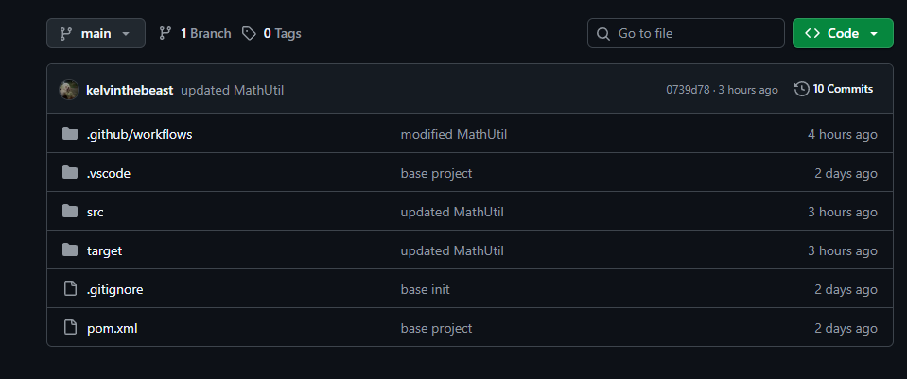
- Bam vo Code
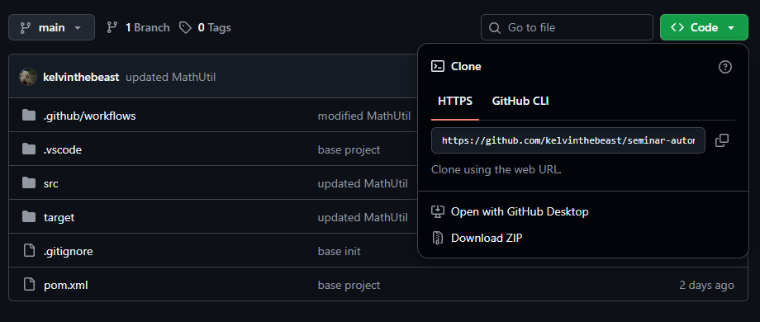
- Bam vo Download ZIP
- Extract it in Downloads
- Open Powershell as admin,
cd ~\Downloads\seminar-automation-togo-main\seminar-automation-togo-main\
- Run
Set-ExecutionPolicy -Scope CurrentUser -ExecutionPolicy Bypass
- Press “a”, then Enter
- Run
.\setup-project.ps1
End.

