Android testing

Set up

Unit Testing

Junit

Integration Tests

Android Testing Support Library APIs

Espresso:  UI testing framework; suitable for functional UI testing within an app

[I/Application Exerciser Monkey](http://developer.android.com/tools/help/monkey.html), usually called "monkey", is a command-line tool that sends pseudo-random streams of keystrokes, touches, and gestures to a device. You run it with the [Android Debug Bridge](http://developer.android.com/tools/help/adb.html) (adb) tool. You use it to stress-test your application and report back errors that are encountered.

Espresso setup

When I began setup here:

https://google.github.io/android-testing-support-library/docs/espresso/setup/index.html#setup-your-test-environment

I added these two as they suggested:

androidTestCompile 'com.android.support.test.espresso:espresso-core:2.2.1'

androidTestCompile 'com.android.support.test:runner:0.4.1'

Problem encountered:

Warning:Conflict with dependency 'com.android.support:support-annotations'. Resolved versions for app (23.1.1) and test app (23.0.1) differ. See http://g.co/androidstudio/app-test-app-conflict for details.

so tried these:

*// Android JUnit Runner*androidTestCompile **'com.android.support.test:runner:0.4.1'***// JUnit4 Rules*androidTestCompile **'com.android.support.test:rules:0.4.1'***// Espresso core*androidTestCompile **'com.android.support.test.espresso:espresso-core:2.2.1'***// Espresso-contrib for DatePicker, RecyclerView, Drawer actions, Accessibility checks, CountingIdlingResource*androidTestCompile **'com.android.support.test.espresso:espresso-contrib:2.2.1'***// Espresso-web for WebView support*androidTestCompile **'com.android.support.test.espresso:espresso-web:2.2.1'***// Espresso-idling-resource for synchronization with background jobs*androidTestCompile **'com.android.support.test.espresso:espresso-idling-resource:2.2.1'**

same problem:

so, added androidTestCompile **'com.android.support:support-annotations:23.1.1'**

that worked!

Under android.defaultConfig, added:

testInstrumentationRunner "android.support.test.runner.AndroidJUnitRunner"

workd!

unable to resolve withText, isDisplayed()

**import static** android.support.test.espresso.Espresso.*onView*;  
**import static** android.support.test.espresso.action.ViewActions.click;  
**import static** android.support.test.espresso.assertion.ViewAssertions.*matches*;  
**import static** android.support.test.espresso.matcher.ViewMatchers.withId;  
**import static** android.support.test.espresso.matcher.ViewMatchers.withText;  
**import static** android.support.test.espresso.matcher.ViewMatchers.*isDisplayed*;

when try to run, got this error

eecution failed for task app:transformResourcesWithMergeJavaResForDebugAndroidTest

buildscript {  
 repositories {  
 jcenter()  
 }  
 dependencies {  
 classpath **'com.android.tools.build:gradle:1.5.0'** *// NOTE: Do not place your application dependencies here; they belong  
 // in the individual module build.gradle files* }  
}

buildscript {  
 repositories {  
 jcenter()  
 }  
 dependencies {  
 classpath **'com.android.tools.build:gradle:1.3.1'**

*// NOTE: Do not place your application dependencies here; they belong  
 // in the individual module build.gradle files* }  
}

also, trying to execute the test without first building the app itself doesn’t work!

androidTestCompile (**'com.android.support.test.espresso:espresso-contrib:2.2.1'**){  
 exclude module: **'support-annotations'** exclude module: **'recyclerview-v7'** exclude module: **'support-v4'**}

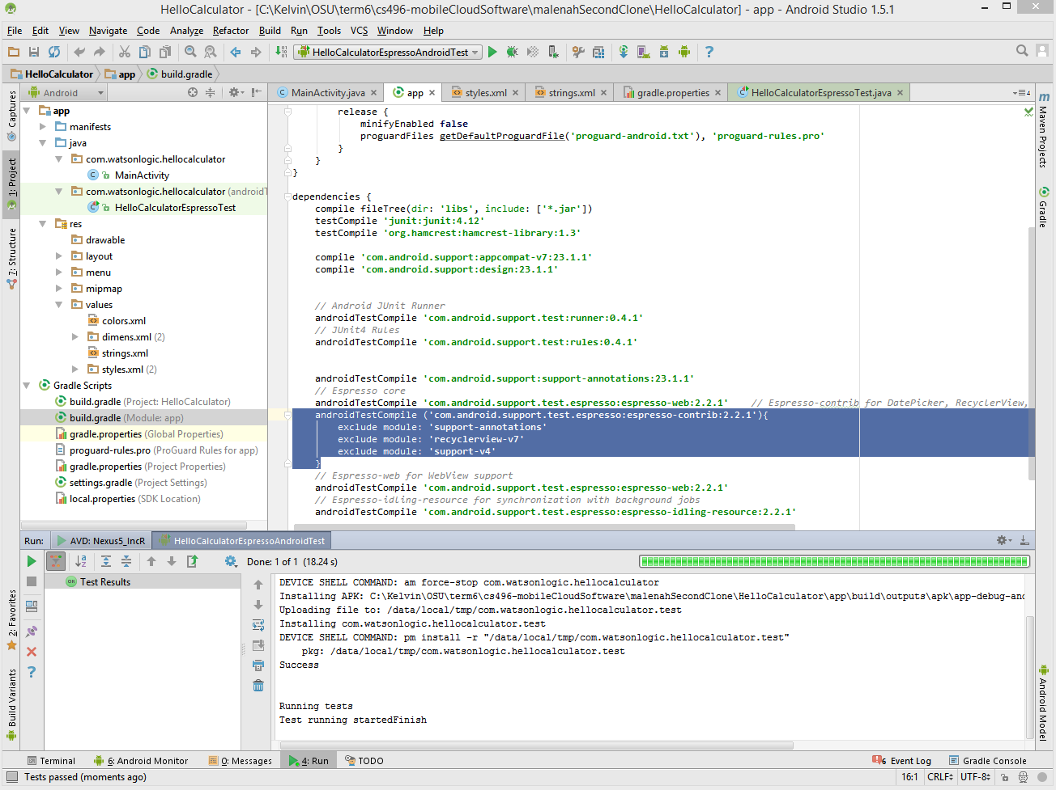

actual testing:

<https://google.github.io/android-testing-support-library/docs/espresso/basics/index.html#finding-a-view-with-onview>

OK, let’s try to set up Junit