**UNIVERSITY OF DAR ES SALAAM**



**COLLEGE OF INFORMATION AND COMMUNICATION TECHNOLOGIES**

**DEPARTMENT OF ELECTRONICS AND TELECOMMUNICATIONS ENGINEERING**

**ES324: SYSTEM DESIGN AND IMPLEMENTATION**

**CASE PROJECT REPORT**

**PROJECT TITLE**: SIMPLE REMOTE CONTROLLED HOME APPLIANCES

**STUDENT’S NAME**: ZACHARIA, KELVIN KEDYSON

**REGISTRATION NUMBER**: 2018-04-01847

**COURSE INSTRUCTOR**: DR ISACK BULUGU

**DECLARATION**

I, Zacharia Kelvin Kedyson of registration number 2018-04-01847 a student in the department of Electronics and Telecommunications engineering at the college of Information and Communication Technologies, University of Dar es Salaam hereby declaring that I have prepared and written this report as per regulations and standards of the course ES324 titled SYSTEM DESIGN AND IMPLEMENTATION to fulfill the curricular requirements of Bachelor of Science in Telecommunications engineering. The views, findings, circuits, simulations and recommendations written there in are of me (a student).

**ABSTRACT**

This report is written as the summary of the case study project as per the course ES324 titled SYSTEM DESIGN AND IMPLEMENTATION. The report of the project titled SIMPLE REMOTE CONTROLLED HOME APPLIANCES consists of eight(8) important key notes which are Title of the project, Background of the project, problem statement, Scope of the project, Objectives both main objectives and specific objectives, requirements both user and project requirements, project block diagram, project circuit diagrams both schematic circuit and prototype breadboard circuit and finally the simulation results.

**ACKNOWLEDGEMENT**

I would like to thank Dr Bulugu for the guidance, support and instructions he gave us during the course ES324, his efforts have been of tremendous and colorful outcomes that helped me to have a very good understanding on how to apply scientific knowledge and technical skills to solve real world problems based on human nature.

**TABLE OF CONTENTS**

Declaration .................................................................................................. 2

Abstract .................................................................................................. 3

Acknowledgment .................................................................................................. 4

Project Information Sheet ..................................................................................... 7

Project Background ..................................................................................... 8

Problem Statement ..................................................................................... 8

Literature Review .................................................................................... 8

Scope of the Project ..................................................................................... 10

Objectives .................................................................................... 10

Significance of the Project ..................................................................................... 10

User Requirements .................................................................................................. 11

Project Requirements ..................................................................................... 11

Block Diagram .................................................................................................. 11

Schematic Circuit ..................................................................................... 12

Breadboard Circuit ..................................................................................... 13

Simulation results ..................................................................................... 14

Conclusion ..................................................................................... 17

References ..................................................................................... 18

**LIST OF FIGURES**

Project Net List ....................................................................... 7

Project Requirements table ........................................................... 9

Block Diagram ....................................................................... 11

Schematic Circuit ....................................................................... 12

Prototype Breadboard Circuit ........................................................... 13

Figure 1 ................................................................................... 14

Figure 2 ................................................................................... 14

Figure 3 ................................................................................... 15

Figure 4 ................................................................................... 15

Figure 5 ................................................................................... 16

Figure 6 ................................................................................... 16

**PROJECT INFORMATION SHEET**

1. PROJECT TITLE: SIMPLE REMOTE CONTROLLED HOME APPLIANCES
2. STUDENT’S NAME: ZACHARIA, KELVIN KEDYSON
3. INSTRUCTOR: DR BULUGU
4. PROJECT REPOSITORY : [**https://github.com/kelvkedyson/ES324**](https://github.com/kelvkedyson/ES324)
5. PROJECT NET LIST:

|  |  |  |  |
| --- | --- | --- | --- |
| S/N | COMPONENT NAME | QUANTITY | COST (TZS) |
| 1 | Arduino UNO R3 Board | 1 | 35,000 |
| 2 | AC Power source | 1 | - |
| 3 | 2-Channels relay module (5V relay) | 2 | 10,000 |
| 4 | Breadboard | 1 | 8,000 |
| 5 | 220 ohms resistor | 2 | 500 |
| 6 | IR Receiver module | 1 | 3,000 |
| 7 | IR Remote | 1 | 2,000 |
| 8 | AC Bulb | 1 | 5,000 |
| 9 | AC fan | 1 | 15,000 |
| 10 | Electronic jumper wires | 20 | 2,000 |
| 11 | Copper wires (5m long) | 2 | 1,200 |
|  | TOTAL | 32 | 81,700 |

# **PROJECT BACKGROUND**

As per experience, electrical users at home, offices and industries need and use electricity for different purposes as per their requirements. Appliances like bulbs, Air conditioners, electrical gates, doors, Television, Radio, Refrigerators, Electric bells, among others have been very used because they are user friendly and in today’s digital world, they are vital and necessary to have. Large and heavy electrical wiring has been installed to bring electrical services at homes, offices and industries allowing users to work reliably, effective and productive.

The use of wireless technology eliminates the need for the operators to be in direct contact with the running machine. This means that the operators can position themselves in a safer manner, protecting themselves from danger, hazards, electric current outages, harmful dust, noise and slipping as well as the falling of debris and so on.

# PROBLEM STATEMENT

Regardless of the advanced technology development in the use of electronics and electrical to manufacture and design digital devices to control systems and automation, still there are difficulties controlling the appliances. Users experience dangers, hazards and ineffectiveness when having a direct contact with the running machine to control the appliances. Children who are able to use TV remotes but still not able to reach the height of a switch to light on/off a bulb are not able to make it and when they do, danger and harmful effects like falling and electric shock get along.

# LITERATURE REVIEW

With a deep dive into the pre-existing systems with almost a similar working structure and operational mechanism, it is necessary to build the firm foundation of researching the problem at hands towards improvements by providing knowledge contribution and way through toward embarking the problem so as to obtain an advanced system which aim at improving the pre-existed systems.

The advancement of Internet of Things through the implementation and application of advanced intelligent embedded systems has been so broad encompassing the multitude to wireless connected devices that surround us. It applies not only to smart-phones and tablets but also to millions of devices, machines and new twists on traditional products which were previously not wireless connected and operated.

**History of Remote Controls**

Remote control technology has developed over time using mechanical, wired, light, ultrasonic, wireless and infrared transmission links (Wang, 2001). Some devices can also be controlled with the TCP/IP protocol that is used with computer networking. Infrared remote controls are cheap and simple. As a result they are a common component used to control consumer electronic devices.

### Automatic Volume Control

Automatic Gain Control (AGC) is often implemented in electronics to normalize a signal level. In radios this may be the volume. By the inclusion of a microphone that can pick up the sound pressure level in the room the MCU software can then send volume down and up command based on a hysteresis type algorithm. It is intended that this optimization of the algorithm will require some trial and error testing

### Multiple Appliance Remote Control Circuit

This project done by Mr Saeed Abu focused on the design of a simple IR Remote Control Circuit which can be used for controlling many appliances independently through a single transmitter handset. The idea employs ordinary components like IC LM567, IC 555 does not incorporate micro-controller devices. For controlling multiple gadgets using a single transmitter handset, many of the components and modules used were constructed and integrated with the corresponding appliances for the intended switching. The project was very expensive and very difficult to implement.

### Remote Controlled Smart Lamp

A project done by Team Gadget Programmers. With this project it is easy to control any appliance through any of the old or new remote. The project is cost effective and reliable.

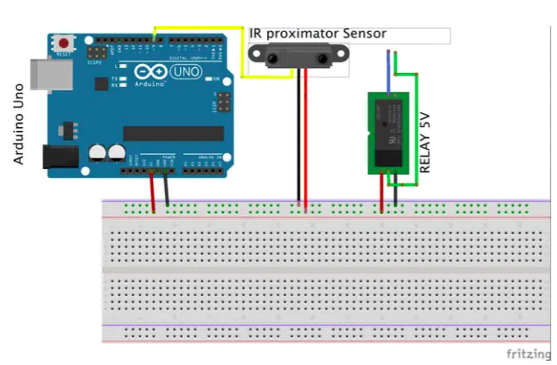

Source:<https://hackster.imgix.net/uploads/attachments/374573/remote_light_lZNjvonG3Q.jpg?auto=compress%2Cformat&w=680&h=510&fit=max>

# SCOPE OF THE PROJECT

In this case project, One will be able to control an AC Bulb and AC fan by using an IR Remote.

This will help users(or operators) at home be able to control lighting bulbs and a fan using a single press respectively according the the need. User safety is the most considered factor.

# OBJECTIVES

###### **Main Objectives**

The main objective of this project is to design and implement a simple remote controlled home appliances system that will remotely control the bulb and an electric fan.

###### **Specific Objectives**

1. To establish project requirements.
2. To design a simple remote controlled home appliances
3. To study and analyze the circuit using simulation on proteus software.
4. To implement the project prototype.

# SIGNIFICANCE OF THE PROJECT

An obvious benefit of using a remote is that it causes less fatigue than traditional, manual, machine operation. Moving a body or pushing a button to run the equipment is much easier. While performing delicate operations, some remotes used on surface preparation machines enable the operator to multitask.

Remote controlled home appliances technology may appeal to a younger audience who is aware of the physical toll that comes from manual labor. Because using a remote control does not fatigues an operator’s body in the same way that running a manual surface prep grinder or jackhammer does. With this project, operators will be able to avoid injury and stay safe for a longer period of time. Reducing the physical requirement of brute strength will decrease the downtime for operators and lower the risk of injury on the operations in offices and homes at large

# USER REQUIREMENTS

1. The system should allow for remote switch ON/OFF both the AC Bulb and an Electric fan only when needed.
2. The system should indicate if the bulb or fan is ON/OFF.

# PROJECT REQUIREMENTS

|  |  |  |
| --- | --- | --- |
| S/N | COMPONENT NAME | QUANTITY |
| 1 | Arduino UNO R3 Board | 1 |
| 2 | AC Power source (220V-240V) | 1 |
| 3 | 2-Channels relay module (5V relay) | 2 |
| 4 | Breadboard | 1 |
| 5 | 220 ohms resistor | 2 |
| 6 | IR Receiver module | 1 |
| 7 | IR Remote | 1 |
| 8 | AC Bulb | 1 |
| 9 | AC fan | 1 |
| 10 | Electronic jumper wires | 20 |
| 11 | Copper wires (5m long) | 2 |

**BLOCK DIAGRAM**

BULB

2 CHANNES RELAY

IR REMOTE

ARDUINO UNO R3

FAN

IR RECEIVER

LED1

LED2

AC POWER SOURCE

AC TO DC CONVERTER

# SCHEMATIC DIAGRAM

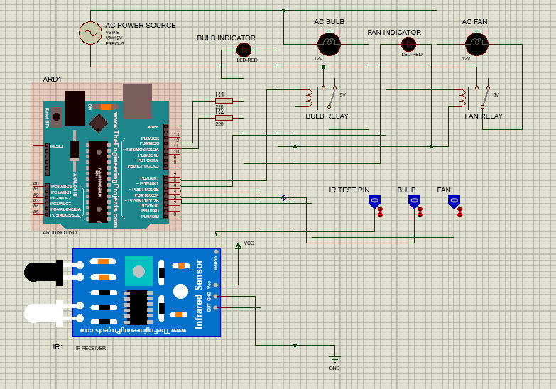

*Project Schematic Circuit*

**BREADBOARD CIRCUIT**

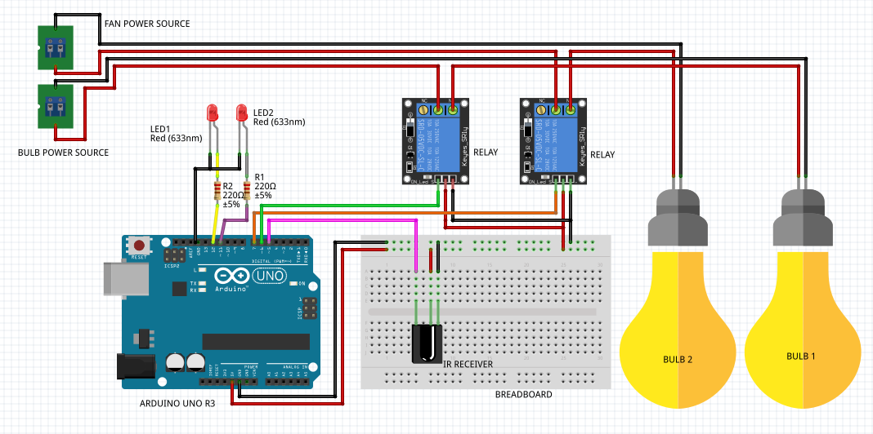

*Prototype breadboard circuit*

***Note****: - Bulb 1 stands for AC Fan*

*- Bulb 2 stands for the AC Bulb*

*From the circuits*,

The signal received from the IR remote is sent as infrared rays to the IR Receiver module and then fed to the Arduino board where there is a ATMega328P micro-controller which then receives the value of the IR received by the IR Receiver from the IR Remote as hexadecimal value. The value is interpreted and a subsequent response is produced such that a bulb relay will receive a signal (5V DC) from the digital pins of the ATMega328P micro-controller through the Arduino UNO R3 Board if the received signal from the IR Remote through the IR Receiver controlling the Bulb is available, similarly to the Fan relay. Both bulb and fan are connected to their respective relays with a Normally Open pin that means a 5V DC will provide a closed connection to complete a circuit.

In simulation, logic gates are used to represent the IR remote. When the Bulb logic gate is HIGH and the IR Receiver testing pin is HIGH, the bulb lights ON, similarly when the Fan logic gate is HIGH and the IR Receiver testing pin is HIGH, the AC Fan lights ON, and vice-versa applies.

# SIMULATION RESULTS

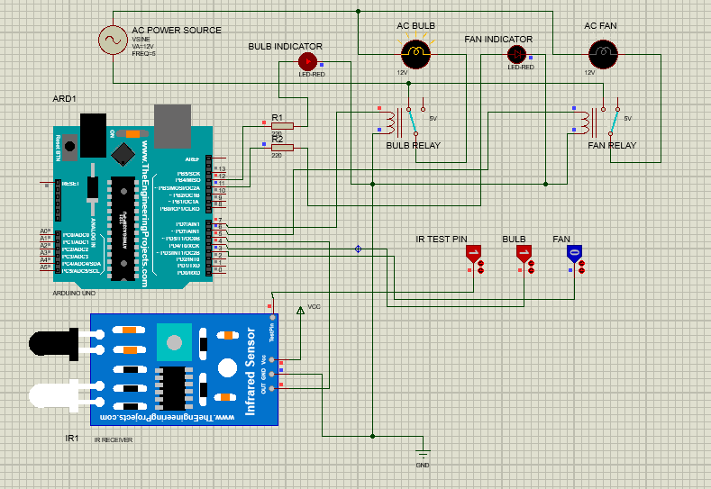

**Figure 1**: *Circuit simulation results showing the BULB logic gate HIGH and the AC BULB switched ON when the IR TEST PIN also HIGH*

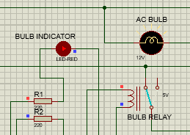

**Figure 2**: *BULB INDICATOR is ON when the AC Bulb is switched ON as the relay receives a 5V DC signal to complete the voltage loop circuit*

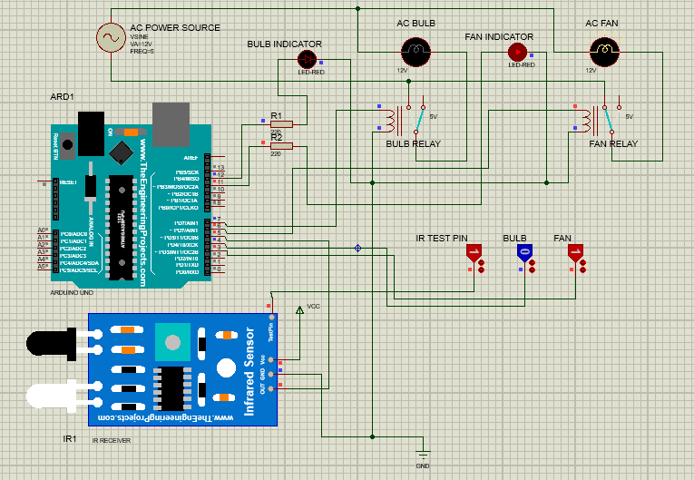

**Figure 3**: *Circuit simulation results showing the FAN logic gate HIGH and the AC FAN switched ON when the IR TEST PIN also HIGH*

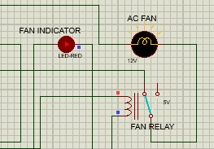

**Figure 4**: *FAN INDICATOR is ON when the AC Fan is switched ON as the relay receives a 5V DC signal to complete the voltage loop circuit*

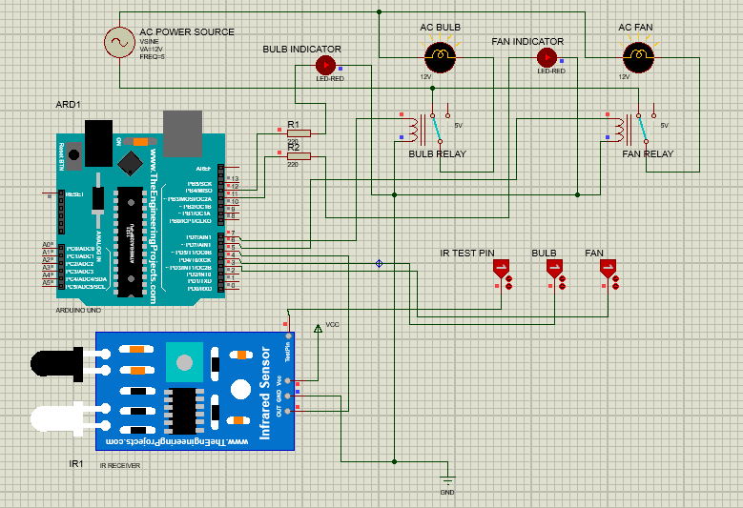

**Figure 5**: *Simulation results when both BULB, FAN and IR TEST PIN are HIGH and the AC BULB and AC FAN are both HIGH*

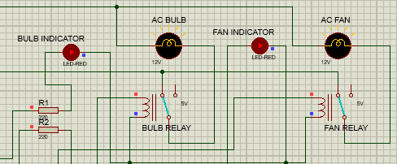

**Figure 6***: FAN and BULB indicator are both ON, both BULB and FAN Relays receives 5V DC to complete the voltage loop circuits*

## **CONCLUSION**

Operating by wireless remote control allows the operator to move more freely, enabling him/her to gain the best viewpoint of the work being performed. This is common in the demolition robot world where the operator can send the robot into a serious dangerous environment such as furnace or hanging from a crane. The operating machine is taking all the risks while the operator is located in a safer location.

Being able to control home appliance such as the bulbs and fans will provide ease of use, diverse workforce and cheap operations of the appliances with minimum and less efforts.

## **REFERENCES**

1. Arduino, 2012, *Arduino home web site*, Arduino, Cocos (Keeling) Islands, <https://www.arduino.cc/>
2. Bergmans, S 2012, SB-Projects: I*R Control*, Oisterwijk, Netherlands, <http://www.sbprojects.com/projects/ircontrol/index.php>
3. Vishay, 2003, *IR Receiver Module for Remote Control Systems*, <http://www.vishay.com/ir-receiver-modules/list/product-82135/>
4. Wang C, 2001, *Infrared Remote Room Light Switch*, Chapter 2.1, University of Queensland, Brisbane, <http://innovexpo.itee.uq.edu.au/2001/projects/s369729/thesis.pdf>
5. Swagatam, 2019, *Multiple Appliance Remote Control Circuit*, <https://www.homemade-circuits.com/remote-control-circuit-for-multiple/>