VIETNAM LABOR UNION GENERAL

**TON DUC THANG UNIVERSITY**

**FACULTY OF INFORMATION TECHNOLOGY**



**FINAL EXERCISE**

**SOFTWARE TECHNOLOGY**

Instructor: **THS ĐẶNG MINH THẮNG**

Implementer: **HUỲNH TRẦN TRUNG HIẾU– 518H0090**

**NGUYỄN THÀNH KHANG – 518H0372**

Class **: 18H50303**

School year  **: 22**

**HO CHI MINH CITY, 2020**

VIETNAM LABOR UNION GENERAL

**TON DUC THANG UNIVERSITY**

**FACULTY OF INFORMATION TECHNOLOGY**



**FINAL EXERCISE**

**SOFTWARE TECHNOLOGY**

Instructor: **TS ĐẶNG MINH THẮNG**

Implementer: **HUỲNH TRẦN TRUNG HIẾU**

**NGUYỄN THÀNH KHANG**

Class **: 18H50303**

School year  **: 22**

**HO CHI MINH CITY, 2020**

TEACHER'S EVALUATION SECTION

_______________________________________________________________________________________________________________________________________________________________________________________________________________________________________________________________________________________________________________________________________________________________________________________________________________

City. Ho Chi Minh City, month date year

(sign and write full name)

Hieu

Huỳnh Trần Trung Hiếu

Khang

Nguyễn Thành Khang

Nội dung

CHAPTER 1 - SURVEY, ANALYSIS OF CUSTOMER REQUIREMENTS, SOFTWARE INTRODUCTION 5

1.1 INTRODUCTION TO THE COMPUTER STORE 5

1.2 ORGANIZATION CHART OF COMPUTER STORE. 5

1.3 PROBLEMS THE COMPUTER STORE IS MEETING. 6

1.4 ABOUT COMPUTER STORE MANAGEMENT SOFTWARE. 6

CHAPTER 2-SRS DOCUMENT 7

2.1 Actor 7

2.2 FLOW CHART 7

2.3 Question Of Author And Customer Answer 10

2.4 List of functions and non-functions 13

2.5 List of Use Cases 14

2.6 Use Case Diagram And Description. 16

CHAPTER 3 - DESIGN DOCUMENT. 26

3.1 Class diagram 26

3.2 Activity and sequence diagram 27

CHAPTER 4 - REALIZE SOFTWARE. 34

4.1 Database 34

TABLE nhanvien 35

TABLE hoadonban 36

TABLE hoadonnhap 36

TABLE nhacungcap 37

TABLE khachhang 37

4.2. Interface design and manipulation. 37

CHAPTER 5 – TEST CASE 40

5.1 Alpha Test 40

5.2 Unit Test: 48

5.3 SVN/GIT 49

5.4.Hardware and software requirements: 50

*5.4.1* Technologies Used 50

*5.4.2* Software Used 50

CHAPTER 6 – REFERENCES 50

LIST OF TABLES, FIGURES, GRAPHICS

**LIST OF FIGURES**

ORGANIZATION CHART 1 5

FLOW CHART CUSTOMER 2 8

FLOW CHART STAFF 3 9

FLOW CHART STORE OWNER 4 10

USE CASE DIAGRAM 5 16

CLASS DIAGRAM 6 26

ACTIVITY DIAGRAM-LOGIN 7 27

SEQUENCE DIAGRAM-LOGIN 8 28

ACTIVITY DIAGRAM-STATISTICAL 9 29

SEQUENCE DIAGRAM-STATISTICAL 10 30

ACTIVITY DIAGRAM-PRODUCT MANAGEMENT 11 31

SEQUENCE DIAGRAM-PRODUCT MANAGEMENT 12 32

ENTITY RELATIONSHIP DIAGRAM 13 33

DATA DIAGRAM 14 34

ALPHA TEST-LOGIN 15 37

ALPHA TEST-LOGIN 16 38

ALPHA TEST-MENU 17 38

ALPHA TEST- Computer Information 18 39

ALPHA TEST- Staff information 19 40

ALPHA TEST- Import bill 20 41

ALPHA TEST-BILL OF SALE 21 41

ALPHA TEST- Statistical 22 42

UNIT TEST RESULT 23 43

SVN/GIT 24 44

# CHAPTER 1 - SURVEY, ANALYSIS OF CUSTOMER REQUIREMENTS, SOFTWARE INTRODUCTION

## 1.1 INTRODUCTION TO THE COMPUTER STORE

-The customer is the owner of a shop specializing in selling computers and computer accessories, with a variety of products, good quality, comfortable prices and most importantly, the staff is always very enthusiastic, helping customers when they have difficulty choosing products, always enthusiastically advise customers.

-Because the above reasons have made the store more popular, the store's sales are also increasing, but currently the store does not have a useful tool in managing the amount of data. The increasing fact that most of the staff here only use paper for notes has inadvertently made managing products, orders, and customers of the store inadvertently difficult.

## 1.2 ORGANIZATION CHART OF COMPUTER STORE.

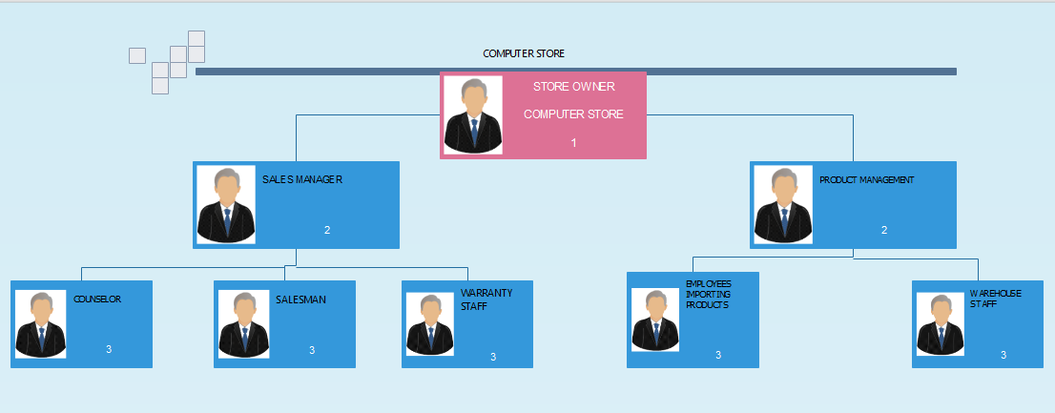

ORGANIZATION CHART 1

## 1.3 PROBLEMS THE COMPUTER STORE IS MEETING.

- The number of customers is increasing, the number of products is more and more diversified, making it ineffective to take notes on paper, making it difficult to manage, it may take longer to search for real information. products, customers.

- Low information security because sometimes only a small mistake is required to take notes on paper, which leads to the loss of a huge amount of data, which can inadvertently cause huge losses in the store.

It-Difficult to update customer information because it takes a lot of time to search when it is needed.

-Creating newspapers takes a lot of time, money, and effort because paper-based notes must then be recorded in-store information then the store has to spend a lot of money and effort to preserve the information.

It- Difficult to manage products, because the products on the market are very diverse, always updating new products and prices, so when you need to import a new order or reject a product that is not needed, it consumes a lot of time. time to do.

=> So the shop owner has ordered a product that helps their store easily manage employees, customers, and products more efficiently and economically to increase productivity.

## 1.4 ABOUT COMPUTER STORE MANAGEMENT SOFTWARE.

-For the problem that the computer store owner is facing, the computer store management software was born to mistakenly replace the inefficient computer store management with paper.

-The main purpose of this project is to replace paper-based data with computer data, when the user stores information on a product it will be stored in the system database and when needed. device users can access the information stored by the system.

# CHAPTER 2-SRS DOCUMENT

## 2.1 Actor

Customer:

-The customer is not the object of interacting with the system, but the customer will act as the object providing information and requirements to implement the system.

Staff:

- Employees can create and store customer information, orders that customers request, then the system is used to store product and customer information and when needed, the staff will create a simple and system The system will automatically calculate the price.

- Employees can search for products and orders stored in the system.

Store owner:

-The store owner is the person who has full authority to decide which products the store is selling, including adding, deleting, and updating the store's products.

- The store owner also has the right to manage employees and orders, and customer information has been stored in the system.

## 2.2 FLOW CHART

CUSTOMER

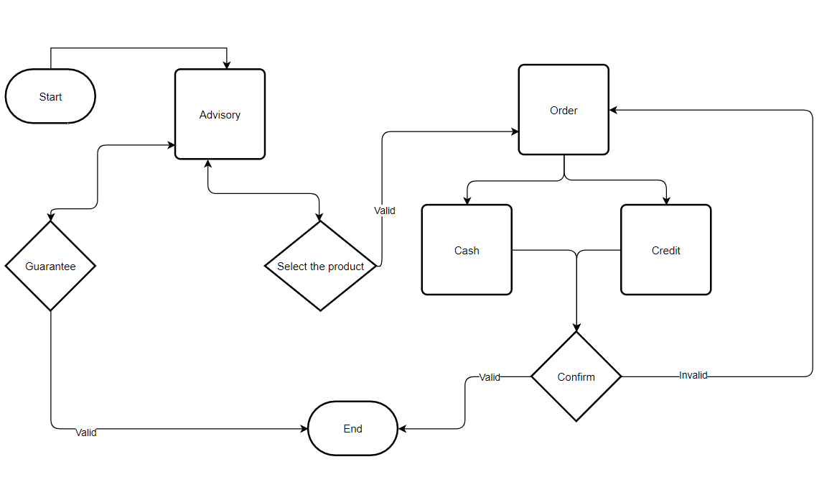

FLOW CHART CUSTOMER 2

STAFF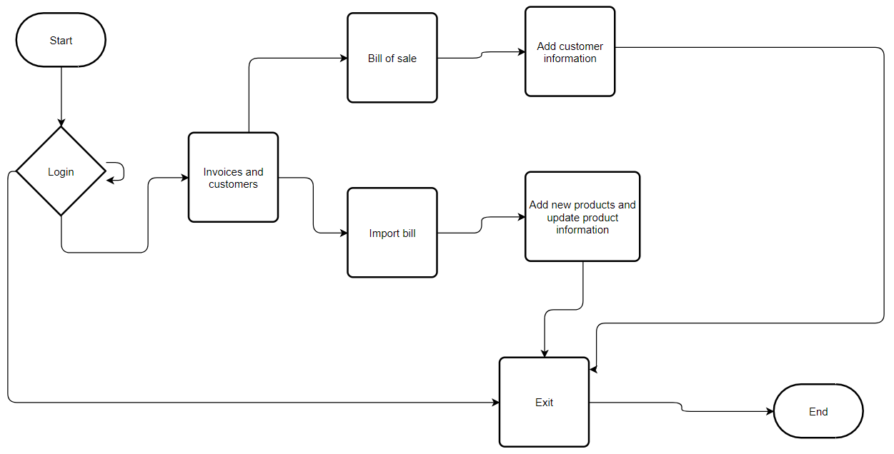

FLOW CHART STAFF 3

STORE OWNER 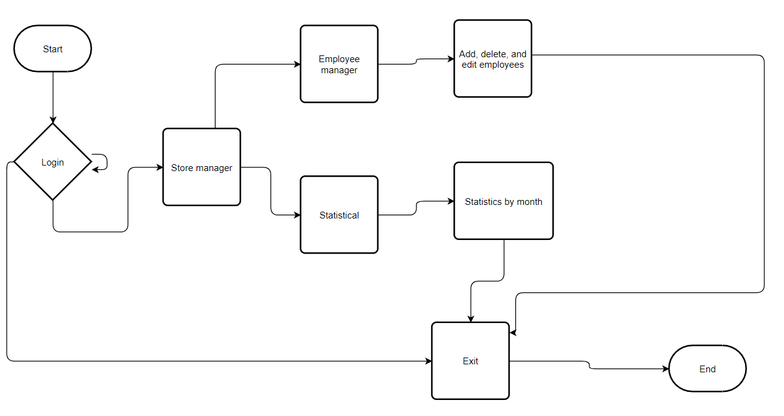

FLOW CHART STORE OWNER 4

## 2.3 Question Of Author And Customer Answer

|  |  |  |
| --- | --- | --- |
| REQUEST | Asking and making choices | ANSWER |
| Login interface | **Question**: About login  In the system, I don't see the mention of the hierarchy for the user at login here. What positions and powers does this include?  **Recommendation**: Here, the 2 main positions are employees and administrators.  Staff can only log into the system and create invoices, add and delete products, and create customer information.  An administrator can log in to view expense management reports, bills, and a current number of store employees. | We agree |
| Customer Information Management. | **Question**: Employees have the right to create and view customer information.  **Recommendation**: Employees can easily create customer information for the first time and in the following times, employees just need to save the information, the number of products that the customer has purchased to check if this is a potential customer. function or not at the same time all employees can see customer information when necessary can contact the customer | We agree |
| Service | **Recommendation**: We will have a function as an add-on service at special events so that the staff can know and notify the customer, when the employee records customer information if the customer has rated as a loyal customer of the store, the store will notify staff so that customers can enjoy preferential services from the service. | We totally agree |
| Pay | **Recommendation**: The staff will propose the form of payment service to the customer, when the customer finishes choosing the form of payment, the staff will create an invoice and store in the system and output the amount that the customer paid. | We totally agree |
| Consulting and finding product information | **Recommendation**: When customers have a need to advise on services and products, employees can now easily view existing service and product information at the store and if there is a problem, staff are completely available. You can contact the store owner directly. | We totally agree |

## 2.4 List of functions and non-functions

|  |  |  |
| --- | --- | --- |
| **REQUEST** | **FUNCTION** | **NON-FUNCTION** |
| The system allows shop owners to manage products (add, delete, modify products) | x |  |
| The system needs high security, a logical database designed with constraints, compliance with standards, high reliability. |  | x |
| The system allows shop owners and employees to search for detailed information about the product. | x |  |
| The system allows the shop owner to manage all employees of the store. | x |  |
| Finding information does not take more than 5 seconds. |  | x |
| The system allows employees to create invoices and store them in the system. | x |  |
| The loading time for UI screens should not take more than 2 seconds. |  | x |
| The system allows shop owners and employees to record customer information. | x |  |
| The shop owner can use the system to list sales orders and incoming orders. | x |  |
| There is a need for a system with fast performance, each process does not exceed 5 seconds, capable of storing information quickly. |  | x |

## 2.5 List of Use Cases

**Login**: The function allows users to log in to the system with the accounts and passwords stored in the database.

**Product Management**: Employees and store owners have the right to manage all products of the store on the system by adding, deleting, and modifying existing items so that information can be updated quickly.

**Employee manager**: The store owner has the right to add a new employee to the system when new employees are added to the system and at the same time create an account for new employees, besides, the store owner has the right to delete and edit information and accounts. of the staff in the store.

**Supplier information**: The store owner has the right to add, delete, and modify the vendor that has contacted the store.

**Customer information:** The staff and the store owner both have the right to create customer information, and when necessary, both the staff and the store owner have the right to view information and contact the customer.

**Search**: Employees and shop owners can find products using a smart search toolbar with product names or product codes in the system.

**Bill of sale:** When a customer requests a new order, the employee can then create a new invoice.

The owner of the store is the manager of sales invoices. When the employee creates a sales invoice, the system will save it for the store owner to view, delete, and modify the sale invoice.

**Invoice entered:** When the store imports some new products, then the staff, the store owner will check and then create a new invoice to save in the system.

The store owner is the manager who manages the imported invoices when the store orders new products, then the imported invoices will be created and stored in the system, the store owner can view, delete and modify the imported invoices.

**Order request**: Although the customer cannot participate directly in the system, the customer is the object of providing information and requirements to the system.

**Statistical**: Statistics of sales, import, and export, invoices of the store by month.

## 2.6 Use Case Diagram And Description.

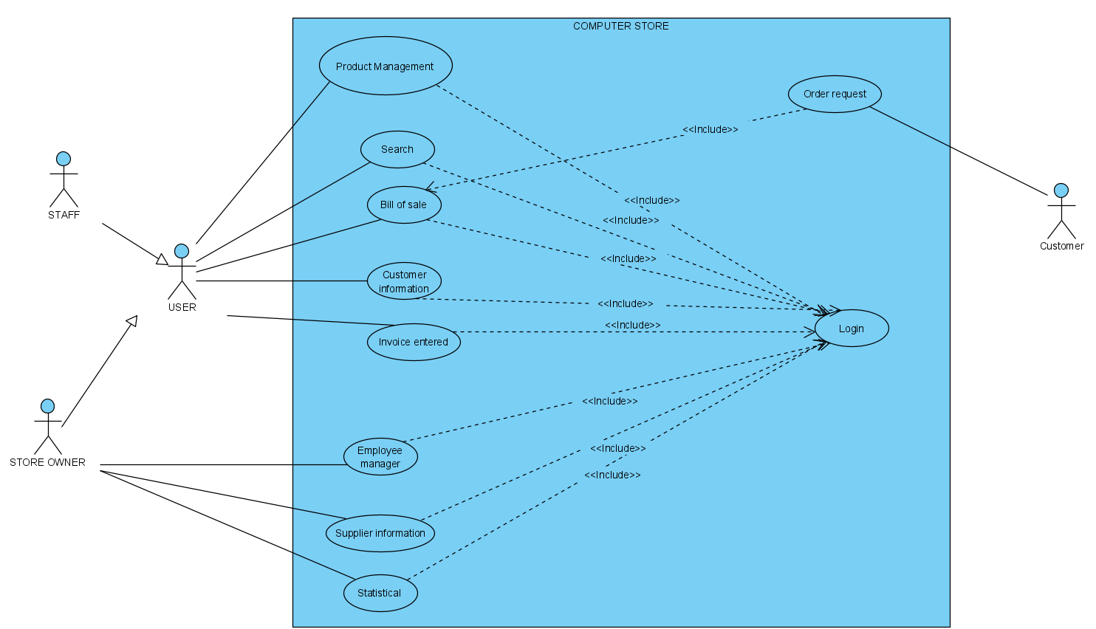

USE CASE DIAGRAM 5

**USE CASE DESCRIPTION**

**Product Management**

|  |  |
| --- | --- |
| USE CASE NAME | Product Management |
| ACTOR | Store owner  Staff |
| DESCRIBE | -User enters computer information with the following information: computer code, computer name, selling price, brand.  -When the input is finished, press the "Add" button, all information on the computer will be loaded up and added to the system.  -If you want to "Edit" information of a computer, you just need to select that product on the system and users can edit the product information.  -Similarly, with the function "Delete", you just need to select the product on the system and click delete.  -If the user presses the "Refresh" button, all the fields currently entered will be empty and the user can enter new product information. |
| ILLEGAL | -User entered not enough product information.  -The user enters in the box the quantity and unit price in text.  -User entered invalid search product information. |
| SCRIPT | -If the user completes and correctly the product information, the system will save the product in the data and notify the user.  -If the user enters incomplete information or enters characters in the quantity and unit price boxes, the system will report an error and request the user to re-enter.  -Users search for products by computer code, computer name, selling price, brand, if found, the system will return relevant product information to the user.  -When the user enters the wrong product information, the system will return the result that could not be found for the user. |

**Login.**

|  |  |
| --- | --- |
| USE CASE NAME | Login |
| ACTOR | Store owner  Staff |
| DESCRIBE | This use case starts when the user runs the program.  The system will check the validity of the Account and Password.  If it is correct, it will give a user group notice of the user and show the main interface screen of the program with the menu system displayed by the function of the user, depending on the user group of that username.  Otherwise, it will issue an error message and ask the user to log in again. |
| ILLEGAL | User entered an invalid account or password. |
| SCRIPT | The user enters correct username and password for the open form system.  If the user's username and password are incorrect, the Login system displays a message asking the user to re-enter the username and password. |

**Customer information**

|  |  |
| --- | --- |
| USE CASE NAME | Customer information |
| ACTOR | Store owner  Staff |
| DESCRIBE | The user will enter full customer information into the textbox.  When finished entering, press the button "Add", all customer information will be checked by the system and saved in the data.  If you want to "Edit" information of any customer, you just need to select that customer in the system then the information is loaded back into the textboxes then the user can edit the information.  Similarly, with the function "Delete", we just need to select the customer to delete in the system and click the delete button to delete that customer information.  If the user presses the "Refresh" button, all textboxes will go back to empty allowing the user to enter new customer information. |
| ILLEGAL | User entered incomplete customer information.  The user enters character or string data in the phone number box. |
| SCRIPT | The user enters fully customer information and without errors, the system will check and save it in the data.  If the user enters incorrectly, the system will issue an error message and request the user to re-enter the information. |

**Supplier information**

|  |  |
| --- | --- |
| USE CASE NAME | Supplier information |
| ACTOR | Store owner |
| DESCRIBE | The manager will enter full information of the provider including supplier code, name of the supplier.  When the information is complete, press the button "Add", all information is checked by the system and stored in the database.  The button "Edit" when you want to modify information, we select the supplier code to edit in the system, then the information is loaded back into the Textbox and the user can edit the information.  The "Delete" button is used when the user wants to delete a provider for some reason.  When the user wants to search for information, the user enters the information into the information textbox and presses the search button, the information includes the code and the name of the provider. |
| ILLEGAL | User entered incomplete supplier information. |
| SCRIPT | The user enters full information of the supplier and without errors, the system will check and save it in the data.  If the user enters incorrectly, the system will issue an error message and request the user to re-enter the information. |

**Employee manager**

|  |  |
| --- | --- |
| USE CASE NAME | Employee manager |
| ACTOR | Store owner |
| DESCRIBE | The manager will enter the employee's information including information such as: NV code, NV name, gender, address, phone number, entered in the textbox.  When the entry is complete, press the "Add" button, all employee information is loaded onto the system and simultaneously saved in the database.  If the user presses the "Refresh" button, all textboxes will be empty, allowing the manager to enter a new employee.  The "Edit" button when you want to modify information, we select the employee whose information needs to be edited in the system, then the information is loaded back into the Textbox, then the manager can edit the information.  The "Delete" button is used when the user wants to delete an employee for a certain reason. |
| ILLEGAL | User entered incomplete employee's information. |
| SCRIPT | User enters full employee information and without errors, the system will check and save it in the data.  If the user enters incorrectly, the system will issue an error message and request the user to re-enter the information. |

**Bill of sale**

|  |  |
| --- | --- |
| USE CASE NAME | Bill of sale |
| ACTOR | Store owner  Staff |
| DESCRIBE | When the Store Owner and employee create a new invoice, information about the invoice will be entered, then the information will be saved on the information system.  When the input is finished, press the button "Add", all information about billing, date, total amount will be loaded onto the system and simultaneously saved in the database.  If you want to "Edit" any invoice information, you just need to select that invoice on the system then the information is loaded back into the textbox and the user can edit the information.  Similarly, with the function "Delete", you just need to select the invoice that needs to be deleted on the system and click the delete button to delete the invoice information.  If the user presses the "Refresh" button, all textboxes will be empty, allowing the administrator to enter a new invoice.  If you want to "Print sale invoice", you just need to select the Print invoice button, you will print out EXCEL |
| ILLEGAL | User entered incomplete invoice information.  When the user corrects an invoice, he / she enters incorrect information or does not enter complete information. |
| SCRIPT | The user enters all information of the invoice and without errors, the system will check and save it in the data.  If the user enters incorrectly, the system will issue an error message and request the user to re-enter the information.  If the user enters missing information, the system will report an error and ask the user to enter full information. |

**Invoice entered**

|  |  |
| --- | --- |
| USE CASE NAME | Invoice entered |
| ACTOR | Store owner  Staff |
| DESCRIBE | When the Store Owner and employee create a new invoice, information about the invoice will be entered, then the information will be saved on the information system.  When the input is finished, press the button "Add", all information about billing, date, total amount will be loaded onto the system and simultaneously saved in the database.  If the user presses the "Refresh" button then all textboxes will be empty allowing the user to enter a new invoice.  If you want to "Edit" any invoice information, you just need to select that invoice on the system then the information is loaded back into the textbox and the user can edit the information.  Similarly, with the function "Delete", you just need to select the invoice you want to delete on the system and click on the delete button to delete the invoice information. |
| ILLEGAL | User entered incomplete invoice information.  When the user corrects an invoice, he / she enters incorrect information or does not enter complete information. |
| SCRIPT | The user enters all information of the invoice and without errors, the system will check and save it in the data.  If the user enters incorrectly, the system will issue an error message and request the user to re-enter the information.  If the user enters missing information, the system will report an error and ask the user to enter full information. |

**Search**

|  |  |
| --- | --- |
| USE CASE NAME | Search |
| ACTOR | Store owner  Staff |
| DESCRIBE | If users enter product information to look for in the textbox, the system will display the information that needs to be displayed. |
| ILLEGAL | User entered incorrect information or information does not exist in the system. |
| SCRIPT | The user who correctly entered the system information will display the search results.  User enters incorrect information or does not exist the system will result in not found. |

**Order request**

|  |  |
| --- | --- |
| USE CASE NAME | Order request |
| ACTOR | Customer |
| DESCRIBE | Customers cannot interact with the system but the customer will provide information and requests to the system.  When the order comes into effect, the employee will create an order.  If the customer cancels the order, the staff will notify the manager and the manager will consider to cancel the order. |
| ILLEGAL | Customers do not make orders.  The customer has placed an order but wants to cancel the order. |
| SCRIPT | Customers who make orders will be confirmed by staff and stored in the system.  Customers in the process of product selection contact the employee who does not want to select an order, the order will not be established.  Customers who have made an order for products but want to cancel orders will be considered for cancellation or not. |

**Statistical**

|  |  |
| --- | --- |
| USE CASE NAME | Statistical |
| ACTOR | Store owner |
| DESCRIBE | The manager enters time information into the textbox, the datagrid view will show information about the invoice for that month. |
| ILLEGAL | The monthly invoice will not be displayed if the shop owner has deleted the invoice. |
| SCRIPT | If the user enters the correct time, the system will statistic the invoice for the store owner.  Invoices do not show up when the user has deleted that month's invoice information. |

# CHAPTER 3 - DESIGN DOCUMENT.

## 3.1 Class diagram

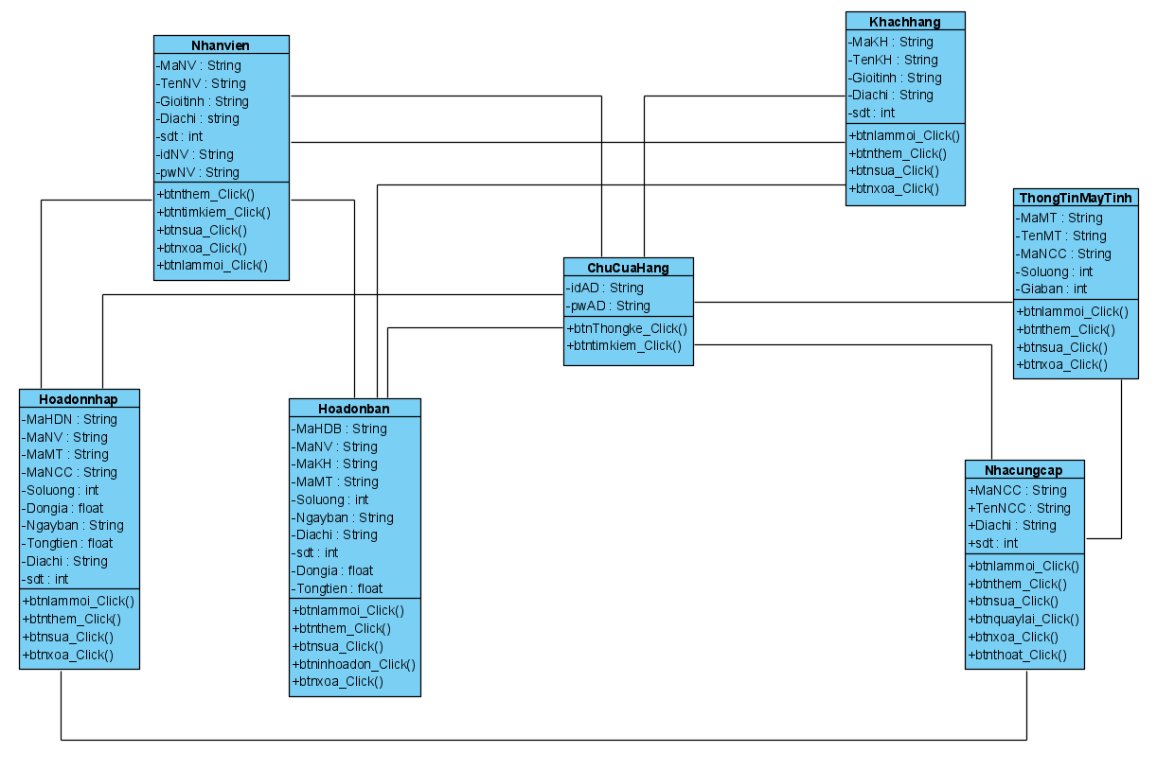

CLASS DIAGRAM 6

-With Hoadonban class: it will save information about products sold, including date, quantity, unit price, total invoice amount.

-With Nhanvien class: this is the place to store the information of the store employee, the shop owner will be the employee manager who can add, delete, edit the store employee information.

-With Hoadonnhap class: this is the place to store information about the bill of goods, price, new items that the store has imported.

-With ChuCuaHang class: place save account and password for process sign in with admin, owner rule.

-With the Khachhang class: with the Customers table, this is the place to store customer information that has transacted with the shop.

-With ThongTinMayTinh class : this is the place to store information about the store's products including computer name, price, supplier, quantity in stock.

-With Nhacungcap class: this is the place where the suppliers contacted the store including vendor name, address and phone number.

## 3.2 Activity and sequence diagram

**Login**

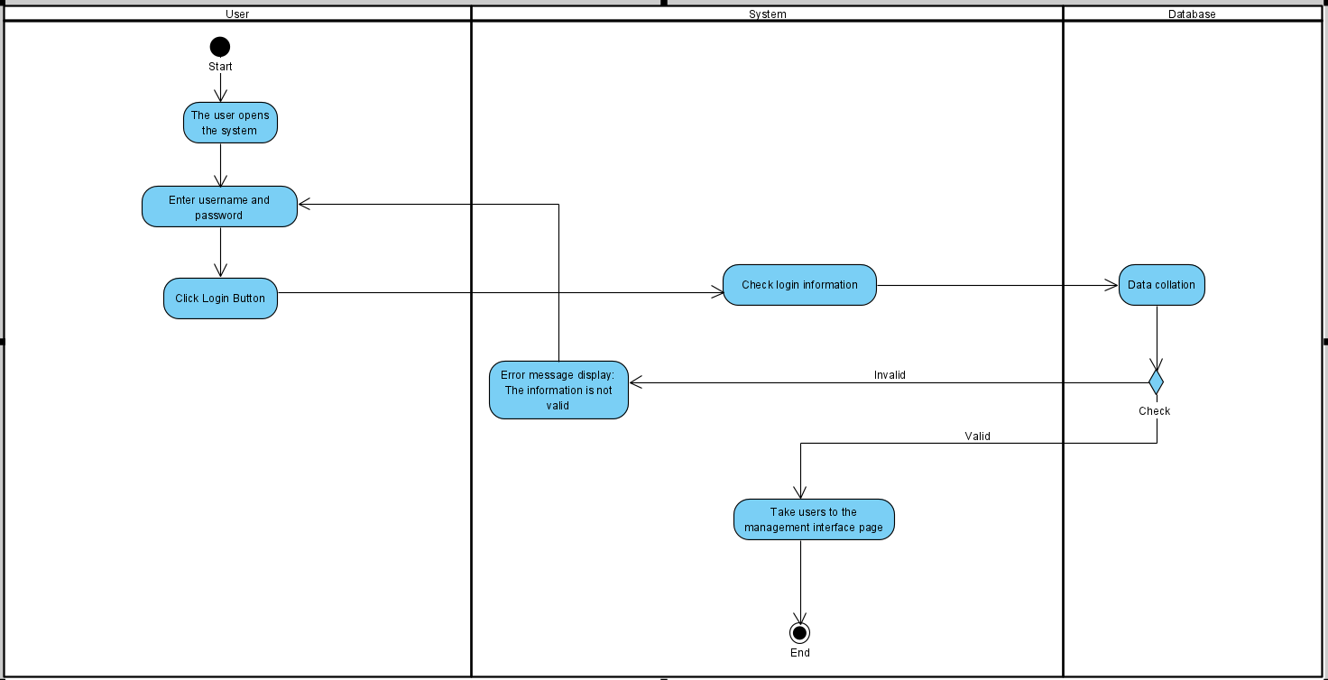

ACTIVITY DIAGRAM-LOGIN 7

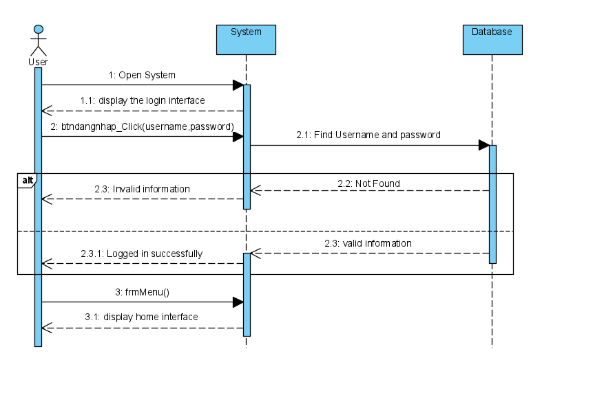

SEQUENCE DIAGRAM-LOGIN 8

**Statistical**

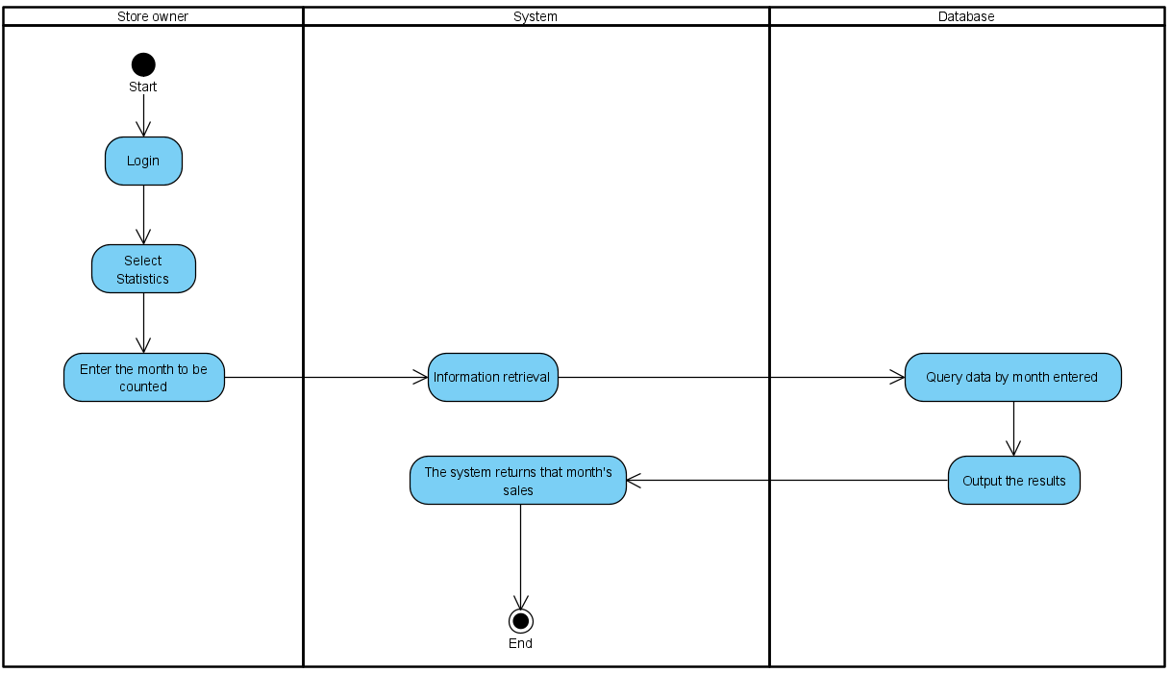

ACTIVITY DIAGRAM-STATISTICAL 9

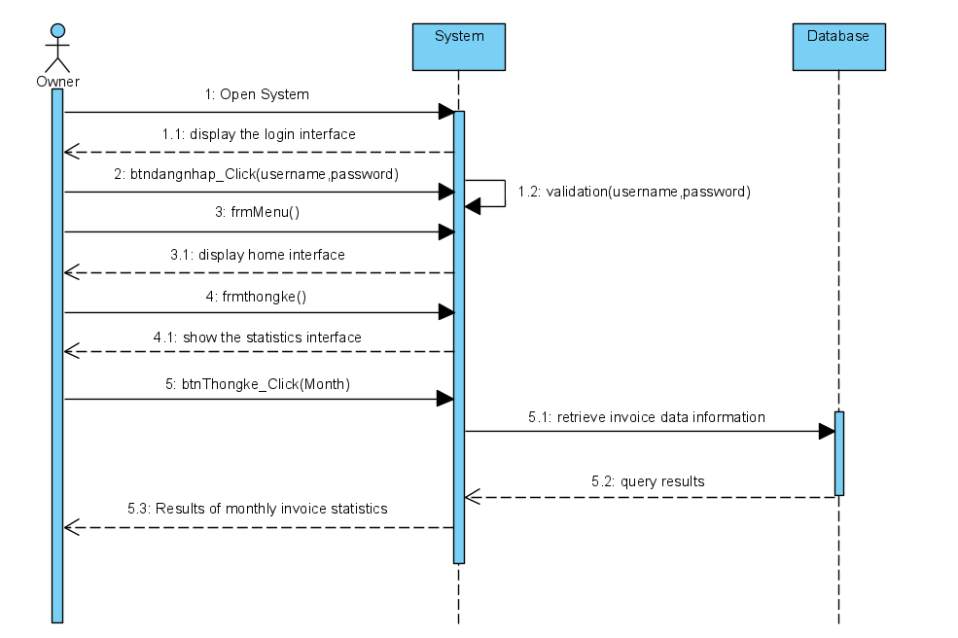

SEQUENCE DIAGRAM-STATISTICAL 10

**Product Management**

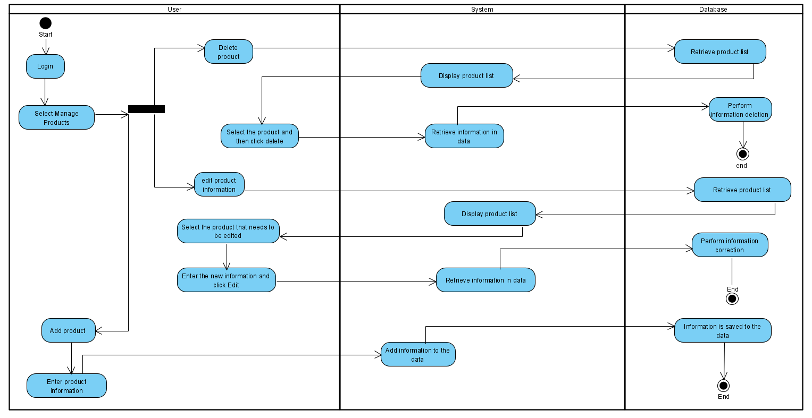

ACTIVITY DIAGRAM-PRODUCT MANAGEMENT 11

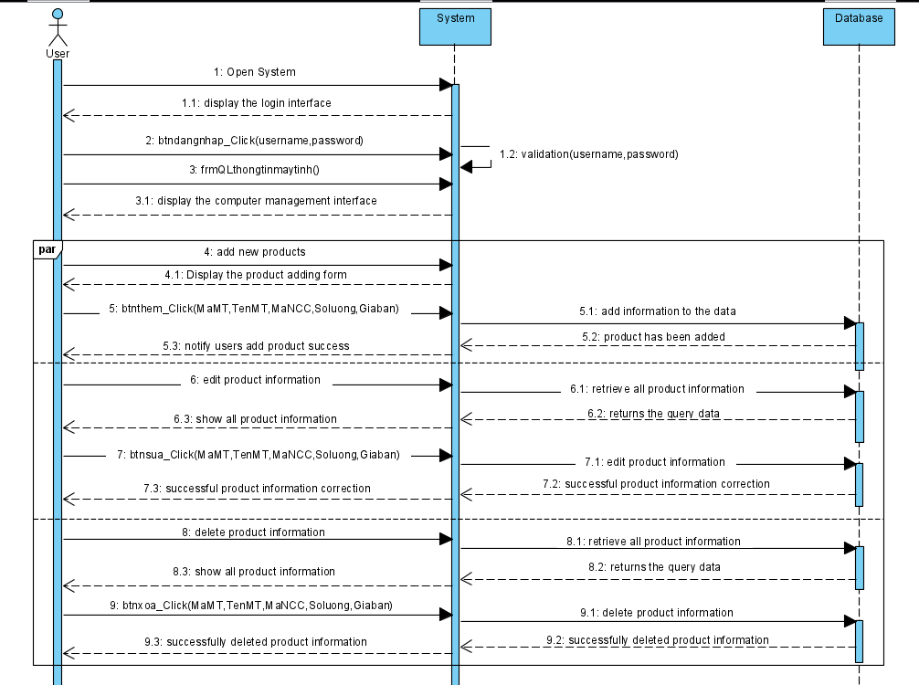

SEQUENCE DIAGRAM-PRODUCT MANAGEMENT 12

**3.3 Entity Relationship Diagram.**

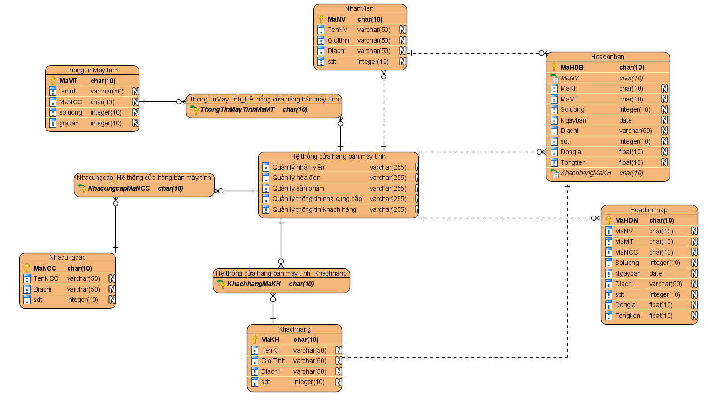

ENTITY RELATIONSHIP DIAGRAM 13

# CHAPTER 4 - REALIZE SOFTWARE.

## 4.1 Database

**Data diagram:**

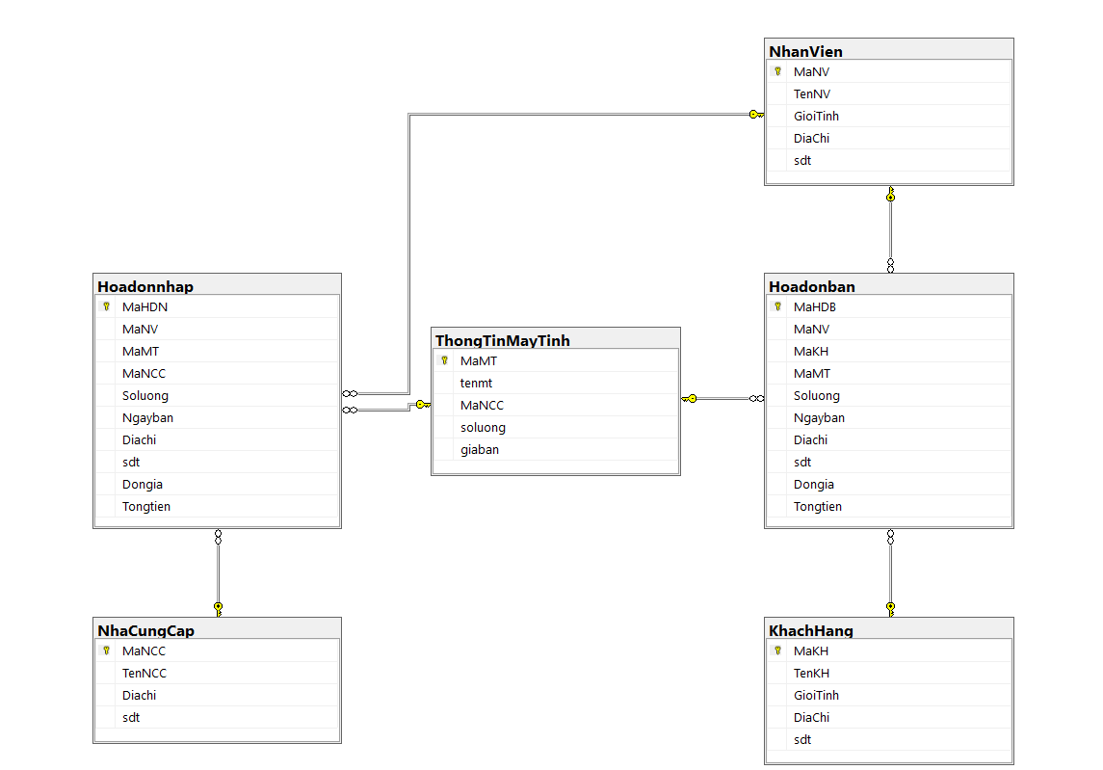

DATA DIAGRAM 14

**Details of the tables:**

TABLE ThongTinMayTinh

|  |  |  |  |  |
| --- | --- | --- | --- | --- |
| **STT** | **Tên thuộc tính** | **Kiểu dữ liệu** | **Kích thước** | **Ý nghĩa** |
| 1 | MaMT | Char(10) | 10 | Mã máy tính- khóa chính |
| 2 | TenMT | Varchar(50) | 50 | Tên máy tính |
| 3 | NCC | Char(10) | 10 | Mã nhà cung cấp |
| 4 | Soluong | Int |  | Số lượng |
| 5 | Giaban | Int |  | Giá bán |

### TABLE nhanvien

|  |  |  |  |  |
| --- | --- | --- | --- | --- |
| **STT** | **Tên thuộc tính** | **Kiểu dữ liệu** | **Kích thước** | **Ý nghĩa** |
| 1 | MaNV | Char(10) | 10 | Mã máy tính- khóa chính |
| 2 | TenNV | Varchar(50) | 50 | Tên nhân viên |
| 3 | Gioitinh | NVarchar(50) | 50 | Giới tính |
| 4 | Diachi | NVarchar(50) | 50 | Địa chỉ |
| 5 | sdt | int |  | Số điện thoại |

### TABLE hoadonban

|  |  |  |  |  |
| --- | --- | --- | --- | --- |
| **STT** | **Tên thuộc tính** | **Kiểu dữ liệu** | **Kích thước** | **Ý nghĩa** |
| 1 | MaHDB | Char(10) | 10 | Mã chủng loại – khóa chính |
| 2 | MaNV | Char(10) | 10 | Mã nhân viên |
| 3 | MaKH | Char(10) | 10 | Mã Khách hàng |
| 4 | MaMT | Char(10) | 10 | Mã máy tính |
| 5 | Soluong | Int |  | Số lượng |
| 6 | Ngayban | Date |  | Ngày bán |
| 7 | Diachi | Nvarchar(50) | 50 | Địra chi |
| 8 | sdt | Int |  | Số điện thoại |
| 10 | Dongia | Float |  | Giá bán |
| 11 | Tongtien | Float |  | Tổng tiền |

### TABLE hoadonnhap

|  |  |  |  |  |
| --- | --- | --- | --- | --- |
| **STT** | **Tên thuộc tính** | **Kiểu dữ liệu** | **Kích thước** | **Ý nghĩa** |
| 1 | MaHDN | Char(10) | 10 | Mã Hóa Đơn nhập – khóa chính |
| 2 | MaNV | Char(10) | 10 | Mã nhân viên |
| 3 | MaMT | Char(10) | 10 | Mã máy tính |
| 4 | MaNCC | Char(10) | 10 | Mã nhà cung cấp |
| 5 | Soluong | Int |  | Số lượng |
| 6 | Ngaynhap | Date |  | Ngày nhập |
| 7 | Diachi | Varchar(50) | 50 | Địa chỉ |
| 8 | Sdt | Int |  | Số điện thoại |
| 9 | Dongia | Float |  | Giá bán |
| 10 | Tongtien | Float |  | Tổng tiền |

### TABLE nhacungcap

|  |  |  |  |  |
| --- | --- | --- | --- | --- |
| **STT** | **Tên thuộc tính** | **Kiểu dữ liệu** | **Kích thước** | **Ý nghĩa** |
| 1 | MaNCC | Char(10) | 10 | Mã nhà cung cấp-khóa chính |
| 2 | TenNCC | Varchar(50) | 50 | Tên nhà cung cấp |
| 3 | Diachi | Nvarchar(50) | 50 | Địa chỉ |
| 4 | Sdt | Int |  | Số điện thoại |

### TABLE khachhang

|  |  |  |  |  |
| --- | --- | --- | --- | --- |
| **STT** | **Tên thuộc tính** | **Kiểu dữ liệu** | **Kích thước** | **Ý nghĩa** |
| 1 | MaKH | Char(10) | 10 | Mã khách hàng-khóa chính |
| 2 | TenKH | Varchar(50) | 50 | Tên khách hàng |
| 3 | Gioitinh | Nvarchar(50) | 50 | Giới tính |
| 4 | Diachi | Nvarchar(50) | 50 | Địa chỉ |
| 5 | Sdt | Int |  | Số điện thoại |

## 4.2. Interface design and manipulation.

**Form Đăng Nhập**

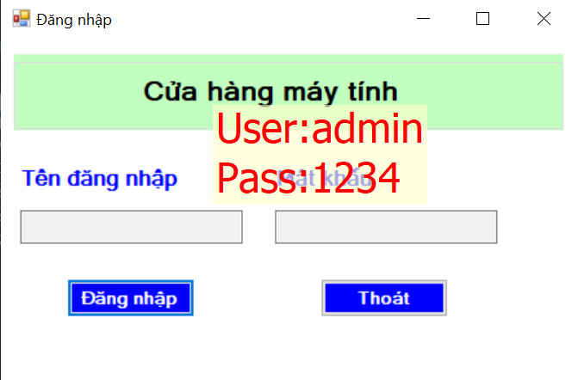

**Form Thông Tin Máy Tính**

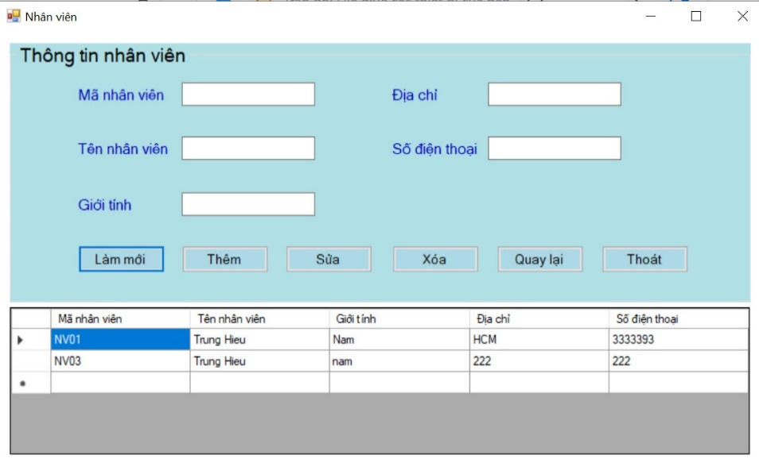

Form Thông Tin Máy Tính

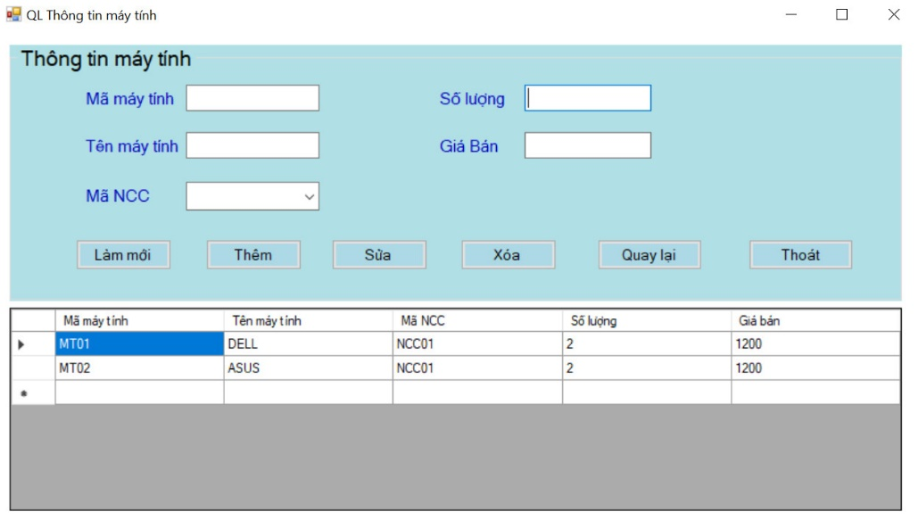

Form Thông Tin Nhân Viên

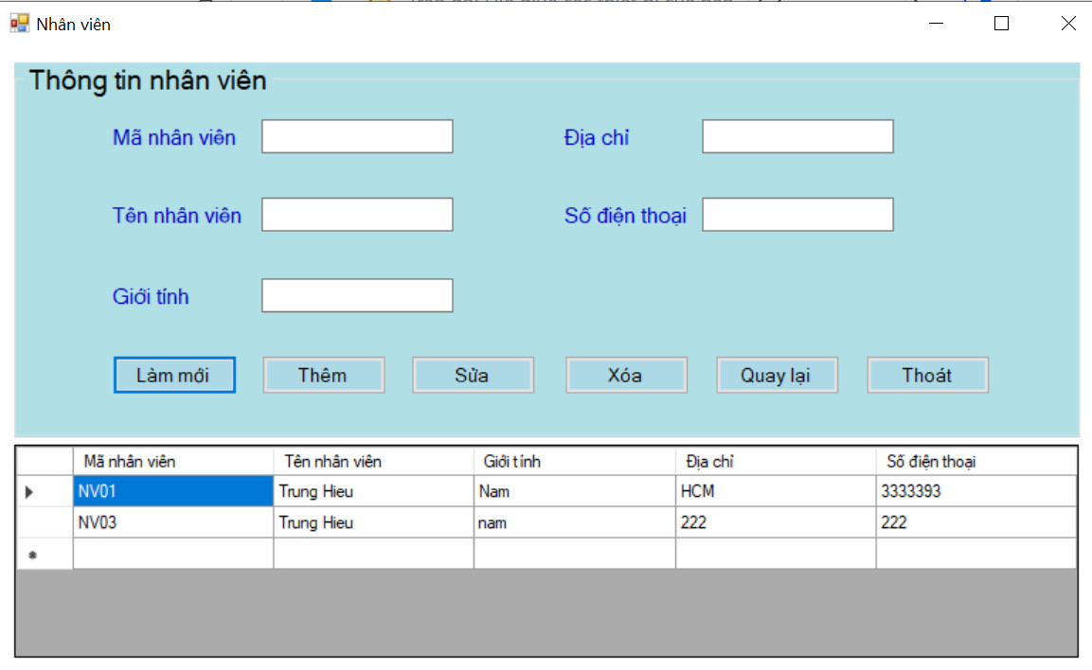

Form Thống Kê

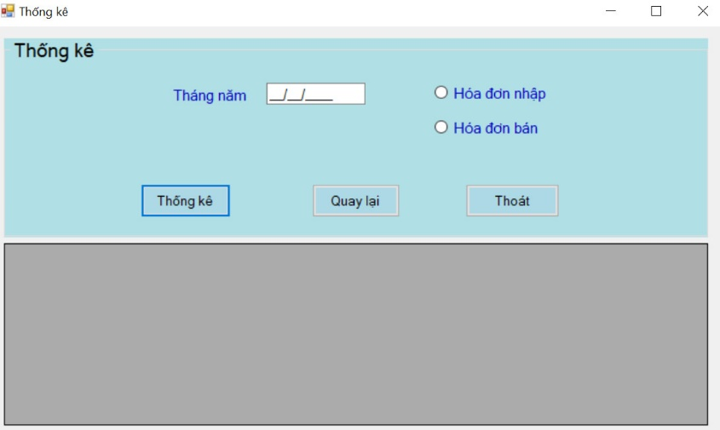

# CHAPTER 5 – TEST CASE

## 5.1 Alpha Test

1. Form “Sign In”: This is the main login interface of the application and users are required to log in to get into the system.

Case 1: Admin or Owner Sign In.

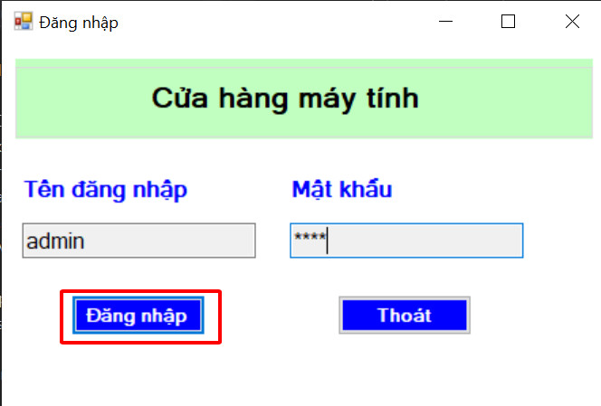

ALPHA TEST-LOGIN

* + - * After the admin inputs User and Password on the textbox, the admin needs to click the button “Đăng Nhập” to log in to the system.
      * Exam:

User: admin

Password: 1234.

Case 2: Do not have an account.

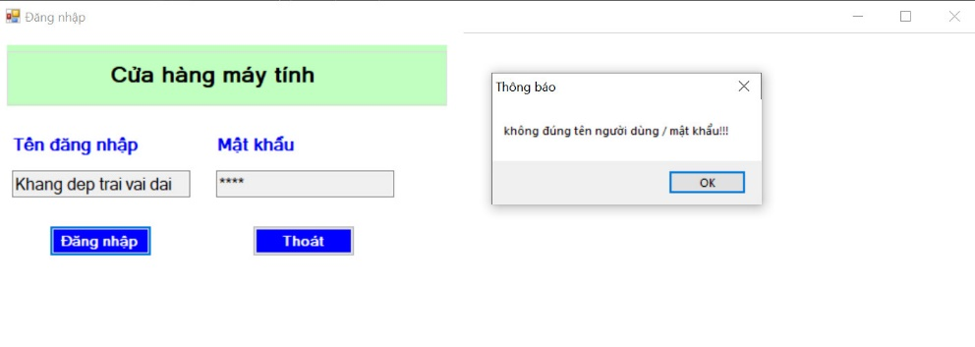

ALPHA TEST-LOGIN

* + - * Exam:

User: Khang Dep Trai

Password: 1234.

* The system will not allow users to login and require re-entry
* User selects "OK" to return to login page

1. Form “Menu”: This is a form for the customer service manager as well as Shop services.

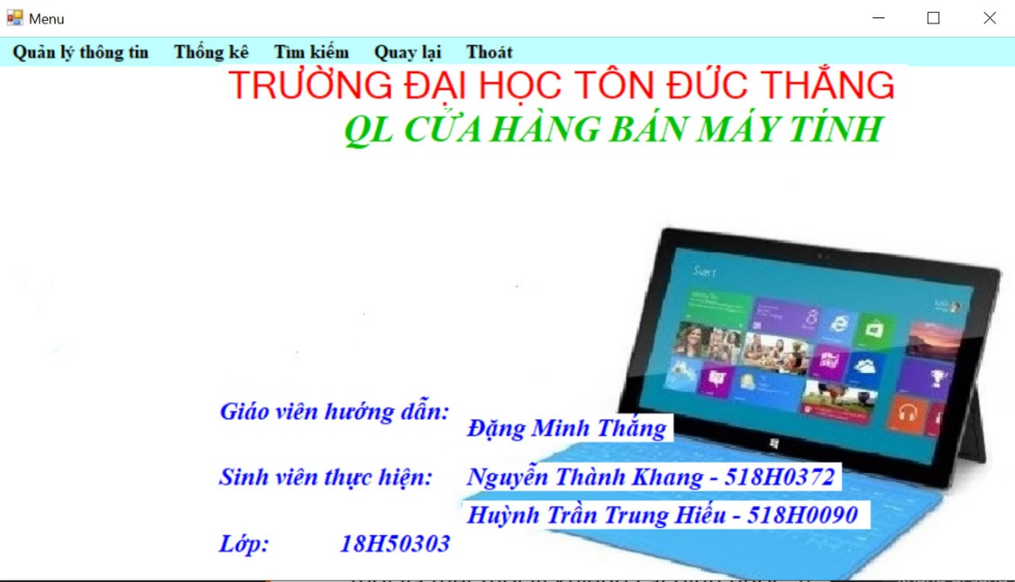

ALPHA TEST-MENU

* After logging in, employees can perform the following functions: Information management, Statistics, Report, Search, Back, Exit.

1. Form “QL Thông Tin Máy Tính”: This is a form for computer information management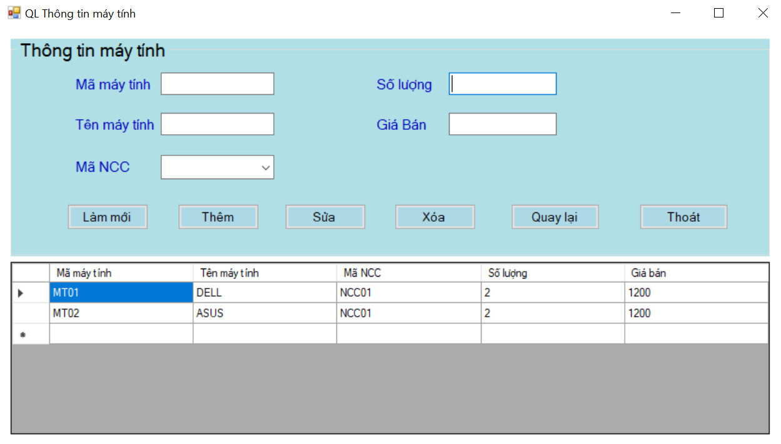

ALPHA TEST- Computer Information

* The user presses the "Làm mới" button to empty the input area
* User enter the information into blank and click to "Thêm" to add information into Database.
* The user selects the data he wants to edit and clicks the "Sửa" button to change the Database.
* The user selects the data he wants to delete and clicks the "Xóa" button to change the Database.
* The user presses the "Quay Lại" button to return to the Menu form
* The user presses the "Thoát" button to exit the program

Case: Computer Information in the database is displayed

Case 1: The user entered information does not exist in the Database:

* Information will be added to the database, updated to display information in the box below and empty the input box

Case 2: User information already exists in the database

* The error system is asking the user to re-enter

Case 3: Not enter full of box

* The error system is asking the user to re-enter

1. Form “Thông Tin Nhân Viên”: This is a form for managing employee information

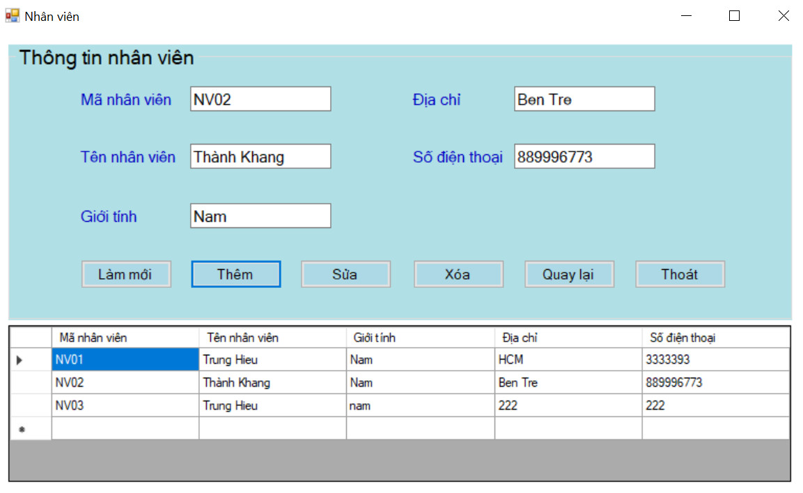

ALPHA TEST- Staff information

* The user presses the "Làm mới" button to empty the input area
* User enter the information into blank and click to "Thêm" to add information into Database.
* The user selects the data he wants to edit and clicks the "Sửa" button to change the Database.
* The user selects the data he wants to delete and clicks the "Xóa" button to change the Database.
* The user presses the "Quay Lại" button to return to the Menu form
* The user presses the "Thoát" button to exit the program

Case 0: Computer Information in the database is displayed

Case 1: The user entered information does not exist in the Database:

* Information will be added to the database, updated to display information in the box below and empty the input box

Case 2: User information already exists in the database

* The error system is asking the user to re-enter

Case 3: Not enter full of box

* The error system is asking the user to re-enter

1. Form “Hóa Đơn Nhập”: This is a form for managing your Invoice information

Case 1: Import bill:

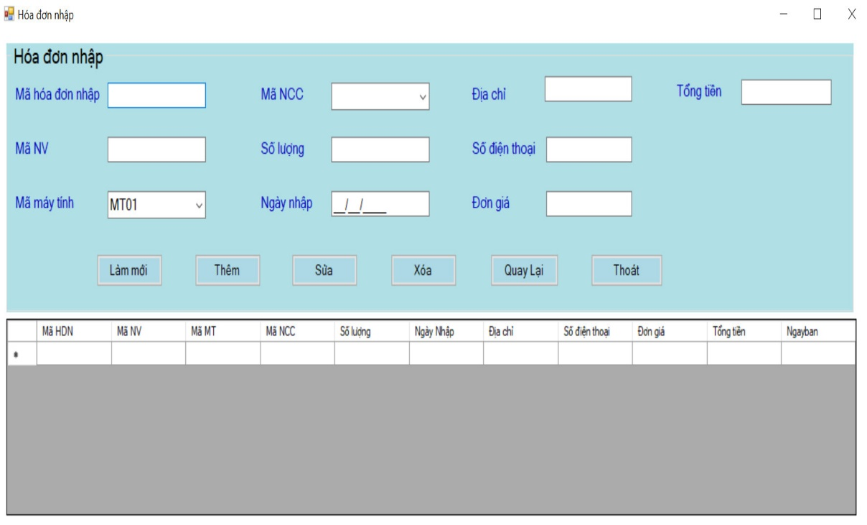

ALPHA TEST- Import bill 20

* When the user logs in to the Calculator Code, the Vendor Code will be retrieved, the total amount will be calculated by Quantity * Unit price.

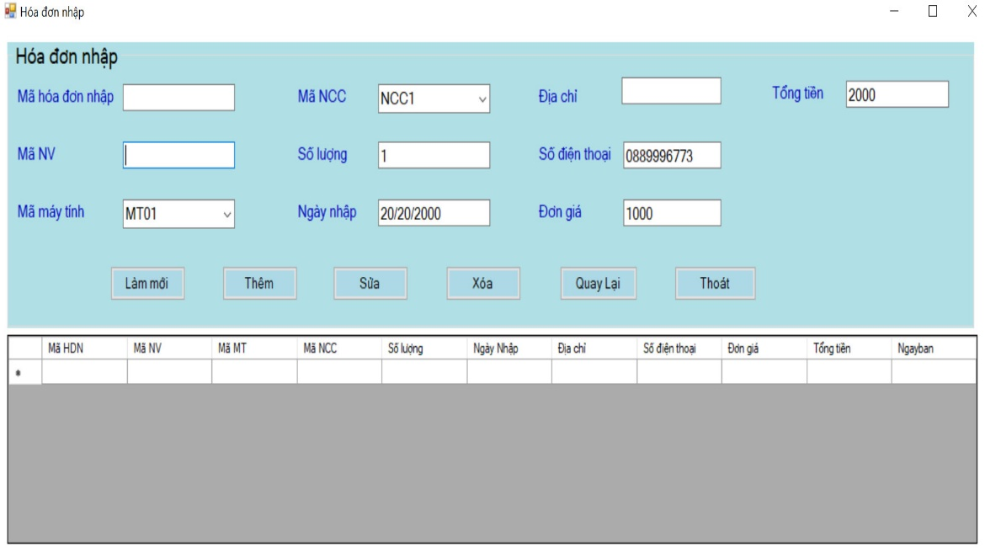

Example: (“001”,”NV001”,”MT01”,”NCC1”,”1”,”20/04/2000”,”BenTre”,”0889996773”,”1000”,”2000)

Case 2: Bill of Sale:

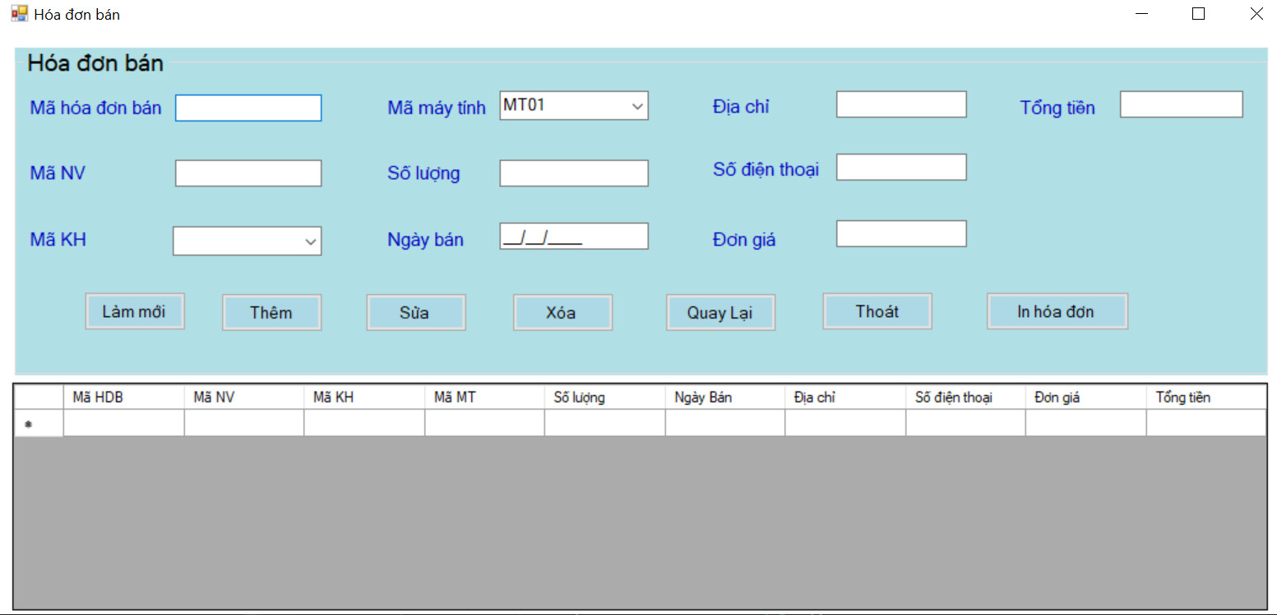

ALPHA TEST-BILL OF SALE

* The user presses the "Làm mới" button to empty the input area
* User enter the information into blank and click to "Thêm" to add information into Database.
* The user selects the data he wants to edit and clicks the "Sửa" button to change the Database.
* The user selects the data he wants to delete and clicks the "Xóa" button to change the Database.
* The user presses the "Quay Lại" button to return to the Menu form
* The user presses the "Thoát" button to exit the program

Example:

(“001”,”NV001”,”MT01”,”NCC1”,”1”,”20/04/2000”,”BenTre”,”0889996773”,”1000”,”2000)

1. Form “Thống Kê”: This is the Order Statistics form:

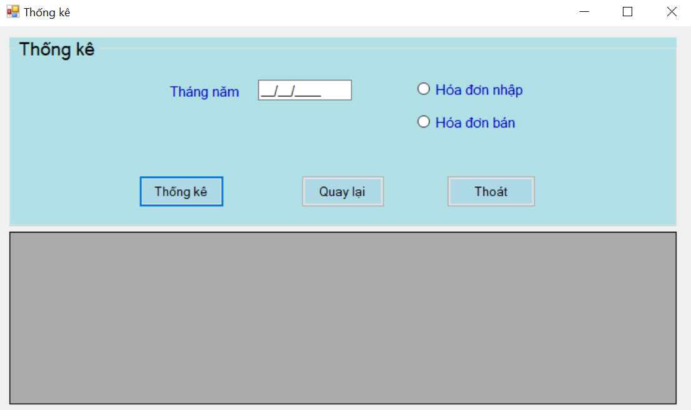

ALPHA TEST- Statistical

* The user selects the date and clicks the Statistics button to place an order at that time
* Example: 15/08/2015
* The user presses the "Quay Lại" button to return to the Menu form
* The user presses the "Thoát" button to exit the program

## 5.2 Unit Test:

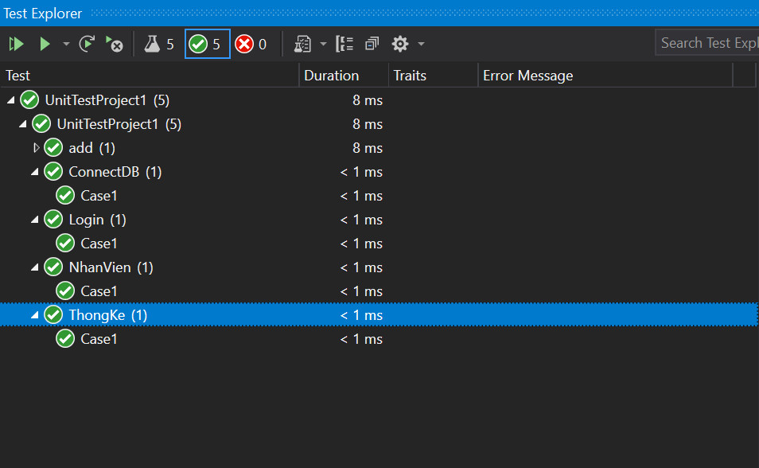

UNIT TEST RESULT

|  |  |  |  |  |  |
| --- | --- | --- | --- | --- | --- |
| **No** | TestCase | Input | Function | Output | Result |
| **1** | Login | (“admin”,”1234”) | DangNhap | T | Pass |
| **2** | Login | (“Khang Dep Trai”,”123”) | DangNhap | F | False |
| **3** | Add Form “Thông Tin Nhân Viên”: | (“NV01”,”Thanh Khang”,”BenTre”,”0889996773” | NhanVien | T | Pass |
| **4** | Add | (“NV01”,”Trung Hieu”,”BenTre”,”0889996773” | NhanVien | F | False |
| **5** | Delete | (“NV01”,”Thanh Khang”,”BenTre”,”0889996773”) | NhanVien | T | Pass |
| **6** | Delete | (“NV01”,”Thanh Khang”,”BenTre”,”0889996773”) | NhanVien | F | False |
| **7** | Logout |  | Menu | T | Pass |
| **8** | Return |  | Menu | T | Pass |
| **9** | Bill | 15/8/2015 | ThongKe | T | Pass |

## 5.3 SVN/GIT

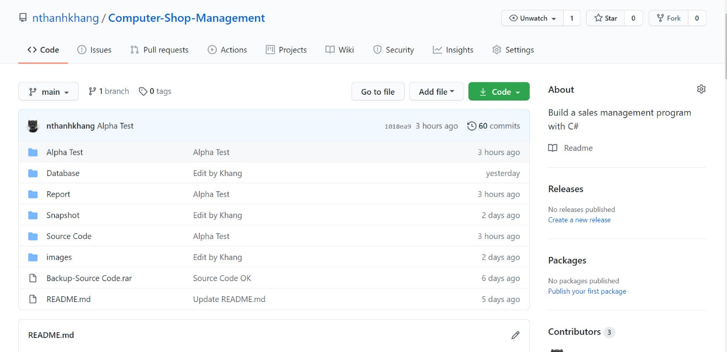

SVN/GIT

Demo: [Github](https://github.com/nthanhkhang/Computer-Shop-Management)

## 5.4.Hardware and software requirements:

### Technologies Used

* VB.Net as front end.
* SQL Server Edition as back end.

### Software Used

* Windows 10.
* Visual Studio 2019.
* Microsoft SQL Server.

# CHAPTER 6 – REFERENCES

Vietnamese

English

1. Sile Software Engineering.
2. [Report Exam](https://github.com/nthanhkhang/Computer-Shop-Management/blob/main/Report/report_sample.pdf)
3. [Computer Shop Management Software – Student Project Guidance & Development (studentprojectguide.com)](https://www.studentprojectguide.com/visual-basic-6-0/computer-shop-management-software/)