Full Stack Web Application Developer Test: User Documentation
1. Project Overview
This is a full-stack platform designed to bridge the gap between Corporate HR departments and Service Vendors. The application automates the event request lifecycle, from secure authentication to final approval.

2. Security & Authentication
The system implements industry-standard security protocols to ensure data privacy and authorized access.
2.1 Secure Login
- Password Encryption: User passwords are never stored in plain text. We utilize Bcrypt to hash passwords with a salt factor before they reach the database.
- Role-Based Access Control (RBAC): Upon login, users are identified as either HR or Vendor. This determines which dashboard and API routes they can access.
2.2 Session Management (JWT)
- JSON Web Tokens: After a successful login, the server issues a unique JWT.
- Stateless Authentication: This token is stored on the client-side (Local Storage) and sent in the header of every request. This ensures that only authenticated users can create or approve events.

3. HR User Guide: Requesting Services
3.1 Creating an Event
The Create Event module allows HR to submit a request.
- Smart Address Helper: Enter a Postal Code. The system automatically populates the Street Name, State, and Country from our global venue library.
- Categorization: Select a service type (Medical, Wellness, etc.). This ensures your request is only sent to qualified vendors.
3.2 Managing HR Dashboard
- Status Tracking: Monitor requests in real-time.
  - 🟡 Pending: Waiting for vendor response.
  - 🟢 Approved: Vendor has confirmed a date.
  - 🔴 Rejected: Vendor cannot fulfill the request.
- Editing: Updates are permitted only while the status is "Pending."

4. Vendor User Guide: Fulfillment & Scheduling
4.1 Managing Vendor dashboard
Vendors have a filtered view tailored to their specific expertise.
- Automatic Filtering: You will only see "New Requests" that match your specialty (e.g., Medical vendors only see Medical events).
- View Details: Access the HR company name, precise location, and the proposed date options.
4.2 Approval & Rejection
- Approval: Review the request, select one confirmed date, and click Approve. The event moves to your "My Schedule" tab.
- Rejection: If unavailable, click Reject and provide a reason. This moves the event to the "Archive" and notifies HR.

5. Technical Architecture
5.1 Database Schema (ER Diagram)
Our database uses a relational NoSQL approach with Mongoose:
- Users: Stores encrypted credentials and role-specific metadata.
- Events: The central transaction record linking HR, Vendors, and Event Types.
- VendorTypes: The source of truth for all service categories.
- Venue: Store data than can populate the venue

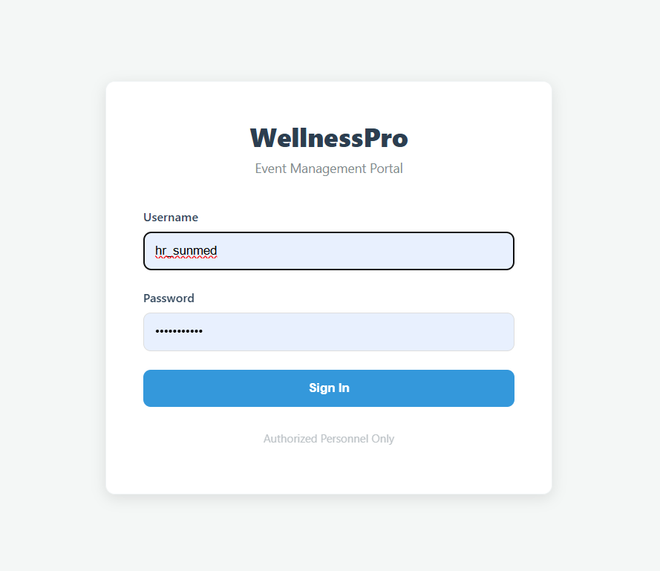
Photo above refers to 2.1
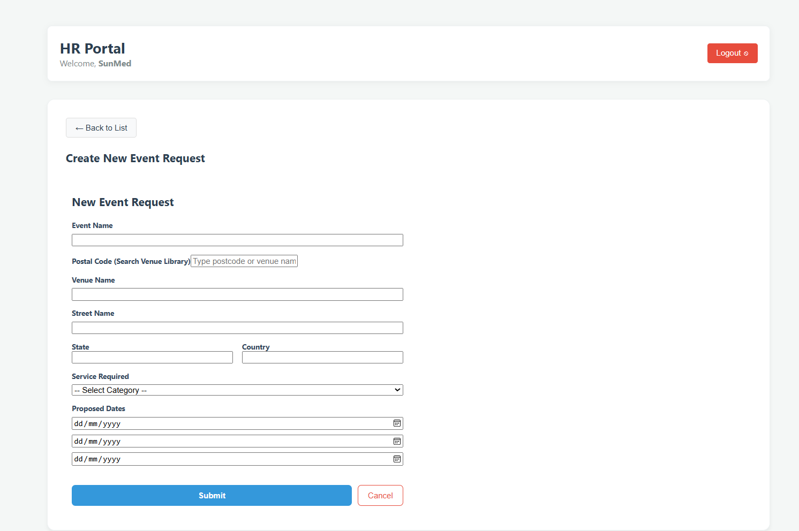
Photo above refer to 3.1
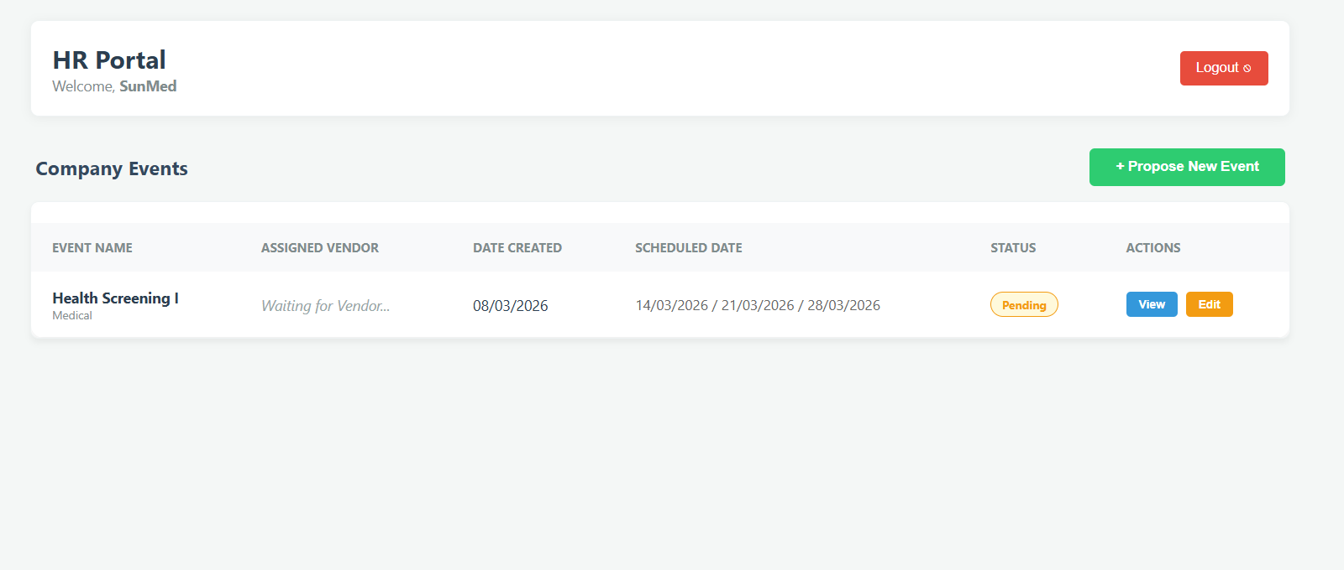
Photo above refer to 3.2

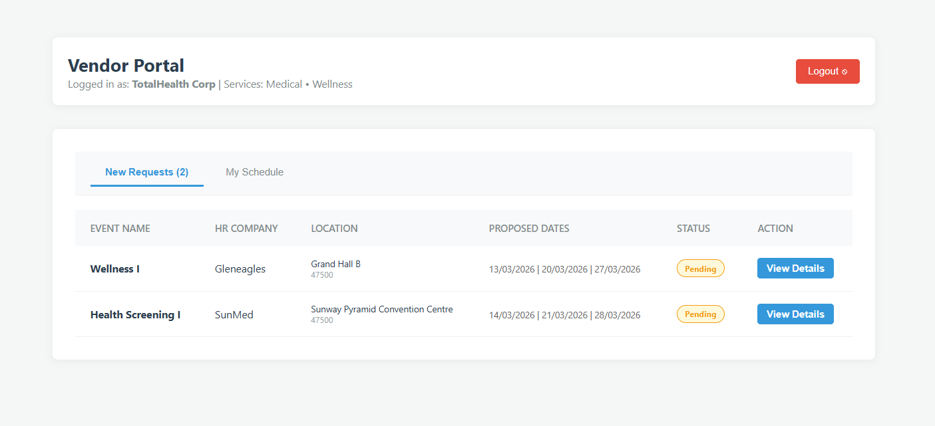
Photo above refers to 4.1

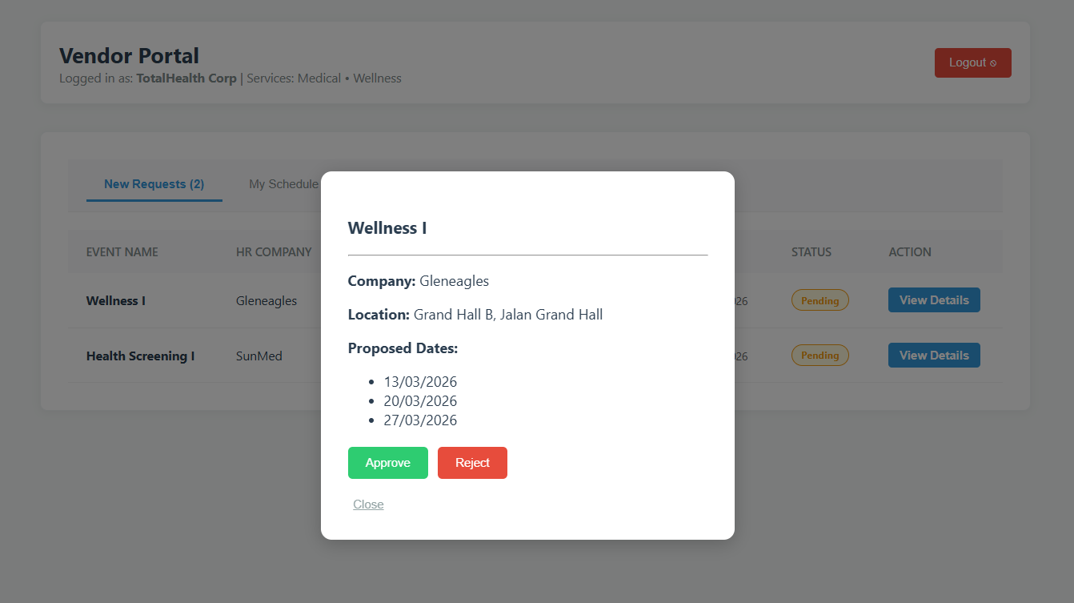
Photo above refers to 4.2
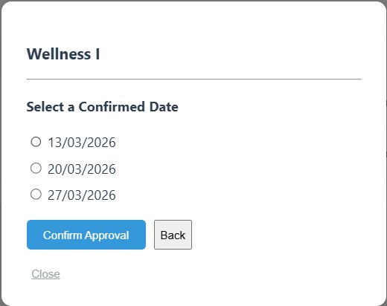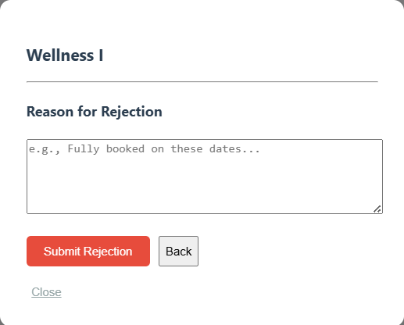

photo above refers to 4.2
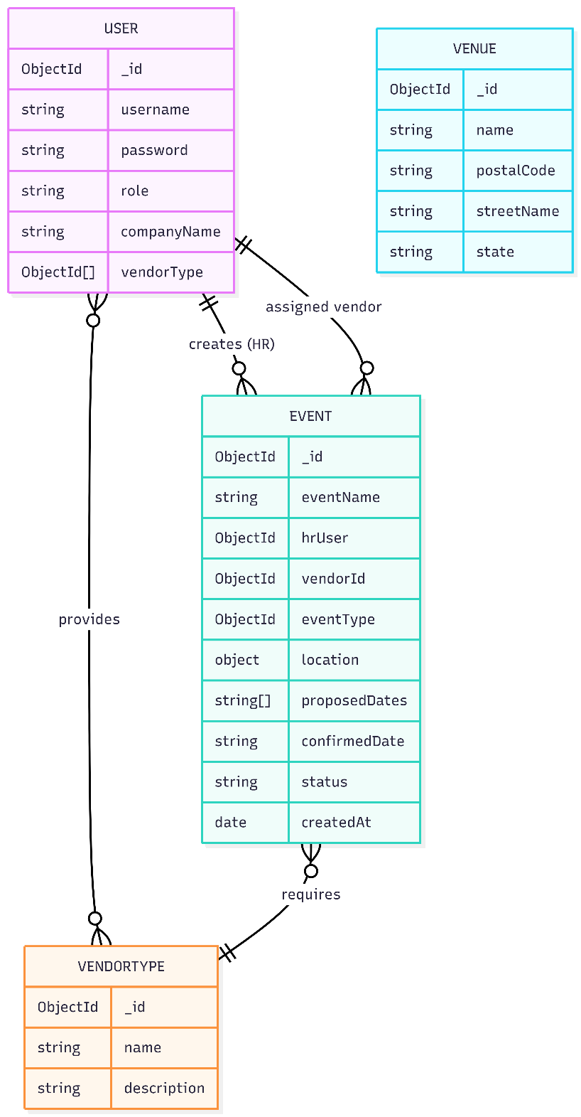
ER diagram

