**Title**: DNA-ploidy Oral Cancer Screening

**Materials and methods**

This is a single-center retrospective study approved by the University of British Columbia (H20-03982). All methods were performed in accordance with ethical standards and with the 1964 Helskinki declaration and its later amendments.

**Sample collection**. Patients who had abnormal lesions in the oral cavity and were followed up at our institution from Jan 2010 to November 2023 were retrospectively identified and reviewed. Patients who had oral brushing lesions collected at the time of initial biopsy or during post-surgery follow-up were included in the study. Brushing samples were collected using a targeted brushing technique directly over a suspicious clinical lesion with a curved interdental brush (Innovatek cytology brush). After 15-20 brushing strokes, the brush with the exfoliated cells was placed into a 1.5mL cryovial containing 1.5ml of preservative and stored at 4C. In addition, the control normal oral brushing samples were collected at the community clinics from January 2005 to January 2009.

**Clinical profiles**. Patient charts and pathology reports were reviewed for demographics, smoking history, clinic-pathological information, and outcome of 5-year progression survival. The pathological diagnosis of brushing is considered concurrent if taken from a biopsy within 6 months of brushing. Diagnosis are grouped into reactive (acanthosis, candiadiasis, follicle epithelial polyp, granuloma, hyperkeratosis, inflammation, lichenoid mucositis, lichen planus, papilloma, scar, or trauma), low-grade lesion (LGL; lichenoid dysplasia, mild dysplasia, moderate dysplasia, and verrucous hyperplasia), high-grade lesion ( Progression is defined as a diagnosis of D3/CIS/SCC occurring at least 6 months after a brushing of the same site among reactive or LGL samples.

**Image acquisition.** The oral brushing samples were aliquoted into 150ul and spun down onto charged glass slides using Cytospin4. To optimize the staining quality and minimize overcrowding of cells, each brushing sample was processed into 2 slides if cell density was greater than 7.5/ul.

**Statistical analysis.** The continuous variables were reported as mean and standard deviation or median and interquartile range, as appropriate. For categorical variables, frequencies and proportions were reported. The difference between DNA index between diagnostic groups was assessed via unpaired Wilcoxon signed-rank test. Survival analysis on progression-free survival was performed via Cox-proportional hazards models. Kapaln-Meier curves were plotted with log-rank tests to compare survival curves. The cutoff values of the proportion of abnormal ploidy cells was determined by threshold which gave the highest sensitivity and specificity based on receiver-operative characteristics curves. All statistical analyses were performed using R statistical software (v.4.2.2, R Foundation for Statistical Computing, Vienna Austria, <https://www.R-project.org>). Statistical significance was set at P < 0.05.

**Results**

Patient and brushing clinical profiles. A total of 506 patients were included which accounts for 779 oral brushing samples. The patient selection process is depicted in Figure 1. The baseline characteristics of the patient cohort is summarized in Table 1. The mean age was 62±13 years old with a little over half were males (288/506 (57%)), and approximately 1:1 ratio of ever-smokers and non-smokers.

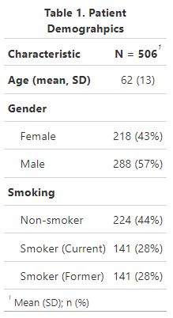

Of the 506 patients, 780 brushing samples were collected from 607 clinically positively (cP) abnormal lesion and 173 clinically negative or scar mucosal areas (cN). The samples were collected mainly from the tongue or floor of mouth (75%) follwed by buccal mucosa/gingiva/hard palate (22%) and soft palate complex (2.8%). Between the cN and cP groups, there was no difference in anatomical sites (p = 0.13). Besides the 95 normal controls, 425 samples had concurrent pathology diagnosis with 180 reactive or low-grade lesions and 245 high-grade or cancerous of which 50 appeared to be clinically negative (Table 2).

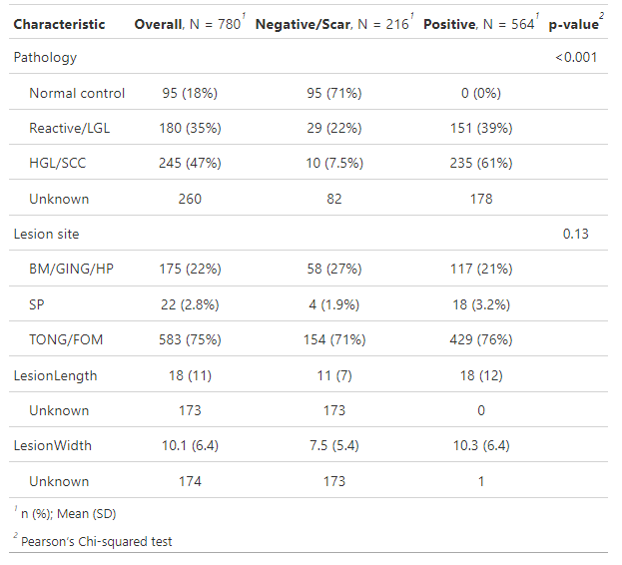

**Isolated epithelial cellularity**

To have meaningful cytology results, there needs to be sufficient isolated epithelial cellularity. While our protocol was optimized to ensure overcrowding of cells, cellularity can be affected by number of clinical reasons. As before mentioned, each brushing samples were processed to make two cytology slides to avoid overcrowding of cells. The number of isolated epithelial cells for each samples is summarized in Figure 1 by clinical appearance and pathological diagnosis. Overall, much more cells were collected from clinically negative/scar group (p < 0.001) and between pathological group comparisons (p < 0.001) with no association between cellularity and lesion size (Figure 1C)

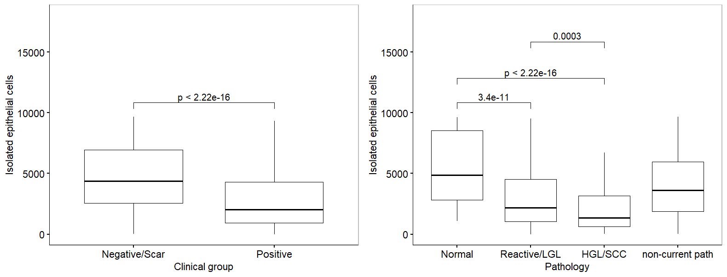

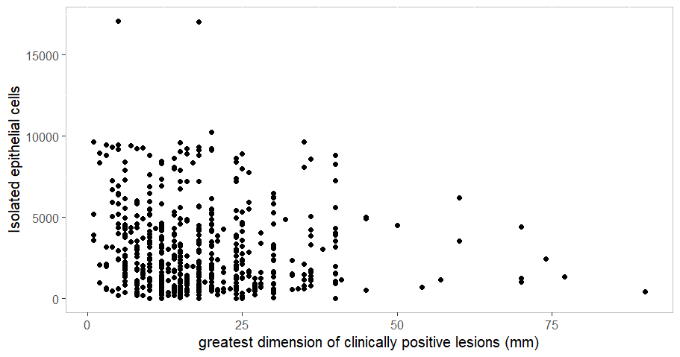

**Association of clinical variables with DNA-ploidy**

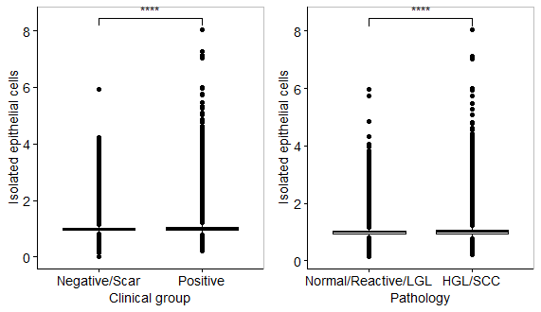

We observed higher DI in the clinically positive and pathologically HGL/SCC groups (1.00 vs 0.98; 1.00 vs 0.99). By grouping the isolated epithelial cells in bins of DI at interval of 0.05, we can described each sample in cell counts and proportion (Figure 2A and 2B) of each bin. In addition, DI is categorized into ploidy group based on the pre-determined cut-offs as per the previously published work (ref). On average, cP and pP groups had more cells in cycling, tetraploid and aneuploid groups and less cells in the diploid group (p < 0.001; Table 3a and 3b).

|  |  |  |  |  |
| --- | --- | --- | --- | --- |
| **Table 3. Average cell counts of each ploidy group** | | | | |
| mean (sd) | Negative / Scar (216) | Positive (563) | Normal/Reactive/LGL (275) | HGL/SCC (244) |
| Diploid | 4,417 (2,784) | 2,542 (2,394) | 3458 (2727) | 1854 (1906) |
| Cycling | 267 (361) | 338 (388) | 279 (378) | 285 (325) |
| Tetraploid | 11.3 (55.5) | 37.4 (92.4) | 18.8 (76.6) | 31.3 (72.4) |
| Aneuploid | 1 (3.86) | 5.45 (24.1) | 1.16 (4.52) | 5.32 (16.6) |

|  |  |  |  |  |
| --- | --- | --- | --- | --- |
| **Table 4. Average proportion of cells of each ploidy group** | | | | |
| mean (sd) | Negative / Scar (216) | Positive (563) | Normal/Reactive/LGL (275) | HGL/SCC (244) |
| %Diploid | 91.1 (12.1) | 83.5 (13.1) | 87.5 (11.4) | 82.2 (11.3) |
| %Cycling | 8.46 (11.7) | 14.4 (11.5) | 11.6 (13.5) | 15.3 (9.81) |
| %Tetraploid | 0.37 (1.41) | 1.84 (4.23) | 0.82 (2.67) | 2.14 (4.28) |
| %Aneuploid | 0.06 (0.29) | 0.27 (0.98) | 0.07 (0.28) | 0.35 (0.91) |

Figure x. Histogram of cell counts in bins of DI by clinical (a) and pathological (b) groups.

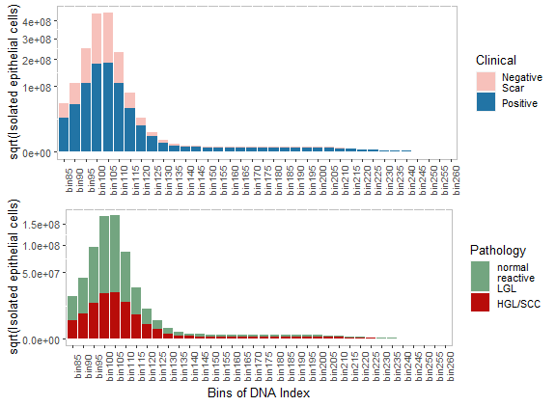

Figure x. Histogram of proportion of cells in each bins of DI by clinical (a) and pathological (b) groups.

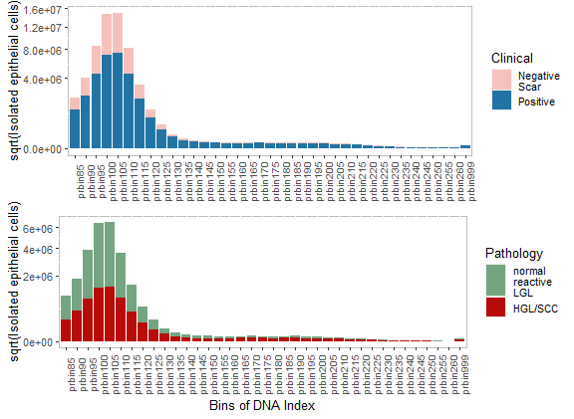

Figure x. Histogram of proportion of cells in each ploidy groups clinical (a) and pathological (b) groups.

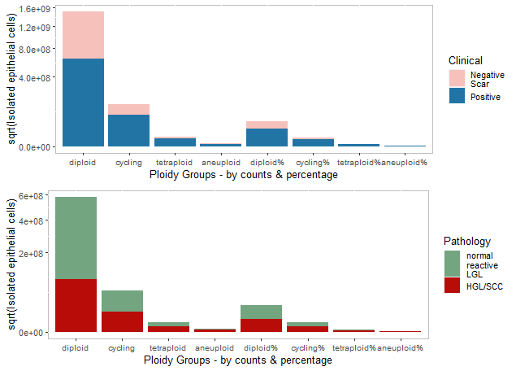

**Association of Ploidy with Pathology**

In order to investigate the association of ploidy with pathology and evaluate its potential as a screening tool, we performed logistic regression analysis of clinical and ploidy variables for the 520 brushings with concurrent pathology of normal/reactive/LGL vs positive (HGL/SCC).

**Screening algorithm with DNA ploidy for oral cancer – the DOC screening test**

To develop a screening strategy for any patients, with or without clinical lesions, we integrated previously develop quality assurance criteria and tested different algorithms that yield highest sensitivity. The DOC screening consists the following steps: 1) filtering out samples with 1 or more aneuploid cell, that is, cells DI ≥ 2.25, as positive; 2) filtering out samples with less than 400 isolated epithelial nuclei and flag them as unsatisfactory, 3) for the remaining samples (aneuploid-negative with at least 400 nuclei), we split them into 70% training and 30% test sets for linear discriminant and ROC analysis with input of ploidy varaibles against outcome of path-negative and path-positive.

ROC analysis showed that proportion of abnormal cells (abnormal_p) having the highest AUC with best 2-group threshold at 2.98 with sensitivity of 0.98 and specificity of 0.92. Applying the cut-off of 2.98 to the test set gave sensitivity of 1.0 and specificity of 0.93, while 1.0 sensitivity on the 9 unmatched validation set.

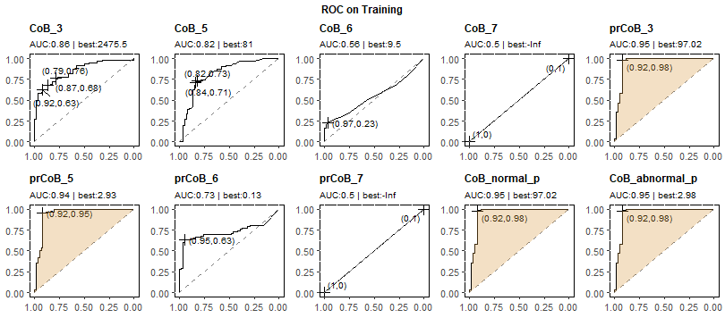

Given that there may be abnormal changes in reactive lesions or LGLs, we performed progression-free survival analysis with lesions categorized as low-risk or high-risk. Kaplan-Meier analysis showed that high-risk group had significantly poorer progression-free survival, and that low-risk group had no progression within 3 years. It is thus plausible that ploidy may reflect early changes in progressive lesions and routine monitoring needs to be incorporated in the management of reactive and LGL.

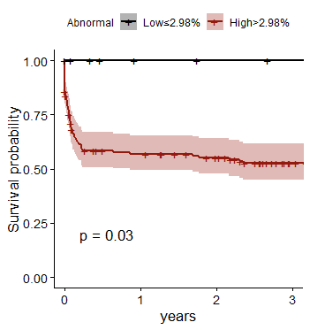

As a screening procedure with the potential false-positive and negative results. If the patient has any clinically suspicisous lesions, abnormal bleeding or other relevant symptoms, further evaluation is required, even if the screening test was normal.