**One-to-one biases in a non-linguistic and non-communicative domain: young children map novel animal vocalizations to unfamiliar animals**

When young children are presented with a novel object and one or more familiar objects as they hear a novel name (e.g. *Where’s the dax?*), they tend to select the novel object. This bias in referent selection, which we will call *disambiguation*, was first reported nearly 40 years ago (Carey & Bartlett, 1978; Vincent-Smith, Bricker, & Bricker, 1974), and it took foreground in the word learning literature since the publication of Markman’s *Categorization and Naming in Children* (Markman, 1991). This shift was motivated by the claim that vocabulary learning is a complex and challenging problem of induction, with an emphasis on how children figure out the referent of new words in underspecified contexts. The argument was that ambiguity in referent selection could only be solved because children came to the word-learning situation with assumptions about the nature of words and categories. The most debated of these assumptions was that the names of objects are mutually exclusive, meaning that a given object will have one and only one label. Research during the following decades aimed at pinpointing the origins, scope, and importance of this assumption, as well as children’s motivations during the process of referent selection (P Bloom, 2002; Clark, 1990a; Diesendruck & Markson, 2001; R. Golinkoff, C. Mervis, & K. Hirsh-Pasek, 1994; Landau, Smith, & Jones, 1988; MacWhinney, 1989; Mervis & Bertrand, 1994; Smith, 1999). In this paper, we revisit the debate on children’s motivations during disambiguation by using a looking-time paradigm to explore children’s referent-selection in a domain that is non-linguistic and non-communicative: the vocalizations that animals produce. [describe goals]

*Why do children select a novel object when hearing a novel label?*

The disambiguation effect has been consistently demonstrated in children two years and older (Golinkoff, Hirsh-Pasek, Bailey, & Wenger, 1992; Markman, 1991; Markman & Wachtel, 1988; Merriman & Bowman, 1989), with less robust effects beginning to emerge at younger ages (Byers Heinlein, 2010; Halberda, 2003). The main debate surrounding this bias in referent-selection focused on children’s motivations to select a novel object after hearing a novel label. According to lexical accounts, this bias was motivated by children’s expectation regarding the nature of words. The most influential of these accounts proposed that children approached word-learning situations with a Mutual Exclusivity (ME) constraint specifying that every object must have just one name (Markman, 1991; Markman & Wachtel, 1988; Markman, Wasow, & Hansen, 2003). Evidence for this constraint as a default assumption came from a series of different tasks, including children’s revision of the original name of an object after it was labeled with a novel name, and children’s resistance in assigning a second label to a familiar object (for a review, see Merriman & Bowman, 1989). Yet, most evidence for the ME constraint came from disambiguation tasks in which children hear a novel label in the presence of a novel object and one or more familiar objects with known names. According to the ME assumption, children are motivated to select the novel object because they reason that the novel label cannot refer to the familiar objects because they already have a name, and since objects cannot have two labels, the novel name should refer to the novel object. Another lexical account, the Novel-Name Nameless Category principle (N3C, R. M. Golinkoff, C. B. Mervis, & K. Hirsh-Pasek, 1994; Mervis & Bertrand, 1994), proposes that children are motivated to find a name for each object, contrasting to the ME prediction that children are motivated to reject a second label for a familiar object. These are important distinctions that result in the same behavior in the classic disambiguation task, but for the purpose of this paper we will be addressing both theories as *lexical accounts.*

While lexical accounts emphasize children’s expectations about the nature of words, pragmatic accounts emphasize children’s expectations about the people who use these words. According to Clark (Clark, 1990b), children are aware that speakers use conventional words to express conventional meanings, what she calls the principle of conventionality. Whenever a speaker is using a non-conventional word, it means that she is trying to convey a new meaning, what Clark calls the principle of contrast. In a disambiguation task, children reason that a novel word should refer to a novel object because the speaker would have use the conventional names if she meant to refer to the familiar objects. Since the speaker did not use the conventional forms and words contrast in meaning, she must have intended to refer to the novel object instead. This explanation for the disambiguation effect is particularly appealing to newer theories emphasizing the importance of children’s pragmatic knowledge and reading of intentionality in word learning (P Bloom, 2002; Tomasello, 2001).

Support for the pragmatic account comes mainly from tasks focusing on children’s referent-selection in situations involving novel and familiar facts. Diesendruck and Markson (2001) showed that 3-year-olds respond to the request for the referent of a novel fact similarly to how they respond to the request for the referent of a novel word. In specific, when children are told a fact about an object (e.g., “my sister gave this to me”), and are subsequently asked to pick an object described with a novel fact (e.g., “the one my dog likes to play with”), they tend to select a novel object as the referent for the novel fact. Presumably, children infer that if the experimenter wanted them to pick the object she was previously talking about (i.e., the one her sister gave her), she would have asked for that object using that mutually known fact. Since she did not, children inferred that she must have intended them to pick the object without a fact associated with it. In short, there are two main explanations for children’s motivations during referent selection in disambiguation tasks. The *lexical account* emphasizes children’s expectations about the nature of words, while the *pragmatic account* emphasizes children’s expectation about the intentions of speakers.

*Is the disambiguation effect domain-general or domain specific?*

In recent years, the debate about children’s motivation during disambiguation tasks turned into a debate about the domain generality or specificity of children’s biases. Despite referring to Mutual Exclusivity as a *lexical constraint*, Markman was agnostic about the domain specificity of this default assumption. She emphasizes that ME “might be either a language-specific constraint or a domain-general constraint” (Markman, 1991), that it could potentially be “the expression of a more general cognitive bias” (Markman & Abelev, 2004), and “one instantiation of a widespread attempt to find simple, regular relations between elements in a domain” (Markman, 1992). However, these same agnostic papers were subsequently cited as claiming that ME was a “domain specific mechanism specific to word leaning” (de Marchena, Eigsti, Worek, Ono, & Snedeker, 2011), or that it “predicts disambiguation only within the domain of word learning (i.e., it is domain-general)” (Scofield & Behrend, 2003).

A central issue in the field of language acquisition concerns whether learning mechanisms are specific or general in nature (P. Bloom & Markson, 2001; Fiser & Aslin, 2002; Peña, Bion, & Nespor, 2011; Saffran, Pollak, Seibel, & Shkolnik, 2007; Saffran & Thiessen, 2007; Waxman & Booth, 2000). Many parallels to one-to-one biases were pointed out by Markman (1992), including biases in the learning of morphology and syntax, classical conditioning, and attribution theory. Considering limited resources, one-to-one biases might reflect a general tendency to impose order in complex domains, favoring simple mappings and establishing order and predictability (Markman, 1992). More recent computational word suggests that one-to-one biases emerge from attempts to find regularity in domains in which consistent mappings are observed. In these approaches, the probability of a word receiving a second label decreases as it becomes more associated with a single referent, without the necessity of coding specific constraints to learning. This pattern of responding has been found in both Bayesian (Frank, Goodman, & Tenenbaum, 2009) and connectionist models of word learning (McMurray, Horst, & Samuelson, unpublished manuscript; Regier, 2003; Regier, et al., 2001). In McMurray et al. (unpublished) and Regier’s work (2003), disambiguation biases reflect the degree to which irrelevant associations between words and referents have been suppressed. In principle, the same models could be applied to another domain in which there are consistent mappings between two sets of stimuli.

Another domain general-approach is Halberda’s disjunctive syllogism (Halberda, 2003; Spiegel & Halberda, 2010). In this approach, children deduce the correct referent for novel words through a process of elimination of the form: A or B, not A, therefore B. Children reason that the novel name or fact in a disambiguation task refers either to the familiar or to the novel object, since it cannot refer to the familiar object, because it already has a name or fact associated to it, then it must refer to the novel object instead. Halberda emphasizes that this sort of computation is not restricted to word learning and can be implemented without the child being an explicit hypothesis-tester. More recent studies by Halberda demonstrated that one-to-one biases are also observed in the mapping of voices and faces (Moher, Feigenson, & Halberda). In this study, children learned the mapping between faces and voices after brief exposures, generalizing voices to novel tokens of the same person. Crucially, children selected a novel face when hearing a novel voice in the presence of both a face previously associated with a voice and a novel face. This finding demonstrated that toddlers have one-to-one biases that generalize not only to the mapping of words and facts to objects, but also to the mapping of voices to faces. However, this study was done with children with a mean age of 4 years and 9 months, in a domain that was both linguistic and communicative. It is therefore unclear whether similar biases would be present in younger children in a domain that does not involve linguistic input or communicative intent.

Support for the domain-specificity of the disambiguation effect comes from studies comparing the performance of different groups of children in their selection of referents for novel words and facts. These studies did not discarded the domain-general approaches, but showed that a pragmatic explanation might not be sufficient to explain children’s biases in referent selection. Preissler and Carey (Preissler & Carey, 2005) found that autistic children who are known to have impairments in their pragmatic inferences were successful in mapping novel words to novel referents. This finding was replicated by de Marchena et al. (de Marchena, et al., 2011) with the addition of the finding that autistic children are not successful in disambiguating novel facts despite their success in disambiguating novel words. One limitation of these studies is that the children investigated where nearly 8 years old, and spanning a broad range in the autism spectrum. In addition, de Marchena (2011) presented autistic children with novel facts, which might be inherently less interesting than names for autistic children. A similar dissociation between children’s disambiguation of words and facts was seen in a study by Scofield and Behrend (Scofield & Behrend, 2003). The main finding of this study was that two-and-a-half-year-olds showed disambiguation for words but a familiarity bias for facts. These studies suggest that children’s referent-selection biases might not be uniquely motivated by pragmatic inferences, but they do not reject a domain-general mechanism that attempts to find regularities in complex domains. Crucially, it is not clear whether the children who failed to select a novel object when hearing a novel fact would succeed in a task involving non-linguistic and non-communicative stimuli in which strong one-to-one mappings are observed.

Therefore, in this study we aim at testing children’s disambiguation biases in a domain in which strong one-to-one sound-to-object correspondences can be found, but with no linguistic or communicative information for children: the vocalizations that animals produce. Animal names and their onomatopoetic sounds are among the first words that children learn (cite CDI), and five-month-olds already succeed in matching some animal vocalizations and the animals that produce them (Vouloumanos, Druhen, Hauser, & Huizink, 2009).

*What do children know about the vocalizations that animals produce?*

Young children seem to easily create associations between non-linguistic sounds and novel objects, but at around 20 months of age, they only provide evidence of learning word-object linkages (A. Woodward & Hoyne, 1999; A. L. Woodward, Markman, & Fitzsimmons, 1994). Throughout this same period, in addition to restricting arbitrary associations to objects, children are also learning a series of non-arbitrary associations between sounds and objects. As pointed out by Nelson (Nelson, 1973), children’s learning about objects in their environment involves more than learning their names. Before object names are learned, sounds and actions might form the basis on which objects are conceptualized, and these cues can occasionally stand for the concepts they define (Nelson, 1973). As pointed out by Nelson, children might see barking as a defining feature of dogs, even before they learn the animal name.

The recognition of some animal vocalizations can be observed very early in development. Vouloumanos (Vouloumanos, et al., 2009) found that 5-month-olds match human speech to the face of humans and monkey calls to the faces of monkeys. In specific, they look longer at the face of the correct animal when hearing monkey calls or speech in the presence of the picture of a human face, a monkey face, and a duck face. However, infants failed to match duck vocalizations to ducks, and did not show evidence of finding the referent for the duck vocalization through disambiguation biases. These findings suggest that very young infants already have expectations regarding the kinds of vocalizations that animals are likely to produce. In another recent study, Ferry (ref) found that 6-month-olds can use speech and monkey calls to create categories for similar objects, but they are not able to create categories when the objects are paired with stimuli other than speech or animal vocalizations.

There are many reasons for animal vocalizations to have a special status for humans. The vocalizations that animals produce are species-specific and might provide information about animals and their groups, helping localize predators and prey, including those not immediately in sight (Fitch & Hauser, 1995). In addition, they are rich auditory signals that are meaningful, naturally occurring, and reflect animals’ emotional states (Seyfarth & Cheney, 2003). However, while words are arbitrary signals, vocalizations are causally connected to the animals that produced them and determined by the shape of their vocal tract.

Yet, little is known about how children appreciate the link between animals and the vocalizations they produce. The few studies looking at children’s recognition of the sounds that animals produce did not distinguish them from other environmental sounds (e.g., the sound of a piano or of a helicopter). For example, Cummings et al. compared how children ranging from 15 to 25 months of age recognized the links between objects and nonverbal environmental sounds with the link between objects and the linguistic description of these environmental sounds. Among their 20 environmental sounds, 7 were animal vocalizations. The main finding from this study was that performance on the recognition of the link between animals and their vocalization improved with age, and was indistinguishable from performance on the recognition of the description of the environmental sounds (e.g., dog barking, someone kissing, alarm click ringing). However, this study did not report separate analyses for the animal vocalizations, did not provide a name-only condition, and included many low-frequency descriptions that are not likely to be known by the infants (e.g., 15-month-olds were tested with phrases such as *grandfather clock chiming*, and were expected to look at a longcase clock). A similar paradigm was used with children with developmental language impairment, with children with language delay showing deficits in the processing of linguistic descriptions but not of environmental sounds (Cummings & Čeponienė, 2010).

Interestingly, children with autism spectrum disorders showed deficits in the processing of linguistic description but not in the processing of environmental sounds (McCleery, et al., 2010). This finding encourages us to look for one-to-one biases for animal vocalizations. If young children in our study show one-to-one biases for animal vocalizations, it opens the possibility that similar biases would be observed in autistic children, weakening the appeal of the domain-specific approaches.

Keeping these findings in mind, this study aims at answering two questions: The first question was whether children could appreciate the associations between familiar animals and their characteristic vocalizations. Specifically, we focused on children’s efficiency in recognizing links between animals and three types of auditory stimuli: the natural animal vocalization (e.g., dog barking), the lexicalized animal sound (e.g. *bow-wow*), and the animal name (e.g., *dog*). Animal vocalizations were included as a potential intermediate stimuli between the name of the animal and the vocalization that it produces, which has been suggested to potentially provide young children with intermodal associations, providing a basis to learn more arbitrary sound-object associations such as those between words and objects.

The second question was whether children showed one-to-one biases for the types of vocalizations that animals produce, similar to their biases in word learning. In specific, we aimed at exploring the domain-general account to the disambiguation effect, compared against the predictions of the lexical-specific and the pragmatic accounts. Lexical-specific accounts predict that one-to-one biases are unique to word learning, pragmatic accounts predict that they generalize to communicative acts more broadly, and domain-general accounts predict that they apply to any domain in which consistent one-to-one mappings are observed. To explore the hypothesis of these three accounts, this study investigated whether children show one-to-one biases in a domain that is non-linguistic and non-communicative for them, but in which strong regularities can be found: the vocalizations that animals produce.

We used a sensitive measure of word recognition that has been used in dozens of studies with young children, and was shown to have both concurrent and predictive validity (refs) and to be related to children’s linguistic experiences (ref). This same method has also been used in studies testing children’s disambiguation biases, with children ranging from 14 to 30 months of age, and it provides an efficient way to look at disambiguation biases without relying on children’s explicit choices and feedback from the experimenter.

**Experiment 1**

***Motivate experiment in detail.***

*Method*

*Participants.* Participants were 21 31-month-old children (*M*=31.8 months; range = 30.2-34.3), 10 girls. All were reported by parents to be typically developing and from families where English was the dominant language. Two participants were excluded due to fussiness.

*Visual stimuli.* The visual stimuli were pictures of four familiar animals (horse, dog, cow, sheep) and two novel animals (pangolin, tapir), each centered on a grey background in a 640 x 480 pixel space. The novel animals were real animals, selected because they were uncommon and unlikely to be familiar to the children in the study. All children were reported by parents to have had no exposure to either novel animal.

*Auditory stimuli.* The auditory stimuli consisted of auditory cues that were thought to be either Familiar or Novel to 30-month-olds. Familiar cues consisted of: a) *familiar animal names* (horse, dog, cow and sheep*,* b) *familiar* *lexical sounds* (neigh, woof-woof, moo and baa)*,* and c) *familiar natural animal vocalizations* (horse neighing, dog barking, cow mooing and sheep baaing). Novel cues consisted of: a) *novel animal names* (capa, nadu)and b) *novel natural animal vocalizations* (rhino grunting, gorilla snorting). Trials in which the target cue was an animal name or lexical sound began with a brief carrier frame and concluded with simple questions that served to introduce prosodic variability across trials (e.g., *Where’s the dog?/Which one goes woof? Can you find it?*). The duration of the target cue was 800 ms for lexical sounds and 750 ms for animal names, and the intensity of the phrases was normalized using Praat speech analysis software (Boersma, 2002). Trials with natural animal vocalizations began with a single word recorded by the same native speaker of American English, which served to draw children’s attention (e.g., *Look! “dog barking*”). Familiar animal vocalizations were selected based on representativeness of the familiar animal. Novel animal vocalizations were selected based on unfamiliarity and affordances (i.e., the plausibility that the novel animal could produce the novel sound). All children were reported by parents to have had no exposure to either novel animal’s natural vocalization. The duration of all target animal vocalizations was 2000 ms.

*Books.* To ensure that all children had at least some experience with the familiar animals and familiar auditory cues used in our study, we gave parents two children’s books, both titled *Sounds on the Farm,* at least a week before their visit*.* Parents were instructed to share each book with their child for five to ten minutes in the days leading up to the experiment. The first book was created by our lab and consisted of colorful pictures of each familiar animal and text designed to prompt parents to produce each animal’s lexical sound (e.g., *Wow, look at all those cows! This cow says moo, moo!*). To give children exposure to the natural animal vocalizations, we used a Hear and There BookTM book, which contained buttons that children could press to hear the actual noise that each animal produces.

*Procedure.* Speed and accuracy in identifying the correct target picture was assessed using the looking-while-listening (LWL) procedure (see Fernald, Zangl, Portillo, & Marchman, 2008). On each trial, a pair of pictures was presented on the screen for approximately 4 s, with the auditory stimuli starting after 2 s, followed by 1 s of silence.

Children were tested at two different visits. On the first visit, each child saw 27 trials, consisting of three different trial types (Figure 1). On 8 *Familiar Animal Name* trials, each familiar animal served as the target twice and was paired once with another familiar animal and once with a novel animal. On 8 *Familiar Lexical Sound* trials, each familiar animal served as the target two times and was always paired with another familiar animal. On 6 *Novel Animal Name* trials, each novel animal was labeled three times with a novel animal name (i.e., *capa, nadu*), always paired with a familiar animal. 5 *Filler* trials were interspersed throughout to add variety and maintain children’s attention. Pairings of the novel animal and name, and side of presentation of target object, were counterbalanced across participants. Caregivers wore darkened sunglasses so that they could not influence infants’ looking to the correct picture throughout the 5-min procedure.

On the second visit, children saw 29 trials, consisting of two different trial types (Figure 1). On 16 *Familiar Animal Vocalization* trials, each familiar animal served as the target four times and was paired with another familiar animal twice and each novel animal once. On 8 *Novel Animal Vocalization* trials, each novel animal vocalization served as the target four times and was paired with each familiar animal once. As in the first visit, 5 *Filler* trials were interspersed throughout to add variety and maintain children’s attention. Counterbalancing was the same as in the first visit.

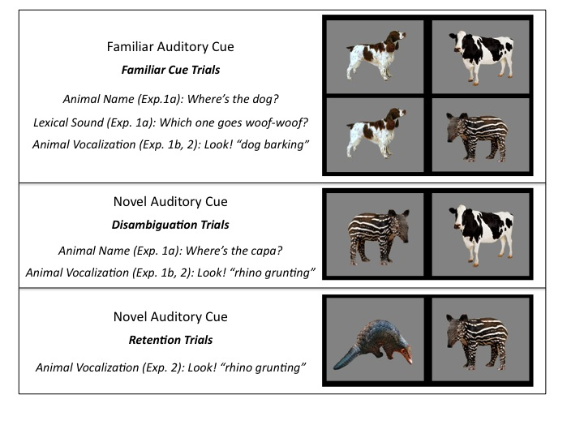

**Figure 1.** Trial types in Experiments 1 and 2 organized by type of cue: Familiar vs. Novel. The target animal for each trial type is on the left. Familiar cues consisted of: a) *familiar animal names* (horse, dog, cow and sheep)*,* b) *familiar* *lexical sounds* (neigh, woof-woof, moo and baa)*,* and c) *familiar natural animal vocalizations* (horse neighing, dog barking, cow mooing and sheep baaing). Novel cues consisted of: a) *novel animal names* (capa, nadu)and b) *novel natural animal vocalizations* (rhino grunting, gorilla snorting).

Participants’ eye movements were video-recorded and coded with a precision of 33 ms by observers who were blind to trial type. Inter- and intra-observer reliability checks were conducted for all coders. For 25% of the subjects, two measures of inter-observer reliability were assessed. The ﬁrst was the proportion of frames (33-ms units) on each trial on which two coders agreed. In this case, agreement was XX%. However, because this analysis included many frames on which the child was maintaining ﬁxation on one picture, we also calculated a more stringent test of reliability. This second measure focused only on shifts in gaze, ignoring steady-state ﬁxations in each trial on which agreement was inevitably high. By this more conservative measure, coders agreed within one frame on XX% of all shifts.

On those trials in which the infant was fixating a picture at the onset of the speech stimulus, accuracy was computed by dividing the time looking to the target object by the time looking to both target and distracter, from 300 to 4300 ms from the onset of the target word. Accuracy before 300 ms was not included because shifts to the target occurring in this window had presumably been initiated before the onset of the noun (Haith, Wentworth, & Canfield, 1993). This analyses window included the entire duration of the trial, and it was longer than that of studies with familiar words (Fernald et al., 1996) because of the longer duration of the animal vocalizations (2 s.) and because of the introduction of novel auditory cues. Analysis windows of up to 10 s. have been used in looking-time experiments with novel words (Mather and Plunkett, 2010). A single analyses window was used for all trial types for consistency, and the entire duration of the trial was used in order to avoid arbitrary decisions. Mean accuracy was then computed for each participant on each trial type.

Mean reaction time (RT) for each child was computed from trials when the child stared looking at the distracter image and shifted to the target picture within 300-1800 ms from target-cue onset. Because children vary in the likelihood they will by chance start out on the distracter on a given trial, mean RTs are based on different numbers of trials across participants.

*Results and Discussion:*

*Using familiar animal names, lexicalized sounds, and animal vocalization to identify familiar animals:*

Our first question is whether children can use associations between familiar animals and each of three different familiar auditory cues to identify the appropriate animal. Specifically, we evaluate and compare children’s efficiency in recognizing links between animals and their names (e.g., *dog*), their lexicalized sounds (e.g., *bow-wow*), and their natural vocalizations (e.g., *dog barking*).

*Accuracy measures:* Figure 1a presents children’s proportion looking to the familiar animal when hearing each of the three different familiar auditory cues, with looking time averaged over a window from 300 to 4300 ms after the onset of the cue. The three types of auditory cue were equally effective in guiding children’s attention to the target animal. Children looked to the correct animal when hearing the animal name (*M =* 0.62, *t* (18) = 3.57, *p* = 0.002), the lexicalized sound (*M =* 0.64, *t* (18) = 3.54, *p* = 0.002), and the animal vocalization (*M =* 0.64, *t* (18) = 5.90, *p* < 0.001), and performance was indistinguishable across the three conditions (*p* > 0.6). These results show that the animal vocalization can be as good a cue to identify familiar animals as their names or lexicalized sounds.

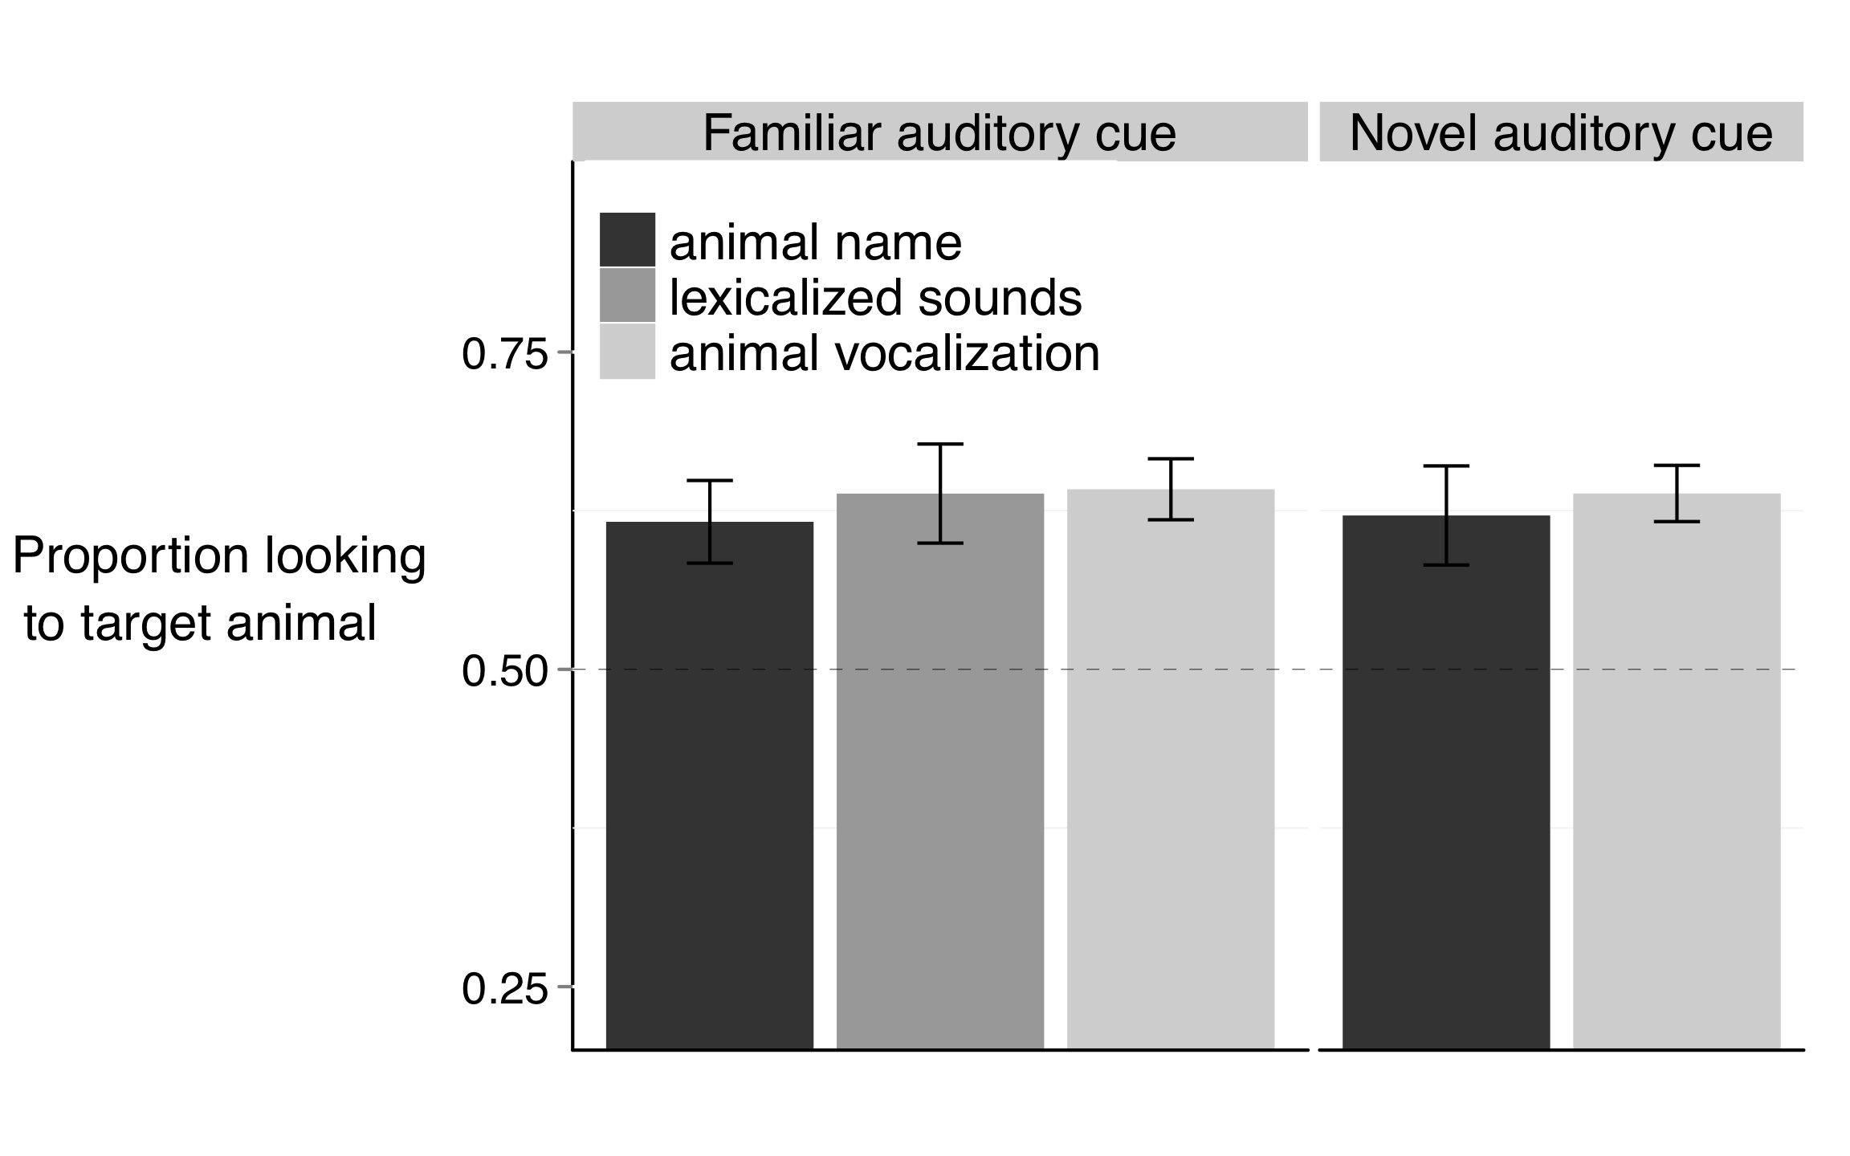

(1.a)

(1.b)

**Figure 1.** Accuracy of responses to familiar and novel auditory cues. 1.a. When hearing familiar animal names, lexicalized sounds, or animal vocalizations, children reliably looked to the target familiar animal. 1.b. When hearing novel animal names or animal vocalizations, children reliably looked at the novel animal. The different auditory cues were equally effective in guiding children’s attention to the target.

Are children who are better at using one of these cues also better at using the other cues to identify familiar animals? We found a relation between children’s efficiency in interpreting familiar animal names and lexicalized sounds (*r* (17) = 0.51, *p* = 0.023), but neither skill related to efficiency in interpreting familiar animal vocalizations (*p* > 0.2). Children who were more accurate in identifying animals based on their name were also more accurate in identifying them based on their lexicalized sounds. While knowledge about the animal name went hand in hand with knowledge about its lexicalized sound, success in recognizing these associations did not relate to success in recognizing the natural animal vocalization.

In short, three main findings emerged from these accuracy analyses: First, children successfully used familiar animal names, lexicalized sounds, and animal vocalizations to recognize familiar animals. Second, these three cues were equally effective in guiding children’s attention to the target animal. Third, children’s efficiency in interpreting familiar animal names related to their efficiency in interpreting familiar lexicalized animal sounds, but neither skill related to efficiency in interpreting familiar animal vocalizations.

*Reaction-time measures:* Figure 2a presents children’s speed in recognizing animals on the different trial types, showing that the animal name can be more rapidly exploited to identify animals than the lexicalized sound or animal vocalization. That is, children were faster to identify the target animal when hearing its name (*M* = 541ms), as compared to its vocalization (*M* = 840 ms, *t* (18) = 4.61, *p* < 0.001) or lexicalized sound (*M* = 801 ms, *t* (18) = 3.40, *p* = 0.002), with the last two conditions not differing from each other (*t* (18) = 0.47, *p* > 0.6).

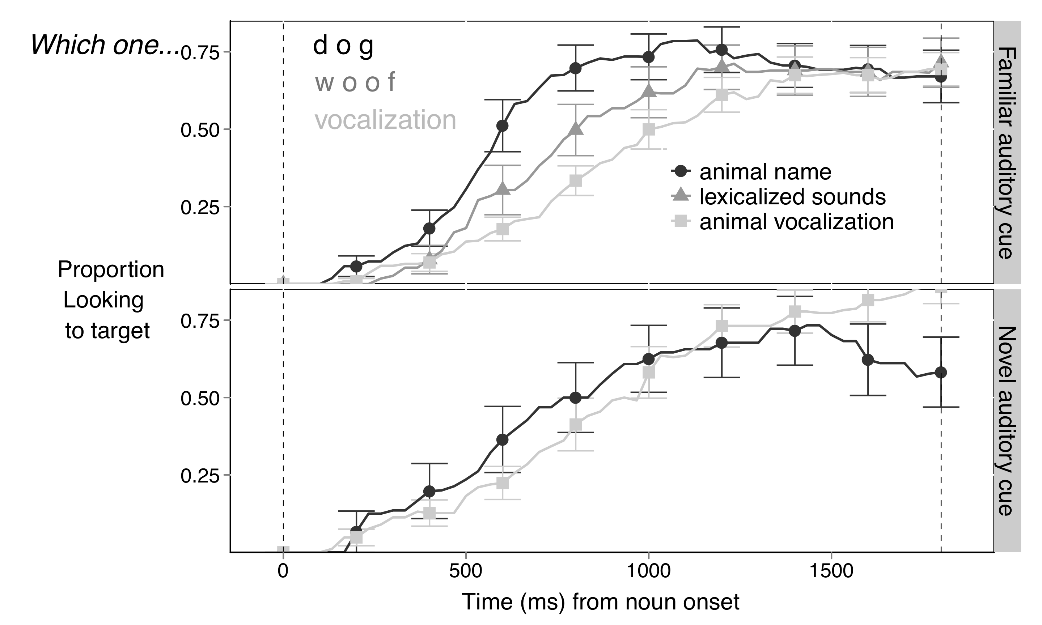

(2.b)

(2.a)

**Figure 2.** Time course of children’s looking to the target animal after hearing different familiar and novel auditory cues. The curves depict changes in the proportion of looking to the target animal as sounds unfolded, measured from sound onset (in milliseconds). When hearing a familiar auditory cue (2.a), children were faster to orient to the target animal after hearing its name, than when hearing the lexicalized sound or animal vocalization. Children were equally fast to orient to the novel animal after hearing a novel animal name or vocalization (2.b).

Are children who are faster at using one of these cues also faster at using the other cues to identify familiar objects? As previously found with accuracy, we found a relation between children’s RT to familiar animal names and lexicalized sounds (*t* (18) = 0.48, *p* < 0.05). Children who were faster to orient to the familiar animal after hearing a familiar animal name were also faster to orient to the animal after hearing a familiar lexicalized sound. Again, there was no relationship between responses to animal vocalizations and either animal names or lexicalized sounds (*p* > 0.2).

In short, two main findings emerged from these RT analyses: First, children were faster to orient to an animal after hearing its name, than after hearing a lexicalized sound or animal vocalization. Second, children’s speed in recognizing familiar animal names related to their speed in recognizing familiar lexicalized animal sounds, but neither skill related to speed in recognizing familiar animal vocalizations.

*Using novel animal names and animal vocalization to disambiguate novel animals*

Our second question is whether children would orient to a novel animal after hearing a novel animal name or vocalization. Specifically, we evaluate and compare children’s response to a novel animal name or animal vocalization in the presence of both a familiar and a novel animal.

*Accuracy measures:* Figure 1b shows children’s proportion of looking to the novel animal when hearing a novel animal name or a novel animal vocalization. Children reliably looked to the novel animal when hearing the novel animal name (*M* = 0.62) or novel animal vocalization (*M* = 0.63). Performance did not differ between these two conditions (*t* (18) = 0.38, *p >* 0.70). Therefore, children seem to have one-to-one biases for the vocalizations that animals produce already at 30 months of age, the earliest age at which the disambiguation effect has been observed in a domain other than word learning.

Are children who are better at using novel animal names also better at using novel animal vocalizations to disambiguate novel animals? For familiar cues, we had not found a relationship between responses to animal names and vocalizations. For novel cues, we again did not find a relation between children’s efficiency in interpreting novel animal names and novel animal vocalizations (*p* = 0.48).

In short, three main findings emerged from these accuracy analyses: First, children successfully disambiguated a novel animal name and novel animal vocalization. Second, these two novel unfamiliar cues were equally effective in guiding children’s attention to the novel animal. Third, children’s efficiency in interpreting novel animal vocalizations did not relate to their efficiency in interpreting novel animal names.

*Reaction-time measures:* As seen in Figure 2b, there was no difference in RT between children’ speed in recognizing the novel animal after hearing a novel animal name (*M =* 783 ms) or animal vocalization (*M =* 770 ms, *t* (18) = 0.08, *p* > 0.9).

Are children who are faster at interpreting novel animal names also faster at interpreting novel animal vocalizations to disambiguate novel animals? Again, there was no correlation between individual children’s RT to these two novel auditory cues (*p*  > 0.6).

In short, two main findings emerged from these RT analyses: First, there was no difference between RT to novel animal names and vocalizations. Second, there was no relationship between RT to novel animal names and vocalizations.

*Links between accuracy responses to familiar and novel auditory stimuli:*

Are children who are better at recognizing familiar animals after hearing a familiar cue also better at recognizing novel animals after hearing a novel cue? Figure 3 shows that success in these two tasks was indeed related; accuracy on trials with familiar auditory cues was correlated with accuracy on trials with novel auditory cues (*r*(36) = 0.5, *p* = 0.001). This relationship was present in children’s responses to familiar and novel animal names (*r*(17) = 0.54, *p* = 0.015) and in their responses to familiar and novel animal vocalizations (*r*(17) = 0.42, *p* = 0.077). RT to familiar and novel cues were not related (*p* > 0.34).

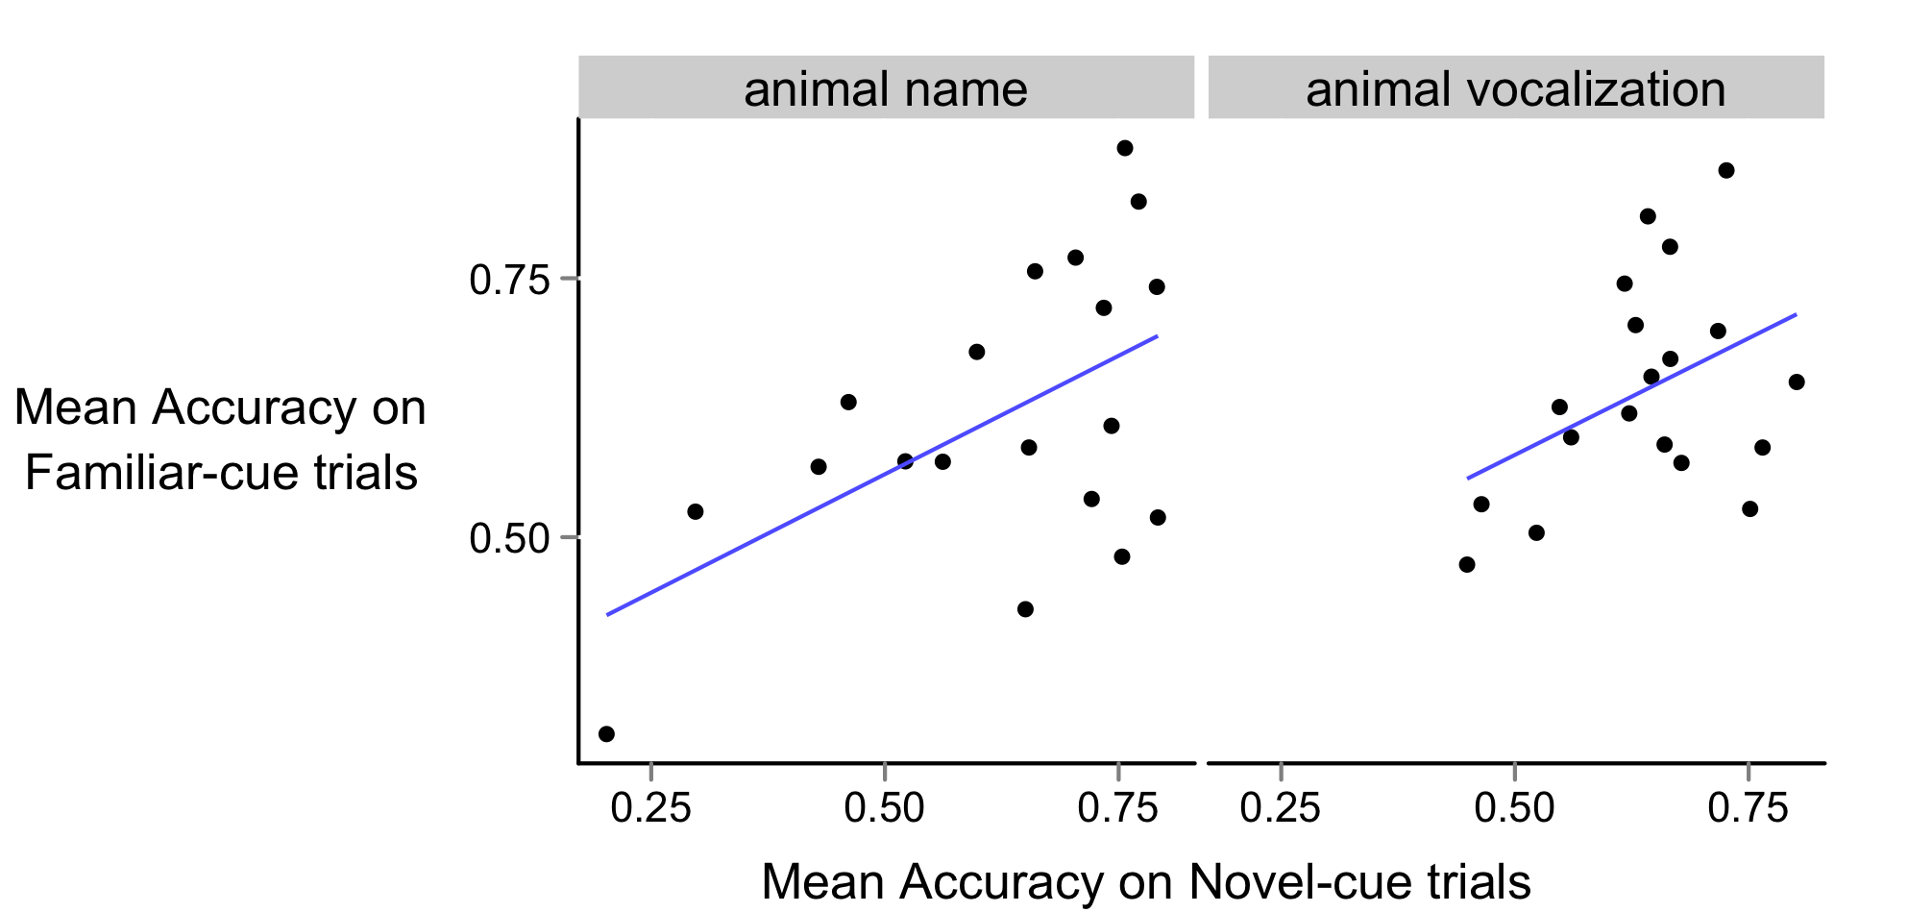

(3.b) *r* (17) = 0.42, *p* = 0.077

(3.a) *r* (17) = 0.54, *p* = 0.015

**Figure 3:** Relationship between children’s accuracy when hearing a novel and a familiar auditory cue, presented separately for trials with animal names and vocalizations. Children who were better at recognizing familiar animal names were better at disambiguating novel animal names. Children who were better at recognizing familiar animal vocalizations were better at disambiguating novel animal vocalizations.

Are children more efficient to interpret familiar or novel auditory cues? Children’s accuracy on trials with familiar auditory cues (*M =* 0.63, averaged across familiar animal names, lexicalized sounds, and vocalizations) did not differ from their accuracy on trials with novel auditory cues (*M =* 0.64, averaged across novel animal names and vocalization, *t* (18) = 0.26, *p* > 0.79). Children’s RT in trials with familiar (*M =* 775 ms) and novel cues did not differ either (*M =* 805 ms, *t* (18) = 0.35, *p* > 0.72).

Two main findings emerged from this analyses of the relation between familiar and novel auditory cues: First, children who were more accurate in interpreting familiar cues were also more accurate in interpreting novel cues. Second, children were equally efficient in interpreting familiar and novel auditory cues.

***Experiment 2***

**Motivate the importance of looking at retention.**

*Method*

*Participants.* Participants were 22 31-month-old children (*M*=31.1 months; range = 27.4-32.5), 12 girls. All were reported by parents to be typically developing and from families where English was the dominant language.

*Visual stimuli.* The visual stimuli were the same as in Experiment 1, except for the novel animals (aardvark and capybara), which replaced the novel animals (pangolin and tapir) used in Experiment 1. All children were reported by parents to have had little to no exposure to the novel animals.

*Auditory stimuli.* The auditory stimuli consisted of only the natural animal vocalizations and they were the same as in Experiment 1.

*Books.* As in Experiment 1, we sent home a children’s book to ensure that all participants had at least some exposure to the familiar animals and auditory cues. Since, in Experiment 2, we were interested in the natural animal vocalizations and not the names/lexical sounds, only the Hear and ThereTM *Sounds on the Farm* book was used. Instructions given to the parents were the same as in Experiment 1, and the book was sent home a week before the visit.

*Procedure.* Experiment 2 consisted of one visit. Each child saw 35 trials, consisting of three trial types (Figure 1). The 16 *Familiar Animal Vocalization* trials and 8 *Novel Animal Vocalization* trials were identical in structure to Experiment 1. In addition, on 6 *Retention* trials, the two novel animals were presented side by side, with each serving as the target three times. The same coding and speed/accuracy measures were used as in Experiment 1.

*Results and Discussion:*

*Retention of the link between a novel animal and a novel vocalization:*

While Experiment 1 focused on children’s responses to familiar and novel animal names, lexicalized animal sounds, and animal vocalizations, Experiment 2 focused exclusively on responses to familiar and novel animal vocalizations.

This experiment aimed at replicating and expanding on three findings from Experiment 1: First, children identified familiar animals based on the vocalizations they produce. Second, children used novel vocalizations to disambiguate novel animals. Third, children who were better at identifying familiar animals were better at disambiguating novel animals. In addition, we also ask whether children can retain the link created through disambiguation between a novel animal and a novel animal vocalization.

*Accuracy measures:* Figure 4 presents children’s proportion looking to the target animal after hearing a familiar or a novel animal vocalization over a window from 300 to 4300 ms after the onset of the vocalization. When children heard a familiar animal vocalization, they oriented to the target familiar animal (*M =* 0.62, *t* (21) = 5.47, *p* < 0.001). When children heard a novel animal vocalization, they looked at a novel animal instead (*M =* 0.63, *t* (21) = 3.76, *p* = 0.001). In addition, children who were more efficient in identifying a familiar animal after hearing a familiar animal vocalization were also more efficient in disambiguating a novel animal after hearing a novel animal vocalization (*r* (20) = 0.59, *p* = 0.003). These results replicate three main findings from Experiment 1.

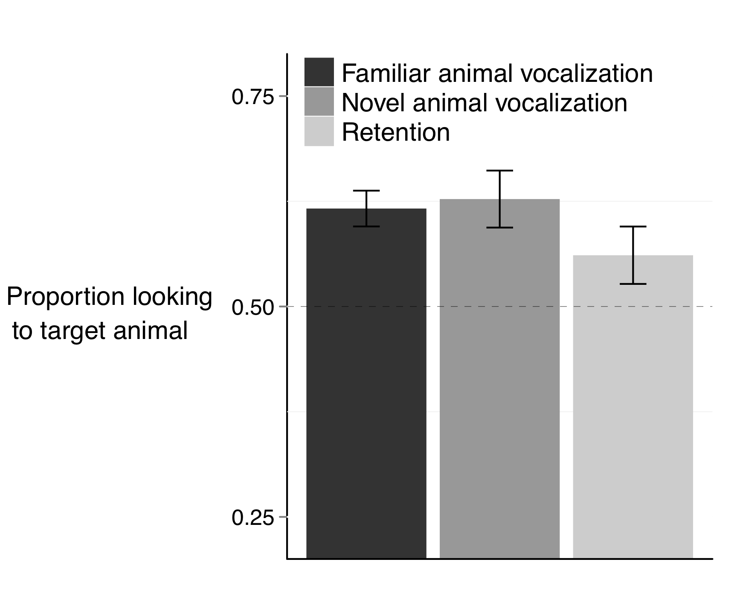

**Figure 1.** Accuracy of responses to familiar and novel animal vocalizations. Children reliably looked to the target animal after hearing a familiar animal vocalization and a novel animal vocalization. Children were marginally successful in retaining the map between a novel animal and a novel vocalization. Performance was indistinguishable across the three conditions.

Can children remember the association between the novel animal and the novel vocalization, when this association is created through a disambiguation strategy? In order to test this hypothesis, two novel animals were paired with each other, as children heard the animal vocalization previously associated with one of the two animals.

Children remembered the link between the novel animal and the novel vocalization (Figure 4, *M =* 0.56, *t* (21) = 1.79, *p* = 0.089). This trend is supported by the fact that performance on retention trials was marginally above chance, and was indistinguishable from performance on trials in which children had to identify a familiar animal (*t* (21) = 1.38, *p* = 0.177) or disambiguate a novel animal (*t* (21) = 1.39, *p* = 0.176).

Are children who are better at interpreting novel animal vocalizations in disambiguation trials also better at remembering the animal vocalizations in retention trials? Children who were more efficient at disambiguating the novel animal when hearing the novel animal vocalization spent more time looking at the correct animal on subsequent retention trials (*r* (20) = 0.38, *p* = 0.087). Again, this effect is marginally significant. There was no correlation between retention skills and recognition of familiar animals (*p* > 0.6).

Five findings emerged from this analyses of accuracy, the first three replicating findings from Experiment 1: First, children oriented to a familiar animal after hearing a familiar animal vocalization. Second, children oriented to a novel animal after hearing a novel animal vocalization. Third, these two skills were related. Fourth, children were marginally successful in retaining the link between a novel animal vocalization and a novel animal. Fifth, there was a marginal relationship between children’s efficiency in disambiguating novel animal vocalization and subsequently remembering these mappings.

*RT measures:* Reaction time measures were indistinguishable between the three experimental conditions in this experiment. Children were equally fast to orient to a familiar animal after hearing a familiar animal vocalization (*M =* 730 ms), to orient to a novel animal after hearing a novel animal vocalization (*M =* 809 ms), and on retention trials to orient to the novel animal previously paired with a novel animal vocalization (*M* = 824 ms, all *p* > 0.25).

As found in Experiment 1, children’s speed to orient to a familiar animal after hearing a familiar vocalization was correlated to their speed to orient to a novel animal after hearing a novel vocalization (*r* (20) = 0.46, *p* = 0.047). There was no relationship between RT on Disambiguation and Retention trials (*p =* 0.29).

In short, two main findings emerged from these RT analyses: First, children were equally fast to orient to the target animal after hearing a familiar or novel vocalization. Second, children’s speed in recognizing familiar animal vocalizations related to their speed in recognizing familiar animal vocalizationss. These two findings replicate paralel findings in Experiment 1. The third finding was that there was no relationship between speed to respond to novel vocalizations in Disambiguation and Retention trials.

ADDITIONAL GRAPHS THAT I RATHER NOT INCLUDE:

PP for ANIMOO

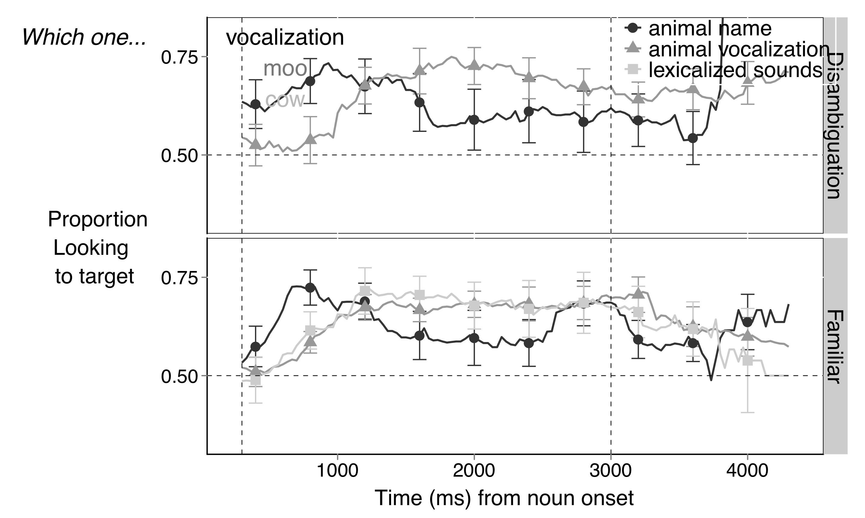

PP for ANIME

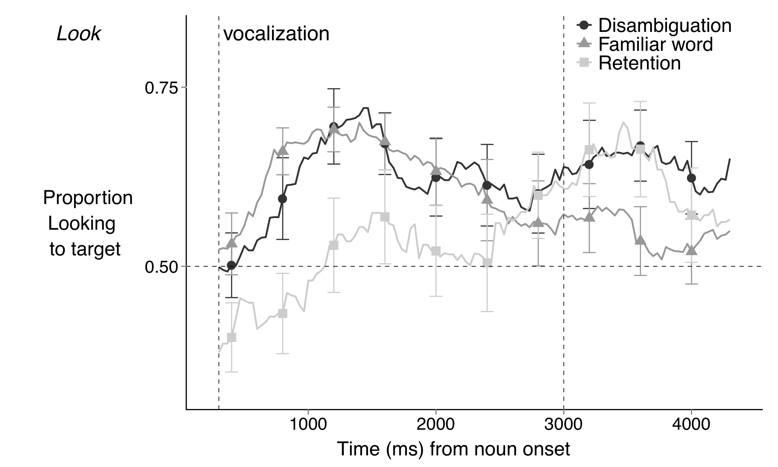

OC for ANIME

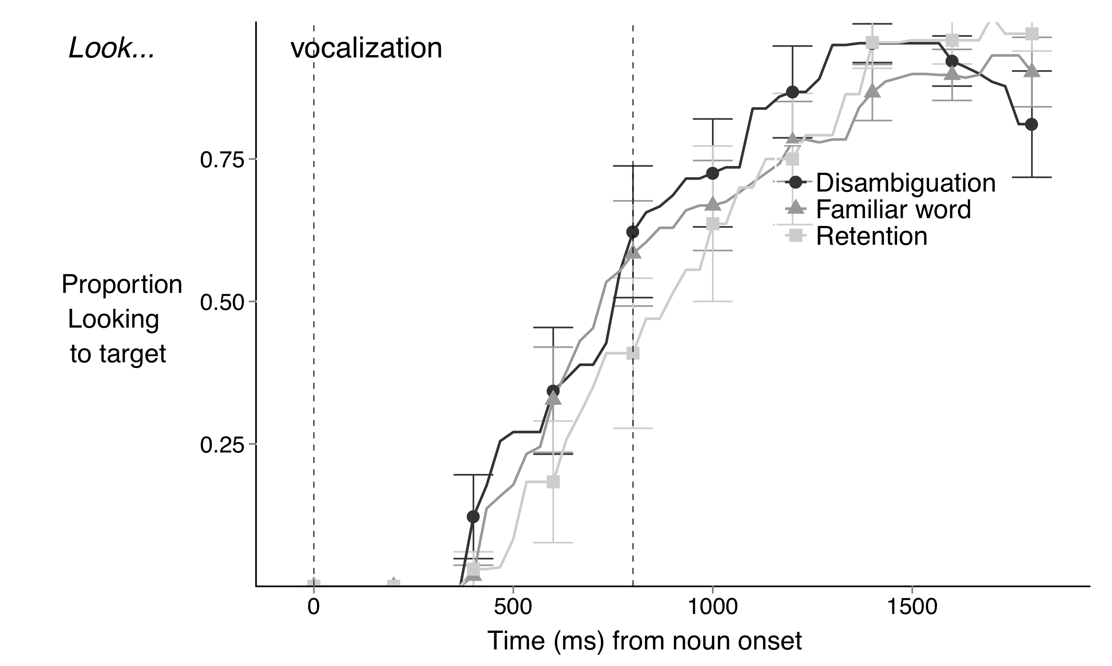

*General Discussion*

Revise studies on the LWL procedure, testing whether processing abilities are specific to language or reflect instead domain-general skills. This study suggests that there is some experience-dependent aspect of processing skill.

Revise literature on cross-semantic integration, suggesting different processing of sounds and words. Emphasize that there might be different processes involved in referent selection for words and vocalizations.

Revise brain-imaging studies.

Emphasize that parsimony favors a domain-general account, but the same behavioral response might reflect different motivations. Say that we are not saying that everything is domain specific. Older children probably use pragmatic inferences as well.

There might be developmental changes with age. Young, old kids, etc. paradigm with 18 months not the same as 7 year-olds. Cite Halberda’s unpublished work.

Talk about the other recent challenges to ME, regarding the role of experience (Krista, Adriana, etc), and the importance of ME for early word learning (Bion, Horst, etc).

End by concluding that ME depends on experience, that it might not be crucial for language-learning, and that it might reflect a general bias to find regularities in complex learning tasks in which strong one-to-one biases are observed.

*References*

Bloom, P. (2002). *How children learn the meanings of words*: The MIT Press.

Bloom, P., & Markson, L. (2001). Are there principles that apply only to the acquisition of words? A reply to Waxman and Booth.

Byers Heinlein, K. (2010). *Bilingualism in infancy: a window on language acquisition.* University of British Columbia.

Carey, S., & Bartlett, E. (1978). Acquiring a single word. *Papers and Reports on Child Language Development, 15*, 17-29.

Clark, E. (1990a). On the pragmatics of contrast. *Journal of Child Language, 17*(02), 417-431.

Clark, E. (1990b). On the pragmatics of contrast. *Journal of Child Language, 17*(2), 417-431.

Cummings, A., & Čeponienė, R. (2010). Verbal and nonverbal semantic processing in children with developmental language impairment. *Neuropsychologia, 48*(1), 77-85.

de Marchena, A., Eigsti, I., Worek, A., Ono, K., & Snedeker, J. (2011). Mutual Exclusivity in Autism Spectrum Disorders: Testing the Pragmatic Hypothesis. *Cognition*.

Diesendruck, G., & Markson, L. (2001). Children's avoidance of lexical overlap: A pragmatic account. *Developmental Psychology, 37*(5), 630-641.

Fiser, J., & Aslin, R. N. (2002). Statistical learning of new visual feature combinations by infants. *Proceedings of the National Academy of Sciences, 99*(24), 15822.

Fitch, W., & Hauser, M. D. (1995). Vocal production in nonhuman primates: Acoustics, physiology, and functional constraints on “honest” advertisement. *American Journal of Primatology, 37*(3), 191-219.

Frank, M., Goodman, N., & Tenenbaum, J. (2009). Using speakers' referential intentions to model early cross-situational word learning. *Psychological Science, 20*(5), 578.

Golinkoff, R., Hirsh-Pasek, K., Bailey, L., & Wenger, N. (1992). Young children and adults use lexical principles to learn new nouns. *Developmental Psychology, 28*(1), 99-108.

Golinkoff, R., Mervis, C., & Hirsh-Pasek, K. (1994). Early object labels: The case for a developmental lexical principles framework. *Journal of Child Language, 21*(01), 125-155.

Golinkoff, R. M., Mervis, C. B., & Hirsh-Pasek, K. (1994). Early object labels: The case for a developmental lexical principles framework. *Journal of Child Language, 21*, 125-125.

Halberda, J. (2003). The development of a word-learning strategy. *Cognition, 87*(1), 23-34.

Landau, B., Smith, L., & Jones, S. (1988). The importance of shape in early lexical learning. *Cognitive Development, 3*(3), 299–321.

MacWhinney, B. (1989). Competition and lexical categorization. *Linguistic categorization*, 195-242.

Markman, E. (1991). *Categorization and naming in children: Problems of induction*: The MIT Press.

Markman, E. (1992). Constraints on word learning: Speculations about their nature, origins, and domain specificity. *Modularity and constraints in language and cognition, 25*, 59-101.

Markman, E., & Abelev, M. (2004). Word learning in dogs? *TRENDS in Cognitive Sciences, 8*(11), 479-481.

Markman, E., & Wachtel, G. (1988). Children’s use of mutual exclusivity to constrain the meanings of words. *Cognitive Psychology, 20*(2), 121-157.

Markman, E., Wasow, J., & Hansen, M. (2003). Use of the mutual exclusivity assumption by young word learners. *Cognitive Psychology, 47*(3), 241-275.

McCleery, J. P., Ceponiene, R., Burner, K. M., Townsend, J., Kinnear, M., & Schreibman, L. (2010). Neural correlates of verbal and nonverbal semantic integration in children with autism spectrum disorders. *Journal of Child Psychology and Psychiatry, 51*(3), 277-286.

McMurray, B., Horst, J., & Samuelson, L. (unpublished manuscript). Using your lexicon at two timescales: Investigating the interplay of word learning and recognition.

Merriman, W., & Bowman, L. (1989). The mutual exclusivity bias in children's word learning. *Monographs of the Society for Research in Child Development, 54*(3).

Mervis, C., & Bertrand, J. (1994). Acquisition of the novel name–nameless category (N3C) principle. *Child Development, 65*(6), 1646-1662.

Moher, M., Feigenson, L., & Halberda, J. A One‐to‐One Bias and Fast Mapping Support Preschoolers’ Learning About Faces and Voices. *Cognitive Science, 34*(5), 719-751.

Nelson, K. (1973). Structure and strategy in learning to talk. *Monographs of the Society for Research in Child Development*, 1-135.

Peña, M., Bion, R. A. H., & Nespor, M. (2011). How modality specific is the iambic–trochaic law? Evidence from vision. *Journal of Experimental Psychology: Learning, Memory, and Cognition, 37*(5), 1199.

Preissler, M. A., & Carey, S. (2005). The role of inferences about referential intent in word learning: Evidence from autism. *Cognition, 97*(1), B13-B23.

Regier, T. (2003). Emergent constraints on word-learning: A computational perspective. *TRENDS in Cognitive Sciences, 7*(6), 263-268.

Regier, T., Corrigan, B., Cabasaan, R., Woodward, A., Gasser, M., & Smith, L. (2001). *The emergence of words*.

Saffran, J. R., Pollak, S. D., Seibel, R. L., & Shkolnik, A. (2007). Dog is a dog is a dog: Infant rule learning is not specific to language. *Cognition, 105*(3), 669-680.

Saffran, J. R., & Thiessen, E. D. (2007). Domain‐General Learning Capacities. *Blackwell handbook of language development*, 68-86.

Scofield, J., & Behrend, D. A. (2003). Two-year-olds differentially disambiguate novel words and facts. *Unpublished manuscript, University of Arizona*.

Seyfarth, R. M., & Cheney, D. L. (2003). Meaning and emotion in animal vocalizations. *Annals of the New York Academy of Sciences, 1000*(1), 32-55.

Smith, L. (1999). Children’s noun learning: How general learning processes make specialized learning mechanisms. *The emergence of language*, 277–303.

Spiegel, C., & Halberda, J. (2010). Rapid fast-mapping abilities in 2-year-olds. *Journal of experimental child psychology, 109*(1), 132-140.

Tomasello, M. (2001). Perceiving intentions and learning words in the second year of life. *Language acquisition and conceptual development*, 132–158.

Vincent-Smith, L., Bricker, D., & Bricker, W. (1974). Acquisition of receptive vocabulary in the toddler-age child. *Child Development*, 189-193.

Vouloumanos, A., Druhen, M. J., Hauser, M. D., & Huizink, A. T. (2009). Five-month-old infants' identification of the sources of vocalizations. *Proceedings of the National Academy of Sciences, 106*(44), 18867-18872.

Waxman, S. R., & Booth, A. E. (2000). Principles that are invoked in the acquisition of words, but not facts. *Cognition, 77*(2), B33-B43.

Woodward, A., & Hoyne, K. (1999). Infants' learning about words and sounds in relation to objects. *Child Development, 70*(1), 65-77.

Woodward, A. L., Markman, E. M., & Fitzsimmons, C. M. (1994). Rapid word learning in 13-and 18-month-olds. *Developmental Psychology, 30*(4), 553.