AniMOO/ME Methods

**Experiment 1**

*Participants.* Participants were 21 31-month-old children (*M*=31.8 months; range = 30.2-34.3), 10 girls. All were reported by parents to be typically developing and from families where English was the dominant language. Two participants were excluded due to fussiness.

*Visual stimuli.* The visual stimuli were pictures of four familiar animals (horse, dog, cow, sheep) and two novel animals (pangolin, tapir), each centered on a grey background in a 640 x 480 pixel space. The novel animals were real animals, selected because they were uncommon and unlikely to be familiar to the children in the study. *Auditory stimuli.* The auditory stimuli consisted of auditory cues that were thought to be either Familiar or Novel to 30-month-olds. Familiar cues consisted of: a) *familiar animal names,* b) *familiar* *lexical sounds* (list them?)*,* and c) *familiar natural animal vocalizations* (list). Novel cues consisted of: a) *novel animal names* (list)and b) *novel natural animal vocalizations* (list). Trials in which the target cue was an animal name or lexical sound began with a brief carrier frame and concluded with simple questions that served to introduce prosodic variability across trials (e.g., *Where’s the dog?/Which one goes woof? Can you find it?* ). The duration of the target cue was 800 ms for lexical sounds and 750 ms for animal names, and the intensity of the phrases was normalized using Praat speech analysis software (Boersma, 2002). Trials with natural animal vocalizations began with a single word recorded by the same native speaker of American English, which served to draw children’s attention (e.g., *Look! “dog barking*”). Familiar animal vocalizations were selected based on representativeness of the familiar animal. Novel animal vocalizations were selected based on unfamiliarity and affordances (i.e., the plausibility that the novel animal could produce the novel sound). The duration of all target animal vocalizations was 2000 ms.

*Books.* To ensure that all children had at least some experience with the familiar animals and familiar auditory cues used in our study, we gave parents two children’s books, both titled *Sounds on the Farm* at least a week before their visit*.* Parents were instructed to share each book with their child for five to ten minutes in the days leading up to the experiment. The first book was created by our lab and consisted of colorful pictures of each familiar animal and text designed to prompt parents to produce each animal’s lexical sound (e.g., *Wow, look at all those cows! This cow says moo, moo!*). To give children exposure to the natural animal vocalizations, we used a “push-and-play” book, which contained buttons that children could press to hear the actual noise that each animal produces.

*Procedure.* Speed and accuracy in identifying the correct target picture was assessed using the looking-while-listening (LWL) procedure (see Fernald, Zangl, Portillo, & Marchman, 2008). [[must refer to picture somewhere]] On each trial, a pair of pictures was presented on the screen for approximately 4 s, with the auditory stimuli starting after 2 s, followed by 1 s of silence.

Children were tested at two different visits. On the first visit, each child saw 27 trials, consisting of three different trial types (Figure 1). On 8 *Familiar Animal Name* trials, each familiar animal served as the target twice and was paired once with another familiar animal and once with a novel animal. On 8 *Familiar Lexical Sound* trials, each familiar animal served as the target two times and was always paired with another familiar animal. On 6 *Novel Animal Name* trials, each novel animal was labeled three times with a novel animal name (i.e., *capa, nadu*), always paired with a familiar animal . 5 *Filler* trials were interspersed throughout to add variety and maintain children’s attention. Pairings of the novel animal and name, and side of presentation of target object, were counterbalanced across participants. Caregivers wore darkened sunglasses so that they could not influence infants’ looking to the correct picture throughout the 5-min procedure.

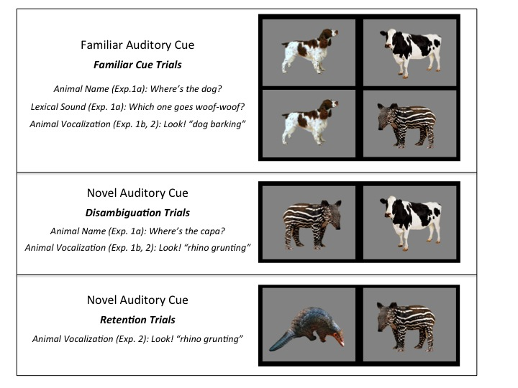 On the second visit, children saw 29 trials, consisting of two different trial types (Figure 1). On 16 *Familiar Animal Vocalization* trials, each familiar animal served as the target four times and was paired with another familiar animal twice and each novel animal once. On 8 *Novel Animal Vocalization* trials, each novel animal vocalization served as the target four times and was paired with each familiar animal once. As in the first visit, 5 *Filler* trials were interspersed throughout to add variety and maintain children’s attention. Counterbalancing was the same as in the first visit.

**Figure 1.** Trial types in Experiments 1 and 2. [describe the picture]

Participants’ eye movements were video-recorded and coded with a precision of 33 ms by observers who were blind to trial type. Inter- and intra-observer reliability checks were conducted for all coders. For 25% of the subjects, two measures of inter-observer reliability were assessed. The ﬁrst was the proportion of frames (33-ms units) on each trial on which two coders agreed. In this case, agreement was XX%. However, because this analysis included many frames on which the child was maintaining ﬁxation on one picture, we also calculated a more stringent test of reliability. This second measure focused only on shifts in gaze, ignoring steady-state ﬁxations in each trial on which agreement was inevitably high. By this more conservative measure, coders agreed within one frame on XX% of all shifts.

On those trials in which the infant was fixating a picture at the onset of the speech stimulus, accuracy was computed by dividing the time looking to the target object by the time looking to both target and distracter, from 300 to 4300 ms from the onset of the target word. Accuracy before 300 ms was not included because shifts to the target occurring in this window had presumably been initiated before the onset of the noun (Haith, Wentworth, & Canfield, 1993). This analyses window included the entire duration of the trial, and it was longer than that of studies with familiar words (Fernald et al., 1996) because of the longer duration of the animal vocalizations (2 s.) and because of the introduction of novel auditory cues. Analysis windows of up to 10 s. have been used in looking-time experiments with novel words (Mather and Plunkett, 2010). A single analyses window was used for all trial types for consistency, and the entire duration of the trial was used in order to avoid arbitrary decisions. Mean accuracy was then computed for each participant on each trial type.

Mean reaction time (RT) for each child was computed from trials when the child stared looking at the distracter image and shifted to the target picture within 300-1800 ms from target-cue onset. Because children vary in the likelihood they will by chance start out on the distracter on a given trial, mean RTs are based on different numbers of trials across participants.

**Experiment 2**

*Participants.* Participants were 26 31-month-old children (*M*=31.1 months; range = 27.4-32.5), 12 girls. All were reported by parents to be typically developing and from families where English was the dominant language.

*Visual stimuli.* The visual stimuli were the same as in Experiment 1, except for the novel animals (aardvark and capybara), which replaced the novel animals (pangolin and tapir) used in Experiment 1.

*Auditory stimuli.* The auditory stimuli consisted of only the natural animal vocalizations and they were the same as in Experiment 1.

*Books.* As in Experiment 1, we sent home a children’s book to ensure that all participants had at least some exposure to the familiar animals and auditory cues. Since, in Experiment 2, we were interested in the natural animal vocalizations and not the names/lexical sounds, only the “push-and-play” *Sounds on the Farm* book was used. Instructions given to the parents were the same as in Experiment 1, and the book was sent home a week before the visit.

*Procedure.* Experiment 2 consisted of one visit. Each child saw 35 trials, consisting of three trial types (Figure 1). The 16 *Familiar Animal Vocalization* trials and 8 *Novel Animal Vocalization* trials were identical in structure to Experiment 1. In addition, on 6 *Retention* trials, the two novel animals were presented side by side, with each serving as the target three times. The same coding and speed/accuracy measures were used as in Experiment 1.