**Experiment 1:**

*Using familiar animal names, lexicalized sounds, and animal vocalization to identify familiar animals:*

Our first question is whether children can appreciate the associations between familiar animals and each of three different familiar auditory cues. Specifically, we evaluate and compare children’s efficiency in recognizing links between animals and their names (e.g., *dog*), their lexicalized sounds (e.g., *bow-wow*), and their natural vocalizations (e.g., *dog barking*).

*Accuracy measures:* Figure 1a presents children’s proportion of looks to the familiar animal after hearing each of the three different familiar auditory cues, showing that they were equally effective in guiding children’s attention to the target animal. Children looked to the correct animal after hearing the animal name (*M =* 0.62, *t* (18) = 3.57, *p* = 0.002), the lexicalized sound (*M =* 0.64, *t* (18) = 3.54, *p* = 0.002), and the animal vocalization (*M =* 0.64, *t* (18) = 5.90, *p* < 0.001). Interestingly, performance was indistinguishable across the three conditions, showing that the animal vocalization can be as good of a cue to identify familiar animals as their names or lexicalized sounds (*p* > 0.6).

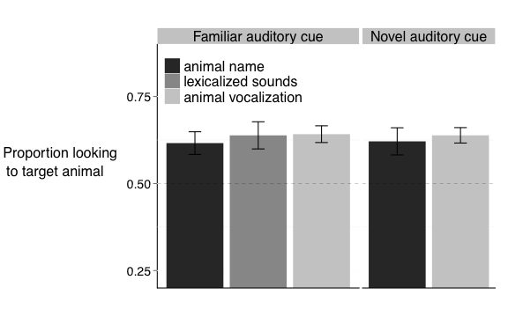

**Figure 1.** Accuracy of responses to Familiar and Novel auditory cues. When hearing familiar animal names, lexicalized sounds, or animal vocalizations, children reliably looked to the target familiar animal. When hearing novel animal names or animal vocalizations, children reliably looked at the target novel animal instead. The different auditory cues were equally effective in guiding children’s attention to the target animal. Error bars indicate standard errors of the means.

Across children, accuracy of responses to familiar names, lexicalized sounds, and vocalizations was undistinguishable. We subsequently asked whether there was a relation between individual children’s to these three auditory cues. Children who were more accurate in identifying animals based on their name were also more efficient to identify them after hearing their lexicalized sounds (*r* (17) = 0.51, *p* = 0.023). Children’s efficiency in identify animals based on their vocalizations did not relate to their accuracy in identifying animals based on names or lexicalized sounds (*p* > 0.2). This finding suggests that knowledge about animal names and their lexicalized sounds might be learned in conjunction, possibly through interactions with adults. In contrast, knowledge about animal vocalizations might be learned separately, as it depends more heavily on experience with real animals. Interestingly, success in identifying the lexicalized animal sound (e.g., *bow-wow*) does not imply success in recognizing the natural animal vocalization (e.g, an actual dog barking).

*Reaction-time measures:* Figure 2a presents children’s speed in recognizing animals on the different trial types, showing that the animal name can be more rapidly explored to identify animals than the lexicalized sound or animal name. That is, children were faster to identify the target animal when hearing its name (*M* = 541ms), as compared to its vocalization (*M* = 840 ms, *t* (18) = 4.61, *p* < 0.001) or lexicalized sound (*M* = 801 ms, *t* (18) = 3.40, *p* = 0.002), with these two conditions not differing from each other (*t* (18) = 0.47, *p* > 0.6).

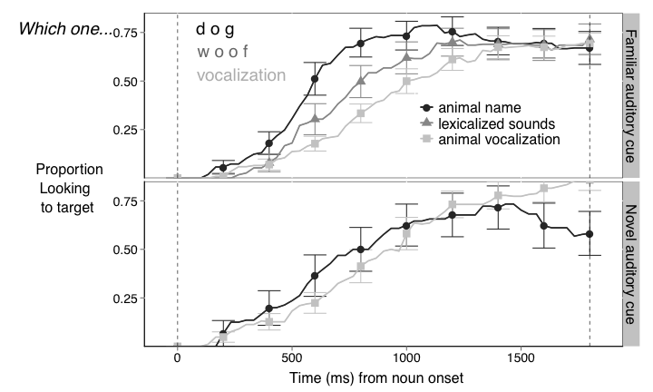

**Figure 2.** Time course of children’s looking to the target animal after hearing different familiar and novel auditory cues. The curves depict changes in the proportion of looking to the target animal as sounds unfolded, measured from sound onset (in milliseconds). When hearing a familiar auditory cue, children were faster to orient to the target familiar animal after hearing its name, than when hearing the lexicalized sound or animal vocalization. Children were equally fast to respond to the three auditory cues.

As a group, children were faster to orient to the target animal after hearing its name than after hearing the lexicalized sound or animal vocalization. We subsequently asked whether individual children’s reaction times were related across these three conditions. As previously found for accuracy, children who were faster to orient to the familiar animal after hearing its name were also faster to orient to the familiar animals after hearing the lexicalized animal sound (*t* (18) = 0.48, *p* < 0.05). Children’s RT to the animal vocalization was not related to their RT to the animal name or lexicalized sound (*p* > 0.5).

*Using novel animal names and animal vocalization to disambiguate novel animals*

*Accuracy measures:* The second question was whether children showed one-to-one biases for the types of vocalizations that animals produce, similar to their biases in word learning. Figure 1b show children’s proportion of looks to the unfamiliar animal (e.g. tapir) after hearing a novel animal name (e.g., *nadu*) or an unfamiliar animal vocalization (e.g., gorilla vocalization). Children reliably looked to the novel animal when hearing the novel animal name (*M* = 0.62 ms) or vocalization (*M* = 0.63 ms). The proportion of looks to the novel animal was equally high when children heard a novel animal name and an unfamiliar animal vocalization (*t* (18) = 0.38, *p >* 0.70).

As found with familiar auditory stimuli, there was no correlation between individual children’s proportion of looks to the target animal after hearing the animal vocalization and animal name (*p* > 0.48). [more]

*Reaction-time measures:* As seen in Figure 2b, there was no difference in RT between children’ speed in recognizing the novel animal after hearing a novel animal name (*M =* 783 ms) or animal vocalization (*M =* 770 ms, *t* (18) = 0.08, *p* > 0.9). There was also no correlation between individual children’s RT to these two auditory stimuli (*p*  > 0.6).

*Links between accuracy responses to familiar and novel auditory stimuli:*

Are children who are better at recognizing the familiar animals after hearing a familiar auditory cue also better at recognizing the novel animal after hearing a novel auditory cue? Figure 3 shows that these two abilities are indeed related, and that accuracy on trials with familiar auditory cues can predict accuracy on trials with novel auditory cues (*r*(36) = 0.5, *p* = 0.001). This correlation was significant for both the animal name (*r*(17) = 0.54, *p* = 0.015) and animal vocalization (*r*(17) = 0.42, *p* = 0.077).

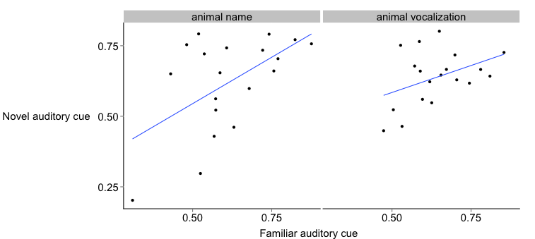

**Figure 3:** Correlation between children’s proportion of looks to target animal after hearing the novel and familiar animal names and animal vocalizations. For both animal names and animal vocalizations, children with higher accuracy after hearing familiar names also had higher accuracy after hearing novel names.

Elaborate on difference in accuracy between novel and familiar auditory cues…

**Experiment 2:**

***Anime – retention vocalization…***