*Results and Discussion:*

*Using familiar animal names, lexicalized sounds, and animal vocalization to identify familiar animals:*

Our first question is whether children can use associations between familiar animals and each of three different familiar auditory cues to identify the appropriate animal. Specifically, we evaluate and compare children’s efficiency in recognizing links between animals and their names (e.g., *dog*), their lexicalized sounds (e.g., *bow-wow*), and their natural vocalizations (e.g., *dog barking*).

*Accuracy measures:* Figure 1a presents children’s proportion looking to the familiar animal when hearing each of the three different familiar auditory cues, with looking time averaged over a window from 300 to 4300 ms after the onset of the cue. The three types of auditory cue were equally effective in guiding children’s attention to the target animal. Children looked to the correct animal when hearing the animal name (*M =* 0.62, *t* (18) = 3.57, *p* = 0.002), the lexicalized sound (*M =* 0.64, *t* (18) = 3.54, *p* = 0.002), and the animal vocalization (*M =* 0.64, *t* (18) = 5.90, *p* < 0.001), and performance was indistinguishable across the three conditions (*p* > 0.6). These results show that the animal vocalization can be as good a cue to identify familiar animals as their names or lexicalized sounds.

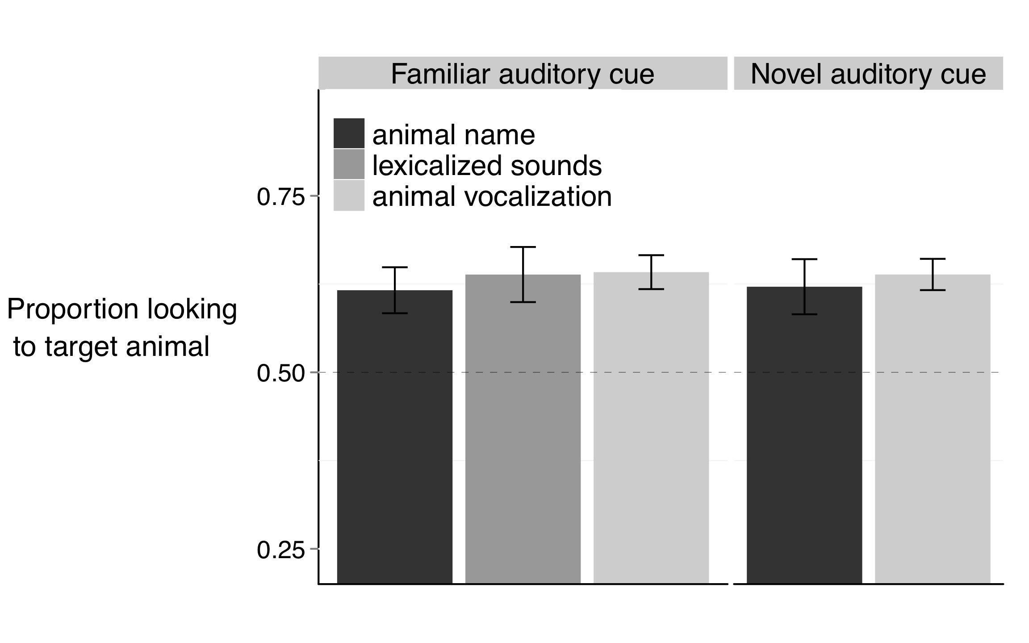

(1.a)

(1.b)

**Figure 1.** Accuracy of responses to familiar and novel auditory cues. 1.a. When hearing familiar animal names, lexicalized sounds, or animal vocalizations, children reliably looked to the target familiar animal. 1.b. When hearing novel animal names or animal vocalizations, children reliably looked at the novel animal. The different auditory cues were equally effective in guiding children’s attention to the target.

Are children who are better at using one of these cues also better at using the other cues to identify familiar animals? We found a relation between children’s efficiency in interpreting familiar animal names and lexicalized sounds (*r* (17) = 0.51, *p* = 0.023), but neither skill related to efficiency in interpreting familiar animal vocalizations (*p* > 0.2). Children who were more accurate in identifying animals based on their name were also more accurate in identifying them based on their lexicalized sounds. While knowledge about the animal name went hand in hand with knowledge about its lexicalized sound, success in recognizing these associations did not relate to success in recognizing the natural animal vocalization.

In short, three main findings emerged from these accuracy analyses: First, children successfully used familiar animal names, lexicalized sounds, and animal vocalizations to recognize familiar animals. Second, these three cues were equally effective in guiding children’s attention to the target animal. Third, children’s efficiency in interpreting familiar animal names related to their efficiency in interpreting familiar lexicalized animal sounds, but neither skill related to efficiency in interpreting familiar animal vocalizations.

*Reaction-time measures:* Figure 2a presents children’s speed in recognizing animals on the different trial types, showing that the animal name can be more rapidly exploited to identify animals than the lexicalized sound or animal vocalization. That is, children were faster to identify the target animal when hearing its name (*M* = 541ms), as compared to its vocalization (*M* = 840 ms, *t* (18) = 4.61, *p* < 0.001) or lexicalized sound (*M* = 801 ms, *t* (18) = 3.40, *p* = 0.002), with the last two conditions not differing from each other (*t* (18) = 0.47, *p* > 0.6).

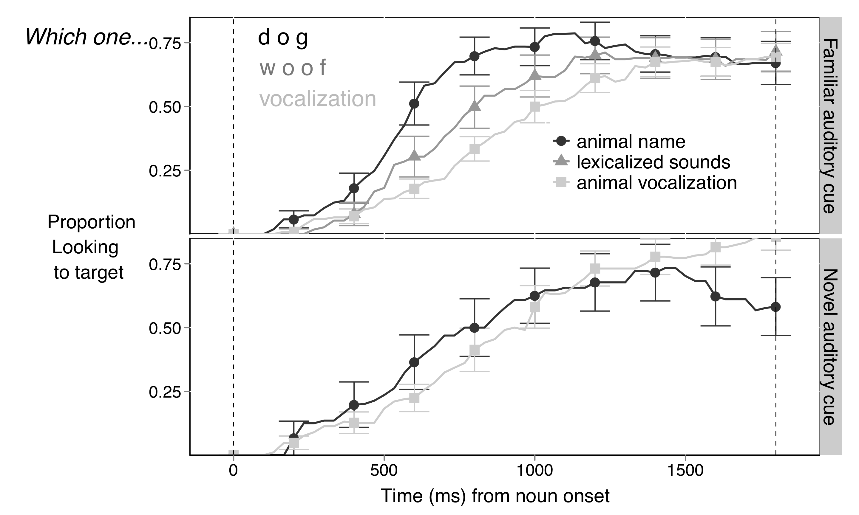

(2.b)

(2.a)

**Figure 2.** Time course of children’s looking to the target animal after hearing different familiar and novel auditory cues. The curves depict changes in the proportion of looking to the target animal as sounds unfolded, measured from sound onset (in milliseconds). When hearing a familiar auditory cue (2.a), children were faster to orient to the target animal after hearing its name, than when hearing the lexicalized sound or animal vocalization. Children were equally fast to orient to the novel animal after hearing a novel animal name or vocalization (2.b).

Are children who are faster at using one of these cues also faster at using the other cues to identify familiar objects? As previously found with accuracy, we found a relation between children’s RT to familiar animal names and lexicalized sounds (*t* (18) = 0.48, *p* < 0.05). Children who were faster to orient to the familiar animal after hearing a familiar animal name were also faster to orient to the animal after hearing a familiar lexicalized sound. Again, there was no relationship between responses to animal vocalizations and either animal names or lexicalized sounds (*p* > 0.2).

In short, two main findings emerged from these RT analyses: First, children were faster to orient to an animal after hearing its name, than after hearing a lexicalized sound or animal vocalization. Second, children’s speed in recognizing familiar animal names related to their speed in recognizing familiar lexicalized animal sounds, but neither skill related to speed in recognizing familiar animal vocalizations.

*Using novel animal names and animal vocalization to disambiguate novel animals*

Our second question is whether children would orient to a novel animal after hearing a novel animal name or vocalization. Specifically, we evaluate and compare children’s response to a novel animal name or animal vocalization in the presence of both a familiar and a novel animal.

*Accuracy measures:* Figure 1b shows children’s proportion of looking to the novel animal when hearing a novel animal name or a novel animal vocalization. Children reliably looked to the novel animal when hearing the novel animal name (*M* = 0.62) or novel animal vocalization (*M* = 0.63). Performance did not differ between these two conditions (*t* (18) = 0.38, *p >* 0.70). Therefore, children seem to have one-to-one biases for the vocalizations that animals produce already at 30 months of age, the earliest age at which the disambiguation effect has been observed in a domain other than word learning.

Are children who are better at using novel animal names also better at using novel animal vocalizations to disambiguate novel animals? For familiar cues, we had not found a relationship between responses to animal names and vocalizations. For novel cues, we again did not find a relation between children’s efficiency in interpreting novel animal names and novel animal vocalizations (*p* = 0.48).

In short, three main findings emerged from these accuracy analyses: First, children successfully disambiguated a novel animal name and novel animal vocalization. Second, these two novel unfamiliar cues were equally effective in guiding children’s attention to the novel animal. Third, children’s efficiency in interpreting novel animal vocalizations did not relate to their efficiency in interpreting novel animal names.

*Reaction-time measures:* As seen in Figure 2b, there was no difference in RT between children’ speed in recognizing the novel animal after hearing a novel animal name (*M =* 783 ms) or animal vocalization (*M =* 770 ms, *t* (18) = 0.08, *p* > 0.9).

Are children who are faster at interpreting novel animal names also faster at interpreting novel animal vocalizations to disambiguate novel animals? Again, there was no correlation between individual children’s RT to these two novel auditory cues (*p*  > 0.6).

In short, two main findings emerged from these RT analyses: First, there was no difference between RT to novel animal names and vocalizations. Second, there was no relationship between RT to novel animal names and vocalizations.

*Links between accuracy responses to familiar and novel auditory stimuli:*

Are children who are better at recognizing familiar animals after hearing a familiar cue also better at recognizing novel animals after hearing a novel cue? Figure 3 shows that success in these two tasks was indeed related; accuracy on trials with familiar auditory cues was correlated with accuracy on trials with novel auditory cues (*r*(36) = 0.5, *p* = 0.001). This relationship was present in children’s responses to familiar and novel animal names (*r*(17) = 0.54, *p* = 0.015) and in their responses to familiar and novel animal vocalizations (*r*(17) = 0.42, *p* = 0.077). RT to familiar and novel cues were not related (*p* > 0.34).

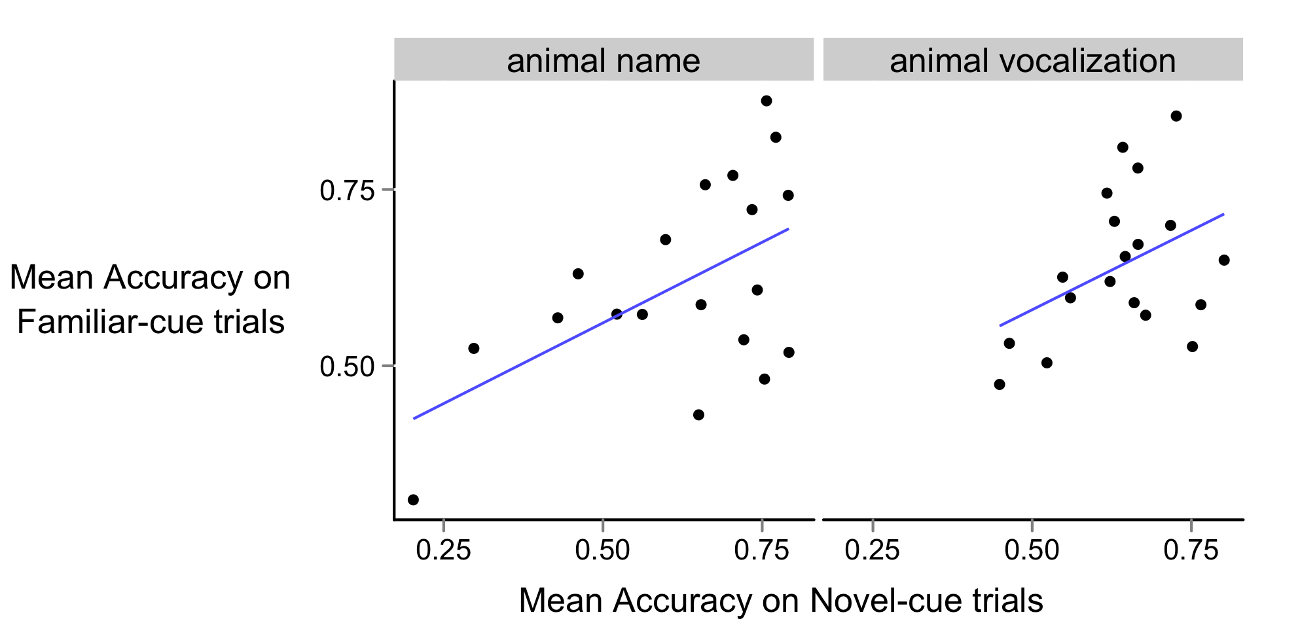

(3.b) *r* (17) = 0.42, *p* = 0.077

(3.a) *r* (17) = 0.54, *p* = 0.015

**Figure 3:** Relationship between children’s accuracy when hearing a novel and a familiar auditory cue, presented separately for trials with animal names and vocalizations. Children who were better at recognizing familiar animal names were better at disambiguating novel animal names. Children who were better at recognizing familiar animal vocalizations were better at disambiguating novel animal vocalizations.

Are children more efficient to interpret familiar or novel auditory cues? Children’s accuracy on trials with familiar auditory cues (*M =* 0.63, averaged across familiar animal names, lexicalized sounds, and vocalizations) did not differ from their accuracy on trials with novel auditory cues (*M =* 0.64, averaged across novel animal names and vocalization, *t* (18) = 0.26, *p* > 0.79). Children’s RT in trials with familiar (*M =* 775 ms) and novel cues did not differ either (*M =* 805 ms, *t* (18) = 0.35, *p* > 0.72).

Two main findings emerged from this analyses of the relation between familiar and novel auditory cues: First, children who were more accurate in interpreting familiar cues were also more accurate in interpreting novel cues. Second, children were equally efficient in interpreting familiar and novel auditory cues.

***Experiment 2***

**Motivate the importance of looking at retention.**

*Method*

*Participants.* Participants were 22 31-month-old children (*M*=31.1 months; range = 27.4-32.5), 12 girls. All were reported by parents to be typically developing and from families where English was the dominant language.

*Visual stimuli.* The visual stimuli were the same as in Experiment 1, except for the novel animals (aardvark and capybara), which replaced the novel animals (pangolin and tapir) used in Experiment 1. All children were reported by parents to have had little to no exposure to the novel animals.

*Auditory stimuli.* The auditory stimuli consisted of only the natural animal vocalizations and they were the same as in Experiment 1.

*Books.* As in Experiment 1, we sent home a children’s book to ensure that all participants had at least some exposure to the familiar animals and auditory cues. Since, in Experiment 2, we were interested in the natural animal vocalizations and not the names/lexical sounds, only the Hear and ThereTM *Sounds on the Farm* book was used. Instructions given to the parents were the same as in Experiment 1, and the book was sent home a week before the visit.

*Procedure.* Experiment 2 consisted of one visit. Each child saw 35 trials, consisting of three trial types (Figure 1). The 16 *Familiar Animal Vocalization* trials and 8 *Novel Animal Vocalization* trials were identical in structure to Experiment 1. In addition, on 6 *Retention* trials, the two novel animals were presented side by side, with each serving as the target three times. The same coding and speed/accuracy measures were used as in Experiment 1.

*Results and Discussion:*

*Retention of the link between a novel animal and a novel vocalization:*

While Experiment 1 focused on children’s responses to familiar and novel animal names, lexicalized animal sounds, and animal vocalizations, Experiment 2 focused exclusively on responses to familiar and novel animal vocalizations.

This experiment aimed at replicating and expanding on three findings from Experiment 1: First, children identified familiar animals based on the vocalizations they produce. Second, children used novel vocalizations to disambiguate novel animals. Third, children who were better at identifying familiar animals were better at disambiguating novel animals. In addition, we also ask whether children can retain the link created through disambiguation between a novel animal and a novel animal vocalization.

*Accuracy measures:* Figure 4 presents children’s proportion looking to the target animal after hearing a familiar or a novel animal vocalization over a window from 300 to 4300 ms after the onset of the vocalization. When children heard a familiar animal vocalization, they oriented to the target familiar animal (*M =* 0.62, *t* (21) = 5.47, *p* < 0.001). When children heard a novel animal vocalization, they looked at a novel animal instead (*M =* 0.63, *t* (21) = 3.76, *p* = 0.001). In addition, children who were more efficient in identifying a familiar animal after hearing a familiar animal vocalization were also more efficient in disambiguating a novel animal after hearing a novel animal vocalization (*r* (20) = 0.59, *p* = 0.003). These results replicate three main findings from Experiment 1.

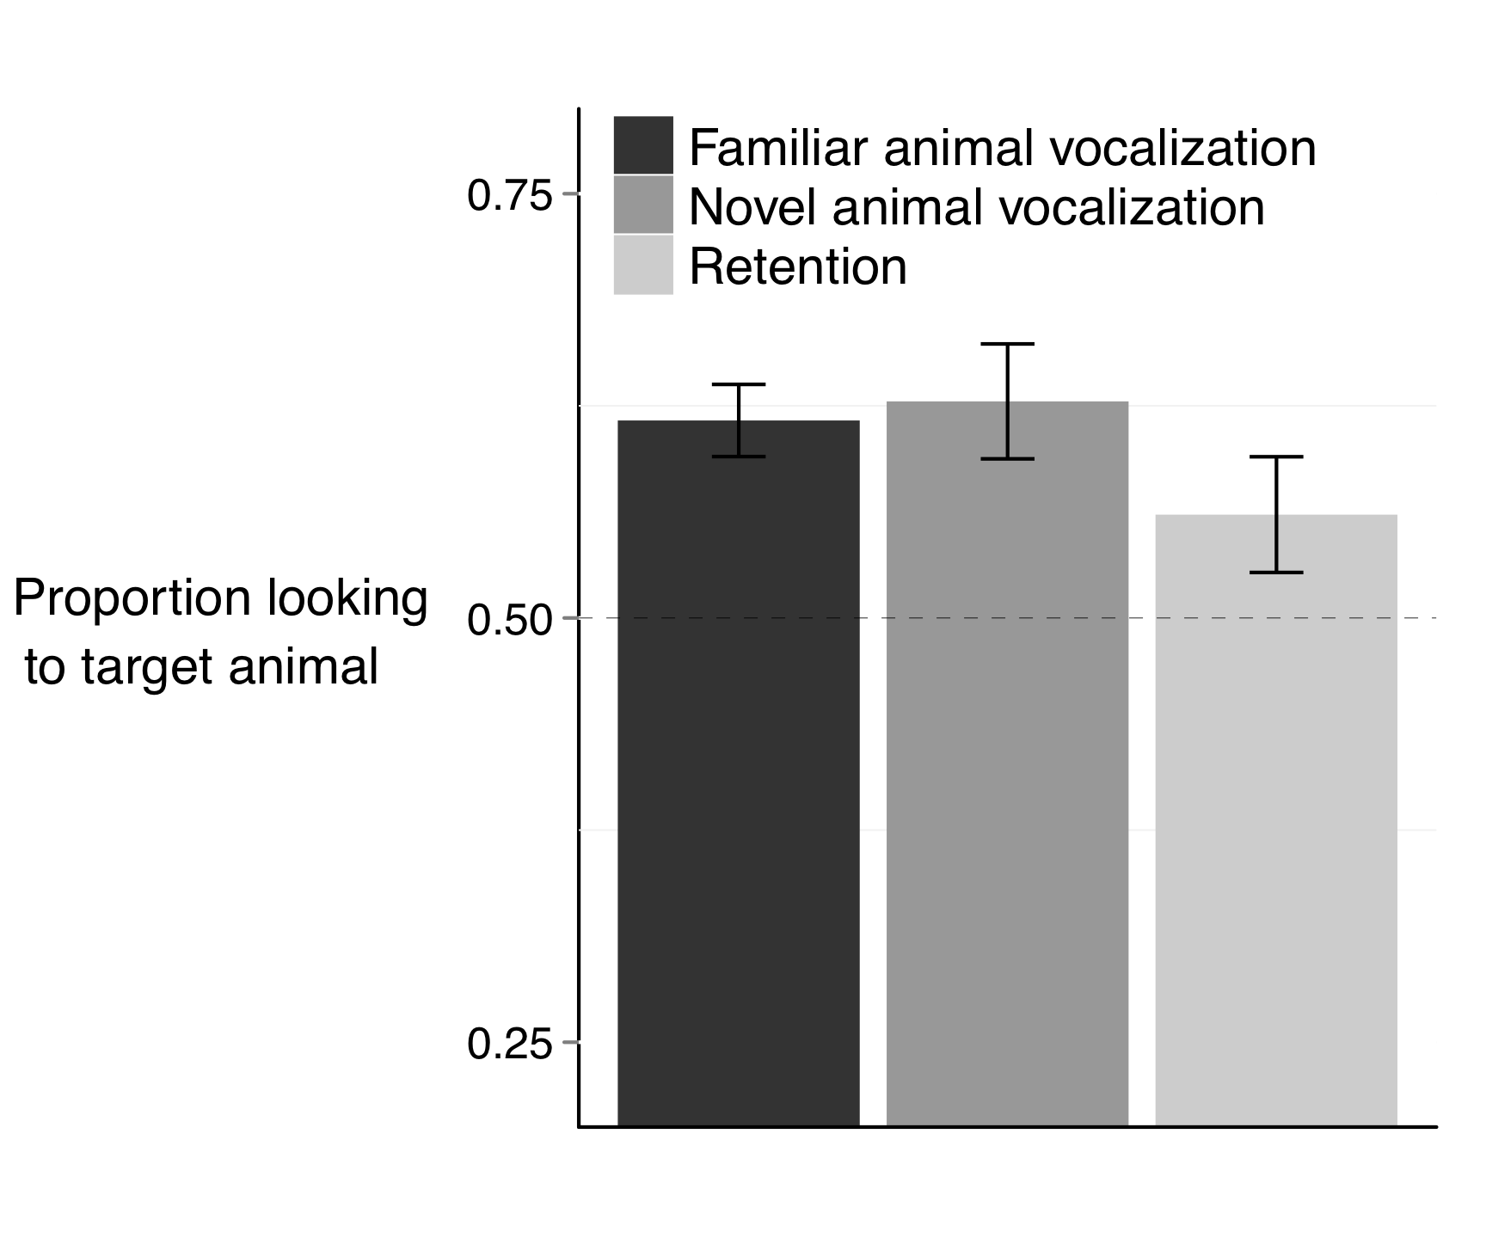

**Figure 1.** Accuracy of responses to familiar and novel animal vocalizations. Children reliably looked to the target animal after hearing a familiar animal vocalization and a novel animal vocalization. Children were marginally successful in retaining the map between a novel animal and a novel vocalization. Performance was indistinguishable across the three conditions.

Can children remember the association between the novel animal and the novel vocalization, when this association is created through a disambiguation strategy? In order to test this hypothesis, two novel animals were paired with each other, as children heard the animal vocalization previously associated with one of the two animals.

Children remembered the link between the novel animal and the novel vocalization (Figure 4, *M =* 0.56, *t* (21) = 1.79, *p* = 0.089). This trend is supported by the fact that performance on retention trials was marginally above chance, and was indistinguishable from performance on trials in which children had to identify a familiar animal (*t* (21) = 1.38, *p* = 0.177) or disambiguate a novel animal (*t* (21) = 1.39, *p* = 0.176).

Are children who are better at interpreting novel animal vocalizations in disambiguation trials also better at remembering the animal vocalizations in retention trials? Children who were more efficient at disambiguating the novel animal when hearing the novel animal vocalization spent more time looking at the correct animal on subsequent retention trials (*r* (20) = 0.38, *p* = 0.087). Again, this effect is marginally significant. There was no correlation between retention skills and recognition of familiar animals (*p* > 0.6).

Five findings emerged from this analyses of accuracy, the first three replicating findings from Experiment 1: First, children oriented to a familiar animal after hearing a familiar animal vocalization. Second, children oriented to a novel animal after hearing a novel animal vocalization. Third, these two skills were related. Fourth, children were marginally successful in retaining the link between a novel animal vocalization and a novel animal. Fifth, there was a marginal relationship between children’s efficiency in disambiguating novel animal vocalization and subsequently remembering these mappings.

*RT measures:* Reaction time measures were indistinguishable between the three experimental conditions in this experiment. Children were equally fast to orient to a familiar animal after hearing a familiar animal vocalization (*M =* 730 ms), to orient to a novel animal after hearing a novel animal vocalization (*M =* 809 ms), and on retention trials to orient to the novel animal previously paired with a novel animal vocalization (*M* = 824 ms, all *p* > 0.25).

As found in Experiment 1, children’s speed to orient to a familiar animal after hearing a familiar vocalization was correlated to their speed to orient to a novel animal after hearing a novel vocalization (*r* (20) = 0.46, *p* = 0.047). There was no relationship between RT on Disambiguation and Retention trials (*p =* 0.29).

In short, two main findings emerged from these RT analyses: First, children were equally fast to orient to the target animal after hearing a familiar or novel vocalization. Second, children’s speed in recognizing familiar animal vocalizations related to their speed in recognizing familiar animal vocalizationss. These two findings replicate paralel findings in Experiment 1. The third finding was that there was no relationship between speed to respond to novel vocalizations in Disambiguation and Retention trials.

ADDITIONAL GRAPHS THAT I RATHER NOT INCLUDE:

PP for ANIMOO

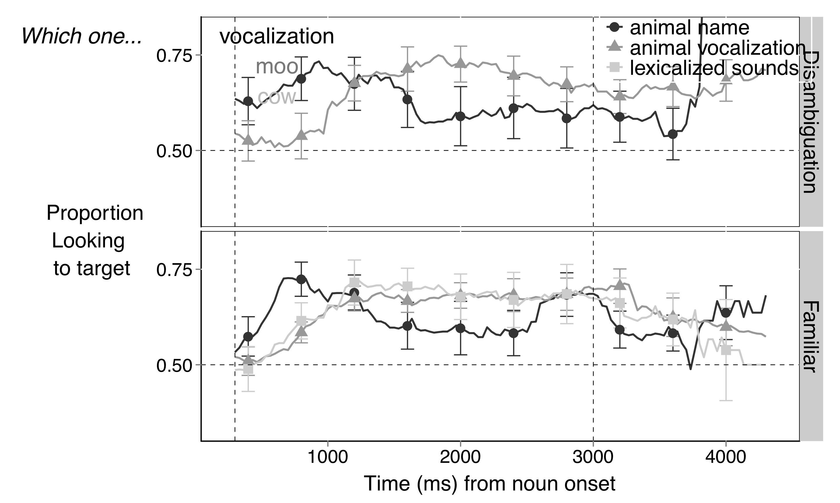

PP for ANIME

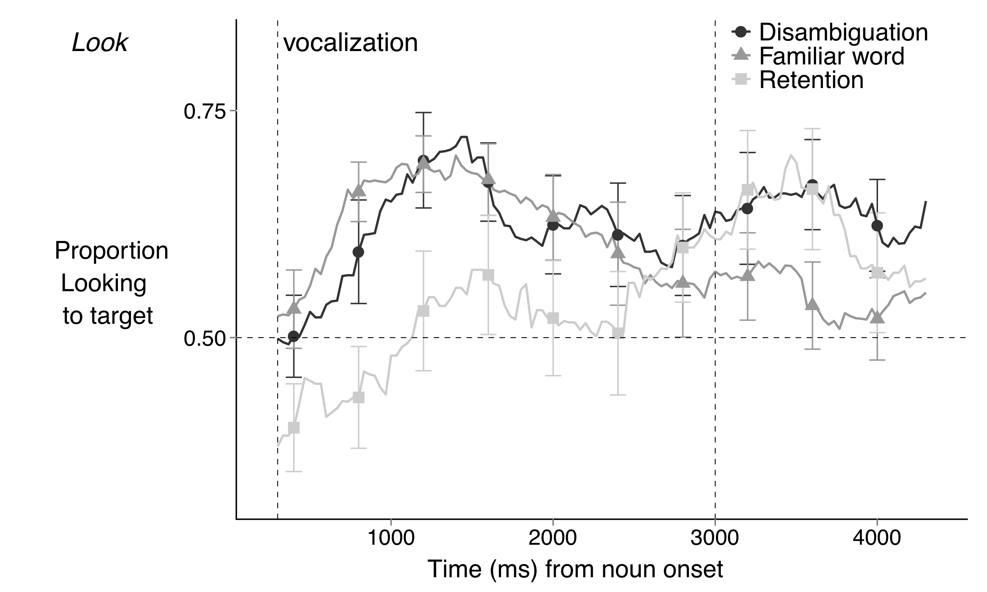

OC for ANIME

