Real-time lexical comprehension in young children learning American Sign Language

Kyle MacDonald

Todd LaMarr

David Corina

Virginia A. Marchman

Anne Fernald

**Word count: 1928** = acknowledgements, +introduction, + discussion

# Author contributions:

K. MacDonald, V.A. Marchman, and A. Fernald developed the study concept. All authors contributed to the study design. Testing and data collection were performed by K. MacDonald and T. LaMarr. K. MacDonald and V.A. Marchman performed the data analysis and interpretation. K. MacDonald and V.A. Marchman drafted the manuscript, and all authors provided critical revisions. All authors approved the final version of the manuscript for submission.

# Author note:

We are grateful to the children and parents who participated in this research, and the California School for the Deaf in Fremont. Special thanks to Karina Pedersen and Lisalee Egbert for their help with participant recruitment, to Pearlene Utley and Rosa Lee Timm for help with creation of the stimuli, and to Shane Blau, Kat Adams, Melanie Ashland, and the staff of the Language Learning Lab at Stanford University. This work was made possible by an NIDCD grant to Anne Fernald and David Corina (R21 DC012505).

**Abstract (word count=150; limit=150)**

The ability to interpret language rapidly as the signal unfolds in time is critical for language development. But, we know little about how children learning visual languages develop proficiency in real-time language understanding. In this study, we created the first developmental measures of real-time American Sign Language (ASL) comprehension, investigating links between these skills, children’s age, vocabulary, and hearing status. Native ASL-learning children (16-53 mos, *n*=29, 16 deaf, 13 hearing) and fluent adult signers (*n*=19) completed a real-time ASL comprehension task. Children’s comprehension skills improved with age and were correlated with vocabulary size, showing meaningful links to language learning. Finally, we found similar patterns of results for deaf and hearing ASL learners, suggesting that ASL processing is driven by experience with a visual language, and not by deafness. These novel findings show striking parallels between the development of language comprehension in visual language learners and in children learning spoken languages.

Keywords: Sign Language, Language Development, Comprehension, Deaf

**Real-time lexical comprehension in young children learning**

**American Sign Language (ASL)**

Learning to find meaning in a spoken or a signed language requires learning to establish reference during real-time interaction – relying on audition to interpret spoken words, and on vision to interpret manual signs. Starting in infancy, children learning a spoken language make dramatic gains in their ability to link acoustic signals representing lexical forms to concrete objects in the world. Studies of early spoken language comprehension have measured children’s gaze as they look at pairs of familiar objects while listening to speech naming one of the objects (Bergelson & Swingley, 2013; Fernald, Pinto, Swingley, Weinberg, & McRoberts, 1998). Such research shows that young listeners process language incrementally, shifting their gaze to a named object as soon as the auditory information is sufficient to enable referent identification. Moreover, individual differences in real-time processing efficiency predict vocabulary growth and later language and cognitive outcomes (Fernald, Perfors & Marchman, 2006; Marchman & Fernald, 2008). However, little is known about how young children learning a visual language develop skill in processing signs from moment to moment. Here we ask whether children learning American Sign Language (ASL) develop skill in real-time processing of signs in ways that are parallel to children learning spoken language, and whether variability among ASL-learning children in real-time processing skills are related to their expressive vocabulary development, as in children learning spoken language. We also explore how deaf children learning ASL compare with hearing children learning ASL in the accuracy and time course of real-time lexical processing.

### ASL processing in adults

Psycholinguistic studies of adults show that language processing in signed and spoken languages is in many ways parallel. For example, as in spoken language processing, signers are influenced by both lexicality and frequency; non-signs are identified more slowly than real signs (Corina & Emmorey, 1993) and high frequency signs are recognized faster than low frequency signs (Carreiras, Gutiérrez-Sigut, Baquero, & Corina, 2008). Using a version of the visual world paradigm, Lieberman, Borovsky, Hatrak, & Mayberry (2014) found that adult signers are also sensitive to sub-lexical features of signs during real-time comprehension, showing evidence of incremental semantic processing.

However, differences between spoken and signed languages in the linguistic structure and surface features of lexical forms could have consequences for the time course of sign interpretation (Corina & Knapp, 2006). Using a gating procedure, Emmorey & Corina (1990) showed deaf participants increasingly longer videos of signs in isolation and asked them to identify the signs in an open-ended, non-timed response format, while English speakers heard increasingly longer segments of spoken words in isolation. Sign identification required less of the linguistic signal compared to spoken word identification, suggesting that features of a visual-manual language such as simultaneous presentation of phonological information might alter the time course of lexical access. Thus, there is evidence of both parallels and differences between signed and spoken language processing by adults. However, no studies have explored the development of real-time language comprehension in young ASL-learning children.

### Lexical development in ASL

Diary studies of sign language acquisition show that ASL-learning children follow a similar developmental path as children learning spoken languages (Lillo-Martin, 1999; Mayberry & Squires, 2006). For example, young signers typically produce recognizable signs before the end of the first year and two-sign sentences by their 2nd birthday (Newport & Meier, 1985). And as in spoken language, young ASL learners tend first to learn more nouns than verbs or other predicates (Anderson & Reilly, 2002).

Other research has investigated how the visual nature of sign language might influence children’s interactions with caregivers and thus also affect learning mechanisms such as joint attention that support lexical development (e.g., Tomasello & Farrar, 1986). Because children learning ASL must rely on vision both to process linguistic information and to look at referenced objects, they must alternate gaze between the signer and objects in environment to achieve joint attention (Waxman & Spencer, 1997(?); Harris & Mohay, 1997). Lieberman, Hatrak, & Mayberry (2014) compared gaze patterns during book-reading in deaf caregiver-child dyads with those of hearing dyads. Deaf children made frequent shifts in gaze to their caregiver during book reading, whereas hearing children looked primarily at the book, rarely shifting gaze to the caregiver.

Taken together, these findings show that the lexical development in children learning signed and spoken languages is parallel in important ways, but that modality-specific features make control of gaze potentially more important for children learning a visual language. By examining these critical visual attention skills in both deaf and hearing signers, this study is the first to reveal links between early individual differences in real-time language comprehension skills and other language outcomes in visual language learners.

### Research questions

By adapting a well-established paradigm for measuring spoken language processing efficiency for use with young visual language learners, this study addresses three main questions. First, do children learning ASL develop skill in real-time processing of familiar signs in ways that are parallel to children learning spoken language? Second, is variability among ASL-learning children in their real-time processing skills related to their expressive vocabulary development, as in children learning spoken language? And third, how do deaf children learning ASL compare with hearing children learning ASL in the accuracy and time course of real-time lexical processing?

# Method

### Participants

Participants were 16 deaf and 13 hearing children with native exposure to ASL (17 females, 12 males, = 28.5 months, range = 16-53 months) and 19 fluent adult signers, recruited by bi-cultural/bilingual researchers fluent in ASL. Native ASL learners are a difficult population to recruit because approximately 95% of deaf children are born to hearing parents with little prior exposure to a signed language (Mitchell & Karchmer, 2004). All children were exposed to ASL from birth via at least one fluent ASL caregiver and currently used ASL as their primary mode of communication at home. The majority of children also attended a center-based early childhood education program in which ASL was the primary mode of instruction. An additional 17 participants were tested but not included in the analyses, due to insufficient ASL exposure (*n* = 12) or fussiness during testing (*n* = 5).

### Measures

*Expressive vocabulary size*: Parents completed a 90-item vocabulary checklist based on the MacArthur-Bates Communicative Development Inventories (Fenson et al., 2007) and designed to be linguistically appropriate for children learning ASL. Vocabulary size was computed as the number of signs reported to be produced.

*ASL Processing*: Efficiency in online comprehension was assessed using a version of the looking-while-listening procedure (Fernald et al., 2006) adapted for ASL learners, which we call the Visual Language Processing (VLP) task[1]. Since this is the first study to measure online ASL processing efficiency in children of this age, several important modifications to the procedure were made, which we describe below.

### Stimuli

On each trial, the stimuli consisted of a pair of familiar objects with a central video of an adult female signing the name of one of the pictures. To allow for generalization beyond characteristics of a specific signer and sentence structure, ASL sentences were videorecorded from two native ASL users who used two different but acceptable ASL sentence structures for asking questions[2]:

* Sentence-initial wh-phrase: “HEY! WHERE [target noun]?”
* Sentence-final wh-phrase: “HEY! [target noun] WHERE?”

Before each sentence, the signer used a hand-wave gesture commonly used in ASL discourse to gain an interlocutor’s attention before initiating a linguistic utterance. This served to shift children's attention away from the images on the screen to the signer in preparation for the upcoming sentence.

Four yoked pairs of eight target nouns (cat—bird, car—book, bear—doll, ball—shoe) were used. These nouns were selected such that they would be familiar to most children learning ASL at this age and have minimal phonological overlap. To prepare the stimuli, two female native ASL users recorded several tokens of each sentence in a child-directed register. These candidate stimuli were digitized, analyzed, and edited using Final Cut Pro software. The final tokens were chosen based on naturalness. Five filler trials were interspersed among the 32 test trials (e.g. “YOU LIKE PICTURES? MORE WANT?”). Images were digitized pictures presented in fixed pairs, matched for visual salience with 3–4 tokens of each object type. Side of target picture was counterbalanced across trials.

### Apparatus and Trial Structure

In the VLP task, stimuli were presented using a Macbook Pro laptop with a 27” monitor. A video of the child’s gaze was recorded using a digital camcorder set up behind the monitor. To minimize visual distractions during the testing, the child sat on the caregiver’s lap inside a portable 5’ by 5’ tent with opaque walls, which reduced the potential for visual distractions during the task.

Figure 1 shows the trial structure of one question type (sentence final wh-phrase) in the VLP task. On each trial, the child saw two images of familiar objects on the screen for two seconds before the signer appeared. This allowed the child to inspect both images prior to the start of the sentence. Next, children saw a still frame of the signer for 1 s, which gave them the opportunity to orient to the signer prior to sentence onset. The target sentence was then presented, followed by a question and 2-s hold, followed by an exclamation to encourage attention to the 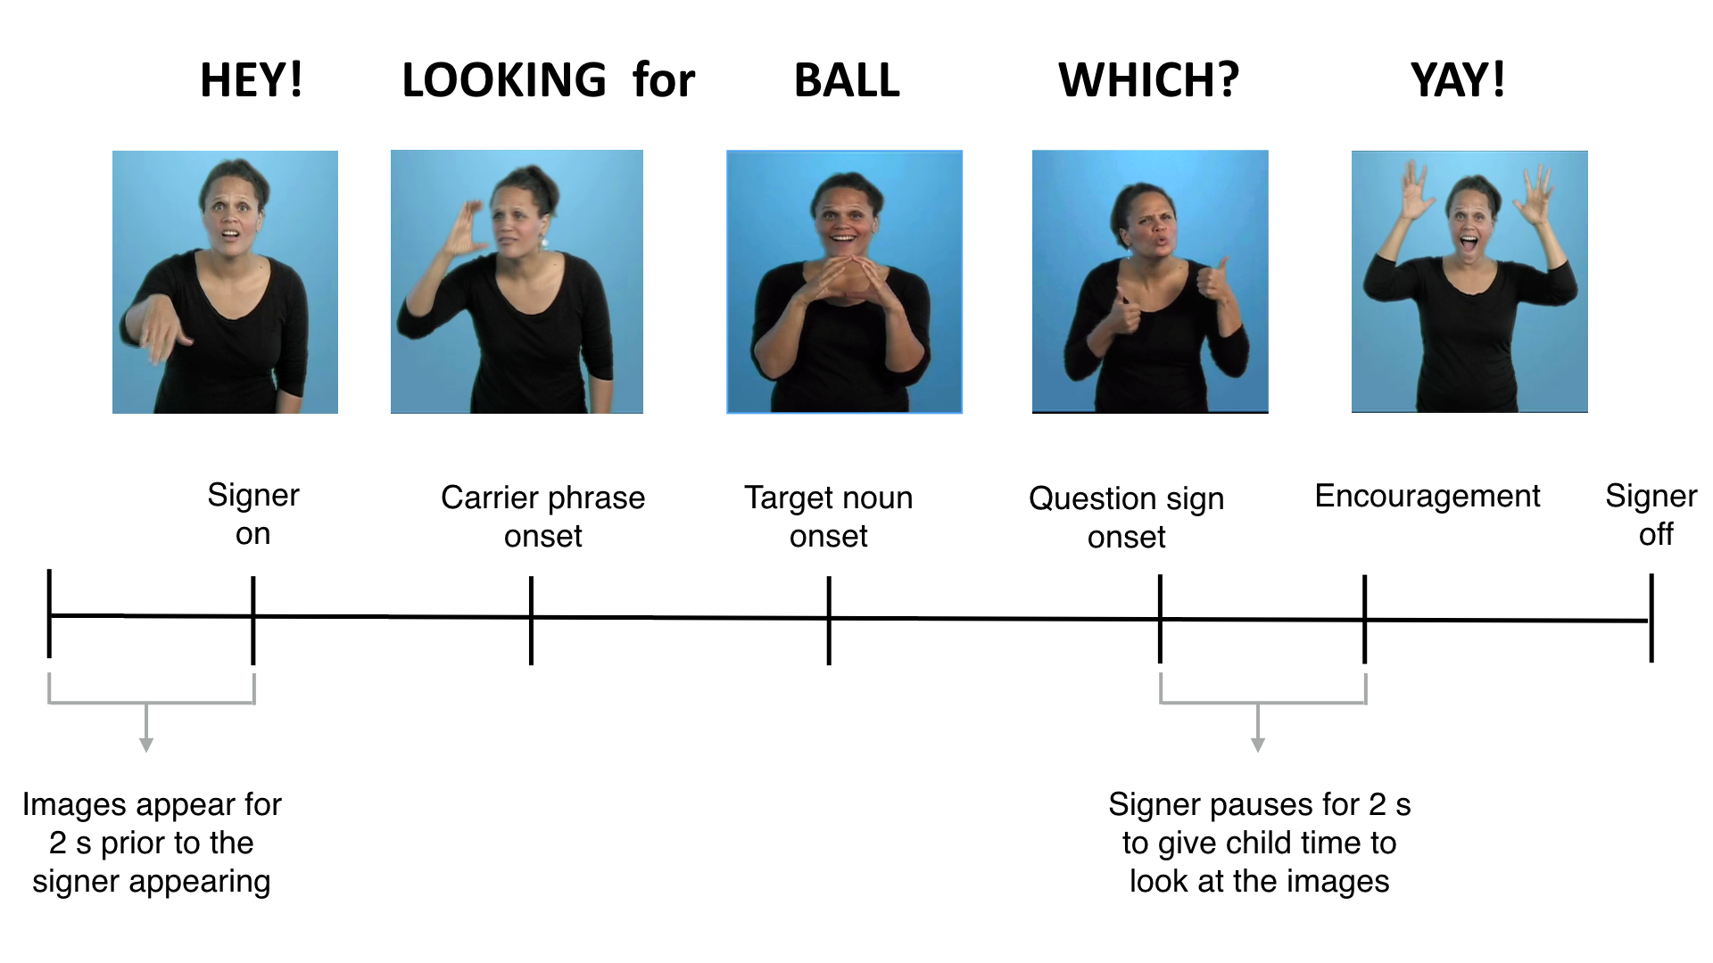task. Each trial lasted approximately 7 s.

**Figure 1:** Overview of the trial structure for one question type (sentence final wh-phrase) on the VLP task.

### Coding and reliability

Children’s and adults’ gaze patterns were videotaped and later coded frame-by-frame (33-ms resolution) by highly-trained coders blind to target side. On each trial, coders indicated whether the eyes were fixated on the central signer, one of the images (left or right picture), shifting between pictures, or away (off). This coding yielded a high-resolution record of eye movements aligned with target noun onset. Prior to coding, all sessions were pre-screened for parental interference and excluded on a trial-by-trial basis. A total of 25% of videos were re-coded to assess inter-coder reliability - agreement within a single frame averaged 98% on these reliability assessments.

### Calculating linguistic processing efficiency

*Computing critical sign onset.* In the VLP task, computing accuracy and RT requires defining the appropriate response window, starting at the earliest moment when there is sufficient information to discriminate the pairs of pictures and to initiate a shift in gaze off of the central signer and to the target image. In studies of spoken language processing, critical word onset is typically identified using acoustic analysis software that measures the moment in the auditory signal when there first is acoustic evidence of the target noun. In signed languages like ASL, phonological information is presented simultaneously in several parts of the visual signal (e.g., hands and face) making it difficult to precisely determine the beginning of the target sign. This problem is somewhat simplified in the VLP task because the pictures are presented in yoked pairs, and so on each trial, critical sign onset is always determined in reference to a particular distracter object, the name of which does not overlap phonologically with the target picture. Thus, sign onset can be defined as the earliest point in the signed sentence when the two pictures can be discriminated.

Here, we took an empirical approach to defining critical sign onset. As a starting point, the first and second authors, both fluent ASL signers, viewed each stimulus sentence and achieved a consensus regarding target noun onset. The next step was to validate these preliminary judgments by asking fluent native signers to identify the target pictures based on videos in which different amounts of the target sign was shown. For each sign token, we created six videos, each showing a different amount of the target sign, ranging from three frames before to three frames after the noun onsets defined by our initial consensus judgments. Since our experimental stimuli consisted of 3-4 tokens for each of the 8 target nouns (28 tokens), fluent adult signers unfamiliar with the stimuli (*n* = 10) watched 168 videos (28 x 6 videos) while viewing the same picture pairs as in the VLP task. On each trial, the signers made force-choice decisions indicating which of two images was signed in the video, yielding a proportion correct target identification for each of the 6 videos. For each sign token, final noun onset values were identified as the earliest point in the signed sentence at which adults successfully discriminated the pictures with 100% agreement. .

*Reaction Time:* In the VLP task, four different types of responses are possible on a given trial: (1) signer-to-target shift, (2) signer-to-distractor shift, (3) signer-to-away shift, and (4) no-shift. Reaction time (RT) corresponds to the latency to shift away from the central signer to the target picture on all signer-to-target shifts, measured from the empirically-defined onset of the target sign. Following Ratcliff (1993), we chose specific cutoff response times based on the empirical distribution of children’s RTs in our task. We selected the middle 90% of the RT distribution (600-2500 ms), since these data are the most likely to be generated by the underlying process of interest: children’s lexical access. Incorrect shifts (signer-to-distracter (19%), signer to away (14%), no-shift (8%)) were not included in the computation of mean RT. Since children varied in the likelihood that they would generate a signer-to-target shift, mean RTs were based on different numbers of trials across participants (*M* = 12.7 trials, range = 3—25).

The computation of RT assumes that children’s first shift reflects lexical access. However, it is possible that some children’s first signer-to-target shifts may be the result of randomly shifting off the signer. Thus, we excluded participants from the RT analysis if their shifting behavior over the course of the entire task was determined to likely be the result of guessing, since this suggests that the average latency of signer-to-target shifts is not a meaningful measure of language processing speed for these children. To quantify the probability that participants' initial shifts were the result of guessing, we computed the proportion of signer-to-target (correct) and signer-to-distracter (incorrect) shifts for each child. We then used a Bayesian latent mixture model implemented in JAGS (Plummer, 2003), in which we assumed that the observed data (children’s initial shifts away from the signer) were generated by two processes (guessing and knowledge) that had different overall probabilities of success, with the “guessing group” having a probability of 50% and the “knowledge” group having a probability > 50%. The group membership of each participant was a latent variable that we inferred based on that participant’s proportion of correct signer-to-target shifts relative to the overall proportion of correct shifts across all participants (see Lee & Wagenmakers (2013) for a detailed discussion of this modeling approach). Five children were excluded because more than 50% of their posterior probability mass indicated a guessing strategy with relatively little uncertainty -- posterior probabilities of 0.99, 0.78, 0.98, 0.98, and 0.94 respectively (mean proportion signer-to-target scores for these participants were: 0.54, 0.58, 0.42, 0.29, 0.33). Thus, only signer-to-target shifts for 24 children were included in the RT analyses.

*Target Accuracy:* Correct looking is a function of the child’s tendency to shift quickly away from the central signer to the target picture in response to the target sign, and also to maintain fixation on the target picture. To determine the degree to which participants fixated the named picture across trials, mean proportion looking to target was calculated for each participant at each 33 ms frame from the onset of the target noun. Accuracy was defined as the mean proportion of time spent looking at the target picture out of the total time spent on either the target picture, the distracter picture, or the signer from 600 to 2500 ms from target noun onset. All children and response types were included in the computation of accuracy, nevertheless, the number of trials contributing to the analysis varied across participants (*M* = 19.1, range = 6 to 35).

# Results

First, we present an overview of looking behavior on the VLP task. Then we show that children become faster and more accurate at comprehending familiar signs as they get older and make progress towards adult levels of language fluency. We use multiple regression analyses to model the links between children’s real-time ASL processing skills and both age and productive ASL vocabulary. Finally, we present a comparison of deaf and hearing ASL learners’ performance on the VLP task.

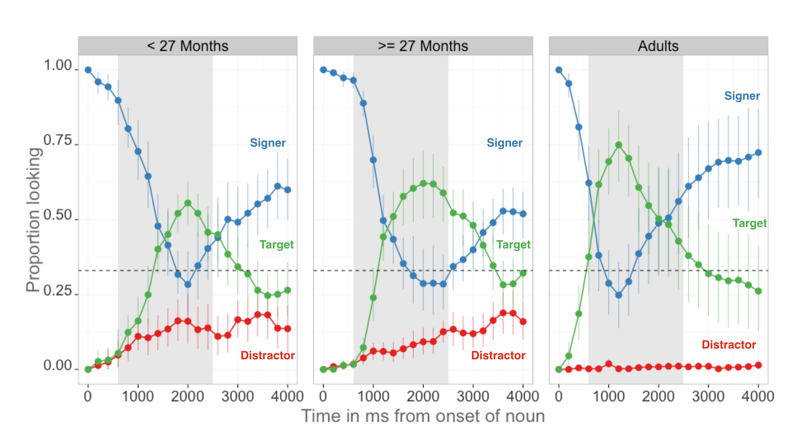**Figure 2:** *An overview of the time course of looking behavior for younger children, older children, and adults. The curves show proportion looking to the signer (blue), the target image (green), and the distractor image (red). The grey shaded region represents the analysis window (600-2500ms), and the error bars represent +/- 95% CI computed by non-parametric bootstrap.*

### Overview of ASL processing

Figure 2 provides an overview of the time course of looking behavior in the VLP task[3]. The three curves show changes in the mean proportion of trials on which participants in each age group fixated to the signer, the target image, or the distractor image at every 33 ms interval of the stimulus sentence. At the onset of the target sign, all participants are looking at the signer. As the sign unfolded, proportion looking to the signer decreases rapidly as participants shift their gaze to either the target or the distractor image. Proportion looking to the target increases sooner in the sentence and reaches a higher asymptote compared to proportion looking to the distractor for all age groups, providing evidence that even the youngest children were capable of doing the task. After looking to the target image, participants’ tended to rapidly shift their gaze back to the signer, reflected by the increase in proportion looking to signer around 2000 ms after target noun onset. In all three groups, proportion looking to distracter was small decreasing to almost zero in the adults(Younger = 0.12, Older = 0.05),

Figure 2 also provides an overview of age-related development in real-time ASL processing efficiency. Older children spent more time looking to the target picture compared to younger children, but not as much as adults (reflected by the increase in asymptote for the target looking curve across the three age groups). Moreover, older children tended to shift to the target picture sooner in the sentence than younger children, but not as rapidly as adults (reflected by the slope of the target looking curve).

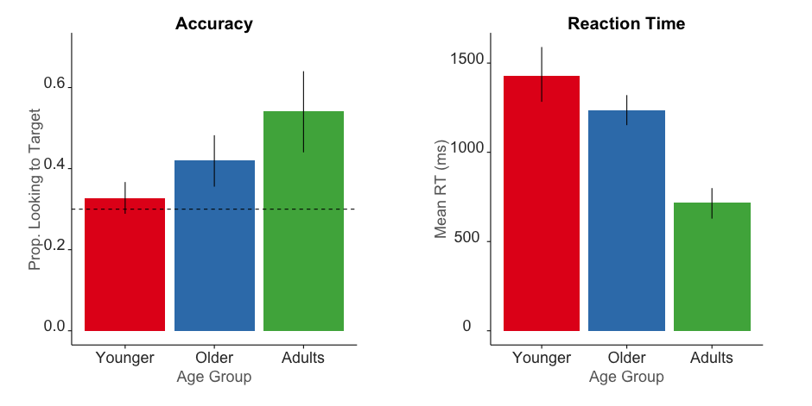Figure 3 shows group-level summary measures of ASL processing efficiency, and Table 1 shows the summary statistics for these measures. Younger children were less accurate (t(27) = -2.96, d = 1.1) and had longer mean latencies to orient to the target image (t(22) = 2.05, d = 0.57). As a group, children were less accurate (t(43) = 3.28, d = 1.1 ) and slower to shift to the target image (t(43) = -8.85 , d = 2.67) compared to adults.

**Figure 3.** Summary measures of developmental changes in ASL processing efficiency.The left panel shows mean Accuracy, and the right panel shows mean RT. Error bars represent +/- 95% CI computed by non-parametric bootstrap.

|  |  |  |  |
| --- | --- | --- | --- |
| **Age Group** | **Accuracy** | **RT** | |
| < 27 Months | 0.33 (0.08) |  | 1374 (265) | |
| >= 27 Months | 0.42 (0.13) |  | 1237 (169) | |
| Adults | 0.54 (0.22) |  | 717 (182) | |

**Table 1.** Means and standard deviations for Accuracy and Reaction Time on the VLP task for each age group: younger children, older children, and adults.

### Links between processing efficiency and age

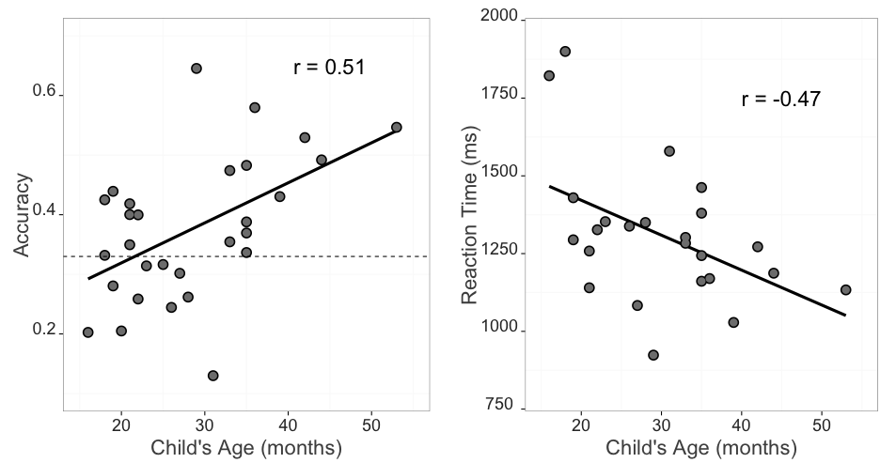Mean accuracy scores, computed over the 600–2500 ms window from noun onset, were examined as a function of age. Accuracy was strongly correlated with age ((27) = 0.51), indicating that older ASL learners were more reliable than younger children in fixating the target picture. Mean reaction times were negatively correlated with age ((22) = -0.47), indicating that older children were faster to shift to the target picture than younger ones. Mean reaction times were also negatively correlated with mean accuracy scores ((22) = -0.6) such that those children who were faster to shift to the target were also more likely to stick on the target image throughout a greater proportion of the analysis window. Figure 4 shows these relations.

***Figure 4:*** *Scatterplot of the relation between scores on the VLP measures and children’s age. Left Panel shows the positive relationship between accuracy and age. Right panel shows the negative relationship between RT and age.*

Together, the Accuracy and Reaction Time analyses show that signers will reliably leave a central signer to shift to a target image in the VLP task. Importantly, signers varied in their response times and accuracy, and this variation was meaningfully linked to age. Thus, like children learning spoken language, ASL learners improve their real-time language processing skills over the second and third years of life, progressing towards adult levels of language fluency.

### Links between processing efficiency and vocabulary

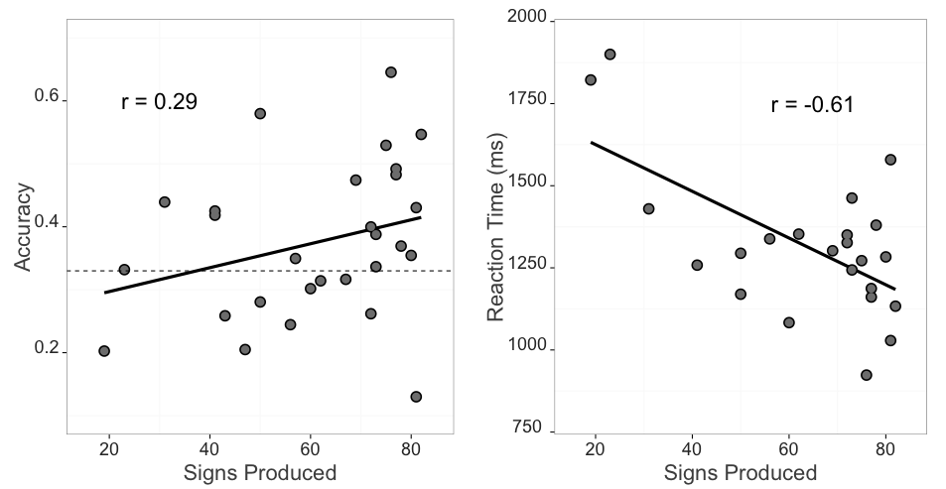Figure 5 shows the relationships between both VLP processing measures and children's productive ASL vocabulary. Mean accuracy was positively related to vocabulary size ((27) = 0.29) such that children with higher accuracy scores also had larger productive vocabularies. Mean reaction times were negatively correlated with vocabulary ((22) = -0.61) indicating that children who were faster to recognize ASL signs were those children with larger sign vocabularies.

**Figure 5:** Relation between VLP measures and productive ASL vocabulary. Left panel shows the positive relationship between accuracy and vocabulary. Right panel shows the negative relationship between RT and vocabulary.

It is important to point out that age and vocabulary were strongly intercorrelated in our sample ((21) = 0.74). To quantify the effect of each factor on children's online language processing skills, we fit separate multiple regression models to children's accuracy and RT data (Tables 1 and 2 show model specification and output). In the accuracy model, age and vocabulary together accounted for approximately 30.1% of the variance in accuracy ((2, 25) = 5.4). Although vocabulary did not contribute significant variance after age was taken into account (-change: 21.9%), age contributed approximately 17.5% additional variance beyond vocabulary. Thus, the majority of the variation in accuracy was attributable to the shared variance between these two factors, yet some sources of individual differences in accuracy were attributable to age above and beyond vocabulary.

|  |  |  |  |  |
| --- | --- | --- | --- | --- |
|  | Estimate | Std. Error | t.value | p.value |
| **Intercept** | 0.206 | 0.0733 | 2.82 | < .001 |
| **Vocabulary** | -0.00179 | 0.00172 | -1.04 | 0.309 |
| **Age** | 0.00964 | 0.00344 | 2.8 | < .01 |

***Table 2:*** *Multiple regression model output for accuracy data. The model was specified as: Accuracy ~ Vocabulary + Age.*

Next, we modeled predictors of children's RT. Table 3 shows that age and vocabulary together accounted for approximately 36.5% of the variance in RT. However, in contrast to accuracy, only vocabulary remained a significant predictor after including age in the model (r2-change = 17.5%). Thus, children who were faster to identify the target sign also had larger vocabularies, even after controlling for age.

|  |  |  |  |  |
| --- | --- | --- | --- | --- |
|  | Estimate | Std. Error | t.value | p.value |
| **Intercept** | 1795 | 145 | 12.4 | < .001 |
| **Vocabulary** | -5.76 | 3.12 | -1.85 | 0.07 |
| **Age** | -3.7 | 6.41 | -0.577 | 0.57 |

***Table 3:*** *Multiple regression model output for RT data. The model was specified as: RT ~ Vocabulary + Age*

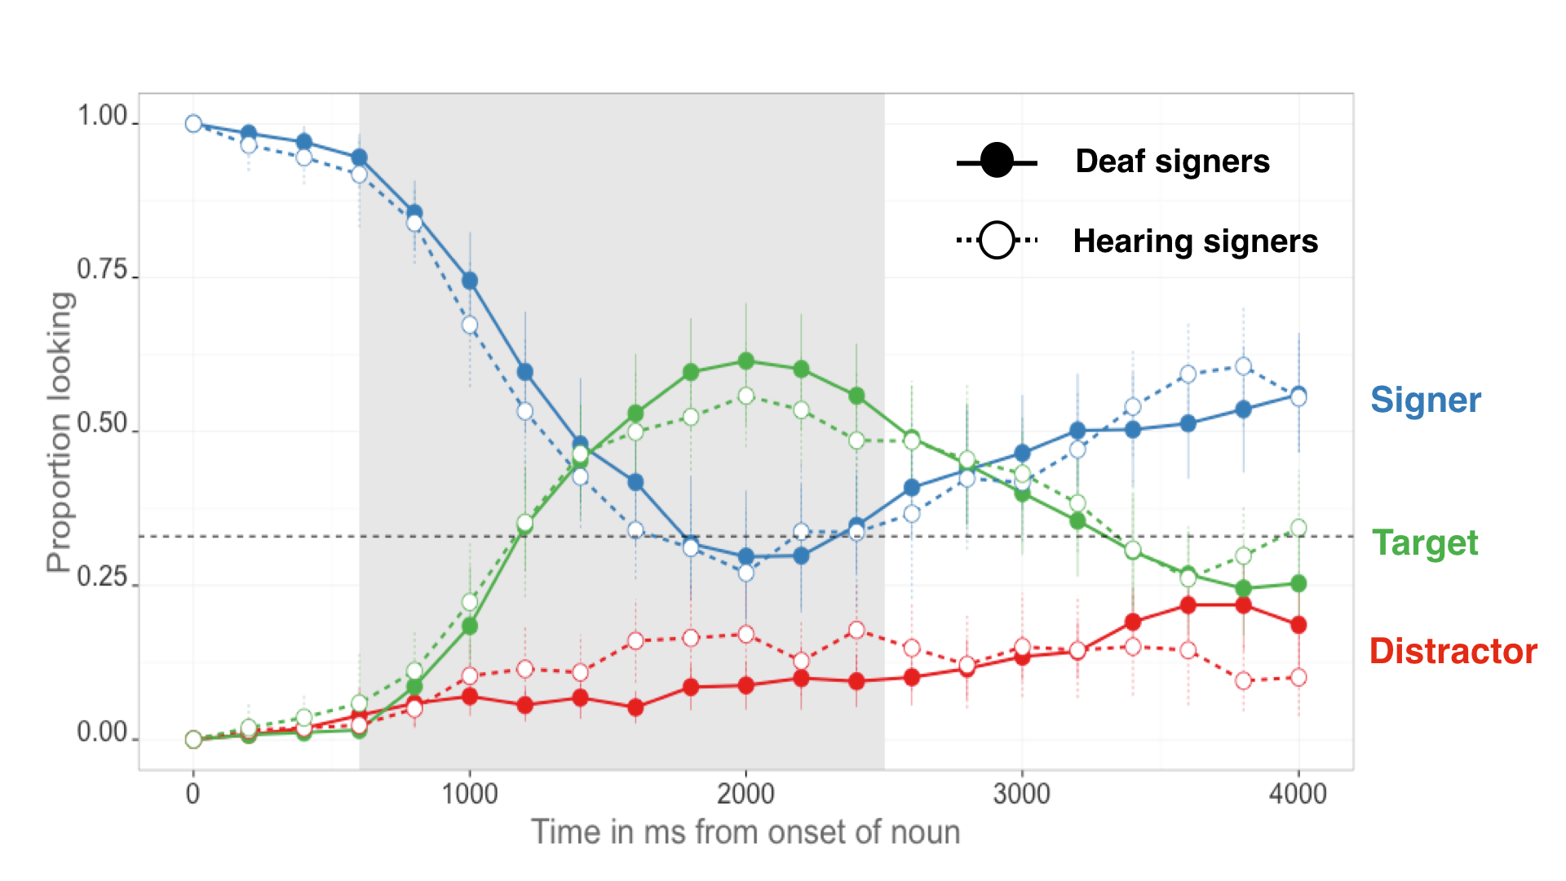Taken together, these analyses indicate that children learning ASL were more accurate and efficient in identifying the referents of familiar signs as they got older and developed a larger expressive vocabulary. These findings are consistent with previous research with monolingual children learning English or Spanish (Fernald et al., 2006; Hurtado, Marchman, & Fernald, 2007).

***Figure 6.*** *The time course of looking behavior for deaf and hearing signers. The curves show proportion looking to the signer (blue), the target image (green), and the distractor image (red). The circle fill and the line type represent hearing status; the grey shaded region represents the analysis window (600-2500ms); error bars represent +/- 95% CI computed by non-parametric bootstrap.*

### Effects of hearing status

Figure 6 shows an overview of performance in the VLP task for deaf (n=16, = 28m, = 7.48m) and hearing (n=13, = 29m, = 11.19m) children. Overall, these two groups showed a remarkably similar time course of looking behavior: shifting away from the signer, increasing looks to the target, and shifting back to the signer at similar time points as the sign unfolded. We found no differences in Accuracy (t(27) = 0.93, ns.) or Reaction Time (t(22) = 0.16, ns.). These analyses provide evidence that auditory experience does not qualitatively change patterns of visual language processing observed in the VLP task.

# Discussion

Establishing reference in real-time is a fundamental component of language learning. With this study, we aimed to develop and validate the first measures of young ASL learners’ real-time language comprehension skills and explore the links between these skills and age, vocabulary, and hearing status. There are three main findings from this work.

The first main finding was that, like children learning spoken language (Fernald et al., 1998), young ASL learners' show measurable age-related improvement in the efficiency with which they processed language. Even in ASL-learning 2-year olds, looking to the target picture occurred rapidly, with few looks to the distracter. After establishing reference, signers tended to return to fixate the central signer. All of the target signs were familiar to children; yet older children more quickly and accurately identified the correct referents than younger children, were less likely to fixate the unlabeled picture and shifted more rapidly back to the information source. Evidence of these striking developmental changes provides additional evidence that ASL acquisition in native contexts follows a strikingly similar developmental path as children learning spoken language (Lillo-Martin, 1999; Mayberry & Squires, 2006). Moreover, this is the first study to show that real-time ASL *comprehension* skills are linked to early development. Prior work on the developmental trajectories of deaf children has relied on aspects of language production, often because production is easier to see, making it easier to measure. However, it is a well-known phenomenon in language acquisition that comprehension tends to precede production (see Clark, 2009). By developing a precise measure of real-time ASL comprehension, we have provided a tool that can measure children's language skills earlier in development.

The second result was the discovery of a link between early ASL processing skills and children's productive ASL vocabularies. ASL-learning children who knew more signs were also faster and more accurate in identifying the correct referent than those who were lexically less advanced. These results with children learning ASL are consistent with other studies with English- and Spanish- learning children, which find strong relations between efficiency in online language comprehension and other concurrent and longitudinal measures of linguistic achievement (Fernald et al., 2006, 2001; Marchman & Fernald, 2008; Zangl et al., 2005).

The third finding was that native ASL learning deaf and hearing children show remarkably similar patterns of visual language processing. Both groups showed similar speed of processing and spent about the same amount of time looking to the target image before looking back to the signer. These similarities suggest that auditory experience does not appear to qualitatively change the time course of visual language processing.

### Limitations

This study has several limitations that are worth noting. First, while our sample is large relative to past work investigating early ASL development, it is still a small sample. These results should be replicated in future studies that include more participants. We have made all of our stimuli, data, and analysis code publicly available at the project page for this study[4], with the hope that other researchers will benefit from what we have learned in this work.

Second, our sample included a broad age range of children. Recall that age explained the majority of individual variation in accuracy, but not in RT. Based on the strength of past evidence, it is likely that testing a narrower age range would allow us to see an independent effect of vocabulary size on both ASL processing measures. We need more evidence in order to best characterize the relationships between accuracy, RT, and vocabulary.

Third, the novelty of the VLP task makes it difficult to directly compare our findings with previous work on ASL and spoken language processing. For example, in contrast to prior ASL gating studies (e.g., Emmorey & Corina, 1990; Morford & Carlsen, 2011), our stimuli were full sentences signed in a child-directed manner, not isolated signs, and our dependent measure was the latency to shift gaze away from a signer to one of two images, not a free response. In addition, the VLP task contains a natural central fixation point – the signer – making it substantially different from previous work on the development of children’s spoken language processing (e.g., Fernald, 1998). These differences do not allow us to make any general claims about the time course of processing in signed vs. spoken languages in absolute terms. Nevertheless, our results again show remarkable similarities with previous findings with learners of spoken languages in terms of age-related changes and links to measures of vocabulary.

Finally, our sample is not representative of the majority of children learning ASL in the United States. We took great care to include only children who are native signers with exposure to ASL from birth. However, we might anticipate that the development of online language processing might look different in children who are late learners or who have much more heterogeneous and inconsistent language exposure. An important next step is to explore the relations between ASL processing skills and children's experience with signed languages. It is well known that children's efficiency of online processing is tightly linked to the quantity and quality of the speech that they hear (Hurtado et al., 2008; Weisleder & Fernald, 2013). We would expect similar relations in children learning ASL.

In sum, this study provides the first evidence that young ASL learners’ processing skills undergo remarkable developmental changes that are linked to meaningful vocabulary outcomes. Such age- and vocabulary-related links contribute to the now significant body of literature highlighting the parallels between signed and spoken language development when children are exposed to native sign input. Moreover, we found similar patterns for deaf and hearing ASL-learning children, suggesting that experience with ASL, and not deafness, shapes these visual language processing skills. We hope that the development of the VLP task will provide a useful method for researchers and educators, providing a way to track developmental trajectories of early language learning in native learners of ASL.

# References (count = 32; limit = 40)

Anderson, D., & Reilly, J. (2002). The MacArthur communicative development inventory: Normative data for American Sign Language. *Journal of Deaf Studies and Deaf Education*, 83–106.

Arendsen, J., Van Doorn, A. J., & de Ridder, H. (2009). When do people start to recognize signs?. *Gesture*, *9*(2), 207-236.

Bergelson, E., & Swingley, D. (2012). At 6 to 9 months, human infants know the meanings of many common nouns. *Proceedings of the National Academy of Sciences of the USA, 109,* 3253-3258.

Carreiras, M., Gutiérrez-Sigut, E., Baquero, S., & Corina, D. (2008). Lexical processing in Spanish Sign Language (lSE). *Journal of Memory and Language*, *58*(1), 100–122.

Clark, E. V. (2009). *First language acquisition*. Cambridge University Press.

Corina, D. P., & Emmorey, K. (1993). Lexical priming in American Sign Language. In *34th annual meeting of the Psychonomics Society*.

Corina, D. P., & Knapp, H. P. (2006). Lexical retrieval inAmerican Sign Language production. *Papers in Laboratory Phonology*, *8*, 213–240.

Emmorey, K., & Corina, D. (1990). Lexical recognition in sign language: Effects of phonetic structure and morphology. *Perceptual and Motor Skills*, *71*(3f), 1227–1252.

Fenson, L. (2007). *MacArthur-Bates communicative development inventories: User’s guide and technical manual*. Paul H. Brookes Publishing Company.

Fernald, A., & Marchman, V. A. (2012). Individual differences in lexical processing at 18 months predict vocabulary growth in typically developing and late-talking toddlers. *Child Development*, *83*(1), 203–222.

Fernald, A., Perfors, A., & Marchman, V. A. (2006). Picking up speed in understanding: Speech processing efficiency and vocabulary growth across the 2nd year. *Developmental Psychology*, *42*(1), 98.

Fernald, A., Pinto, J. P., Swingley, D., Weinberg, A., & McRoberts, G. W. (1998). Rapid gains in speed of verbal processing by infants in the 2nd year. *Psychological Science*, *9*(3), 228–231.

Grosjean, F. (1980). Spoken word recognition processes and the gating paradigm. *Perception & Psychophysics*, *28*(4), 267–283.

Harris, M., & Mohay, H. (1997). Learning to look in the right place: A comparison of attentional behavior in deaf children with deaf and hearing mothers. *Journal of Deaf Studies and Deaf Education*, *2*(2), 95–103.

Hurtado, N., Marchman, V. A., & Fernald, A. (2007). Spoken word recognition by Latino children learning Spanish as their first language. *Journal of Child Language*, *34*(02), 227–249.

Hurtado, N., Marchman, V. A., & Fernald, A. (2008). Does input influence uptake? Links between maternal talk, processing speed and vocabulary size in Spanish-learning children. *Developmental Science*, *11*(6), F31–F39.

Lee, M., & Wagenmakers, E. (2013). Bayesian modeling for cognitive science: A practical course. *Cambridge UP*.

Lieberman, A. M., Borovsky, A., Hatrak, M., & Mayberry, R. I. (2014). Real-time processing of ASL signs: Delayed first language acquisition affects organization of the mental lexicon. *Journal of Experimental Psychology: Learning, Memory, and Cognition*.

Lieberman, A. M., Hatrak, M., & Mayberry, R. I. (2014). Learning to look for language: Development of joint attention in young deaf children. *Language Learning and Development*, *10*(1), 19–35.

Lillo-Martin, D. (1999). Modality effects and modularity in language acquisition: The acquisition of American Sign Language. *Handbook of Child Language Acquisition*, *531*, 567.

Marchman, V. A., & Fernald, A. (2008). Speed of word recognition and vocabulary knowledge in infancy predict cognitive and language outcomes in later childhood. *Developmental Science*, *11*(3), F9–F16.

Marslen-Wilson, W., & Zwitserlood, P. (1989). Accessing spoken words: The importance of word onsets. *Journal of Experimental Psychology: Human Perception and Performance*, *15*(3), 576.

Mayberry, R. I., & Squires, B. (2006). Sign language acquisition.

Meier, R. P., Mauk, C., Mirus, G. R., & Conlin, K. E. (1998). Motoric constraints on early sign acquisition. *29*, 63–72.

Mitchell, R. E., & Karchmer, M. A. (2004). Chasing the mythical ten percent: Parental hearing status of deaf and hard of hearing students in the United States. *Sign Language Studies*, *4*(2), 138–163.

Morford, J. P., & Carlson, M. L. (2011). Sign perception and recognition in non-native signers of ASL. *Language learning and development*, *7*(2), 149-168.

Newport, E. L., & Meier, R. P. (1985). *The acquisition of American Sign Language.* Lawrence Erlbaum Associates, Inc.

Petronio, K., & Lillo-Martin, D., (1997). WH-Movement and the Position of Spec-CP: Evidence from American Sign Language. *Language*, *73*(1), 18–57.

Plummer, M. (2003, March). JAGS: A program for analysis of Bayesian graphical models using Gibbs sampling. In *Proceedings of the 3rd international workshop on distributed statistical computing* (Vol. 124, p. 125). Technische Universit at Wien.

Ratcliff, R. (1993). Methods for dealing with reaction time outliers. *Psychological bulletin*, *114*(3), 510.45, R. P., & Spencer, P. E. (1997). What mothers do to support infant visual attention: Sensitivities to age and hearing status. *Journal of Deaf Studies and Deaf Education*, *2*(2), 104–114.

Weisleder, A., & Fernald, A. (2013). Talking to children matters: Early language experience strengthens processing and builds vocabulary. *Psychological Science*, *24*(11), 2143–2152.

Zangl, R., Klarman, L., Thal, D., Fernald, A., & Bates, E. (2005). Dynamics of word comprehension in infancy: Developments in timing, accuracy, and resistance to acoustic degradation. *Journal of Cognition and Development*, *6*(2), 179–208.

1. The stimuli can be viewed at the project page for this experiment: <https://github.com/kemacdonald/SOL>.
2. See Petronio, K. and Lillo-Martin, D., (1997) for a detailed discussion of the acceptability of these two question structures.
3. Preliminary analyses examined response patterns for the two sentence types separately and found no significant differences. Thus, all reported analyses collapse across the two sentence structures.
4. <https://github.com/kemacdonald/SOL>