Real-time lexical comprehension in young children learning American Sign Language (ASL)

Kyle MacDonald

Todd LaMarr

David Corina

Virginia A. Marchman

Anne Fernald

**Word count: 1958**= acknowledgements, +introduction, + discussion

# Author note:

We are grateful to the California School for the Deaf in Fremont, CA, and to the parents and children who participated in this research. Special thanks to Karina Pedersen, Lisalee Egbert, Laura Petersen, and Michele Berke for help with participant recruitment; to Pearlene Utley and Rosa Lee Timm for help with stimuli creation; to Michael Henry Tessler for help with data analysis; and to Shane Blau, Kat Adams, Melanie Ashland, and the staff of the Language Learning Lab at Stanford University. This work was made possible by an NIDCD grant to Anne Fernald and David Corina (R21 DC012505).

**Abstract**

The ability to interpret language rapidly is critical for the development of language proficiency. Research on real-time sentence processing has used eye movements to measure children’s emerging comprehension abilities. Here we developed the first measures of real-time comprehension of a *visual* *language*, American Sign Language (ASL) by very young children. Participants were 29 native ASL-learning children (16-53 mos, 16 deaf and 13 hearing) and 19 fluent adult signers. Children’s real-time processing skills in ASL improved with age, and variation in children’s processing efficiency was associated with vocabulary size, linking the ability to establish reference in real time with language learning. Moreover, both deaf and hearing ASL learners showed qualitatively similar patterns of looking behavior, suggesting that visual language processing is shaped by the immediate modality-specific constraints of processing a visual language. These findings indicate that processing efficiency is a fundamental skill essential for language learning regardless of language modality.

[149 words]

**Real-time lexical comprehension in young children learning**

**American Sign Language (ASL)**

Finding meaning in a spoken or a signed language requires learning to establish reference during real-time interaction – relying on audition to interpret spoken words, and on vision to interpret manual signs. Starting in infancy, children learning a spoken language make dramatic gains in their ability to link acoustic signals representing lexical forms to objects in the world. Studies of spoken language comprehension, using the Looking-while-Listening procedure, have measured children’s gaze as they look at pairs of familiar objects while listening to speech naming one of the objects (Bergelson & Swingley, 2013; Fernald et. al., 1998). Such research finds that young listeners show age-related increases in the speed and accuracy with which they recognize familiar objects, shifting gaze as soon as the auditory information is sufficient to enable referent identification. Moreover, individual differences in real-time processing efficiency predict vocabulary growth and later language and cognitive outcomes (Fernald, Perfors & Marchman, 2006; Marchman & Fernald, 2008).

However, little is known about how children learning a visual language develop skill in comprehending signs from moment to moment. Here, we adapt the LWL procedure to develop the first high-resolution measures of speed and accuracy in real-time language processing in American Sign Language (ASL). First, we ask whether children learning ASL show age-related increases in processing efficiency parallel to those previously shown in children learning spoken language. Second, we explore whether variability in processing skill among ASL-learning children is related to their expressive vocabulary development, again as in children learning spoken language. Finally, we compare the accuracy and time course of ASL processing in deaf and hearing native-ASL learners.

### ASL processing in adults

Psycholinguistic studies of adults show that language processing in signed and spoken languages is similar in many ways. For example, as in spoken language processing, signers are influenced by both lexicality and frequency; non-signs are identified more slowly than real signs (Corina & Emmorey, 1993) and high frequency signs are recognized faster than low frequency signs (Carreiras, Gutiérrez-Sigut, Baquero, & Corina, 2008). Using an eye-tracking procedure, Lieberman, Borovsky, Hatrak, & Mayberry (2014) found that adult signers are also sensitive to sub-lexical features of signs during real-time comprehension, showing evidence of incremental semantic processing.

However, differences between spoken and signed languages in the linguistic structure and surface features of lexical forms could have consequences for the time course of sign interpretation (Corina & Knapp, 2006). Using a gating procedure, Emmorey & Corina (1990) showed deaf adults increasingly longer videos of signs in isolation and asked them to identify the signs in an open-ended, non-timed response format, while. English speakers in this study heard increasingly longer segments of spoken words in isolation. Accurate identification of signed words required relatively less of the linguistic signal as compared to spoken word identification, suggesting that features of visual-manual languages such as simultaneous presentation of phonological information might alter the time course of lexical access. Thus, there are parallels and differences between signed and spoken language processing by adults. However, no previous studies have explored the development of real-time language comprehension in young ASL-learners.

### Lexical development in ASL

Diary studies of sign language acquisition show that ASL-learners follow a similar developmental path as children learning spoken languages (Lillo-Martin, 1999; Mayberry & Squires, 2006). For example, young signers typically produce recognizable signs before the end of the first year and two-sign sentences by their 2nd birthday (Newport & Meier, 1985). And as in spoken language, young ASL learners tend first to learn more nouns than verbs or other predicates (Anderson & Reilly, 2002).

Other research has investigated how the visual nature of sign language might influence children’s interactions with caregivers and thus affect learning mechanisms such as joint attention that support lexical development (Tomasello & Farrar, 1986). Because children learning ASL must rely on vision to process linguistic information and to look at referenced objects, they must alternate gaze between the signer and objects in the environment to achieve joint attention (Harris & Mohay, 1997). In an observational study of caregiver-child interactions in deaf and hearing dyads, Lieberman, Hatrak, & Mayberry (2014) found that deaf children frequently shifted their gaze to caregivers during book reading to maintain contact with the signed signal. Hearing children, in contrast, looked continuously at the book while the caregiver was speaking, rarely shifting gaze to the caregiver.

Taken together, these findings show that lexical development in children learning signed and spoken languages is parallel in important ways, but that modality-specific features could alter the time-course of establishing reference for children learning a visual language. Moreover, little is known about differences between deaf and hearing ASL learners in their real-time comprehension of ASL. One possibility is that the time course of lexical access will be similar in deaf and hearing signers, driven by the immediate modality-specific constraints of comprehending a visual language in real time. Another possibility is that given their extensive experience relying on vision to monitor both the linguistic signal and the named referent, deaf children will wait longer to disengage from the signer. Here, we present the first comparison of real-time processing in deaf and hearing native-ASL learners.

### Research questions

By adapting a well-established paradigm for measuring spoken language processing efficiency in young visual language learners, we addressed three main questions. First, do children learning ASL show development of speed and accuracy in real-time processing of familiar signs in ways that are parallel to children learning spoken language? Second, are differences among ASL-learning children in real-time processing skills related to differences in expressive vocabulary development, as in children learning spoken language? And third, how do deaf and hearing ASL-learners compare in the accuracy and time course of real-time lexical processing?

# Method

### Participants

This exploratory study is the first to measure American Sign Language processing skills in young children. Participants were 16 deaf and 13 hearing children with native exposure to ASL (17 females, 12 males, = 28.5 months, range = 16-53 months) and 19 fluent adult signers, recruited by bi-cultural/bilingual researchers fluent in ASL. Our sample size was determined by our success over the 2-year period of an NIDCD R21 grant in recruiting and testing children and adults who were native ASL users. Children learning ASL from birth from a native signer are a difficult population to recruit, given that approximately 95% of deaf children are born to hearing parents with little prior exposure to a signed language (Mitchell & Karchmer, 2004). The majority of child participants were recruited through a center-based early childhood education program in which ASL was the primary mode of instruction. All children were exposed to ASL from birth through extensive interaction with at least one fluent ASL caregiver, and they currently used ASL as their primary mode of communication at home. Adult participants were all fluent users of ASL and reported using ASL as their primary method of communication. All participants who met the inclusionary criteria and who had complete data were analyzed. An additional 17 child participants were tested but not included in the analyses because they were not exposed to ASL from birth (*n* = 12) or they did not complete the real-time language assessment (*n* = 5).

### Measures

*Expressive vocabulary size*: Parents completed a 90-item vocabulary checklist based on the MacArthur-Bates Communicative Development Inventories (Fenson et al., 2007) and designed to be linguistically appropriate for children learning ASL. Vocabulary size was computed as the number of signs reported to be produced.

*ASL Processing*: Efficiency in online comprehension was assessed using a version of the Looking-while-Listening procedure (Fernald et al., 2008) adapted for ASL learners, which we call the Visual Language Processing (VLP) task[1]. The VLP task yields two measures of processing efficiency, reaction time (RT) and accuracy. RT corresponds to the latency to shift the target picture after the onset of the target noun, and accuracy corresponds to the amount of time spent looking at the target picture within a pre-defined response window. Since this is the first study to develop measures of online ASL processing efficiency in children of this age, several important modifications to the procedure were made, as described below.

### Procedure

In the VLP task, stimuli were presented using a Macbook Pro laptop connected to a 27” monitor. The child sat on their caregiver’s lap, and the child’s gaze was recorded using a digital camcorder set up behind the monitor. To minimize visual distractions, testing occurred in a portable 5’ by 5’ tent with opaque walls, which reduced the potential for visual distractions during the task. On each trial, pictures of two familiar objects appeared on the screen, a target object corresponding to the target noun, and a distracter object matched for visual salience. Between these two pictures was a central video of an adult female signing the name of one of the pictures. Participants saw a total of 32 test trials with five filler trials interspersed throughout (e.g. “YOU LIKE PICTURES? MORE WANT?”). These filler trials served to maintain children’s interest in the task.

Children and adults’ gaze patterns were videotaped and later coded frame-by-frame (33-ms resolution) by highly-trained coders blind to target side. On each trial, coders indicated whether the eyes were fixated on the central signer, one of the images (left or right picture), shifting between pictures, or away (off). This coding yielded a high-resolution record of eye movements aligned with target noun onset. Prior to coding, all trials were pre-screened for parental interference and excluded on a trial-by-trial basis. To assess inter-coder reliability, 25% of the videos were re-coded. Agreement within a single frame averaged 98% on these reliability assessments.

### Stimuli

*Linguistic stimuli.* To allow for generalization beyond characteristics of a specific signer and sentence structure, we recorded two separate sets of ASL stimuli. Both sets were recorded with a native ASL user, and each set used a different but acceptable ASL sentence structure for asking questions[2]:

* Sentence-initial wh-phrase: “HEY! WHERE [target noun]?”
* Sentence-final wh-phrase: “HEY! [target noun] WHERE?”

Before each sentence, the signer made a hand-wave gesture commonly used in ASL discourse to gain an interlocutor’s attention before initiating a linguistic utterance. This served to draw the children's attention to the signer in preparation for the upcoming sentence. To prepare the stimuli, two female native ASL users recorded several tokens of each sentence in a child-directed register. These candidate stimuli were digitized, analyzed, and edited using Final Cut Pro software. The final tokens were chosen based on naturalness.

*Visual stimuli.* Target nouns consisted of eight object names familiar to most children learning ASL at this age. Visual stimuli consisted of colorful digitized pictures of these objects presented in four fixed pairs, in which the object names had no phonological overlap (cat—bird, car—book, bear—doll, ball—shoe). Images were digitized pictures presented in fixed pairs, matched for visual salience with 3–4 tokens of each object type. Each object was a target four times and a distracter four times. Side of target picture was counterbalanced across trials.

### Trial Structure

Figure 1 shows the structure of a trial with one question type (sentence final wh-phrase) in the VLP task. On each trial, the child saw two images of familiar objects on the screen for 2 s before the signer appeared. This allowed the child to inspect both images prior to the start of the sentence. Next, children saw a still frame of the signer for 1 s, which gave them the opportunity to orient to the signer prior to sentence onset. The target sentence was then presented, followed by a question and 2-s hold, followed by an exclamation to encourage attention to the task. Each trial lasted approximately 7 s.

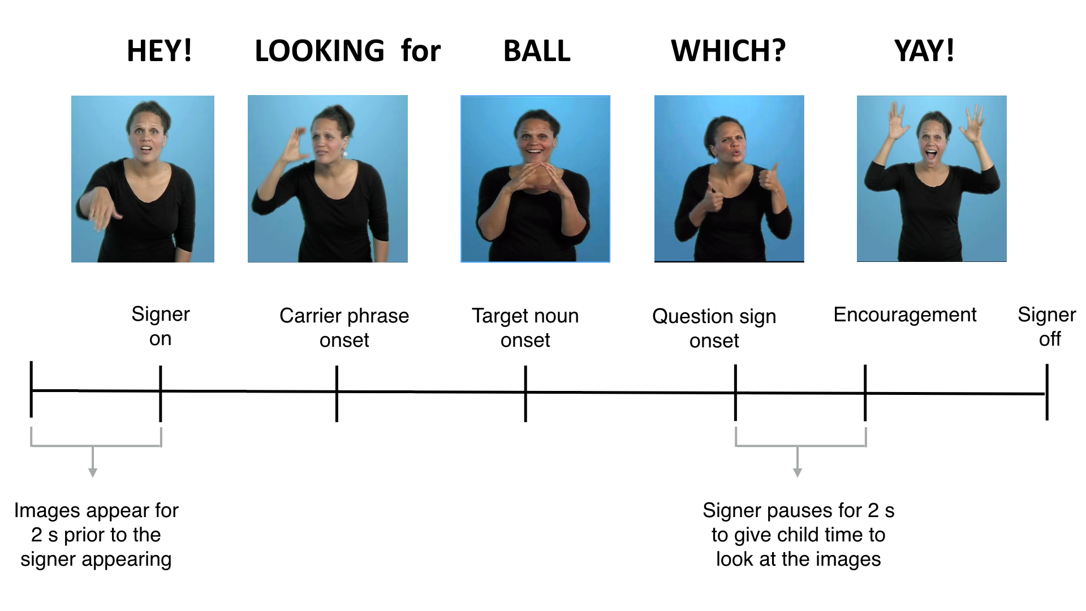**Figure 1:** Overview of the trial structure for one question type (sentence final wh-phrase) shown in the central video on the VLP task.

### Calculating measures of linguistic processing efficiency

*Computing target sign onset.* In the VLP task, computing accuracy and RT requires defining the appropriate response window, starting at the earliest moment when there is sufficient linguistic information to discriminate the pairs of pictures and to initiate a shift in gaze from the central signer to the named target image. In studies of spoken language processing, target word onset is typically identified as the first moment in the auditory signal when there acoustic evidence of the target noun. However, in signed languages like ASL, phonological information is presented in several parts of the visual signal (e.g., hands and face) simultaneously, making it difficult to precisely determine the beginning of the target sign. In the VLP task, this problem is somewhat simplified because the pictures are presented in yoked pairs; thus on each trial, target sign onset is always determined in reference to a particular distracter object, the name of which does not overlap phonologically with the target object. Thus, target sign onset can be defined as the earliest point in the signed sentence when the two pictures can be reliably discriminated.

Here, we took an empirical approach to defining target sign onset. As a starting point, the first and second authors, both fluent ASL signers, viewed each stimulus sentence and achieved consensus regarding the onset of the target noun. The next step was to validate these preliminary judgments by asking fluent native signers to identify the target pictures based on videos in which different amounts of the target sign were shown. Thus, for each sign token, we created six videos, each showing a different amount of the target sign, ranging from three frames before to three frames after the noun onset determined based on our initial consensus judgments. Since our experimental stimuli consisted of 3-4 tokens for each of the 8 target nouns (28 tokens), fluent adult signers unfamiliar with the stimuli (*n* = 10) watched 168 videos (28 x 6 videos) while viewing the same picture pairs as in the VLP task. On each trial, the signers made forced-choice decisions indicating which of two images was signed in the video, yielding a proportion correct target identification for each of the six videos. For each sign token, final target noun onset values were identified as the earliest point in the signed sentence at which adults discriminated the pictures with 100% agreement.

*Reaction Time (RT).* In the VLP task, four different types of responses are possible on a given trial: (1) signer-to-target object shift, (2) signer-to-distracter object shift, (3) signer-to-away shift, and (4) no shift. Reaction time (RT) corresponds to the latency to shift away from the central signer to the target picture on all signer-to-target shifts, measured from the empirically-defined onset of the target sign. Following Ratcliff (1993), we chose specific cutoff response times based on the empirical distribution of children’s RTs in our task. We selected the middle 90% of the RT distribution (600-2200 ms), since responses made during this window are most likely to be generated by the underlying process of interest: children’s lexical access. Incorrect shifts (signer-to-distracter (19%), signer-to-away (14%), no shift (8%)) were not included in the computation of median RT[3]. Since children varied in the likelihood that they would generate a signer-to-target shift, mean RTs were based on different numbers of trials across participants (*M* = 12.7 trials, range = 3-25).

*Target Accuracy.* Accuracy was defined as the mean proportion of time spent looking at the target picture out of the total time spent looking at either the target picture or the distracter picture from 600 to 2200 ms from target noun onset. Although the measure of mean RT was based only on correct signer-to-target shifts, the accuracy measure included both correct and incorrect shifts. While accuracy is in part a function of the child’s tendency to shift quickly from the central signer to the target picture in response to the target sign, accuracy also depends on how well the child maintains fixation on the target picture. To determine the degree to which participants shifted correctly and then fixated the named picture across trials, mean proportion looking to target was calculated for each participant at each 33 ms frame from the onset of the target noun, using the same response window as in the RT analyses. Although all children and response types were included in the computation of accuracy, the number of trials contributing to the analysis varied across participants (*M* = 19.1).

# Results

First, we present a high-level overview of our analytic approach and a qualitative analysis of developmental changes in looking behavior on the VLP task. Then, we present a series of Bayesian regression analyses showing that a) older children were faster and more accurate in comprehending familiar signs compared to younger children and b) children with better ASL processing skills also had larger ASL vocabularies. Finally, we compare the performance of deaf and hearing ASL-learning children and find no meaningful difference between the two groups, suggesting that auditory experience does not change the dynamics of reference in ASL.

We use Bayesian analyses for three reasons. First, it allowed us to deal with outliers in our data in a principled way. By excluding fewer participants we were able to maximize the data we had collected. Second, Bayesian methods allowed us to quantify support in favor of a null hypothesis – the lack of a difference between deaf and hearing ASL learners’ real-time processing skills. And third, we were able to include two kinds of relevant prior knowledge in order to more accurately estimate the strength of the associations between RT/accuracy on the VLP task and age/vocabulary. Specifically, we used previous work on the development of real-time processing efficiency in children learning spoken language (Fernald et al., 2008) to constrain the range of plausible values for the associations between RT/accuracy and age/vocabulary, and we quantified the quality of our RT measurements based on the probability that each participant was guessing during the task. Because the use of RT as a processing measure is based on the assumption that the timing of children’s first shifts reflects the speed of their lexical access and not random shifting, it was important to take the probability of guessing behavior into account. Thus, we created an analysis model where participants who were more likely to be guessers would have less of an influence on the estimated relations between RT and age/vocabulary[4].

In all of the Bayesian linear models, our goal is to infer the distribution of intercept and slope values that are most likely to characterize the associations between age/vocabulary and RT/accuracy. For each analysis, we present the following pieces of information: a) the Bayes Factor[5] (BF) computed via the Savage-Dickey method (Wagenmakers et al., 2010), which provides the strength of evidence for the linear model compared to an intercept-only model, b) the point estimates of the intercept, α, and the slope, β, that maximize the posterior probability of the data, and c) the 95% Highest Density Interval[6] (HDI) of slope parameter’s posterior distribution, which provides information about the uncertainty of our estimate. Models with categorical predictors were implemented in STAN (Stan Development Team, 2016), and models with continuous predictors were implemented in JAGS (Plummer, 2003). The Supplemental Material available online presents more detail about all model specifications and simulations.

### Overview of ASL processing

In the first set of analyses, we compare real-time processing skills by ASL-learning children and fluent adult signers. Figure 2 provides an overview of the time course of looking behavior in the VLP task[7]. The three curves show changes in the mean proportion of trials on which participants in each age group fixated the signer, the target image, or the distracter image at every 33 ms interval of the stimulus sentence. At the onset of the target sign, all participants were looking at the signer. As the sign unfolded, mean proportion looking to the signer decreased rapidly as participants shifted their gaze to the target or the distracter image. Proportion looking to the target increased sooner in the sentence and reached a higher asymptote compared to proportion looking to the distracter for all age groups.

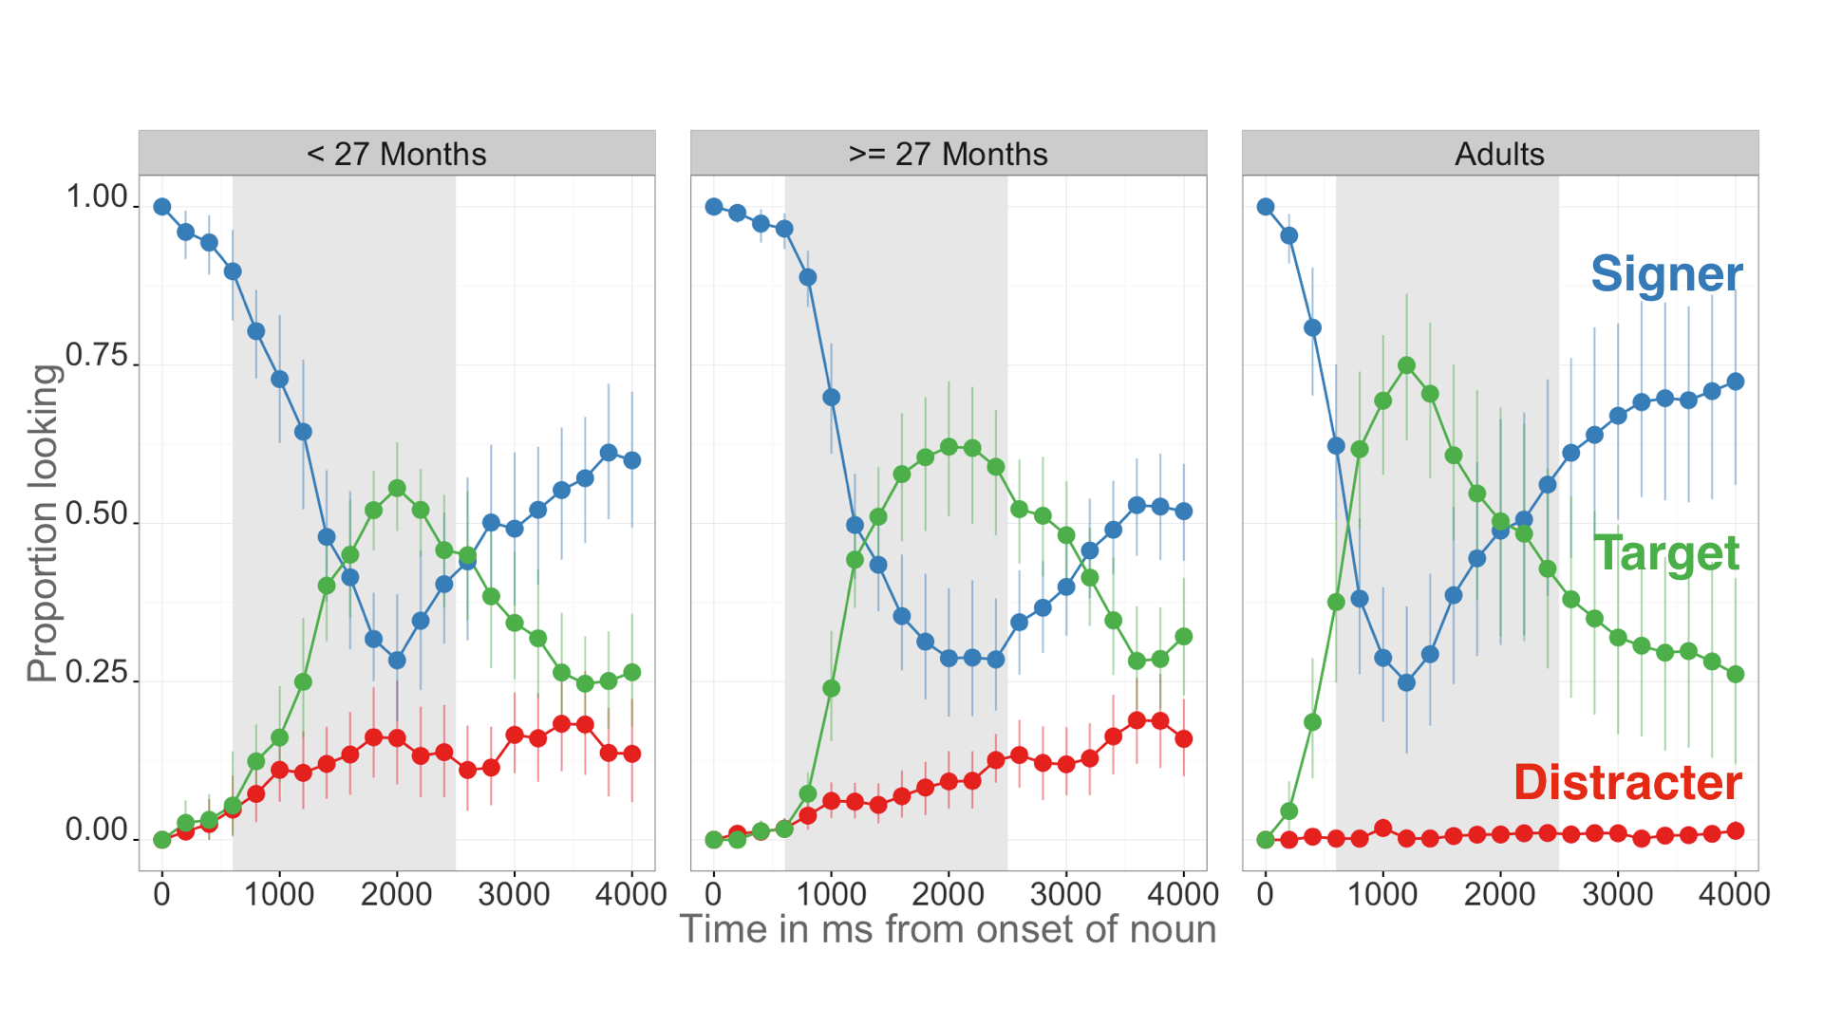**Figure 2:** *An overview of the time course of looking behavior for younger children, older children, and adults. The curves show the raw proportion looking to the signer (blue), the target image (green), and the distracter image (red). The grey shaded region represents the analysis window (600-2200ms) and the error bars represent +/- 95% CI computed by non-parametric bootstrap.*

When modeling the difference between proportions looking to the target vs. the distracter pictures for each age group, all three groups spent more time looking at the target (younger:= 0.32, 95% HDI [0.24, 0.40]; older:**=** 0.55, 95% HDI [0.47, 0.62]; adults: **=** 0.81, 95% HDI [0.74, 0.89]). Moreover, when we modeled mean target looking as a function of age group, the 95% HDI for each group did not include the value of 0.5 (younger:**β=** 0.59, 95% HDI [0.52, 0.65]; older:**β=** 0.70, 95% HDI [0.64, 0.76]; adults: **β=** 0.82, 95% HDI [0.76, 0.88]), providing evidence that, as a group, the lower bound of the mean estimates for accuracy for even the youngest children was above 0.5 (i.e., better than chance performance). After looking to the target image, participants tended to rapidly shift their gaze back to the signer, reflected by the increase in proportion looking to signer around 2000 ms after target noun onset. In all three groups, proportion looking to distracter was small, decreasing to almost zero in the adults (Younger = 0.26, Older = 0.12, Adults = 0.05).

Figure 2 also provides a visual overview of age-related change in real-time ASL processing efficiency. Older children were more accurate compared to younger children, but not as much as adults (reflected by the increase in asymptote for the target looking curve across the three age groups). Moreover, older children tended to shift to the target picture sooner in the sentence than did younger children, but not as rapidly as adults (reflected by the slope of the target looking curve).

Figure 3 shows group-level summary measures of ASL processing efficiency. Older children were more accurate than younger children ( = 0.11, 95% HDI [0.02, 0.19]) and had shorter mean RT to orient to the target image ( = -181.98, 95% HDI [-315.50, -40.01]). As a group, children were less accurate ( = -0.18, 95% HDI [0.10, 0.26]) and slower to shift to the target image ( = 379.28, 95% HDI [254.18, 526.51]) compared to adults. Importantly, none of the HDIs for each parameter estimate included zero, providing evidence that we were able to reliably measure group-level changes in ASL processing efficiency.

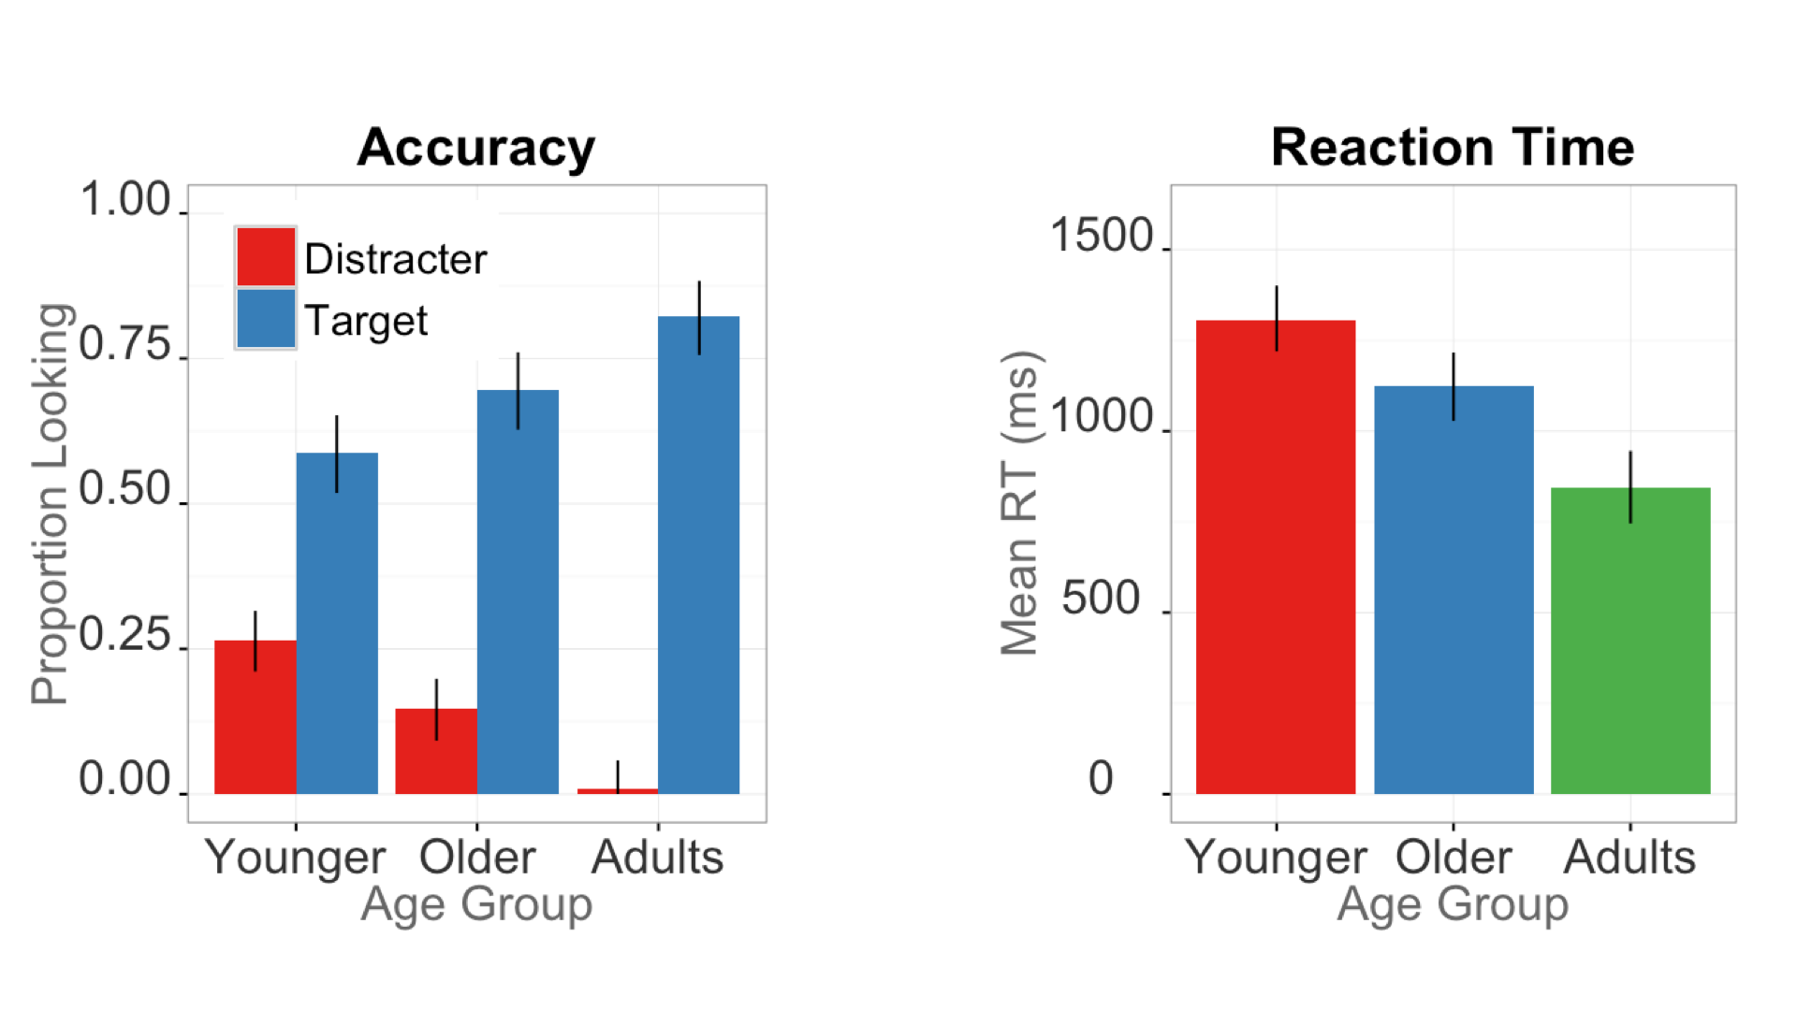

**Figure 3.** *Summary measures of developmental changes in ASL processing efficiency. The left panel shows mean Accuracy for younger kids, older kids, and adults; the right panel shows mean RT for all three groups. Error bars represent +/- 95% Highest Density Intervals.*

|  |  |  |  |  |  |
| --- | --- | --- | --- | --- | --- |
| Model |  | β MAP | 2.5% HDI | | 97.5% HDI |
| **Accuracy ~ Age** | 12.2 | 0.011 | | 0.002 | 0.012 |
| **Accuracy ~ Vocab** | 8.8 | 0.004 | | 0.001 | 0.006 |
| **RT ~ Age** | 1.5 | -6.414 | | -15.308 | -0.004 |
| **RT ~ Vocab** | 9.4 | -8.237 | | -10.00 | -0.55 |

***Table 1:*** *Summary of the four univariate linear models using age and vocabulary size to predict accuracy and reaction time.* is the Bayes Factor comparing the evidence in favor of linear model to an intercept-only (null) model; β *MAP is the maximum a posteriori estimate for the slope parameter for each model (strength of association); and the Highest Density Interval (HDI) shows the interval containing 95% of the plausible slope values given the model and the data.*

### Links between processing efficiency and age

In the next set of analyses, we use Bayesian linear regressions to explore the quantitative relations between individual children’s age and real-time processing skills. SOMETHING ABOUT PREVIOUS WORK IN SPOKEN LANUGAGE

Table 1 shows a summary of all four linear models that we report here[8]. Mean accuracy scores were positively associated with age (Figure 4A) indicating that older ASL learners were more accurate than younger children in fixating the target picture. More precisely, the Bayes Factor comparing the linear to the null model was 12.2, meaning that the linear model is 12 times more likely to explain the data. The beta estimates indicate that for each month of age children increased their accuracy score by 0.011, i.e., an increase of ~1% point, meaning that over the course of one year the model estimates a ~12% point gain in accuracy on the VLP task. Moreover, the value of zero was not included in the 95% Highest Density Interval, providing evidence for a positive association between age and accuracy.

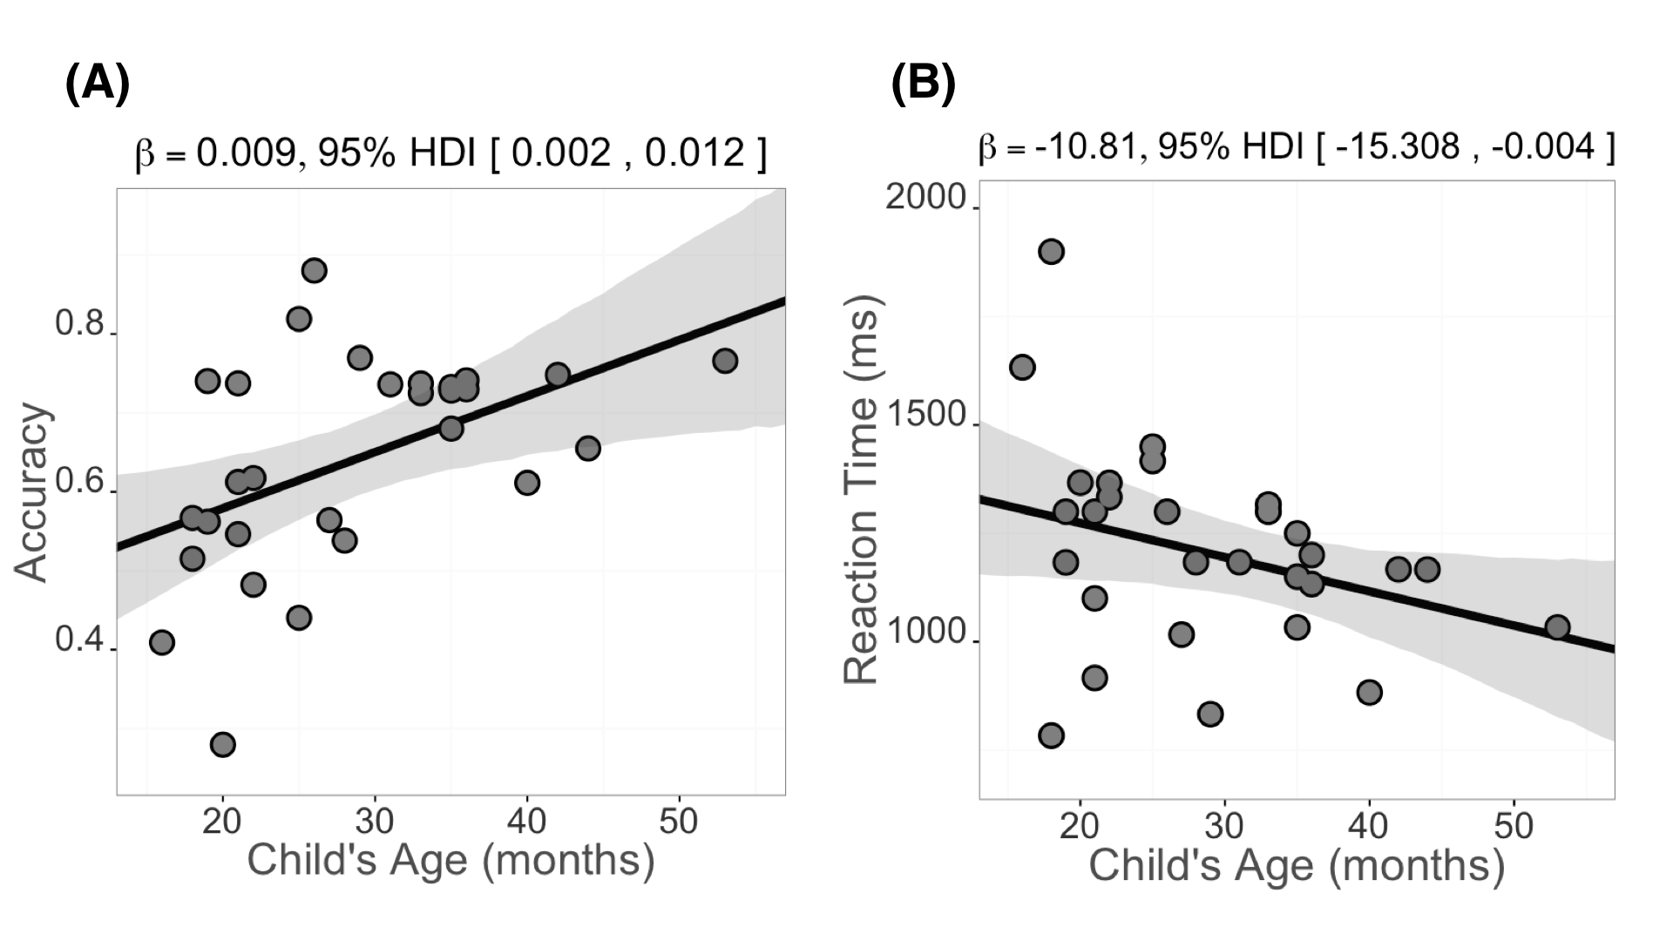

***Figure 4:*** *Scatterplots of the relations between children’s age and measures of their mean accuracy (panel A) and mean RT (panel B) in the VLP procedure. Each point represents a participant. The solid black line is the maximum a posteriori model estimate for the mean accuracy at each age point. The shaded gray regions represent the 95% Highest Density Interval around the regression line.*

Mean RTs were negatively associated with age (Figure 4B), with older children shifting more quickly to the target picture than younger children. The Bayes Factor was relatively small, in that the data were 1.5 times more likely given the linear model. The model estimates an ~6 ms gain in RT for each month, leading to ~72 ms gain over a year of development. However, the 95% HDI for the slope parameter in this analysis is wide, suggesting that there is relatively more uncertainty in our estimate of the association between age and RT. Mean RTs were also related to mean accuracy scores, such that those children who were faster to shift to the target were also more likely to maintain fixation on the target image throughout a greater proportion of the analysis window (**β=** -571.73, 95% HDI [-1357.60, -0.09]).

Together, the accuracy and RT analyses show that signers will reliably leave a central signer to shift to a target image in the VLP task. Importantly, signers varied in their response times and accuracy, and this variation was meaningfully linked to age. Thus, like children learning spoken language, ASL learners improve their real-time language processing skills over the second and third years of life as they make progress towards adult levels of language fluency.

### Links between processing efficiency and vocabulary

The next question we addressed was whether individual differences in processing skills were related to the size of children’s ASL vocabularies. Figure 5 shows relations between the processing measures, accuracy and RT (Figure 5B), and children's productive ASL vocabulary. Mean accuracy (Figure 5A) was positively related to vocabulary size ( = 8.83) such that children with higher accuracy scores also had larger productive vocabularies, with the model estimating a 0.004 (~0.5%) increase for each additional sign children knew. Moreover, mean RT was negatively associated with vocabulary ( = 9.42), indicating that children who were faster to recognize ASL signs were those with larger sign vocabularies, with each additional sign resulting in a ~8 ms decrease in estimated RT.

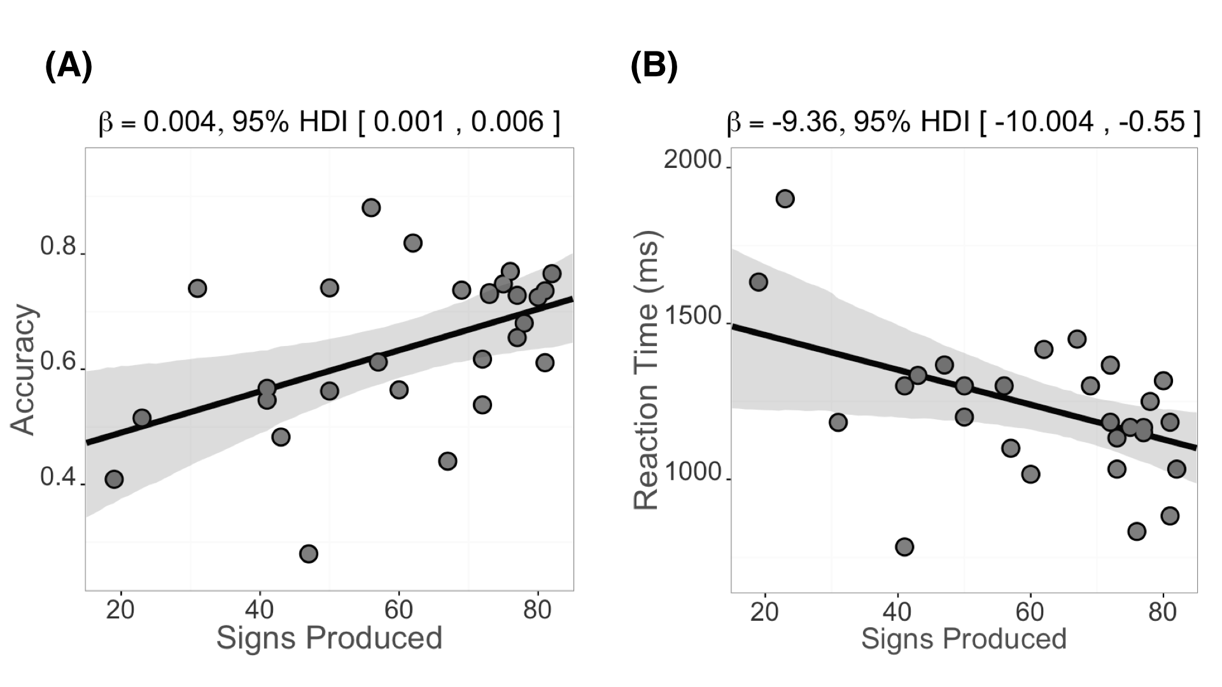

**Figure 5:**  Scatterplot of relations between children’s productive ASL vocabulary and measures of their mean accuracy (panel A) and mean RT (panel B) in the VLP procedure. Plotting conventions are the same as in Figure 4.

One important question is whether age and vocabulary make independent contributions to the development of real-time ASL processing skill. When we included both predictors in a multiple regression analysis, neither accounted for unique variance in our processing measures. This is unsurprising given the strong correlation between age and vocabulary in our sample ( = 0.74). This multicollinearity can lead to wide posterior distributions on parameter values, thus making it difficult to infer the unique contribution of each predictor (see McElreath [2016] for a discussion of issues related to multicollinearity). However, based on previous work on children’s processing of spoken language (e.g., Fernald & Marchman, 2012), we hypothesize that if participants were tested over a narrow age range, thus controlling for age, then vocabulary could emerge as a unique predictor of ASL processing skills.

Taken together, these analyses indicate that older children and children with larger expressive vocabularies were more accurate and efficient in identifying the referents of familiar signs. These findings parallel results in the substantial body of previous research with monolingual children learning English or Spanish (Fernald et al., 2006; Hurtado, Marchman, & Fernald, 2007).

### Effects of hearing status

In the final set of analyses, we compared deaf and hearing native ASL learning children’s performance on the VLP task. This exploratory analysis allows us to ask if auditory experience changed the dynamics of reference in a visual language. Figure 6 shows an overview of looking behavior in the VLP task for deaf (n=16, = 28m, = 7.48m) and hearing (n=13, = 29m, = 11.19m) children. Overall, these two groups showed a similar time course of looking behavior: shifting away from the signer, increasing looks to the target, and shifting back to the signer at similar time points as the sign unfolded. We found no differences in mean accuracy (= -0.04, 95% HDI [-0.12, 0.04]) or RT (= 69.25, 95% HDI [-83.60, 237.21]), with the HDI including zero for both models. Moreover, the Bayes Factor favored the null model indicating no difference between the two groups for each processing measure ( = 3.3, = 2.9). These analyses provide evidence that both hearing and deaf ASL-learners show parallel sensitivity to the modality-specific constraints of processing a visual language in real time. 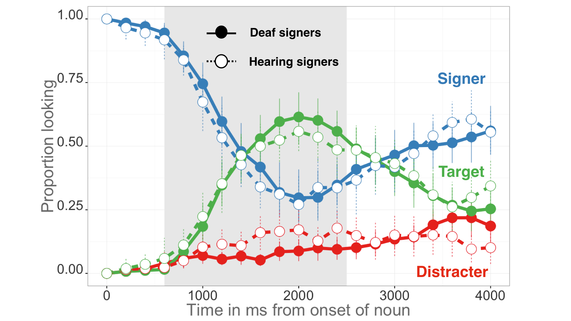

***Figure 6.*** *The time course of looking behavior for deaf and hearing signers. The curves show raw mean proportion looking to the signer (blue), the target image (green), and the distracter image (red). The circle fill and the line type represent hearing status; the grey shaded region represents the analysis window (600-2200ms); error bars represent +/- 95% CI computed by non-parametric bootstrap.*

# Discussion

Efficiency in establishing reference in real-time is a fundamental component of language learning. Here, we developed and validated the first measures of young ASL learners’ real-time language comprehension skills, exploring how language processing skills are linked to age, vocabulary, and hearing status. There are three main findings from this research.

The first is that, like children learning spoken language (Fernald et al., 1998), young ASL learners showed measurable age-related improvements in the efficiency with which they processed language. Even ASL-learning 2-year olds shifted from the signer to the target picture rapidly, with few false alarms to the distracter. However, although all target signs were familiar to all children, older children identified the correct referent more quickly and accurately and were less likely to shift to the unlabeled picture, as compared to younger children. These patterns of developmental change suggest that the real-time comprehension skills of children learning ASL in native contexts follow a similar developmental path to that of children learning spoken language, as has been shown in other domains (Lillo-Martin, 1999; Mayberry & Squires, 2006). Prior work on the developmental trajectories of deaf children has focused on language production, since production is easy to observe and to measure than comprehension. By developing a precise measure of real-time ASL comprehension, we were able to study the emergence of children's language skills much earlier in development than is possible using other methods.

The second main result is the discovery of a link between early ASL processing skills and children's productive ASL vocabularies. ASL-learning children who knew more signs were also faster and more accurate to identify the correct referent than those who were lexically less advanced. These results are consistent with other studies with English- and Spanish-learning children, which find strong relations between efficiency in online language comprehension and concurrent and longitudinal measures of linguistic achievement (Fernald et al., 2006; Marchman & Fernald, 2008).

The third finding is that deaf and hearing children learning ASL as a first language were similar in processing speed and spent about the same amount of time looking to the target image before looking back to the signer. Even though the hearing children could use both vision and hearing to process incoming information, this experience did not appear to change the time course of visual language processing compared to their deaf peers. Instead, both groups showed parallel sensitivity to the modality-specific constraints of processing a visual language in real time.

### Limitations

This research has several limitations. First, while the sample size was large relative to those in previous research on ASL, it was still a small sample. To facilitate replication, we have made all of our stimuli, data, and analysis code publicly available[9], with the hope that other researchers will benefit from what we have learned in this work.

Second, our sample included young children across a broad age range. Recall that using both age and vocabulary to predict accuracy or RT resulted in high levels of uncertainty about the contribution of either predictor. Based on past evidence, testing groups of children within a narrower age range might have revealed independent effects of vocabulary size on both ASL processing measures. Thus, more evidence is needed in order to best characterize the relations between accuracy, RT, and vocabulary in young ASL-learners.

Third, the novelty of the VLP task makes it difficult to directly compare our findings with previous work on ASL and spoken language processing. For example, in contrast to prior ASL gating studies with adults (e.g., Emmorey & Corina, 1990; Morford & Carlsen, 2011), our stimuli were full sentences signed in a child-directed register, not isolated signs, and our dependent measure used eye gaze, not an open-ended, free response. Moreover, the VLP task included a central fixation image – the signer – making it substantially different in task demands from previous studies of the development of children’s spoken language processing (e.g., Fernald et al. 1998). These differences do not allow us to make any general claims about the time course of processing in signed vs. spoken languages in absolute terms. Nevertheless, our results show impressive similarities with previous findings in learners of spoken languages in terms of age-related changes and links to measures of vocabulary.

Finally, our sample is not representative of the majority of children learning ASL in the United States. We took great care to include only children who were native signers with exposure to ASL from birth. It is very likely that the development of real-time language processing would look different in children who are late learners or who have more heterogeneous and inconsistent exposure to ASL. An important next step is to explore how differences in ASL processing are influenced by differences in children’s experience with signed languages. Since children's efficiency of real-time processing of spoken language is linked to the quantity and quality of the speech that they hear (Hurtado et al., 2008; Weisleder & Fernald, 2013; Marchman et al., 2016), we would expect similar relations in children learning ASL.

In conclusion, this study provides the first evidence that young ASL learners’ processing skills are meaningfully linked to age and to vocabulary outcomes. Such links contribute to the now significant body of literature highlighting parallels between signed and spoken language development when children are exposed to native sign input. Moreover, we found similar results for deaf and hearing ASL-learning children, suggesting that both groups were sensitive to the modality-specific constraints of processing a visual language in real-time. We hope that the VLP task will provide a useful method for both researchers and educators, providing a way to precisely track developmental trajectories of children learning ASL.

# References (count = 37; limit = 40)

Anderson, D., & Reilly, J. (2002). The MacArthur communicative development inventory: Normative data for American Sign Language. *Journal of Deaf Studies and Deaf Education*, 83–106.

Arendsen, J., Van Doorn, A. J., & de Ridder, H. (2009). When do people start to recognize signs?. *Gesture*, *9*(2), 207-236.

Bergelson, E., & Swingley, D. (2012). At 6 to 9 months, human infants know the meanings of many common nouns. *Proceedings of the National Academy of Sciences of the USA, 109,* 3253-3258.

Carreiras, M., Gutiérrez-Sigut, E., Baquero, S., & Corina, D. (2008). Lexical processing in Spanish Sign Language (lSE). *Journal of Memory and Language*, *58*(1), 100–122.

Corina, D. P., & Emmorey, K. (1993). Lexical priming in American Sign Language. In *34th annual meeting of the Psychonomics Society*.

Corina, D. P., & Knapp, H. P. (2006). Lexical retrieval inAmerican Sign Language production. *Papers in Laboratory Phonology*, *8*, 213–240.

Emmorey, K., & Corina, D. (1990). Lexical recognition in sign language: Effects of phonetic structure and morphology. *Perceptual and Motor Skills*, *71*(3f), 1227–1252.

Fenson, L. (2007). *MacArthur-Bates communicative development inventories: User’s guide and technical manual*. Paul H. Brookes Publishing Company.

Fernald, A., & Marchman, V. A. (2012). Individual differences in lexical processing at 18 months predict vocabulary growth in typically developing and late-talking toddlers. *Child Development*, *83*(1), 203–222.

Fernald, A., Perfors, A., & Marchman, V. A. (2006). Picking up speed in understanding: Speech processing efficiency and vocabulary growth across the 2nd year. *Developmental Psychology*, *42*(1), 98.

Fernald, A., Pinto, J. P., Swingley, D., Weinberg, A., & McRoberts, G. W. (1998). Rapid gains in speed of verbal processing by infants in the 2nd year. *Psychological Science*, *9*(3), 228–231.

Fernald, A., Zangl, R., Portillo, A. L., & Marchman, V. A. (2008). Looking while listening: Using eye movements to monitor spoken language.*Developmental psycholinguistics: On-line methods in children’s language processing*, 113-132.

Grosjean, F. (1980). Spoken word recognition processes and the gating paradigm. *Perception & Psychophysics*, *28*(4), 267–283.

Harris, M., & Mohay, H. (1997). Learning to look in the right place: A comparison of attentional behavior in deaf children with deaf and hearing mothers. *Journal of Deaf Studies and Deaf Education*, *2*(2), 95–103.

Hurtado, N., Marchman, V. A., & Fernald, A. (2007). Spoken word recognition by Latino children learning Spanish as their first language. *Journal of Child Language*, *34*(02), 227–249.

Hurtado, N., Marchman, V. A., & Fernald, A. (2008). Does input influence uptake? Links between maternal talk, processing speed and vocabulary size in Spanish-learning children. *Developmental Science*, *11*(6), F31–F39.

Lee, M.D., & Vanpaemel, W. (submitted). Determining informative priors for cognitive models.

Lee, M., & Wagenmakers, E. (2013). Bayesian modeling for cognitive science: A practical course. *Cambridge UP*.

Lieberman, A. M., Borovsky, A., Hatrak, M., & Mayberry, R. I. (2014). Real-time processing of ASL signs: Delayed first language acquisition affects organization of the mental lexicon. *Journal of Experimental Psychology: Learning, Memory, and Cognition*.

Lieberman, A. M., Hatrak, M., & Mayberry, R. I. (2014). Learning to look for language: Development of joint attention in young deaf children. *Language Learning and Development*, *10*(1), 19–35.

Lillo-Martin, D. (1999). Modality effects and modularity in language acquisition: The acquisition of American Sign Language. *Handbook of Child Language Acquisition*, *531*, 567.

Marchman, V. A., & Fernald, A. (2008). Speed of word recognition and vocabulary knowledge in infancy predict cognitive and language outcomes in later childhood. *Developmental Science*, *11*(3), F9–F16.

Marslen-Wilson, W., & Zwitserlood, P. (1989). Accessing spoken words: The importance of word onsets. *Journal of Experimental Psychology: Human Perception and Performance*, *15*(3), 576.

Mayberry, R. I., & Squires, B. (2006). Sign language acquisition.

McElreath, R. (2016). Statistical Rethinking: A Bayesian Course with Examples in R and Stan (Vol. 122). CRC Press.

Meier, R. P., Mauk, C., Mirus, G. R., & Conlin, K. E. (1998). Motoric constraints on early sign acquisition. *29*, 63–72.

Mitchell, R. E., & Karchmer, M. A. (2004). Chasing the mythical ten percent: Parental hearing status of deaf and hard of hearing students in the United States. *Sign Language Studies*, *4*(2), 138–163.

Morford, J. P., & Carlson, M. L. (2011). Sign perception and recognition in non-native signers of ASL. *Language learning and development*, *7*(2), 149-168.

Newport, E. L., & Meier, R. P. (1985). *The acquisition of American Sign Language.* Lawrence Erlbaum Associates, Inc.

Petronio, K., & Lillo-Martin, D., (1997). WH-Movement and the Position of Spec-CP: Evidence from American Sign Language. *Language*, *73*(1), 18–57.

Plummer, M. (2003, March). JAGS: A program for analysis of Bayesian graphical models using Gibbs sampling. In *Proceedings of the 3rd international workshop on distributed statistical computing* (Vol. 124, p. 125). Technische Universit at Wien.

Ratcliff, R. (1993). Methods for dealing with reaction time outliers. *Psychological bulletin*, *114*(3), 510.45, R. P., & Spencer, P. E. (1997). What mothers do to support infant visual attention: Sensitivities to age and hearing status. *Journal of Deaf Studies and Deaf Education*, *2*(2), 104–114.

Stan Development Team. 2016. RStan: the R interface to Stan, Version 2.9.0. http://mc-stan.org

Wagenmakers, E. J., Lodewyckx, T., Kuriyal, H., & Grasman, R. (2010). Bayesian hypothesis testing for psychologists: A tutorial on the Savage–Dickey method. *Cognitive psychology*, *60*(3), 158-189.

Weisleder, A., & Fernald, A. (2013). Talking to children matters: Early language experience strengthens processing and builds vocabulary. *Psychological Science*, *24*(11), 2143–2152.

Zangl, R., Klarman, L., Thal, D., Fernald, A., & Bates, E. (2005). Dynamics of word comprehension in infancy: Developments in timing, accuracy, and resistance to acoustic degradation. *Journal of Cognition and Development*, *6*(2), 179–208.

1. The stimuli can be viewed at the project page for this experiment: <https://github.com/kemacdonald/SOL>.
2. Each participant only saw one question type. See Petronio, K. and Lillo-Martin, D., (1997) for a detailed discussion of the acceptability of these two question structures.
3. We chose to use the median because this point estimate is less sensitive to outliers, which can have a large effect on individual RT estimates when participants contribute a small number of RTs.
4. Four children (ages: 18, 20, 22, and 25 months) had high posterior probability mass on guessing: posterior probabilities of 0.89, 0.86, 0.82, and 0.77, respectively (mean proportion signer-to-target scores for these participants were: 0.55, 0.46, 0.38, 0.33).
5. The Bayes Factor can be interpreted as a measure of the relative strength of evidence one model (M1) over another model (M2): e.g., a of 5 means that the data are 5 times more likely given M1.
6. The HDI can be interpreted as meaning there is a 95% chance that the true parameter value falls within this interval given the model specification and the data.
7. Preliminary analyses examined response patterns for the two sentence types separately and found no significant differences. Thus, all reported analyses collapse across the two sentence structures.
8. Recall that the latent mixture model used to infer participants’ guessing behavior was only fit for the RT analyses.
9. <https://github.com/kemacdonald/SOL>