Real-time lexical comprehension in young children learning American Sign Language (ASL)

Kyle MacDonald1, Todd LaMarr2, David Corina2,

Virginia A. Marchman1, & Anne Fernald1

1. Stanford University

2. UC Davis

Author Note:

We are grateful to the California School for the Deaf in Fremont, CA, and to the parents and children who participated in this research. Special thanks to Karina Pedersen, Lisalee Egbert, Laura Petersen, and Michele Berke for help with participant recruitment; to Pearlene Utley and Rosa Lee Timm for help with creating stimuli; to Michael Henry Tessler for help with data analysis; and to Shane Blau, Kat Adams, Melanie Ashland, and the staff of the Language Learning Lab at Stanford University. This work was made possible by an NIDCD grant to Anne Fernald and David Corina (R21 DC012505).

Abstract

The ability to interpret language rapidly is critical for the development of language proficiency. Research on real-time sentence processing has used eye movements to measure children’s emerging comprehension abilities. Here we developed the first measures of real-time comprehension of a *visual* *language*, American Sign Language (ASL), by very young children. Participants were 29 native ASL-learning children (16-53 mos, 16 deaf and 13 hearing) and 16 fluent adult signers. Deaf and hearing ASL-learners showed similar patterns of looking behavior, suggesting that visual language processing is shaped by the immediate modality-specific constraints of processing a visual language. Children’s real-time processing skills in ASL improved with age as they made progress towards adult-like fluency. Finally, variation in children’s processing efficiency was associated with vocabulary size, linking the ability to establish reference in real time with language learning. These findings indicate that processing efficiency is a fundamental skill for language acquisition regardless of language modality.

*Keywords:* sign language, language processing, language acquisition

Real-time lexical comprehension in young children learning American Sign Language (ASL)

Finding meaning in a spoken or a signed language requires learning to establish reference during real-time interaction – relying on audition to interpret spoken words, or on vision to interpret manual signs. Starting in infancy, children learning a spoken language make dramatic gains in their ability to link acoustic signals representing lexical forms to objects in the world. Studies of spoken language comprehension have measured children’s gaze as they look at pairs of familiar objects while listening to speech naming one of the objects (Fernald, Pinto, Swingley, Weinberg, & McRoberts, 1998; Law & Edwards, 2014; Venker, Eernisse, Saffran, & Ellis Weismer, 2013). Such research finds that young listeners show age-related increases in the speed and accuracy with which they recognize familiar objects, shifting gaze as soon as the auditory information is sufficient to enable referent identification. Moreover, individual differences in real-time processing efficiency predict vocabulary growth and later language and cognitive outcomes (Fernald, Perfors & Marchman, 2006; Marchman & Fernald, 2008).

However, little is known about how children learning a visual language develop skill in comprehending signs from moment to moment. Here, we adapt the Looking-while-Listening (LWL) procedure (Fernald, Zangl, Portillo, & Marchman, 2008) to develop the first high-resolution measures of speed and accuracy in real-time comprehension by very young children learning a visual language : American Sign Language (ASL). First, we compare the accuracy and time course of ASL processing in deaf and hearing children who are native ASL-learners. Next, we compare the performance of children learning ASL to fluent adult signers, and ask whether there are age-related increases in children’s processing efficiency that parallel those previously shown in children learning spoken language. Finally, we explore whether variability in processing skill among ASL-learning children is related to their expressive vocabulary development.

## ASL processing in adults

Psycholinguistic studies with adults show that language processing in signed and spoken languages is similar in many ways. For example, as in spoken language processing, signers are influenced by both lexicality and frequency; non-signs are identified more slowly than real signs (Corina & Emmorey, 1993) and high frequency signs are recognized faster than low frequency signs (Carreiras, Gutiérrez-Sigut, Baquero, & Corina, 2008). Using an eye-tracking procedure, Lieberman, Borovsky, Hatrak, & Mayberry (2014) found that adult signers are also sensitive to sub-lexical features of signs during real-time comprehension, showing evidence of incremental lexical processing.

However, differences between spoken and signed languages in the linguistic structure and surface features of lexical forms could have consequences for the time course of sign interpretation (Corina & Knapp, 2006). Using a gating procedure, Emmorey & Corina (1990) showed deaf adults increasingly longer videos of signs in isolation and asked them to identify the signs in an open-ended, non-timed response format. English-speaking adults in this study heard increasingly longer segments of spoken words in isolation. Accurate identification of signed words required relatively less of the linguistic signal as compared to spoken word identification, suggesting that features of visual-manual languages such as simultaneous presentation of phonological information might alter the time course of lexical access. Thus, there are both parallels and differences between signed and spoken language processing by adults. However, no previous studies have explored the development of real-time language comprehension in young ASL-learners.

## Lexical development in ASL

Diary studies of sign language acquisition show that ASL-learners follow a similar developmental path as children learning spoken languages (Lillo-Martin, 1999; Mayberry & Squires, 2006). For example, young signers typically produce recognizable signs before the end of the first year and two-sign sentences by their 2nd birthday (Newport & Meier, 1985). And as in many spoken languages (Waxman et al., 2013), young ASL learners tend first to learn more nouns than verbs or other predicates (Anderson & Reilly, 2002).

Other research has investigated how the visual nature of sign language might influence children’s interactions with caregivers and thus affect learning mechanisms, such as joint attention, that support lexical development (Tomasello & Farrar, 1986). Because children learning ASL must rely on vision both to process linguistic information and to look at referenced objects, they must alternate gaze between the signer and objects in the environment to achieve joint attention (Harris & Mohay, 1997). In an observational study of caregiver-child interactions in deaf and hearing dyads, Lieberman, Hatrak, and Mayberry (2014) found that deaf children frequently shifted their gaze to caregivers during book reading to maintain contact with the signed signal. Hearing children, in contrast, looked more continuously at the book while the caregiver was speaking, rarely shifting gaze to the caregiver.

Taken together, these findings show that lexical development is parallel in important ways in children learning signed and spoken languages, but that modality-specific features could alter the time-course of establishing reference for children learning a visual language. Yet little is known about potential differences between deaf and hearing ASL learners in their real-time comprehension of ASL. One possibility is that the time course of establishing reference is similar in deaf and hearing signers, driven by the immediate modality-specific constraints of comprehending a visual language in real time. Another possibility is that given the demands of relying on vision to monitor both the linguistic signal and the named referent, deaf children wait longer to disengage from the signer and to look toward the named referent than do hearing children. Here, we present the first comparison of real-time language processing in deaf and hearing native ASL-learners.

## Research questions

By adapting the LWL procedure (Fernald et al., 2008) for young visual language learners, we addressed three main questions. First, how do deaf and hearing ASL-learners compare in the accuracy and time course of real-time lexical processing? Second, like children learning spoken language, do ASL-learners show age-related development in real-time processing skill as they make progress towards adult levels of fluency? And third, are differences among ASL-learning children’s processing skills related to differences in expressive vocabulary development, as in children learning spoken language?

# Method

## Participants

Participants were 29 native, monolingual ASL-learning children (16 deaf, 13 hearing, 17 females, 12 males, = 28.5 months, range = 16-53 months) and 16 fluent adult signers. Native ASL-learners are an extremely difficult population to recruit. The incidence of deafness at birth in the US is only .002-.003%, and less than 5% of the 2-3 children per 1000 children born deaf have a deaf parent who is likely to be fluent in ASL (Mitchell & Karchmer, 2004). Moreover, a rapidly increasing number of deaf infants receive cochlear implants and are raised in exclusively oral language environments, further reducing the population of native ASL-learners. At the same time, many children born to deaf parents are themselves hearing, but live in homes where ASL is the primary language. Since the main goal of the current study was to document developmental changes in processing efficiency in native ASL-learners, we set strict inclusion criteria. All children, regardless of hearing status, were exposed to ASL from birth through extensive interaction with at least one fluent ASL caregiver. All children were reported to experience at least 80% ASL in their daily lives, and 25 of 29 lived in households with two deaf caregivers, fluent in ASL. Although the hearing children could access linguistic information in the auditory signal, we selected only native learners who used ASL as their primary mode of communication in and outside the home (10 out of 13 hearing children had two deaf caregivers and all participants reported >80% ASL exposure). Adult participants were all fluent signers who reported using ASL as their primary method of communication.

Our final sample size was determined by our success over a two-year funding period in recruiting and testing children who met our strict inclusion criteria: monolingual, native ASL users. We should note that an additional 17 ASL-learning child participants were tested but not included in the analyses because it was later determined that they were not exposed to ASL from birth (*n* = 12), or they did not complete the real-time language assessment (*n* = 5).

## Measures

*Expressive vocabulary size*: Parents completed a 90-item vocabulary checklist designed for young children learning ASL. Vocabulary size was computed as the number of signs reported to be produced by the child.

*ASL Processing*: Efficiency in online comprehension was assessed using a version of the LWL procedure adapted for ASL learners, which we call the Visual Language Processing (VLP) task. The VLP task yields two measures of processing efficiency, reaction time (RT) and accuracy. Since this was the first study to develop measures of online ASL processing efficiency in children of this age, several important modifications to the procedure were made, as described below.

## Procedure

The VLP task was presented on a Macbook Pro laptop connected to a 27” monitor. The child sat on their caregiver’s lap, and the child’s gaze was recorded using a digital camcorder set up behind the monitor. To minimize visual distractions, testing occurred in a portable 5’ by 5’ booth with cloth sides, which reduced visual distractions during the task. On each trial, pictures of two familiar objects appeared on the screen, a target object corresponding to the target noun, and a distracter object matched for visual salience. Between the two pictures was a central video of an adult female signing the name of one of the pictures. Participants saw 32 test trials with five filler trials (e.g. “YOU LIKE PICTURES? MORE WANT?”) interspersed to maintain children’s interest.

*Coding and Reliability.* Participants’ gaze patterns were videotaped and later coded frame-by-frame at 33-ms resolution by highly-trained coders blind to target side. On each trial, coders indicated whether the eyes were fixated on the central signer, one of the images, shifting between pictures, or away (off), yielding a high-resolution record of eye movements aligned with target noun onset. Prior to coding, all trials were pre-screened to exclude those few trials on which the participant was inattentive or there was external interference. To assess inter-coder reliability, 25% of the videos were re-coded. Agreement within a single frame averaged 98% on these reliability assessments.

## Stimuli

*Linguistic stimuli.* To allow for generalization beyond characteristics of a specific signer and sentence structure, we recorded two separate sets of ASL stimuli. Both sets were recorded with a native ASL signer, using alternative ASL sentence structures for asking questions (see Petronio and Lillo-Martin, 1997):

* Sentence-initial wh-phrase: “HEY! WHERE [target noun]?”
* Sentence-final wh-phrase: “HEY! [target noun] WHERE?”

To prepare the stimuli, two female native ASL users recorded several tokens of each sentence in a child-directed register. Before each sentence, the signer made a hand-wave gesture commonly used in ASL to gain an interlocutor’s attention before initiating an utterance. These candidate stimuli were digitized, analyzed, and edited using Final Cut Pro software. The final tokens were chosen based on naturalness.

*Visual stimuli.* Target nouns consisted of eight object names familiar to most children learning ASL at this age. Visual stimuli consisted of colorful digitized pictures of these objects presented in four fixed pairs, in which the object names had no phonological overlap (cat—bird, car—book, bear—doll, ball—shoe). Images were digitized pictures presented in fixed pairs, matched for visual salience with 3–4 tokens of each object type. Each object served as target four times and as distracter four times. Side of target picture was counterbalanced across trials.

## Trial Structure

Figure 1 shows the structure of a trial with a sentence-final *wh*-phrase, one of the two question types in the VLP task. On each trial, the child saw two images of familiar objects on the screen for 2 s before the signer appeared, allowing the child to inspect both images. Next, children saw a still frame of the signer for 1 s, so they could orient to the signer prior to sentence onset. The target sentence was then presented, followed by a question and 2-s hold, followed by an exclamation to encourage attention to the task.

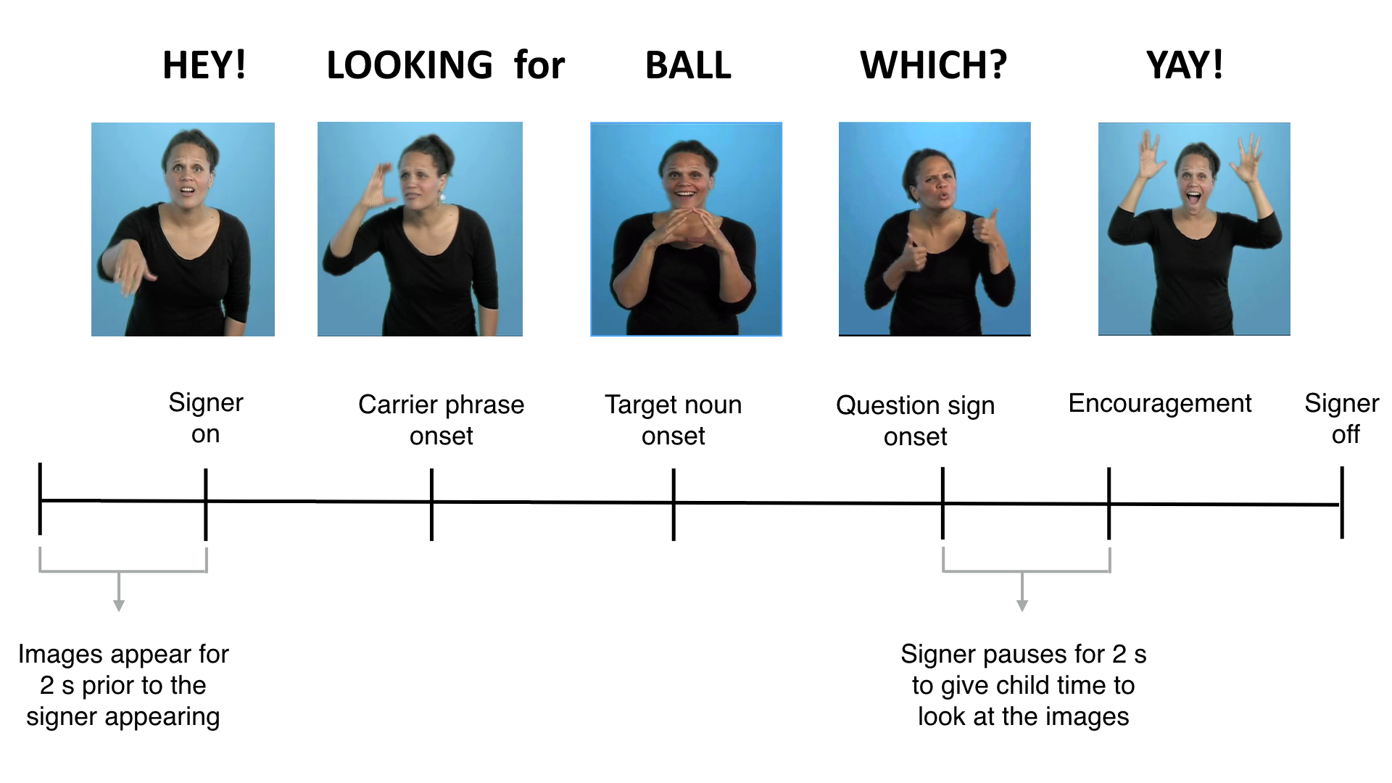

**Figure 1:** Overview of the trial structure for one question type (sentence final wh-phrase) shown in the central video on the VLP task.

## Calculating measures of language processing efficiency

*Computing target sign onset.* In studies of spoken language processing, target word onset is typically identified as the first moment in the auditory signal when there is acoustic evidence of the target word. However, in signed languages like ASL, phonological information is present in several components of the visual signal simultaneously – for example, in one or both hands as well as in the face of the signer - making it difficult to determine precisely the beginning of the target sign. Here, we took an empirical approach to defining target sign onset, by asking 10 fluent adult signers unfamiliar with the stimuli to watch videos of the target signs while viewing the same picture pairs as in the VLP task. For each sign token, the onset of the target noun was operationalized as the earliest point in the signed sentence at which adults selected the correct picture with 100% agreement.

*Reaction Time.* Reaction time (RT) corresponds to the latency to shift from the central signer to the target picture on all signer-to-target shifts, measured from target-noun onset. We chose cutoffs for the window of relevant responses based on the distribution of children’s RTs in the VLP task, including the middle 90% (600-2500 ms) (see Ratcliff, 1993). Incorrect shifts (signer-to-distracter [19%], signer-to-away [14%], no shift [8%]) were not included in the computation of median RT.

*Target Accuracy.* Accuracy was the mean proportion of time spent looking at the target picture out of the total time looking at either target or distracter picture over the 600 to 2500 ms window from target noun onset. This measure of accuracy reflects the tendency both to shift quickly from the signer to the target picture in response to the target sign and to maintain fixation on the target picture. Mean proportion looking to target was calculated for each participant for both correct and incorrect shifts.

# Results

Our analyses use Bayesian linear models to test our hypotheses of interest and to estimate the associations between hearing status, age, vocabulary, and RT and accuracy in the VLP task. We used Bayesian methods for three reasons: First, Bayesian methods allowed us to quantify support in favor of a null hypothesis of interest – in this case, the absence of a difference in real-time processing skills between deaf and hearing ASL learners. Second, since native ASL learners are so difficult to recruit, it was critical to use a statistical approach that was robust to the potential for outliers. And third, relevant prior knowledge was included to estimate more accurately the strength of the associations between RT/accuracy on the VLP task and age/vocabulary.

Specifically, we used prior work on the development of real-time processing efficiency in children learning spoken language (Fernald et al., 2008) to consider only plausible linear associations between age/vocabulary and RT/accuracy, thus making our alternative hypotheses more precise. In studies with adults, the common use of eye movements as a processing measure is based on the assumption that the timing of the first shift reflects the speed of their lexical access (Tanenhaus, Magnuson, Dahan, & Chambers, 2000). However, while adults are likely to stay focused and on-task in such an experimental procedure, children are more variable in their attentiveness as well as in their language knowledge. Thus some children have a first shift that appears random and may be unassociated with lexical access. We quantify this possibility for each participant explicitly (i.e., the probability that the participant is a “guesser”), creating an analysis model where participants who were more likely to be guessers have less influence on the estimated relations between RT and age/vocabulary. Note that we use this approach only in the analysis of RT, since “guessing behavior” is integral to our measure of children’s mean accuracy in the VLP task, but not to our measure of mean RT. The Supplemental Material available online fully describes our model specifications, as well as two sensitivity analyses, which provide evidence that our results are robust to different specifications of the prior distribution and to different cutoffs used for the analysis window.

To test if there is developmental change, we report the strength of evidence for a linear model with an intercept and slope compared to an intercept-only model in the form of a Bayes Factor (BF) computed via the Savage-Dickey method (Wagenmakers et al., 2010). To estimate the strength of the linear association, we report the mean and the 95% Highest Density Interval (HDI) of the posterior distribution of the intercept and slope. The HDI provides information about the uncertainty of our point estimate of the linear association. Models with categorical predictors were implemented in STAN (Stan Development Team, 2016), and models with continuous predictors were implemented in JAGS (Plummer, 2003).

## Real-time ASL comprehension in deaf and hearing native signers

Although all of the children in our sample, regardless of hearing status, were native ASL learners, it was possible that the deaf and hearing children would differ in their visual language processing since hearing children could also access auditory information. Would both groups show a similar time course of lexical processing, driven by their similar language experiences and the immediate modality-specific constraints of interpreting a visual language in real time? Or would deaf children’s reliance on vision to monitor both the linguistic signal and the referent result in a qualitatively different pattern of performance, e.g., their waiting longer to disengage from the signer? We directly compared deaf and hearing children’s real-time comprehension of ASL using a Bayesian analysis that allowed us to explicitly provide evidence for the null hypothesis of no difference between the two groups.

Figure 2 presents an overview of looking behavior in the VLP task for deaf (n=16, = 28m, = 7.5m) and hearing (n=13, = 29m, = 11.2m) children. This plot shows changes in the mean proportion of trials on which participants fixated the signer, the target image, or the distracter image at every 33 ms interval of the stimulus sentence. At the onset of the target sign, all participants were looking at the signer on all trials. As the target sign unfolded, mean proportion looking to the signer decreased rapidly as participants shifted their

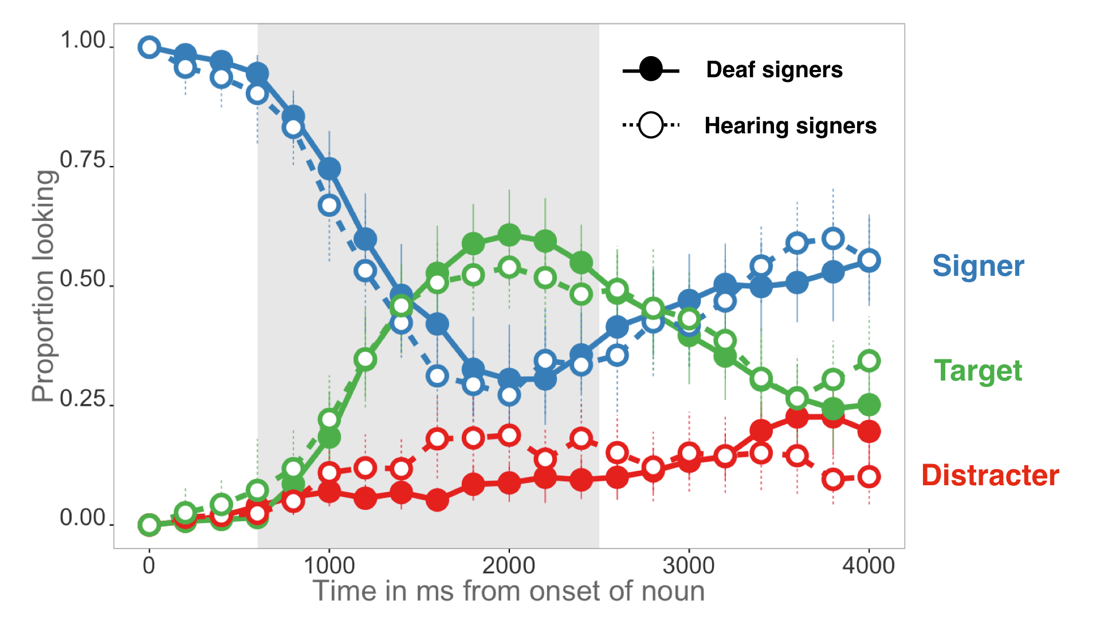

***Figure 2.*** *The time course of looking behavior for young deaf and hearing ASL-learners. The curves show mean proportion looking to the signer (blue), the target image (green), and the distracter image (red). Filled circles represent deaf signers, while open circles represent hearing signers; the grey shaded region marks the analysis window (600-2500ms); error bars represent +/- 95% CI computed by non-parametric bootstrap.*

gaze to the target or the distracter image. Proportion looking to the target increased sooner and reached a higher asymptote compared to proportion looking to the distracter for both hearing and deaf children. After looking to the target image, participants tended to shift their gaze rapidly back to the signer, reflected by the increase in proportion looking to signer around 2000 ms after target noun onset.

Overall, deaf and hearing children showed a similar time course of looking behavior: shifting away from the signer, increasing looks to the target, and shifting back to the signer at similar time points as the sign unfolded. We found no differences in mean accuracy (= -0.04, 95% HDI [-0.13, 0.04]) or RT (= 70.06, 95% HDI [-103.32, 239.64]), with the HDI including zero for both models. Moreover, the Bayes Factor slightly favored the null model indicating no difference between the two groups for each processing measure ( = 2.9, = 2.9). These analyses provide evidence that hearing and deaf ASL-learners show parallel sensitivity to the modality-specific constraints of processing a visual language in real time. Moreover, they provide additional justification for treating the deaf and hearing children as samples from the same population (native ASL-learners) in the subsequent analyses.

## Age-related changes in ASL processing

Next, we compare real-time processing skills by younger and older ASL-learning children and fluent adult signers. Figure 3 shows the mean proportion of trials on which participants in each age group fixated the signer, the target image, or the distracter image at every 33 ms interval. Mean proportion looking to the signer decreased rapidly as participants shifted their gaze to one of the images in all age groups. Older children tended to shift to the target picture sooner in the sentence than did younger children, but not as rapidly as adults. Older children were more accurate than younger children, but not as accurate as adults.

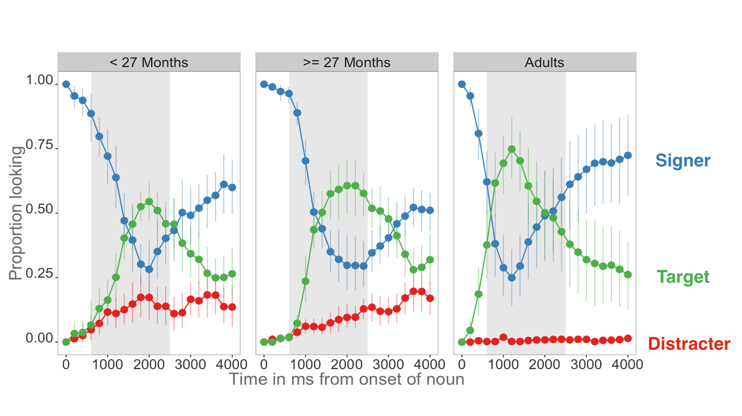**Figure 3:** *An overview of the time course of looking behavior for younger children, older children, and adults. The curves show the raw proportion looking to the signer (blue), the target image (green), and the distracter image (red). The grey shaded region represents the analysis window (600-2500ms) and the error bars represent +/- 95% CI computed by non-parametric bootstrap.*

Figure 4 shows group-level summary measures of ASL processing efficiency. When modeling differences between proportions looking to target vs. the distracter pictures, all three groups spent more time looking at the target than the distracter (younger:= 0.35, 95% HDI [0.27, 0.43]; older:= 0.55, 95% HDI [0.47, 0.63]; adults: = 0.81, 95% HDI [0.74, 0.90]). Moreover, even the youngest children were looking at the target more than would be expected by chance (younger: β= 0.59, 95% HDI [0.52, 0.65]; older: β= 0.70, 95% HDI [0.64, 0.76]; adults: β=0.82, 95% HDI [0.76, 0.88]). In all three groups, proportion looking to distracter was small, decreasing to almost zero in the adults (younger = 0.26, older = 0.15, adults = 0.01). Older children were more accurate than younger children ( = 0.09, 95% HDI [0.01, 0.19]) and had shorter mean RT to orient to the target image ( = -184.50 ms, 95% HDI [-326.01, -38.48]). Children were less accurate overall ( = -0.16, 95% HDI [-0.24, -0.09]) and slower to shift to the target image ( = 373.12, 95% HDI [236.64, 503.57]) compared to adults.

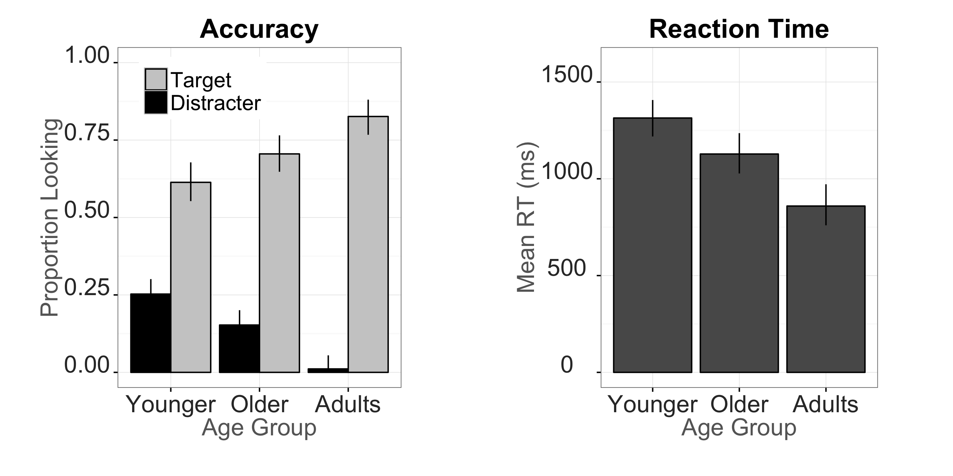

**Figure 4.** *Summary measures of developmental changes in ASL processing efficiency. The left panel shows mean proportion looking to the target and distracter pictures for younger kids, older kids, and adults; the right panel shows mean RT for all three groups. Error bars represent +/- 95% Highest Density Intervals.*

|  |  |  |  |  |  |
| --- | --- | --- | --- | --- | --- |
| Model |  | Mean β | 2.5% HDI | | 97.5% HDI |
| **Accuracy ~ Age** | 12.8 | 0.007 | | 0.002 | 0.012 |
| **Accuracy ~ Vocab** | 6.8 | 0.003 | | 0.001 | 0.005 |
| **RT ~ Age** | 12.5 | -10.6 | | -17.98 | -3.36 |
| **RT ~ Vocab** | 18.2 | -6.27 | | -10.39 | -2.29 |

***Table 1:*** *Summary of the four linear models using age and vocabulary size to predict accuracy (proportion looking to target) and reaction time (latency to first shift in msecs). is the Bayes Factor comparing the evidence in favor of linear model to an intercept-only (null) model; Mean β is the mean of the posterior distribution for the slope parameter for each model (i.e., the linear association); and the Highest Density Interval (HDI) shows the interval containing 95% of the plausible slope values given the model and the data.*

## Links between children’s age and processing efficiency

Next we used Bayesian linear regressions to test whether young ASL learners showed age-related increases in the speed and accuracy with which they interpreted familiar signs (see Table 1). Mean accuracy was positively associated with age (Figure 5A), indicating that older ASL learners were more accurate than younger children in fixating the target picture. The Bayes Factor indicated that a model including a linear association was 12.8 times more likely than an intercept-only model, providing strong evidence for developmental change. The estimate indicates that for each month of age children increased their accuracy score by 0.007, i.e., an increase of ~1% point, meaning that over the course of one year the model estimates a ~12% point gain in accuracy when establishing reference in the VLP task.

Mean RTs were negatively associated with age (Figure 5B), indicating that older children shifted to the target picture more quickly than did younger children. The Bayes Factor was ~12, providing strong evidence for a linear association. The model estimates a ~10 ms gain in RT for each month, leading to a ~120 ms gain in speed of lexical access over a year of development.

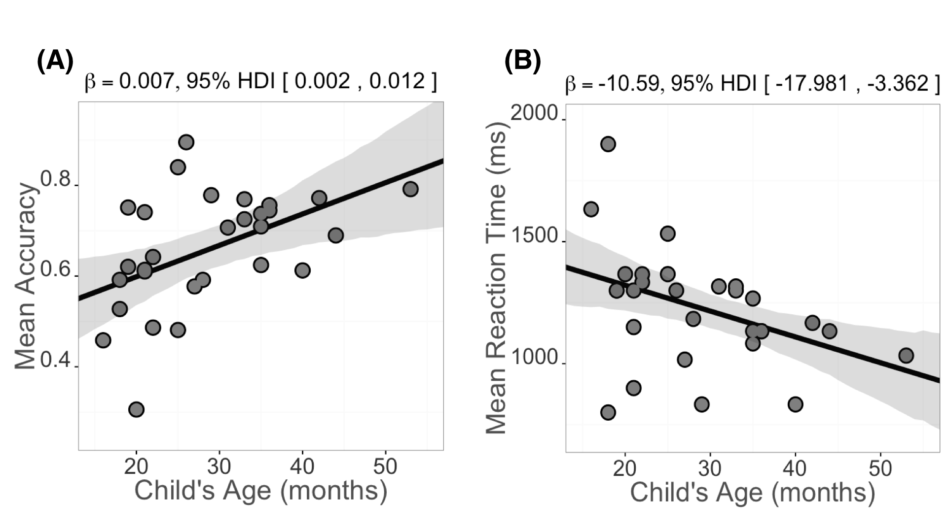

***Figure 5:*** *Scatterplots of the relations between children’s age and measures of their mean accuracy (5A) and mean RT (5B) in the VLP procedure. The solid black line is the maximum a posteriori model estimate for the mean accuracy at each age point. The shaded gray regions represent the 95% Highest Density Interval around the regression line.*

Together, the accuracy and RT analyses showed that young ASL learners reliably looked away from the central signer to shift to a target image in the VLP task. Importantly, children varied in their response times and accuracy, and this variation was meaningfully linked to age. Thus, like children learning spoken language, ASL learners improve their real-time language processing skills over the second and third years of life as they make progress towards adult levels of language fluency.

## Links between children’s processing efficiency and vocabulary

The next question we addressed was whether individual differences in processing skills were related to the size of children’s ASL vocabularies. As shown in Figure 6, children with higher accuracy scores also had larger productive vocabularies (although this relationship was weaker, with a = 6.8), with the model estimating a 0.003 increase for each additional sign children knew. Moreover, children who were faster to recognize ASL signs were those with larger sign vocabularies ( = 18.2), with each additional sign resulting in a ~6 ms decrease in estimated RT.

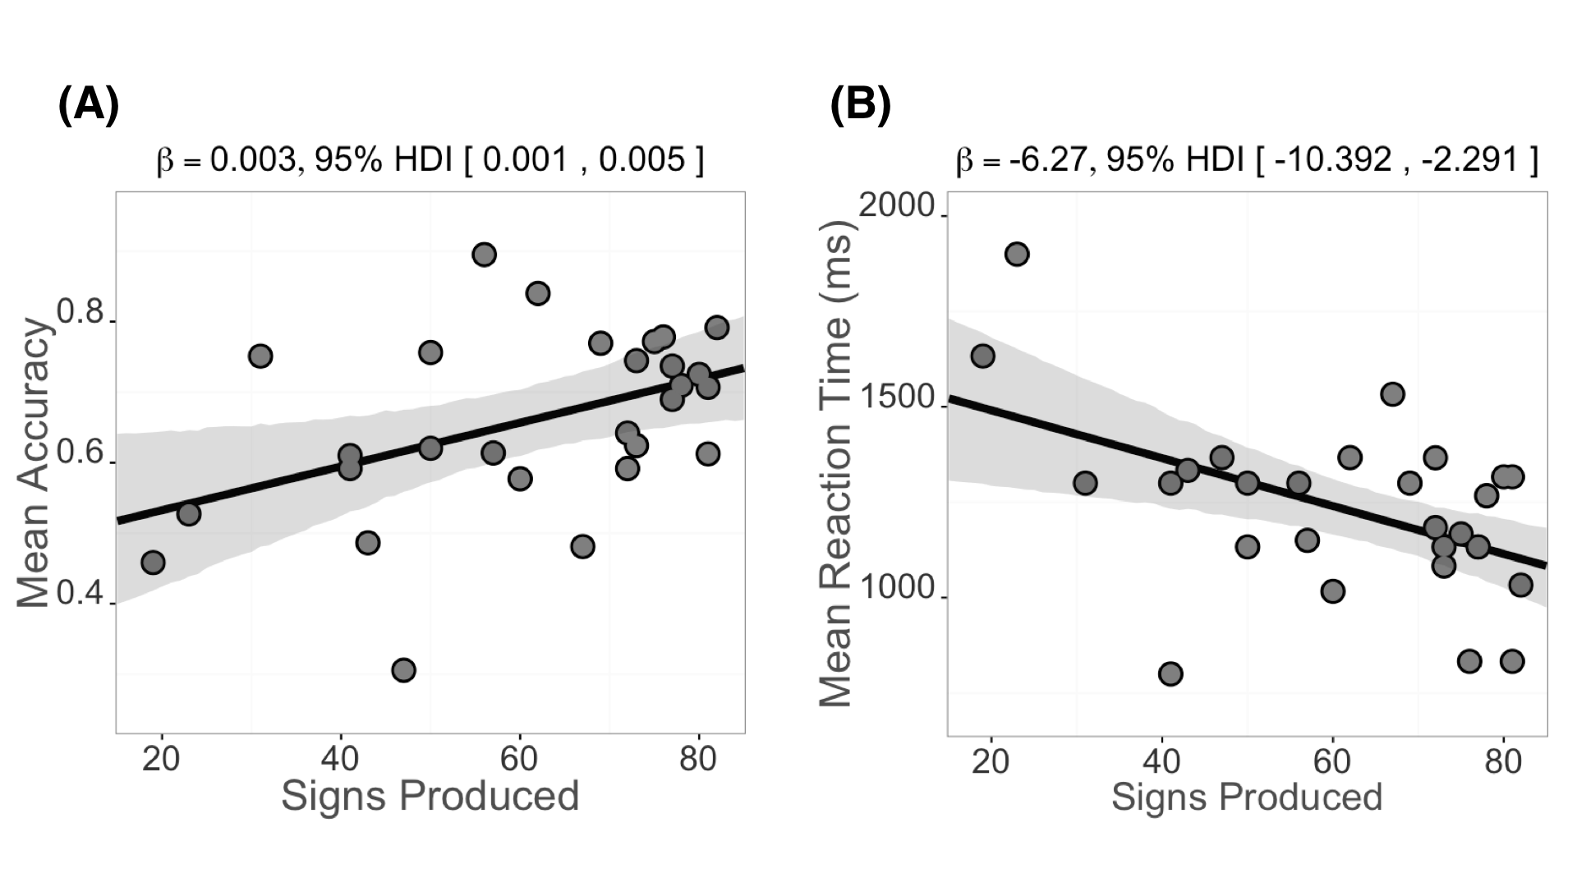

**Figure 6:**  Scatterplot of relations between children’s productive ASL vocabulary and measures of their mean accuracy (panel A) and mean RT (panel B) in the VLP procedure. Plotting conventions are the same as in Figure 5.

Taken together, these analyses indicate that older children and children with larger expressive vocabularies were more accurate and efficient in identifying the referents of familiar signs. These findings parallel results in the substantial body of previous research with monolingual children learning English (Fernald et al., 2006) and Spanish (Hurtado, Marchman, & Fernald, 2007).

# Discussion

Efficiency in establishing reference in real time lexical processing is a fundamental component of language learning. Here, we developed and validated the first measures of young ASL learners’ real-time language comprehension skills, exploring how language processing skills are linked to hearing status, age, and vocabulary. There are three main findings from this research.

First, we found that deaf and hearing children learning ASL as a first language showed similar patterns of interpreting signs in real time. Even though the hearing children use both vision and hearing to process incoming information in their daily lives, this experience did not appear to change the time course of processing in a visual language as compared to their deaf peers. Instead, both groups showed parallel sensitivity to the modality-specific constraints of processing a visual language in real time.

Second, like children learning spoken language (Fernald et al., 1998), young ASL learners were significantly less efficient than adults in their real-time language processing skills, but they showed significant improvement with age over the first four years. Even ASL-learning 2-year olds shifted from the signer to the target picture rapidly, with few incorrect shifts to the distracter. However, although all target signs were familiar to both younger and older children, the older children identified the correct referent more quickly and accurately and were less likely to shift to the unlabeled picture. These patterns of developmental change suggest that the real-time comprehension skills of children learning ASL in native contexts follow a similar developmental path to that of children learning spoken language, as has been shown in previous work using other behavioral methods (Lillo-Martin, 1999; Mayberry & Squires, 2006). However, most prior work on developmental trajectories of deaf children has focused on language production, since production is easier to observe and to measure than comprehension. By developing precise measures of real-time ASL comprehension, we were able to study the emergence of children's language skills much earlier in development than is possible using other methods.

Third, we also discovered a link between early ASL processing skills and children's productive ASL vocabularies. ASL-learning children who knew more signs were also faster and more accurate to identify the correct referent than those who were lexically less advanced. These results are consistent with studies with English- and Spanish-learning children, which find strong relations between efficiency in online language comprehension and concurrent and longitudinal measures of linguistic achievement (Fernald et al., 2006; Marchman & Fernald, 2008).

## Limitations

One important limitation of this research is that while the sample size is larger than in most previous studies of ASL development, it was still relatively small. More data are needed in order to precisely estimate the developmental trajectory of visual language processing skills. To facilitate replication, we have made all of our stimuli, data, and analysis code publicly available (http://kemacdonald.github.io/SOL), with the hope that other researchers will benefit from what we have learned in this work.

Second, testing groups of children within a narrower age range might have revealed independent effects of vocabulary size on ASL processing measures controlling for age, which could not be assessed here given the confound between age and vocabulary size in our sample of 1- to 4-year-olds. Thus, more evidence is needed to characterize more precisely the relations between accuracy, RT, and vocabulary in young ASL-learners.

Third, characteristics of the VLP task make it difficult to directly compare our findings with previous work on ASL and spoken language processing. For example, in contrast to prior ASL gating studies with adults (e.g., Emmorey & Corina, 1990; Morford & Carlsen, 2011), our stimuli were signed as full sentences in a child-directed register, not as isolated signs, and we used a fine-grained temporal response measure rather than an open-ended untimed response. Moreover, the VLP task included the signer as a central fixation image, resulting in different task demands from those in research using the two-alternative LWL procedure to study the development of children’s spoken language processing (e.g., Fernald et al. 1998). Given these differences, we cannot make any general claims about the time course of processing in signed vs. spoken languages in absolute terms. However, our results show impressive parallels with previous findings on the early development of efficiency in real-time processing by children learning spoken languages in terms of links to measures of vocabulary.

Finally, our sample is not representative of the majority of children learning ASL in the United States. Since most deaf children are born to hearing parents unfamiliar with ASL, they may have inconsistent early exposure to this visual language. We took great care to include only children who were native signers exposed to ASL from birth. The development of real-time language processing may look different in children who are late learners or who have more heterogeneous and inconsistent exposure to ASL. An important next step is to explore how individual variation in ASL processing is influenced by differences among children in their early experience with signed languages. Since children's efficiency in interpreting spoken language is linked to the quantity and quality of the speech that they hear from caregivers (Hurtado, Marchman, & Fernald, 2008; Weisleder & Fernald, 2013), we would expect similar relations between early language input and outcomes in children learning ASL. We hope that the VLP task will provide a useful method for both researchers and educators, providing a way to precisely track developmental trajectories of children learning ASL.

In conclusion, this study provides the first evidence that young ASL learners’ processing skills are meaningfully linked to age and to vocabulary outcomes. These results contribute to a growing literature highlighting parallels between signed and spoken language development when children are exposed to native sign input. Moreover, we found similar results for deaf and hearing ASL-learning children, suggesting that both groups were sensitive to the modality-specific constraints of processing a visual language from moment to moment. These findings indicate that real-time language processing skills essential for language learning develop rapidly in early childhood, regardless of language modality.

# References

Anderson, D., & Reilly, J. (2002). The MacArthur communicative development inventory: Normative data for American Sign Language. *Journal of Deaf Studies and Deaf Education*, 83–106.

Arendsen, J., Van Doorn, A. J., & de Ridder, H. (2009). When do people start to recognize signs?. *Gesture*, *9*(2), 207-236.

Carreiras, M., Gutiérrez-Sigut, E., Baquero, S., & Corina, D. (2008). Lexical processing in Spanish Sign Language (LSE). *Journal of Memory and Language*, *58*(1), 100–122.

Corina, D. P., & Emmorey, K. (1993). Lexical priming in American Sign Language. In *34th annual meeting of the Psychonomics Society*.

Corina, D. P., & Knapp, H. P. (2006). Lexical retrieval inAmerican Sign Language production. *Papers in Laboratory Phonology*, *8*, 213–240.

Emmorey, K., & Corina, D. (1990). Lexical recognition in sign language: Effects of phonetic structure and morphology. *Perceptual and Motor Skills*, *71*(3f), 1227–1252.

Fenson, L. (2007). *MacArthur-Bates communicative development inventories: User’s guide and technical manual*. Paul H. Brookes Publishing Company.

Fernald, A., & Marchman, V. A. (2012). Individual differences in lexical processing at 18 months predict vocabulary growth in typically developing and late-talking toddlers. *Child Development*, *83*(1), 203–222.

Fernald, A., Perfors, A., & Marchman, V. A. (2006). Picking up speed in understanding: Speech processing efficiency and vocabulary growth across the 2nd year. *Developmental Psychology*, *42*(1), 98.

Fernald, A., Pinto, J. P., Swingley, D., Weinberg, A., & McRoberts, G. W. (1998). Rapid gains in speed of verbal processing by infants in the 2nd year. *Psychological Science*, *9*(3), 228–231.

Fernald, A., Zangl, R., Portillo, A. L., & Marchman, V. A. (2008). Looking while listening: Using eye movements to monitor spoken language. *Developmental psycholinguistics: On-line methods in children’s language processing*, 113-132.

Grosjean, F. (1980). Spoken word recognition processes and the gating paradigm. *Perception & Psychophysics*, *28*(4), 267–283.

Harris, M., & Mohay, H. (1997). Learning to look in the right place: A comparison of attentional behavior in deaf children with deaf and hearing mothers. *Journal of Deaf Studies and Deaf Education*, *2*(2), 95–103.

Hurtado, N., Marchman, V. A., & Fernald, A. (2007). Spoken word recognition by Latino children learning Spanish as their first language. *Journal of Child Language*, *34*(02), 227–249.

Hurtado, N., Marchman, V. A., & Fernald, A. (2008). Does input influence uptake? Links between maternal talk, processing speed and vocabulary size in Spanish-learning children. *Developmental Science*, *11*(6), F31–F39.

Law, F. & Edwards, J. R. (2014). Effects of vocabulary size on online lexical processing by preschoolers. *Language Learning and Development, 11*, 331 – 355.

Lieberman, A. M., Borovsky, A., Hatrak, M., & Mayberry, R. I. (2014). Real-time processing of ASL signs: Delayed first language acquisition affects organization of the mental lexicon. *Journal of Experimental Psychology: Learning, Memory, and Cognition*.

Lieberman, A. M., Borovsky, A., Hatrak, M., & Mayberry, R. I. (2015). Real-time processing of ASL signs: Delayed first language acquisition affects organization of the mental lexicon. *Journal of Experimental Psychology: Learning, Memory, and Cognition*, *41*(4), 1130.

Lillo-Martin, D. (1999). Modality effects and modularity in language acquisition: The acquisition of American Sign Language. *Handbook of Child Language Acquisition*, *531*, 567.

Marchman, V. A., & Fernald, A. (2008). Speed of word recognition and vocabulary knowledge in infancy predict cognitive and language outcomes in later childhood. *Developmental Science*, *11*(3), F9–F16.

Marslen-Wilson, W., & Zwitserlood, P. (1989). Accessing spoken words: The importance of word onsets. *Journal of Experimental Psychology: Human Perception and Performance*, *15*(3), 576.

Mayberry, R. I., & Squires, B. (2006). Sign language acquisition.

McElreath, R. (2016). Statistical Rethinking: A Bayesian Course with Examples in R and Stan (Vol. 122). CRC Press.

Meier, R. P., Mauk, C., Mirus, G. R., & Conlin, K. E. (1998). Motoric constraints on early sign acquisition. *29*, 63–72.

Mitchell, R. E., & Karchmer, M. A. (2004). Chasing the mythical ten percent: Parental hearing status of deaf and hard of hearing students in the United States. *Sign Language Studies*, *4*(2), 138–163.

Morford, J. P., & Carlson, M. L. (2011). Sign perception and recognition in non-native signers of ASL. *Language learning and development*, *7*(2), 149-168.

Newport, E. L., & Meier, R. P. (1985). *The Acquisition of American Sign Language.* Lawrence Erlbaum Associates, Inc. Petronio, K., & Lillo-Martin, D., (1997). WH-Movement and the Position of Spec-CP:

Evidence from American Sign Language. *Language*, *73*(1), 18–57.

Plummer, M. (2003, March). JAGS: A program for analysis of Bayesian graphical models using Gibbs sampling. In *Proceedings of the 3rd international workshop on distributed statistical computing* (Vol. 124, p. 125).

Ratcliff, R. (1993). Methods for dealing with reaction time outliers. *Psychological bulletin*, *114*(3), 510.45, R. P., & Spencer, P. E. (1997). What mothers do to support infant visual attention: Sensitivities to age and hearing status. *Journal of Deaf Studies and Deaf Education*, *2*(2), 104–114.

Stan Development Team. 2016. RStan: the R interface to Stan, Version 2.9.0. <http://mc-stan.org>

Tanenhaus, M.K., Magnuson, J.S., Dahan, D., & Chambers, C. (2000). Eye movements and lexical access in spoken-language comprehension: Evaluating a linking hypothesis between fixations and linguistic processing, *Journal of Psycholinguistic Research*, 29(6), 557 – 580.

Venker, C. E., Eernisse, E. R., Saffran, J. R., Ellis Weismer, S. (2013). Individual differences in the real-time comprehension of children with ASD. *Autism Research*, 6, 417 – 432.

Wagenmakers, E. J., Lodewyckx, T., Kuriyal, H., & Grasman, R. (2010). Bayesian hypothesis testing for psychologists: A tutorial on the Savage–Dickey method. *Cognitive psychology*, *60*(3), 158-189.

Waxman, S., Fu, X., Arunachalam, S., Leddon, E., Geraghty, K., & Song, H. (2013). Are nouns learned before verbs? Infants provide insight into a long-standing debate. *Child Development Perspectives*, 7(3), 155-159.

Weisleder, A., & Fernald, A. (2013). Talking to children matters: Early language experience strengthens processing and builds vocabulary. *Psychological Science*, *24*(11), 2143–2152.