Real-time lexical comprehension in young children learning American Sign Language (ASL)

Kyle MacDonald1, Todd LaMarr2, David Corina2,

Virginia A. Marchman1, & Anne Fernald1

1. Stanford University

2. UC Davis

Author Note:

We are grateful to the California School for the Deaf in Fremont, CA, and to the parents and children who participated in this research. Special thanks to Karina Pedersen, Lisalee Egbert, Laura Petersen, and Michele Berke for help with participant recruitment; to Pearlene Utley and Rosa Lee Timm for help with creating stimuli; to Michael Henry Tessler for help with data analysis; and to Shane Blau, Kat Adams, Melanie Ashland, and the staff of the Language Learning Lab at Stanford University. This work was made possible by an NIDCD grant to Anne Fernald and David Corina (R21 DC012505).

Abstract

When children comprehend spoken language in real time, linguistic information drives rapid shifts in visual attention, providing insights into developing efficiency in lexical access. But, how does language influence visual attention when the linguistic signal and the visual world are both processed via the visual channel? Here, we developed precise measures of eye movements during real-time comprehension of a visual-manual language, American Sign Language (ASL). Participants were 29 native, monolingual ASL-learning children (16-53 mos, 16 deaf, 13 hearing) and 16 fluent deaf adult signers. Deaf and hearing ASL-learners showed remarkably similar patterns of eye movements, suggesting comparable constraints driving ASL processing. All signers showed incremental language comprehension, initiating shifts in gaze prior to sign offset. Finally, variation in children’s ASL processing was positively correlated with age and vocabulary size. Thus, despite channel competition, deployment of visual attention during ASL comprehension reflects information processing skills that are fundamental for language acquisition

*Keywords:* sign language, language processing, language acquisition, visual attention

Real-time lexical comprehension in young children learning American Sign Language (ASL)

Finding meaning in a spoken or a signed language requires learning to establish reference during real-time interaction – relying on audition to interpret spoken words, or on vision to interpret manual signs. Starting in infancy, children learning a spoken language make dramatic gains in their efficiency in linking acoustic signals representing lexical forms to objects in the visual world. Studies of spoken language comprehension using the looking-while-listening (LWL) procedure have measured children’s gaze shifts as they look at pairs of familiar objects while listening to speech naming one of the objects (Fernald, Pinto, Swingley, Weinberg, & McRoberts, 1998; Fernald, Zangl, Portillo, & Marchman, 2008; Law & Edwards, 2014; Venker, Eernisse, Saffran, & Ellis Weismer, 2013). Such research finds that spoken language is processed incrementally, with eye movements occurring as soon as the auditory information is sufficient to enable referent identification (Allopenna, Magnuson, & Tanenhaus, 1998). Moreover, young listeners show age-related increases in the speed and accuracy with which they recognize familiar objects, and individual differences in spoken language processing efficiency predict vocabulary growth and later language and cognitive outcomes (Fernald, Perfors & Marchman, 2006; Marchman & Fernald, 2008).

Much less is known about how language influences visual attention during online comprehension of a visual-manual language. Do the findings from research with spoken language reflect language-general phenomena or are they specific to spoken language development? Here, we address this question by adapting the LWL procedure and developing the first high-resolution measures of speed and accuracy in real-time *sign* *language* comprehension by very young children learning American Sign Language (ASL). First, we explore the accuracy and time course of ASL processing in deaf and hearing children who are native ASL-learners. Next, we compare the performance of children learning ASL to fluent adult signers and ask whether there are age-related increases in children’s processing efficiency that parallel those previously shown in children learning spoken language. Then, we test whether adults and children shift their visual attention away from a language source and to a named referent prior to the offset of the target sign, showing evidence of incremental language processing. Finally, we explore whether variability in processing skill among ASL-learning children is related to their expressive vocabulary development, linking their processing skill to language acquisition.

## ASL processing in adults

Psycholinguistic studies with adults show that language processing in signed and spoken languages is similar in many ways. As in spoken language processing, sign recognition is thought to unfold in a two-stage process at both the lexical and sub-lexical levels. For example, sign processing is influenced by both lexicality and frequency; non-signs are identified more slowly than real signs (Corina & Emmorey, 1993) and high frequency signs are recognized faster than low frequency signs (Carreiras, Gutiérrez-Sigut, Baquero, & Corina, 2008). More recent work using eye-tracking methods found that adult signers produce more gaze shifts to phonological competitors, showing sensitivity to sub-lexical features of signs, and that these shifts were initiated prior to the offset of the sign, showing evidence of incremental sign processing (Lieberman, Borovsky, Hatrak, & Mayberry, 2014). In addition to this experimental work, Caselli and Cohen-Goldberg (2014) successfully adapted a computational model, originally developed for spoken word recognition (Chen & Mirman, 2012), to explain patterns of lexical access in sign languages, suggesting that the two languages share a common processing architecture.

However, differences between spoken and signed languages in the sub-lexical structure and surface features of lexical forms could have consequences for the time course of sign interpretation (for reviews, see Carreiras, 2010 and Corina & Knapp, 2006). For example, using a gating procedure, Emmorey and Corina (1990) showed deaf adults increasingly longer videos of signs in isolation and asked them to identify the signs in an open-ended, non-timed response format. English-speaking adults in this study heard increasingly longer segments of spoken words in isolation. Accurate identification of signed words required relatively less of the linguistic signal as compared to spoken word identification (see also Morford & Carlsen, 2011), suggesting that features of visual-manual languages, such as simultaneous presentation of phonological information might alter the time course of lexical access. More recent work by Gutierrez and colleagues (2012) used EEG measures during on-line ASL processing to provide evidence that semantic and phonological information might be more tightly linked in the sign language lexicon compared to the spoken language lexicon.

While, there is evidence for both parallels and differences in the processes underlying spoken word and manual sign recognition, the majority of this work has relied on offline methods with dependent measures that do not characterize lexical processing as it unfolds in time during sentence processing (e.g., lexical decision tasks and gating procedures). Further, no previous studies have explored the timing and accuracy of *young* ASL-learners’ eye movements during real-time language comprehension, an important skill for children who must constantly divide visual attention between the language source and the nonlinguistic visual world.

## Lexical development in ASL

Diary studies of sign language acquisition show that, despite modality differences, ASL-learners follow a similar developmental path as children learning spoken languages (Lillo-Martin, 1999; Mayberry & Squires, 2006). For example, young signers typically produce recognizable signs before the end of the first year and two-sign sentences by their 2nd birthday (Newport & Meier, 1985). And as in many spoken languages (Waxman et al., 2013), young ASL learners tend first to learn more nouns than verbs or other predicates (Anderson & Reilly, 2002).

However, because children learning ASL rely on vision to process linguistic information and to look at named objects, it is possible that basic language learning mechanisms, such as the allocation of visual attention might differ in how they support lexical development in this population (Harris & Mohay, 1997). For example, in an observational study of caregiver-child interactions in deaf and hearing dyads, Lieberman, Hatrak, and Mayberry (2014) found that deaf children frequently shifted their gaze to caregivers during book reading to maintain contact with the signed signal. Hearing children, in contrast, looked more continuously at the book while the caregiver was speaking, rarely shifting gaze to the source of language.

The competition for visual attention in ASL learning contexts could lead to a qualitatively different timing of gaze shifts during real-time ASL comprehension, thus complicating the linking hypothesis between eye movements and the underlying construct of speed of lexical access. On the one hand, the processing demands of relying on vision to monitor both the linguistic signal and the named referent might cause signers to wait until the end of the named referent, or even the entire utterance, before shifting visual attention away from the language source. In this case, eye movements would be less likely to reflect the rapid, incremental influence of language on visual attention that is characteristic of real-time spoken language processing. Another possibility is that ASL-learners, like adults and children learning a spoken language, will shift their visual attention incrementally, as soon as they have enough linguistic information to identify the target sign, leading them to shift prior to sign offset. Evidence for incremental language processing would further predict that eye movements during ASL processing would index individual differences in the speed of lexical access in signed languages, as previously shown in spoken languages.

## Research questions

By adapting the LWL procedure (Fernald et al., 2008) for young sign language learners, we address four main questions. First, how do deaf and hearing ASL-learners compare in the accuracy and time course of real-time lexical processing? Second, how do patterns of eye-movements in ASL-learners compare, at the group level, to those of fluent 6signers? Third, do children and adult signers shift their gaze away from a language source to a named referent prior to the offset of the target sign, showing evidence of incremental language processing and the rapid influence of language on visual attention? Fourth, like children learning spoken language, do ASL-learners show measurable age-related development in real-time processing skill as they make progress towards adult levels of fluency? And, finally, are those individual differences among ASL-learning children’s processing skills related to differences in expressive vocabulary development?

# Method

## 6

Participants were 29 native, monolingual ASL-learning children (16 deaf, 13 hearing, 17 females, 12 males, = 28.5 months, range = 16-53 months) and 13 fluent adult signers (all deaf). Since the goal of the current study was to document developmental changes in processing efficiency in native ASL-learners, we set strict inclusion criteria. The sample consisted of both deaf children of deaf adults and hearing Children of Deaf Adults (CODAs). Importantly, all children, regardless of hearing status, were exposed to ASL from birth through extensive interaction with at least one caregiver fluent in ASL and were reported to experience at least 80% ASL in their daily lives. Twenty-five of the 29 children lived in households with two deaf caregivers, both fluent in ASL. Although the hearing children could access linguistic information in the auditory signal, we selected only native monolingual learners who used ASL as their primary mode of communication in and outside the home (10 out of 13 hearing children had two deaf caregivers). Adult participants were all deaf, fluent signers who reported using ASL as their primary method of communication on a daily basis. Thirteen of the 16 adults acquired ASL from their parents and three learned ASL while at school.

|  |  |  |  |  |  |
| --- | --- | --- | --- | --- | --- |
| Hearing Status | n | Mean | SD | Min | Max |
| deaf | 16 | 28.0 | 7.5 | 16 | 42 |
| hearing | 13 | 29.4 | 11.2 | 18 | 53 |

**Table 1:** *Descriptive statistics and age distributions for hearing and deaf ASL-learners. All ages are reported in months.*

Our final sample size was determined by our success over a two-year funding period in recruiting and testing children who met our strict inclusion criteria: monolingual, native ASL users. It is important to note that native ASL-learners are a small and decreasing population of children who are extremely difficult to recruit. The incidence of deafness at birth in the US is less than .003%, and only 10% of the 2-3 per 1000 children born with hearing loss have a deaf parent who is likely to be fluent in ASL (Mitchell & Karchmer, 2004). In addition to the 29 child participants who met our inclusionary criteria and contributed adequate data, we also recruited and tested 17 more ASL-learning children who were not included in the analyses, either because it was later determined that they did not meet our stringent criterion of exposure to ASL from birth (*n* = 12), or because they did not complete the real-time language assessment due to inattentiveness or parental interference (*n* = 5).

## Measures

*Expressive vocabulary size*: Parents completed a 90-item vocabulary checklist developed for this project and designed for young children learning ASL. Vocabulary size was computed as the number of signs reported to be produced by the child.

*ASL Processing*: Efficiency in online comprehension was assessed using a version of the LWL procedure adapted for ASL learners, which we call the Visual Language Processing (VLP) task. The VLP task yields two measures of processing efficiency, reaction time (RT) and accuracy. Since this was the first study to develop measures of online ASL processing efficiency in children of this age, several important modifications to the procedure were made, as described below.

## Procedure

The VLP task was presented on a MacBook Pro laptop connected to a 27” monitor. The child sat on their caregiver’s lap, and the child’s gaze was recorded using a digital camcorder set up behind the monitor. To minimize visual distractions, testing occurred in a portable 5’ by 5’ booth with cloth sides, which reduced visual distractions during the task. On each trial, pictures of two familiar objects appeared on the screen, a target object corresponding to the target noun, and a distracter object matched for visual salience. Between the two pictures was a central video of an adult female signing the name of one of the pictures. Participants saw 32 test trials with five filler trials (e.g. “YOU LIKE PICTURES? MORE WANT?”) interspersed to maintain children’s interest.

*Coding and Reliability.* Participants’ gaze patterns were videotaped and later coded frame-by-frame at 33-ms resolution by highly-trained coders blind to target side. On each trial, coders indicated whether the eyes were fixated on the central signer, one of the images, shifting between pictures, or away (off), yielding a high-resolution record of eye movements aligned with target noun onset. Prior to coding, all trials were pre-screened to exclude those few trials on which the participant was inattentive or there was external interference. To assess inter-coder reliability, 25% of the videos were re-coded. Agreement was scored at the level of individual frames of video and averaged 98% on these reliability assessments.

## Stimuli

*Linguistic stimuli.* To allow for generalization beyond characteristics of a specific signer and sentence structure, we recorded two separate sets of ASL stimuli. Both sets were recorded with a native ASL signer, using alternative ASL sentence structures for asking questions (see Petronio and Lillo-Martin, 1997):

* Sentence-initial wh-phrase: “HEY! WHERE [target noun]?”
* Sentence-final wh-phrase: “HEY! [target noun] WHERE?”

To prepare the stimuli, two female native ASL users recorded several tokens of each sentence in a child-directed register. Before each sentence, the signer made a hand-wave gesture commonly used in ASL to gain an interlocutor’s attention before initiating an utterance. These candidate stimuli were digitized, analyzed, and edited using Final Cut Pro software. The final tokens were chosen based on naturalness.

*Visual stimuli.* Target nouns consisted of eight object names familiar to most children learning ASL at this age. Visual stimuli consisted of colorful digitized pictures of these objects presented in four fixed pairs, in which the object names had no phonological overlap (cat—bird, car—book, bear—doll, ball—shoe). Images were digitized pictures presented in fixed pairs, matched for visual salience with 3–4 tokens of each object type. Each object served as target four times and as distracter four times. Side of target picture was counterbalanced across trials.

## Trial Structure

Figure 1 shows the structure of a trial with a sentence-final *wh*-phrase, one of the two question types in the VLP task. On each trial, the child saw two images of familiar objects on the screen for 2 s before the signer appeared, allowing the child to inspect both images. Next, children saw a still frame of the signer for 1 s, so they could orient to the signer prior to sentence onset. The target sentence was then presented, followed by a question and 2-s hold, followed by an exclamation to encourage attention to the task.

## Calculating measures of language processing efficiency

*Computing target sign onset and offset.* In studies of spoken language processing, target word onset is typically identified as the first moment in the auditory signal when there is acoustic evidence of the target word. However, in signed languages like ASL, phonological information is present in several components of the visual signal simultaneously – for example, in one or both hands as well as in the face of the signer - making it difficult to determine precisely the beginning of the target sign. Because sign onset is critical to operationalizing speed of lexical access in this task, we applied an empirical approach to defining target sign onset. Ten fluent adult signers unfamiliar with the stimuli watched videos of the target signs while viewing the same picture pairs as in the VLP task. For each sign token, the onset of the target noun was operationalized as the earliest point in the signed sentence at which adults selected the correct picture with 100% agreement. To determine sign offset, two native signers independently marked the final point at which the handshape of each target sign was no longer identifiable. Agreements were resolved by discussion. Sign length was defined as sign offset minus sign onset 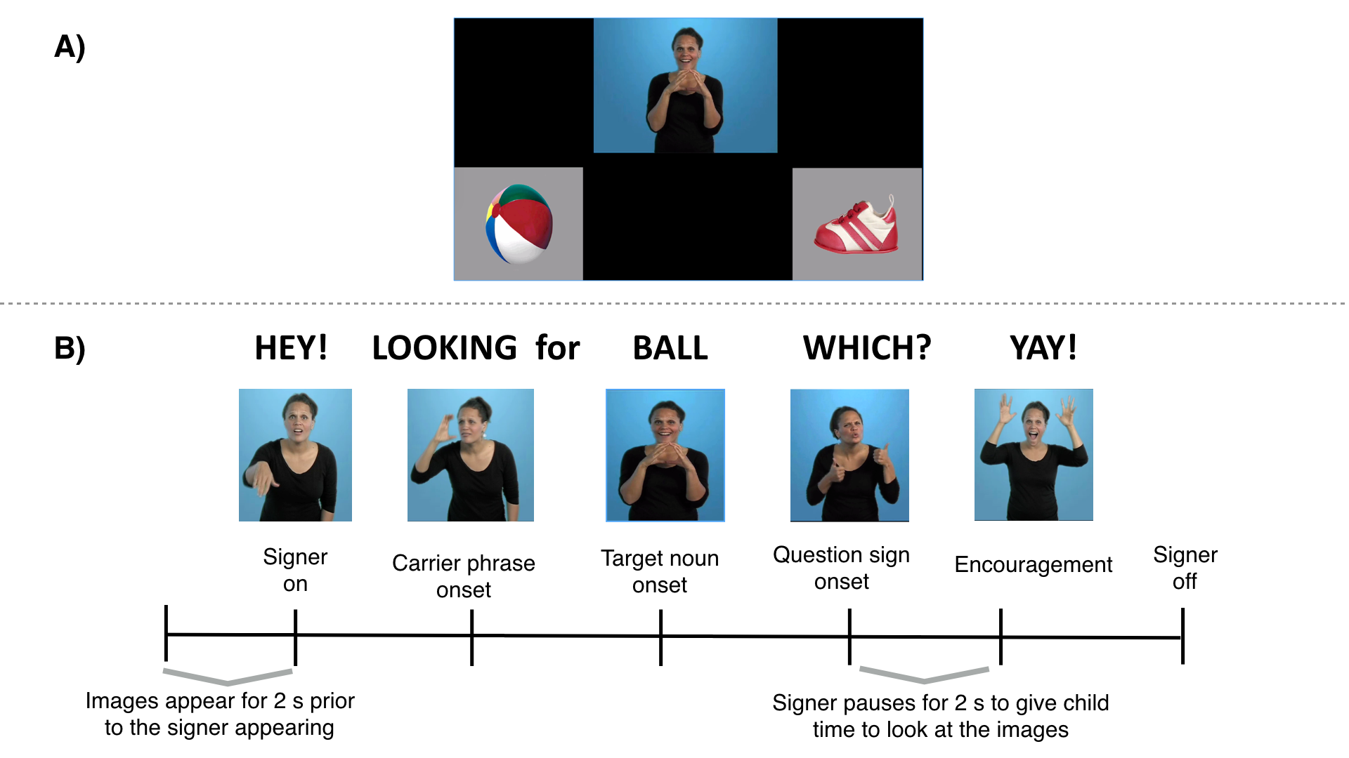(Median sign length was 1204 ms, ranging from 693 ms to 1980 ms).

***Figure 1:*** *Stimuli layout (1A) and trial structure (1B) for one question type (sentence final wh-phrase) shown in the central video on the VLP task.*

*Reaction Time.* Reaction time (RT) corresponds to the latency to shift from the central signer to the target picture on all signer-to-target shifts, measured from target-noun onset. We chose cutoffs for the window of relevant responses based on the distribution of children’s RTs in the VLP task, including the middle 90% (600-2500 ms) (see Ratcliff, 1993). Incorrect shifts (signer-to-distracter [19%], signer-to-away [14%], no shift [8%]) were not included in the computation of median RT.

*Target Accuracy.* Accuracy was the mean proportion of time spent looking at the target picture out of the total time looking at either target or distracter picture over the 600 to 2500 ms window from target noun onset. This measure of accuracy reflects the tendency both to shift quickly from the signer to the target picture in response to the target sign and to maintain fixation on the target picture. Mean proportion looking to target was calculated for each participant for both correct and incorrect shifts.

*Proportion sign processed prior to shifting.* This measure corresponds to the mean proportion of the target sign that children and adults saw before generating an initial eye movement away from the central signer. Because target signs differed in lengths across trials, we took each trial with a valid correct RT and divided by the length of the corresponding target sign, adding 200 ms (). We added 200 ms since previous research on spoken language suggests that at least this length of time is required to program an eye-movement (Salverda, Kleinschmidt, & Tanenhaus, 2014). Mean proportion of sign processed was computed for each token of each target sign and then averaged over all target signs within participants. This measure reflects the amount of information signers processed before generating an eye movement, on average. A score of ≥ 1.0 reflects that a signer tended to initiate eye movements to the target pictures after sign offset. An average < 1.0 indicates eye-movements were planned during the target sign, reflecting the degree to which signers show evidence of rapid, incremental language processing.

# Analysis Plan

Our analyses use Bayesian methods to test our hypotheses of interest and to estimate the associations between hearing status, age, vocabulary, and RT and accuracy in the VLP task. We used Bayesian methods for two reasons: First, Bayesian methods allowed us to quantify support in favor of a null hypothesis of interest – in this case, the absence of a difference in real-time processing skills between deaf and hearing ASL learners. Second, since native ASL learners are so difficult to recruit, we wanted to use a statistical approach that incorporated relevant prior knowledge to help constrain our estimates of the strength of association between RT/accuracy on the VLP task and age/vocabulary.

Specifically, we used prior work on the development of real-time processing efficiency in children learning spoken language (Fernald et al., 2008) to consider only plausible linear associations between age/vocabulary and RT/accuracy, thus making our alternative hypotheses more precise. In studies with adults, the common use of eye movements as a processing measure is based on the assumption that the timing of the first shift reflects the speed of their lexical access (Tanenhaus, Magnuson, Dahan, & Chambers, 2000). However, some children have a first shift that appears random and may be unassociated with lexical access. We quantify this possibility for each participant explicitly (i.e., the probability that the participant is a “guesser”), creating an analysis model where participants who were more likely to be guessers have less influence on the estimated relations between RT and age/vocabulary. Note that we use this approach only in the analysis of RT, since “guessing behavior” is integral to our measure of children’s mean accuracy in the VLP task, but not to our measure of mean RT. The Supplemental Material available online provides more details about the analysis, as well as two additional sensitivity analyses, which provide evidence that our results are robust to different specifications of prior distributions and to different cutoffs used for the analysis window.

To test if there is developmental change, we report the strength of evidence for a linear model with an intercept and slope compared to an intercept-only model in the form of a Bayes Factor (BF) computed via the Savage-Dickey method (Wagenmakers et al., 2010). To estimate the uncertainty around our estimates of the linear associations, we report the 95% Highest Density Interval (HDI) of the posterior distribution of the intercept and slope. The HDI provides a range of plausible values and gives information about the uncertainty of our point estimate of the linear association. Models with categorical predictors were implemented in STAN (Stan Development Team, 2016), and models with continuous predictors were implemented in JAGS (Plummer, 2003). Finally, all of the linear regressions include only children’s data and take the form: and .

**Results**

First, we compare real-time ASL comprehension in deaf and hearing children to ask if access to auditory information leads to qualitative changes in looking behavior. Next, we test if there are group-level differences by comparing ASL-learners’ processing skill to that of the adult signers. Third, we compare the degree to which children and adults tended to initiate eye-movements prior to target sign offset, exploring evidence for incremental ASL processing. Finally, we ask whether individual variation in children’s efficiency in ASL comprehension is related to productive vocabulary.

## Real-time ASL comprehension in deaf and hearing children and deaf adults

Do deaf and hearing native signers show a similar time course of lexical processing, driven by their similar language experiences and the immediate modality-specific constraints of interpreting a sign language in real time? Or would deaf children’s reliance on vision to monitor both the linguistic signal and the nonlinguistic visual world result in a qualitatively different pattern of performance, e.g., their waiting longer to disengage from the signer?

Figure 2A presents an overview of looking behavior in the VLP task for deaf and hearing children. This plot shows changes in the mean proportion of trials on which participants fixated the signer, the target image, or the distracter image at every 33 ms interval of the stimulus sentence. At the onset of the target sign, all participants were looking at the signer on all trials. As the target sign unfolded, mean proportion looking to the signer decreased rapidly as participants shifted their gaze to the target or the distracter image. Proportion looking to the target increased sooner and reached a higher asymptote, compared to proportion looking to the distracter, for both hearing and deaf children. After looking to the target image, participants tended to shift their gaze rapidly back to the signer, reflected by the increase in proportion looking to signer around 2000 ms after target noun onset.

Overall, deaf and hearing children showed a remarkably similar time course of looking behavior: shifting away from the signer, increasing looks to the target, and shifting back to the signer at similar time points as the sign unfolded. To quantify this difference, we compared the posterior distributions for mean accuracy (Figure 2C) and mean RT (Figure 2D) across the deaf and hearing groups. We did not find evidence for a difference in mean accuracy (= 0.03, 95% HDI [-0.07, 0.13]) or RT = 78.32 ms, 95% HDI [-86.01 ms, 247.04 ms]), with the 95% HDI including zero for both models indicating that no difference between hearing and deaf signers is a plausible value. These analyses provide evidence that same-aged hearing and deaf ASL-learners showed qualitatively similar looking behavior during real-time sentence processing, reflecting parallel sensitivity to the modality-specific constraints of processing a sign language. Moreover, the similarity between young deaf and hearing signers provides additional justification for treating the deaf and hearing children as samples from the same population (native ASL-learners) in the subsequent analyses.

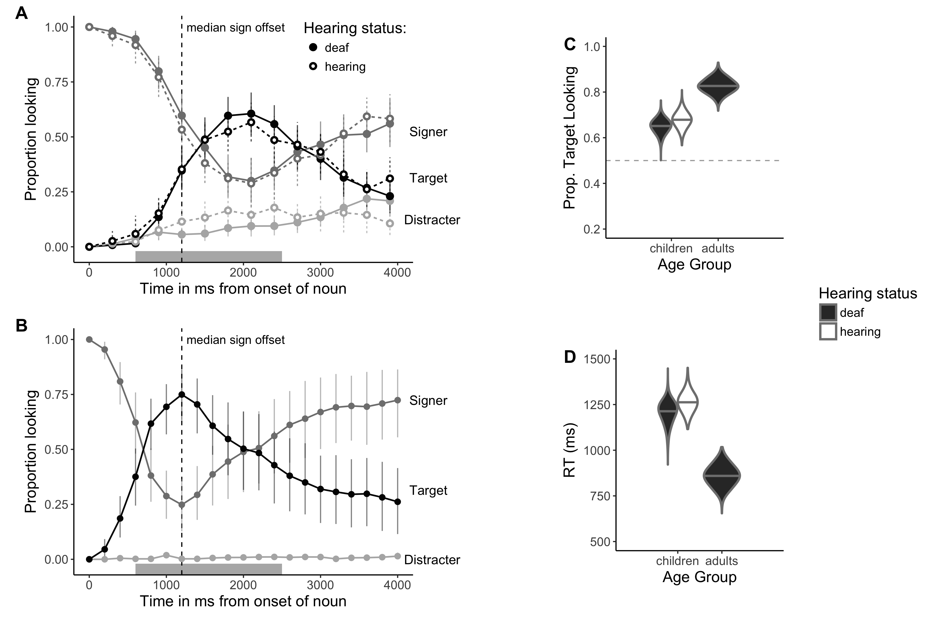***Figure 2.*** *The time course of looking behavior for young deaf and hearing ASL-learners (2A) and ASL-proficient adults (2B). The curves show mean proportion looking to the signer (dark grey), the target image (black), and the distracter image (light grey). Filled circles represent deaf signers, while open circles represent hearing signers; the grey shaded region marks the analysis window (600-2500ms); error bars represent +/- 95% CI computed by non-parametric bootstrap. Panels C and D show full posterior distributions over model estimates for mean Accuracy (2C) and Reaction Time (2D) for children and adults. Fill represents hearing status of the children. (Note that there were no hearing adult signers in our sample).*

Next, we compared real-time processing efficiency of ASL-learners to adult signers. Figure 2B shows the mean proportion of trials on which adults fixated the signer, the target image, or the distracter image at every 33 ms interval. Mean proportion looking to the signer decreased rapidly as participants shifted their gaze to one of the images. Adults tended to shift to the target picture sooner in the sentence than the children and well before the average offset of the target sign. Moreover, adults rarely looked to the distractor image at any point in the trial. Figures 2C and 2D show the full posterior distribution for adults’ mean Accuracy and RT. Overall, adults were more accurate ( 0.85, 0.68, = 0.17, 95% HDI for the difference in means [0.11, 0.24]) and faster to shift to the target image ( 861.98 ms, 1229.95 ms; = -367.76 ms, 95% HDI for the difference in means [-503.42 ms, -223.85 ms]) compared to children.

## Evidence of incremental ASL processing

One of the behavioral signatures of proficient spoken language processing is the rapid influence of language on visual attention, with eye movements occurring as soon as listeners have enough information to identify the named object. Would young ASL-learners and adult signers also show evidence of rapid gaze shifts in response to language, despite the apparent competition for visual attention between the language source and the nonlinguistic visual world? Or would signers delay their shifts until the very end of the target sign or even the end of the entire utterance?

To answer this question, we conducted an exploratory analysis, computing the proportion of each target sign that participants required before generating an eye movement to the named object (RT / length of target sign). Figure 3 shows this measure for each target sign for both children and adults. Adults shifted prior to the offset of the target sign for all items and processed on average 54% of the target sign before generating a response (M = 0.54, 95% HDI [0.38, 0.69]). Children processed more of the target sign before shifting their gaze compared to adults, but children did reliably initiate saccades prior to the offset of the target sign (M = 0.85, 95% HDI [0.76, 0.94]) and for 7 out of the 8 items. This analysis provides evidence that both adults and young signers process signs incrementally as they unfold in time. Moreover, since signers do not wait until the very end of the target sign or utterance, this suggests that eye movements in the VLP provide an index of speed of lexical access, allowing us to ask questions about the links between individual variation in processing speed and age/vocabulary.

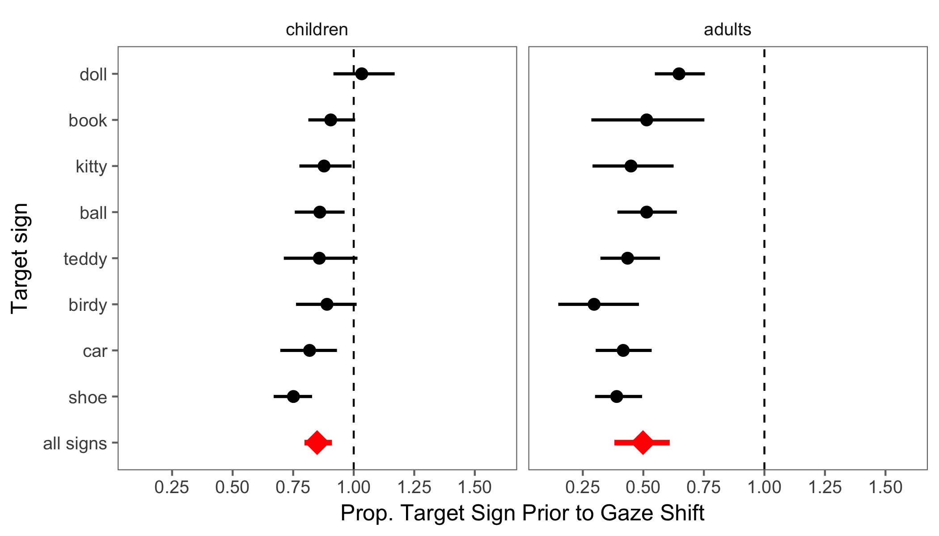

**Figure 3:** *The mean proportion of each target sign required prior to shifting visual attention away from the language source to a named object for children and adults. The diamond indicates the mean estimate for all signs. The dashed vertical line corresponds to a median proportion of 1.0. A median of < 1.0 reflects response latencies that occur prior to the offset of the target sign; a median of ≥ 1.0 reflects response latencies that occur after target sign offset. Error bars represent 95% CIs computed by nonparametric bootstrap*

## Links between children’s age and processing efficiency

Next we used Bayesian linear regressions to estimate the relations between young ASL learners’ age-related increases in the speed and accuracy with which they interpreted familiar signs (see Table 2 for point and interval estimates). Mean accuracy was positively associated with age (Figure 4A), indicating that older ASL learners were more accurate than younger children in fixating the target picture. The Bayes Factor (BF) indicated that a model including a linear association was 12.8 times more likely than an intercept-only model, providing evidence for developmental change. The estimate indicates that, for each month of age, children increased their accuracy score by 0.007, i.e., an increase of ~1% point, meaning that over the course of one year the model estimates a ~12% point gain in accuracy when establishing reference in the VLP task. Mean RTs were negatively associated with age (Figure 4A), indicating that older children shifted to the target picture more quickly than did younger children. The BF was ~14, providing evidence for a linear association. The model estimates a ~11 ms gain in RT for each month, leading to a ~132 ms gain in speed of lexical access over a year of development.

Together, the accuracy and RT analyses showed that young ASL learners reliably looked away from the central signer to shift to a target image in the VLP task. Importantly, children varied in their response times and accuracy, and this variation was meaningfully linked to age. Thus, like children learning spoken language, ASL learners improve their real-time language processing skills over the second and third years of life as they make progress towards adult levels of language fluency.

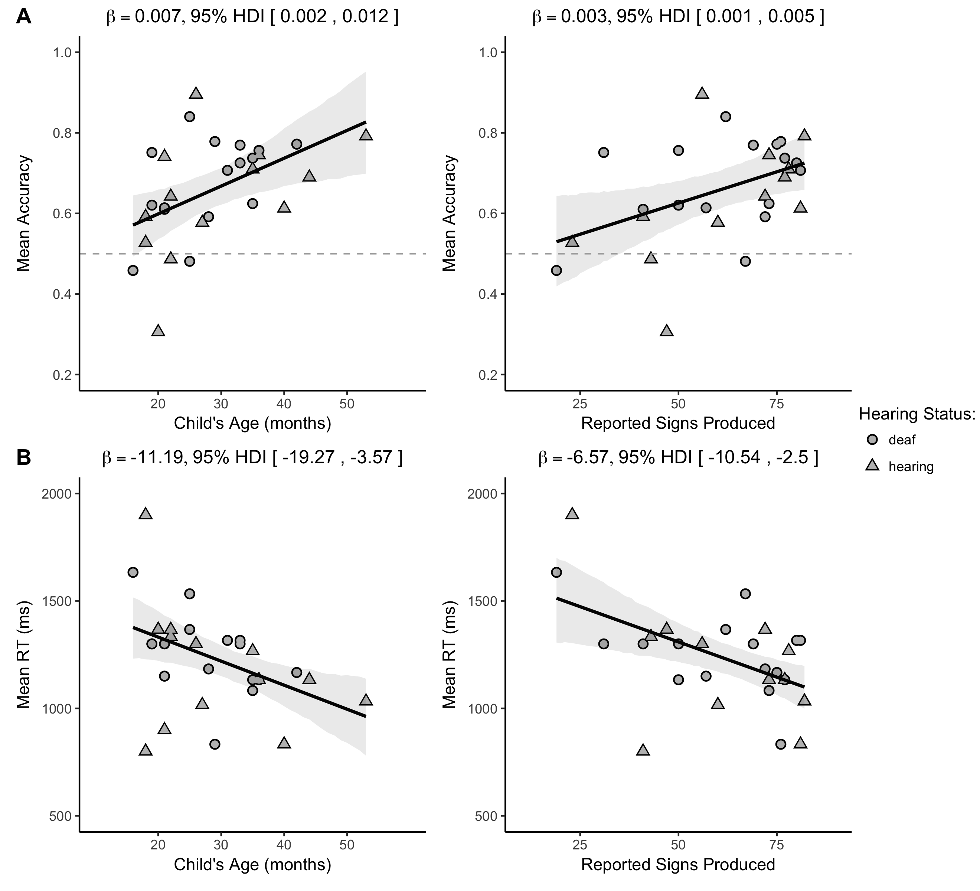

***Figure 4:*** *Scatterplots of the relations between children’s age and vocabulary and measures of*

*their mean accuracy and mean RT in the VLP procedure. Shape represents children’s hearing status. The solid black line is the maximum a posteriori model estimate for the mean accuracy at each age point. The shaded gray regions represent the 95% Highest Density Interval (range of plausible values) around the regression line.*

## Links between children’s processing efficiency and vocabulary

The next question was whether individual differences in processing skills were related to the size of children’s ASL vocabularies. As shown in Figure 4B, children with higher accuracy scores also had larger productive vocabularies (*BF*= 6.8), with the model estimating a 0.003 increase for each additional sign known. Moreover, children who were faster to recognize ASL signs were those with larger sign vocabularies (*BF*= 18.7), with each additional sign resulting in a ~7 ms decrease in estimated RT. Taken together, older children and children with larger expressive vocabularies were more accurate and efficient in identifying the referents of familiar signs. These findings parallel results in the substantial body of previous research with monolingual children learning spoken languages, such as English (Fernald et al., 2006) and Spanish (Hurtado, Marchman, & Fernald, 2007).

|  |  |  |  |
| --- | --- | --- | --- |
| **Model specification** |  | **Mean β** | **95% HDI** |
| Accuracy ~ Age + Hearing Status | 12.8 | 0.007 | 0.002, 0.012 |
| Accuracy ~ Vocab + Hearing Status | 6.8 | 0.003 | 0.001, 0.005 |
| RT ~ Age + Hearing Status | 14.4 | -11.2 ms | -19.27 ms, -3.57 ms |
| RT ~ Vocab + Hearing Status | 18.7 | -6.57 ms | -10.54 ms, -2.50 ms |

***Table 2:*** *Summary of the four linear models using children’s age and vocabulary size to predict accuracy (proportion looking to target) and reaction time (latency to first shift in ms). All models controlled for hearing status. BF is the Bayes Factor comparing the evidence in favor of linear model to an intercept-only (null) model; Mean β is the mean of the posterior distribution for the slope parameter for each model (i.e., the linear association); and the Highest Density Interval (HDI) shows the interval containing 95% of the plausible slope values given the model and the data.*

# Discussion

Efficiency in establishing reference in real time lexical processing is a fundamental component of language learning. Here, we developed and validated the first measures of young ASL learners’ real-time language comprehension skills, exploring how language processing skills are linked to hearing status, age, and vocabulary. There are three main findings from this research.

First, we found that deaf and hearing native signers, despite having differential access to auditory information, showed remarkably similar patterns of looking behavior when interpreting signs in real time. Even though the hearing children use both vision and hearing to process incoming information in their daily lives, this experience did not appear to change the time course of processing in a sign language as compared to their deaf peers. Instead, both groups showed parallel sensitivity to the modality-specific constraints of processing a sign language in real time.

Second, like children learning spoken language (Fernald et al., 1998), young ASL learners were significantly less efficient than adults in their real-time language processing skills, but they showed significant improvement with age over the first four years. Even ASL-learning 2-year olds shifted from the signer to the target picture rapidly, with few incorrect shifts to the distracter. However, although all target signs were familiar to both younger and older children, the older children identified the correct referent more quickly and accurately and were less likely to shift to the unlabeled picture. These patterns of developmental change suggest that the real-time comprehension skills of children learning ASL in native contexts follow a similar developmental path to that of children learning spoken language, as has been shown in previous work using other behavioral methods (Lillo-Martin, 1999; Mayberry & Squires, 2006). However, most prior work on developmental trajectories of deaf children has focused on language production, since production is easier to observe and to measure than comprehension. By developing precise measures of real-time ASL comprehension, we were able to study the emergence of children's language skills much earlier in development than is possible using other methods.

Third, both adults and young ASL-learners showed evidence of incremental language processing, shifting their gaze as soon as they had enough information to do so and prior to sign offset. The rapid influence of language on visual attention in ASL is perhaps even more striking since ASL users could incur a cost for shifting away from a speaker by missing subsequent information relevant to the speaker’s utterance. This evidence of incremental gaze shifts also suggests that eye movements during ASL processing provide an index of individual differences in the speed of lexical access in signed languages, as previously shown in spoken languages, which will be important for future work on the psycholinguistics of sign language acquisition.

Fourth, we also discovered a link between early ASL processing skills and children's productive ASL vocabularies. ASL-learning children who knew more signs were also faster and more accurate to identify the correct referent than those who were lexically less advanced. These results are consistent with studies with English- and Spanish-learning children, which find strong relations between efficiency in online language comprehension and concurrent and longitudinal measures of linguistic achievement (Fernald et al., 2006; Marchman & Fernald, 2008).

## Limitations

One important limitation of this research is that while the sample size is larger than in most previous studies of ASL development, it was still relatively small compared to many developmental studies. Thus, we would need more data in order to precisely estimate the developmental trajectory of sign language processing skills. To facilitate replication, we have made all of our stimuli, data, and analysis code publicly available (http://kemacdonald.github.io/SOL), with the hope that other researchers will benefit from what we have learned in this work. Nevertheless, this work makes an important contribution since it is the first to explore the development of real-time language processing skills in very young children learning a visual-manual language; a rare population that may become even more difficult to study as rates of cochlear implant use continue to rise.

Second, testing groups of children within a narrower age range might have revealed independent effects of vocabulary size on ASL processing measures controlling for age, which could not be assessed here given the confound between age and vocabulary size in our sample of 1- to 4-year-olds. Thus, more evidence is needed to characterize more precisely the relations between accuracy, RT, and vocabulary in young ASL-learners.

Third, characteristics of our task make it difficult to directly compare our findings with previous work on ASL and spoken language processing. For example, in contrast to prior ASL gating studies with adults (e.g., Emmorey & Corina, 1990; Morford & Carlsen, 2011), our stimuli were signed as full sentences in a child-directed register, not as isolated signs, and we used a fine-grained temporal response measure rather than an open-ended untimed response. Moreover, the VLP task included the signer as a central fixation image, resulting in different task demands from those in research using the two-alternative LWL procedure to study the development of children’s spoken language processing (e.g., Fernald et al. 1998). Given these methodological differences, we cannot yet make any general claims about processing in signed vs. spoken languages in absolute terms. A direct comparison of the time course of language processing in signed and spoken languages using comparable paradigms is a focus of our ongoing work. Nevertheless, the current results reveal parallels with previous findings showing incremental processing during real-time language comprehension in both children and adults. Moreover, we have established links between early efficiency in real-time processing and measures of vocabulary in children learning signed languages that suggest parallel underlying mechanisms driving learning in children, regardless of language modality.

Finally, our sample is not representative of the majority of children learning ASL in the United States. Since most deaf children are born to hearing parents unfamiliar with ASL, they may have inconsistent early exposure to this sign language. We took great care to include only children who were native signers exposed to ASL from birth. The development of real-time language processing may look different in children who are late learners or who have more heterogeneous and inconsistent exposure to ASL (Mayberry, 2007). An important next step is to explore how individual variation in ASL processing is influenced by differences among children in their early experience with signed languages. Since children's efficiency in interpreting spoken language is linked to the quantity and quality of the speech that they hear from caregivers (Hurtado, Marchman, & Fernald, 2008; Weisleder & Fernald, 2013), we would expect similar relations between early language input and outcomes in children learning ASL. We hope that the VLP task will provide a useful method for both researchers and educators, providing a way to precisely track developmental trajectories of children learning ASL.

In conclusion, this study provides the first evidence that young ASL learners’ rapidly shift visual attention as soon as they have enough of the linguistic signal to do so. In addition, individual variation in speed of lexical access as indexed by these movements is meaningfully linked to age and to vocabulary outcomes. These results contribute to a growing literature that highlights parallels between signed and spoken language development when children are exposed to native sign input. Moreover, similar results for deaf and hearing ASL-learning children suggest that both groups of children were sensitive to the modality-specific constraints of processing a sign language from moment to moment. These findings indicate that eye movements during real-time ASL processing are linked to efficiency of lexical access, suggesting that skill in real-time information processing is a language-general phenomenon that develops rapidly in early childhood, regardless of language modality.

# References

Anderson, D., & Reilly, J. (2002). The MacArthur communicative development inventory: Normative data for American Sign Language. *Journal of Deaf Studies and Deaf Education*, 83–106.

Arendsen, J., Van Doorn, A. J., & de Ridder, H. (2009). When do people start to recognize signs? *Gesture*, *9*(2), 207-236.

Carreiras, M., Gutiérrez-Sigut, E., Baquero, S., & Corina, D. (2008). Lexical processing in Spanish Sign Language (LSE). *Journal of Memory and Language*, *58*(1), 100–122.

Caselli, N. K., & Cohen-Goldberg, A. M. (2014). Lexical access in sign language: a computational model. *Frontiers in Psychology*, *5*.

Chen, Q., & Mirman, D. (2012). Competition and cooperation among similar representations: toward a unified account of facilitative and inhibitory effects of lexical neighbors. *Psychological review*, *119*(2), 417.

Corina, D. P., & Emmorey, K. (1993). Lexical priming in American Sign Language. In *34th annual meeting of the Psychonomics Society*.

Corina, D. P., & Knapp, H. P. (2006). Lexical retrieval in American Sign Language production. *Papers in Laboratory Phonology*, *8*, 213–240.

Emmorey, K., & Corina, D. (1990). Lexical recognition in sign language: Effects of phonetic structure and morphology. *Perceptual and Motor Skills*, *71*(3f), 1227–1252.

Fenson, L. (2007). *MacArthur-Bates communicative development inventories: User’s guide and technical manual*. Paul H. Brookes Publishing Company.

Fernald, A., & Marchman, V. A. (2012). Individual differences in lexical processing at 18 months predict vocabulary growth in typically developing and late-talking toddlers. *Child Development*, *83*(1), 203–222.

Fernald, A., Perfors, A., & Marchman, V. A. (2006). Picking up speed in understanding: Speech processing efficiency and vocabulary growth across the 2nd year. *Developmental Psychology*, *42*(1), 98.

Fernald, A., Pinto, J. P., Swingley, D., Weinberg, A., & McRoberts, G. W. (1998). Rapid gains in speed of verbal processing by infants in the 2nd year. *Psychological Science*, *9*(3), 228–231.

Fernald, A., Zangl, R., Portillo, A. L., & Marchman, V. A. (2008). Looking while listening: Using eye movements to monitor spoken language. *Developmental psycholinguistics: On-line methods in children’s language processing*, 113-132.

Grosjean, F. (1980). Spoken word recognition processes and the gating paradigm. *Perception & Psychophysics*, *28*(4), 267–283.

Gutierrez, E., Williams, D., Grosvald, M., & Corina, D. (2012). Lexical acess in American Sign Language: An ERP investigation of effects of semantics and phonology. *Brain Research*, *1468,* 63-83.

Harris, M., & Mohay, H. (1997). Learning to look in the right place: A comparison of attentional behavior in deaf children with deaf and hearing mothers. *Journal of Deaf Studies and Deaf Education*, *2*(2), 95–103.

Hurtado, N., Marchman, V. A., & Fernald, A. (2007). Spoken word recognition by Latino children learning Spanish as their first language. *Journal of Child Language*, *34*(02), 227–249.

Hurtado, N., Marchman, V. A., & Fernald, A. (2008). Does input influence uptake? Links between maternal talk, processing speed and vocabulary size in Spanish-learning children. *Developmental Science*, *11*(6), F31–F39.

Law, F. & Edwards, J. R. (2014). Effects of vocabulary size on online lexical processing by preschoolers. *Language Learning and Development, 11*, 331 – 355.

Lieberman, A. M., Borovsky, A., Hatrak, M., & Mayberry, R. I. (2014). Real-time processing of ASL signs: Delayed first language acquisition affects organization of the mental lexicon. *Journal of Experimental Psychology: Learning, Memory, and Cognition*.

Lieberman, A. M., Borovsky, A., Hatrak, M., & Mayberry, R. I. (2015). Real-time processing of ASL signs: Delayed first language acquisition affects organization of the mental lexicon. *Journal of Experimental Psychology: Learning, Memory, and Cognition*, *41*(4), 1130.

Lillo-Martin, D. (1999). Modality effects and modularity in language acquisition: The acquisition of American Sign Language. *Handbook of Child Language Acquisition*, *531*, 567.

Marchman, V. A., & Fernald, A. (2008). Speed of word recognition and vocabulary knowledge in infancy predict cognitive and language outcomes in later childhood. *Developmental Science*, *11*(3), F9–F16.

Marslen-Wilson, W., & Zwitserlood, P. (1989). Accessing spoken words: The importance of word onsets. *Journal of Experimental Psychology: Human Perception and Performance*, *15*(3), 576.

Mayberry, R. I. (2007). When timing is everything: Age of first-language acquisition effects on second-language learning. *Applied Psycholinguistics*, *28*(3), 537.

Mayberry, R. I., & Squires, B. (2006). Sign language acquisition.

Mitchell, R. E., & Karchmer, M. A. (2004). Chasing the mythical ten percent: Parental hearing status of deaf and hard of hearing students in the United States. *Sign Language Studies*, *4*(2), 138–163.

Morford, J. P., & Carlson, M. L. (2011). Sign perception and recognition in non-native signers of ASL. *Language learning and development*, *7*(2), 149-168.

Newport, E. L., & Meier, R. P. (1985). *The Acquisition of American Sign Language.* Lawrence Erlbaum Associates, Inc. Petronio, K., & Lillo-Martin, D., (1997). WH-Movement and the Position of Spec-CP:

Evidence from American Sign Language. *Language*, *73*(1), 18–57.

Plummer, M. (2003, March). JAGS: A program for analysis of Bayesian graphical models using Gibbs sampling. In *Proceedings of the 3rd international workshop on distributed statistical computing* (Vol. 124, p. 125).

Ratcliff, R. (1993). Methods for dealing with reaction time outliers. *Psychological bulletin*, *114*(3), 510.45,

Waxman, R. P., & Spencer, P. E. (1997). What mothers do to support infant visual attention: Sensitivities to age and hearing status. *Journal of Deaf Studies and Deaf Education*, *2*(2), 104–114.

Salverda, A. P., Kleinschmidt, D., & Tanenhaus, M. K. (2014). Immediate effects of anticipatory coarticulation in spoken-word recognition. *Journal of memory and language*, *71*(1), 145-163.

Stan Development Team. 2016. RStan: the R interface to Stan, Version 2.9.0. <http://mc-stan.org>

Tanenhaus, M.K., Magnuson, J.S., Dahan, D., & Chambers, C. (2000). Eye movements and lexical access in spoken-language comprehension: Evaluating a linking hypothesis between fixations and linguistic processing, *Journal of Psycholinguistic Research*, 29(6), 557 – 580.

Venker, C. E., Eernisse, E. R., Saffran, J. R., Ellis Weismer, S. (2013). Individual differences in the real-time comprehension of children with ASD. *Autism Research*, 6, 417 – 432.

Wagenmakers, E. J., Lodewyckx, T., Kuriyal, H., & Grasman, R. (2010). Bayesian hypothesis testing for psychologists: A tutorial on the Savage–Dickey method. *Cognitive psychology*, *60*(3), 158-189.

Waxman, S., Fu, X., Arunachalam, S., Leddon, E., Geraghty, K., & Song, H. (2013). Are nouns learned before verbs? Infants provide insight into a long-standing debate. *Child Development Perspectives*, 7(3), 155-159.

Weisleder, A., & Fernald, A. (2013). Talking to children matters: Early language experience strengthens processing and builds vocabulary. *Psychological Science*, *24*(11), 2143–2152.