**Research Highlights**

* We develop precise measures that characterize the timecourse of eye movements during real-time comprehension of American Sign Language (ASL) by native ASL-learning children and adults.
* Young ASL learners and fluent adults rapidly shift visual attention as signs unfold in time and do so prior to sign offset, providing evidence that these eye movements index efficiency of incremental sign comprehension.
* Parallel looking patterns for deaf and hearing native ASL learners suggest that the dynamics of eye movements during real-time ASL processing are shaped by learning a visual language and not by differential access to auditory information in children’s daily lives.
* Individual variation in speed of incremental sign comprehension is linked to age and vocabulary, suggesting that skill in processing lexical items in real-time is a language-general phenomenon that shows parallel developmental effects in children learning spoken and signed languages.

**Abstract**

When children interpret spoken language in real time, linguistic information drives rapid shifts in visual attention to objects in the visual world, which can provide insights into the development of efficiency in language comprehension. But how does language influence visual attention when the linguistic signal and the visual world are both processed via the visual channel? Here, we measured eye movements during real-time comprehension of a visual-manual language, American Sign Language (ASL), by 29 native ASL-learning children (16-53 mos, 16 deaf, 13 hearing) and 16 fluent deaf adult signers. All signers showed evidence of rapid, incremental language comprehension, tending to initiate an eye movement prior to sign offset. Deaf and hearing ASL-learners showed similar gaze patterns, suggesting that the in-the-moment dynamics of eye movements during ASL processing are shaped by the constraints of processing a visual language in real time and not by differential access to auditory information in day-to-day life. Finally, variation in children’s ASL processing was positively correlated with age and vocabulary size. Thus, despite competition for attention within a single modality, the timing and accuracy of visual fixations during ASL comprehension reflect information processing skills that are fundamental for language acquisition regardless of language modality.

*Keywords:* sign language, language processing, language acquisition, visual attention

**Real-time lexical comprehension in young children learning American Sign Language**

Finding meaning in a spoken or a signed language requires learning to establish reference during real-time interaction – relying on audition to interpret spoken words, or on vision to interpret manual signs. Starting in infancy, children learning spoken language make dramatic gains in their efficiency in linking acoustic signals representing lexical forms to objects in the visual world. Studies of spoken language comprehension using the looking-while-listening (LWL) procedure have tracked developmental gains in language processing efficiency by measuring the timing and accuracy of young children’s gaze shifts as they look at familiar objects and listen to simple sentences (e.g., Where’s the ball?”) naming one of the objects (Fernald, Zangl, Portillo, & Marchman, 2008; Law & Edwards, 2014; Venker, Eernisse, Saffran, & Ellis Weismer, 2013). Such research finds that eye movements to named objects occur soon after the auditory information is sufficient to enable referent identification, and often prior to the offset of the spoken word (Allopenna, Magnuson, & Tanenhaus, 1998). Moreover, individual differences in the speed and accuracy of eye movements in response to familiar words predict vocabulary growth and later language and cognitive outcomes (Fernald, Perfors & Marchman, 2006; Marchman & Fernald, 2008). Together, these results suggest that gaze shifts to objects in response to spoken language reflect a rapid integration of linguistic and visual information, and that variability in the timing of these gaze shifts provides researchers a way to measure the efficiency of the underlying integration process.

Much less is known about how language influences visual attention during sign language comprehension, especially in young learners. Given the many surface-level differences between signed and spoken languages, it is not immediately clear whether the findings from spoken language will generalize to signed languages or whether they are specific to mechanisms of language comprehension in the auditory modality. In particular, studies with children learning spoken languages find that these skills undergo dramatic developmental changes over the 2nd and 3rd years of life. Moreover, there are significant relations between variation in efficiency in online language processing, as indexed by language-driven eye movements, and measures of linguistic achievement, such as vocabulary size and scores on standardized tests (Fernald et al., 2006; Marchman & Fernald, 2008). Will individual variation in language processing among children learning a signed language also be related to their age and vocabulary outcomes, as observed in children learning a spoken language?

Here we address this question by developing precise measures of speed and accuracy in real-time sign language comprehension by children learning American Sign Language (ASL). First, we estimate the extent to which adults and children tend to shift visual attention to a referent and away from the language source prior to the offset of a sign naming an object in the visual scene. Will signers wait until the end of the signed utterance, perhaps to reduce the probability of missing upcoming linguistic information? Or will signers shift gaze incrementally as the signs unfold in time, initiating saccades soon after there is enough information in the signal to identify the referent, similar to children and adults processing spoken language? Another related possibility is that signers would produce incremental gaze shifts to the named objects while still monitoring the linguistic signal in the periphery. This analysis provides an important first step towards validating the linking hypothesis that eye movements generated in our task reflect efficiency of sign recognition, rather than some other process, such as attending to the objects after the process of sign comprehension is complete. If children and adults produce rapid gaze shifts prior to target sign offset, this would provide positive evidence of incremental ASL processing.

Next, we compare the time course of ASL processing in deaf and hearing native ASL-learners to ask whether having the *potential* to access auditory information in their day-to-day lives would change the dynamics of eye movements during ASL processing. Do deaf and hearing native signers show parallel patterns of looking behavior driven by their similar language background experiences and the in-the-moment constraints of interpreting a sign language (i.e., fixating on a speaker as a necessary requirement for gathering information about language)? Or would the massive experience deaf children have in relying on vision to monitor both the linguistic signal and the potential referents in the visual world result in a qualitatively different pattern of performance compared to hearing ASL learning, e.g., waiting until the end of the sentence to disengage from the signer? This analysis is motivated by prior work that has used comparisons between native hearing and deaf signers to dissociate the effects of learning a visual-manual language from the effects of lacking access to auditory information (e.g., Bavelier, Dye, & Hauser, 2006).

Finally, we compare timing and accuracy of the eye movements of young ASL-learners to those of adult signers, and ask whether there are age-related increases in processing efficiency that parallel those found in spoken languages. We also examine the links between variability in children’s ASL processing skills and their expressive vocabulary development. A positive association between these two aspects of language proficiency, as previously shown in children learning spoken languages, provides important evidence that skill in lexical processing efficiency is a language-general phenomenon that develops rapidly in early childhood, regardless of language modality.

## ASL processing in adults

Research with adults shows that language processing in signed and spoken languages is similar in many ways. As in spoken language, sign recognition is thought to unfold at both the lexical and sub-lexical levels. Moreover, sign processing is influenced by both lexicality and frequency; non-signs are identified more slowly than real signs (Corina & Emmorey, 1993) and high frequency signs are recognized faster than low frequency signs (Carreiras, Gutiérrez-Sigut, Baquero, & Corina, 2008). Recent work using eye-tracking methods found that adult signers produce gaze shifts to phonological competitors, showing sensitivity to sub-lexical features, and that these shifts were initiated prior to the offset of the sign, showing evidence of incremental processing (Lieberman, Borovsky, Hatrak, & Mayberry, 2015). In addition, Caselli and Cohen-Goldberg (2014) adapted a computational model, developed for spoken language (Chen & Mirman, 2012), to explain patterns of lexical access in sign languages, suggesting that the languages share a common processing architecture.

However, differences between spoken and signed languages in both sub-lexical and surface features of lexical forms could affect the time course of sign recognition (for reviews, see Carreiras, 2010 and Corina & Knapp, 2006). For example, Emmorey and Corina (1990) showed deaf adults repeated video presentations of increasingly longer segments of signs in isolation and asked them to identify the signs in an open-ended response format. In the same study, English-speaking adults heard repeated presentations of increasingly longer segments of spoken words. Accurate identification of signs required seeing a smaller proportion of the total sign length compared to words (see also Morford & Carlsen, 2011), suggesting that features of visual-manual languages, such as simultaneous presentation of phonological information, might increase speed of sign recognition. Moreover, Gutierrez and colleagues (2012) used EEG measures to provide evidence that semantic and phonological information might be more tightly linked in the sign language lexicon than in the spoken language lexicon.

Thus there is evidence for both similarities and dissimilarities in the processes underlying spoken-word and manual-sign recognition. However, with a few exceptions (e.g. Lieberman et al., 2015, 2017), most of this work has relied on offline methods that do not capture lexical processing as it unfolds in time during naturalistic language comprehension. In addition, no previous studies have characterized how young ASL-learners choose to divide visual attention between a language source and the nonlinguistic visual world during real-time language comprehension.

## Lexical development in ASL

Diary studies show that ASL acquisition follows a similar developmental trajectory to that of spoken language (Lillo-Martin, 1999; Mayberry & Squires, 2006). For example, young signers typically produce recognizable signs before the end of the first year and two-sign sentences by their 2nd birthday (Newport & Meier, 1985). And as in many spoken languages (Waxman et al., 2013), young ASL-learners tend first to learn more nouns than verbs or other predicates (Anderson & Reilly, 2002).

However, because children learning ASL must rely on vision to process linguistic information and to look at named objects, it is possible that basic learning processes, such as the coordination of joint visual attention, might differ in how they support lexical development (Harris & Mohay, 1997). For example, in a study of book reading in deaf and hearing dyads, Lieberman, Hatrak, and Mayberry (2015) found that deaf children frequently shifted gaze to caregivers in order to maintain contact with the signed signal. Hearing children, in contrast, tended to look continuously at the book, rarely shifting gaze while their caregiver was speaking. This finding suggests that the modality of the linguistic signal may affect how young language learners negotiate the demands of processing a visual language while simultaneously trying to fixate on the referents of that language.

This competition for visual attention in ASL could lead to qualitatively different looking behavior during real-time ASL comprehension, making the link between eye movements and efficiency of language comprehension in ASL less transparent. On the one hand, demands of relying on vision to monitor both the linguistic signal and the named referent might cause signers to delay gaze shifts to named objects in the world until the end of the target sign, or even the entire utterance. In this case, eye movements would be less likely to reflect the rapid, incremental influence of language on visual attention that is characteristic of spoken language processing. Another possibility is that ASL-learners, like spoken language learners, will shift visual attention as soon as they have enough linguistic information to do so, producing saccades prior to the offset of the target sign. Evidence for incremental language processing would further predict that eye movements during ASL processing could index individual differences in speed of incremental comprehension, as previously shown in spoken languages.

## Research questions

Adapting the LWL procedure for ASL enables us to address four questions. First, to what extent do children and adult signers shift their gaze away from the language source and to a named referent prior to the offset of the target sign? Second, how do deaf and hearing ASL-learners compare in the time course of real-time lexical processing? Third, how do patterns of eye movements during real-time language comprehension in ASL-learners compare to those of adult signers? Finally, are individual differences in ASL-learners’ processing skill related to age and to expressive vocabulary development?

# Method

Participants were 29 native, deaf and hearing ASL-learning children (17 females, 12 males) and 16 fluent adult signers (all deaf), as shown in Table 1. Since the goal of the current study was to document developmental changes in processing efficiency in native ASL-learners, we set strict inclusion criteria. The sample consisted of both deaf children of deaf adults and hearing Children of Deaf Adults (CODAs), across a similar age range. It is important to note that all children, regardless of hearing status, were exposed to ASL from birth through extensive interaction with at least one caregiver fluent in ASL and were reported to experience at least 80% ASL in their daily lives. Twenty-five of the 29 children lived in households with two deaf caregivers, both fluent in ASL. Although the hearing children could access linguistic information in the auditory signal, we selected only ASL-dominant learners who used ASL as their primary mode of communication both within and outside the home (10 out of 13 hearing children had two deaf caregivers). Adult participants were all deaf, fluent signers who reported using ASL as their primary method of communication on a daily basis. Thirteen of the 16 adults acquired ASL from their parents and three learned ASL while at school.

Our final sample size was determined by our success over a two-year funding period in recruiting and testing children who met our strict inclusion criteria – receiving primarily ASL language input. It is important to note that native ASL-learners are a small population. The incidence of deafness at birth in the US is less than .003%, and only 10% of the 2-3 per 1000 children born with hearing loss have a deaf parent who is likely to be fluent in ASL (Mitchell & Karchmer, 2004). In addition to the 29 child participants who met our inclusion criteria and contributed adequate data, we also recruited and tested 17 more ASL-learning children who were not included in the analyses, either because it was later determined that they did not meet our stringent criterion of exposure to ASL from birth (*n* = 12), or because they did not complete the real-time language assessment due to inattentiveness or parental interference (*n* = 5).

|  |  |  |  |  |  |
| --- | --- | --- | --- | --- | --- |
| Hearing Status | n | Mean | SD | Min | Max |
| Deaf | 16 | 28.0 | 7.5 | 16 | 42 |
| Hearing | 13 | 29.4 | 11.2 | 18 | 53 |
| All children | 29 | 28.6 | 9.2 | 16 | 53 |

**Table 1:** *Age (in months) of hearing and deaf ASL-learning participants*

## Measures

*Expressive vocabulary size*: Parents completed a 90-item vocabulary checklist, adapted from Anderson and Reilly (2002), and developed specifically for this project to be appropriate for children between 1½ and 4 years of age. Vocabulary size was computed as the number of signs reported to be produced by the child.

*ASL Processing*: Efficiency in online comprehension was assessed using a version of the LWL procedure adapted for ASL learners, which we call the Visual Language Processing (VLP) task. The VLP task yields two measures of language processing efficiency, reaction time (RT) and accuracy. Since this was the first study to develop measures of online ASL processing efficiency in children of this age, several important modifications to the procedure were made, as described below.

## Procedure

The VLP task was presented on a MacBook Pro laptop connected to a 27” monitor. The child sat on the caregiver’s lap approximately 60 cm from the screen, and the child’s gaze was recorded using a digital camcorder mounted behind the monitor. To minimize visual distractions, testing occurred in a 5’ x 5’ booth with cloth sides. On each trial, pictures of two familiar objects appeared on the screen, a target object corresponding to the target noun, and a distracter object. All picture pairs were matched for visual salience based on prior studies with spoken language (Fernald et al., 2008). Between the two pictures was a central video of an adult female signing the name of one of the pictures. Participants saw 32 test trials with five filler trials (e.g. “YOU LIKE PICTURES? MORE WANT?”) interspersed to maintain children’s interest.

*Coding and Reliability.* Participants’ gaze patterns were video recorded and later coded frame-by-frame at 33-ms resolution by highly-trained coders blind to target side. On each trial, coders indicated whether the eyes were fixated on the central signer, one of the images, shifting between pictures, or away (off), yielding a high-resolution record of eye movements aligned with target noun onset. Prior to coding, all trials were pre-screened to exclude those few trials on which the participant was inattentive or there was external interference. To assess inter-coder reliability, 25% of the videos were re-coded. Agreement was scored at the level of individual frames of video and averaged 98% on these reliability assessments.

## Stimuli

*Linguistic stimuli.* To allow for generalization beyond characteristics of a specific signer and sentence structure, we recorded two separate sets of ASL stimuli. These were recorded with two native ASL signers, using a different alternative grammatical ASL sentence structures for asking questions (see Petronio and Lillo-Martin, 1997):

* Sentence-initial wh-phrase: “HEY! WHERE [target noun]?”
* Sentence-final wh-phrase: “HEY! [target noun] WHERE?”

Each participant saw one stimulus set which consisted of one ASL question structure, with roughly an even distribution of children across the two stimulus sets (16 saw sentence-initial wh-phrase structure; 13 saw the sentence-final wh-phrase structure).

To prepare the stimuli, two female native ASL users recorded several tokens of each sentence in a child-directed register. Before each sentence, the signer made a hand-wave gesture commonly used in ASL to gain an interlocutor’s attention before initiating an utterance. These candidate stimuli were digitized, analyzed, and edited using Final Cut Pro software, and two native signers selected the final tokens. The target nouns consisted of eight object names familiar to most children learning ASL at this age.

. *Visual stimuli.* Thevisual stimuli consisted of colorful digitized pictures of objects corresponding to the target nouns presented in four fixed pairs (cat—bird, car—book, bear—doll, ball—shoe). See Table 2 for information about the degree of phonological overlap in each item-pair and the degree of iconicity for each sign (values were taken from ASL-LEX [Caselli et al., 2017])[1]. Images were digitized pictures presented in fixed pairs, matched for visual salience with 3–4 tokens of each object type. Each object served as target four times and as distracter four times for a total of 32 trials. Side of target picture was counterbalanced across trials.

|  |  |  |  |
| --- | --- | --- | --- |
| Item Pair  (iconicity score 1-7) | Number of  matched features | | Matched features |
| bear (3.0)—doll (1.2) | 1 | Movement | |
| cat (4.6)—bird (4.5) | 3 | Selected Fingers, Major Location,  Sign Type | |
| car (6.2)—book (6.7) | 4 | Selected Fingers, Major Location,  Movement, Sign Type | |
| ball (5.7)—shoe (1.5) | 4 | Selected Fingers, Major Location,  Movement, Sign Type | |

**Table 2:** *Iconicity scores (1 = not iconic at all; 7 = very iconic) and degree of phonological overlap (out of 5 features) for each sign item-pair. Values were taken from ASL-LEX, a database of lexical and phonological properties of signs in ASL.*

## Trial Structure

Figure 1 shows the structure of a trial with a sentence-final *wh*-phrase, one of the two question types in the VLP task. On each trial, children saw two images of familiar objects on the screen for 2 s before the signer appeared, allowing time for children to inspect both images. Next, children saw a still frame of the signer for one second, so they could orient to the signer prior to sentence onset. The target sentence was then presented, followed by a question and 2-s hold, followed by an exclamation to encourage attention to the task. This structure is nearly identical to the auditory LWL task, differing only in the addition of the 2-s hold. The hold was included to give participants additional time to shift gaze from the signer to the objects.

## Calculating measures of language processing efficiency

*Computing target sign onset and offset.* In studies of spoken language processing, target word onset is typically identified as the first moment in the auditory signal when there is acoustic evidence of the target word. However, in signed languages like ASL, phonological information is present in several components of the visual signal simultaneously – for example, in one or both hands as well as in the face of the signer - making it difficult to determine precisely the beginning of the target sign. Because sign onset is critical to operationalizing speed of ASL comprehension in this task, we applied an empirical approach to defining target-sign onset. We used a gating task in which adult signers viewed short videos of randomly presented tokens that varied in length. Two native signers first selected a sequence of six candidate frames for each token, and then 10 fluent adult signers unfamiliar with the stimuli watched videos of the target signs in real-time while viewing the same picture pairs as in the VLP task. Participants indicated their response with a button press. For each sign token, the onset of the target noun was operationalized as the earliest video frame? at which adults selected the correct picture with 100% agreement. To determine sign offset, two native signers independently marked the final frame at which the handshape of each target sign was no longer identifiable. Agreements were resolved by discussion. Sign length was defined as sign offset minus sign onset (Median sign length was 1204 ms, ranging from 693-1980 ms).

*Reaction Time.* Reaction time (RT) corresponds to the latency to shift from the central signer to the target picture on all signer-to-target shifts, measured from target-noun onset. We chose cutoffs for the window of relevant responses based on the distribution of children’s RTs in the VLP task, including the middle 90% (600-2500 ms) (see Ratcliff, 1993). Incorrect shifts (signer-to-distracter [19%], signer-to-away [14%], no shift [8%]) were not included in the computation of median RT. The RT measure was reliable within participants (Cronbach’s α = 0.8).

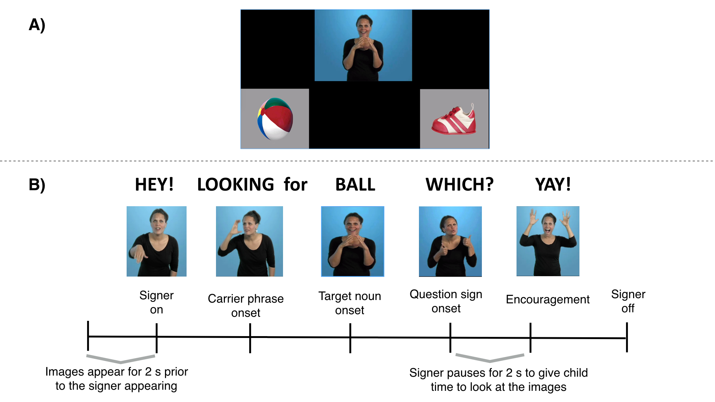**Figure 1*:*** *Configuration of visual stimuli (1A) and trial structure (1B) for one question type (sentence final wh-phrase) shown in the central video on the VLP task.*

*Target Accuracy.* Accuracy was the mean proportion of time spent looking at the target picture out of the total time looking at either target or distracter picture over the 600 to 2500 ms window from target noun onset. We chose this window to be consistent with the choice of the RT analysis window. This measure of accuracy reflects the tendency both to shift quickly from the signer to the target picture in response to the target sign and to maintain fixation on the target picture. Mean proportion looking to target was calculated for each participant for all trials on which the participant was fixating on the center image at target-sign onset. To make accuracy proportion scores more suitable for modeling on a linear scale, all analyses were based on scores that were scaled in log space using a logistic transformation. The Accuracy measure was reliable within participants (Cronbach’s α = 0.92)

*Proportion Sign Length Processed Prior to Shifting.* As a measure of incremental processing, we used the mean proportion of the target sign that children and adults saw before generating an initial eye movement away from the central signer. Because target signs differed in length across trials, we divided each RT value by the length of the corresponding target sign. Previous research on spoken language suggests that at least 200 ms is required to program an eye-movement (Salverda, Kleinschmidt, & Tanenhaus, 2014), so we subtracted 200 ms from each RT to account for eye movements that were initiated during the end of the target sign (). Mean proportion of sign processed was computed for each token of each target sign and then averaged over all target signs within participants, reflecting the amount of information signers processed before generating an eye movement, on average. A score of ≥ 1.0 indicates that a signer tended to initiate eye movements to the target pictures after sign offset. An average < 1.0 indicates eye-movements were planned during the target sign, reflecting the degree to which signers showed evidence of incremental language processing.

# Analysis Plan

We used Bayesian methods to estimate the associations between hearing status, age, vocabulary, and RT and accuracy in the VLP task. Bayesian methods are desirable for two reasons: First, Bayesian methods allowed us to quantify support in favor of a null hypothesis of interest – in this case, the absence of a difference in real-time processing skills between age-matched deaf and hearing ASL learners. Second, since native ASL learners are rare, we wanted to use a statistical approach that allowed us to incorporate relevant prior knowledge to constrain our estimates of the strength of association between RT/accuracy on the VLP task and age/vocabulary.

Concretely, we used prior work on the development of real-time processing efficiency in children learning spoken language (Fernald et al., 2008) to consider only plausible linear associations between age/vocabulary and RT/accuracy, thus making our alternative hypotheses more precise. In studies with adults, the common use of eye movements as a processing measure is based on the assumption that the timing of the first shift reflects the speed of their word recognition[2] (Tanenhaus, Magnuson, Dahan, & Chambers, 2000). However, studies with children have shown that early shifts are more likely to be random than later shifts (Fernald et al., 2008), suggesting that some children’s shifting behavior may be unrelated to real-time ASL comprehension. We use a mixture-model to quantify the probability that each child participant’s response is unrelated to their real-time sign recognition (i.e., that the participant is responding randomly, or is “guessing”), creating an analysis model where participants who were more likely to be guessers have less influence on the estimated relations between RT and age/vocabulary. Note that we use this approach only in the analysis of RT, since “guessing behavior” is integral to our measure of children’s mean accuracy in the VLP task, but not to our measure of mean RT. The Supplemental Material available online provides more details about the analysis model, as well two additional sensitivity analyses, which provide evidence that our results are robust to different specifications of prior distributions and to different analysis windows. We also provide a parallel set of analyses using a non-Bayesian approach, which resulted in comparable findings.

To provide evidence of developmental change, we report the strength of evidence for a linear model with an intercept and slope, compared to an intercept-only model in the form of a Bayes Factor (BF) computed via the Savage-Dickey method (Wagenmakers et al., 2010). To estimate the uncertainty around our estimates of the linear associations, we report the 95% Highest Density Interval (HDI) of the posterior distribution of the intercept and slope. The HDI provides a range of plausible values and gives information about the uncertainty of our point estimate of the linear association. Models with categorical predictors were implemented in STAN (Stan Development Team, 2016), and models with continuous predictors were implemented in JAGS (Plummer, 2003). Finally, we chose the linear model because it a simple model of developmental change with only two parameters to estimate, and the outcome measures – mean RT and Accuracy for each participant – were normally distributed. All of the linear regressions include only children’s data and take the form: and .

**Results**

The results are presented in five sections addressing the following central questions in this research. First, where do ASL users look while processing sign language in real-time? Here we provide an overview of the time course of looking behavior in our task for both adults and children. Second, would young ASL-learners and adult signers show evidence of rapid gaze shifts that reflect lexical processing, despite the apparent competition for visual attention between the language source and the nonlinguistic visual world? In this section, we estimate the degree to which children and adults tended to initiate eye-movements prior to target sign offset, providing evidence that these gaze shifts occur prior to sign offset and index speed of incremental ASL comprehension. Third, do deaf and hearing native signers show a similar time course of eye movements, despite having differential access to auditory information in their daily lives? Or would deaf children’s daily experience relying on vision to monitor both the linguistic signal and the potential referents in the visual world result in a qualitatively different pattern of performance, e.g., their waiting longer to disengage from the signer to seek the named object? Fourth, do young ASL-learners show age-related increases in processing efficiency that parallel those found in spoken languages? Here we compare ASL-learners’ processing skills to those of adult signers and exploring relations to age among the children. Finally, is individual variation in children’s ASL processing efficiency related to the size of their productive ASL vocabularies?

## Overview of looking behavior during real-time ASL comprehension

The first question of interest was where do ASL users look while processing sign language in real-time? Figure 2 presents an overview of adults (2A) and children’s (2B) looking behavior in the VLP task. This plot shows changes in the mean proportion of trials on which participants fixated the signer, the target image, or the distracter image at every 33-ms interval of the stimulus sentence. At target-sign onset, all participants were looking at the signer on all trials. As the target sign unfolded, the mean proportion looking to the signer decreased rapidly as participants shifted their gaze to the target or the distracter image. Proportion looking to the target increased sooner and reached a higher asymptote, compared to proportion looking to the distracter, for both adults and children. After looking to the target image, participants tended to

shift their gaze rapidly back to the signer, shown by the increase in proportion looking to the signer around 2000 ms after target-noun onset. Adults tended to shift to the target picture sooner in the sentence than did children, and well before the average offset of the target sign. Moreover, adults rarely looked to the distractor image at any point in the trial. This systematic pattern of behavior – participants reliably shifting attention from the signer to the named object and back to the signer – provides qualitative evidence that the VLP task is able to capture interpretable eye movement behavior during ASL comprehension.

## Evidence that eye movements during ASL processing index incremental sign comprehension

One of the behavioral signatures of proficient spoken language processing is the rapid influence of language on visual attention, with eye movements occurring soon after listeners have enough information to identify the named object. Our second question of interest was whether young ASL-learners and adult signers would also show evidence of rapid gaze shifts in response to signed language, despite the apparent competition for visual attention between the language source and the nonlinguistic visual world. Or would signers delay their shifts until the very end of the target sign, or even until the end of the utterance, perhaps because they did not want to miss subsequent linguistic information?

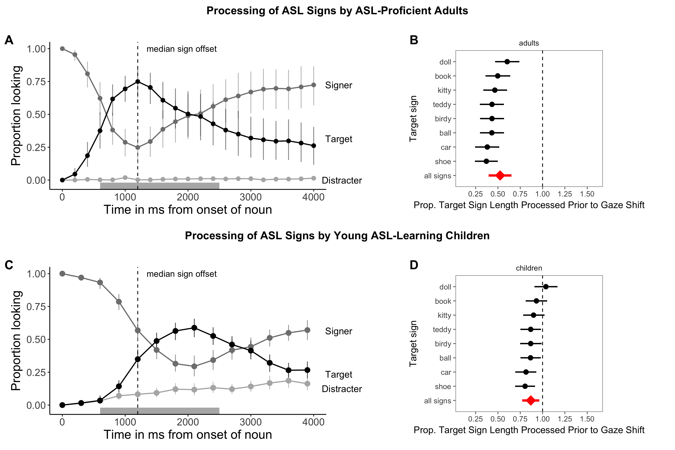

**Figure 2:** *The time course of looking behavior for ASL-proficient adults (2A) and young ASL-learners (2C). The curves show mean proportion looking to the signer (dark grey), the target image (black), and the distracter image (light grey). The grey shaded region marks the analysis window (600-2500ms); error bars represent +/- 95% CI computed by non-parametric bootstrap. The mean proportion of each target sign length (see the Methods section for details on how sign length was defined) processed prior to shifting visual attention away from the language source to a named object for adults (2B) and children (2D). The diamond indicates the mean estimate for all signs. The dashed vertical line corresponds to a median proportion of 1.0. A median of < 1.0 reflects response latencies that occur prior to the offset of the target sign; a median of ≥ 1.0 reflects response latencies that occur after target sign offset. Error bars represent 95% Highest Density Intervals.*

To answer these questions, we conducted an exploratory analysis, computing the proportion of each target sign that participants processed before generating an eye movement to the named object. Figure 2 shows this measure for each target sign for both adults (2B) and children (2D). Adults shifted prior to the offset of the target sign for all items and processed on average 51% of the target sign before generating a response (M = 0.51, 95% HDI [0.35, 0.66]). Children processed 88% of the target sign on average, requiring more information before shifting their gaze compared to adults. Children reliably initiated saccades prior to the offset of the target sign overall (M = 0.88, 95% HDI [0.79, 0.98]) and for five out of the eight signed stimuli.

These results suggest that young signers as well as adults process signs incrementally as they unfold in time (for converging evidence see Lieberman et al., 2015, 2017). It is important to point out that we would not interpret signers waiting until the end of the sign or the end of the sentence as evidence against an incremental processing account since there could be other explanations for that pattern of results such as social norms of looking at a person until they finish speaking. However, this result provides positive evidence that eye movements in the VLP task provide an index of speed of incremental ASL comprehension, allowing us to perform the subsequent analyses that estimate (a) group differences in looking behavior and (b) links between individual variation in speed and accuracy of eye movements during ASL processing and variation in productive vocabulary.

## Real-time ASL comprehension in deaf and hearing children and deaf adults

The third question of interest was whether deaf and hearing native signers show a similar time course of lexical processing, driven by their similar language experiences and the in-the-moment constraints of interpreting a sign language in real time? Or would deaf children’s daily experience relying on vision to monitor both the linguistic signal and the potential referents in the visual world result in a qualitatively different pattern of performance, e.g., their waiting longer to disengage from the signer to seek the named object?

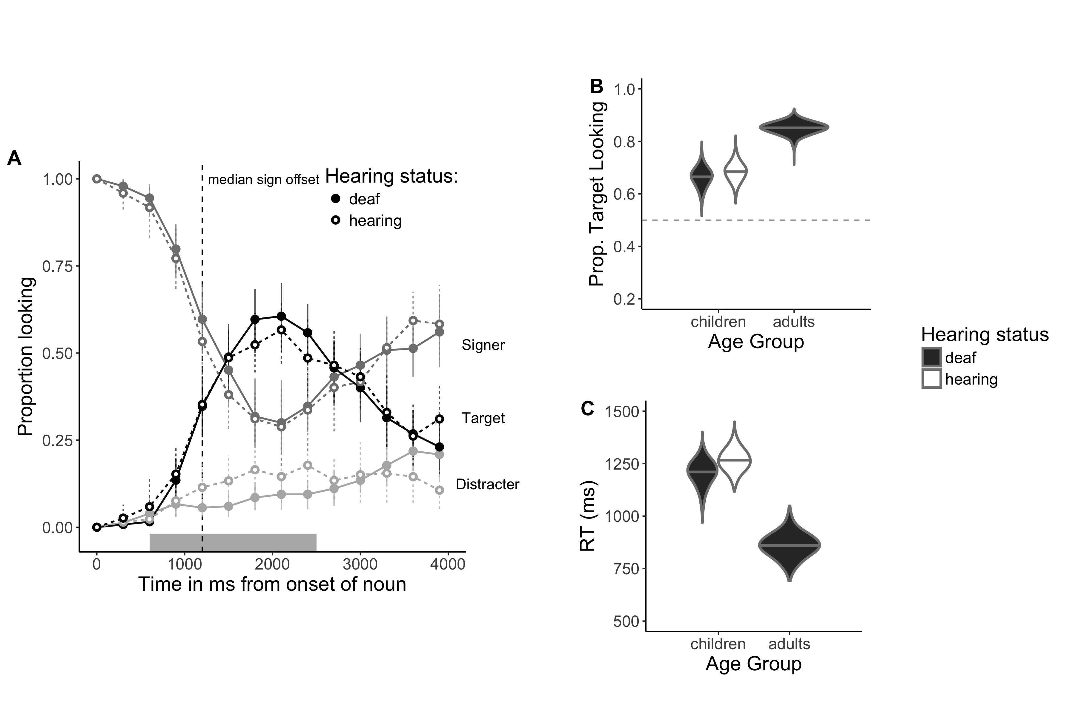**Figure 3.***The time course of looking behavior for young deaf and hearing ASL-learners (3A). Filled circles represent deaf signers, while open circles represent hearing signers; All other plotting conventions are the same as in Figure 2. Panels B and C show full posterior distributions over model estimates for mean Accuracy (3B) and Reaction Time (3C) for children and adults. Fill (white/black) represents children’s hearing status. (Note that there were no hearing adult signers in our sample).*

Figure 3A presents the overview of looking behavior for deaf and hearing children. At target-sign onset, all children were looking at the signer on all trials. Overall, deaf and hearing

children showed a remarkably similar time course of looking behavior: shifting away from the signer, increasing looks to the target, and shifting back to the signer at similar time points as the sign unfolded. To quantify any differences, we compared the posterior distributions for mean accuracy (Figure 3B) and mean RT (Figure 3C) across the deaf and hearing groups. We did not find evidence for a difference in mean accuracy (= 0.03, 95% HDI [-0.07, 0.13]) or RT = 78.32 ms, 95% HDI [-86.01 ms, 247.04 ms]), with the 95% HDI including zero for both models. These parallel results provide evidence that same-aged hearing and deaf native ASL-learners showed qualitatively similar looking behavior during real-time sentence processing, suggesting that decisions about where to allocate visual attention are not modulated by differential access to auditory information, but rather are shaped by learning ASL as a first language (see Bavelier et al., 2006 for a review of the differential effects of deafness compared to learning a visual language on perception and higher-order cognitive skills). Moreover, these results provide additional justification (over and above children’s highly similar language background experience) for analyzing all the native ASL-learning children together, regardless of hearing status, in the subsequent analyses.

Returning to the overview of looking behavior shown in Figure 2, we see that adults tended to shift to the target picture sooner in the sentence than did children, and well before the average offset of the target sign. Moreover, adults rarely looked to the distractor image at any point in the trial. To quantify these age-related differences we computed the full posterior distribution for children and adults’ mean Accuracy (Figure 3B) and RT (Figure 3C). Overall, adults were more accurate ( 0.85, 0.68, = 0.17, 95% HDI for the difference in means [0.11, 0.24]) and faster to shift to the target image compared to children ( 861.98 ms, 1229.95 ms; = -367.76 ms, 95% HDI for the difference in means [-503.42 ms, -223.85 ms]). This age-related difference parallels findings in spoken language (Fernald et. al., 2006) and shows that young ASL learners are still making progress towards adult-levels of ASL processing efficiency.

Next, we compared real-time processing efficiency in ASL-learners and adult signers. Returning to the overview of looking behavior shown in Figure 2, we see that adults tended to shift to the target picture sooner in the sentence than did children, and well before the average offset of the target sign. Moreover, adults rarely looked to the distractor image at any point in the trial. To quantify these differences we computed the full posterior distribution for children and adults’ mean Accuracy (Figure 3B) and RT (Figure 3C). Overall, adults were more accurate ( 0.85, 0.68, = 0.17, 95% HDI for the difference in means [0.11, 0.24]) and faster to shift to the target image compared to children ( 861.98 ms, 1229.95 ms; = -367.76 ms, 95% HDI for the difference in means [-503.42 ms, -223.85 ms]). This age-related difference parallels findings in spoken language (Fernald et. al., 2006) and shows that young ASL learners are still making progress towards adult-levels of ASL processing efficiency.

## Links between children’s age and efficiency in incremental sign comprehension

The fourth question of interest was whether young ASL-learners show age-related increases in processing efficiency that parallel those found in spoken languages. To answer this question, we estimated relations between young ASL learners’ age-related increases in the speed and accuracy with which they interpreted familiar signs (see Table 3 for point and interval estimates). Mean accuracy was positively associated with age (Figure 4A), indicating that older ASL learners were more accurate than younger children in fixating the target picture. The Bayes Factor (BF) indicated that a model including a linear association was 12.8 times more likely than an intercept-only model, providing strong evidence for developmental change. The estimate indicates that, for each month of age, children increased their accuracy score by 0.007, i.e., an

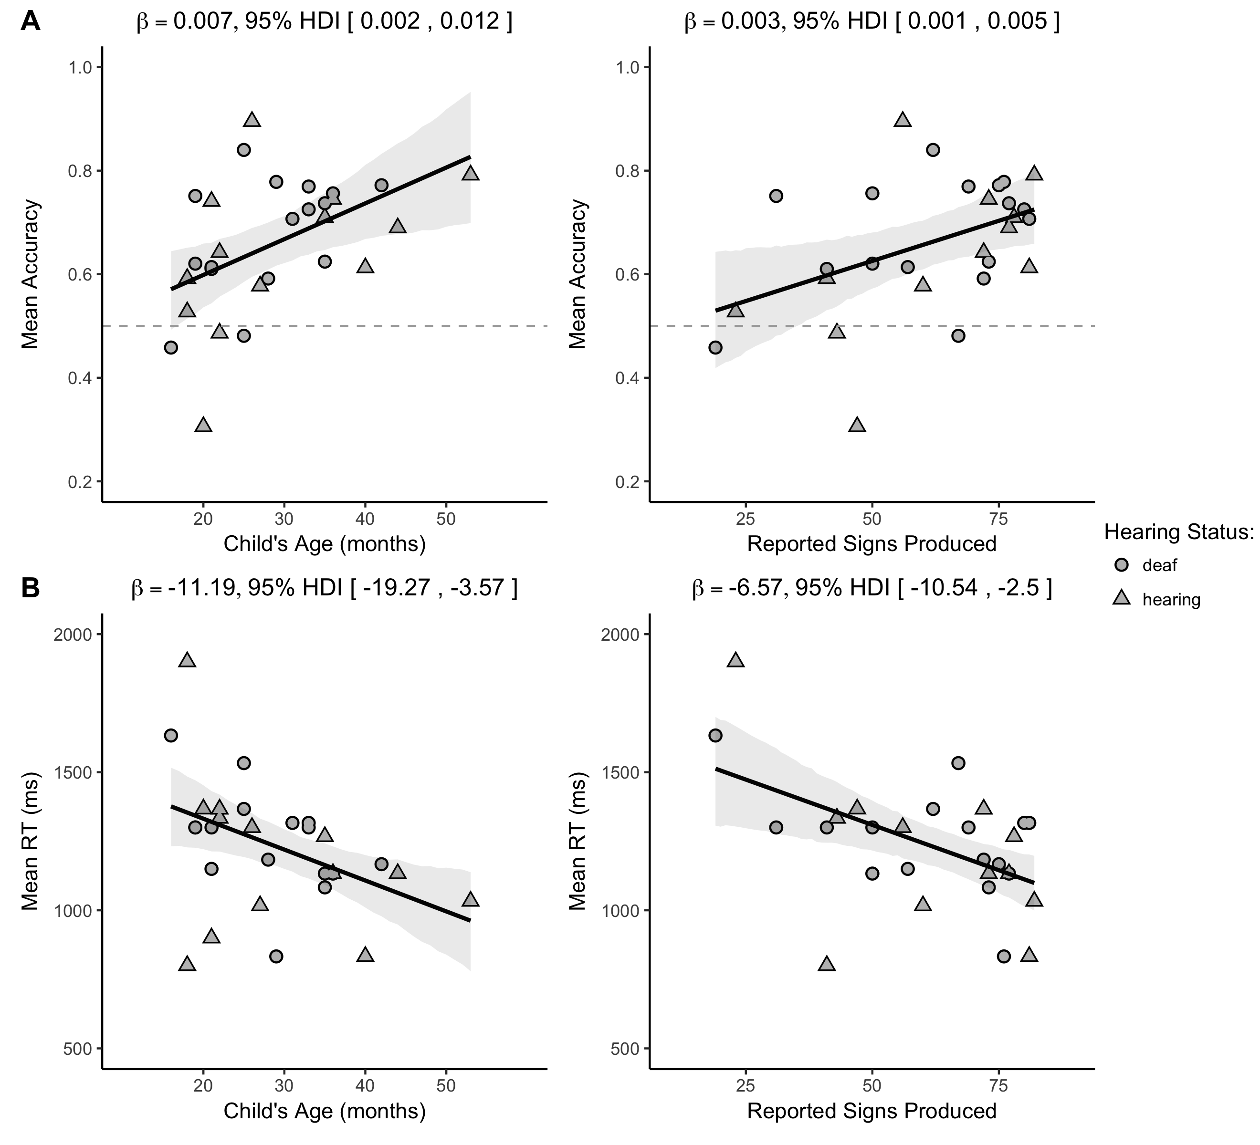

***Figure 4:*** *Scatterplots of relations between children’s age and vocabulary and measures of their mean accuracy (4A) and mean RT (4B) in the VLP procedure. Shape represents children’s hearing status. The solid black line is the maximum a posteriori model estimate for the mean accuracy at each age point. The shaded gray regions represent the 95% Highest Density Interval (range of plausible values) around the regression line.*

increase of ~1% point, meaning that over the course of one year the model estimates a ~12% point gain in accuracy when establishing reference in the VLP task. Mean RTs were negatively associated with age (Figure 4A), indicating that older children shifted to the target picture more quickly than did younger children. The BF was ~14, providing strong evidence for a linear association. The model estimates a ~11 ms gain in RT for each month, leading to a ~132 ms gain in speed of incremental ASL comprehension over one year of development.

Together, the accuracy and RT analyses showed that young ASL learners reliably looked away from the central signer to shift to the named target image in the VLP task. Importantly, children varied in their response times and accuracy, and this variation was meaningfully linked to age. Thus, like children learning spoken language, ASL learners improve their real-time language processing skills over the second and third years of life as they make progress towards adult levels of language fluency.

## Links between children’s incremental sign comprehension and productive vocabulary

The final question of interest was whether individual differences in processing skills were related to the size of children’s ASL vocabularies. As shown in Figure 4B, children with higher accuracy scores also had larger productive vocabularies (*BF*= 6.8), with the model estimating a 0.003 increase for each additional sign known. Moreover, children who were faster to recognize ASL signs were those with larger sign vocabularies (*BF*= 18.7), with each additional sign resulting in a ~7 ms decrease in estimated RT. Taken together, older children and children with larger expressive vocabularies were more accurate and efficient in identifying the referents of familiar signs. It is important to point out that the independent effect of vocabulary size on ASL processing could not be assessed here given the correlation between age and vocabulary (r = 0.76) in our sample of children ages one to four years. However, these findings parallel results in the substantial body of previous research with monolingual children learning spoken languages, such as English (Fernald et al., 2006) and Spanish (Hurtado, Marchman, & Fernald, 2007).

|  |  |  |  |
| --- | --- | --- | --- |
| **Model specification** |  | **Mean β** | **95% HDI** |
| Accuracy ~ Age | 12.8 | 0.007 | 0.002, 0.012 |
| Accuracy ~ Vocab | 6.8 | 0.003 | 0.001, 0.005 |
| RT ~ Age | 14.4 | -11.2 ms | -19.3 ms, -3.6 ms |
| RT ~ Vocab | 18.7 | -6.6 ms | -10.5 ms, -2.5 ms |

***Table 3:*** *Summary of the four linear models using children’s age and vocabulary size to predict accuracy (proportion looking to target) and reaction time (latency to first shift in ms). BF is the Bayes Factor comparing the evidence in favor of linear model to an intercept-only (null) model; Mean β is the mean of the posterior distribution for the slope parameter for each model (i.e., the linear association); and the Highest Density Interval (HDI) shows the interval containing 95% of the plausible slope values given the model and the data.*

# Discussion

Efficiency in establishing reference in real-time lexical processing is a fundamental component of language learning. Here, we developed the first measures of young ASL learners’ real-time language comprehension skills. There are five main findings from this research.

First, both adults and children showed a similar qualitative pattern of looking behavior as signs unfolded in time. They began by looking at the signer to gather information about the signed sentence, before shifting gaze to the named object, followed by a return in looking to the signer. All signers allocated very few fixations to the distractor image at any point during the signed sentence.

Second, children and adults tended to shift their gaze away from the signer and to the named referent prior to sign offset, providing evidence of incremental ASL processing. This rapid influence of language on visual attention in ASL is perhaps even more striking since premature gaze shifts could result in a degraded the linguistic signal processed in the periphery or in missing subsequent linguistic information altogether. Furthermore, evidence of incremental gaze shifts suggests that eye movements during ASL processing index efficiency of lexical comprehension, as previously shown in spoken languages, which is important for future work on the psycholinguistics of early sign language acquisition.

Third, deaf and hearing native signers, despite having differential access to auditory information, showed remarkably similar looking behavior during real-time ASL comprehension. Even though the deaf and hearing children had differential access to auditory information in their daily lives, this experience did not change their overall looking behavior or the timing of their gaze shifts during ASL comprehension. Instead, both groups showed parallel sensitivity to the in-the-moment constraints of processing ASL in real time. That is, both deaf and hearing children allocated similar amounts of visual attention to the signer, presumably because this was the only fixation point in the visual scene that also provided information with respect to their goal of language comprehension. This is in stark contrast to what hearing children could potentially do in a similar grounded language comprehension task where a speaker was a potential visual target. In that case, the hearing listener couldchoose to look at the speaker or to look elsewhere, without losing access to the incoming language via the auditory channel. Thus, they can look while they listen.

Fourth, like children learning spoken language, young ASL-learners were less efficient than adults in their real-time language processing, but they showed significant improvement with age over the first four years. Moreover, although all target signs were familiar to children, older children identified the named referents more quickly and accurately than younger children. This result suggests that the real-time comprehension skills of children who are learning ASL in native contexts follow a similar developmental path to that of spoken language learners, as has been shown in previous work on ASL production (Lillo-Martin, 1999; Mayberry & Squires, 2006). By developing precise measures of real-time ASL *comprehension*, we were able to study children's language skills earlier in development as compared to other methods.

Fifth, we found a link between ASL processing skills and children's productive vocabularies. ASL-learning children who knew more signs were also faster and more accurate to identify the correct referent than those who were lexically less advanced. These results are consistent with studies of English- and Spanish-learning children, which find strong relations between efficiency in online language comprehension and measures of linguistic achievement (Fernald et al., 2006; Marchman & Fernald, 2008).

## Limitations and open questions

This study has several limitations. First, while the sample size is larger than in most previous studies of ASL development, it is still relatively small compared to many studies of spoken language acquisition - an unsurprising limitation, given that native ASL-learners are a rare population. Thus more data are needed to characterize more precisely the developmental trajectories of sign language processing skills. Second, testing children within a narrower age range might have revealed independent effects of vocabulary size on ASL processing, which could not be assessed here given the correlation between age and vocabulary size in our broad sample of children from one to four years. To facilitate replication and extension of our results, we have made all of our stimuli, data, and analysis code publicly available (repository *URL removed for blinded review*).

Third, we did not collect measures of age-related gains in children’s general cognitive abilities. Thus, it is possible that our estimates of age-related changes in lexical processing are influenced by children’s developing efficiency in other aspects of cognition, e.g., increased control of visual attention. Work on the development of visual attention from adolescence to early adulthood shows that different components of visual attention (the ability to distribute attention across the visual field, attentional recovery from distraction, and multiple object processing) develop at different rates (Dye and Bavelier, 2009). Moreover, work by Elsabbagh et. al., (2013) shows that infants become more efficient in their ability to disengage from a central stimulus to attend to a stimulus in the periphery between the ages 7 months and 14 months. However, there is a large body of work showing that features of language use and structure (e.g., the frequency of a word, a word’s neighborhood density, and the amount of language input a child experiences) affect the speed and accuracy of eye movements in the Looking-While-Listening style tasks (see Tanenhaus et al., 2000 for a review). Thus, while it possible that age-related improvements in general cognitive abilities are a factor in our results, we think that the strength of the prior evidence suggests that more efficient gaze shifts in the VLP task are indexing improvements in the efficiency of incremental ASL comprehension.

A fourth limitation is that characteristics of our task make it difficult to directly compare our findings with previous work on ASL processing by adults. For example, in contrast to prior gating studies (e.g., Emmorey & Corina, 1990; Morford & Carlsen, 2011), our stimuli consisted of full sentences in a child-directed register, not isolated signs, and we used a temporal response measure rather than an open-ended untimed response. However, it is interesting to note that the mean reaction time of the adults in our task (M = 862 ms) is strikingly close to the average performance of native adult signers in Lieberman et al.’s (2015) “unrelated” condition (*M* = 844 ms). In addition, we did not select stimuli that parametrically varied features of signs that may influence speed of incremental ASL comprehension, including iconicity and degree of phonological overlap. However, we were able to use a recently created database of lexical and phonological properties of 1000 signs (Caselli et. al., 2017) to explore this possibility. We did not see evidence that iconicity or degree of phonological overlap influenced speed or accuracy of eye movements in children or adults in our sample of eight target signs (see Figures S4 and S5 in the online supplement).

We also cannot yet make strong claims about processing in signed vs. spoken languages in absolute terms because the VLP task included the signer as a central fixation, resulting in different task demands compared to the two-alternative procedure used to study children’s spoken language processing (e.g., Fernald et al. 1998). However, a direct comparison of the timecourse of eye movements during signed and spoken language processing is a focus of our ongoing work (MacDonald et al., 2017). Nevertheless, the current results reveal parallels with previous findings showing incremental processing during real-time spoken language comprehension (see Tanenhaus et al., 2000) and sign language comprehension in adults (Lieberman et al., 2015). Moreover, we established links between early processing efficiency and measures of vocabulary in young ASL-learners, suggesting that parallel mechanisms drive language development, regardless of the language modality.

Finally, our sample is not representative of most children learning ASL in the United States. Since most deaf children are born to hearing parents unfamiliar with ASL, many are exposed quite inconsistently to sign language, if at all. We took care to include only children exposed to ASL from birth. The development of real-time ASL processing may look different in children who have inconsistent or late exposure to ASL (Mayberry, 2007). An important step is to explore how variation in ASL processing is influenced by early experience with signed languages. Since children's efficiency in interpreting spoken language is linked to the quantity and quality of the speech that they hear (Hurtado, Marchman, & Fernald, 2008; Weisleder & Fernald, 2013), we would expect similar relations between language input and outcomes in ASL-learners. We hope that the VLP task will provide a useful method to track precisely the developmental trajectories of a variety of ASL-learners.

**Conclusion**

This study provides evidence that both child and adult signers rapidly shift visual attention as signs unfold in time and prior to sign offset during real-time sign comprehension. In addition, individual variation in speed of lexical processing in child signers is meaningfully linked to age and vocabulary. These results contribute to a growing literature that highlights parallels between signed and spoken language development when children are exposed to native sign input, suggesting that it is the quality of children’s input and not features of modality (auditory vs. visual) that facilitate language development. Moreover, similar results for deaf and hearing ASL-learners suggest that both groups, despite large differences in their access to auditory information in their daily lives, allocated attention in similar ways while processing sign language from moment to moment. Finally, these findings indicate that eye movements during ASL comprehension are linked to efficiency of incremental sign recognition, suggesting that increased efficiency in real-time language processing is a language-general phenomenon that develops rapidly in early childhood, regardless of language modality.

# References

Anderson, D., & Reilly, J. (2002). The MacArthur communicative development inventory: Normative data for American Sign Language. *Journal of Deaf Studies and Deaf Education*, 83–106.

Bavelier, D., Dye, M. W., & Hauser, P. C. (2006). Do deaf individuals see better?. *Trends in cognitive sciences*, *10*(11), 512-518.

Carreiras, M., Gutiérrez-Sigut, E., Baquero, S., & Corina, D. (2008). Lexical processing in Spanish Sign Language (LSE). *Journal of Memory and Language*, *58*(1), 100–122.

Caselli, N. K., & Cohen-Goldberg, A. M. (2014). Lexical access in sign language: a computational model. *Frontiers in Psychology*, *5, 428*.

Caselli, N. K., Sehyr, Z. S., Cohen-Goldberg, A. M., & Emmorey, K. (2017). ASL-LEX: A lexical database of American Sign Language. *Behavior research methods*, *49*(2), 784-801.

Chen, Q., & Mirman, D. (2012). Competition and cooperation among similar representations: toward a unified account of facilitative and inhibitory effects of lexical neighbors. *Psychological review*, *119*(2), 417.

Corina, D. P., & Emmorey, K. (1993). Lexical priming in American Sign Language. In *34th annual meeting of the Psychonomics Society*.

Corina, D. P., & Knapp, H. P. (2006). Lexical retrieval in American Sign Language production. *Papers in Laboratory Phonology*, *8*, 213–240.

Emmorey, K., & Corina, D. (1990). Lexical recognition in sign language: Effects of phonetic structure and morphology. *Perceptual and Motor Skills*, *71*(3), 1227–1252.

Fenson, L. (2007). *MacArthur-Bates communicative development inventories: User’s guide and technical manual*. Paul H. Brookes Publishing Company.

Fernald, A., & Marchman, V. A. (2012). Individual differences in lexical processing at 18 months predict vocabulary growth in typically developing and late-talking toddlers. *Child Development*, *83*(1), 203–222.

Fernald, A., Perfors, A., & Marchman, V. A. (2006). Picking up speed in understanding: Speech processing efficiency and vocabulary growth across the 2nd year. *Developmental Psychology*, *42*(1), 98.

Fernald, A., Pinto, J. P., Swingley, D., Weinberg, A., & McRoberts, G. W. (1998). Rapid gains in speed of verbal processing by infants in the 2nd year. *Psychological Science*, *9*(3), 228–231.

Fernald, A., Zangl, R., Portillo, A. L., & Marchman, V. A. (2008). Looking while listening: Using eye movements to monitor spoken language. In Sekerina, I.A., Fernandez, E.M., & Clahsen, H. (Eds.). *Developmental psycholinguistics: On-line methods in children’s language processing*, 113-132.

Gutierrez, E., Williams, D., Grosvald, M., & Corina, D. (2012). Lexical access in American Sign Language: An ERP investigation of effects of semantics and phonology. *Brain Research*, *1468,* 63-83.

Harris, M., & Mohay, H. (1997). Learning to look in the right place: A comparison of attentional behavior in deaf children with deaf and hearing mothers. *Journal of Deaf Studies and Deaf Education*, *2*(2), 95–103.

Hurtado, N., Marchman, V. A., & Fernald, A. (2007). Spoken word recognition by Latino children learning Spanish as their first language. *Journal of Child Language*, *34*(02), 227–249.

Hurtado, N., Marchman, V. A., & Fernald, A. (2008). Does input influence uptake? Links between maternal talk, processing speed and vocabulary size in Spanish-learning children. *Developmental Science*, *11*(6), F31–F39.

Law, F. & Edwards, J. R. (2014). Effects of vocabulary size on online lexical processing by preschoolers. *Language Learning and Development, 11*, 331 – 355.

Lieberman, A. M., Borovsky, A., Hatrak, M., & Mayberry, R. I. (2015). Real-time processing of ASL signs: Delayed first language acquisition affects organization of the mental lexicon. *Journal of Experimental Psychology: Learning, Memory, and Cognition*, *41*(4), 1130.

Lieberman, A. M., Borovsky, A., & Mayberry, R. I. (2017). Prediction in a visual language: real-time sentence processing in American Sign Language across development. *Language, Cognition and Neuroscience*, 1-15.

Lieberman, A. M., Hatrak, M., & Mayberry, R. I. (2014). Learning to look for language: Development of joint attention in young deaf children. *Language Learning and Development*, *10* (1), 19-35.

Lillo-Martin, D. (1999). Modality effects and modularity in language acquisition: The acquisition of American Sign Language. In Ritchie, W. & Bhatia, K. (Eds.). *Handbook of Child Language Acquisition*, *531*, 567.

MacDonald, K., Blonder, A., Marchman, V., Fernald, A., & Frank, M. C. (2017) An information-seeking account of eye movements during spoken and signed language comprehension. In *Proceedings of the 39th Annual Meeting of the Cognitive Science Society.*

Marchman, V. A., & Fernald, A. (2008). Speed of word recognition and vocabulary knowledge in infancy predict cognitive and language outcomes in later childhood. *Developmental Science*, *11*(3).

Mayberry, R. I. (2007). When timing is everything: Age of first-language acquisition effects on second-language learning. *Applied Psycholinguistics*, *28*(3), 537.

Mayberry, R. I., & Squires, B. (2006). Sign language acquisition. In Keith Brown (ed.), *Encyclopedia of Language and Linguistics*, 711-739.

Mitchell, R. E., & Karchmer, M. A. (2004). Chasing the mythical ten percent: Parental hearing status of deaf and hard of hearing students in the United States. *Sign Language Studies*, *4*(2), 138–163.

Morford, J. P., & Carlson, M. L. (2011). Sign perception and recognition in non-native signers of ASL. *Language learning and development*, *7*(2), 149-168.

Newport, E. L., & Meier, R. P. (1985). *The Acquisition of American Sign Language.* Lawrence Erlbaum Associates, Inc.

Petronio, K., & Lillo-Martin, D., (1997). WH-Movement and the Position of Spec-CP:

Evidence from American Sign Language. *Language*, *73*(1), 18–57.

Plummer, M. (2003, March). JAGS: A program for analysis of Bayesian graphical models using Gibbs sampling. *Proceedings of the 3rd international workshop on distributed statistical computing,* 124, 125.

Ratcliff, R. (1993). Methods for dealing with reaction time outliers. *Psychological bulletin*, *114*(3), 510.

Waxman, R. P., & Spencer, P. E. (1997). What mothers do to support infant visual attention: Sensitivities to age and hearing status. *Journal of Deaf Studies and Deaf Education*, *2*(2), 104–114.

Salverda, A. P., Kleinschmidt, D., & Tanenhaus, M. K. (2014). Immediate effects of anticipatory coarticulation in spoken-word recognition. *Journal of memory and language*, *71*(1), 145-163.

Stan Development Team. (2016). RStan: the R interface to Stan, Version 2.9.0. <http://mc-stan.org>

Tanenhaus, M.K., Magnuson, J.S., Dahan, D., & Chambers, C. (2000). Eye movements and lexical access in spoken-language comprehension: Evaluating a linking hypothesis between fixations  and linguistic processing, *Journal of Psycholinguistic Research*, 29(6), 557 – 580.

Venker, C. E., Eernisse, E. R., Saffran, J. R., Ellis Weismer, S. (2013). Individual differences in the real-time comprehension of children with ASD. *Autism Research*, 6, 417 – 432.

Wagenmakers, E. J., Lodewyckx, T., Kuriyal, H., & Grasman, R. (2010). Bayesian hypothesis testing for psychologists: A tutorial on the Savage–Dickey method. *Cognitive psychology*, *60*(3), 158-189.

Waxman, S., Fu, X., Arunachalam, S., Leddon, E., Geraghty, K., & Song, H. (2013). Are nouns learned before verbs? Infants provide insight into a long-standing debate. *Child Development Perspectives*, 7(3), 155-159.

Weisleder, A., & Fernald, A. (2013). Talking to children matters: Early language experience strengthens processing and builds vocabulary. *Psychological Science*, *24*(11), 2143–2152.

1. We did not find evidence that these features were related to the speed or accuracy of participants’ eye movements in our task. However, this study was not designed to vary these features systematically. See the online supplement for the analysis.
2. The assumption that first shifts reflects speed of incremental word recognition depends on the visual display containing candidate objects with minimal initial phonological overlap. If there are phonological competitors present (e.g., *candy* vs. *candle)*, then participants’ early shifting behavior could reflect consideration of alternative lexical hypotheses for the incoming linguistic information.