Age-related changes in children’s real-time American Sign Language comprehension

Kyle MacDonald

Todd LaMarr

David Corina

Virginia Marchman

Anne Fernald

Word count:

(not including author names and affiliations, acknowledgments, figure captions and references)

# Author note:

We are grateful to the many children and parents who participated in this research, and to the staff of the California School for the Deaf in Fremont. We extend a special thanks to Karina Pedersen and Lisalee Egbert for their help with participant recruitment. And thanks to Shane Blau, Kat Adams, Melanie Ashland, and the staff of the Language Learning Lab at Stanford University. This work was made possible by an NIDCD grant to Anne Fernald and David Corina (R21 DC012505-1).

**Abstract**

Research with children learning spoken language shows that the ability to link the auditory signal to objects in the world with high efficiency is critical to language development (Fernald & Marchman, 2012). Children learning sign language must use vision to process *both* linguistic information and objects in the visual world, creating a challenge for young learners' real-time language comprehension. This cross-sectional study is the first to explore how young learners of American Sign Language (ASL) comprehend signed language in real time, investigating links between these skills, children’s age, and vocabulary development. Native ASL-learning children (16-53 mos, n=29) and fluent adult signers (n=19) participated in a real-time language comprehension task of ASL processing efficiency. Children’s comprehension skills improved with age, with adult signers being most efficient. Importantly, children’s processing skills significantly correlated with age and vocabulary size, providing evidence that the ability to establish reference in real-time is linked meaningfully to language development. These novel findings show striking parallels between efficiency of language comprehension in visual language learners and children learning spoken languages, with both groups making impressive gains in the efficiency of language interpretation over the first few years of life as they progress towards adult-like levels of fluency.

# Introduction

Understanding language rapidly and accurately is central to our ability to function effectively in daily life. One fundamental component of language understanding is establishing reference during real-time language interaction by linking abstract symbols (i.e., words and signs) to concrete objects in the world. While children learning spoken languages can simultaneously attend to objects and listen to their caregivers talk, children learning American Sign Language (ASL) must rely on vision to both process linguistic information and look at objects in the visual scene. This dual functionality requires children to disengage from the source of language to seek out the named object, increasing the likelihood of a mapping error or potentially creating a situation where subsequent linguistic information is missed.

However, we know relatively little about how children acquiring ASL learn to efficiently allocate visual attention in the service of language comprehension. In the current work, we adapt a well-established paradigm for measuring spoken language processing efficiency to be used with young children learning ASL. Next, we ask whether increased efficiency in early comprehension by native ASL learners follows a similar developmental trajectory as that of children learning spoken language. Finally, we test whether individual variation in ASL processing skills show similar concurrent relations to children’s age and vocabulary size.

### Spoken language processing

To follow a typical conversation, skilled listeners must rapidly apprehend meaning in combinations of words from moment to moment as the speech signal unfolds at rates of 10-15 phonemes/second. Extensive research with adults using online measures shows that skilled listeners can identify spoken words before their acoustic offset, evaluating hypotheses about word identity incrementally based on what they have heard up to that moment, typically within 150 ms of word onset (Marslen-Wilson & Zwitserlood, 1989). Moreover, adults are adept in the parallel processing of multiple streams of information, rapidly integrating the acoustic speech signal as it unfolds in time with information from the visual scene to derive intended meaning (Altmann & Kamide, 1999; Dahan & Tanenhaus, 2004; Tanenhaus, Spivey-Knowlton, Eberhard, & Sedivy, 1995).

Over the past fifteen years, research with infants and young children has incorporated the same high-resolution measures of language processing (Fernald, Pinto, Swingley, Weinbergy, & McRoberts, 1998; Snedeker & Trueswell, 2004), making it possible to obtain continuous measures of speed and accuracy that enable sensitive assessment of efficiency in spoken language processing even by very young children. Using these procedures, researchers have found systematic age-related changes in the speed and accuracy of responses to familiar words (Fernald et al., 1998), and that efficiency in word recognition is correlated with both individual differences in vocabulary knowledge (Fernald, Swingley, & Pinto, 2001; Zangl, Klarman, Thal, Fernald, & Bates, 2005) as well as faster rates of vocabulary growth across the second year (Fernald, Perfors, & Marchman, 2006). While studies have also found associations between faster word recognition and more advanced linguistic development in both English (Fernald et al., 2001; Zangl & Fernald, 2007) and Spanish (Hurtado, Marchman, & Fernald, 2008; Lew-Williams & Fernald, 2007), this is the first study to adapt these online processing efficiency measures to be used with children learning ASL.

### ASL processing with adults

ASL is a visual-gestural language expressed with hands, arms and face, a modality difference with potential consequences for how linguistic information is processed. In many ways, language processing appears to be parallel in spoken and manual modalities. Signers show effects of: (a) lexicality, response times to identify non-signs are slower than for actual signs (Corina & Emmorey, 1993), (b) frequency, high frequency signs are recognized faster than low frequency signs (Carreiras, Gutiérrez-Sigut, Baquero, & Corina, 2008), and (c) phonological parameters, the sublexical units of sign – handshape, location, and movement – influence sign recognition (Carreiras et al., 2008; Corina & Emmorey, 1993; Hildebrandt & Corina, 2002). But, differences in linguistic structure and surface features of lexical forms in the spoken vs. manual modality have consequences for the efficiency with which signs are understood (Carreiras, 2010; Corina & Knapp, 2006). Using a gating procedure, Emmorey & Corina (1990) found that deaf participants identified monomorphemic signs after approximately 35% of the sign form had been seen; in contrast, in spoken English approximately 83% of a word must be heard before words are uniquely identified (Grosjean, 1980).

Another line of research has explored the consequences of delayed first language acquisition for language processing, finding consistent processing advantages for early learners. For example, Mayberry & Fischer (1989) had native and non-native signers complete a linguistic shadowing task and found that non-native signers expended more cognitive resources processing signs at the phonological level. Processing advantages for native signers also show up in sentence recall tasks (Mayberry & Eichen, 1991), grammaticality judgments (Boudreault & Mayberry, 2006), and gating experiments (Emmorey & Corina, 1990; Morford & Carlsen, 2011).

More recent work using an adaptation of the visual world paradigm (Tanenhaus et al., 1995) asks questions about ASL processing in more naturalistic contexts. By measuring adult signers' eye movements while they process full ASL sentences[1], Lieberman, Borovsky, Hatrak, & Mayberry (2014a) found that early, but not late-learners, show evidence of real-time activation of sublexical features of sign and that incremental semantic processing occurs during real-time sign comprehension. And Thompson, Vinson, Fox, & Vigliocco (2013) showed that both semantic and phonological aspects of signs affect real-time lexical processing. Thus, there is considerable evidence that signs, like spoken words, are processed incrementally by adults, and that there are substantial individual differences in adults' linguistic processing skills. At the same time, we know very little about how young ASL learners develop these critical, real-time language processing skills and whether these skills are linked to lexical development.

### Lexical development in ASL

Since the seminal work of Bellugi (1979) established that signed languages are natural human languages not derivative from spoken languages, researchers have explored the effects of a visual-manual communication system on lexical development. The upshot of this work is that acquisition of ASL in native, natural contexts follows a strikingly similar developmental path to children learning spoken language (Lillo-Martin, 1999; Mayberry & Squires, 2006). For example, like children learning spoken languages, young signers produce first signs typically before the end of the first year and two-sign sentences by their 2nd birthday (Newport & Meier, 1985). Moreover, young ASL learners show a preponderance of nouns, rather than verbs or other predicates, in the early lexicon (Anderson & Reilly, 2002).

A separate body of research has investigated how children learning ASL alternate gaze between linguistic information and objects in real-world learning contexts to achieve joint attention (Waxman & Spencer, 1997).[2] For example, Harris & Mohay (1997) found that at 18 months, deaf children frequently shifted visual attention towards their mothers during a free play interaction. More recent work by Lieberman, Hatrak, & Mayberry (2014b) showed that deaf children make frequent shifts in gaze during book reading in order to perceive both linguistic input and the non-linguistic context. Thus, gaze shifts are a critical aspect of sign language comprehension, but we do not have precise experimental measures of how young ASL users develop these visual attention skills.

In sum, data on the developmental trajectories of deaf children learning signed languages has been largely confined to diary studies and small-group investigations. These studies have also tended to focus on aspects of language production, for example, the development of ASL articulatory skills (Meier, Mauk, Mirus, & Conlin, 1998) or the appearance of specific grammatical forms (Lillo-Martin, 2000). Moreover, no prior studies have systematically investigated how young ASL learners establish reference during real-time sentence processing, or whether early language comprehension skills are linked to other meaningful linguistic outcomes. In the current work, we address this gap by developing the first measures of young learners' visual language comprehension skills.

### Current study

This study will be the first to explore the early development of real-time processing of signs by very young children learning ASL. First, we adapt a well-established paradigm for measuring spoken language processing efficiency to be used with young children learning ASL. Next, we ask whether efficiency of ASL comprehension reveals similar age-related changes as that seen in previous studies with children learning spoken language. Finally, we test whether individual variation in ASL processing efficiency shows concurrent relations to children’s vocabulary size.

# Method

### Participants

16 deaf and 13 hearing children with native exposure to ASL (17 females, 12 males, Mage = 28.5 months, range = 16-53 months) and 19 fluent adult signers were recruited from several locations by bi-cultural/bilingual researchers fluent in ASL. All children were exposed to ASL at birth from at least one fluent ASL caregiver and currently used ASL as their primary mode of communication at home. The majority of children attended a center-based early childhood education program in which ASL was the primary mode of instruction. Thus, all children in the sample had at least one deaf caregiver and were immersed in ASL from birth, both at home and in the daycare setting. An additional 20 participants were tested, but not included in the analyses due to fussiness (n = 5), being outside the target age range (n = 3), or not receiving enough ASL exposure (n = 12). For visualization purposes, children were divided into two groups using a median split by age: Younger (<= 27 Months), Older (> 27 Months), but we conduct all critical statistical tests treating age as a continuous variable.[3]

### Measures

*Parent report of vocabulary size*: Parents completed a 90-item vocabulary checklist based on the MacArthur-Bates Communicative Development Inventories (Fenson, 2007) and designed to be culturally and linguistically appropriate for children learning ASL. Parents completed the checklist during the visit, and vocabulary size was computed as the number of signs reported to be produced.

*ASL Processing*: Efficiency in online comprehension was assessed using a version of the looking-while-listening procedure (LWL) (Fernald et al., 2006) adapted for ASL learners, which we call the Visual Language Processing (VLP) task. Since this was the first study to measure online ASL processing efficiency in children of this age, several important modifications to the procedure were made, which we describe below.

### Apparatus

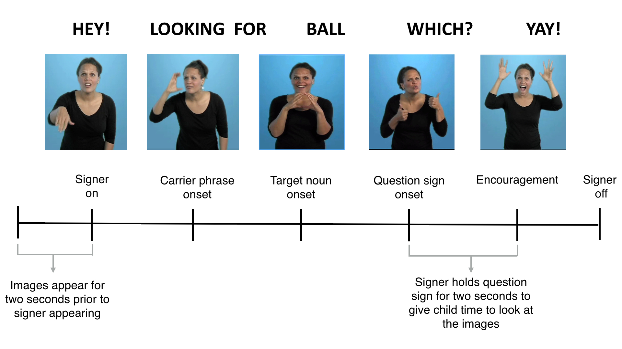To facilitate recrutiment[4], we created a portable version of the VLP task with stimuli presented on a 27” monitor using a Macbook Pro laptop. Video of the child’s gaze was recorded using a digital camcorder set up behind the monitor. To minimize visual distractions, children sat on their caregivers’ laps inside of a portable 5’ by 5’ tent with opaque walls. The tent reduced the potential for visual distractions to occur during the task.

**Figure 1:** Timeline of a trial on the VLP task.

### Trial Structure

Figure 1 shows the timeline of one trial in the VLP task. On each trial the child saw two images of familiar objects on the screen for two seconds before the signer appeared. This allowed the child to inspect both images prior to the start of the sentence. Next, children saw a still frame of the signer for one second, which gave them the opportunity to orient to the signer prior to the sentence onset. The target noun was then presented, followed by a question and hold, which gave the child the opportunity to shift their attention to the target object. After the hold, the signer gave neutral, positive feedback to help maintain the children's focus throughout the task. Each trial lasted approximately seven seconds

### Linguistic and visual stimuli

The linguistic stimuli were designed to be comparable to those used in previous research and to allow for generalization beyond characteristics of a specific signer and sentence structure. To accomplish this, we recorded ASL sentences from two native ASL users who used two different but acceptable ASL sentence structures for asking questions[5]:

* Sentence-initial wh-phrase: “HEY! WHERE [target noun]?”
* Sentence-final wh-phrase: “HEY! [target noun] WHERE?”

Both versions of the stimuli can be viewed at the project page for this experiment:. <https://github.com/kemacdonald/SOL>.

Before each sentence, the signer used a hand-wave gesture commonly used in ASL discourse to gain an interlocutor’s attention before initiating a linguistic utterance. This served to shift children's attention away from the images on the screen to the signer in preparation for the upcoming sentence.

Four yoked pairs of eight target nouns (cat—bird, car—book, bear—doll, ball—shoe) were used. These nouns were selected such that they would be familiar to most children learning ASL at this age and have minimal phonological overlap. To prepare the stimuli, two female native ASL users recorded several tokens of each sentence, matching them closely in prosody. These candidate stimuli were then digitized, analyzed, and edited using Final Cut Pro software. The final tokens were chosen based on naturalness and prosodic comparability. The mean duration of target nouns was 1134 ms (range = 495-1947 ms). Five filler trials were interspersed among the 32 test trials (e.g. “YOU LIKE PICTURES? MORE WANT?”). Images were digitized pictures presented in fixed pairs, matched for visual salience with 3–4 tokens of each object type. Side of target picture was counterbalanced across trials.

### Coding and reliability

Children’s gaze patterns were videotaped and coded frame-by-frame, yielding a high-resolution record of eye movements aligned with target noun onset. 25% of videos were re-coded to assess coder reliability -- agreement within a single frame averaged 98% on these reliability assessments.

### Calculating linguistic processing efficiency

*Computing critical sign onset.* Computing accuracy and RT requires defining the appropriate response window, starting at the earliest moment when there is sufficient information to shift gaze off of the central signer and initiate a looking response to the target image. In studies of spoken language processing, critical word onset is typically identified using acoustic analysis software that measures the moment in the speech when the target noun begins. Because of co-articulation in ASL, it is difficult to precisely determine the beginning of the target sign. Prior work has used different definitions. For example, in the gating literature sign onset has been defined as the moment when the signer’s hand(s): (a) appeared on the screen (Grosjean, 1981), (b) entered signing space (Emmorey & Corina, 1990), or (c) left the resting position (Arendsen, Van Doorn, & de Ridder, 2009). In one of the few tasks that used complete ASL sentences, Morford and Carlsen (2011) defined sign onset as, “the frame in which the dominant signing hand moved out of the trajectory of the preceding sign and began the movement trajectory of the target sign.”

Here, we decided to take an empirical approach to defining critical sign onset. To get an initial judgment, the first and second authors, both fluent signers, viewed each stimulus sentence and achieved a consensus regarding target noun onset. Then, to validate these judgments, we conducted an additional study in which fluent adult signers unfamiliar with the stimuli (n = 10) watched videos of each signed sentence and made forced choice decisions indicating which of two images was signed in the video. For each sign, we selected six tokens, with each token containing a different amount of the target sign. These tokens were chosen to be plus or minus three frames of video from the noun onsets defined by the initial consensus judgments. Participants saw a total of 168 trials (28 sentences x 6 tokens), with order randomized across participants. We derived the final noun onset values for each stimulus sentence based on the earliest point when participants' judgments achieved 100% agreement. To our knowledge this is the first study to use empirically derived sign onsets, but we felt it was critical to maximize the precision in our processing measures.

*Accuracy:* Correct looking is a function of the child’s tendency to shift quickly away from the central signer to the target picture in response to the target sign, and also to remain fixated on the target picture. To determine the degree to which participants fixated the appropriate picture across trials, mean proportion looking to target was calculated for each participant at each 33 ms frame from the onset of the target noun. Accuracy was defined as the mean proportion of time spent looking at the target picture out of the total time spent on either the target picture, the distracter picture, or the signer from 600 to 2100 ms from target noun onset. We selected this window after looking at the distribution of children's first shifts over time, with the goal of maximizing the amount of meaningful looking behavior. This window includes 90% of children's first shifts. I

*First Shift Accuracy:* Importantly, the VLP task includes a central signer, which functions as a center fixation point similar to adult psycholinguistic experiments. Thus, children could produce four different types of responses on a given trial: (1) signer-to-target shift, (2) signer-to-distractor shift, (3) signer-to-away shift, (4) no-shift. First shift accuracy was defined as the number of signer-to-target (correct) initial shifts divided by the number of signer-to-distractor (incorrect) shifts. All four trial types contribute to Accuracy analyses and all 29 children were included.

*Reaction Time:* Reaction time (RT) corresponds to the latency to shift away from the central signer to the target picture, measured from the empirically defined onset of the target sign. Incorrect shifts from the signer to the distractor picture were not included in the computation of mean RT. Moreover, we excluded participants from the RT analysis if their first shift behavior was determined to be the result of guessing, since this suggests that RTs are not a meaningful measure of language processing skill for these children. To quantify the probability that participants' initial shifts were the result of guessing behavior, we used a Bayesian latent mixture model implemented in JAGS (Plummer, 2003). In this model, the data are assumed to be generated by two different processes (guessing and knowledge) that have different probabilities of success, with the guessing group having a probability of 50% and the knowledge group having a probability greater than 50%. The group membership of each participant is a latent variable that we inferred based on their proportion of correct shifts to the target picture relative to the overall proportion of correct shifts across all participants (see Lee & Wagenmakers (2013) for a detailed discussion of this modeling approach). Five children were excluded because more than 50% of their posterior mass indicated a guessing strategy with relatively little uncertainty -- posterior probabilities of 0.99, 0.78, 0.98, 0.98, and 0.94 respectively.[6] Thus, only signer-to-target shifts for 24 children were included in the RT analyses.

Within children, shifts that occurred prior to 600 ms from noun onset were excluded because it is likely that these shifts were initiated before the child had enough time to process sufficient linguistic input and to mobilize an eye movement; shifts that occurred after 2100 ms were excluded because these delayed looks are less likely to reflect a response to the target sign (see Fernald et al. (2001)). In addition, 8% of trials were excluded because children never shifted off of the signer. Since children vary in the likelihood that they will shift on a given trial, mean RTs 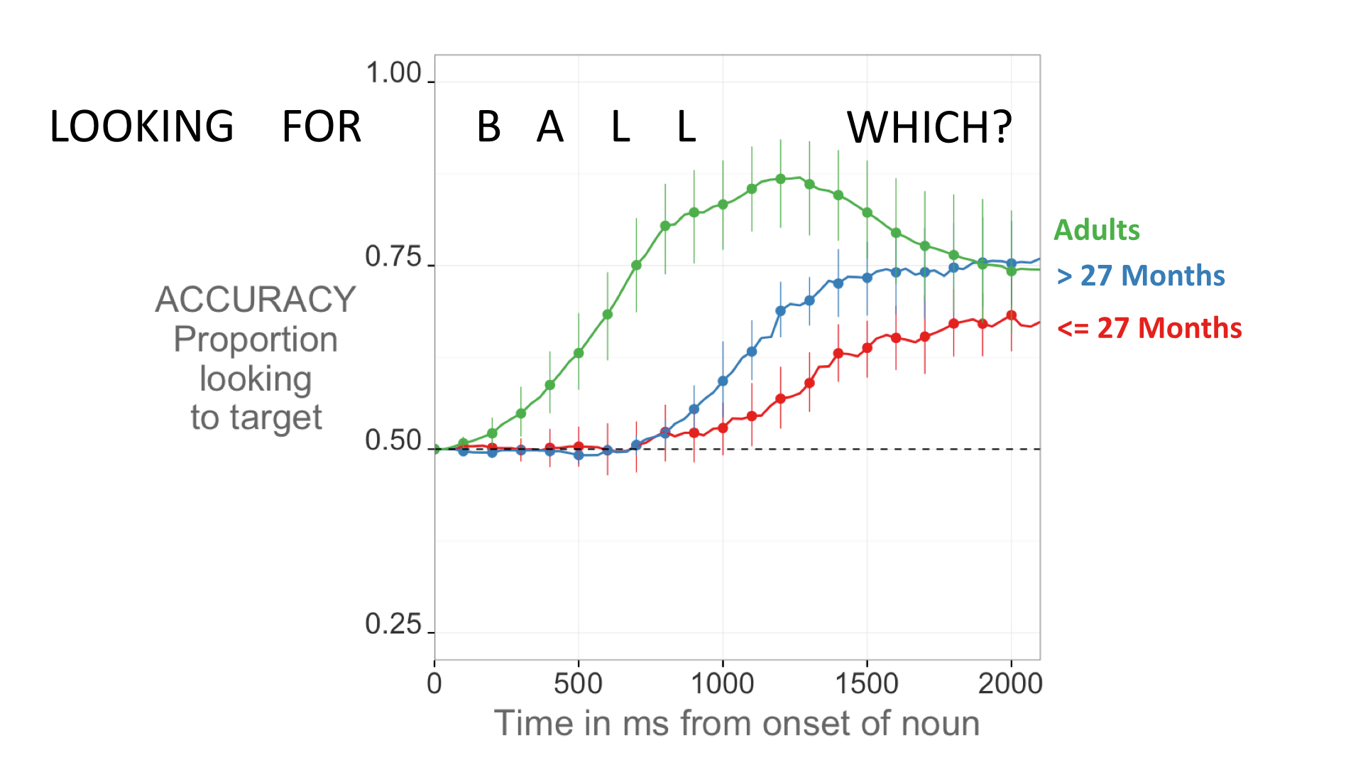are based on different numbers of trials across participants (M = 12.7 trials, range = 3—25).

**Figure 2.** The timecourse of participants' responses to the target picture in relation to the unfolding signed sentence for younger children, older children, and adults. Curves show changes over time in the mean proportion looking to the correct picture, measured in ms from noun onset; error bars represent +/- 95% CI computed by non-parametric bootstrap.

# Results

First we present an overview of performance on the VLP task, showing that children become faster and more accurate at comprehending familiar signs as they get older and make progress towards adult levels of language fluency. [7] Then we present multiple regression analyses, modeling the links between children’s real-time ASL processing skills and both age and productive ASL vocabulary.

|  |  |  |  |  |
| --- | --- | --- | --- | --- |
| Age Group | Accuracy | First Shift Accuracy |  | RT |
| <= 27 Months | 0.59 (0.058) | 0.66 (0.2) |  | 1304 (255) |
| > 27 Months | 0.66 (0.069) | 0.8 (0.09) |  | 1191 (120) |
| Adults | 0.8 (0.1) | 0.97 (0.03) |  | 699 (170) |

**Table 1.** Summary statistics for all language processing measures for each age group.

### ASL processing efficiency

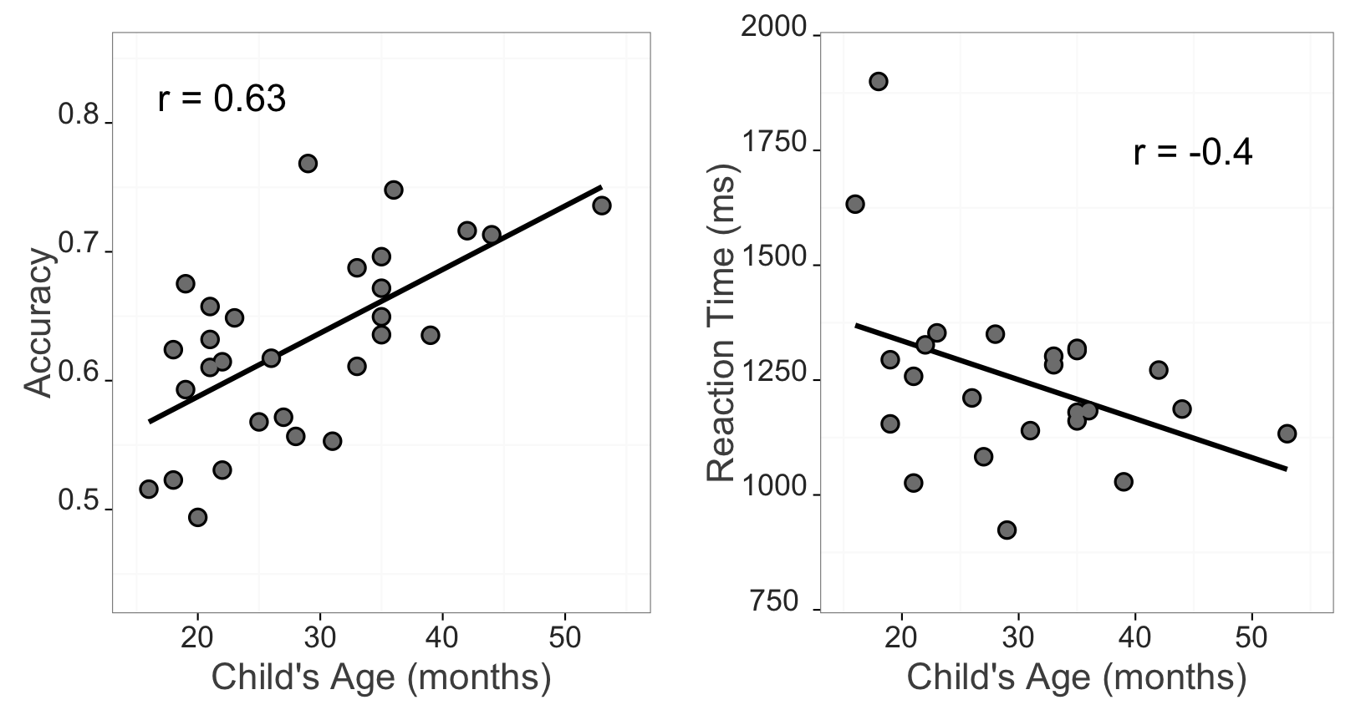Figure 2 provides an overview of the timecourse of correct orienting to the referent in response to the target sig. The three curves show changes in the mean proportion of trials on which participants in each age group fixated the correct referent at every 33 ms interval as the target sign unfolded. Table 1 provides summary statistics. Before seeing the target sign, all participants fixated on the signer. Children were slower to respond and less accurate than adults, on average, maintaining their gaze on the center signer longer and reaching a lower asymptote. The youngest children took longest to orient to the target (t(22) = 2.05, d = 0.21) and were less accurate than older children (t(27) = -2.96, d = 0.33).

***Figure 3:*** *Relationship between VLP measures and children’s age. Each data point is an individual child. Left Panel shows the positive relationship between accuracy and age. Right panel shows the negative relationship between RT and age.*

### Links between processing efficiency and age

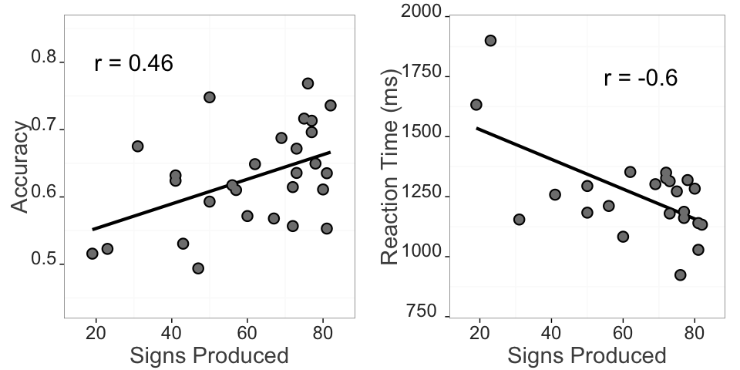Mean accuracy scores, computed over the 600–2100 ms window from noun onset, were examined as a function of age. Accuracy was strongly correlated with age ((27) = 0.63), indicating that older ASL learners were more reliable than younger children in fixating the target picture. Mean reaction times were negatively correlated with age ((22) = -0.4), indicating that older children were faster to shift to the target picture than younger ones. Mean reaction times were also negatively correlated with mean accuracy scores ((22) = -0.6) such that those children who were faster to shift to the target were also more likely to stick on the target image throughout a greater proportion of the analysis window. Figure 4 shows these relationships.

**Figure 4:** Relationship between VLP measures and productive ASL vocabulary. Each data point is an individual child. Left panel shows the positive relationship between accuracy and vocabulary. Right panel shows the negative relationship between RT and vocabulary.

Together, the Accuracy and Reaction Time analyses show that signers will reliably leave a central signer to shift to a target image in the VLP task. Importantly, signers varied in their response times and accuracy, and this variation was meaningfully linked to age. Thus, like children learning spoken language, ASL learners improve their real-time language processing skills over the second and third years of life, progressing towards adult levels of language fluency.

### Links between processing efficiency and vocabulary

Figure 4 shows the relationships between both VLP processing measures and children's productive ASL vocabulary. Mean accuracy was positively related to vocabulary size ((27) = 0.46) such that children with higher accuracy scores also had larger productive vocabularies. Mean reaction times were negatively correlated with vocabulary ((22) = -0.6) indicating that children who were faster to recognize ASL signs were those children with larger sign vocabularies.

It is important to point out that age and vocabulary were strongly intercorrelated in our sample ((27) = 0.74). So in order to quantify the effect of each factor on children's online language processing skills, we fit separate multiple regression models to children's Accuracy and RT data. Tables 1 and 2 show model specification and output. In the Accuracy model, age and vocabulary together accounted for approximately 42.2% of the variance in accuracy ((2, 25) = 9.1). Although vocabulary did not contribute significant variance after age was taken into account (-change: 21.1%), age contributed approximately 18% additional variance beyond vocabulary. Thus, the majority of the variation in accuracy was attributable to the shared variance between these two factors, yet some sources of individual differences in accuracy were attributable to age above and beyond vocabulary.

|  |  |  |  |
| --- | --- | --- | --- |
|  | Estimate | Std. Error | t.value |
| **Intercept** | 0.486 | 0.0399 | 12.2 |
| **Vocabulary** | -0.000346 | 0.000939 | -0.368 |
| **Age** | 0.00567 | 0.00188 | 3.02 |

**Table 2:** Multiple regression model output for accuracy data. The model was specified as: Accuracy ~ Vocabulary + Age

Next, we fit the same multiple regression model to children's RT data. This analysis showed that age and vocabulary together accounted for approximately 36.5% of the variance in RT. However, in contrast to the accuracy measure, vocabulary contributed significant variance even after age was included in the model. Thus, children who were faster to identify the target sign also had larger vocabularies controlling for the relationshipb between age and RT.

|  |  |  |  |
| --- | --- | --- | --- |
|  | Estimate | Std. Error | t.value |
| **Intercept** | 1660 | 128 | 13 |
| **Vocabulary** | -5.87 | 2.77 | -2.12 |
| **Age** | -0.901 | 5.68 | -0.159 |

**Table 3:** Multiple regression model output for RT data. The model was specified as:

RT ~ Vocabulary + Age

Taken together, these analyses indicate that children learning ASL were more accurate and efficient in identifying the referents of familiar signs as they got older and developed a larger expressive vocabulary. These findings are consistent with previous research with children learning English and Spanish (Fernald et al., 2006; Hurtado, Marchman, & Fernald, 2007).

# Discussion

Establishing reference in real-time is a fundamental component of language learning. To link signs to objects, young ASL users must learn to resolve an apparent conflict between attending to the source of linguistic information and shifting their gaze to the surrounding visual scene. Moreover, they must learn to do this efficiently because if a child does not see a sign, or does not see the intended referent, then the information in that naming event is effectively unavailable. With this study, we aimed to develop and validate the first measures of young ASL learners’ real-time language comprehension skills and explore the links between these skills and both age and vocabulary. There are three main findings from this work.

First, analyzing gaze shifts during real-time sentence processing is a valid way to measure young ASL learners' language development. Previous work using online measures with adult ASL users has revealed important aspects of the psycholinguistics of sentence processing. For example, Lieberman et al. (2014a) showed evidence of real-time activation of sublexical features of sign and that incremental semantic processing occurs during real-time sign comprehension. But we did not yet know whether these online measures would work with very young learners. Moreover, because gaze serves a variety of functions in ASL, using eye movements as an index of language comprehension skills might not have been possible. For example, proficient ASL users rely on vision for: (a) processing linguistic information, (b) monitoring the visual world, (c) regulating turn-taking during conversation (Baker & Padden, 1978), and (d) role shifts during narrative production (Bahan & Supalla, 1995).

Despite these modality-driven differences, the current study shows that we can use the VLP task to measure subtle differences in real-time ASL processing skills. It is interesting to consider how the rapid gaze shifts we measured would compare to the gaze shifting behavior required in naturalistic interactions to establish mutual gaze to objects (i.e., joint attention), which is thought to be critical for early lexical development (see Lieberman et al. (2014b) for a discussion of joint attention behavior in ASL).

The second main finding was that, like children learning spoken language (Fernald et al., 1998), young ASL learners' show measurable age-related improvement in the efficiency with which they processed language. All of the target signs were familiar to children in this age range, yet older children more quickly and accurately identified the correct referents than younger children. This finding provides additional evidence that ASL acquisition in native, natural contexts follows a strikingly similar developmental path to children learning spoken language (Lillo-Martin, 1999; Mayberry & Squires, 2006). Moreover, this is the first study to show that real-time ASL *comprehension* skills are linked to early development. Prior work on the developmental trajectories of deaf children has relied on aspects of language production often because production is easier to see, making it easier to measure. However, it is a well-known phenomenon in language acquisition that comprehension tends to precede production (see Clark, 2009). By developing a fine-grained measure of real-time ASL comprehension, we have provided a tool that can measure children's language skills earlier in development than previously possible.

The third result was the discovery of a link between early ASL processing skills and children's productive ASL vocabularies. ASL-learning children who knew more signs were also faster and more accurate in language processing than those who were lexically less advanced. However, the factors of age and vocabulary size were highly intercorrelated in this sample and the majority of the association between vocabulary and accuracy, but not RT, was attributable to variance that was shared between these two factors. Nevertheless, these results with children learning ASL are consistent with other studies with English- and Spanish- learning children, which find strong relations between efficiency in online language comprehension and other concurrent and longitudinal measures of linguistic achievement (Fernald et al., 2006, 2001; Marchman & Fernald, 2008; Zangl et al., 2005).

### Limitations

This study has several limitations that are worth noting. First, while our sample is large relative to past work investigating early ASL development, it is still a small sample. These results should be replicated in future studies that include more participants. We have made all of our stimuli, data, and analysis code publicly available at the project page for this study (<https://github.com/kemacdonald/SOL>), with the hope that other researchers will benefit from what we have learned in this work.

Second, our sample included a broad age range of children. Recall that age explained the majority of individual variation in accuracy, but, interestingly, not in RT. Based on the strength of past evidence, it is likely that testing a narrower age range would allow us to see an independent effect of vocabulary size in both language processing measures. But we need more evidence in order to best characterize the relationships between accuracy, RT, and vocabulary.

Third, the novelty of the VLP task makes it difficult to directly compare our findings with previous work on ASL and spoken language processing. For example, in contrast to prior ASL gating studies (e.g., Emmorey & Corina, 1990; Morford & Carlsen, 2011), our stimuli were full sentences signed in a child-directed manner, not isolated signs, and our dependent measure was the latency to shift gaze away from a signer to one of two images, not a free response. In addition, the VLP task contains a natural central fixation point – the signer – making it substantially different from previous work on the development of children’s spoken language processing (e.g., Fernald, 1998). Because of these differences we have avoided making any general claims related to the time course of processing in signed vs. spoken languages. However, our lab is currently working on a new spoken language paradigm that will be more analogous to the VLP task. We hope this new task will allow for more direct comparisons of language processing across the two modalities.

Finally, our sample is not representative of the majority of children learning ASL in the United States. We took great care to include only children who are native signers with exposure to ASL from birth from at least one deaf caregiver. However, we might anticipate that the development of online language processing might look different in children who are late learners or who have much more heterogeneous and inconsistent language exposure than the ones tested in the current work. An important next step is to explore the relations between the development of language processing skills and children's experience with signed languages during interactions with caregivers, the norm for most children born deaf and learning a visual language. It is well-known that children's efficiency of online processing is tightly linked to the quantity and quality of the speech that they hear (Hurtado et al., 2008; Weisleder & Fernald, 2013). We would expect similar relations in children learning ASL.

In sum, this study provides the first evidence that eye movements during real-time ASL sentence processing provide a valid measure of age-related changes in young children's visual language comprehension skills. These findings contribute to the now significant body of literature highlighting the parallels between signed and spoken language development when children are exposed to native sign input. We hope that the development of the VLP task will provide a useful method for researchers and educators, providing a way to track developmental trajectories of early language learning in native learners of signed languages, like ASL.

# References

Altmann, G. T., & Kamide, Y. (1999). Incremental interpretation at verbs: Restricting the domain of subsequent reference. *Cognition*, *73*(3), 247–264.

Anderson, D., & Reilly, J. (2002). The macArthur communicative development inventory: Normative data for american sign language. *Journal of Deaf Studies and Deaf Education*, 83–106.

Arendsen, J., Van Doorn, A. J., & de Ridder, H. (2009). When do people start to recognize signs?. *Gesture*, *9*(2), 207-236.

Bahan, B., & Supalla, S. (1995). Line segmentation and narrative structure: A study of eyegaze behavior in american sign language. *Language, Gesture, and Space*, 171–191.

Baker, C., & Padden, C. (1978). Focusing on the nonmanual components of american sign language. *Understanding Language Through Sign Language Research*, 27–57.

Baldwin, D. A. (1995). Understanding the link between joint attention and language.

Bellugi, U. (1979). *The signs of language*. Harvard University Press.

Boudreault, P., & Mayberry, R. I. (2006). Grammatical processing in american sign language: Age of first-language acquisition effects in relation to syntactic structure. *Language and Cognitive Processes*, *21*(5), 608–635.

Brooks, R., & Meltzoff, A. N. (2008). Infant gaze following and pointing predict accelerated vocabulary growth through two years of age: A longitudinal, growth curve modeling study. *Journal of Child Language*, *35*(01), 207–220.

Carreiras, M. (2010). Sign language processing. *Language and Linguistics Compass*, *4*(7), 430–444.

Carreiras, M., Gutiérrez-Sigut, E., Baquero, S., & Corina, D. (2008). Lexical processing in spanish sign language (lSE). *Journal of Memory and Language*, *58*(1), 100–122.

Clark, E. V. (2009). *First language acquisition*. Cambridge University Press.

Corina, D. P., & Emmorey, K. (1993). Lexical priming in american sign language. In *34th annual meeting of the psychonomics society*.

Corina, D. P., & Knapp, H. P. (2006). Lexical retrieval in american sign language production. *Papers in Laboratory Phonology*, *8*, 213–240.

Dahan, D., & Tanenhaus, M. K. (2004). Continuous mapping from sound to meaning in spoken-language comprehension: Immediate effects of verb-based thematic constraints. *Journal of Experimental Psychology: Learning, Memory, and Cognition*, *30*(2), 498.

Emmorey, K., & Corina, D. (1990). Lexical recognition in sign language: Effects of phonetic structure and morphology. *Perceptual and Motor Skills*, *71*(3f), 1227–1252.

Fenson, L. (2007). *MacArthur-bates communicative development inventories: User’s guide and technical manual*. Paul H. Brookes Publishing Company.

Fernald, A., & Marchman, V. A. (2012). Individual differences in lexical processing at 18 months predict vocabulary growth in typically developing and late-talking toddlers. *Child Development*, *83*(1), 203–222.

Fernald, A., Perfors, A., & Marchman, V. A. (2006). Picking up speed in understanding: Speech processing efficiency and vocabulary growth across the 2nd year. *Developmental Psychology*, *42*(1), 98.

Fernald, A., Pinto, J. P., Swingley, D., Weinbergy, A., & McRoberts, G. W. (1998). Rapid gains in speed of verbal processing by infants in the 2nd year. *Psychological Science*, *9*(3), 228–231.

Fernald, A., Swingley, D., & Pinto, J. P. (2001). When half a word is enough: Infants can recognize spoken words using partial phonetic information. *Child Development*, *72*(4), 1003–1015.

Grosjean, F. (1980). Spoken word recognition processes and the gating paradigm. *Perception & Psychophysics*, *28*(4), 267–283.

Harris, M., & Mohay, H. (1997). Learning to look in the right place: A comparison of attentional behavior in deaf children with deaf and hearing mothers. *Journal of Deaf Studies and Deaf Education*, *2*(2), 95–103.

Hildebrandt, U., & Corina, D. (2002). Phonological similarity in american sign language. *Language and Cognitive Processes*, *17*(6), 593–612.

Hurtado, N., Marchman, V. A., & Fernald, A. (2007). Spoken word recognition by latino children learning spanish as their first language. *Journal of Child Language*, *34*(02), 227–249.

Hurtado, N., Marchman, V. A., & Fernald, A. (2008). Does input influence uptake? Links between maternal talk, processing speed and vocabulary size in spanish-learning children. *Developmental Science*, *11*(6), F31–F39.

Lee, M., & Wagenmakers, E. (2013). Bayesian modeling for cognitive science: A practical course. *Cambridge UP*.

Lew-Williams, C., & Fernald, A. (2007). Young children learning spanish make rapid use of grammatical gender in spoken word recognition. *Psychological Science*, *18*(3), 193–198.

Lieberman, A. M., Borovsky, A., Hatrak, M., & Mayberry, R. I. (2014a). Real-time processing of aSL signs: Delayed first language acquisition affects organization of the mental lexicon. *Journal of Experimental Psychology: Learning, Memory, and Cognition*.

Lieberman, A. M., Hatrak, M., & Mayberry, R. I. (2014b). Learning to look for language: Development of joint attention in young deaf children. *Language Learning and Development*, *10*(1), 19–35.

Lillo-Martin, D. (1999). Modality effects and modularity in language acquisition: The acquisition of american sign language. *Handbook of Child Language Acquisition*, *531*, 567.

Lillo-Martin, D. (2000). Early and late in language acquisition: Aspects of the syntax and acquisition of wh-questions in american sign language. *The Signs of Language Revisited: An Anthology to Honor Ursula Bellugi and Edward Klima*, 71–90.

Marchman, V. A., & Fernald, A. (2008). Speed of word recognition and vocabulary knowledge in infancy predict cognitive and language outcomes in later childhood. *Developmental Science*, *11*(3), F9–F16.

Marslen-Wilson, W., & Zwitserlood, P. (1989). Accessing spoken words: The importance of word onsets. *Journal of Experimental Psychology: Human Perception and Performance*, *15*(3), 576.

Mayberry, R. I., & Eichen, E. B. (1991). The long-lasting advantage of learning sign language in childhood: Another look at the critical period for language acquisition. *Journal of Memory and Language*, *30*(4), 486–512.

Mayberry, R. I., & Fischer, S. D. (1989). Looking through phonological shape to lexical meaning: The bottleneck of non-native sign language processing. *Memory & Cognition*, *17*(6), 740–754.

Mayberry, R. I., & Squires, B. (2006). Sign language acquisition.

McClelland, G., Lynch, J. G., Irwin, J. R., Spiller, S. A., & Fitzsimons, G. J. (2015). Median splits, type iI errors, and false positive consumer psychology: Don’t fight the power. *Type II Errors, and False Positive Consumer Psychology: Don’t Fight the Power (March 10, 2015)*.

Meier, R. P., Mauk, C., Mirus, G. R., & Conlin, K. E. (1998). Motoric constraints on early sign acquisition. *29*, 63–72.

Mitchell, R. E., & Karchmer, M. A. (2004). Chasing the mythical ten percent: Parental hearing status of deaf and hard of hearing students in the united states. *Sign Language Studies*, *4*(2), 138–163.

Morford, J. P., & Carlson, M. L. (2011). Sign perception and recognition in non-native signers of ASL. *Language learning and development*, *7*(2), 149-168.

Neidle, C., MacLaughlin, D., Lee, R. G., Bahan, B., & Kegl, J. (1998). Wh-questions in aSL: A case for rightward movement. *American Sign Language Linguistic Research Project*, *6*.

Newport, E. L. (1990). Maturational constraints on language learning. *Cognitive Science*, *14*(1), 11–28.

Newport, E. L., & Meier, R. P. (1985). *The acquisition of american sign language.* Lawrence Erlbaum Associates, Inc.

Plummer, M., & others. (2003). JAGS: A program for analysis of bayesian graphical models using gibbs sampling. In *Proceedings of the 3rd international workshop on distributed statistical computing* (Vol. 124, p. 125). Technische Universit at Wien.

Quine, W. (1960). *Word and object*. MIT press.

Snedeker, J., & Trueswell, J. C. (2004). The developing constraints on parsing decisions: The role of lexical-biases and referential scenes in child and adult sentence processing. *Cognitive Psychology*, *49*(3), 238–299.

Tanenhaus, M. K., Spivey-Knowlton, M. J., Eberhard, K. M., & Sedivy, J. C. (1995). Integration of visual and linguistic information in spoken language comprehension. *Science*, *268*(5217), 1632–1634.

Thompson, R., Vinson, D., Fox, N., & Vigliocco, G. (2013). Is lexical access driven by temporal order or perceptual salience? Evidence from british sign language. In *Proceedings of the 35th annual meeting of the cognitive science society* (pp. 1450–1455).

Waxman, R. P., & Spencer, P. E. (1997). What mothers do to support infant visual attention: Sensitivities to age and hearing status. *Journal of Deaf Studies and Deaf Education*, *2*(2), 104–114.

Weisleder, A., & Fernald, A. (2013). Talking to children matters: Early language experience strengthens processing and builds vocabulary. *Psychological Science*, *24*(11), 2143–2152.

Zangl, R., & Fernald, A. (2007). Increasing flexibility in children’s online processing of grammatical and nonce determiners in fluent speech. *Language Learning and Development*, *3*(3), 199–231.

Zangl, R., Klarman, L., Thal, D., Fernald, A., & Bates, E. (2005). Dynamics of word comprehension in infancy: Developments in timing, accuracy, and resistance to acoustic degradation. *Journal of Cognition and Development*, *6*(2), 179–208.

1. This is in contrast to the gating tasks where participants watch videos of different amounts of a sign in isolation and are allowed as much time as needed to generate a response before moving to the next trial.
2. Experimental and observational data with children learning spoken language shows that joint attention facilitates language acquisition (Baldwin, 1995; Brooks & Meltzoff, 2008).
3. See McClelland, Lynch, Irwin, Spiller, & Fitzsimons (2015) for a discussion of the potential for increasing Type I and Type II errors through the loss of power caused by using median splits.
4. Native ASL learners are a difficult population to recruit because approximately 95% of deaf children are born to hearing parents with little prior exposure to a signed language (Mitchell & Karchmer, 2004).
5. See Neidle, MacLaughlin, Lee, Bahan, & Kegl (1998) for a detailed discussion of the acceptability of these two question structures. We analyzed responses for the two sentence frames separately and found no significant differences between the two. All of the analyses we report collapse across the two sentence structures.
6. Mean proportion accuracy scores for these participants were: 0.54, 0.58, 0.42, 0.29, 0.33. See the supplementary materials for more details about this model.
7. We compared deaf and hearing children’s performance to ensure that there were no differences between these two groups. See the supplementary materials for this analysis, as well as individual and item-level analyses of performance on the VLP task. We found no difference between the two groups, and all of the analyses that we report here collapse across the two.