SAN Preliminary Plot Interpretations

Things to consider:

* Children are looking more to the speaker and are more accurate on exposure trials in the gaze condition
* But this increased accuracy in the gaze condition does not seem to be generalizing from exposure to test trials
* We seem to be seeing floor effects: It is difficult to see a lot of learning
* There may be an effect of order (children who experience the gaze condition second might be using it more effectively)
* We seem to see fatigue effects in children’s reaction times

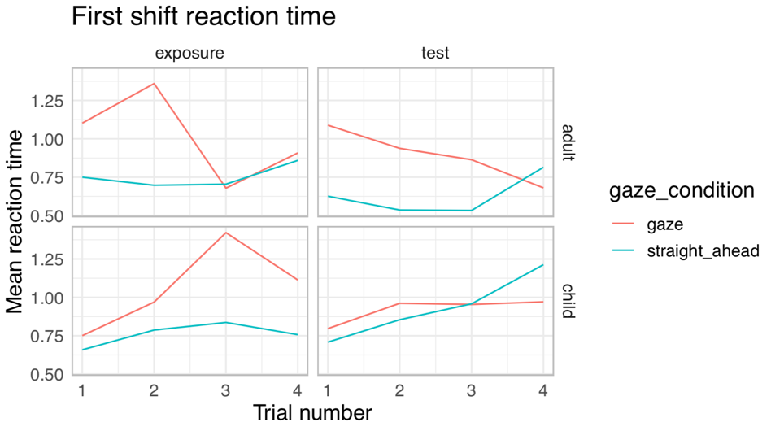  
  
For adults in the gaze condition, reaction time on exposure trials seems to increase slightly and then decrease. This is what we predicted: an increase in RT as they learn to use gaze, but then a rapid decrease as they quickly learn word-object mappings. Adults in the gaze condition also seem to be getting gradually faster on test trials. Surprisingly, adults’ RT is staying mostly steady or increasing slightly on straight ahead trials. This is similar to children’s RT in the straight ahead condition. It may possible reflect a fatigue effect.

Children’s RT in the gaze condition is mostly increasing on exposure trials. This suggests that children are learning to seek more information from the speaker (and potentially follow gaze more) as the trials go on. There is also a slight decrease in RT at trial 4, which might reflect learning, but it is difficult to tell. Interestingly, children’s RT is not changing much on test trials in the gaze condition. This might also be due to a fatigue effect. However, it is still noticeably lower than in exposure trials. It seems like children are adjusting their gaze as trials go on to seek more information from a helpful speaker.



As expected, adults in the gaze condition seem to be more accurate than adults in the straight ahead condition. Their first shifts become more accurate more quickly in both exposure and test trials. However, adults in both conditions are able to learn so rapidly from statistical information that gaze does not seem to give them that much of an advantage.

Children are consistently more accurate in the gaze condition on exposure trials. This makes sense, as they are receiving helpful, reliable information from the speaker about word-object mappings. It is possible that children are also more accurate in the gaze condition on test trials, but it is difficult to tell if there is a significant difference between the gaze and straight ahead conditions on test trials. The social information gathered on exposure trials might not generalize to test trials as well.

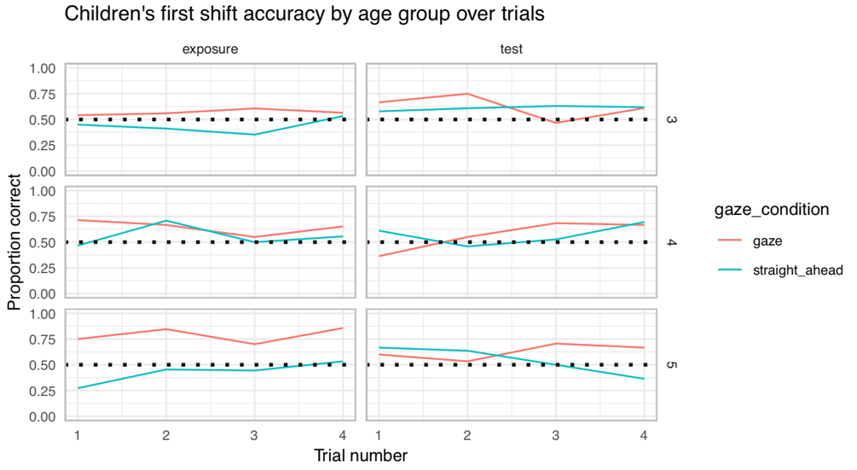

Age seems to make a big difference in children’s first shift accuracy! For 3-year-olds, there do not seem to be large differences in accuracy in the gaze and straight ahead conditions (though they do seem slightly more accurate in the gaze condition on exposure trials. 4-year-olds seem to be more accurate in general. For example, it looks like they are becoming more accurate more quickly in the gaze condition on test trials (though this may not be a significant difference). 5-year-olds show a very noticeable contrast between the gaze and straight ahead conditions on exposure trials. They seem to be very good at using gaze to be more accurate! Their accuracy also may be increasing in the gaze condition on test trials, but again, it is difficult to tell if this is a significant difference.

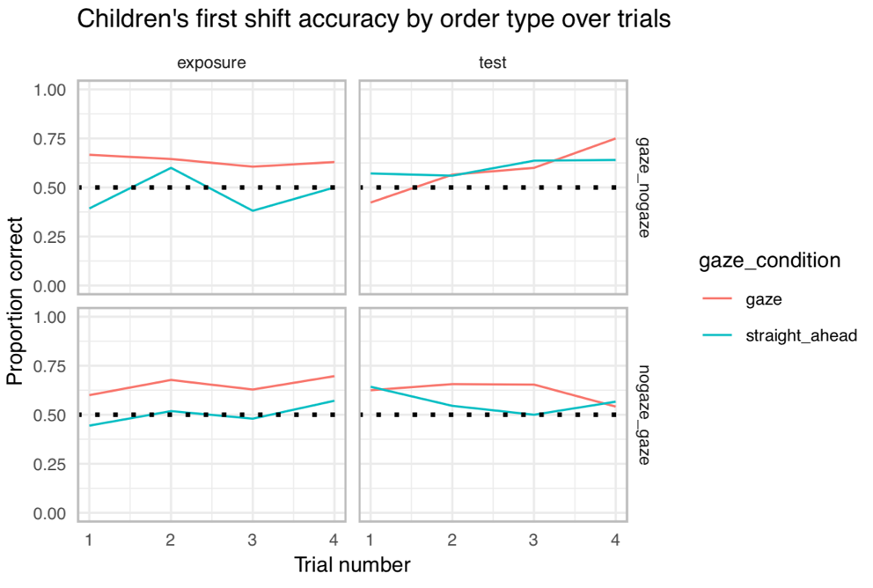

There may be an effect of order (whether children experienced the gaze or straight ahead condition first). Exposure trials look fairly similar between the two orders, but it looks like there might be a difference between the two orders on test trials. Children who had gaze second seem to be performing better on test trials in the beginning, but worse at the end—possibly due to a fatigue effect.

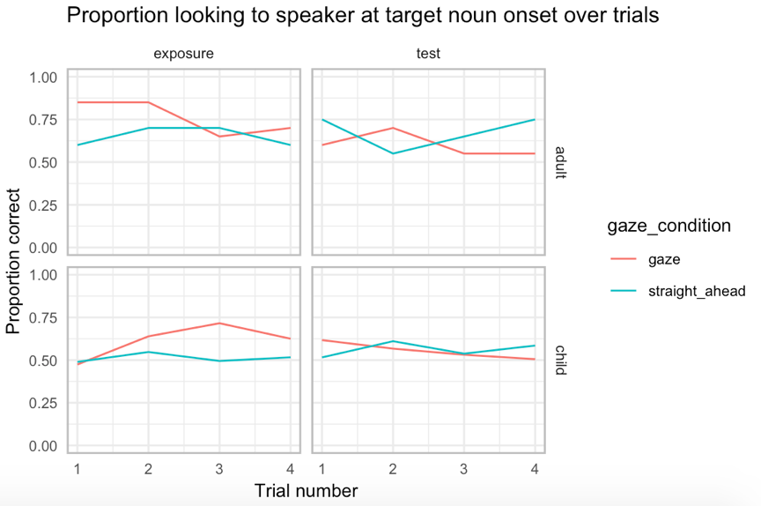

At target noun onset, it looks like children in the gaze condition are looking more and more at the speaker as exposure trials go on. However, they are looking less at the speaker during test trials as time goes on. This suggests that children are learning to seek social information when it is helpful, but less so when it is not. This pattern does not seem to appear for straight ahead trials. Also, adults in the gaze condition show the expected pattern of looking more to the speaker in the beginning for exposure trials but looking less later on.

\*\*\*The rest of these plots are all preliminary, using data from about 35 children. They will need to be remade with updated data for actual analysis.\*\*\*



This RT plot is fairly similar to the updated one, but this one has extreme RTs filtered out. The new RT plot shows more indications of RT decreases in adults. Note the large error bars for the adults—we still need much more adult data. Similar to the other RT, children’s increasing RTs might reflect fatigue effects.

Proportion looking to the speaker:



Children in the gaze condition seem to be looking more to the speaker over time on exposure trials, possibly indicating that they are learning to seek more helpful social information over time. Notice that this contrasts with adults, who do not need to look at the speaker much to learn word-object mappings (except possibly during the first trial or two).

Interestingly, children in the straight ahead condition (for both exposure and test trials) and in the gaze condition (for test trials) seem to be looking somewhat more to the speaker over time. Perhaps they are getting confused and trying to seek social information even when they are not really getting any? However, they still do look noticeably more at the speaker when they get an actual gaze cue.

Proportion looking at the target:



This plot suggests that children are more accurate on exposure trials in the gaze condition. Again, it seems that they are using helpful social information to increase accuracy. Here, there does not seem to be a difference between the gaze and straight ahead conditions on test trials. This should be re-examined with the full data set.

Meanwhile, adults are learning rapidly in both conditions. They might be slightly more accurate in the gaze condition at first, but they are learning so rapidly in both conditions that there are not large condition differences.

Effect of gaze block:



This is another plot that shows possible order effects. It seems like children who had the gaze condition second were more accurate on exposure trials than those who had the gaze cue first. However, this plot should be compared to the other plot of order effects.