Design

1. High Level Design (add explanation)  
  
Explain in general about :  
Android Application  
Mysql Database  
Webservices

Linux Server

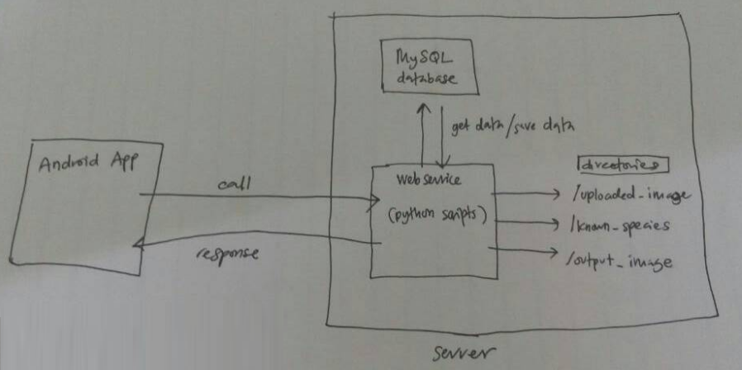  
  
2. Database design  
  
2.1 List of tables and data types

Table : kelulut_user

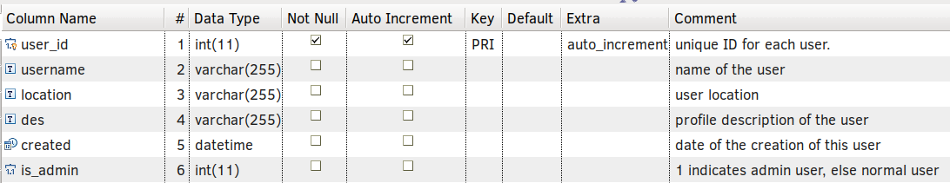

Table : kelulut_login

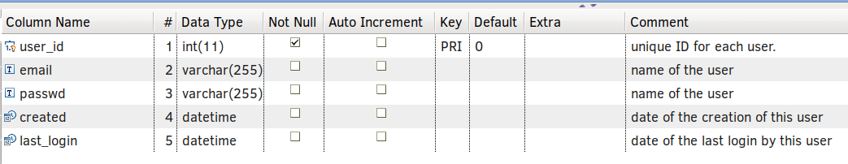

Table : genus

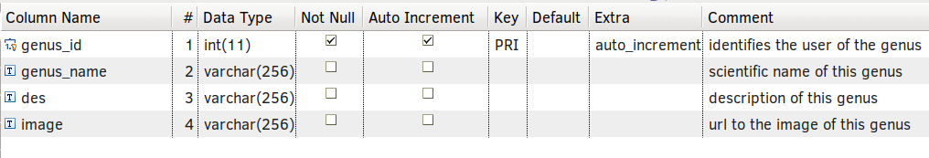

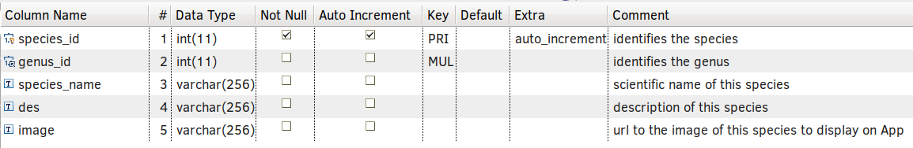Table : species

Table : uploaded_images

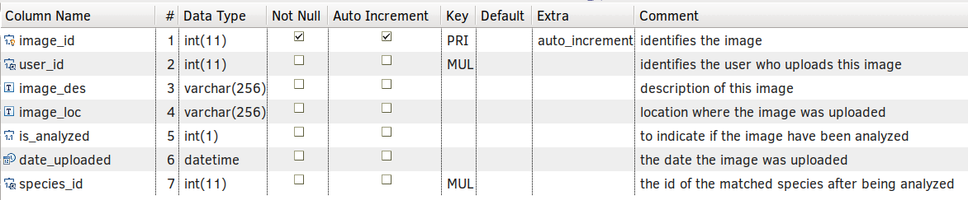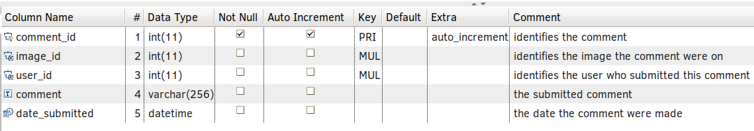

Table : comments

Table : quiz

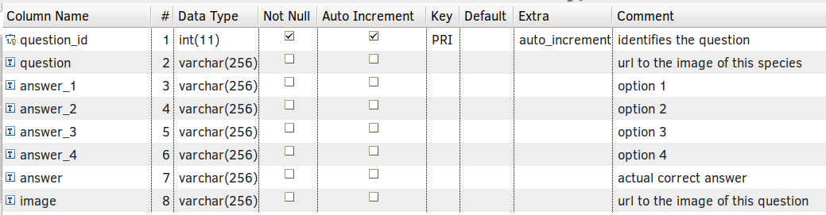

Table : score

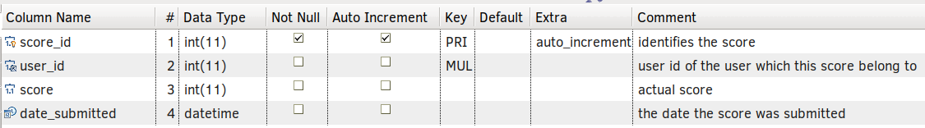

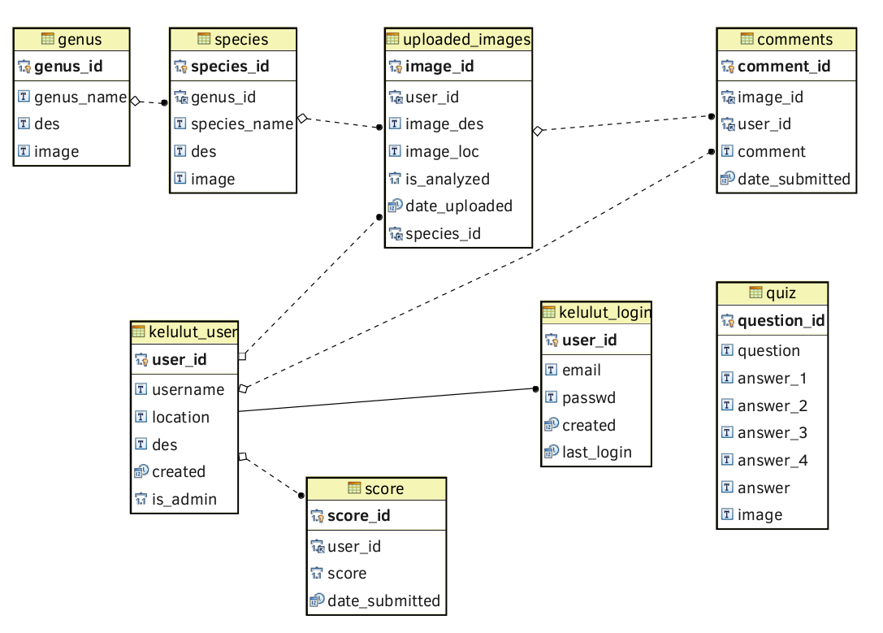2.2 Entity Relationship Diagram (ERD)

3 Android App Design

3.1 Functional  
  
Rewrite again the Requirement Specification in a more elaborated manner than the Requirement Specification.   
  
In short, whatever in here should cover the Requirement Specification part.  
  
Example :  
  
(a) Login Page

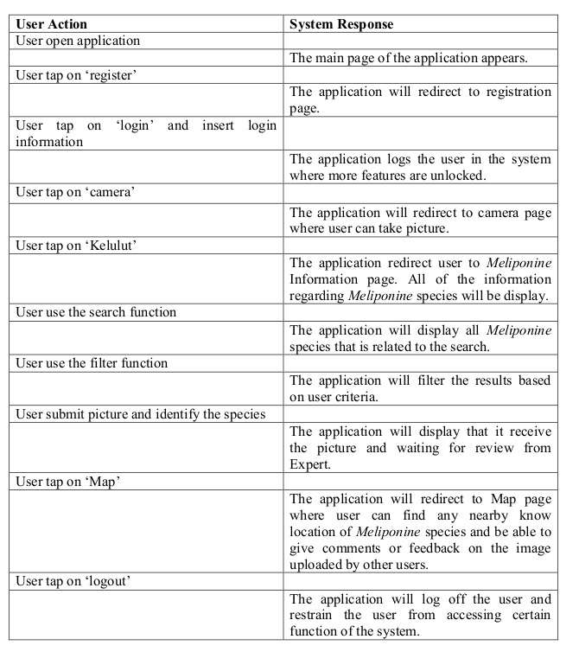….  
  
(b) Register Page  
….  
  
(c) Home Page  
….  
  
Example of Requirement Specification  
  
  
3.2 Interface   
  
Android App UI design. Create a mockup images from actual interface yg dah siap. Refer Report Report from page 91-97.  
  
Contoh mockup :

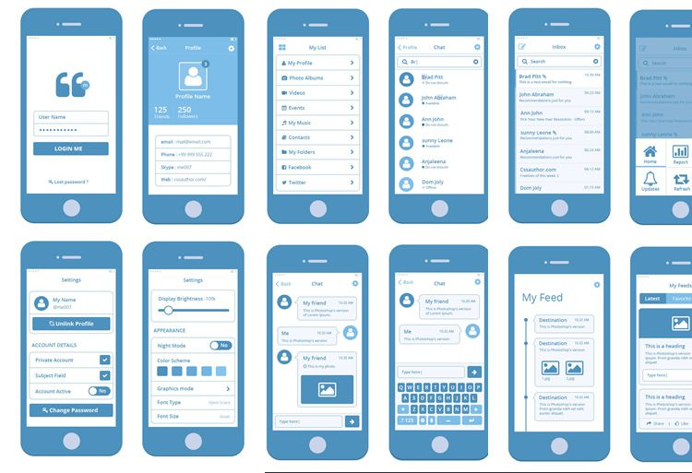

4 Webservice Design  
  
4.1 List of web services

|  |  |  |  |
| --- | --- | --- | --- |
| No. | Command | Parameter | Response |
| 1 | login |  |  |
| 2 | register |  |  |
| 3 |  |  |  |

4.2 Image Feature Matching module  
  
1. Explain features of image. Provide sample images etc.  
  
2. Explain in diagram how features of image are extracted, then matched against known species, and then calculate the similarity of the features to give us ‘score’. And then, we decided that higher score is best possible match.