Audit QBO Products & Services
Klasifikasi Legacy vs Integrasi Jubelio · Untuk Review Tim Finance
Tanggal generate: 2026-04-28 10:58 WIB
Sumber data: QBO realm produksi (live query, semua items termasuk inactive)

1. Ringkasan Eksekutif
Total 51 item di QBO Products & Services. Klasifikasi otomatis berdasarkan signal dari kode integrasi (Type, SKU, naming pattern, CreateTime vs tanggal webhook Jubelio pertama).
Temuan utama:
- 9 item (18%) dari integrasi Jubelio (Service items dengan SKU + helper).
- 26 item (51%) legacy QBO (Inventory items + Category folders pre-existing).
- 16 item (31%) Service tanpa SKU — campuran legacy & integrasi tanpa SKU; perlu review manual.
Pie chart di bawah membagi item ke 3 kelompok untuk gambaran cepat:
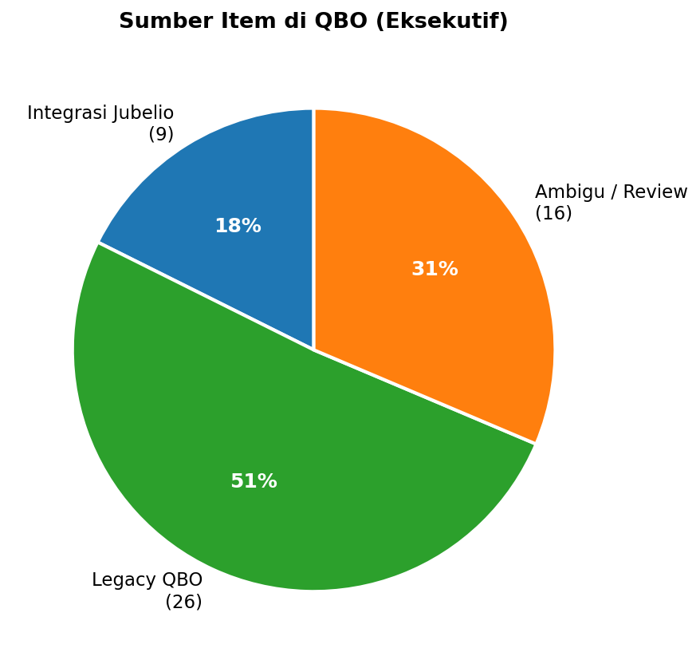

2. Distribusi per Klasifikasi
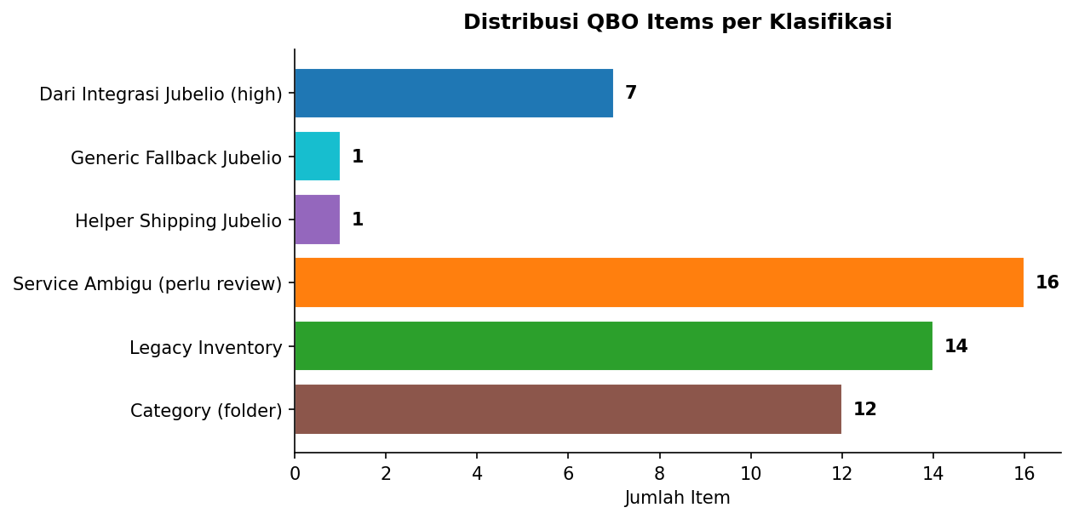
Klasifikasi | Jumlah | % Total | Definisi
Dari Integrasi Jubelio (high) | 7 | 13.7% | Service+SKU, dibuat ≥ tanggal webhook Jubelio pertama
Generic Fallback Jubelio | 1 | 2.0% | "Jubelio Sync Item" — fallback saat item_code/name kosong
Helper Shipping Jubelio | 1 | 2.0% | "Shipping Charge" — dipakai integrasi untuk biaya kirim
Service Ambigu (perlu review) | 16 | 31.4% | Service tanpa SKU — campuran legacy + integrasi tanpa SKU
Legacy Inventory | 14 | 27.5% | Type=Inventory — integrasi tidak pernah bikin Inventory
Category (folder) | 12 | 23.5% | Folder organisasi parent dari Inventory item
TOTAL | 51 | 100%

3. Timeline Pembuatan Item
Item dari integrasi Jubelio mulai muncul setelah webhook pertama (2026-04-22). Sebelum itu semua item dibuat manual / dari connector lain.
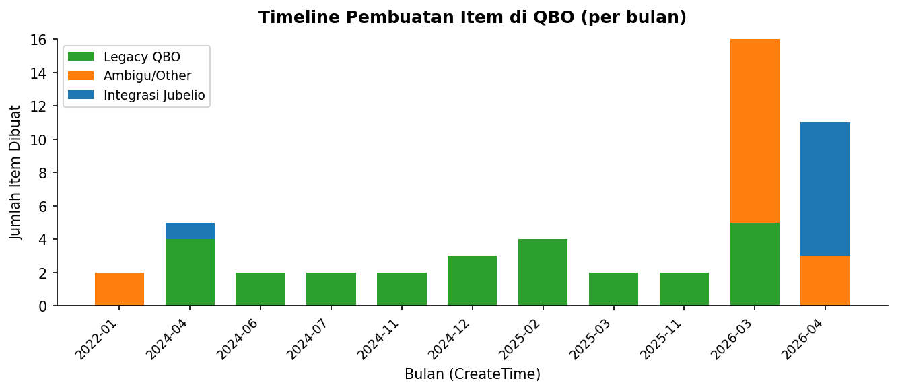

4. Daftar Item per Klasifikasi
Tabel detail untuk setiap kelompok. Gunakan ID untuk cross-reference dengan QBO UI.

Dari Integrasi Jubelio (high) (7)
ID | Nama | Type | SKU | Created | Income Account
50 | Inside Out Moringa Protocol copy | Service | Inside-Out-Protocol | 2026-04-23 | Channel sales
42 | Premium Organic Moringa Capsules / Kapsul Daun Kelor Organik Premium | Service | OMC-180-001 | 2026-04-22 | Channel sales
44 | Premium Organic Moringa Powder / Bubuk Daun Kelor Organik Premium | Service | OMP-45-001 | 2026-04-23 | Channel sales
53 | Premium Organic Moringa Powder / Bubuk Daun Kelor Organik Premium (OMP-45-001) | Service | OMP-45-001 | 2026-04-27 | Channel sales
41 | Premium Organic Moringa Seed Oil / Minyak Biji Kelor Organik Premium | Service | OMO-60-001 | 2026-04-22 | Channel sales
55 | The Discovery Pack | Minyak, Bubuk & Kapsul Kelor Organik Premium – Kulit Cerah, | Service | Discovery-Pack | 2026-04-27 | Channel sales
52 | The Movement & Relief | Moringa Daun Kelor Premium | 180 Kapsul + Oil 60ml | Ban | Service | The-Movement-&-Relief | 2026-04-26 | Channel sales

Generic Fallback Jubelio (1)
ID | Nama | Type | SKU | Created | Income Account
54 | Jubelio Sync Item | Service | — | 2026-04-27 | Channel sales

Helper Shipping Jubelio (1)
ID | Nama | Type | SKU | Created | Income Account
7 | Shipping Charge | Service | — | 2024-04-15 | Shipping Charge

Service Ambigu (perlu review) (16)
ID | Nama | Type | SKU | Created | Income Account
2 | Hours | Service | — | 2022-01-08 | Sales
40 | SAMPLE | Service | — | 2026-03-10 | Sales
1 | Sales | Service | — | 2022-01-08 | Sales
28 | Shopify discount item | Service | — | 2026-03-04 | Shopify discount
25 | Shopify gift card item - EUR | Service | — | 2026-03-04 | Shopify Gift card - EUR
26 | Shopify gift card item - IDR | Service | — | 2026-03-04 | Shopify Gift card - IDR
27 | Shopify gift card item - USD | Service | — | 2026-03-04 | Shopify Gift card - USD
32 | Shopify sale tips item | Service | — | 2026-03-04 | Shopify Tips
34 | Shopify sales item | Service | — | 2026-03-04 | Shopify sales
29 | Shopify sales tax item - EUR | Service | — | 2026-03-04 | Shopify sales tax payable - EU
30 | Shopify sales tax item - IDR | Service | — | 2026-03-04 | Shopify sales tax payable - ID
31 | Shopify sales tax item - USD | Service | — | 2026-03-04 | Shopify sales tax payable - US
33 | Shopify shipping item | Service | — | 2026-03-04 | Shopify shipping income
51 | TREELOGY Moringa Ritual Set | Service | — | 2026-04-26 | Channel sales
49 | The Discovery Pack | Minyak, Bubuk & Kapsul Kelor Organik Premium – Kulit Cerah, | Service | — | 2026-04-23 | Channel sales
43 | The Movement & Relief | Moringa Daun Kelor Premium | 180 Kapsul + Oil 60ml | Ban | Service | — | 2026-04-22 | Channel sales

Legacy Inventory (14)
ID | Nama | Type | SKU | Created | Income Account
24 | Bamboo Scoop | Inventory | Bamboo-Scoop | 2025-11-30 | Sales of Product Income
8 | Consignment - Moringa Dried Leaf Powder - 180grams | Inventory | — | 2024-06-02 | Consignment - Moringa Dried Le
11 | Consignment - Moringa Dried Leaf Powder - 90 grams | Inventory | — | 2024-07-31 | Consignment - Moringa Dried Le
20 | Moringa Capsules-180Pcs | Inventory | — | 2025-02-26 | Moringa Capsules-180Pcs
18 | Moringa Capsules-90Pcs | Inventory | — | 2025-02-26 | Moringa Capsules-90Pcs
22 | Moringa Dried Leaf Powder - 45grams | Inventory | — | 2025-03-09 | Moringa Dried Leaf Powder - 45
9 | Moringa Dried Leaf Powder - 90grams | Inventory | — | 2024-06-16 | Moringa Leaf Powder 90grams
6 | Moringa Dried Leaf Powder 180grams | Inventory | — | 2024-04-02 | Moringa Leaf Powder 180grams
4 | Moringa Leaf Powder 180grams - Discounted Price | Inventory | — | 2024-04-02 | Moringa Leaf Powder 180grams -
13 | Moringa Ritual Set | Inventory | MRS-002 | 2024-11-24 | Channel sales
15 | Moringa Seed Oil - 30ml | Inventory | — | 2024-12-19 | Moringa Seed Oil - 30ml
16 | Moringa Seed Oil - 60ml | Inventory | — | 2024-12-22 | Moringa Seed Oil - 60ml
38 | The Discovery Pack | Inventory | — | 2026-03-04 | Sales of Product Income
36 | The Movement & Relief | Inventory | — | 2026-03-04 | Sales of Product Income

Category (folder) (12)
ID | Nama | Type | SKU | Created | Income Account
23 | Bamboo Scoop | Category | — | 2025-11-30
10 | Consignment - Moringa Dried Leaf Powder - 90 grams | Category | — | 2024-07-31
19 | Moringa Capsules-180Pcs | Category | — | 2025-02-26
17 | Moringa Capsules-90Pcs | Category | — | 2025-02-26
21 | Moringa Dried Leaf Powder - 45grams | Category | — | 2025-03-09
5 | Moringa Leaf Powder 180grams | Category | — | 2024-04-02
3 | Moringa Leaf Powder 180grams - Discounted Price | Category | — | 2024-04-02
14 | Moringa Seed Oil - 30ml | Category | — | 2024-12-19
12 | Moringa Set Box | Category | — | 2024-11-24
39 | SAMPLE | Category | — | 2026-03-10
37 | The Discovery Pack | Category | — | 2026-03-04
35 | The Movement & Relief | Category | — | 2026-03-04

5. Item yang Perlu Perhatian

5.1 Duplikat SKU
Ada 1 SKU yang muncul di lebih dari 1 item. Biasanya terjadi karena integrasi sync 2× dengan nama berbeda dari Jubelio.
SKU | ID | Nama | Type / Bucket
OMP-45-001 | 44 | Premium Organic Moringa Powder / Bubuk Daun Kelor Organik Pr | Service / Dari Integrasi Jubelio (high)
OMP-45-001 | 53 | Premium Organic Moringa Powder / Bubuk Daun Kelor Organik Pr | Service / Dari Integrasi Jubelio (high)

5.2 Service (integrasi) vs Inventory (legacy) untuk produk yang sama
Tidak ada Service (integrasi) yang nama/SKU-nya sama dengan Inventory legacy.

6. Keputusan untuk Tim Finance
Tandai pilihan dengan ☑ atau tulis catatan di kolom kanan.
Topik | Pertanyaan | Pilihan / Catatan
Item duplikat dari integrasi (Powder OMP-45-001 muncul 2×) | Apakah salah satu di-inactive-kan dan invoice di-redirect ke yang benar? | [ ] Ya, jalankan migrate-items [ ] Tidak, biarkan dulu [ ] Tunda
Service ambigu tanpa SKU yang dibuat integrasi (mis. id 43, 49, 51) | Backfill SKU dari Jubelio payload log, atau biarkan? | [ ] Backfill (jalankan /backfill-skus) [ ] Biarkan [ ] Investigasi manual
Inventory legacy + Service paralel untuk produk sama | Konsolidasi ke Inventory (untuk stock tracking) atau ke Service (lebih simpel)? | [ ] Konsolidasi ke Inventory [ ] Konsolidasi ke Service [ ] Biarkan paralel
"Jubelio Sync Item" (id 54) generic fallback | Apakah aman di-inactive-kan? (kalau invoice yang reference sudah dimigrasikan) | [ ] Ya, jalankan migrate-items [ ] Tidak [ ] Cek dulu invoice mana yang pakai
Item dengan suffix "copy" (id 50 Inside Out Moringa Protocol copy) | Rename atau redirect ke item asli? | [ ] Rename (hilangkan ' copy') [ ] Redirect & inactivate [ ] Biarkan
Shopify connector items (10 items, semua 2026-03-04) | Apakah Shopify connector aktif? Apakah dipakai paralel dengan Jubelio? | [ ] Aktif & dipakai [ ] Sudah tidak aktif (bisa di-inactive) [ ] Cek dengan tim

Lampiran: Metodologi Klasifikasi
Klasifikasi otomatis berdasarkan signal dari kode integrasi:
- "Jubelio Sync Item*" → fallback dari getGenericItem (routes/jubelioWebhook.js:553), dipakai saat webhook tidak punya item_code/item_name.
- "Shipping Charge" → helper getShippingItem (routes/jubelioWebhook.js:588) untuk biaya kirim.
- Service + SKU non-empty → getOrCreateItem (routes/jubelioWebhook.js:643). Integrasi selalu bikin Type=Service dengan Sku=item_code Jubelio.
- Service + SKU + CreateTime ≥ tanggal webhook Jubelio pertama → confidence "high" (pasti dari integrasi).
- Inventory / NonInventory → legacy. Integrasi tidak pernah membuat Inventory items.
- Service tanpa SKU → ambigu. Bisa legacy QBO default ("Sales", "Hours"), bisa juga integrasi tanpa SKU yang belum di-backfill.
- Category → folder organisasi parent dari Inventory item, bukan jualable item.
Tanggal webhook Jubelio pertama yang tercatat di JubelioPayloadLog: 2026-04-24 (payload log retention 30 hari). Berarti integrasi mulai sebelum tanggal itu — item Service+SKU yang dibuat ≥ 2026-04-22 sangat mungkin dari integrasi.
Source code: scripts/audit-qbo-items.js, scripts/generate-qbo-items-docx.py

