**Publish-Subscribe**

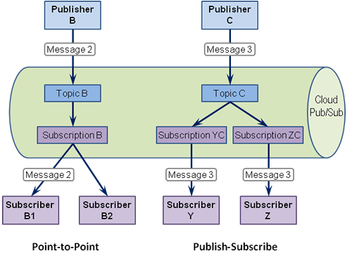

**Configuration**

Open Eclipse:

1. Create New Java Project.
2. Create Two Classes Producer and Consumer.
3. Copy the Above Code.
4. Add This Jar File -> kafka-clients-0.10.2.0.
5. The go to your Kafka Folder in that folder there is a lib folder in that there are some jar file just add those jar files.
6. Then Run the Zookeeper.
7. Then Run the Kafka Server.

In Program you have to set these properties in Producer Program:

1. props.put("bootstrap.servers", "localhost:9092");
2. props.put("acks", "all");
3. props.put("retries", 0);
4. props.put("batch.size", 16384);
5. props.put("linger.ms", 1);
6. props.put("max.block.ms", 1000);
7. props.put("buffer.memory", 33554432);
8. props.put("key.serializer","org.apache.kafka.common.serialization.

StringSerializer");

1. props.put("value.serializer","org.apache.kafka.common.serialization.StringSerializer");

In Program you have to set these properties in Consumer Program:

1. props.put("bootstrap.servers", "localhost:9092");
2. props.put("group.id", "group-1");
3. props.put("enable.auto.commit", "true");
4. props.put("auto.commit.interval.ms", "100");
5. props.put("auto.offset.reset", "earliest");
6. props.put("auto.commit.interval.ms", "1000");
7. props.put("session.timeout.ms", "30000");
8. props.put("key.deserializer","org.apache.kafka.common.serialization.StringDeserializer");
9. props.put("value.deserializer","org.apache.kafka.common.serialization.StringDeserializer");

Then Run Producer Program and then run the Consumer Program you get the output.

1-> this line is to Kafka server Path and the Server port Number.

2-> this line is for server group id.

