**Human-induced Arctic sea ice loss   
and cold Eurasian winters**

Kelly E. McCusker1,2, John C. Fyfe2 and Michael Sigmond2

1School of Earth and Ocean Sciences, University of Victoria, Victoria, BC V8P 5C2, Canada, 2Canadian Centre for Climate Modelling and Analysis, Environment Canada, Victoria, BC V8W 2Y2, Canada

Submitted to *Nature Geoscience*February 5, 2015

Arctic sea ice loss has been implicated in the recent trend toward unusually cold Eurasian winters1,2. Whether the linkage follows from anthropogenic sea ice loss, however, remains an open question as the sea-ice loss combines anthropogenic response and internal (random) variability3,4, and because of confounding wintertime variability over the Eurasian continent5,6 Here, we isolate the anthropogenic and random components of the linkage using a large ensemble of atmosphere-only model simulations with prescribed sea ice loss taken from simulations of the companion atmosphere-ocean-cryosphere model. We find no evidence of a sea-ice loss related increase in the prevalence of cold Eurasian winters. However, we do find long periods of significant early winter Eurasian cooling linked to internally-generated circulation features over the Barents and Kara Sea regions of the Arctic. These results challenge the perception that Arctic sea ice loss was responsible for the recent prevalence of unusually cold Eurasian winters, showing instead that these winters were more likely the consequence of internal variability, with implications for our understanding of impacts and adaptation in human and natural high-northern latitude systems.

Internal variability in the climate system plays an important role in determining the evolution of Arctic sea-ice extent (cite Wettstein14, Swart15), contributing approximately 50% to the magnitude of the observed trend (cite Stroeve07, Kay11). Recent reductions in Arctic sea- ice area (cite@@) have coincided with an apparent prevalence of colder wintertime surface air temperature over Eurasian land surfaces (cite@@), prompting associations to be drawn in the literature between the two observed phenomena (cite Francis12,Mori14, Kim14, Inoue12, Overland11, Liu12,Petoukhov10,Honda09,Peings13). The frequency of anomalously cold Eurasian surface air temperatures (SAT) in winter is particularly sensitive to sea-ice loss in the Barents-Kara Seas (BKS) region through Rossby wave propogation incited by increased surface heat fluxes (Peings13,Kim14,Mori14,Honda09).

**Methods**

**Observations.** Text.

**Model simulations.** Text.

**References**

1. Min, S.-K., Zhang, X. B., Zwiers, F. W. & Agnew, T. Human influence on Arctic sea ice detectable from early 1990s onwards. *Geophys. Res. Lett.* **35**, L21701 (2008).
2. Kay, J. E., Holland, M. M. & Jahn, A. Inter-annual to multi-decadal Arctic sea ice extent trends in a warming world. *Geophys. Res. Lett.* **38**, L15708 (2011).

**Supplementary Information** accompanies the paper on **www.nature.com/nature**.

**Acknowledgements** We thank XX and YY for their insightful comments on an early draft.

**Author Contributions** .

**Competing Interests statement** The authors declare that they have no competing financial interests.

Correspondence and requests for materials should be addressed to K.E.M. (kemccusk@euvic.ca)

Macintosh HD:Users:kelly:CCCma:CanSISE:manuscripts:coldeurasia:Figure1.pdf

**Figure 1 | Observed winter SAT and sea ice concentration.** Text.

Macintosh HD:Users:kelly:CCCma:CanSISE:manuscripts:coldeurasia:partofFigure2.pdf

**Figure 2 | Winter Arctic sea ice area.** Text.

**Figure 3 | Blah blah blah.** Text.

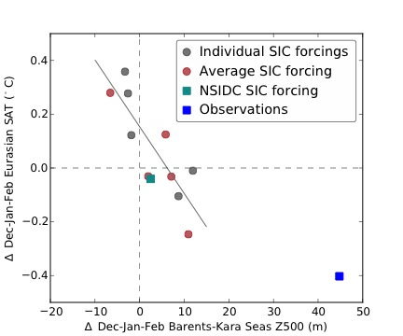

**Figure 4 | Winter Barents-Kara Seas geopotential height at 500 mb versus Eurasian SAT.** Text.

**Supplementary information for**

**No link between human-induced Arctic sea ice loss   
and cold Eurasian winters**

Kelly E. McCusker1,2. John C. Fyfe2 and Michael Sigmond2,

1School of Earth and Ocean Sciences, University of Victoria, Victoria, BC V8P 5C2, Canada, 2Canadian Centre for Climate Modelling and Analysis, Environment Canada, Victoria, BC V8W 2Y2, Canada

**Supplementary Figure 1 | Blah, blah, blah.** Text.