Arctic sea-ice loss and Eurasian surface air temperature from 1979-2012

Kelly E. McCusker^{*1,2}, John C. Fyfe², Michael Sigmond²
¹School of Earth and Ocean Sciences, University of Victoria, Victoria, BC V8P 5C2, Canada
²Canadian Centre for Climate Modelling and Analysis, Environment Canada, University of Victoria, Victoria, British Columbia, V8W 2Y2, Canada

Arctic sea ice concentration has declined in all seasons since satellite observations began in 1979 1. At the same time and in spite of significant hemispheric warming in boreal winter that is in large part anthropogenic 2,3, Eurasian surface air temperature has decreased. Previous studies have suggested that Eurasian surface air temperature in boreal winter is sensitive to changes in Arctic sea ice, and that recent, cold winters were fundamentally caused by the loss of ice 4–9. Here we show, using a large ensemble of atmosphere-ocean-cryosphere model simulations and a large ensemble of simulations from the companion atmosphere-only model in which the response to sea ice loss is isolated, that a decline in Arctic sea ice does not systematically lead to a decrease in Eurasian wintertime surface air temperature. Instead, long term decreases in Eurasian wintertime surface air temperature are associated with internally-generated height anomalies over the Barents and Kara Seas. These results suggest that Arctic sea ice loss is not responsible for the cooling over Eurasia in recent decades, but that it is more likely the consequence of internal variability, with implications for our understanding of impacts and adaptation in human and natural high-northern latitude systems.

Global average surface air temperatures in the boreal cold season have been rising faster than the long-term annual average ¹⁰ and exhibit further enhanced warming over the Arctic in part due to positive feedbacks related to sea-ice loss^{11,12}. Epoch differences of winter (December-January- February; DJF) surface air temperature (SAT) between 2002-12 and 1979-89 reveal warming upward of 2ºC over the polar cap, collocated with areas of sea ice loss (Figure 1a). Contemporaneous cooling of greater than 1ºC over parts of the Eurasian continent in winter is also evident. Since 1979, Eurasian SAT in winter has deviated substantially from hemispheric warming (Figure 1b), which is partly attributable to anthropogenic forcing ^{2,3}. Eurasian SAT has decreased 0.4ºC between these two time periods against significant (p < 0.01) Northern hemisphere warming of 0.5ºC, a total deviation of -0.9ºC. Coincident with this decrease in winter SAT, large reductions in autumn and winter Arctic sea ice area have occurred ¹, particularly in the Barents and Kara Seas (BKS) sector where a statistically significant decrease in winter sea ice area between epochs (-0.3e⁶ km²; p < 0.001) is observed (Figure 1c).

Observationally-based studies confirm a positive correlation exists between Barents/Kara Seas sea ice concentration (SIC) and Eurasian SAT ^{6, 7, 13, 14}, yet the direction of causality is unclear. Some implicate the sea ice loss in the Barents/Kara in initiating Eurasian cooling through a weakened meridional temperature gradient and ensuing changes in circulation and cyclone track ^{6,7}, while others suggest atmospheric circulation variability, not sea ice loss, drives both ^{13,14}. A similar lack of clarity is evident in modelling results in which the influence of a change in sea ice is isolated. There is support for the hypothesis that Barents/Kara sea ice loss can initiate more frequent or more intense cold Eurasian SAT anomalies through a Rossby wave-train emanating out of the Barents/Kara Seas region incited by turbulent heat flux from increased areas of open water ^{4,8,9,15–17}. The magnitude of this modelled effect is typically weak, and the timing and placement of decreased SAT is not consistent. Others suggest the root cause of both Barents/Kara sea ice loss and Eurasian cooling is a third factor ^{13,18}, or find no detectable signal in SAT outside of the Arctic ¹⁹. It thus remains unclear as to the role, if any, changes in SIC play in Eurasian temperature trends. Here we evaluate the likelihood of a long term (1979-2012) Eurasian cooling event on the order of that observed, and further address whether a concurrent decrease of winter Barents/Kara SIC could be the cause of such a decrease in Eurasian winter SAT.

We do this by analysing changes in SIC and SAT in coupled simulations and in atmosphere-only simulations with prescribed sea ice loss. The coupled simulations consist of a fifty-member large ensemble (LE) of Canadian Earth System Model version 2 (CanESM2 ²⁰) simulations with historical forcing. Each CanESM2 realization is executed with identical historical forcings with slightly varied initial conditions. As such, we are able to characterize the impact of external forcing and internal variability on changes in Barents/Kara SIC, Eurasian SAT, and their relationship over the decades since 1979. The historical LE results are presented as epoch differences between 2002-12 and 1979-89 DJF averages for each realization, which we refer to collectively as “CGCM”. The average of CGCM, in which internal variability has been averaged out, represents the response due to external forcings. The externally-forced response of DJF SIC in the Barents/Kara Seas is a decrease in SIC of 5.8% in absolute terms, with a spread of nearly 13%, including 2 members with sea ice growth (Figure 2a), consistent with a significant role for internal variability on sea ice even on timescales greater than 30 years ²¹. Observed sea ice loss (-6.2%), derived from satellite measurements by the National Snow and Ice Data Center (NSIDC; see Methods), is comparable to the externally-forced value in this sector, and is consistent with the presence of a human influence on Arctic sea ice ²². The corresponding forced response of Eurasian SAT in winter is a warming of 1.31ºC, with positive anomalies making up the vast majority of the changes in Eurasian SAT in CGCM (Figure 2b). Just 2 of 50 ensemble members show a decrease in SAT, and only one is comparable to the observed value of -0.40ºC, equaling -0.34ºC. The observed change in boreal winter Eurasian SAT is thus exceptional in the context of multiple realizations of the response to historical forcings, while the observed change in Barents/Kara SIC is comparable to the forced change. Therefore, factors other than sea ice loss are necessary to explain the observed Eurasian cooling. Yet the question remains as to whether Arctic sea ice loss may have contributed to this decrease in SAT.

To isolate the impact of Arctic sea ice loss on Eurasian SAT, we execute pairs of 120-year atmosphere-only “time-slice” simulations with prescribed “past” (1979-89) and “present day” (2002-12) SIC, sea surface temperature (SST), and sea ice thickness (SIT) taken from five members of CGCM. The AGCM experiments are constructed such that the only changes between past and present day are Arctic SIC, SIT, and SST where SIC < 10% in the present day but not in the past (see Methods). The choice to use model output as boundary conditions was made so that all surface forcings are physically consistent, so that multiple forcing patterns can be tested, and so that atmosphere-only results can be cleanly compared to their fully coupled counterparts. The prescribed SIC anomalies averaged in the Barents/Kara Seas in DJF are shown as gray circles in Figure 2a. The atmosphere-only results, which we refer to as “AGCM”, are presented as anomalies between present-day and past simulations, and are sub-sampled into fifty 11-year averages to mirror the sampling uncertainty of CGCM.

We find that Arctic sea ice loss in isolation does not cause a systematic Eurasian winter cooling (Figure 3); the average change in Eurasian SAT in AGCM is 0.09ºC, with 50% of anomalies falling below zero and 50% above. Moreover, changes in Eurasian SAT show no preference for cooling in an additional pair of 120-year time-slice simulations with boundary conditions computed from observed SIC (“AGCM obs”; see Methods). Just 3 of 7 eleven-year anomaly periods show a decrease in SAT. These findings indicate that while Eurasian cooling can occur and appear to be caused by sea ice loss, it is equally likely that warming can occur. Furthermore, changes in Eurasian SAT in boreal winter in AGCM are indistinguishable from those changes in a long Preindustrial control simulation that is treated in a similar manner to retain the same sampling uncertainty as CGCM and AGCM (see Methods and Supplementary Figure S1). Thus, by this measure, the fluctuations in SAT changes in AGCM are indistinguishable from variations in Eurasian SAT changes that are dictated by internal variability, in accordance with evidence that the sphere of influence of sea ice does not robustly reach the mid-latitudes ¹⁹.

To understand what drives Eurasian SAT, if not sea ice, we turn to the large-scale circulation — which has a significant impact on mid-latitude SAT ^{23, 24} — and its manifestation over the Barents/Kara Seas where anomalous anti-cyclones have been linked with Eurasian cold episodes ^{4, 8, 23}. We use the change in DJF geopotential height at 500 hPa (Z500) averaged over the Barents/Kara Seas as a proxy for anomalous northerly flow toward Eurasia and show its relationship to changes in DJF Eurasian SAT in Figure 4. Ellipses encompass 95% of CGCM and AGCM anomalies, respectively, and their linear relationships are marked with regression lines. The red circle depicts the already discussed observed Eurasian cooling, and an anomalous anti-cyclone observed over the Barents/Kara Seas that has been shown to have contributed to cold extremes over central Asia in winter ²³. CGCM contains just 2 ensemble members with comparably large, positive Z500 anomalies, suggesting the observed increase in Z500 is a relatively rare event. The impact of external forcing is evident in CGCM, whose ellipse is made up of primarily positive changes in Eurasian SAT, as we have seen in Figure 2, and primarily positive changes in Z500 that are consistent with a general warming of the atmosphere due to anthropogenic forcing ² (Figure 4). The isolated response to sea ice loss, represented by AGCM, is instead centered on approximately 0ºC SAT change, as has been shown, and shows a slight but insignificant shift toward positive Z500 anomalies. We note, however, that while the change in Z500 over the Barents/Kara Seas is insignificant, isolated sea ice loss does significantly raise Z500 over the whole of the polar cap in boreal winter (Supplementary Figure S2).

All ensembles show that the change in winter Eurasian SAT becomes colder as Z500 anomalies over the Barents/Kara Seas increase (p=0.003 and p<0.0001 for CGCM and AGCM, respectively). This is representative of varying strengths of thermal advection of cold, polar air to Eurasia by anti-cyclonic motion. Due to the absence of the compounding effects of external forcing in AGCM, changes in circulation are more tightly tied to Eurasian SAT changes compared with those
in CGCM, as shown by the higher correlation (r=-0.8) and steeper slope (-0.3ºC/10 m) in AGCM compared with CGCM (r=-0.4, slope=-0.2_C /10 m). However, while the relationship explains more variance in AGCM, it does not indicate a significant preference toward decreases in Eurasian SAT, instead showing Eurasian SAT changes dominated by internally varying circulation changes.

The AGCM results presented above suggest that historical Barents/Kara sea ice loss has not contributed to the observed Eurasian cooling. As the CGCM ensemble also includes other climate changes not related to sea ice loss, such conclusions cannot be derived from CGCM. However, a related question that can be investigated is whether the amplitude of historical Barents/Kara sea ice loss can explain part of the spread of Eurasian temperature change. Figure 4 showed a significant correlation between the strength of the Z500 change over the Barents/Kara Seas and Eurasian temperature. However, we only find a weak relationship between Barents/Kara sea ice loss and Z500 overhead, both in the CGCM (r=-0.28; p=0.05) and AGCM (r=-0.19; p=0.18). Given the weakness of the influence of SIC on circulation, it follows that changes in Barents/Kara SIC show no relation to Eurasian SAT in either CGCM (r=-0.03; p=0.8), or AGCM (r=0.12; p=0.41). This suggests that the amplitude of historical Barents/Kara sea ice loss can not explain part of the spread of Eurasian temperature change.

This finding is confirmed by composite analysis presented in Figure 5. Composites are computed on the 10 highest and 10 lowest changes in Barents/Kara Z500 (‘high-low’; BKS Z500) and Barents/Kara SIC (‘low-high’; BKS SIC), shown with a sign convention that matches the hypothesized chain of events such that a decrease in BKS SIC matches an increase in BKS Z500 (see Methods). The composite on BKS Z500 (Figure 5a and c) shows that, consistent with Figure 4, high Z500 over the Barents/Kara Seas is associated with a cooler Eurasia that is statistically significant with 95% confidence. Furthermore, the composite on BKS SIC (Figure 5b and d) shows that enhanced sea ice loss in the Barents/Kara Seas is associated with an increase in Z500 overhead. However, the spatial pattern of Z500 related to enhanced Barents/Kara sea is loss is different from that presented in Figure 5a; it is approximately half the magnitude over the Barents/Kara Seas, more limited in geographic extent, and lacks the strong gradient along the coast, leading to the absence of a signal in Eurasian temperature. This finding is also true in AGCM (Figure 5c,d and Supplementary Figure S3), and thus confirms that in our simulations, BKS SIC cannot explain part of the spread in Eurasian temperature change. Instead, variations in Eurasian SAT changes from 1979 to 2012 are related to internally-generated circulation variability.

We show that sea-ice loss in the Barents/Kara Seas over multiple decades has a discernible impact on local climate, but limited influence on Eurasian winter climate because of a lack of robust, large-scale circulation changes due to sea ice loss. This result is not sensitive to the region averaged or winter months considered. Thus, while Arctic sea ice loss may influence intraseasonal extreme continental temperatures ²⁵, we conclude that the observed cooling over Eurasia from 1979-2012 is due to a rare instance of a long-term heightening trend over the Barents/Kara Seas and decreasing height over the Eurasian continent that is the product of internal variability.
Methods
Observations and Reanalyses.
The observational data plotted in Figures 1, 2, and 4 are GISTEMP ²⁶ for surface air temperature, National Snow & Ice Data Center (NSIDC) bootstrap dataset ²⁷ for sea ice concentration, and ERA-interim ²⁸ for geopotential height. Except for the timeseries shown in Figure 1b and 1c, observational data is presented as anomalies between the DJF climatology of 1979-80 through 1988-89 and the DJF climatology of 2002-03 through 2011-12 (10 winters).

Earth System model simulations.
Coupled general circulation model simulations were performed with the Canadian Earth System Model, version 2 (CanESM2 20), a comprehensive climate model with interactive atmosphere, ocean, sea ice, land, and carbon cycle components. A large ensemble (LE) of fifty simulations was performed with historical natural and anthropogenic forcings, including solar and volcanic variability, and greenhouse gases, aerosols, ozone, and land use change. LE results are presented as anomalies between the DJF climatology of 1979-80 through 1988-89 and the DJF climatology of 2002-03 through 2011-12 (10 winters) for each of the 50 simulations, and hereafter called ‘CGCM’.

A 1,000 year pre-industrial control simulation was de-trended to remove drift, and sub-sampled into 11-year averages. These averages were then randomly sampled and differenced to produce 50-member sets of 11-year average anomalies to match the sampling uncertainty of CGCM and AGCM (described below). This process was repeated 1,000 times to produce a measure of sampling uncertainty, shown in Figure S1 for DJF Eurasian SAT anomalies and Figure S2 for DJF Z500 averaged north of 60ºN.

Atmospheric model simulations.
A set of AGCM simulations was executed with the atmospheric component of CanESM2, CanAM4 ²⁹. ‘AGCM’ is made up of pairs of 120-year time-slice simulations that were run with prescribed annually-repeating, monthly sea ice concentration (SIC), sea ice thickness (SIT), and sea surface temperature (SST) taken from the five CanESM2 Historical simulations that were submitted to the
CMIP5 archive. Each pair of simulations consists of a control run prescribed with the 1979-1989 monthly climatology of a CanESM2 simulation, and a perturbed run prescribed with the control climatologies everywhere except in the Arctic where the 2002-12 SIC, SIT, and SST climatologies from the same CanESM2 simulation are prescribed. SSTs are only perturbed where the SIC in 2002-12 decreased below 10% (absolute) but was present in the control time period, similar to Ref. 19. The prescribed SIC anomalies averaged in the Barents/Kara Seas are shown for the five simulation pairs in Figure 2a.

In total, the AGCM ensemble is made up of 600 years of control and perturbed simulations, which are presented as anomalies, and sub-sampled into 11-year averages to mirror sampling uncertainty in CGCM, so that the ensemble is made up of 50 11-year anomaly averages. External forcings for all AGCM simulations were set to those in the year 1984, the midpoint of the control time period.

One additional set of 120-year time-slice simulations were executed with SIC boundary conditions computed from the NSIDC observations, which we refer to as “AGCM obs”. Boundary conditions were constructed in the same way as for the AGCM ensembles, except the present-day climatology was averaged over 2002-2011 (one year less). Sea surface temperatures were taken from the Hadley Centre SST dataset version 1.1 (HadISST; ³⁰) and adjusted for consistency with NSIDC SIC. This was done by setting grid cells without sea ice in NSIDC but with sea ice in HadISST to the freezing temperature of seawater (271.2 K). The sea ice thickness boundary condition is a climatology of SIT obtained from the previous version of CanAM ³¹. SIT is also adjusted to be consistent with NSIDC SIC by setting SIT to zero when SIC is zero.

Composites.
Composites are computed on the ten largest increases (‘high’) and ten largest decreases (‘low’) in Z500 averaged over the Barents/Kara Seas in CGCM and AGCM. These are presented as a difference between ‘high’ minus ‘low’ and referred to as ‘BKS Z500’. Similarly, composites are computed on the ten largest decreases (‘low’) and ten smallest decreases, or increases, (‘high’) in SIC averaged in the Barents/Kara Seas in CGCM. Because AGCM has just 5 different sea ice boundary conditions total, its composite is made up of ten 11-year anomaly periods sub-sampled from the simulation with the greatest amount of sea ice loss (‘low’) and sub-sampled from the simulation with the least amount of sea ice loss (‘high’). CGCM and AGCM SIC composites are presented as the difference between ‘low’ minus ‘high’ and referred to as ‘BKS SIC’. The composites are shown as ‘high-low’ and ‘low-high’ for Z500 and SIC, respectively, to reflect the hypothesis that a decrease in sea ice concentration will produce high geopotential height overhead (and further lead to a decrease in Eurasian surface air temperature).

References
- Simmonds, I. Comparing and contrasting the behaviour of Arctic and Antarctic sea ice over the 35 year period 1979–2013. Ann. Glaciol 56, 18–28 (2015).

- Gillett, N. P. et al. Attribution of polar warming to human influence. Nature Geoscience 1, 750–754 (2008).

- Qian, C. & Zhang, X. Human influences on changes in the temperature seasonality in mid-to-high latitude land areas. Journal of Climate (in press).

- Honda, M., Inoue, J. & Yamane, S. Influence of low arctic sea-ice minima on anomalously cold eurasian winters. Geophysical Research Letters 36 (2009).

- Liu, J., Curry, J. A.,Wang, H., Song, M. & Horton, R. M. Impact of declining arctic sea ice on winter snowfall. Proceedings of the National Academy of Sciences 109, 4074–4079 (2012).

- Outten, S. & Esau, I. A link between arctic sea ice and recent cooling trends over eurasia. Climatic Change 110, 1069–1075 (2012).

- Inoue, J., Hori, M. E. & Takaya, K. The role of barents sea ice in the wintertime cyclone track and emergence of a warm-arctic cold-siberian anomaly. Journal of Climate 25, 2561–2568 (2012).

- Mori, M.,Watanabe, M., Shiogama, H., Inoue, J. & Kimoto, M. Robust arctic sea-ice influence on the frequent eurasian cold winters in past decades. Nature Geoscience (2014).

- Kim, B.-M. et al. Weakening of the stratospheric polar vortex by arctic sea-ice loss. Nature Communications 5 (2014).

- Wallace, J. M., Fu, Q., Smoliak, B. V., Lin, P. & Johanson, C. M. Simulated versus observed patterns of warming over the extratropical northern hemisphere continents during the cold season. Proceedings of the National Academy of Sciences 109, 14337–14342 (2012).

- Screen, J. A. & Simmonds, I. The central role of diminishing sea ice in recent arctic temperature amplification. Nature 464, 1334–1337 (2010).

- Cohen, J. et al. Recent arctic amplification and extreme mid-latitude weather. Nature geoscience 7, 627–637 (2014).

- Sato, K., Inoue, J. & Watanabe, M. Influence of the gulf stream on the barents sea ice retreat and eurasian coldness during early winter. Environmental Research Letters 9, 084009 (2014).

- Sorokina, S. A., Li, C., Wettstein, J. J. & Kvamsto, N. G. Observed atmospheric coupling between barents sea ice and the warm-arctic cold-siberia anomaly pattern. Journal of Climate (submitted).

- Petoukhov, V. & Semenov, V. A. A link between reduced barents-kara sea ice and cold winter extremes over northern continents. Journal of Geophysical Research: Atmospheres (1984–2012) 115 (2010).

- Peings, Y. & Magnusdottir, G. Response of the wintertime northern hemisphere atmospheric circulation to current and projected arctic sea ice decline: a numerical study with cam5. Journal of Climate 27, 244–264 (2014).

- Gerber, F., Sedla´cˇek, J. & Knutti, R. Influence of the western north atlantic and the Barents sea on european winter climate. Geophysical Research Letters 41, 561–567 (2014).

- Peings, Y. & Magnusdottir, G. Forcing of the wintertime atmospheric circulation by the multidecadal fluctuations of the north atlantic ocean. Environmental Research Letters 9, 034018 (2014).

- Screen, J. A., Deser, C., Simmonds, I. & Tomas, R. Atmospheric impacts of arctic sea-ice loss, 1979–2009: separating forced change from atmospheric internal variability. Climate dynamics 43, 333–344 (2014).

- Arora, V. et al. Carbon emission limits required to satisfy future representative concentration pathways of greenhouse gases. Geophysical Research Letters 38 (2011).

- Swart, N. C., Fyfe, J. C., Hawkins, E., Kay, J. E. & Jahn, A. Influence of internal variability on arctic sea-ice trends. Nature Climate Change 5, 86–89 (2015).

- Min, S.-K., Zhang, X., Zwiers, F.W. & Agnew, T. Human influence on arctic sea ice detectable from early 1990s onwards. Geophysical Research Letters 35 (2008).

- Horton, D. E. et al. Contribution of changes in atmospheric circulation patterns to extreme temperature trends. Nature 522, 465–469 (2015).

- Sigmond, M. & Fyfe, J. Tropical variability and the recent prevalence of unusually cold north american winters. Nature Climate Change (submitted).

- Kug, J.-S. et al. Two distinct influences of arctic warming on cold winters over north America and east asia. Nature Geoscience (2015).

- Hansen, J., Ruedy, R., Sato, M. & Lo, K. Global surface temperature change. Reviews of Geophysics 48, n/a–n/a (2010). URL http://dx.doi.org/10.1029/2010RG000345. RG4004.

- Comiso, J. C. Bootstrap Sea Ice Concentrations from Nimbus-7 SMMR and DMSP SSM/ISSMIS. Version 2. http://dx.doi.org/10.5067/J6JQLS9EJ5HU (2000, updated 2015). December 1979 to February 2012.

- Dee, D. P. et al. The ERA-Interim reanalysis: configuration and performance of the data assimilation system. Quarterly Journal of the Royal Meteorological Society 137, 553–597 (2011). URL http://dx.doi.org/10.1002/qj.828.

- von Salzen, K. et al. The Canadian fourth generation atmospheric global climate model (CanAM4). Part I: representation of physical processes. Atmosphere-Ocean 51, 104–125 (2013).

- Rayner, N. et al. Global analyses of sea surface temperature, sea ice, and night marine air temperature since the late nineteenth century. Journal of Geophysical Research: Atmospheres (1984–2012) 108 (2003).

- Merryfield, W. J. et al. The canadian seasonal to interannual prediction system. part i: Models and initialization. Monthly weather review 141, 2910–2945 (2013).

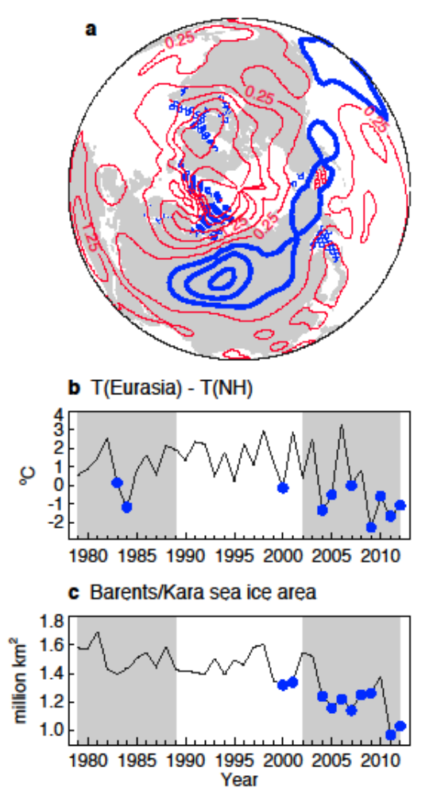
Figure 1 | Observed boreal winter SAT and SIC. a.) Map of GISTEMP winter surface air temperature anomalies as (2002-12) minus (1979-89) in contours. Contour interval is 0.5ºC with zero contour omitted. Stippling indicates regions of sea ice loss (blue) and gain (red) that are greater than 40% in absolute terms. b.) Time series of Eurasian-averaged (35ºN – 60ºN, 40ºE – 120ºE) winter SAT with hemispheric (NH) winter temperature removed. Blue markers indicate the 10 most negative anomalies since 1979. c.) Time series of Barents-Kara Seas region (65ºN – 80ºN, 27ºE – 96ºE) winter sea ice area. Blue markers indicate the 10 lowest concentrations since 1979.
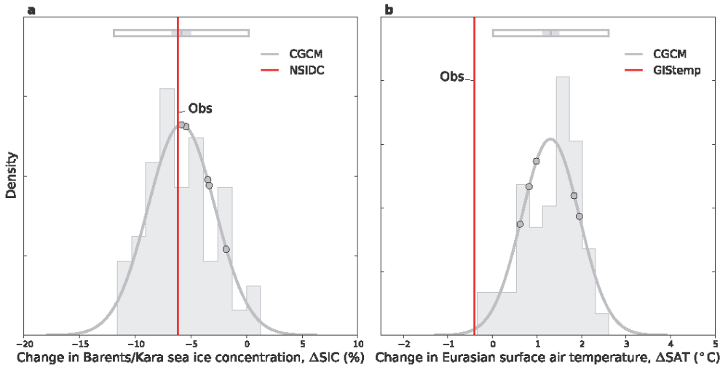
Figure 2 | Boreal winter Barents/Kara SIC and Eurasian SAT anomalies in CGCM a.) Histogram and associated probability distribution of DJF SIC (%) anomalies (2002-12 minus 1979-89) averaged in the Barents/Kara Seas from CGCM (gray). The red vertical line shows the observed anomaly computed from the National Sea Ice Data Center (NSIDC) bootstrap dataset. Gray circles indicate the Barents/Kara Seas SIC anomalies in the 5 simulations whose Arctic sea ice concentration is used as boundary conditions to AGCM. Box at top shows the probability distribution mean (line), 2.5-97.5% confidence range on the mean (shading), and 2.5-97.5% range of the probability distribution (box). b.) is as a. but showing DJF Eurasian SAT anomalies (_C). The red vertical line shows the observed anomaly computed from GISTEMP. Gray circles indicate the Eurasian SAT anomalies in the 5 simulations whose Arctic sea ice concentration is used as boundary conditions to AGCM.

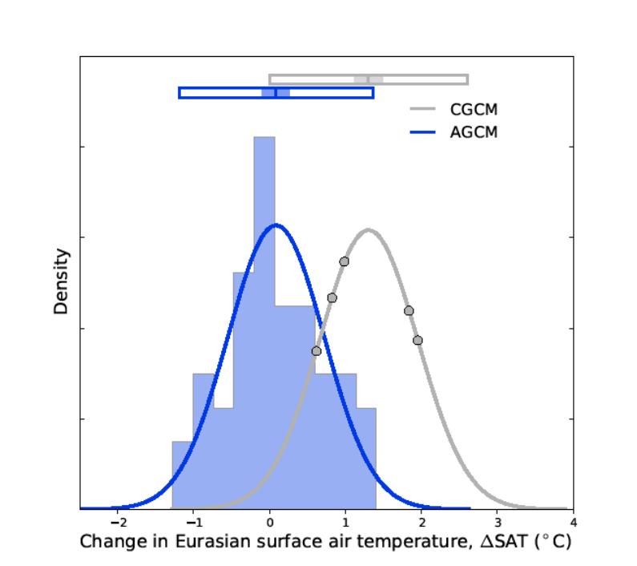
Figure 3 Boreal winter Eurasian SAT anomalies in CGCM and AGCM Histogram and associated probability density distribution of AGCM winter Eurasian SAT (ºC) anomalies (blue). Probability density distribution of CGCM (gray) Eurasian SAT anomalies repeated from Figure 2 for comparison. Gray circles indicate the Eurasian SAT anomalies in the 5 simulations whose Arctic sea ice concentration is used as boundary conditions to AGCM. Boxes at top show the probability density distribution mean (line), 2.5-97.5% confidence range on the mean (shading), and 2.5-97.5% range of the probability density distribution (box).

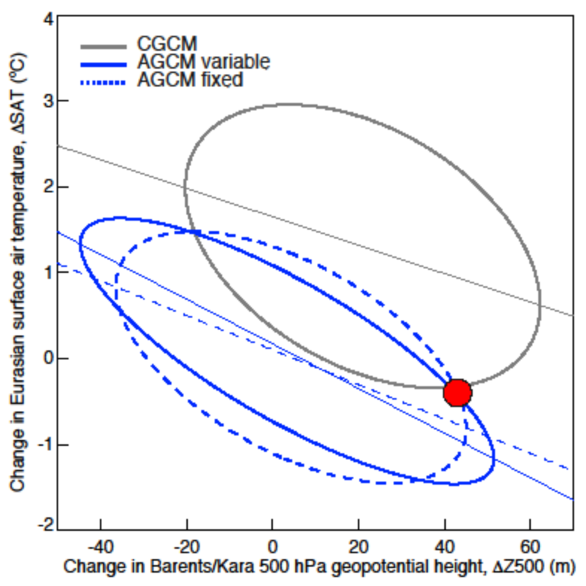
Figure 4 | Boreal winter Barents/Kara Z500 anomalies versus Eurasian SAT anomalies. Ellipses depict the 2.5-97.5% confidence range of the relationship between anomalies in Z500 averaged over the Barents/Kara Seas (m) and anomalies in Eurasian SAT (ºC) in CGCM (gray), AGCM variable (blue solid), and AGCM fixed (blue dashed), with associated linear regression lines. The red circle indicates the observed value from ERA-Interim and GISTEMP for Z500 and SAT, respectively.

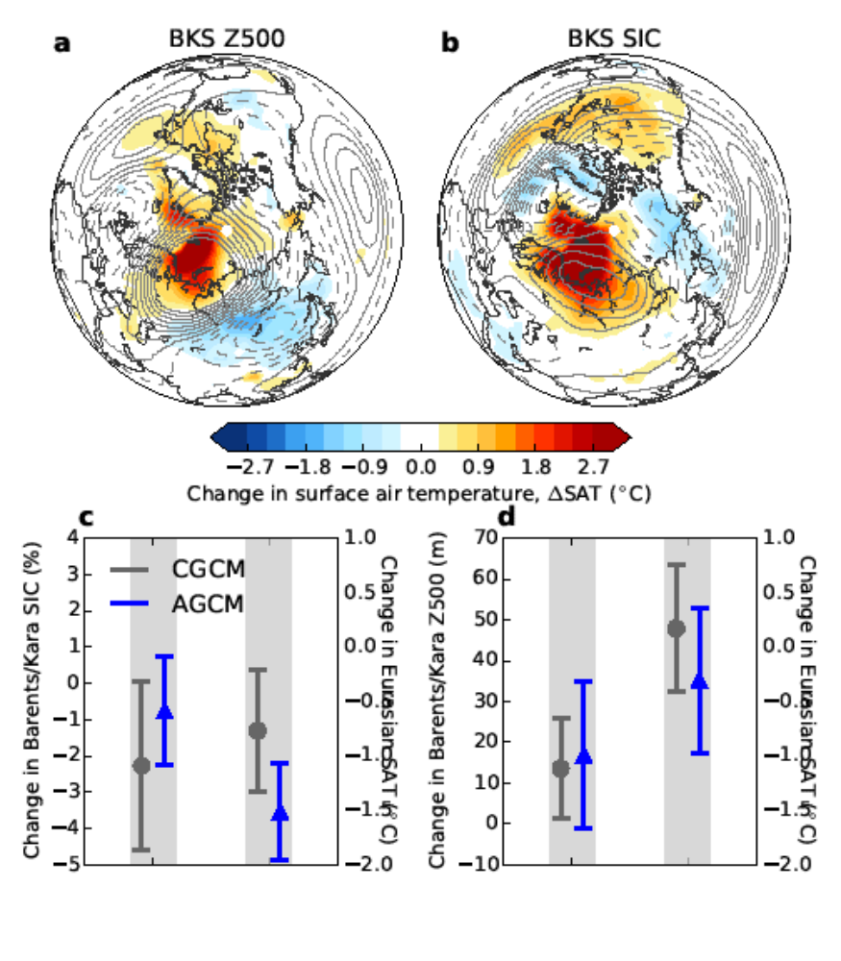
Figure 5 | Winter composites on Barents/Kara Z500 and Barents/Kara SIC. Spatial patterns of change in SAT (shading; ºC) and Z500 (contours; m) in CGCM associated with the a) ‘high-low’ composite of BKS Z500, and b) ‘low-high’ composite of BKS SIC. Z500 contour interval is 4 m starting at +/- 2 m (no zero contour). c-d) show regional average anomalies and 2.5-97.5% confidence ranges associated with the composites shown in a-b. c) The change in SIC in the Barents/Kara Seas (%; left) and change in Eurasian SAT (ºC; right) associated with the ‘high-low’ composite of BKS Z500 (map shown in a.) for CGCM (gray) and AGCM (blue). d) is as c.) but showing the change in Z500 over the Barents/Kara Seas (m; left) and change in Eurasian SAT (ºC; right) associated with the ‘low-high’ composite of BKS SIC (map shown in a.) c-d only show anomalies for composites on a field other than itself.

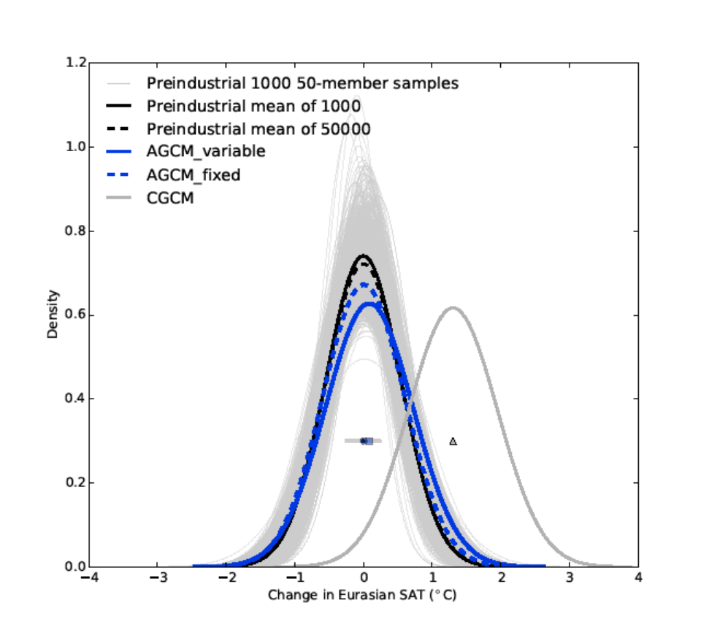

Figure S1 | Boreal winter Eurasian SAT anomalies in CGCM, AGCM, and Preindustrial ensembles. Probability density distributions (pdd) estimated from 50 DJF Eurasian SAT anomalies (ºC) sampled from the long Preindustrial simulation (see Methods) 1,000 times (thin gray) to estimate the sampling uncertainty of a 50-member distribution. Gray diamond markers show the means of the 1,000 pdd. The solid black curve shows the average of the 1,000 pdd, while dashed black shows the pdd estimated from the full 50,000 Preindustrial samples together. Black marker (hidden by blue circle marker) shows the mean of the solid black curve. Also shown are AGCM_variable (blue solid; repeated from Figure 3 in the main text), AGCM_fixed (blue dashed), and CGCM (thick gray; repeated from Figures 2 and 3 in the main text). Their pdd means are shown as markers (blue square, blue circle, and gray triangle for AGCM_variable, AGCM_fixed, and CGCM, respectively).

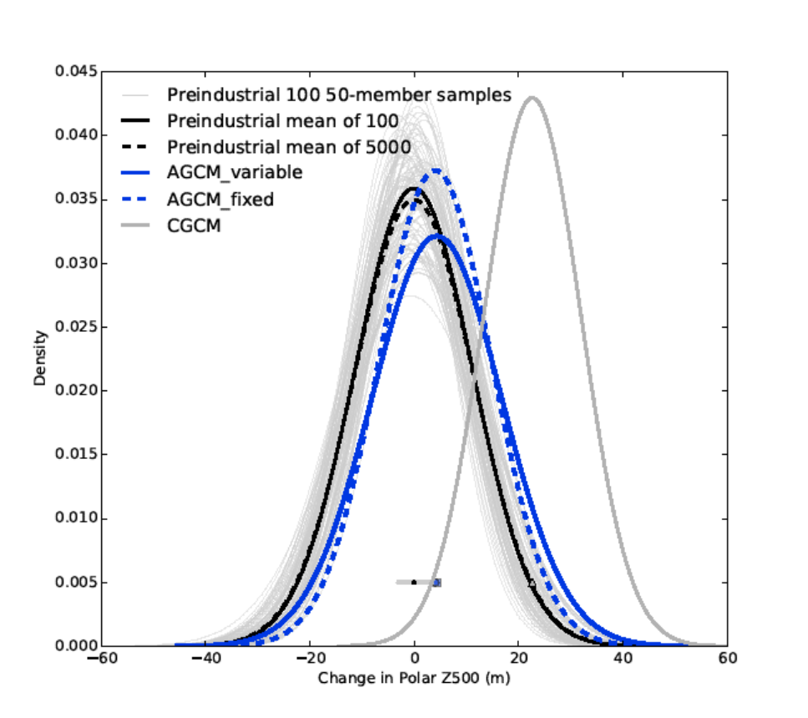
Figure S2 | Boreal polar cap Z500 anomalies in CGCM, AGCM, and Preindustrial ensembles. As Figure S1 except showing DJF Z500 anomalies averaged north of 60ºN.

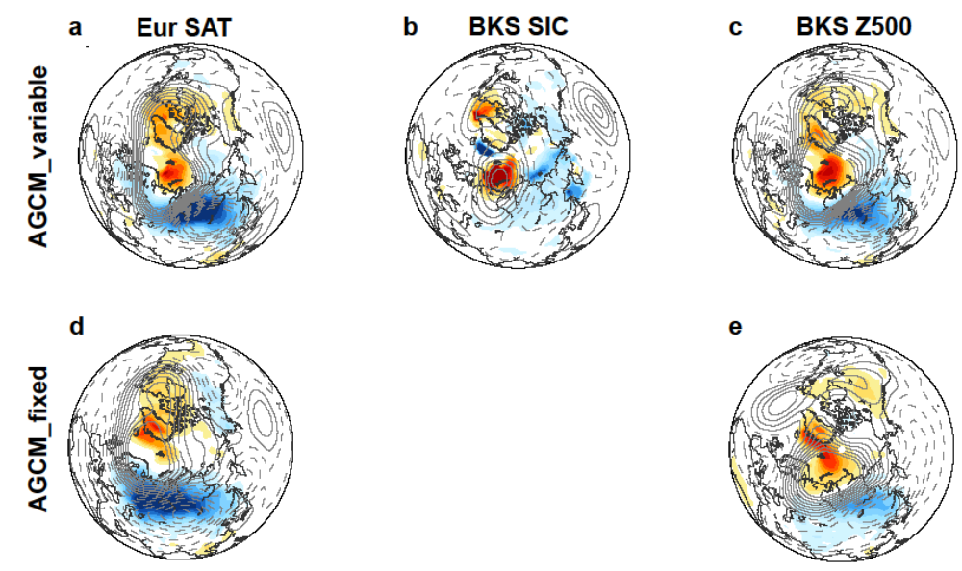
Figure S3 | Winter composites on Eurasian SAT, Barents/Kara SIC, and Barents/Kara Z500. [@@will remove d-e] Spatial patterns of change in SAT (shading; ºC) and Z500 (contours; m) in AGCM variable associated with the a) ‘cold-warm’ composite of Eur SAT, b) ‘low-high’ composite of BKS SIC, and c) ‘high-low’ composite of BKS Z500. Z500 contour interval is 4 m starting at +/- 2 m (no zero contour). d-e) are as a and c but for AGCM fixed where BKS SIC is not defined.

Acknowledgements
We thank XX and YY for helpful comments on the manuscript

Author Contributions

Additional Information
Reprints and permissions information is available at www.nature.com/reprints.
The authors declare no competing financial interests. Correspondence and requests for materials should be addressed to kemccusk@uvic.ca. Supplementary material is available online at www.nature.com.

