

University of Trento

Web Architecture
Online Placement System
Project report
Kemele Muhammed Endris - 160753
Kemele.endris@studenti.unitn.com
Keme686@gmail.com

Submitted to Prof: Marco Ronchetti
September 8, 2013
Table of Contents
1 Introduction 1
2 Requirements analysis 2
2.1 Problem of the current system 2
2.2 Stakeholders 2
2.3 Use Cases 3
2.3.1 General Use Cases 3
2.3.2 Student Use Cases 4
2.3.3 Administrator Use Cases 7
2.4 Functional Requirements 13
2.4.1 Login – OPS-Auth-UC001 13
2.4.2 Student Use Cases 13
2.4.3 Administrator use case 14
2.5 Non-Functional Requirements 16
3 Design 19
3.1 State Diagrams 19
3.1.1 Placement 19
3.1.2 Student 20
3.2 Activity Diagrams 20
3.3 Object Design 22
3.4 Organization of the deployment on the various (logical) tiers 23
4 Implementation and deployment 24
4.1 Web sessions 24
4.2 Stateful bean(s) 24
4.3 Transactional behavior 24
4.4 Technologies used 24
4.5 Main problems encountered during the project development 25
5 User Interfaces 26
5.1 Placements 26
5.2 Rule 26
5.3 Students 27
5.4 Upload students 27
5.5 Colleges 28
5.6 Departments 28
5.7 Make placement 29

List of Figures

Figure 1 Student Use Cases Diagram 5
Figure 2 Administrator Use Cases 8
Figure 3 Placement State Diagram 19
Figure 4 Student State Diagram 20
Figure 5 Activity diagram 21
Figure 6 Class Diagram 22
Figure 7 Deployment Diagram 23

List of tables

Table 1 Login use case description 4
Table 2 Fill Department Choice Form use case description 6
Table 3 Update Choice/ Re-Rank use case description 7
Table 4 View Placement Result description 7
Table 5 Create New Placement use case description 9
Table 6 Allocate Participating Department use case description 9
Table 7 Upload/Enter Student List use case description 10
Table 8 Export Placement Result use case description 11
Table 9 View Placed Students use case description 11
Table 10 Prepare Placement Rule use case description 12
Table 11 Make Placement use case description 13

Introduction
Department placement is a process of assigning students to a department of their choice. In recent year, there has been an increase in the number of students who joined universities in Ethiopia. Even if the number of universities is still growing they still serve more students than their capacity.
Universities use criteria to select a student to a department based on the students’ academic credentials, the number of students that a department can handle per semester, and other criteria set on the time of placement. Most of universities, in Ethiopia, do this kind of process every semester of the academic year. Some Faculties make such placement before starting the first semester and others make placement after the first semester.
This process of placement is mostly done by an academic committee of the faculty. This committee is composed of each department heads in the faculty, registrar office director, research office directors and dean of student affairs. Students will make their department choice on the paper form prepared by secretaries of the faculty. Those forms will be inserted to a spreadsheet application (e.g. excel) by secretaries of the faculty. The secretaries then insert students’ credentials which is send by registrar office. This compiled choice of students and credentials will be given to the committee.
This process takes most of the time at least 2-3 weeks. Then the committee sorts those list based on their department choices and then by their credential (not only academic but also other privileges such as female, region, etc.) in separate files. Then select the top of the list for each department of its capacity. But this process is not a one button task.
Students’ first choice may not be kept because departments’ capacity is limited, then second choice will be considered after finishing students’ first choice placement for all departments is finished. This process will continue until all students are placed in each department.
Finally, list of placed students will be posted on announcement board by secretaries. Students may complain about the placement to secretaries, since his/her choice may not be kept. Secretaries collect such complaints and present to faculty placement committee. The committee evaluates such complain and respond to students.

Requirements analysis

Problem of the current system
The main problem of the current system is time spent for the placement process. As stated above, it takes 2-3 weeks to collect student department choice and insert to excel file. In addition, it needs at least a week for evaluating students credential and choice and to make placement by the committee.
The other problem is, since choice is made manually, inserting students’ choice to excel file is error prone. If a secretary made an error while inserting student choice ranking, this will lead to unfair placement for that specific student. This error cannot be undone after a placement process, because since otherwise the placement process should be repeated again to be fair.
The third problem is, students cannot update department choice/rearrange their preferences before the placement process starts. Once ranking is made, it will be final. Student must be present in the faculty when the secretaries dispatch choice forms and they should till and submit on the same day and hour. If student missed that day, he/she will be placed at any random department without his interest or choice.

Stakeholders
The following are the identified stakeholders:
- Students: are the people that use a system to submit their choice of the department, check their final placement result and submit complaint in case of un-satisfaction.
- Department Heads: are the people that submit capacity of the department.
- Faculty Deans: is the dean of the faculties which wants to make placement of students to the departments in the faculty.
- Registrar Director: is a person who manages registrar office of the university who accepts list of students placed to the university by Ministry of Education and hand over list of students who must be placed further to the departments in those faculties
- Secretaries: are secretaries of the faculty and registrar office who are responsible for dispatching and collect student department choice form to students, and then submit to the faculty placement committee. Then collect final placement list from the placement committee then print and post the final list for students.
- Placement Committee: is the committee which is organized at the time of placement process by the faculty dean. It is composed of the head of each department for placement, registrar office director, and research office director and student dean.

System Users
In the online student placement system the following are major users:
- Student:
- Administrator: is the user who manages the system in general.
For the simplicity and some technological exposure problem the administrator will have the authority to do operations so as to fulfill the goals of other stakeholders. For instance, if students submit their choice in paper, it is the responsibility of the admin to upload their choice by accepting the compiled choice list from the secretary.

Possible user actions
In general, the possible user actions are as follows:
- Crate placement whenever needed
- Upload student list to the placement
- Make department choice
- Set placement rule
- Make placement and publish
- Export list to pdf/excel

Use Cases
In software and systems engineering, a use case is a list of steps, typically defining interactions between a role (known in UML as an "actor") and a system, to achieve a goal. The actor can be a human or an external system. A use case diagram at its simplest is a representation of a user's interaction with the system and depicting the specifications of a use case.

General Use Cases

Login
Use Case Name | Login | Reference ID: | OPS-Auth-UC01
Description | Every user should login to the system before getting any service from the online placement system. This use case should be included in any of use cases described below for each user/stakeholder. Each user will have username and password.
Business Actors | User (Student, Administrator)
Trigger | User wants to use service from the system
Precondition | User should be connected to the network
Post Condition | User authenticated
Basic Workflow | - User enters username and password  - The system checks the credentials  - The system opens home page of the system based on user privilege
Alternative Flow | 2(a) user credentials are incorrect  - The system displays error message  - The system starts counter (maximum 3 attempts) and displays login page  - User is not active yet
Business rule
Priority | High
Business Entities | - User
  Attribute | Required? | Remark
  Username | Yes
  Password | Yes
  Role | Yes | Internal
  Account status | Yes | Internal
Table 1 Login use case description

Student Use Cases
Based on the tactical goals identified in the section above, the following use cases are identified:
- Fill Department Choice Form (Give Rank to departments)
- Update Choice (re-rank)
- View placement result
- Reset password
- View Departments
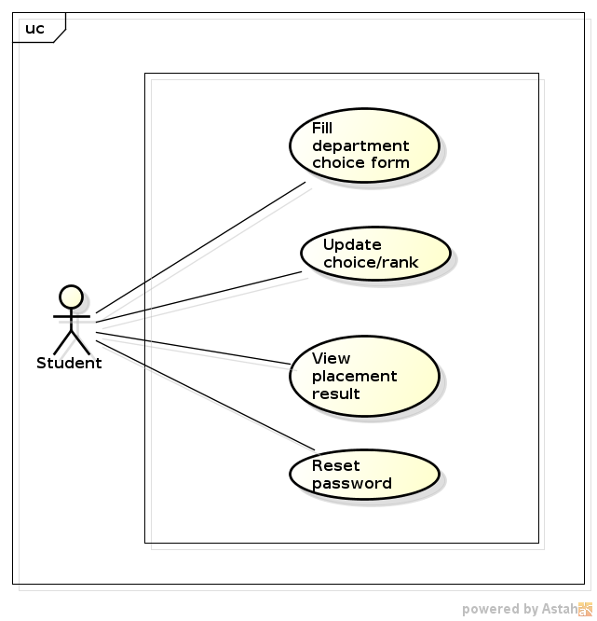
Figure 1 Student Use Cases Diagram

Fill Department Choice Form (OPS-ST-UC02)
Use Case Name | Fill Department Choice Form | Reference ID: | OPS-ST-UC02
Description | Student must fill the choice form to select departments he/she want to be placed and provide additional information. This use case is used to provide the form that a student can rank those departments of interest and save the choice made.
Business Actors | Student
Precondition | - Student must Login(OPS-Auth-UC01)  - Student is eligible for placement, i.e., student should be assigned to the specific placement  - Placement is active
Post Condition | Department choice information saved.
Basic Workflow | - Student opens placement home  - Student click Choice link  - System checks choice status, if not made before  - System opens choice form with list of departments with rank  - Student fills information  - Student click on Update button  - System saves the information
Alternative Flow | 3(a) student already fill department choice  - Go to use case OPS-ST-UC03 step 3
Business rule | - Student should submit the final choice before the deadline  - Student cannot submit choice after the deadline set by registrar office  - Student should at least rank one of the departments with rank number 1.  - Rank numbers should be sequential, means there should not be any jump from 1 to the total number of departments.  - Rank number should be between 1 and total number of departments for choice
Table 2 Fill Department Choice Form use case description

Update Choice/Re-Rank (OPS-ST-UC03)
Use Case Name | Update Choice/Re-Rank | Reference ID: | OPS-ST-UC03
Description | In this use case, students can rearrange the ranking of departments and can update information provided before.
Business Actors | Student
Precondition | - Student must Login(OPS-Auth-UC01)  - Student is eligible for placement, i.e., student should be assigned to the specific placement  - Placement is active
Post Condition | Department choice updated
Basic Workflow | - Student opens placement home  - Student click Choice link  - System checks placement status, if not finished  - System opens choice information with data filled before  - Student re-arranges departments rank  - Student click on Update button  - System updates the information
Alternative Flow | 3(a) placement already made/finished  - System displays the choice information (non-editable)  3(b) student never fill department choice  - Go to use case OPS-ST-UC01 step 3
Business rule | - Student cannot update information after final submission  - Student should submit the final choice before the deadline  - Student cannot submit choice after the deadline set by registrar office  - Student should at least rank one of the departments with rank number 1.  - Rank numbers should be sequential, means there should not be any jump from 1 to the total number of departments.  - Rank number should be between 1 and total number of departments for choice
Table 3 Update Choice/ Re-Rank use case description

View Placement Result (OPS-ST-UC05)
Use Case Name | View Placement Result | Reference ID: | OPS-ST-UC05
Description | After placement result is finalized by placement committee students can view the department they are placed in. This use case is used to display such information for a student so that they can submit complains, if any, before registration.
Business Actors | Student
Precondition | - Student must Login(OPS-XX-UC01)  - Student is eligible for placement, i.e., student should be assigned to the specific placement  - Placement is active
Post Condition | Placement Result displayed
Basic Workflow | - Student opens placement home page  - Student click on placement Result link  - System checks whether placement is finalized or not  - System displays Placement result of a student
Alternative Flow | 3(a) placement result is not finalized  - System displays information, as “placement result is not published yet”
Business rule | - A Student cannot view another students result
Table 4 View Placement Result description

Administrator Use Cases
The following use cases are identified
- Manage departments
- Manage colleges
- Manage placements
- Upload students list
- Manage users account
- Set Placement Rules
- Set Departments Capacity
- View Placed Students
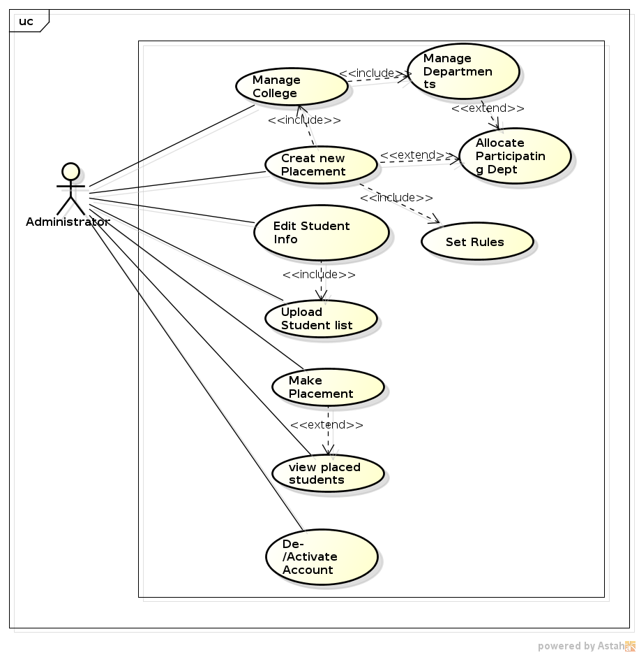
Figure 2 Administrator Use Cases

Create New Placement
Use Case Name | Create New Placement | Reference ID: | OPS-RD-UC01
Description | New placement is created when registrar director receives students who are not placed to department from MOE. In this case the administrator initiates a new placement process by assigning students, departments and placement rule to a newly created placement in the system. Then this placement will be active for participants based on the timeline specified during this process.
Business Actors | Administrator
Trigger | Non placed students received from MOE
Precondition | - The user should login to the system
Post Condition | New placement is created
Basic Workflow | - The user opens home page  - The user selects new placement  - The system opens new placement form  - The user enters code, academic year, college, and name of the placement  - The system checks the placement information provided  - The system creates new placement
Alternative Flow | 5(a) placement already exists
Business rule
Priority | High
Business Entities | - Placement
  Attribute | Required? | Remark
  Code | Yes
  Name | Yes
  College | Yes
  Academic Year | Yes
Table 5 Create New Placement use case description

Allocate Participating Departments
Use Case Name | Allocate Participating Departments | Reference ID: | OPS-RD-UC02
Description | After creating placement, administrator should assign participating departments of the college in which placement is going to be done. These departments will be available for students to choose from.
Business Actors | Registrar director
Trigger | Placement created
Precondition | - The user must be logged in  - Placement already created
Post Condition | Departments are allocated to placement
Basic Workflow | - The user opens placement home  - The user selects allocate departments  - The system displays list of departments in the faculty, in which the placement is set for  - The user selects department  - The system validates selected department  - The system allocated department to placement
Alternative Flow
Business rule
Priority | High
Business Entities | - Placement
  Attribute | Required? | Remark
  Name
  Department | Yes
  Capacity | Yes
  Max. Violation |  | In case more students choose this department beyond capacity
Table 6 Allocate Participating Department use case description

Upload/Enter Students List
Use Case Name | Upload/Enter Students List | Reference ID: | OPS-RD-UC05
Description | In addition to allocating departments to the newly created placement, administrator should also allocate/enter students for the placement process. Students can be added to placement by uploading excel list. Students basic information and grade information should be provided.
Business Actors | Administrator
Trigger | Placement created
Precondition | - The user should be logged in to the system  - Placement already created
Post Condition | Student for placement allocated
Basic Workflow | - The user opens home  - The user selects upload students  - The system displays adding methods  - The system displays upload form  - The user selects excel file and upload  - The system validates file and data  - The system displays preview list  - The user confirms the list  - The system adds students to placement
Alternative Flow
Business rule
Priority | High
Business Entities | - Student
  Attribute | Required? | Remark
  IdNum | Yes
  Name | Yes
  Gender | Yes
  Region
  Grade | Yes
  physicalChallenge
  Placement | Yes
  Choices(list) |  | In case students choice must be uploaded with the list
Table 7 Upload/Enter Student List use case description

Export Placement Result
Use Case Name | Export Placement Result | Reference ID: | OPS-RD-UC06
Description | After placement is finalized administrator can export result from the system to pdf/excel file. This result will be used to register student to placed departments to the registrar system.
Business Actors | Administrator
Trigger | Placement finalized
Precondition | - User should login to the system  - Placement should be finalized
Post Condition | Placement result downloaded
Basic Workflow | - The user opens placement home  - The user selects result  - The system checks the placement result  - The system displays result  - The user selects export
Alternative Flow
Business rule
Priority | High
Business Entities
  Attribute | Required? | Remark
Table 8 Export Placement Result use case description

View Placed Students
Use Case Name | View Placed Students | Reference ID: | OPS-DH-UC05
Description | After placement is made, administrator can review the draft or view the final list of students.
Business Actors | Administrator
Precondition | - The user should Login  - Placement is made
Post Condition | List of students assigned/placed is displayed
Basic Workflow | - The user opens placement home  - The user clicks on Students link  - The system checks whether student placement is made or not  - The system displays list of students assigned to the department.
Alternative Flow
Business rule
Business Entities | - Placement Result
  Attribute | Required? | Remark
  Student
  Department
  Reason |  | By which rule the student is assigned in.
Table 9 View Placed Students use case description

Prepare Placement Rule
Use Case Name | Prepare Placement Rule | Reference ID: | OPS-PC-UC03
Description | Placement rule is the rule which should be used during evaluation of student choice. This rule includes the percentage of students from different perspective such as gender, region, and CGPA/Mark. These percentage rules are specified by MOE. This rule should be set for every placement made.
Business Actors | Administrator
Precondition | - The user should login to the system
Post Condition | Placement rule prepared
Basic Workflow | - The user opens placement home  - The user click on Placement Rule link  - The user click on new rule button  - The system opens a new form  - The user enters general rule for the placement  - The user click on save button  - The system checks the validity of the rule  - The system saves the rule
Alternative Flow | 9(a) placement rule is not valid, inconsistent (>100% or <100%)
Business rule
Business Entities | - Placement Rule
  Attribute | Required? | Remark
  femalePercentage
  regionPercentage
  cgpaPercentage
  Placement
Table 10 Prepare Placement Rule use case description

Make Placement
Use Case Name | Make Placement | Reference ID: | OPS-PC-UC06
Description | After student choice is finalized and students’ document is evaluated then actually placing students to a department is carried out by this use case. This means students choice will be evaluated with respect to the general rule set.
Business Actors | Administrator
Trigger | Document evaluation finished
Precondition | - The user should login to the system  - Student choice is finalized and submitted already
Post Condition | Student placement result is prepared
Basic Workflow | - The user opens placement home  - The user clicks on make placement link  - The system checks placement status  - The system displays list of students to be placed with respect to the departments  - The user clicks start placement button  - The system gets placement rule  - The system ranks students with respect to the rules and other information  - The system gets department capacity  - The system selects the top of the list from the rank based on department capacity  - The system displays the preview of the result  - The user checks the number of students with respect to departments  - The user clicks Save button  - The system saves the result
Alternative Flow | 3(a) placement is made already  8(a) department capacity not set  12(a) user clicks Cancel button
Business rule
Priority | High
Business Entities | - Placement Result
  Attribute | Required? | Remark
  Student
  Department
  Reason
Table 11 Make Placement use case description

Functional Requirements
In software engineering, a functional requirement defines a function of a software system or its component. A function is described as a set of inputs, the behavior, and outputs. Functional requirements may be calculations, technical details, data manipulation and processing and other specific functionality that define what a system is supposed to accomplish.

Login – OPS-Auth-UC001
ID | Description
FR1.1 | The system shall allow all active students to login to the system
FR1.2 | The system shall allow a user to disconnect their session/logout/
FR1.3 | The system shall require a user to enter a valid username and password to login
FR1.4 | The system shall allow a user to request a password when she/he forgets password to login through email or sms
FR1.5 | The system shall restrict the number of login attempts by a user up to 3 times in 30 minutes
FR1.6 | The system shall display users home page based on their role, if user provides valid username and password

Student Use Cases

Fill Department Choice – OPS-ST-UC002
ID | Description
FR3.1 | The system shall allow all active students in an active placement to rank department choice
FR3.2 | The system shall allow students to save their department choice submission for evaluation
FR3.3 | The system shall allow students to reset the choice while filling choice
FR3.4 | The system shall not allow students to fill choice after choice deadline passed
FR3.5 | The system shall require the students to rank departments sequentially, between 1 and total number of departments available for placement(choice)
FR3.6 | The system shall provide the form that a student can fill basic information such as email, name, address, etc
FR3.7 | The system shall provide the form with the list of departments in active placement for choice and a way to rank those departments (either input numbers for each department or dropdown)
FR3.8 | The system shall not allow students to view other students choice

Update Choice /Re-ranking) – OPS-ST-UC003
ID | Description
FR4.1 | The system shall allow students to rearrange/re-rank the choices before deadline for choice passed
FR4.2 | The system shall allow students to update provided information such disability (physical challenge), gender, address, etc
FR4.3 | The system shall not allow students to update choice information after deadline passed for choice
FR4.4 | The system shall provide list of departments in a placement for choice, and ranking that a student already fill before
FR4.5 | The system shall allow students to update their department choice information
FR4.6 | The system shall allow the students to reset/fallback the choice to the previous state(before last update)
FR4.7 | The system shall not allow students to update other students choice

View Placement Result –OPS-ST-UC004
ID | Description
FR6.1 | The system shall display result for students after placement is done and finalized
FR6.2 | The system shall not allow students to view other students result
FR6.3 | The system shall not allow students to change their placement result
FR6.4 | The system shall provide a reason for a student about the placement result
FR6.5 | The system shall not provide a reason for a student about placement of other students
FR6.6

Administrator use case

View Placed Students - OPS-DH-UC07
ID | Description
FR15.1 | The system shall allow department head to view placed students after placement committee finishes as draft or final list
FR15.2 | The system shall not allow department head to view student’s placement before it is sent/set as draft/ by placement committee.
FR15.3 | The system shall allow department head to sort list of students assigned using different criteria using available properties of student list.
FR15.4 | The system shall display message if no student is assigned yet.
FR15.5 | The system shall not allow department head to view other departments placed students.
FR15.6 | The system shall not allow department head to edit/update placed students department.
FR15.7 | The system shall not allow department head to enter additional students to the placement result
FR15.8

Prepare Placement Rule - OPS-PC-UC03
ID | Description
FR20.1 | The system shall allow admin to set general placement rule applier for placement process
FR20.2 | The system shall require admin to set rules for the distribution of all the rules in percentage.
FR20.3 | The system shall require admin to set rules in which the sum of then is exactly 100%.
FR20.4 | The system shall allow to set the placement rule for more than one placement process
FR20.5 | The system shall allow admin to set requirements of each department based on general rule proportion.
FR20.6 | the system shall provide error message when placement rules inconsistent with department rule
FR20.7 | The system shall provide error message when placement committee set placement rule percentage more than or less than 100%.

Make Placement - OPS-PC-UC06
ID | Description
FR23.1 | The system shall allow placement committee to place students to department based general rules and department requirements set before.
FR23.2 | The system shall display preview of the result/list of students in each department before saving
FR23.3 | The system shall save placement results as draft placement result after confirmed by placement committee to save the preview result provided.
FR23.4 | The system shall not allow placement committee to place students before time for student department choice is finalized (deadline expires)
FR23.5 | The system shall provide a button to start (automatic) placement process
FR23.6 | The system shall make placement calculation/evaluation using rules provided and students’ credential s such as student dept choice, document evaluation and student information about gender, region, disability, grade/mark.
FR23.7 | The system shall keep record of the reason for placement of student after evaluation of student info with student dept choice and rules/cotta of placement rule.
FR23.8 | The system shall not place students more than the capacity of department

Create New Placement - OPS-RD-UC01
ID | Description
FR31.1 | The system shall allow registrar director to create a new placement
FR31.2 | The system shall require the registrar director enter unique code for new placement
FR31.3 | The system should require academic year, faculty, and name of placement for new placement created
FR31.4 | The system shall allow registrar director to edit/update placement crated if it is not active for placement process
FR31.5

Allocate Participating Departments - OPS-RD-UC02
ID | Description
FR32.1 | The system shall allow registrar director to allocate departments to placement created
FR32.2 | The system shall allow registrar director to remove department from placement where it was allocated before
FR32.3 | The system shall not allow registrar director to remove department form placement if students are placed in it.
FR32.4 | The system shall provide list of departments in the faculty that was set when placement is created
FR32.5 | The system shall allow registrar director to allocate more than one department to a created placement.
FR32.6 | The system shall not allow registrar director to allocate a department to a single placement more than once (which is already allocated in the selected placement).
FR32.7

Upload/Enter Students List – OPS-RD-UC05
ID | Description
FR35.1 | The system shall allow registrar director to enter student information to the created placement
FR35.2 | The system shall allow registrar director to upload list of students to the created placement with excel, csv, xml or txt file
FR35.3 | The system shall allow the registrar director to select list adding method as single student, list file, or web service to placement created.
FR35.4 | The system shall allow registrar director to fetch student list from web service to the placement created
FR35.5 | The system shall allow registrar director to edit/update/remove student from placement created
FR35.6 | The system shall display preview of uploaded or fetched for web service before saving to database
FR35.7 | The system should require students basic information and grade/mark being provided in the file or web service in the format provided by convention with respect to data needed

Download Placement Result – OPS-RD-UC06
ID | Description
FR36.1 | The system shall allow registrar director to download the placement result as a Excel/pdf file
FR36.2 | The system shall provide a web service that provides students placement result to registrar system
FR36.3 | The system shall allow registrar director to view the placement result before downloading as a file
FR36.4 | The system shall not allow other users to use the web service provided
FR36.5 | The system shall not allow registrar director to edit/update the placement result
FR36.6 | The system shall provide searching and sorting capability while downloading specific department or student result.
FR36.7

Non-Functional Requirements
In systems engineering and requirements engineering, a non-functional requirement is a requirement that specifies criteria that can be used to judge the operation of a system, rather than specific behaviors. Non-functional requirements are often called qualities of a system. Other terms for non-functional requirements are "constraints", "quality attributes", "quality goals", "quality of service requirements" and "non-behavioral requirements". (3)
ID | Quality | Criteria |  | Evaluation
NFR-1 | Usability | The system shall have a clear interface with only needed features, clear terminology and tool tips wherever necessary. Warnings or alerts shall be specified in clear way. |  | The system’s functionality can be tested by layman  who didn’t develop the system;
NFR-3 | Efficiency | The system shall respond to different searches and sorts being conducted like on student, department, choice, documents, result, etc |  | Testing must be done on different machines with different capabilities in order to check the response time of the system.
NFR-4 | Security | The system should be secured in different perspectives of security measures. These are availability, integrity and confidentiality. All this need be checked per month.
NFR-4.1 | Security | Availability | The system shall be available 24/7 to be accessed inside and outside of the University network. Besides authorized users should get the resource they deserved based on the access control defined by the system. | In this regard, there shouldn’t happen for more than 3 complaints per one placement process.
NFR-4.2 | Security | Integrity | The system should protect the data transferred through different parties without modifying the actual data. | The system should protect integrity of data 100%. When there is the integrity problem, the system should detect before sent the destination to inform the sender to send it again or propose the solutions for the problem happening.
NFR-4.3 | Security | Authentication | The system should provide maximum security by providing authentication to identify who can use the sub/system to what extent. Unauthenticated access is unacceptable. | The system should request users to authenticate again after 10 minutes if the users didn’t use in between.
NFR-4.4 | Security | Confidentiality | Restricted information should not be disclosed to unauthorized users. Students’ personal data should not be disclosed to other party either by web service provided or directly to other students. | The system should report when unauthorized user tries to access confidential data.
NFR-5 | Reliability | The software should be reliable  The system shall allow easy recovery from errors and crashes. |  | In one day, there cannot be more than one error in the input/query for data.  There should not be more than 2 crashes a year and should automatically restore data from backup it stores automatically.
NFR-6 | Timely Updates | The system should update the activities performed by any kind of users and make it available for other users who can use the outcome of the previous users. |  | Activities of users shall be updated no more than 1-2 seconds.
NFR-7 | Portability | - The system should support different operating system such as Windows, Linux, and Mac.  - The system should be compatible with different browsers such as Firefox, Chrome, Safari, Opera, IE (>v7.0) and mobile/hand-held devices |  | Check whether the system runs well without any modification when moved from one operating system to another.  Check whether the system runs well in different browser during development and provide mobile web accessibility testing also.
NFR-8 | Interoperability | The system should be able to interact with other different systems without any external help. For instance, it should be possible to interact with registrar system to fetch or transfer student and department data. |  | Check whether data obtained after exporting is accurate or not
NFR-9 | Documentation | The system shall have documentation for providing help to the user whenever required. |  | There should not be any complaints relating to the use of system features. All system users shall access the system satisfactorily. Documentation should be available when one wants to refer as help. Documentation should be prepared for each type of users(student documentation, Department head, Registrar director and placement committee)
NFR-10 | Error Handling and Extreme conditions | The system shall manage Input errors while user fills information (such as choice, complain, uploading list, etc). The system shall have a way to notify the system administers when an extreme conditions happen |  | Input validation has to be performed in detail in order to notify each and specific errors occur while a user is filling data to the system.  When a system faces extreme conditions like accessing a big data or uploading a big file or any other conditions there must be a dialog to notify the condition to the user and no input should be accepted.

Design

State Diagrams
State diagrams are used to give an abstract description of the behavior of a system. This behavior is analyzed and represented in series of events that could occur in one or more possible states.

Placement
Placement object can be in different states from its creation to it being closed. Those states can be Created, Participants Assigned, Activated, or closed.
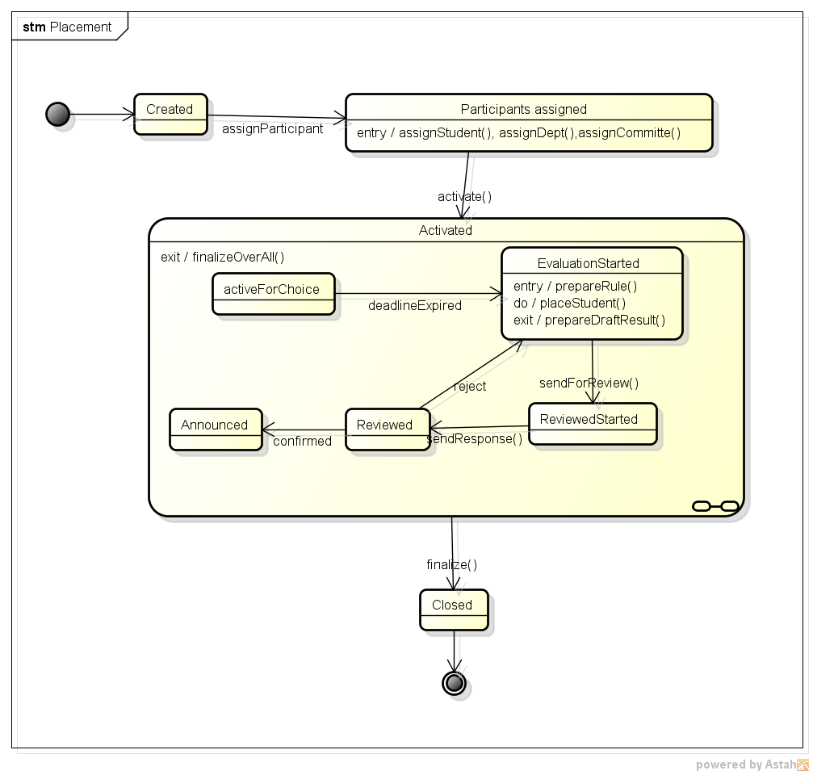
Figure 3 Placement State Diagram

Student
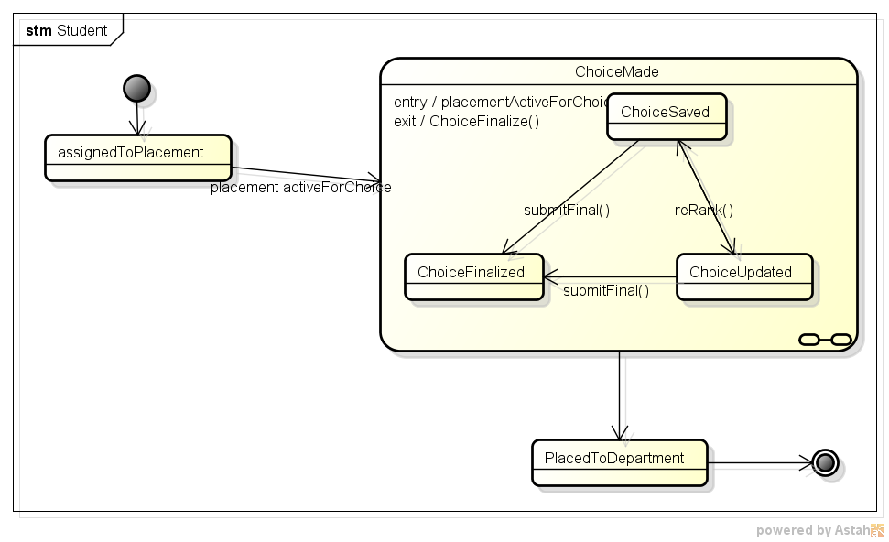
Figure 4 Student State Diagram

Activity Diagrams
The activity diagram shown below depicts the communication between stakeholders and the tasks process carried out by those stakeholders when placement process is processed
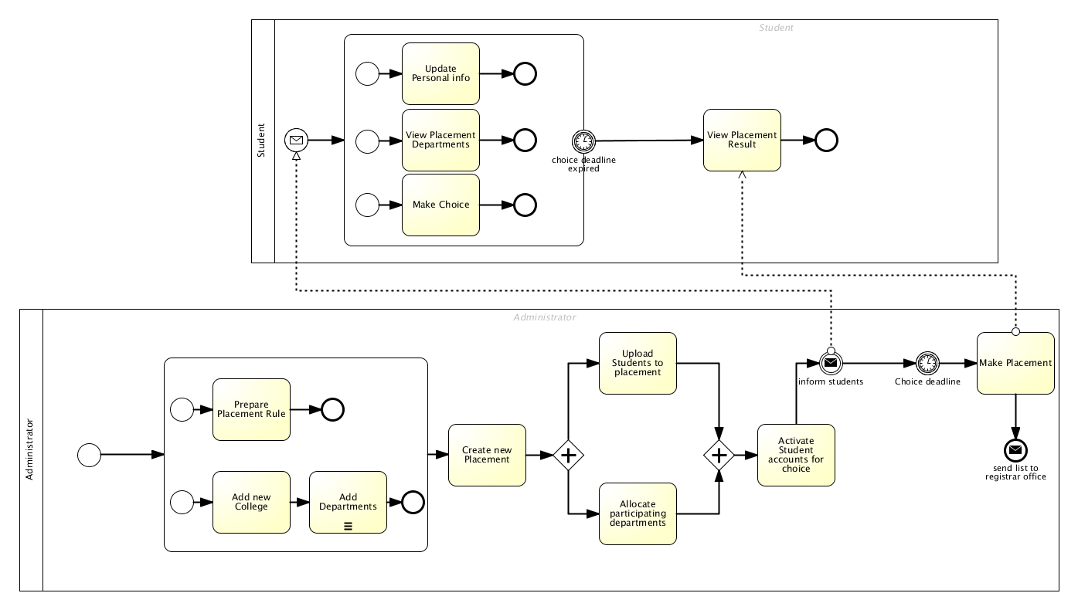
Figure 5 Activity diagram

Object Design
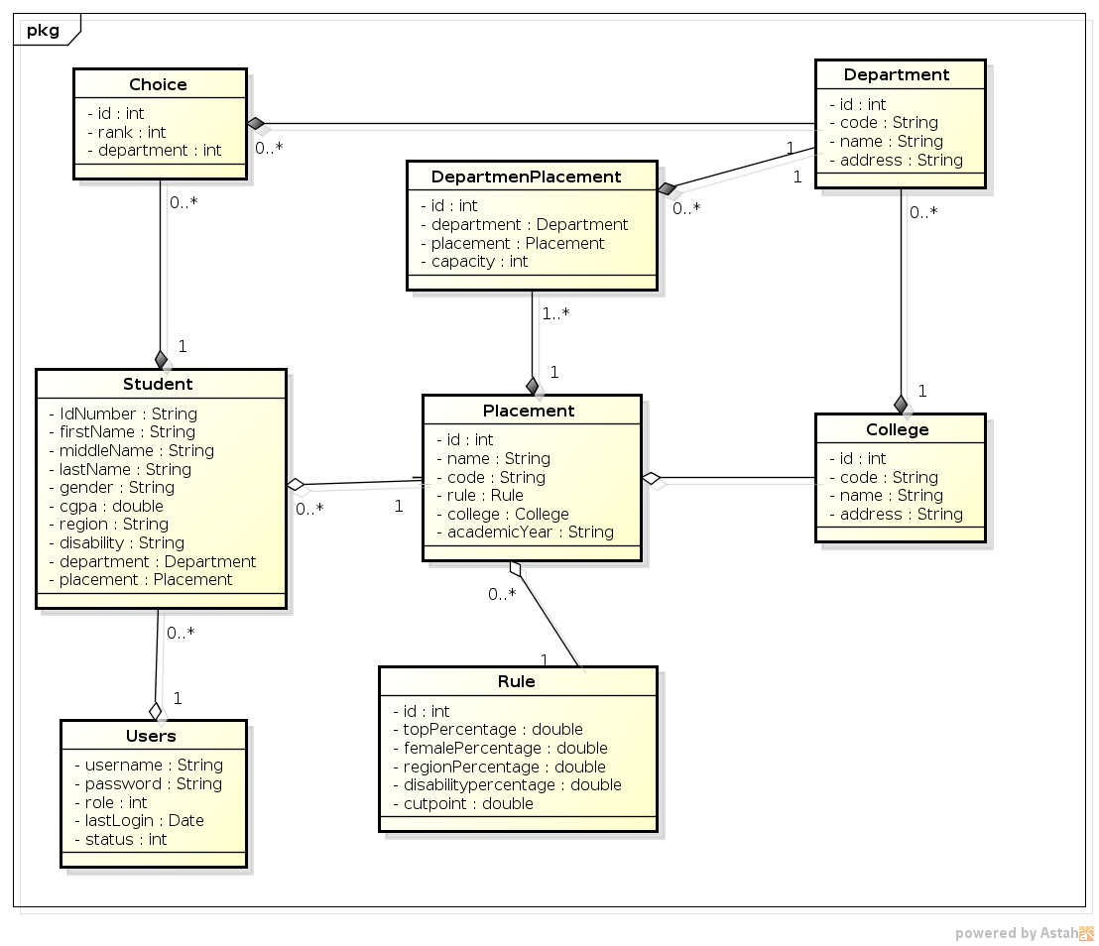
Figure 6 Class Diagram

Organization of the deployment on the various (logical) tiers
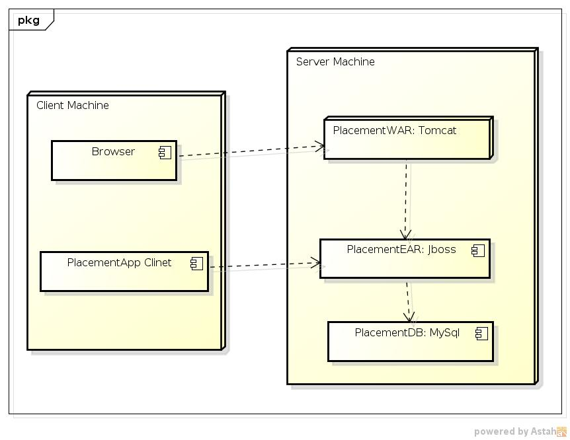
Figure 7 Deployment Diagram

Implementation and deployment

Web sessions
When a user logs in to the system, the web session is created and stores userid with name of the user. These values are checked in every page of the system and if the userid is not found in the session, the user will be redirected to login page.
The maximum idle time/session timeout is set to 10 minutes in web.xml as described in non-functional requirements. When this session expires the user will be redirected to the login page.

Stateful bean(s)
In this application, I used two stateful session beans, StudentPlacementBL and UploadStudentBL. StudentPlacementBL is used to make/process placement after students choice is finished (or uploaded with basic information). This object is set stateful because of the fact that when placement is made the user might need to edit/remove student information and need to confirm the placement result.
The later, UploadStudentBL is set stateful bean because of the reason described above for StudentPlacementBL.

Transactional behavior
Most of the transactions here are managed by the container. However, I implement two bean managed transaction, namely, StudentPlacementBL and UploadStudentBL. Here even if those beans are staeful, the transaction status needs to be managed and communicated to the user while saving the information.

Technologies used
- The application is developed using NetBeans IDE and has been deployed and tested with JBoss Application Server 7.1 installed in Ubuntu 12.04 LTS operating system.
- The pattern used is MVC pattern JSPs as View, EJBs as Model and Servlets as a controller. MySql database is used as a persistent storage and can be accessed using eclipseLink as a JPA provider.
- In the web tier, the view is totally separated from controller and scripts. It uses jQuery library for AJAX call for every communication with the controller. There is no form submission except through the ajax calls. In addition, the interface uses jqGrid jQuery grid library to populate list of information in grid form. This also uses AJAX call to populate information from the controller.
- Users’ password is stored in MD5 encrypted form. When the user attempts login, the system then MD5 the password given by the user and compare with the data in the database to validate.
- JavaMail also used to send email to students to inform about account information and auto generated password. When student account is activated and/or password is re-generated by administrator, the system sends email to that specific student.
- HTML 5 is used for each interface (JSPs). Most of form features of HTML5 is used in student personal information form and other forms too.
- XML to communicate from controller to view/scripts.
- JasperReport to generate report of the placement result in pdf/excel using iReport plugin in Netbeans

Main problems encountered during the project development /deployment
The main problem was finding the right documentation for JBoss application server. Since its versions are a lot and a lot of documents and blogs use deferent versions, without mentioning which version they are using, it is very confusing to which tutorial to follow. The official documentation also have some problems regarding the mismatch between the examples given and the actual defaults. For instance, in the Jboss AS 7.1 the security realm is set by default but the documentation gives examples as if security is not a concern while using remote naming client. In addition, it also specifies a library for client application(web/app) it is enough to user jboss-client.jar which is included in jboss-as-7.1 server package, but it wasn’t enough, it needs at least 4-6 additional libraries for the client application/web client.

The second problem was calling remote object from remote server/ another server/. There was no documentation about accessing the ejb object from tomcat/another server/. This took me a lot of times which I finally managed to do it.

User Interfaces
Some of pages in the system are shown in the following screenshots.

Web Client

Placements

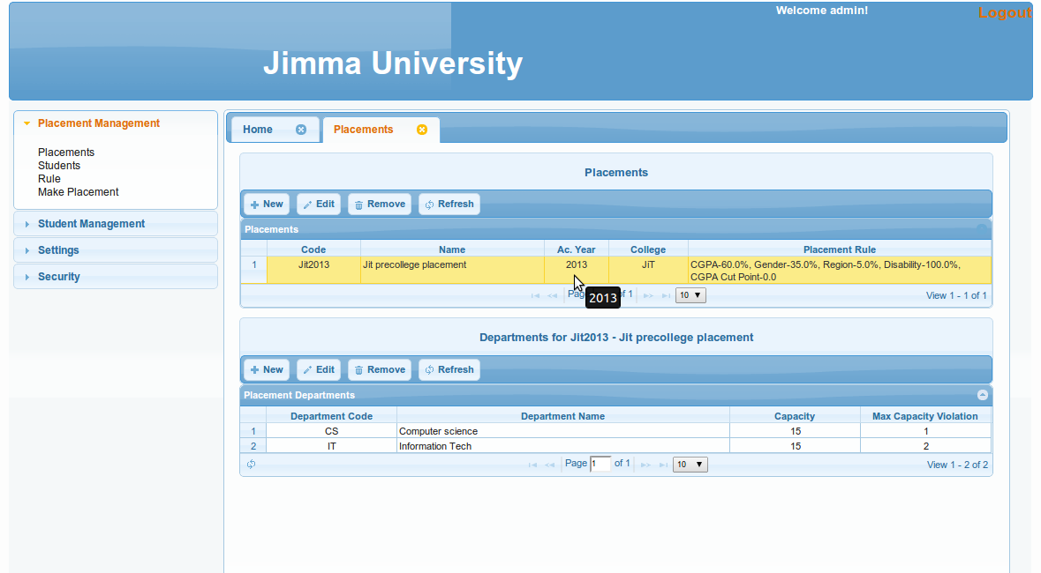

Rule
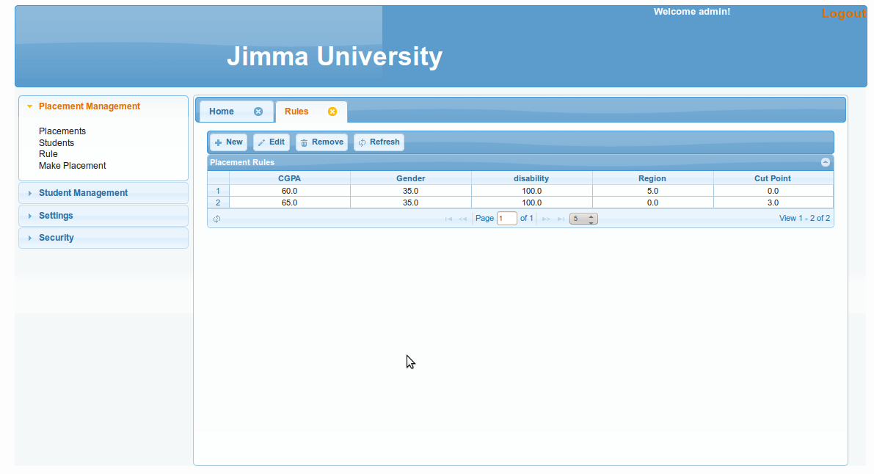

Students
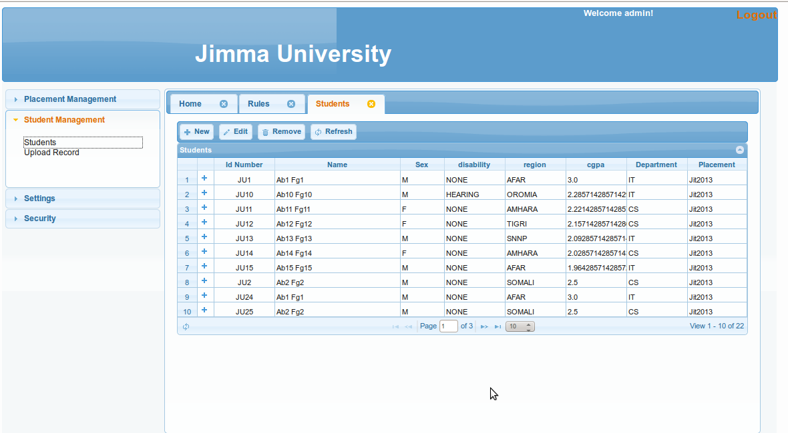

Upload students
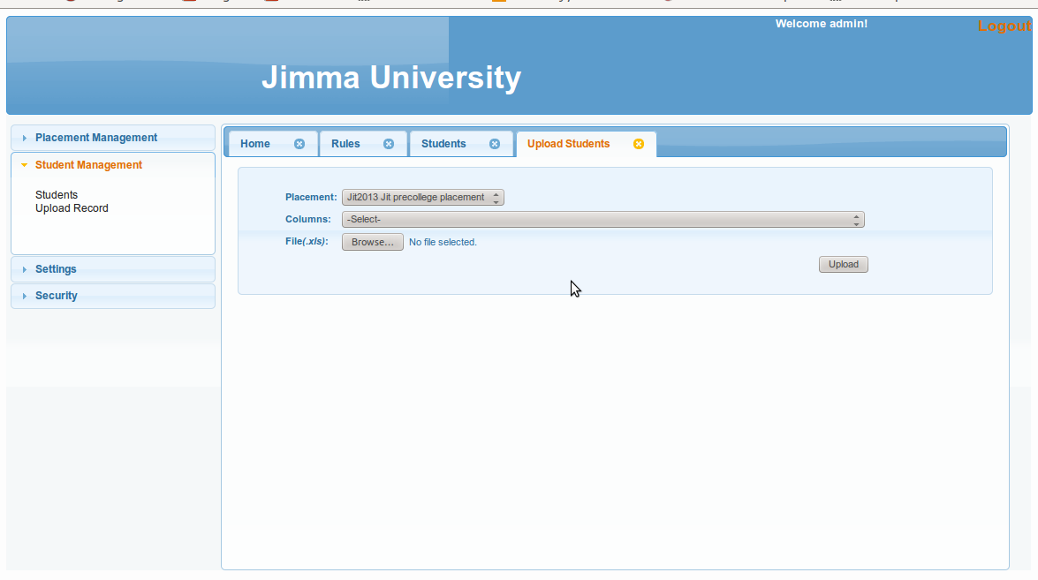

Colleges
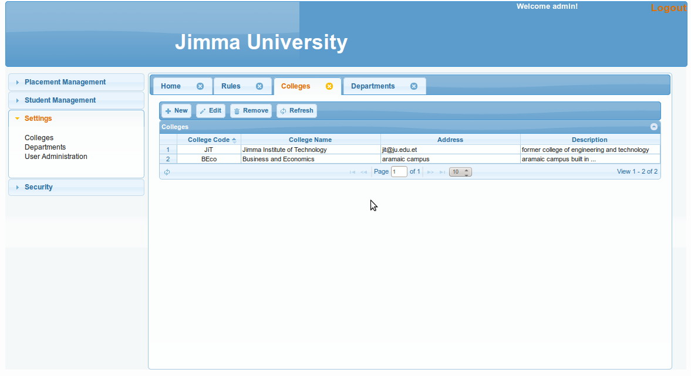

Departments
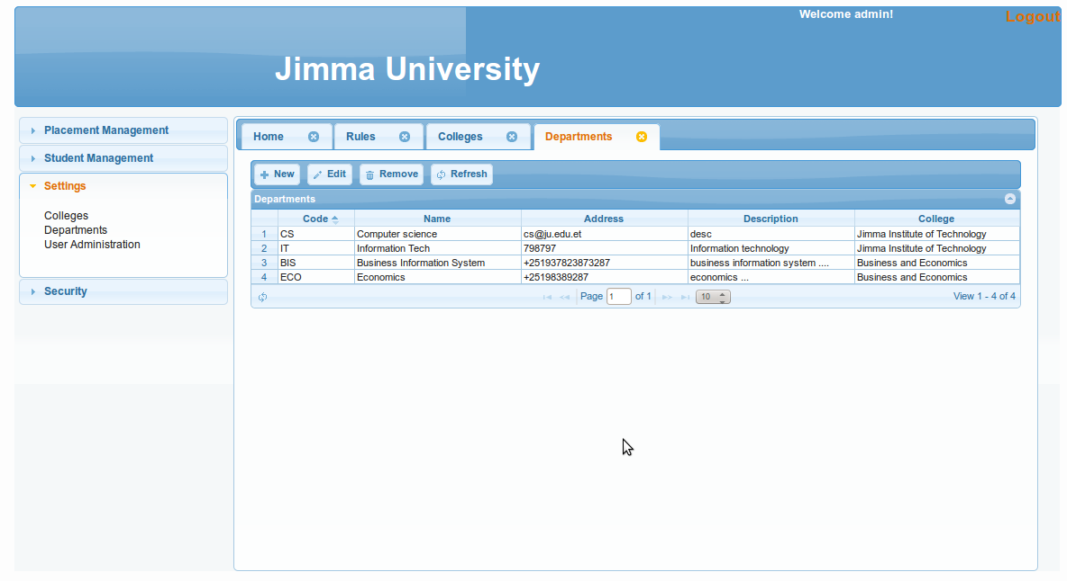

Make placement
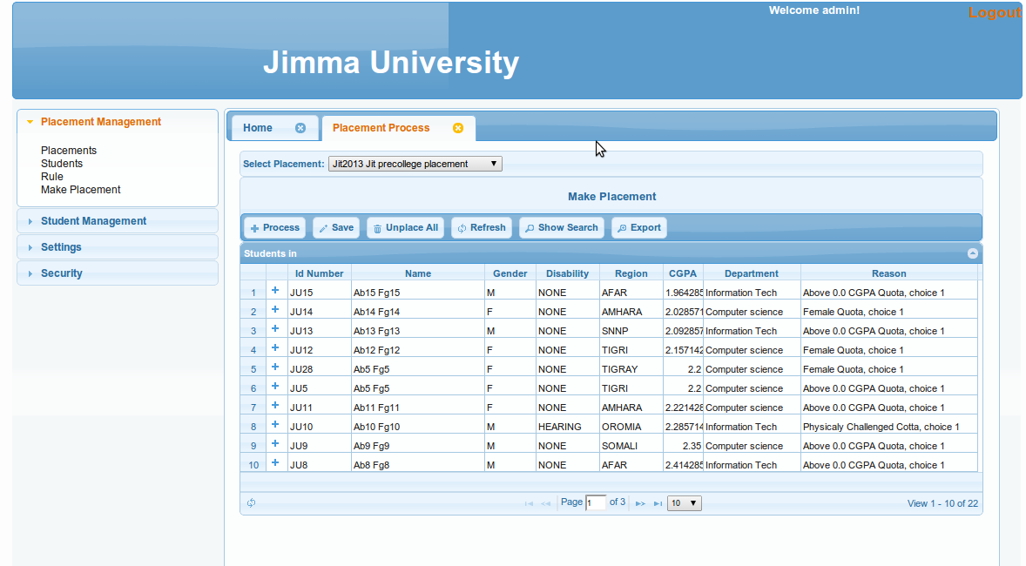

App Client

Placements

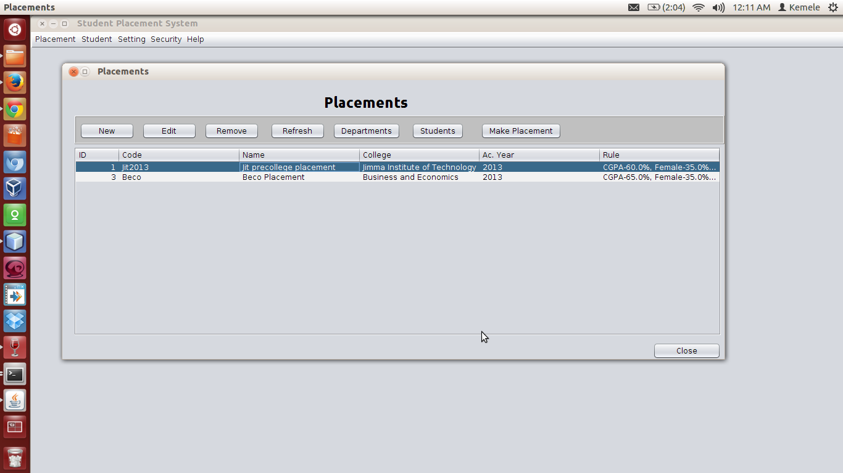

Placement Departments
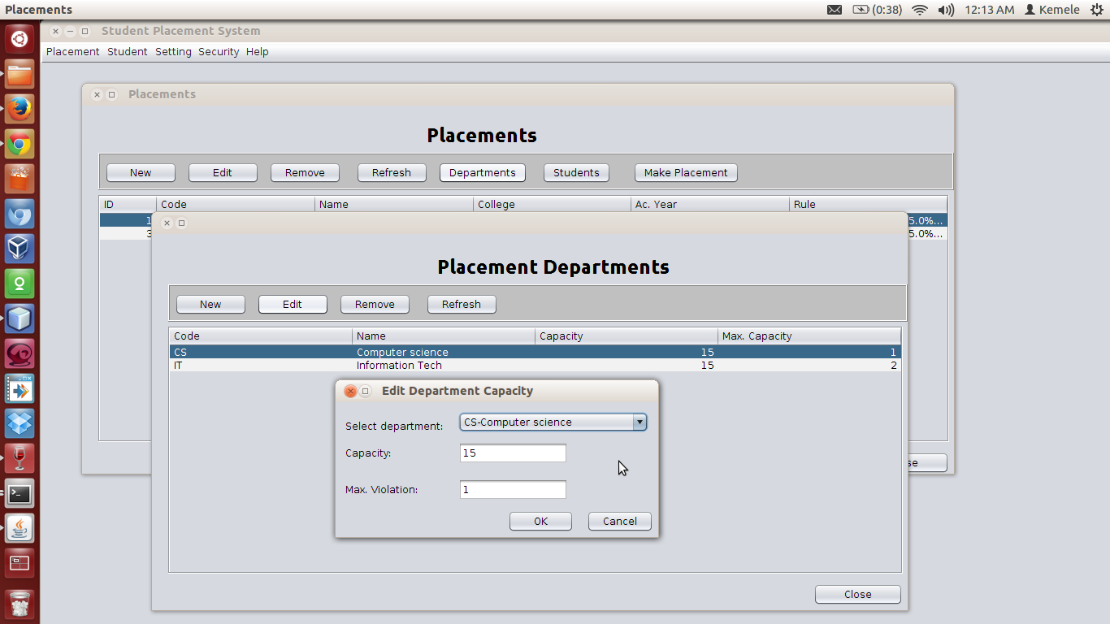

Make placement
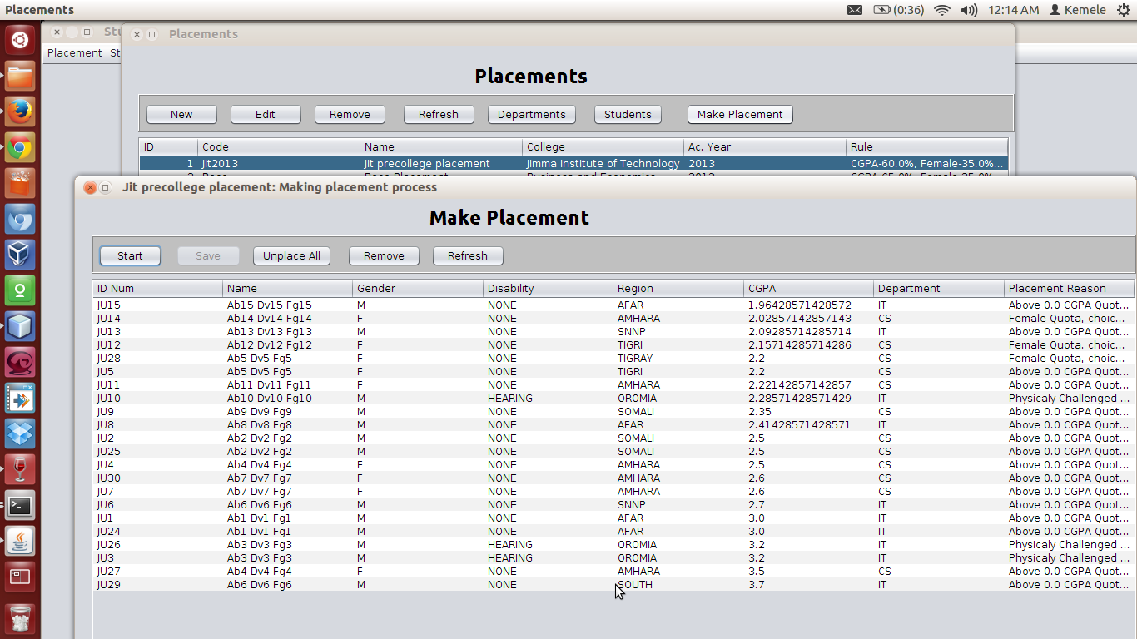

Placement Rules
