Aim 3 Behavior - No Change from Baseline

Kyle Emerson

3/3/2023

This RMarkdown will contain start to finish analysis of Behavioral Assay information compiled from the Stress and the Microbiota experiment (Aim 3). This is raw behavioral analysis at baseline and in response to the addition of sensory cues. It is updated to be more streamlined and easier to knit the output and be placed into my data notebook. Note: This is updated for Manuscript Writing and all analysis was done in RStudio

**Baseline Behavior**

## Warning: package 'readr' was built under R version 4.1.3

## Warning: package 'tidyr' was built under R version 4.1.3

## Warning: package 'dplyr' was built under R version 4.1.3

##   
## Attaching package: 'dplyr'

## The following objects are masked from 'package:stats':  
##   
## filter, lag

## The following objects are masked from 'package:base':  
##   
## intersect, setdiff, setequal, union

## Warning: package 'stringr' was built under R version 4.1.3

## Loading required package: ggplot2

## Warning: package 'ggplot2' was built under R version 4.1.3

## Loading required package: plyr

## Warning: package 'plyr' was built under R version 4.1.3

## ------------------------------------------------------------------------------

## You have loaded plyr after dplyr - this is likely to cause problems.  
## If you need functions from both plyr and dplyr, please load plyr first, then dplyr:  
## library(plyr); library(dplyr)

## ------------------------------------------------------------------------------

##   
## Attaching package: 'plyr'

## The following objects are masked from 'package:dplyr':  
##   
## arrange, count, desc, failwith, id, mutate, rename, summarise,  
## summarize

## Loading required package: scales

## Warning: package 'scales' was built under R version 4.1.3

##   
## Attaching package: 'scales'

## The following object is masked from 'package:readr':  
##   
## col_factor

## Loading required package: grid

## Warning: package 'moments' was built under R version 4.1.3

## Warning: package 'psych' was built under R version 4.1.3

##   
## Attaching package: 'psych'

## The following objects are masked from 'package:scales':  
##   
## alpha, rescale

## The following objects are masked from 'package:ggplot2':  
##   
## %+%, alpha

##   
## Attaching package: 'pastecs'

## The following objects are masked from 'package:dplyr':  
##   
## first, last

## The following object is masked from 'package:tidyr':  
##   
## extract

## Warning: package 'car' was built under R version 4.1.3

## Loading required package: carData

## Warning: package 'carData' was built under R version 4.1.3

##   
## Attaching package: 'car'

## The following object is masked from 'package:psych':  
##   
## logit

## The following object is masked from 'package:dplyr':  
##   
## recode

## Warning: package 'lme4' was built under R version 4.1.3

## Loading required package: Matrix

## Warning: package 'Matrix' was built under R version 4.1.3

##   
## Attaching package: 'Matrix'

## The following objects are masked from 'package:tidyr':  
##   
## expand, pack, unpack

## [1] "C:\\R\\Aim 3 - Stress and the Microbiota\\Behavior - No Change from Baseline.docx"

## Rows: 24 Columns: 25

## -- Column specification --------------------------------------------------------  
## Delimiter: ","  
## chr (6): ID, Stressor, Mobility Rate (%), Visibility Rate (%), Invisibilit...  
## dbl (16): Micro_Trtmt, Av. Speed (mm/s), Mob. Av. Speed (mm/s), Av. Accel (...  
## time (3): Visible Time (m:s), Invisible Time (m:s), Avg. Time Frozen (m:s)  
##   
## i Use `spec()` to retrieve the full column specification for this data.  
## i Specify the column types or set `show_col_types = FALSE` to quiet this message.

These above commands helped me remove percentage signs from columns and turn our time near cue in mm:ss into minutes

Consolodated into our DVs of interest

## Kaiser-Meyer-Olkin factor adequacy  
## Call: KMO(r = baseline.df)  
## Overall MSA = 0.72  
## MSA for each item =   
## Av. Speed (mm/s) Mob. Av. Speed (mm/s)   
## 0.70 0.69   
## Total Distance (mm) Av. Accel (mm/s^2)   
## 0.69 0.91   
## Mobility Rate (%) Exploration Rate (%)   
## 0.79 0.63   
## Base. Time in Center (min) Base. Tot. Time Frozen (min)   
## 0.20 0.67

Want Overall MSA > 0.5. Pass

## R was not square, finding R from data

## $chisq  
## [1] 384.1218  
##   
## $p.value  
## [1] 3.233764e-64  
##   
## $df  
## [1] 28

Pass again.

##   
## Factor analysis with Call: principal(r = baseline.df, nfactors = 2, rotate = "varimax")  
##   
## Test of the hypothesis that 2 factors are sufficient.  
## The degrees of freedom for the model is 13 and the objective function was 9.19   
## The number of observations was 24 with Chi Square = 166.91 with prob < 7.8e-29   
##   
## The root mean square of the residuals (RMSA) is 0.09

As of now, looking at 2 factors. But will confirm via Skree Plot

## Warning: `qplot()` was deprecated in ggplot2 3.4.0.  
## This warning is displayed once every 8 hours.  
## Call `lifecycle::last_lifecycle_warnings()` to see where this warning was  
## generated.

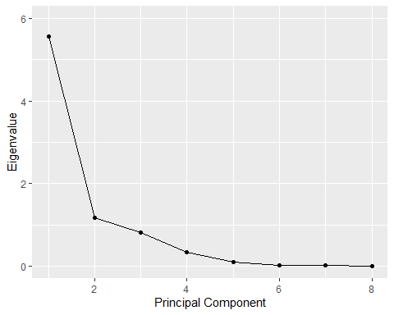 Skree Plot confirms 2 eigenvalues > 1, so we will have 2 PCs

## [1] 5.568638e+00 1.166666e+00 8.026930e-01 3.307831e-01 9.458092e-02  
## [6] 2.391135e-02 1.267105e-02 5.636624e-05

These are our eigenvalues.

## RC1 RC2  
## [1,] 1.36649557 -0.12270816  
## [2,] 1.36262627 0.13634991  
## [3,] -1.02305519 -0.83278203  
## [4,] 0.74878112 0.62313037  
## [5,] 2.96869248 -0.57994500  
## [6,] 0.76875096 0.06452494  
## [7,] -0.49972468 -0.57570528  
## [8,] -0.66761355 -1.72736550  
## [9,] -0.18668701 0.46549563  
## [10,] -1.11967859 -1.32464653  
## [11,] 0.09663086 0.29200759  
## [12,] -1.29903912 -1.20337945  
## [13,] -0.45991966 0.32750563  
## [14,] 0.41717202 0.35996298  
## [15,] -1.05110366 1.77362713  
## [16,] -0.92329748 -0.75569051  
## [17,] -0.24842519 -0.18775699  
## [18,] -0.48606808 -0.20304390  
## [19,] 0.73959885 -0.26970863  
## [20,] -0.50448155 1.77839253  
## [21,] 0.32229198 -0.36665944  
## [22,] -0.56905371 0.36002359  
## [23,] 0.70799361 -0.63710800  
## [24,] -0.46088625 2.60547913

These are our PC numerical values, or our factor scores. These values are our distilled PCs that we will run stats on.

Now, have our final working data frame that includes our variables of interest, our PC values, our Tadpole ID’s and their microbial treatments (1 = Natural, 2 = Autoclaved) and Stressor Treatments (A = Predator Cue, B = Vehicle, C = CORT). The below command was used to add factor scores to a CSV file that we can access without having to run through the PCA pipeline.

#write.table(df, file = “Aim3baselinefactorscores.csv”, sep = “,”)

##   
## Loadings:  
## RC1 RC2   
## Av. Speed (mm/s) 0.984   
## Mob. Av. Speed (mm/s) 0.780 0.358  
## Total Distance (mm) 0.983   
## Av. Accel (mm/s^2) 0.955   
## Mobility Rate (%) 0.947   
## Exploration Rate (%) 0.718 0.552  
## Base. Time in Center (min) -0.145 0.842  
## Base. Tot. Time Frozen (min) -0.812 0.199  
##   
## RC1 RC2  
## SS loadings 5.549 1.186  
## Proportion Var 0.694 0.148  
## Cumulative Var 0.694 0.842

These are our loadings. Anyting approx. greater than 0.7 will be loaded onto a PC. Sign denotes the positive or negative relationship.

PC1: Av Speed, Mob Av Speed, Total Distance, Av Accel, Mob Rate, Exp. Rate, -Total time Frozen PC2: Time in Center

SS loadings = Eigenvalues Prop Variance = % of data spread represented by that PC

## Df Sum Sq Mean Sq F value Pr(>F)  
## Micro_Trtmt 1 1.055 1.0552 1.105 0.307  
## Stressor 2 1.346 0.6732 0.705 0.507  
## Micro_Trtmt:Stressor 2 3.409 1.7047 1.785 0.196  
## Residuals 18 17.189 0.9549

No significance.

## NOTE: Results may be misleading due to involvement in interactions

## $`emmeans of Stressor`  
## Stressor emmean SE df lower.CL upper.CL  
## A 0.0547 0.345 18 -0.671 0.781  
## B 0.2588 0.345 18 -0.467 0.985  
## C -0.3136 0.345 18 -1.039 0.412  
##   
## Results are averaged over the levels of: Micro_Trtmt   
## Confidence level used: 0.95   
##   
## $`pairwise differences of Stressor`  
## 1 estimate SE df t.ratio p.value  
## A - B -0.204 0.489 18 -0.418 0.9088  
## A - C 0.368 0.489 18 0.754 0.7353  
## B - C 0.572 0.489 18 1.171 0.4846  
##   
## Results are averaged over the levels of: Micro_Trtmt   
## P value adjustment: tukey method for comparing a family of 3 estimates

N.S. pairwise

## Df Sum Sq Mean Sq F value Pr(>F)   
## Micro_Trtmt 1 3.816 3.816 3.770 0.068 .  
## Stressor 2 0.651 0.325 0.322 0.729   
## Micro_Trtmt:Stressor 2 0.314 0.157 0.155 0.857   
## Residuals 18 18.219 1.012   
## ---  
## Signif. codes: 0 '***' 0.001 '**' 0.01 '*' 0.05 '.' 0.1 ' ' 1

Close, but no significance.

Below, PC1 Boxplot

## NOTE: Results may be misleading due to involvement in interactions

## $`emmeans of Stressor`  
## Stressor emmean SE df lower.CL upper.CL  
## A 0.1887 0.356 18 -0.559 0.936  
## B -0.2126 0.356 18 -0.960 0.535  
## C 0.0239 0.356 18 -0.723 0.771  
##   
## Results are averaged over the levels of: Micro_Trtmt   
## Confidence level used: 0.95   
##   
## $`pairwise differences of Stressor`  
## 1 estimate SE df t.ratio p.value  
## A - B 0.401 0.503 18 0.798 0.7092  
## A - C 0.165 0.503 18 0.328 0.9428  
## B - C -0.236 0.503 18 -0.470 0.8861  
##   
## Results are averaged over the levels of: Micro_Trtmt   
## P value adjustment: tukey method for comparing a family of 3 estimates

N.S.

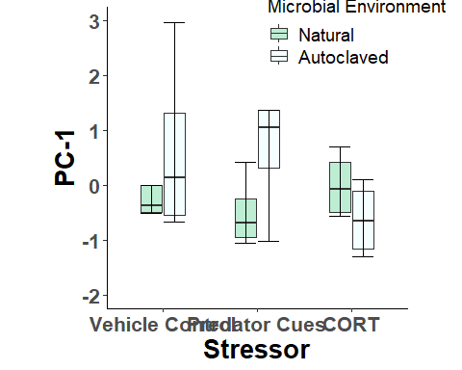 PC1 Boxplot

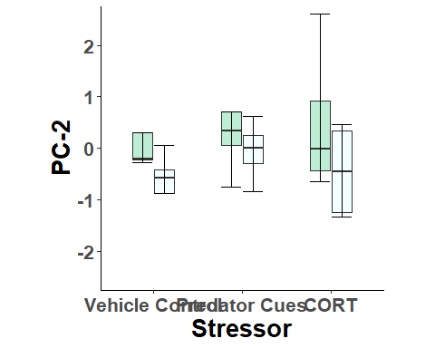 PC2 Boxplot.

None significant. Figures for all DVs can be found in Baseline Behavior.R script in the Aim 3 folder, but for now we are going to continue on. NOTE: For Visual Empty, Visual Food, and Olfactory, some of the future data frames are going to be named similarly to ones used in Baseline Behavior. It is imperative you clear your environment now when running this code! *Clear Environment*

**Visual Empty - Empty Glass Jar**

## [1] "C:\\R\\Aim 3 - Stress and the Microbiota\\Behavior - No Change from Baseline.docx"

## Rows: 24 Columns: 26  
## -- Column specification --------------------------------------------------------  
## Delimiter: ","  
## chr (6): ID, Stressor, Mobility Rate (%), Visibility Rate (%), Invisibilit...  
## dbl (16): Micro_Trtmt, Av. Speed (mm/s), Mob. Av. Speed (mm/s), Av. Accel (...  
## time (4): Visible Time (m:s), Invisible Time (m:s), Avg. Time Frozen (m:s),...  
##   
## i Use `spec()` to retrieve the full column specification for this data.  
## i Specify the column types or set `show_col_types = FALSE` to quiet this message.

## Kaiser-Meyer-Olkin factor adequacy  
## Call: KMO(r = visempty.df)  
## Overall MSA = 0.75  
## MSA for each item =   
## Av. Speed (mm/s) Mob. Av. Speed (mm/s) Total Distance (mm)   
## 0.72 0.87 0.72   
## Av. Accel (mm/s^2) Mobility Rate (%) Exploration Rate (%)   
## 0.84 0.77 0.68   
## Time in Center (min) Tot. Time Frozen (min) Time near cue (m:s)   
## 0.72 0.80 0.07

Pass.

## R was not square, finding R from data

## $chisq  
## [1] 422.6518  
##   
## $p.value  
## [1] 1.704845e-67  
##   
## $df  
## [1] 36

Pass.

##   
## Factor analysis with Call: principal(r = visempty.df, nfactors = 3, rotate = "varimax")  
##   
## Test of the hypothesis that 3 factors are sufficient.  
## The degrees of freedom for the model is 12 and the objective function was 8.87   
## The number of observations was 24 with Chi Square = 152.26 with prob < 2e-26   
##   
## The root mean square of the residuals (RMSA) is 0.05

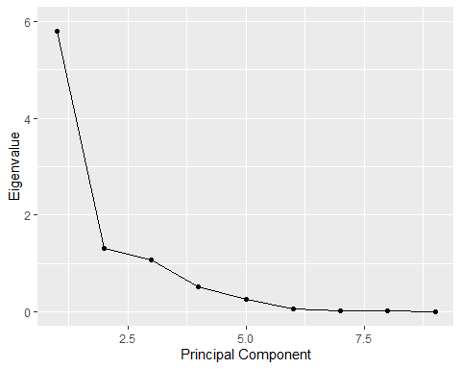 Confirms use of 3 PCs.

## [1] 5.792263e+00 1.301211e+00 1.071926e+00 5.106563e-01 2.492525e-01  
## [6] 5.264426e-02 1.214419e-02 9.862252e-03 4.086721e-05

Eigenvalues.

## RC1 RC2 RC3  
## [1,] 1.32318755 0.25525170 -0.01044035  
## [2,] 2.13849999 0.12360006 -0.29207426  
## [3,] -0.54781633 0.57962968 0.53730555  
## [4,] -0.27865271 0.35126690 0.92353460  
## [5,] 2.35150352 -0.09567919 0.88773702  
## [6,] 0.32694145 0.44405346 -0.27096067  
## [7,] -0.53972863 0.22135031 0.30194837  
## [8,] -1.04632709 0.34562758 -0.86809445  
## [9,] -0.33522783 -0.15232790 -0.33895331  
## [10,] -0.36729167 0.67299819 1.21403879  
## [11,] 0.88210261 0.42084998 0.14876124  
## [12,] -0.41127807 0.53524409 -1.24622113  
## [13,] -0.84927055 0.68809417 1.23582991  
## [14,] 1.77612549 -0.36681840 -1.82299352  
## [15,] -0.94333560 -0.16661285 0.91348326  
## [16,] -1.17519778 0.77522690 -1.14486926  
## [17,] -0.59301048 -2.74139817 -1.51704094  
## [18,] -0.25479673 0.29033724 -0.81165255  
## [19,] -0.90785724 -0.12002680 -1.47655209  
## [20,] 0.20757385 0.14510051 0.73171757  
## [21,] -0.70124132 0.44557001 0.70680763  
## [22,] -0.26885290 -3.42962713 1.66805836  
## [23,] -0.07121396 0.31787603 -0.37044750  
## [24,] 0.28516441 0.46041366 0.90107774

Factor scores.

Now, have our final working data frame that includes our variables of interest, our PC values, our Tadpole ID’s and their microbial treatments (1 = Natural, 2 = Autoclaved) and Stressor Treatments (A = Predator Cue, B = Vehicle, C = CORT). The below command was used to add factor scores to a CSV file that we can access without having to run through the PCA pipeline.

#write.table(df, file = “Aim3visualemptynochangefactorscores.csv”, sep = “,”)

##   
## Loadings:  
## RC1 RC2 RC3   
## Av. Speed (mm/s) 0.977 0.167   
## Mob. Av. Speed (mm/s) 0.748 0.391 -0.257  
## Total Distance (mm) 0.978 0.165   
## Av. Accel (mm/s^2) 0.965 0.125 -0.109  
## Mobility Rate (%) 0.915 0.268   
## Exploration Rate (%) 0.322 0.861 0.130  
## Time in Center (min) -0.135 -0.926 0.102  
## Tot. Time Frozen (min) -0.882 -0.208 -0.182  
## Time near cue (m:s) 0.964  
##   
## RC1 RC2 RC3  
## SS loadings 5.141 1.938 1.086  
## Proportion Var 0.571 0.215 0.121  
## Cumulative Var 0.571 0.787 0.907

These are our loadings. Anyting approx. greater than 0.7 will be loaded onto a PC. Sign denotes the positive or negative relationship.

PC1: Av Speed, Mob Av Speed, Total Distance, Av Accel, Mob Rate, -Total time Frozen PC2: Exp Rate, -Time in Center PC3: Time Near Cue

## Df Sum Sq Mean Sq F value Pr(>F)  
## Micro_Trtmt 1 2.037 2.0369 1.847 0.191  
## Stressor 2 0.408 0.2042 0.185 0.833  
## Micro_Trtmt:Stressor 2 0.700 0.3498 0.317 0.732  
## Residuals 18 19.855 1.1031

No significance.

## NOTE: Results may be misleading due to involvement in interactions

## $`emmeans of Stressor`  
## Stressor emmean SE df lower.CL upper.CL  
## A 0.180 0.371 18 -0.600 0.961  
## B -0.057 0.371 18 -0.837 0.723  
## C -0.123 0.371 18 -0.904 0.657  
##   
## Results are averaged over the levels of: Micro_Trtmt   
## Confidence level used: 0.95   
##   
## $`pairwise differences of Stressor`  
## 1 estimate SE df t.ratio p.value  
## A - B 0.2374 0.525 18 0.452 0.8941  
## A - C 0.3039 0.525 18 0.579 0.8330  
## B - C 0.0665 0.525 18 0.127 0.9912  
##   
## Results are averaged over the levels of: Micro_Trtmt   
## P value adjustment: tukey method for comparing a family of 3 estimates

N.S.

## Df Sum Sq Mean Sq F value Pr(>F)  
## Micro_Trtmt 1 2.284 2.2840 2.174 0.158  
## Stressor 2 0.979 0.4893 0.466 0.635  
## Micro_Trtmt:Stressor 2 0.825 0.4124 0.392 0.681  
## Residuals 18 18.913 1.0507

No significance.

## NOTE: Results may be misleading due to involvement in interactions

## $`emmeans of Stressor`  
## Stressor emmean SE df lower.CL upper.CL  
## A 0.2800 0.362 18 -0.481 1.041  
## B -0.1888 0.362 18 -0.950 0.573  
## C -0.0911 0.362 18 -0.853 0.670  
##   
## Results are averaged over the levels of: Micro_Trtmt   
## Confidence level used: 0.95   
##   
## $`pairwise differences of Stressor`  
## 1 estimate SE df t.ratio p.value  
## A - B 0.4688 0.513 18 0.915 0.6383  
## A - C 0.3711 0.513 18 0.724 0.7527  
## B - C -0.0977 0.513 18 -0.191 0.9802  
##   
## Results are averaged over the levels of: Micro_Trtmt   
## P value adjustment: tukey method for comparing a family of 3 estimates

N.S.

## Df Sum Sq Mean Sq F value Pr(>F)  
## Micro_Trtmt 1 0.162 0.1622 0.162 0.692  
## Stressor 2 2.057 1.0283 1.028 0.378  
## Micro_Trtmt:Stressor 2 2.769 1.3846 1.384 0.276  
## Residuals 18 18.012 1.0007

No significance.

## NOTE: Results may be misleading due to involvement in interactions

## $`emmeans of Stressor`  
## Stressor emmean SE df lower.CL upper.CL  
## A 0.0425 0.354 18 -0.701 0.786  
## B -0.3779 0.354 18 -1.121 0.365  
## C 0.3354 0.354 18 -0.408 1.078  
##   
## Results are averaged over the levels of: Micro_Trtmt   
## Confidence level used: 0.95   
##   
## $`pairwise differences of Stressor`  
## 1 estimate SE df t.ratio p.value  
## A - B 0.420 0.5 18 0.840 0.6834  
## A - C -0.293 0.5 18 -0.586 0.8295  
## B - C -0.713 0.5 18 -1.426 0.3491  
##   
## Results are averaged over the levels of: Micro_Trtmt   
## P value adjustment: tukey method for comparing a family of 3 estimates

N.S.

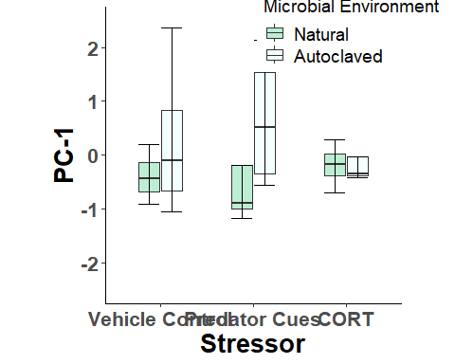 PC1. 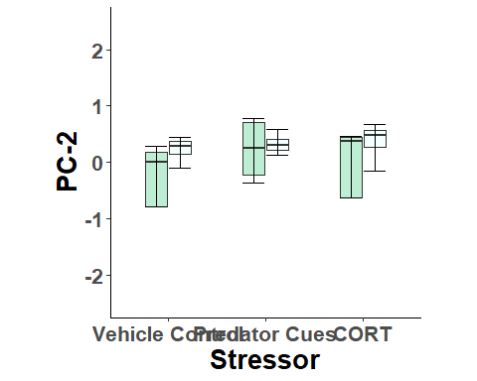 PC2 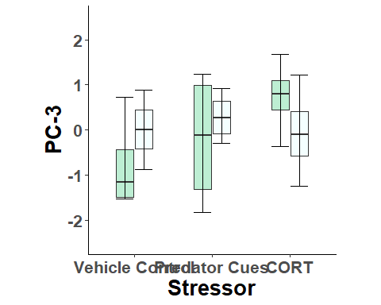 Visual Behavior in response to an empty glass jar was not effected by either microbial environment or stressor treatment.

*Clear Environment*

**Visual Food Behavior - Glass Jar filled with Primary Diet**

## Rows: 24 Columns: 26  
## -- Column specification --------------------------------------------------------  
## Delimiter: ","  
## chr (6): ID, Stressor, Mobility Rate (%), Visibility Rate (%), Invisibilit...  
## dbl (16): Micro_Trtmt, Av. Speed (mm/s), Mob. Av. Speed (mm/s), Av. Accel (...  
## time (4): Visible Time (m:s), Invisible Time (m:s), Avg. Time Frozen (m:s),...  
##   
## i Use `spec()` to retrieve the full column specification for this data.  
## i Specify the column types or set `show_col_types = FALSE` to quiet this message.

## Kaiser-Meyer-Olkin factor adequacy  
## Call: KMO(r = visfood.df)  
## Overall MSA = 0.72  
## MSA for each item =   
## Av. Speed (mm/s) Mob. Av. Speed (mm/s) Total Distance (mm)   
## 0.72 0.71 0.71   
## Av. Accel (mm/s^2) Mobility Rate (%) Exploration Rate (%)   
## 0.94 0.85 0.55   
## Time in Center (min) Tot. Time Frozen (min) Time near cue (m:s)   
## 0.12 0.77 0.16

Pass.

## R was not square, finding R from data

## $chisq  
## [1] 391.443  
##   
## $p.value  
## [1] 2.787735e-61  
##   
## $df  
## [1] 36

Pass.

##   
## Factor analysis with Call: principal(r = visfood.df, nfactors = 3, rotate = "varimax")  
##   
## Test of the hypothesis that 3 factors are sufficient.  
## The degrees of freedom for the model is 12 and the objective function was 8.16   
## The number of observations was 24 with Chi Square = 140.13 with prob < 5.6e-24   
##   
## The root mean square of the residuals (RMSA) is 0.06

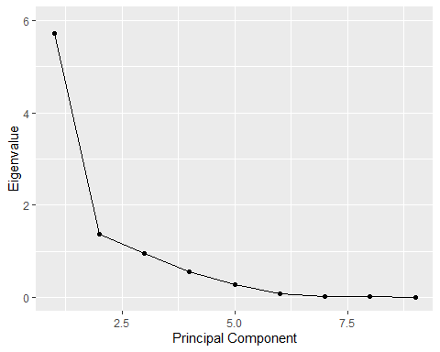 Skree Plot confirms 3 PCs.

## [1] 5.725137e+00 1.376604e+00 9.593685e-01 5.552892e-01 2.792617e-01  
## [6] 6.764019e-02 2.302200e-02 1.362319e-02 5.427711e-05

Eigenvalues.

## RC1 RC2 RC3  
## [1,] 2.060053942 -0.68867461 -0.38225744  
## [2,] 1.584652942 0.34864659 0.07496988  
## [3,] 0.761101870 0.11428248 -0.15113244  
## [4,] 0.166437622 0.97148849 -0.72377308  
## [5,] 2.117927282 0.32247011 0.20141223  
## [6,] -0.007537508 -0.03319348 0.43131636  
## [7,] -0.108887935 1.54821757 -0.88010383  
## [8,] -0.863123477 -0.35620024 -0.65643166  
## [9,] -0.769731213 0.01939658 1.88899775  
## [10,] -0.356949942 -0.74423273 0.66578514  
## [11,] 0.008159838 0.66814726 -0.78403213  
## [12,] -0.735499513 1.15488079 1.69231418  
## [13,] -0.893181052 0.17208036 2.63967856  
## [14,] 1.059914636 -0.43592718 -0.71482167  
## [15,] -0.458299574 -1.34398009 -0.52947434  
## [16,] -0.595433625 0.72847006 -0.79718408  
## [17,] -1.586801395 -2.64540015 -0.91307612  
## [18,] -0.063398333 0.51955506 0.62220883  
## [19,] 0.848433924 -1.12257710 1.04107962  
## [20,] -0.870317611 1.85469435 -0.96133696  
## [21,] -0.965875018 0.49453916 -0.88126049  
## [22,] -1.165348610 -0.27988918 -0.98323771  
## [23,] 0.342238488 0.01232455 0.11047087  
## [24,] 0.491464261 -1.27911864 -0.01011146

PC factor scores.

Now, have our final working data frame that includes our variables of interest, our PC values, our Tadpole ID’s and their microbial treatments (1 = Natural, 2 = Autoclaved) and Stressor Treatments (A = Predator Cue, B = Vehicle, C = CORT). The below command was used to add factor scores to a CSV file that we can access without having to run through the PCA pipeline.

#write.table(df, file = “Aim3visualfoodnochangefactorscores.csv”, sep = “,”)

##   
## Loadings:  
## RC1 RC2 RC3   
## Av. Speed (mm/s) 0.987   
## Mob. Av. Speed (mm/s) 0.758 0.340   
## Total Distance (mm) 0.987   
## Av. Accel (mm/s^2) 0.972   
## Mobility Rate (%) 0.955   
## Exploration Rate (%) 0.604 0.638 0.247  
## Time in Center (min) 0.989  
## Tot. Time Frozen (min) -0.930   
## Time near cue (m:s) 0.924   
##   
## RC1 RC2 RC3  
## SS loadings 5.623 1.385 1.053  
## Proportion Var 0.625 0.154 0.117  
## Cumulative Var 0.625 0.779 0.896

These are our loadings. Anyting approx. greater than 0.7 will be loaded onto a PC. Sign denotes the positive or negative relationship.

PC1: Av Speed, Mob Av Speed, Total Distance, Av Accel, Mob Rate, -Total time Frozen PC2: Exp Rate, Time near Cue PC3: Time in Center

## Df Sum Sq Mean Sq F value Pr(>F)  
## Micro_Trtmt 1 2.479 2.4789 2.921 0.105  
## Stressor 2 2.975 1.4874 1.753 0.202  
## Micro_Trtmt:Stressor 2 2.273 1.1363 1.339 0.287  
## Residuals 18 15.274 0.8485

No significance.

## NOTE: Results may be misleading due to involvement in interactions

## $`emmeans of Stressor`  
## Stressor emmean SE df lower.CL upper.CL  
## A 0.4607 0.326 18 -0.224 1.145  
## B -0.0667 0.326 18 -0.751 0.618  
## C -0.3939 0.326 18 -1.078 0.290  
##   
## Results are averaged over the levels of: Micro_Trtmt   
## Confidence level used: 0.95   
##   
## $`pairwise differences of Stressor`  
## 1 estimate SE df t.ratio p.value  
## A - B 0.527 0.461 18 1.145 0.4999  
## A - C 0.855 0.461 18 1.855 0.1805  
## B - C 0.327 0.461 18 0.710 0.7605  
##   
## Results are averaged over the levels of: Micro_Trtmt   
## P value adjustment: tukey method for comparing a family of 3 estimates

N.S.

## Df Sum Sq Mean Sq F value Pr(>F)  
## Micro_Trtmt 1 1.843 1.8429 1.575 0.225  
## Stressor 2 0.003 0.0017 0.001 0.999  
## Micro_Trtmt:Stressor 2 0.098 0.0492 0.042 0.959  
## Residuals 18 21.055 1.1697

No significance.

## NOTE: Results may be misleading due to involvement in interactions

## $`emmeans of Stressor`  
## Stressor emmean SE df lower.CL upper.CL  
## A -0.01670 0.382 18 -0.820 0.787  
## B 0.01095 0.382 18 -0.792 0.814  
## C 0.00576 0.382 18 -0.798 0.809  
##   
## Results are averaged over the levels of: Micro_Trtmt   
## Confidence level used: 0.95   
##   
## $`pairwise differences of Stressor`  
## 1 estimate SE df t.ratio p.value  
## A - B -0.02765 0.541 18 -0.051 0.9986  
## A - C -0.02246 0.541 18 -0.042 0.9990  
## B - C 0.00519 0.541 18 0.010 0.9999  
##   
## Results are averaged over the levels of: Micro_Trtmt   
## P value adjustment: tukey method for comparing a family of 3 estimates

N.S.

## Df Sum Sq Mean Sq F value Pr(>F)  
## Micro_Trtmt 1 0.316 0.3161 0.306 0.587  
## Stressor 2 0.559 0.2794 0.271 0.766  
## Micro_Trtmt:Stressor 2 3.556 1.7778 1.723 0.207  
## Residuals 18 18.570 1.0316

No significance.

## NOTE: Results may be misleading due to involvement in interactions

## $`emmeans of Stressor`  
## Stressor emmean SE df lower.CL upper.CL  
## A -0.073 0.359 18 -0.827 0.681  
## B -0.139 0.359 18 -0.894 0.615  
## C 0.212 0.359 18 -0.542 0.967  
##   
## Results are averaged over the levels of: Micro_Trtmt   
## Confidence level used: 0.95   
##   
## $`pairwise differences of Stressor`  
## 1 estimate SE df t.ratio p.value  
## A - B 0.0664 0.508 18 0.131 0.9906  
## A - C -0.2854 0.508 18 -0.562 0.8417  
## B - C -0.3517 0.508 18 -0.693 0.7708  
##   
## Results are averaged over the levels of: Micro_Trtmt   
## P value adjustment: tukey method for comparing a family of 3 estimates

N.S.

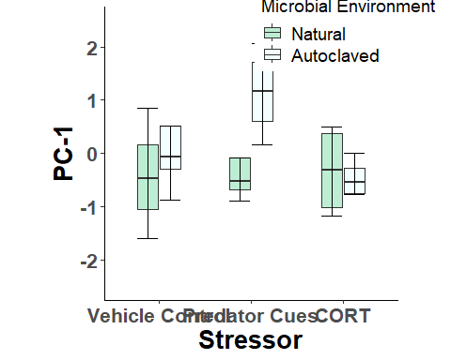 PC1. 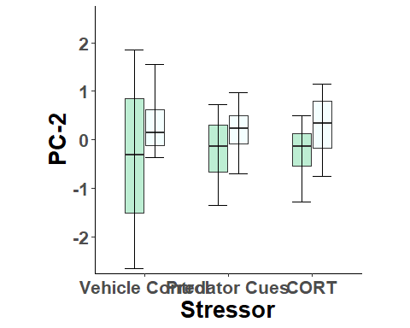 PC2 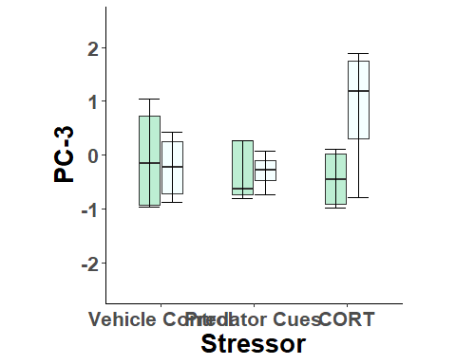 No significance.

Visual Behavior in response to a glass jar filled with the tadpole primary diet was not effected by either microbial environment or stressor treatment.

*Clear Environment*

**Olfactory Behavior - Addition of conspecific tadpole alarm cues**

## [1] "C:\\R\\Aim 3 - Stress and the Microbiota\\Behavior - No Change from Baseline.docx"

## Rows: 24 Columns: 26  
## -- Column specification --------------------------------------------------------  
## Delimiter: ","  
## chr (6): ID, Stressor, Mobility Rate (%), Visibility Rate (%), Invisibilit...  
## dbl (16): Micro_Trtmt, Av. Speed (mm/s), Mob. Av. Speed (mm/s), Av. Accel (...  
## time (4): Visible Time (m:s), Invisible Time (m:s), Avg. Time Frozen (m:s),...  
##   
## i Use `spec()` to retrieve the full column specification for this data.  
## i Specify the column types or set `show_col_types = FALSE` to quiet this message.

## Kaiser-Meyer-Olkin factor adequacy  
## Call: KMO(r = olfactory.df)  
## Overall MSA = 0.69  
## MSA for each item =   
## Av. Speed (mm/s) Mob. Av. Speed (mm/s) Total Distance (mm)   
## 0.72 0.58 0.72   
## Av. Accel (mm/s^2) Mobility Rate (%) Exploration Rate (%)   
## 0.86 0.70 0.63   
## Time in Center (min) Tot. Time Frozen (min) Time near cue (m:s)   
## 0.26 0.63 0.37

Pass.

## R was not square, finding R from data

## $chisq  
## [1] 394.4708  
##   
## $p.value  
## [1] 6.987827e-62  
##   
## $df  
## [1] 36

Pass.

##   
## Factor analysis with Call: principal(r = olfactory.df, nfactors = 2, rotate = "varimax")  
##   
## Test of the hypothesis that 2 factors are sufficient.  
## The degrees of freedom for the model is 19 and the objective function was 10.81   
## The number of observations was 24 with Chi Square = 192.74 with prob < 9.4e-31   
##   
## The root mean square of the residuals (RMSA) is 0.11

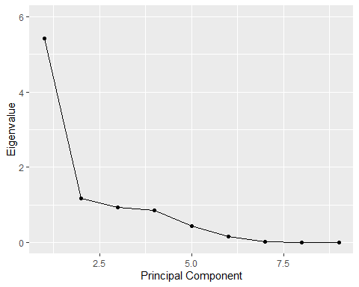 Skree looks like could be 2 or 3. I will move forward with 2.

## [1] 5.421581e+00 1.170472e+00 9.396132e-01 8.599091e-01 4.372283e-01  
## [6] 1.482083e-01 1.962985e-02 3.304768e-03 5.348356e-05

Eigenvalues.

## RC1 RC2  
## [1,] 2.39332271 0.689880442  
## [2,] 0.21008511 -0.424309842  
## [3,] -0.16601994 1.311391248  
## [4,] 1.01799450 0.907978052  
## [5,] 2.21964057 0.614569212  
## [6,] 0.29796280 -1.306522455  
## [7,] 0.13653946 -0.552930418  
## [8,] 0.85495446 0.051119782  
## [9,] 0.14708022 -3.006681225  
## [10,] 0.19629241 -0.006587276  
## [11,] 0.28738332 0.249107376  
## [12,] -0.77147439 0.785119292  
## [13,] -0.58808740 -2.054259223  
## [14,] 0.73027565 -0.127138423  
## [15,] -0.17969035 0.271198881  
## [16,] -0.09164815 0.587384162  
## [17,] -1.63647567 0.247204065  
## [18,] -0.36522875 0.028301502  
## [19,] -0.05981081 -0.119850072  
## [20,] -1.58267341 0.179198603  
## [21,] -0.18873954 0.282334158  
## [22,] -0.80465965 -0.054897260  
## [23,] -1.58636793 1.671144532  
## [24,] -0.47065522 -0.222755115

PC factor scores.

Now, have our final working data frame that includes our variables of interest, our PC values, our Tadpole ID’s and their microbial treatments (1 = Natural, 2 = Autoclaved) and Stressor Treatments (A = Predator Cue, B = Vehicle, C = CORT). The below command was used to add factor scores to a CSV file that we can access without having to run through the PCA pipeline.

#write.table(df, file = “Aim3olfactorynochangefactorscores.csv”, sep = “,”)

##   
## Loadings:  
## RC1 RC2   
## Av. Speed (mm/s) 0.958 0.192  
## Mob. Av. Speed (mm/s) 0.692   
## Total Distance (mm) 0.960 0.197  
## Av. Accel (mm/s^2) 0.949 0.181  
## Mobility Rate (%) 0.918 0.187  
## Exploration Rate (%) 0.745 -0.231  
## Time in Center (min) -0.834  
## Tot. Time Frozen (min) -0.805 -0.166  
## Time near cue (m:s) 0.194 0.602  
##   
## RC1 RC2  
## SS loadings 5.306 1.286  
## Proportion Var 0.590 0.143  
## Cumulative Var 0.590 0.732

These are our loadings. Anyting approx. greater than 0.7 will be loaded onto a PC. Sign denotes the positive or negative relationship.

PC1: Av Speed, Mob Av Speed, Total Distance, Av Accel, Mob Rate, Exp Rate, -Total time Frozen PC2: Time near Cue, -Time in Center

## Df Sum Sq Mean Sq F value Pr(>F)   
## Micro_Trtmt 1 7.761 7.761 12.383 0.00245 **  
## Stressor 2 2.658 1.329 2.121 0.14894   
## Micro_Trtmt:Stressor 2 1.300 0.650 1.037 0.37472   
## Residuals 18 11.281 0.627   
## ---  
## Signif. codes: 0 '***' 0.001 '**' 0.01 '*' 0.05 '.' 0.1 ' ' 1

Significant effect of Microbial Environment on PC1!

## NOTE: Results may be misleading due to involvement in interactions

## $`emmeans of Stressor`  
## Stressor emmean SE df lower.CL upper.CL  
## A 0.4158 0.28 18 -0.172 1.004  
## B -0.0169 0.28 18 -0.605 0.571  
## C -0.3989 0.28 18 -0.987 0.189  
##   
## Results are averaged over the levels of: Micro_Trtmt   
## Confidence level used: 0.95   
##   
## $`pairwise differences of Stressor`  
## 1 estimate SE df t.ratio p.value  
## A - B 0.433 0.396 18 1.093 0.5304  
## A - C 0.815 0.396 18 2.058 0.1271  
## B - C 0.382 0.396 18 0.965 0.6075  
##   
## Results are averaged over the levels of: Micro_Trtmt   
## P value adjustment: tukey method for comparing a family of 3 estimates

N.S.

## Df Sum Sq Mean Sq F value Pr(>F)  
## Micro_Trtmt 1 0.079 0.0789 0.075 0.787  
## Stressor 2 0.273 0.1363 0.129 0.879  
## Micro_Trtmt:Stressor 2 3.695 1.8477 1.755 0.201  
## Residuals 18 18.953 1.0530

No significance for PC2.

## NOTE: Results may be misleading due to involvement in interactions

## $`emmeans of Stressor`  
## Stressor emmean SE df lower.CL upper.CL  
## A 0.1453 0.363 18 -0.617 0.907  
## B -0.1074 0.363 18 -0.870 0.655  
## C -0.0379 0.363 18 -0.800 0.724  
##   
## Results are averaged over the levels of: Micro_Trtmt   
## Confidence level used: 0.95   
##   
## $`pairwise differences of Stressor`  
## 1 estimate SE df t.ratio p.value  
## A - B 0.2526 0.513 18 0.492 0.8758  
## A - C 0.1832 0.513 18 0.357 0.9324  
## B - C -0.0695 0.513 18 -0.135 0.9900  
##   
## Results are averaged over the levels of: Micro_Trtmt   
## P value adjustment: tukey method for comparing a family of 3 estimates

N.S.

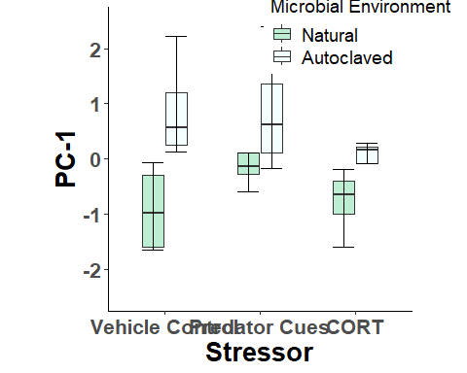 PC1. We found that tadpoles raised in AC pond water exhbited increased locomotory activity, specifically increased Av Speed, Mob Av Speed, Total Distance, Av Accel, Mob Rate, and Exploration Rate when exposed to conspecific alarm cues. Further, they spent less time frozen when exposed to these cues. Conspecific alarm cues have been shown to elicit antipredator responses and decrease locomotory activity of tadpoles. This result suggests that tapdoles raised in AC pond water show alterations in their perception of threat/antipredator defense mechanisms and can make them more susceptible to predation, which can have direct fitness consequences.

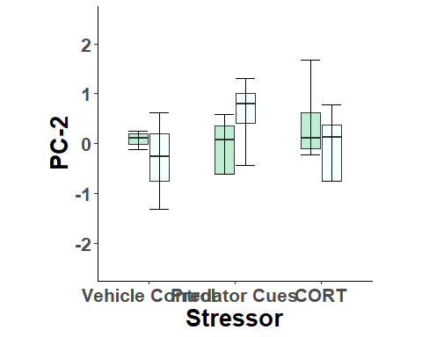 PC2.

**End of Behavior Analysis.**