WESTERN INSTITUTE OF TECHNOLOGY
College of Engineering
Information Technology Department
1st Semester A.Y. 2026-2027

ITPD4 - SOFTWARE ENGINEERING
PREFINAL EXAMINATION - TEST II

SYSTEM PROJECT DOCUMENTATION

Digi-Konek: Electronics-Focused
Online Marketplace
Group Name: TechILO
Group Number: Pending confirmation
BSIT 3 - Section 1
Group Members
Patiño, Keith Erwin Mikhail G.
Peñas, Emmanuel Angelo
Balsomo, John Rey
Bolivar, Jaderick
Tan, Rainier Ryan

Submitted to:
Mohamed Mogib P. Elkordy
ITPD4 Instructor
Date Submitted: ____________________

TABLE OF CONTENTS
Section | Page
1. PROJECT PROFILE AND CONTINUITY | 3
2. PROBLEM, USERS, AND PROJECT OBJECTIVES | 4
3. SCOPE BASELINE AND IMPLEMENTED CORE FEATURES | 5
4. UPDATED FEASIBILITY SUMMARY | 6
5. WORK BREAKDOWN STRUCTURE AND RESPONSIBILITY MATRIX | 7
5.1 Responsibility Matrix | 8
6. PROJECT SCHEDULE / GANTT CHART AND MILESTONES | 9
6.1 Milestones and Dependencies | 10
7. SYSTEM DESIGN SUMMARY | 11
7.2 Database / ERD | 12
7.2 Database / ERD — Key Reference | 13
7.3 Key UML / Workflow Diagram | 14
7.4 Updated Interface / Screen Flow | 15
8. IMPLEMENTED SYSTEM AND WORKING FEATURES | 16
9. GITHUB REPOSITORY AND SOURCE-CODE EVIDENCE | 17
10. BASIC FUNCTIONAL VERIFICATION / CURRENT SYSTEM STATUS | 18
11. RISK REGISTER AND CURRENT RISK RESPONSES | 19
12. VIDEO PRESENTATION AND MEMBER NARRATION RECORD | 20
13. TEAM CONTRIBUTION RECORD | 21
14. APPENDICES / SUPPORTING EVIDENCE | 22
Appendix A - Additional System Screenshots | 22
Appendix B - Updated Diagrams / Models | 22
Appendix C - GitHub Commit / Contribution Evidence | 22
Appendix D - Other Approved Supporting Evidence | 22
Appendix D - Source Register and Reconciliation | 23
FINAL SUBMISSION CHECKLIST | 24
Team Certification | 24

The report follows the approved Digi-Konek project through requirements, design, and the latest Week 8 planning baseline. Evidence-dependent implementation and submission entries are identified in their corresponding sections.

1. PROJECT PROFILE AND CONTINUITY
Field | Team Entry
Approved Project Title | Digi-Konek: Electronics-Focused Online Marketplace
Group Name / Number | TechILO / Pending confirmation
Section | BSIT 3 - Section 1
Target User / Client | Electronics Retailer, Electronics Supplier, System Administrator
Development Methodology | Agile development using Scrum
Current System Version / Build | Pending submission-build identification
GitHub Repository URL | Pending repository upload
Video URL / File Name | Pending recording and submission

1.1 Project Continuity Summary
Digi-Konek continues the approved B2B electronics marketplace developed through the project concept, methodology, requirements, analysis, design, and Week 8 planning materials. It addresses fragmented procurement through phone calls, messages, spreadsheets, websites, and supplier visits. Retailers browse and compare products and submit wholesale orders; suppliers maintain listings, stock, and received orders; administrators verify suppliers and oversee marketplace accounts.
The Prefinal phase carries these requirements into the established three-tier PHP/MySQL web architecture. The latest Week 8 package retains ten marketplace modules and a proposed 45-day implementation schedule. It does not establish completed implementation, instructor acceptance, or individual accomplishments.

1.2 Previous Outputs Reviewed
Previous Output | Review Record
Project Concept and Team Charter | Week 1 concept; Midterm portfolio team context
Methodology and Lifecycle Plan | Week 2; Agile/Scrum lifecycle
SRS / Requirements | Week 3; reconciled Midterm requirements
Use Cases / User Stories | Week 4 and Midterm portfolio
UML / Wireframes / Architecture / ERD | Weeks 5–6 and reconciled Midterm portfolio
Midterm Feedback | Actual instructor-feedback record remains pending in Week 8
Week 8 Planning Package | Latest revised 45-day version; controlling planning baseline

Source: S1–S5, S7 and S8; source register in Appendix D.

2. PROBLEM, USERS, AND PROJECT OBJECTIVES

2.1 Problem / Need Being Addressed
Electronics retailers need reliable access to computer components, input devices, and output devices. Product information, prices, availability, and supplier details are distributed across separate websites, messages, calls, spreadsheets, and face-to-face transactions. Retailers must gather and compare this information manually, while suppliers have limited visibility among potential business customers.
Digi-Konek provides a centralized marketplace for product discovery, supplier information, comparison, wholesale ordering, and order tracking. It supports the documented retailer-to-supplier process without taking responsibility for excluded payment, logistics, or after-sales services.

2.2 Target Users / Stakeholders
User / Stakeholder | Need / Role in the System
Electronics Retailer | Find and compare electronic products; manage a cart; place wholesale orders; monitor order status.
Electronics Supplier | Publish and maintain product information and stock; receive and process orders; view sales reports.
System Administrator | Review supplier documents, verify suppliers, manage accounts and product classifications, and review marketplace reports.

2.3 Approved Project Objectives
1. Provide a centralized B2B platform connecting electronics retailers and suppliers.
2. Help retailers browse, search, filter, and compare product information, prices, suppliers, and availability.
3. Enable suppliers to maintain product listings and inventory information.
4. Support shopping carts, wholesale order submission, supplier decisions, and retailer order tracking.
5. Support supplier verification, administrative oversight, notifications, reporting, and audit records.
Source: S1; S3; S4; S5; S7; S8. Objectives consolidate the documented purpose and requirements without adding scope.

3. SCOPE BASELINE AND IMPLEMENTED CORE FEATURES
The following is the retained scope baseline. “Verification pending” means the uploaded references do not establish a current demonstrated result; it does not mean the feature is absent from the application.
Classification | Feature / Requirement | Implementation Status | Evidence / Reference
IN SCOPE | Accounts, authentication, supplier verification and account/document controls | Verification pending | FR-01–03, 16, 18; WBS 2.0
IN SCOPE | Product listings, images/specifications, search, comparison, categories and brands | Verification pending | FR-04–08, 17; WBS 3.0
IN SCOPE | Cart quantities, wholesale orders, supplier decisions and tracking | Verification pending | FR-09–10, 12–13; WBS 4.0
IN SCOPE | Stock checks and inventory updates without negative quantities | Verification pending | FR-14; WBS 3.0–4.0
IN SCOPE | Notifications, supplier/marketplace reports and audit records | Verification pending | FR-11, 15, 19–20; WBS 5.0–6.0
OUT OF SCOPE | Delivery/logistics, warehouse management, online payments, lending and accounting integration | Excluded from baseline | Week 8 scope; Weeks 1–4
OUT OF SCOPE | Installation, repairs and warranty claims | Excluded from baseline | Week 8 scope; Weeks 1–4

3.1 Core Features Demonstrated in Test II
The final demonstration record is pending. Week 8 establishes the following core implementation priorities, to be confirmed against the submitted build:
1. MySQL schema and authenticated retailer, supplier, and administrator access.
2. Supplier verification, document access checks, and product publication controls.
3. Catalog, categories/brands, stock display, search, comparison, and cart quantities.
4. Pending orders, supplier processing, stock updates, and retailer status tracking.
5. Ordering notifications and audit events, followed by reports and quality checks.
Source: S8 scope and Appendix G traceability; S7 functional requirements. No approved core requirement is silently reclassified as a future enhancement.

4. UPDATED FEASIBILITY SUMMARY
The latest Week 8 decision remains the documented feasibility baseline. A new assessment or approval is not asserted without additional evidence.
Feasibility Area | Current Finding / Evidence | Decision
Technical | The PHP/MySQL web stack matches the Week 2 plan and the established three-tier design. Implementation and integration still require testing. | Feasible
Operational | Retailer ordering, supplier processing, and administrator verification follow the documented workflow. Real-user usability evidence is still needed. | Needs Revision
Economic | A local academic demonstration is the proposed baseline. Equipment, connectivity, and any PHP/MySQL hosting costs must be confirmed. | Needs Revision
Schedule | The proposed 45-day plan needs 240 person-hours plus 48 contingency hours. Five members must confirm part-time availability. | Needs Revision
Legal | Supplier documents, user accounts, and product images require access restrictions, permission, and retention decisions. Use synthetic demonstration data. | Needs Revision
Organizational | TechILO has a documented representative and roster. Client participation, review attendance, and individual work commitments need confirmation. | Needs Revision

Overall Feasibility Decision

Needs Revision
The documented PHP/MySQL architecture is suitable for an academic implementation. However, WBS 1.0 must confirm instructor feedback, acceptance targets, team capacity, available resources, and data permissions. The 45-day schedule and 288-person-hour allowance remain proposed estimates, not verified delivery capacity or a guarantee of production readiness.
Source: S8, Updated Feasibility Study and Final Team Justification. This later decision supersedes the earlier feasibility conclusion in the Midterm materials.

5. WORK BREAKDOWN STRUCTURE AND RESPONSIBILITY MATRIX
Owners and work packages follow the latest Week 8 assignments. Ownership is proposed; actual completion and member acceptance require evidence.
WBS Code | Task / Work Package | Owner | Expected Output | Status
1.0 | Planning and design reconciliation | Patiño | Reconciled backlog, scope, ERD/interfaces, and dated review record. | Pending verification
2.0 | Database, authentication, and supplier verification | Balsomo | Schema plus passing login, role, and supplier-verification checks. | Pending verification
3.0 | Product catalog and inventory interfaces | Bolivar | Catalog and stock interfaces pass role and product checks. | Pending verification
4.0 | Shopping cart and order processing | Peñas | Order flow rejects insufficient stock and repeated processing. | Pending verification
5.0 | Notifications, reporting, and audit | Tan | Notification/report/audit outputs reconcile to seeded orders. | Pending verification
6.0 | End-to-end integration | Patiño | Integrated demonstration with traceable test and defect records. | Pending verification
7.0 | System testing and revisions | Tan | Test report, resolved critical defects, and documented remaining limits. | Pending verification
8.0 | Deployment and handover | Patiño | Reproducible deployment, smoke test, guide, backup, and demo evidence. | Pending verification

Source: S8, Work Breakdown Structure. Completion status is not inferred from elapsed calendar dates.

5.1 Responsibility Matrix
Task / Deliverable | Responsible Member | Support Member | Reviewer | Evidence
1.0 Planning and design reconciliation | Patiño | Bolivar | Tan | Planned: Reconciled backlog, scope, ERD/interfaces, and dated review record.
2.0 Database, authentication, and supplier verification | Balsomo | Peñas | Patiño | Planned: Schema plus passing login, role, and supplier-verification checks.
3.0 Product catalog and inventory interfaces | Bolivar | Peñas, Balsomo | Tan | Planned: Catalog and stock interfaces pass role and product checks.
4.0 Shopping cart and order processing | Peñas | Patiño, Balsomo, Bolivar, Tan | Balsomo | Planned: Order flow rejects insufficient stock and repeated processing.
5.0 Notifications, reporting, and audit | Tan | Patiño | Peñas | Planned: Notification/report/audit outputs reconcile to seeded orders.
6.0 End-to-end integration | Patiño | Balsomo, Bolivar, Tan | Peñas | Planned: Integrated demonstration with traceable test and defect records.
7.0 System testing and revisions | Tan | All members | Patiño | Planned: Test report, resolved critical defects, and documented remaining limits.
8.0 Deployment and handover | Patiño | Peñas, Tan | Balsomo | Planned: Reproducible deployment, smoke test, guide, backup, and demo evidence.

A task is considered Done under the Week 8 reporting rules only when acceptance evidence and reviewer sign-off are attached. Proposed assignments are not a substitute for the actual contribution record in Section 13.
Source: S8, Responsibility Matrix and Weekly Progress-Reporting Rules.

6. PROJECT SCHEDULE / GANTT CHART AND MILESTONES
The controlling proposed schedule spans September 14–October 28, 2026: 45 inclusive calendar days (1.5 months using a 30-day planning month). Work packages run sequentially. The dates require team and course-calendar confirmation; no actual completion dates are established.
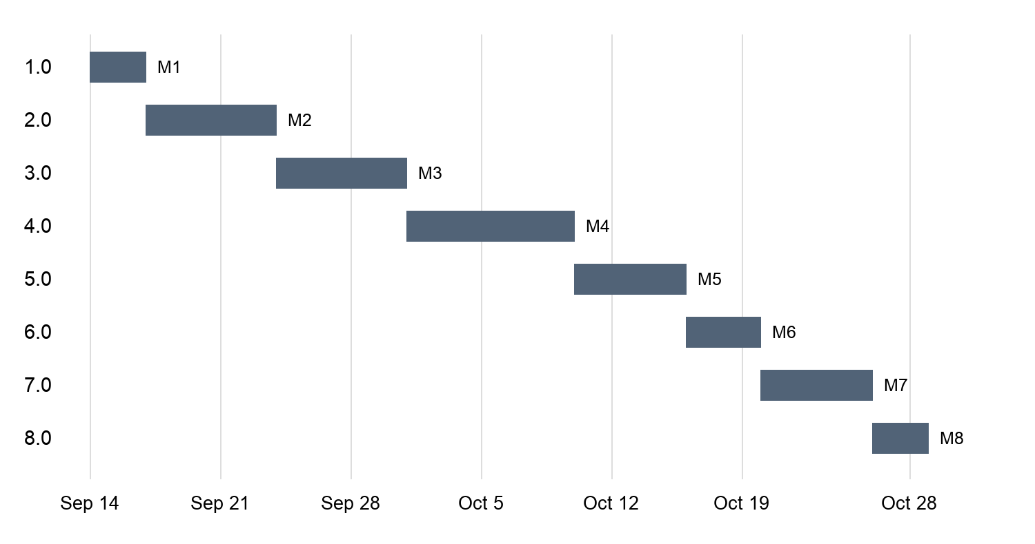
Figure 1. Proposed Week 8 Gantt chart. M1–M8 identify the target milestones; bars do not indicate actual progress.
Task | Owner | Start | End | Dependency
1.0 Planning and design reconciliation | Patiño | 09/14/2026 | 09/16/2026 | None; review access required
2.0 Database, authentication, and supplier verification | Balsomo | 09/17/2026 | 09/23/2026 | 1.0 completed
3.0 Product catalog and inventory interfaces | Bolivar | 09/24/2026 | 09/30/2026 | 2.0 completed
4.0 Shopping cart and order processing | Peñas | 10/01/2026 | 10/09/2026 | 3.0 completed
5.0 Notifications, reporting, and audit | Tan | 10/10/2026 | 10/15/2026 | 4.0 completed
6.0 End-to-end integration | Patiño | 10/16/2026 | 10/19/2026 | 5.0 completed
7.0 System testing and revisions | Tan | 10/20/2026 | 10/25/2026 | 6.0 completed
8.0 Deployment and handover | Patiño | 10/26/2026 | 10/28/2026 | 7.0 completed

Duration allocation: 3 + 7 + 7 + 9 + 6 + 4 + 6 + 3 = 45 days. Baseline effort is 240 person-hours plus 48 contingency hours (288 total). The 48 contingency hours must fit within the schedule. The proposed capacity assumption is five members averaging 10 hours/week for six full weeks; availability and peak-week allocation remain unconfirmed.
Source: S8, Effort Estimates, Project Schedule, and Appendix A.

6.1 Milestones and Dependencies
No. | Milestone / Checkpoint | Dependency / Prerequisite | Target / Actual Date | Status
1 | M1: Reconciled backlog, scope, ERD/interfaces, and dated review record. | 1.0 completed; prerequisites: None; review access required | 09/16/2026 / Actual: pending | Pending verification
2 | M2: Schema plus passing login, role, and supplier-verification checks. | 2.0 completed; prerequisites: 1.0 completed | 09/23/2026 / Actual: pending | Pending verification
3 | M3: Catalog and stock interfaces pass role and product checks. | 3.0 completed; prerequisites: 2.0 completed | 09/30/2026 / Actual: pending | Pending verification
4 | M4: Order flow rejects insufficient stock and repeated processing. | 4.0 completed; prerequisites: 3.0 completed | 10/09/2026 / Actual: pending | Pending verification
5 | M5: Notification/report/audit outputs reconcile to seeded orders. | 5.0 completed; prerequisites: 4.0 completed | 10/15/2026 / Actual: pending | Pending verification
6 | M6: Integrated demonstration with traceable test and defect records. | 6.0 completed; prerequisites: 5.0 completed | 10/19/2026 / Actual: pending | Pending verification
7 | M7: Test report, resolved critical defects, and documented remaining limits. | 7.0 completed; prerequisites: 6.0 completed | 10/25/2026 / Actual: pending | Pending verification
8 | M8: Reproducible deployment, smoke test, guide, backup, and demo evidence. | 8.0 completed; prerequisites: 7.0 completed | 10/28/2026 / Actual: pending | Pending verification

WBS 1.0 closes planning/design revisions. WBS 2.0–3.0 continue Sprint 3; WBS 4.0–6.0 continue Sprint 4; WBS 7.0–8.0 continue Sprint 5. The source does not establish these dates as the official submission deadline.
Source: S8, Milestones and Dependencies; S2 lifecycle plan.

7. SYSTEM DESIGN SUMMARY

7.1 System Architecture
The documented design is a three-tier layered web application. HTML, CSS, and JavaScript provide role-specific interfaces. Modular PHP business logic handles marketplace operations, and the data-access layer persists structured records in MySQL. The current approved design requires no external payment, logistics, or third-party notification service.
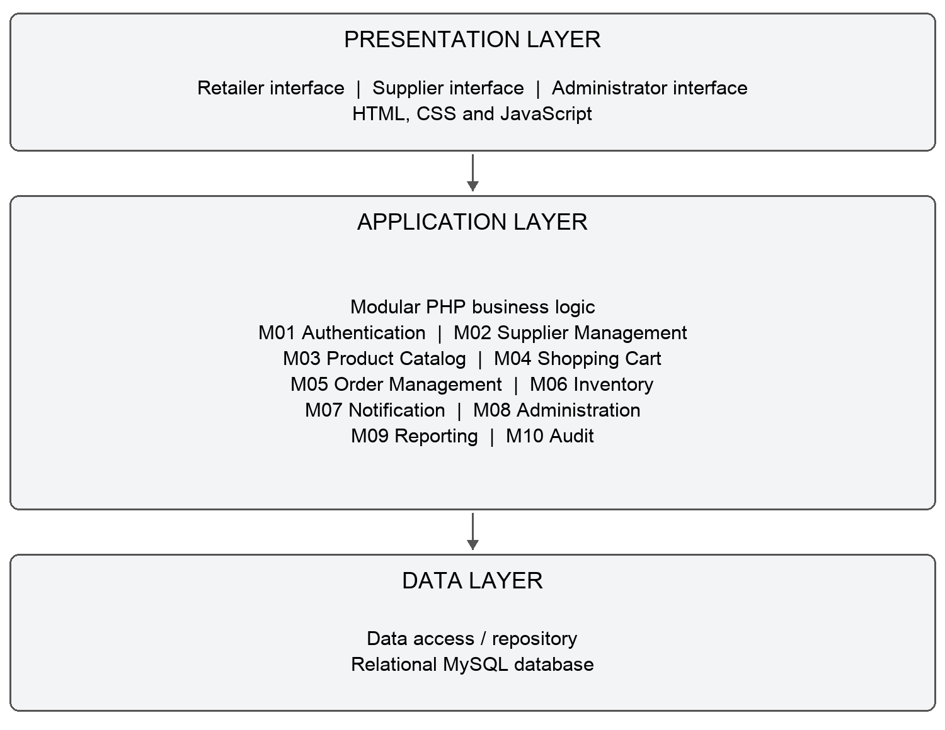
Figure 2. Three-tier architecture redrawn from the Midterm architecture and module list.
Separation of presentation, business logic, and persistence supports maintainability and testing. Authentication, role controls, validation, transactions, referential integrity, and audit records support the documented security and reliability goals. These are design responsibilities, not proof of tested quality targets.
Source: S5, Software Architecture and Module Design; S7, G.1–G.8.

7.2 Database / ERD
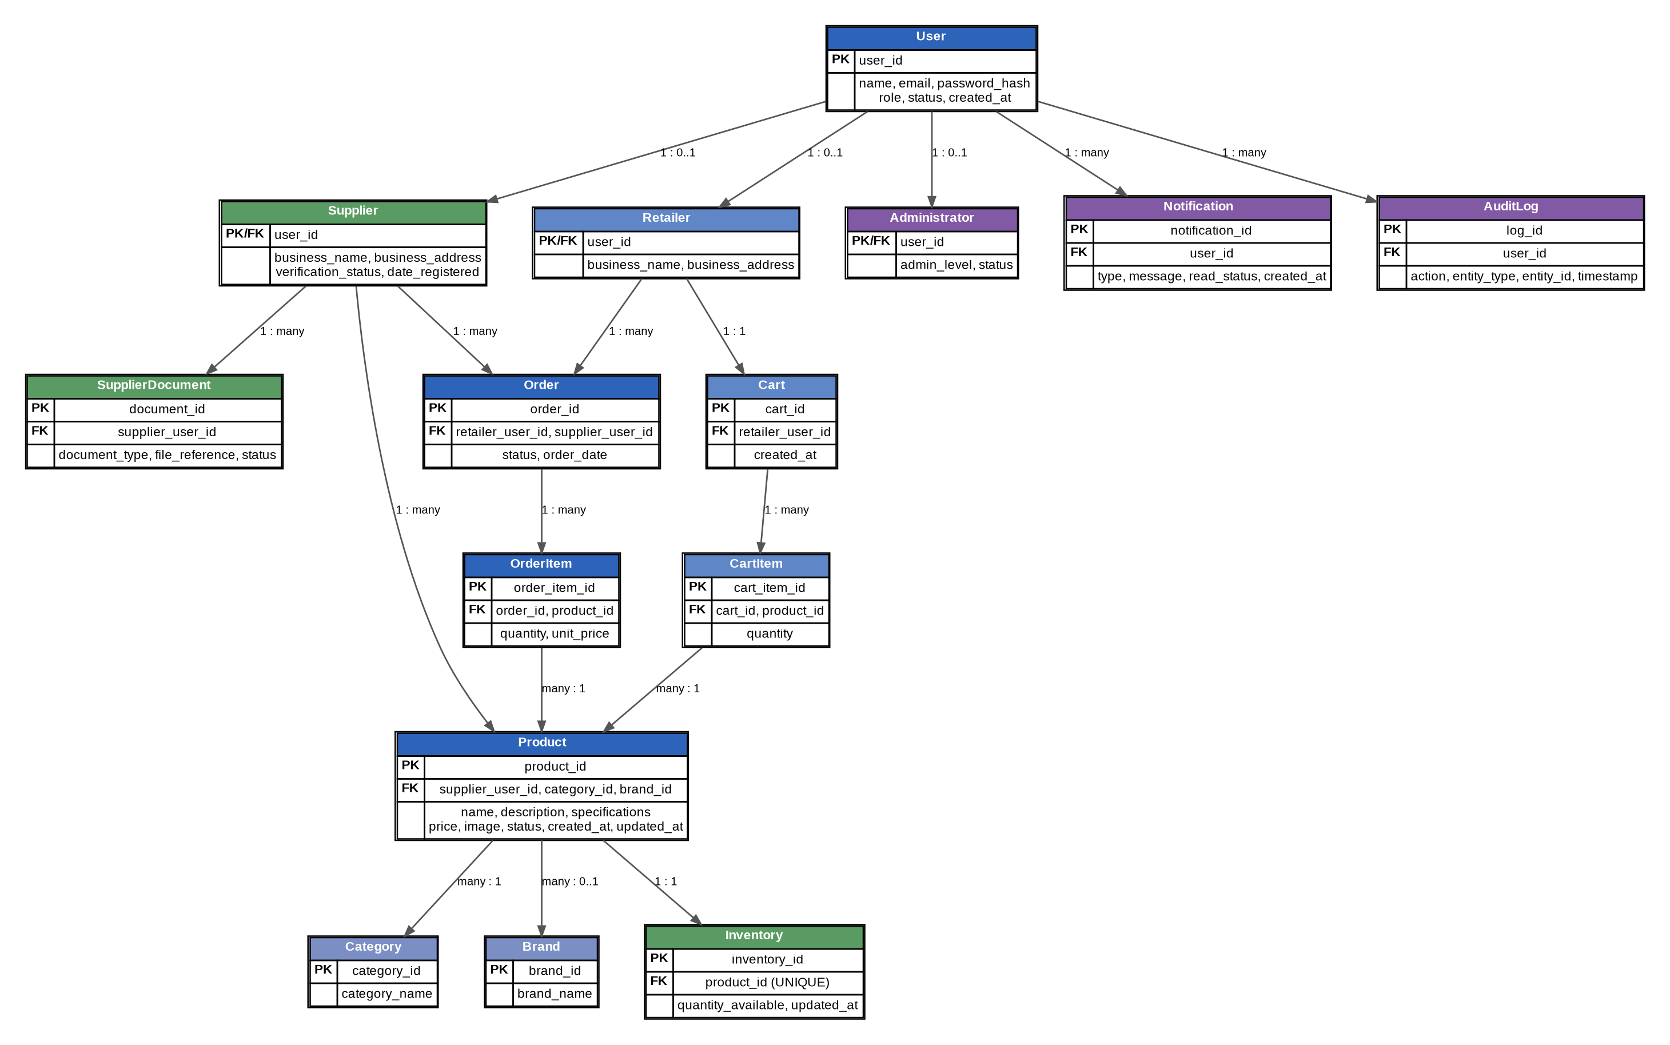
Figure 3. Reconciled ERD reproduced from the Midterm portfolio, Section G.12; shared profile identities retained by Week 8.
Source: S7, G.10–G.12; S8, Appendix E.

7.2 Database / ERD — Key Reference
The reconciled design shares User.user_id as the primary/foreign key of Supplier, Retailer, and Administrator. Week 8 retains this identity rule. Validation against the submission schema remains pending.
Entity | Primary Key | Foreign Key / Relationship
User | user_id | —
Supplier | user_id | user_id → User.user_id
Retailer | user_id | user_id → User.user_id
Administrator | user_id | user_id → User.user_id
SupplierDocument | document_id | supplier_user_id → Supplier.user_id
Category | category_id | —
Brand | brand_id | —
Product | product_id | supplier_user_id, category_id, brand_id
Inventory | inventory_id | product_id → Product.product_id (unique)
Cart | cart_id | retailer_user_id → Retailer.user_id
CartItem | cart_item_id | cart_id, product_id
Order | order_id | retailer_user_id, supplier_user_id
OrderItem | order_item_id | order_id, product_id
Notification | notification_id | user_id → User.user_id
AuditLog | log_id | user_id → User.user_id

Products belong to one category; suppliers may own many products and submit multiple documents. Retailers place orders with suppliers. Orders contain order items; carts contain cart items. Notifications and audit logs reference the responsible or receiving user. The key reference explains the source ERD and is not an exported live schema.
Source: S7, entity/key analysis and relationship table; S8 shared-identity reconciliation.

7.3 Key UML / Workflow Diagram
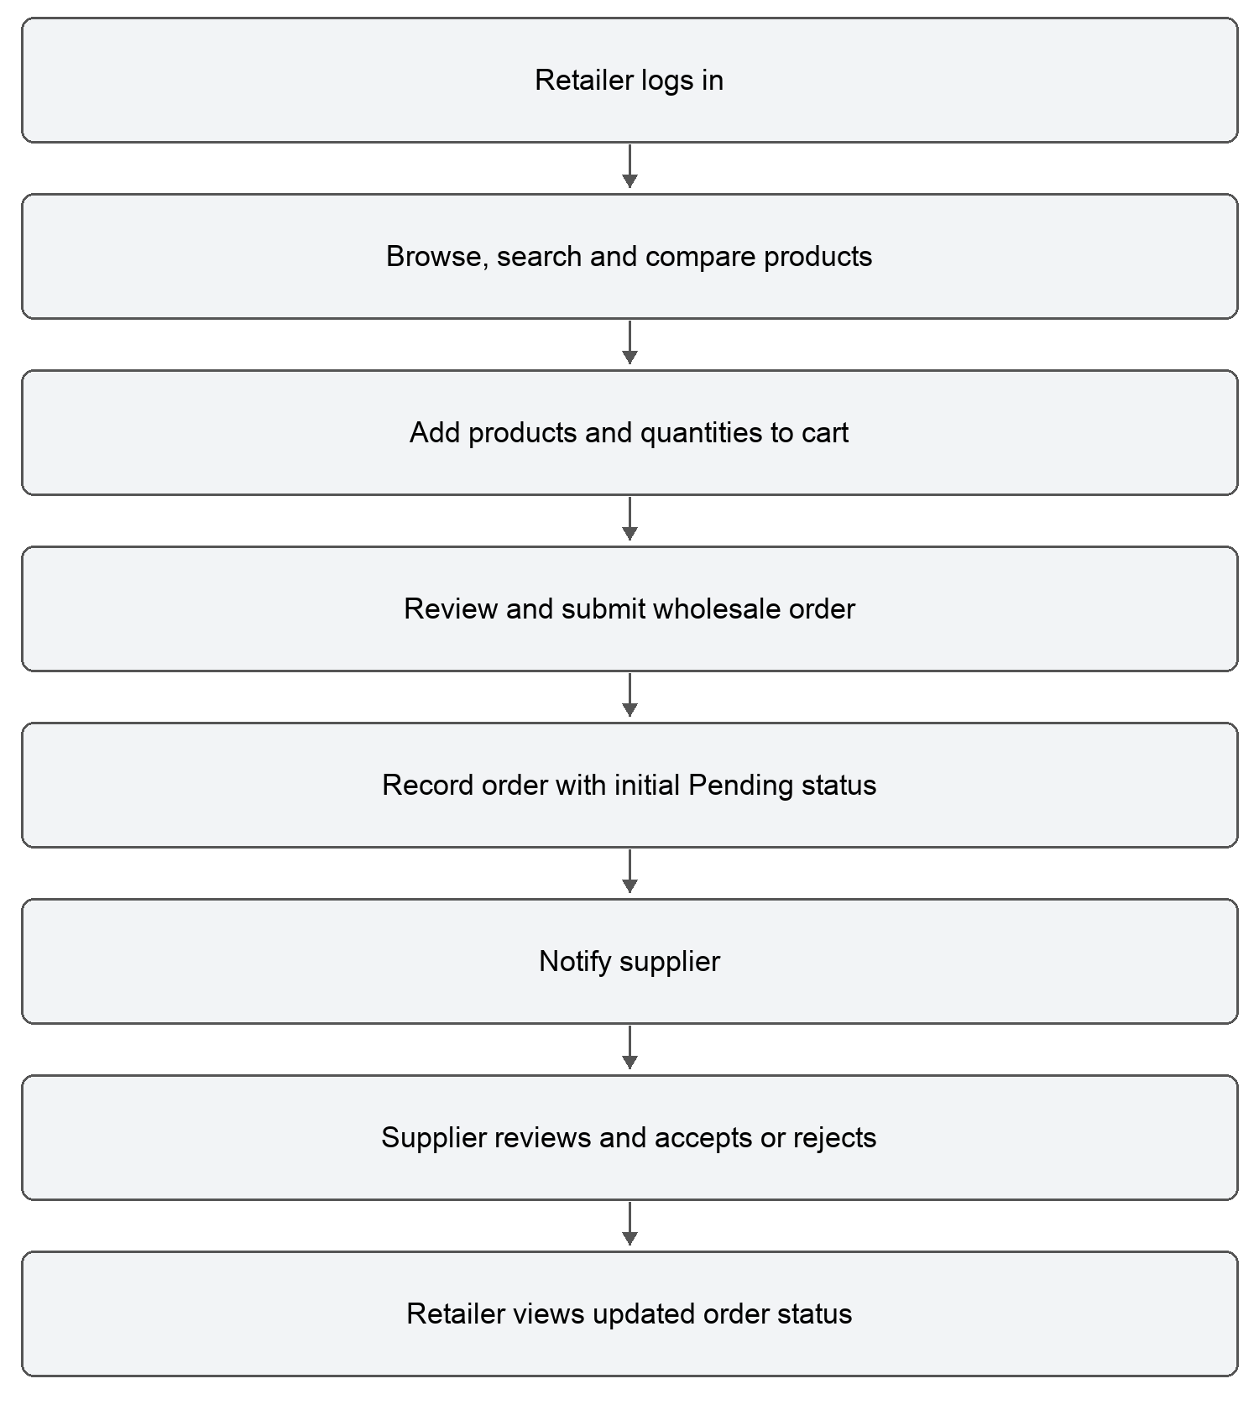
Figure 4. Retailer-to-supplier workflow redrawn from Week 4 To-Be analysis and the later Place Order / Process Order descriptions.
The design connects cart, order, inventory, notification, and audit responsibilities. Week 8 leaves exact order-state transitions and inventory-update timing for reconciliation; this figure therefore preserves only the supported high-level sequence. It does not add cancellation, payment, delivery, or other unsupported processing steps.
Source: S4, Proposed To-Be Process; S5 sequence descriptions; S7 navigation flow; S8 pending order-state decisions.

7.4 Updated Interface / Screen Flow
The latest supplied interface flow covers the following user journeys. The Week 8 package identifies updated wireframes and a recorded usability walkthrough as pending; these flows remain reference design, not working-system screenshots.
Workflow / Use Case | Starting Screen | Key Screens in Order | Expected End State
Register Account | Login / Landing Screen | Register Account → Registration Form → Account Confirmation | User account registered; user can proceed to login.
Authenticate User | Login Screen | Login Form → Credential Validation → Role-Based Dashboard | Authenticated and redirected to the appropriate dashboard.
Search Products | Retailer Dashboard | Product Catalog → Search/Filter → Search Results → Product Details | Matching products displayed based on criteria.
Compare Products | Product Search Results | Select Products → Compare Products → Comparison Results | Selected products displayed side-by-side.
Place Order | Product Details / Shopping Cart | Add to Cart → Shopping Cart → Order Review → Order Confirmation | Wholesale order submitted with Pending status.
Manage Products | Supplier Dashboard | Products → Add/Edit Product → Product Information → Save Confirmation | Supplier listing created or updated.
Process Order | Supplier Dashboard | Orders → Order Details → Accept/Reject Order → Status Confirmation | Order status updated based on decision.
Track Order | Retailer Dashboard | My Orders → Order Details → Order Status | Retailer views current order status.
Verify Supplier | Administrator Dashboard | Supplier Verification → Supplier Details → Documents → Approve/Reject → Confirmation | Supplier verification status updated.
Generate Sales Report | Supplier Dashboard | Sales Reports → Report Filters → Report Results | Supplier views generated sales report.

Source: S7, F.4 Navigation Flow; S5 navigation table; S8, Appendix D.

8. IMPLEMENTED SYSTEM AND WORKING FEATURES
This section retains the approved module responsibilities and Week 8 ownership. The uploaded planning/design documents do not verify a current software build. Each working-status entry therefore remains pending evidence instead of presenting the design as a demonstrated result.
Module / Feature | What It Does | Primary Member | Status | Screenshot / Evidence
M01 Authentication Module | Registration, login, authentication, role control | Balsomo (proposed) | Verification pending | Pending actual-system evidence
M02 Supplier Management Module | Supplier verification and supplier profile management | Balsomo (proposed) | Verification pending | Pending actual-system evidence
M03 Product Catalog Module | Product listing, browsing, searching, filtering, comparison | Bolivar (proposed) | Verification pending | Pending actual-system evidence
M04 Shopping Cart Module | Maintain selected retailer products | Peñas (proposed) | Verification pending | Pending actual-system evidence
M05 Order Management Module | Create and process wholesale orders | Peñas (proposed) | Verification pending | Pending actual-system evidence
M06 Inventory Module | Maintain and update stock quantities | Bolivar / Peñas (proposed) | Verification pending | Pending actual-system evidence
M07 Notification Module | Generate important system/order notifications | Tan (proposed) | Verification pending | Pending actual-system evidence
M08 Administration Module | User, category, brand, and marketplace administration | Balsomo / Bolivar (proposed) | Verification pending | Pending actual-system evidence
M09 Reporting Module | Supplier and marketplace reports | Tan (proposed) | Verification pending | Pending actual-system evidence
M10 Audit Module | Record important marketplace activities | Tan (proposed) | Verification pending | Pending actual-system evidence

Source: S7, G.4 Module List; S8 WBS 2.0–5.0. Assignments show planning responsibility, not individual implementation credit.

8.1 System Screenshots
Actual working-system screenshots are pending. The supplied wireframes must not be labeled as implemented screens. Appendix A identifies the evidence needed for the approved flows; screenshots should be captioned and tied to the final build.

9. GITHUB REPOSITORY AND SOURCE-CODE EVIDENCE
Repository Information | Team Entry
GitHub Repository Name | Pending upload
Repository URL | Pending upload
Default / Submission Branch | Pending identification
Latest Submission Commit ID / Hash | Pending submission commit
README Included | Pending repository verification
Database / Setup Files Included | Pending repository verification
Source Code ZIP Submitted to GClass | Pending submission

9.1 Repository Structure / Selected Code Evidence
Repository-tree and representative code screenshots are pending. The evidence must correspond to the same version described in this report and demonstrated in the video. Only selected implementation evidence belongs in the printed package; the complete source belongs in GitHub and the required ZIP.
The repository must contain organized source files, the README, and database schema/migration/setup files. Private credentials must not be published. Meaningful existing development history should be preserved; unsupported historical commits or member contributions must not be fabricated.
Required source ZIP filename: ITPD4_TestII_TechILO_Digi-Konek_SourceCode.zip
Source: S0, Sections B and D; S8, Appendix F. Repository upload is pending.

10. BASIC FUNCTIONAL VERIFICATION / CURRENT SYSTEM STATUS
Expected results below come from the documented requirements and Week 8 acceptance groups. No execution result is invented from a planned test. Actual results and evidence must be entered for the submission build.
No. | Feature / Flow Checked | Expected Result | Actual Result / Status | Evidence
1 | Registration and login | Required information validated; duplicate/incomplete input rejected; protected access authenticated. | Execution not established | Pending; TC-02
2 | Supplier verification | Administrator reviews documents; unverified supplier cannot publish products. | Execution not established | Pending; TC-02
3 | Catalog and product management | Authorized product maintenance; accurate filters and comparison results. | Execution not established | Pending; TC-03
4 | Cart and wholesale order | Quantities validated; order/items recorded with initial Pending status. | Execution not established | Pending; TC-04
5 | Supplier decision and stock | Accept/reject and tracking work; stock remains nonnegative; duplicate operations checked. | Execution not established | Pending; TC-04
6 | Notifications, reports and audit | Order events notify users; date-filtered totals reconcile; activity is recorded. | Execution not established | Pending; TC-05
7 | Quality and resilience | Browser/UI, access, input, load/availability criteria and backup/restore checked. | Execution not established | Pending; TC-07

Known Limitations / Pending Work
1. Week 8 leaves the NFR-05 availability target and measurement period unresolved (99.99% versus 99% in earlier requirements).
2. Password-storage wording, missing main-table requirement rows, and acceptance criteria require reconciliation.
3. Administrator provisioning, exact order-state transitions, and product deletion/history rules require confirmation.
4. Actual usability, load, browser, backup/restore, deployment, and current-build verification evidence remain to be recorded.
Source: S7 acceptance criteria; S8 findings and Appendix G. TC identifiers are planned test groups, not passing test results.

11. RISK REGISTER AND CURRENT RISK RESPONSES
The latest Week 8 register keeps six risks Open. No subsequent verified closure is established. The table preserves those statuses; controls are planned responses.
Risk ID | Risk Description | Probability / Impact | Mitigation / Contingency | Owner / Status
R-01 | Feedback or unresolved SRS/design conflicts may change the implementation baseline. | Medium / High | Resolve WBS 1.0 findings; log changes and re-estimate affected tasks. | Patiño / Open
R-02 | Competing orders or repeated supplier actions may oversell stock or duplicate orders. | Medium / High | Use atomic stock checks, valid state transitions, and duplicate-request tests in 4.0 and 7.0. | Peñas / Open
R-03 | Unauthorized access or unsafe uploads may expose user or supplier documents. | Medium / High | Enforce role/ownership checks, upload validation, protected storage, and security tests. | Balsomo / Open
R-04 | Member availability or integration complexity may exceed the proposed 45-day capacity. | High / High | Confirm availability, review progress weekly, and use the 48-hour contingency allowance. | Patiño / Open
R-05 | Users may find product discovery or order actions confusing. | Medium / Medium | Run a recorded retailer/supplier walkthrough with synthetic data; revise and retest. | Bolivar / Open
R-06 | Environment failure or a bad change may interrupt the demo or lose test data. | Medium / High | Version code/schema, back up MySQL data, and test restoration before deployment. | Tan / Open

Current Response Priorities
R-04 is Critical; R-01, R-02, R-03, and R-06 are High; R-05 is Medium. Scope/feedback conflicts require a reviewed change record. Inventory problems require reproduction and retesting. Access incidents require containment and credential review. Schedule pressure requires reassignment and the planned contingency allowance. Environment failures require restoration from a verified backup and smoke testing.
Week 8 proposes Friday progress reviews and immediate escalation of dependency, security, or data-loss blockers to Patiño. Other blockers are to be escalated within 48 hours. Meeting attendance, decisions, actual hours, evidence, and review outcomes still need to be recorded.
Source: S8, Risk Register, Risk Response Plan, and Weekly Progress-Reporting Rules.

12. VIDEO PRESENTATION AND MEMBER NARRATION RECORD
Every member must narrate a meaningful part of the actual project. The name should be stated or displayed at the beginning of that segment. The Week 8 assignments below are a planning reference; actual recorded topics and timestamps remain pending.
No. | Member Name | Role / Module | Video Segment / Topic Explained | Time Stamp
1 | Patiño, Keith Erwin Mikhail G. | Group Representative / Integration Lead (proposed) | Pending recorded segment | Pending
2 | Peñas, Emmanuel Angelo | Cart and Order Developer (proposed) | Pending recorded segment | Pending
3 | Balsomo, John Rey | Database and Access Developer (proposed) | Pending recorded segment | Pending
4 | Bolivar, Jaderick | Catalog / UI Developer (proposed) | Pending recorded segment | Pending
5 | Tan, Rainier Ryan | Reporting / QA Coordinator (proposed) | Pending recorded segment | Pending

Video Link / File Name: Pending recording.
Required uploaded filename: ITPD4_TestII_TechILO_Digi-Konek_Video.mp4

Required Video Coverage
1. Opening: project title, group name/number, section, and complete member names.
2. Overview: problem, target users, and purpose.
3. Scope: implemented core features and approved deferred enhancements.
4. Actual-system demonstration of important user flows using realistic sample data.
5. Technical explanation of architecture, database, tools, and connections.
6. Each member’s own module, contribution, or responsibility.
7. GitHub structure and selected implementation evidence.
8. Current status, known limitations, and next implementation/testing work.
Source: S0, Section C and documentation Section 12; S8 proposed roles.

13. TEAM CONTRIBUTION RECORD
The current roster contains five members. Actual Prefinal contributions must be stated and confirmed by each member before signing. Week 8 identifies proposed assignments only; earlier-week contributions are not automatically carried forward as current accomplishments.
No. | Complete Name | Primary Role | Actual Contribution / Deliverables | Signature
1 | Patiño, Keith Erwin Mikhail G. | Group Representative / Integration Lead (proposed) | Pending member confirmation of actual work and evidence. | ________
2 | Peñas, Emmanuel Angelo | Cart and Order Developer (proposed) | Pending member confirmation of actual work and evidence. | ________
3 | Balsomo, John Rey | Database and Access Developer (proposed) | Pending member confirmation of actual work and evidence. | ________
4 | Bolivar, Jaderick | Catalog / UI Developer (proposed) | Pending member confirmation of actual work and evidence. | ________
5 | Tan, Rainier Ryan | Reporting / QA Coordinator (proposed) | Pending member confirmation of actual work and evidence. | ________

Confirmation should identify specific system, documentation, repository, testing, or presentation outputs. A signature confirms the accuracy of the contribution statement; signatures are left blank for the members.
Source: S8, Team Contribution Record; S0, documentation Section 13.

14. APPENDICES / SUPPORTING EVIDENCE

Appendix A - Additional System Screenshots
Pending actual-system evidence. The supplied materials contain design wireframes, not verified Prefinal application screenshots. Capture only the submitted version and label the actor, feature, and result.
Evidence Area | Source-Based Flow to Show
Access and verification | Login/role access; supplier-document review and publication control.
Catalog | Supplier product maintenance; retailer browse/search/compare.
Transactions | Cart, Pending order, supplier decision, stock consistency, and retailer tracking.
Oversight | Notifications, supplier/marketplace reports, and audit records.

Appendix B - Updated Diagrams / Models
Figures 2–4 in Section 7 present the documented architecture, reconciled ERD, and core workflow. Section 7.4 records the supplied screen flow. They explain the reference design; matching them to the final submission build remains pending as required by Week 8.

Appendix C - GitHub Commit / Contribution Evidence
Pending repository upload, final commit identification, and verified member contribution evidence. The source ZIP, video, and report must use the same submitted version.

Appendix D - Other Approved Supporting Evidence
The following source register identifies the documents used. Later-week decisions control conflicts. The Midterm portfolio is used as the consolidation of Weeks 1–6; a separate Week 7 file was not supplied. S0 controls the required Prefinal format.

Appendix D - Source Register and Reconciliation
ID | Document | Use
S0 | ITPD4 Prefinal.pdf | Official format, section order, submission and evidence requirements.
S1 | Week 1 - Project Concept Paper.pdf | Project concept, procurement problem, initial scope and exclusions.
S2 | Week 2.pdf | Agile/Scrum lifecycle, technology stack and change process.
S3 | Week 3.pdf | Elicitation, initial SRS, requirements and traceability.
S4 | Week 4.pdf | As-Is/To-Be process, actors, use cases and user stories.
S5 | ITPD4_Weeks5-6_BSIT3-Section1_TechILO__Digi-Konek.pdf | UML, wireframes, architecture, modules, interfaces and data design.
S7 | ITPD4_Midterm_Project_TechILO_Digi-Konek.docx | Consolidated Weeks 1–6 portfolio; reconciled module and identity models.
S8 | ITPD4_Week8_ProjectPlanning_TechILO.docx (latest revised version) | Controlling roster, feasibility, proposed assignments, 45-day schedule, risks and pending confirmations.

Reconciliation Record
Conflict / Issue | Controlling Treatment
Six-member earlier roster versus five-member Week 8 roster | Use five members from Week 8; retain Emmanuel Angelo and Keith Erwin Mikhail G. spellings.
Earlier feasibility conclusions | Retain Week 8 overall decision: Needs Revision.
Earlier timelines and initial role labels | Use the revised September 14–October 28, 2026 schedule and proposed Week 8 responsibilities.
Availability, password wording and missing requirement rows | Retain Week 8 pending reconciliation; do not silently select an unsupported acceptance target.
Design versus actual implementation | Do not treat wireframes, planned tests, assignments, or dates as execution evidence.

FINAL SUBMISSION CHECKLIST
Complete the evidence-dependent checks before submission and printing. Items marked Pending require confirmation; they are not certified by the planning documents.
Requirement | Status
Long bond paper (8.5 × 13 inches) | Document configured; physical print pending
Required section order and Table of Contents | Included; final page references checked after rendering
Same approved semester project | Digi-Konek retained
Approved core features accurately represented | Baseline included; final implementation verification pending
Video matches GitHub/source-code version | Pending
GitHub link correct and instructor-accessible | Pending
Source-code ZIP uploaded to Google Classroom | Pending
Final documentation PDF uploaded | Pending
Video or accessible link submitted | Pending
Every member has a clear voice-over segment | Pending
Screenshots, diagrams, tables and links readable | Document layout checked; missing external evidence pending
Long white folder with fastener | Pending physical preparation
All materials submitted before official deadline | Pending; confirm deadline in Google Classroom

Team Certification
We certify that the project, code, documentation, repository evidence, and video submitted for Test II represent our group’s actual work and current project status.
Team Leader Signature: __________________________
Date: __________________________
Sign after the pending submission and evidence entries have been completed and reviewed.

