California Water Drought Analysis Using Crowd-sourcing Data Collection

Rucha Brahmankar Darrel Pahm Claudia Furushima Porto Yasuhiko Sasaki Wei An Liao
CMPE272 / Team 12

Graduate School of Software Engineering
San Jose State University
San Jose, California, USA

Abstract— California is facing one of its worst droughts in more than 100 years and one with no end in sight. Conserving water has never been so important as it is becoming one of the most stressed resources. We propose a highly-flexible crowd-sourcing system for water data collection and analyses. The system combines cloud computing resource (Amazon EC2) with NoSQL (MongoDB) and big data analysis (Hadoop/Map Reduce) to monitor and extract informative insight from the huge water-related data.

Index Terms—Water drought, MongoDB, Hadoop/Map Reduce.

Introduction
Water plays an indispensable and irreplaceable role in our life. However, some of areas in the world are suffered from the drought because of geographical environments and anthropic factor. Now, California is facing one of the worst droughts in more than 100 years and one with no end in sight. As we know, although more and more companies are doing research for solving drought problem, there is no fundamental solution to it because of the difficulty in the integration of data collection and analytics for scattered and heterogeneous data. Therefore, we propose a system that enables crowd-sourcing data easily and displays informative chart diagrams as a result of big data analysis using Hadoop. The system is deployed to one of the servers in cloud (Amazon EC2), naturally having a robust elasticity in case of flash crowd. One of the main features of our system is correlation analysis. Users can apply their own data to our correlation-analysis engine and get the result in real time to help them make decision of policy to solve water drought and water waste problem.

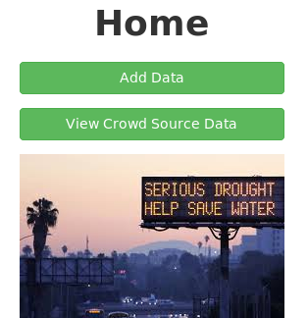

Fig. 1 Water analysis portal
In the paper, section II will describe our system’s web GUI portal. Section III, IV, V and VI will show what system features are, architecture, technologies, system design and its deployment. Section VII will provide several use-cases to show how users can perform their own analyses. In the end, we describe our future work and conclusions.

Water Drought Analytics Portal
Although the volume of data related to “water” is overwhelming in the web space, those data are scattered, making it significantly difficult for users to find useful data and analyze them [1-7]. Our proposing system is intended for fostering the convenient place for water analyses where users can perform their own analyses in a one-stop service way.
At the same time, the data currently available are not sufficient for certain types of analyses. For example, even if we want to analyze household-based water consumption, such kind of data belongs to only the water companies and is not open to public. This situation makes it difficult to leverage advanced analytics technologies to be utilized in the field of household-based big data analyses. The crowd-sourcing data site featuring our system enables the collection of such household-based data and makes it easy for users (especially researchers and students) to perform various types of big data analyses.

System Behavior
The home page of our web system is a simple portal for prompting users to look or upload data. Fig.1 shows the home page of our site. As you see in the top of the page, “adding data” and “viewing data” are the primary functions of the system from the user perspective. Any contributions from the users are collected through the button “Add Data” and any useful contributions (feedbacks) to the users are embedded in the button “View Crowd Source Data”.
The system breaks down the detailed operation under the two; how you can add your own data to the system or how you can view the data from various perspectives. Several examples are shown in Section VII.

System Overview - Architecture and Technologies
To achieve the purpose described in the previous section, we developed a highly flexible system for crowd-sourcing data collection. The system architecture is depicted in Fig. 2 where a typical web system (frontend) is combined with a data-intensive analytics engine (backend). The web system consists of application server (Tomcat7), JavaEE servlet, and JSP (Java server pages). On the other hand, the backend engine consists of MongoDB and Hadoop, and MongoDB connector for Hadoop is used between the two. The technologies we used in the development are listed in Table I.

- Technologies
Name | Technology type
JavaEE | Development platform
Eclipse | IDE
MongoDB | Database (NoSQL)
Hadoop | Scalable distributed computing
git | Distributed version control system
GitHub | Project hosting using git

System Design
Place the materials about common practice in design here.
- Use-case diagram
- ER diagram and schema
- Object diagram
- Functional specifications
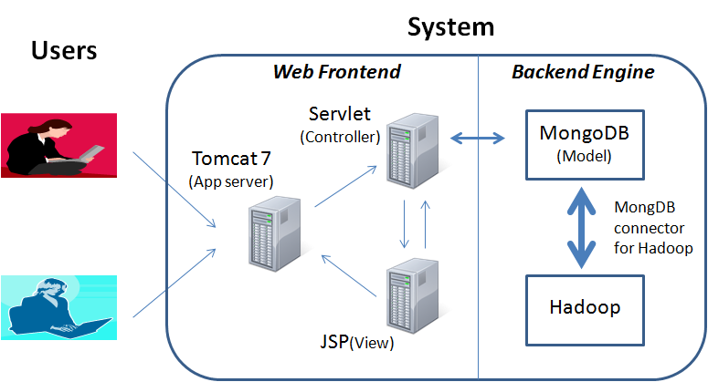

Fig. 2 System architecture
- and others

Use-case diagram
Place use-case diagram here and explain it.

ER diagram and scheme
Place ER diagram and schema here and also explain the data model.

Object diagram
Place object diagram here and explain the object behavior.

Functional specifications
Place functional specification here and explain it.

Other materials related to design
Place any other relevant materials here and explain it.

Deployment
The AWS EC2 was used for the deployment target. Apache Tomcat 7, MongoDB, Hadoop, and the connector between the last two were manually setup in the server in advance. Then, generated war file of our system was deployed to the server.

Analysis Examples
Place several examples in the usage of the system and analyses here.

Related works
Place related works here with reference.

Future work
We have implemented only the basic part of the intended system. Therefore, various features can be attached to the current system to improve user experience, system reliability, and system performance. Several ideas for the future enhancements are listed in Table II.

- Future enhancements
Type | Detail
Automation | Automatic data connection between web frontend and backend engine

Conclusions
We have developed a highly-flexible system for crowd-sourcing data collection especially useful for water drought analyses. The system accumulates various data straddling multiple areas from basic environmental measures such as precipitation to fine grain data of household water consumption.
One analysis example showed that the California water drought is currently a big problem but it can be saved by XXXing YYY.
Although our system is still immature both in the system reliability and the performance as well as the size of data collected, we hope a successful data accumulation will help the analyses in the research field related to water and promote people to reduce the consumption of water under the crisis condition of this drought.

References.
- Department of Water Resources, California Cooperative Show Surveys, http://cdec.water.ca.gov/cgi-progs/iodir_ss?s=WSIHIST, 2013
- Department of Water Resources, 2010 Urban Water Management Plan Data, http://www.water.ca.gov/urbanwatermanagement2010_Urban_Water_Management_Plan_Data.cfm, 2014
- Department of Water Resources, Water Data Library : Continuous Time Series Data, http://www.water.ca.gov/waterdatalibrary/docs/Hydstra/index.cfm?site=12N04E03N003M, 2014
- Western Regional Climate Center, SACRAMENTO FAA ARPT, CALIFORNIA - Climate Summary, http://www.wrcc.dri.edu/cgi-bin/cliMAIN.pl?ca7630, 2014
- California Nevada River Forecast Center, CNRFC - Weather - Observed Precipitation, http://www.cnrfc.noaa.gov/rainfall_data.php, 2014
- Western Regional Climate Center, CalClim: California Climate Data Archive, http://www.calclim.dri.edu/pages/tools.html, 2013
- USGS, USGS Water Use Data for California, http://waterdata.usgs.gov/ca/nwis/wu, 2014

