California Water Drought Analysis Using Crowd-sourcing Data Collection

Rucha Brahmankar Darrel Pahm Claudia Furushima Porto Yasuhiko Sasaki Wei An Liao

Graduate School of Software Engineering
San Jose State University
San Jose, California, USA

Abstract— California is facing its worst drought in more than 100 years and one with no end insight. Conserving water has never been so important as it is becoming one of the most stressed resources. We propose a system using Amazon EC2 with MongoDB to analyze water data by Hadoop Map Reduce techniques for monitoring and managing the water consumption. We can do this by monitoring the water supply and monitoring households who use more than 127 gallons per day(average for single family household size).The system can create a usage report and can help to reduce water consumption up to 5%.

Index Terms—Water drought, MongoDB, Hadoop/Map Reduce.

Introduction
In the past, California has faced worst drought for more than 100 years and one with no end insight.

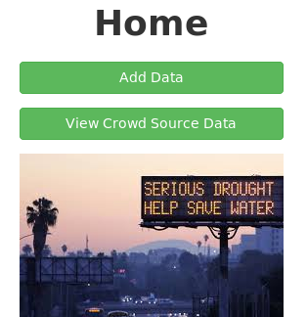

Fig. 1 Water analysis portal

Water Drought Analytics Portal
Although the volume of data related to “water” is overwhelming in the web space, those data are scattered, making it significantly difficult for uses to find useful data and analyze them. Our proposing system is intended for fostering the convenient place for water analyses where users can perform them in a one-stop service way.
At the same time, the data currently available are not sufficient for certain types of analyses. For example, even if we want to analyze household-based water consumption, such kind of data belongs to only the water companies and is not open to public. This situation makes it difficult to leverage advanced analytics technologies to be utilized in the field of household-based big data analyses. The crowd-sourcing data site featuring our system enables the collection of such household-based data and makes it easy for users (especially researchers and students) to perform various types of big data analyses.

System Behavior
The home page of our web system is a simple portal for prompting users to look or upload data. Fig.1 shows the home page of our site. As you see in the top of the page, “adding data” and “viewing data” are the primary functions of the system from user perspective. The system breaks down the detailed operation under the two; how you can add your own data to the system or how you can view the data from various perspectives. Several examples are shown in Section VII.
Any contributions from the users are collected through the button “Add Data” and any useful contributions (feedbacks) to the users are embedded in the button “View Crowd Source Data”.

System Overview - Architecture and Technologies
To achieve the purpose described in the previous section, we developed a highly flexible system for crowd-sourcing data collection. The system architecture is depicted in Fig. 2 where a typical web system (frontend) is combined with a data-intensive analytics engine (backend). The web system consists of application server (Tomcat7), JavaEE servlet, and JSP (Java server pages). On the other hand, the backend engine consists of MongoDB and Hadoop, and MongoDB connector for Hadoop is used between the two. The technologies we used are listed in Table I.

- Technologies
Name | Technology type
JavaEE | Development platform
Eclipse | IDE
MongoDB | Database (NoSQL)
Hadoop | Scalable distributed computing
git | Distributed version control system
GitHub | Project hosting using git

System Design
Place the materials about common practice in design here.
- Use-case diagram
- ER diagram and schema
- Object diagram
- Functional specifications
- and others
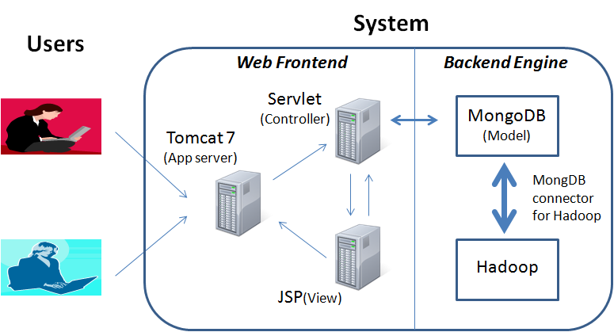

Fig. 2 System architecture

Use-case diagram
Place use-case diagram here and explain it.

ER diagram and scheme
Place ER diagram and schema here and also explain the data model.

Object diagram
Place object diagram here and explain the object behavior.

Functional specifications
Place functional specification here and explain it.

Other materials related to design
Place any other relevant materials here and explain it.

Deployment
The AWS EC2 was used for the deployment target. Apache Tomcat 7, MongoDB, Hadoop, and the connector between the last two were manually setup in the server in advance. Then, generated war file of our system was deployed to the server.

Analysis Examples
Place several examples in the usage of the system and analyses here.

Related work
Place related works here with reference.

Future work
We have implemented only the basic part of the intended system. Therefore, various features can be attached to the current system to improve user experience, system reliability, and system performance. Several ideas for the future enhancements are listed in Table II.

- Future enhancements
Type | Detail
Automation | Automatic data connection between web frontend and backend engine

Conclusions
We have developed a highly-flexible system for crowd-sourcing data collection especially useful for water drought analyses. The system accumulates various data straddling multiple areas from basic environmental measures such as precipitation to fine grain data of household water consumption.
One analysis example showed that the California water drought is currently a big problem but it can be saved by XXXing YYY.
Although our system is still immature both in the system reliability and the performance as well as the size of data collected, we hope a successful data accumulation will help the analyses in the research field related to water and promote people to reduce the consumption of water under the crisis condition of this drought.

References.
- G. Eason, B. Noble, and I. N. Sneddon, “On certain integrals of Lipschitz-Hankel type involving products of Bessel functions,” Phil. Trans. Roy. Soc. London, vol. A247, pp. 529–551, April 1955. (references)
- .

