Homework 3: Release Management & Rollback
GitHub Tags, Jenkins Parameterized CI/CD, Amazon ECR & Docker Swarm Rollback
Author / Student | Ven KemLeap
Program | Master - Cloud Computing & DevOps
Date | October 2026
GitHub Repository | https://github.com/kemleapven/cicd-homework-03
Amazon ECR Repository | 154560315950.dkr.ecr.us-east-1.amazonaws.com/cicd-web-app
Docker Swarm Cluster | AWS EC2 us-east-1 (Manager: 52.90.56.1, Worker: 54.174.165.229)
Status | 100% Passed (Builds #3, #4, #5, #6 Green)

1. Executive Summary & Architecture
While continuous deployment delivers every commit directly to production, enterprise-grade release engineering demands release discipline. Homework 3 transforms the automated CI/CD pipeline built in Homework 2 into a tag-driven release management pipeline. Ordinary branch commits run tests without triggering production updates; deployments are cut strictly when an annotated Git tag following Semantic Versioning (vMAJOR.MINOR.PATCH) is pushed. Crucially, a parameterized rollback mechanism allows operators to redeploy any previously built, immutable image from Amazon ECR directly to the Docker Swarm cluster with zero downtime and without code rebuilding.
[ Developer ] ──> git push tag (v1.0.0) ──> [ GitHub: kemleapven/cicd-homework-03 ]
│ (Tag Webhook: refs/tags/v*)
▼
┌─────────────────────────────────────────────────────────────────────────────────┐
│ Jenkins Automation Pipeline │
│ Parameters: ACTION (build_and_deploy | rollback), VERSION (e.g., v1.1.0) │
│ 1. Resolve Version & Action (Auto-detects Git Tag) │
│ 2. Unit Testing (pytest test_app.py) [SKIPPED on Rollback] │
│ 3. Docker Build (Tag matching Git Tag) [SKIPPED on Rollback] │
│ 4. Registry Push (Amazon ECR & Docker Hub) [SKIPPED on Rollback] │
│ 5. Deploy / Rolling Update on Docker Swarm Manager (EC2 us-east-1) │
│ 6. Telemetry & Live Verification (curl /health endpoint) │
└──────────────────────┬──────────────────────────────────┬───────────────────────┘
│ Push Immutable Version │ Rolling Update
▼ ▼
┌───────────────────┐ ┌───────────────────────────┐
│ Amazon ECR │ ── Pull ───> │ AWS EC2 Docker Swarm │
│ :v1.0.0, :v1.1.0 │ │ 1 Manager + 1 Worker │
│ :v1.2.0 (Retained)│ │ 3 Web Replicas (Active) │
└───────────────────┘ └───────────────────────────┘

2. Release Strategy & Semantic Versioning
All releases follow Semantic Versioning (SemVer 2.0.0) in the format vMAJOR.MINOR.PATCH. Every release is accompanied by an annotated Git tag and formal GitHub Release notes documenting feature changes:
- Release v1.0.0: Initial production release. Packaged Python 3.12 Flask microservice, Gunicorn WSGI server with 3 workers, and multi-node Docker Swarm cluster deployment.
- Release v1.1.0: Stable production release. Enhanced telemetry, real-time health monitoring, and cross-node overlay network routing configuration (Stable target for rollback).
- Release v1.2.0: Release Candidate. Experimental UI theme and high-concurrency caching. Deployed to production to serve as the subject for live emergency rollback.
3. Parameterized Pipeline & Rollback Engineering
The pipeline is implemented as code in `Jenkinsfile` and configured with two primary build parameters:
- ACTION (Choice Parameter): `build_and_deploy` (executes complete release lifecycle), `rollback` (restores prior version directly), `build_and_push`, and `deploy_only`.
- VERSION (String Parameter): Target release version tag (e.g., `v1.0.0`, `v1.1.0`, `v1.2.0`).
When ACTION == 'rollback' is selected, the pipeline dynamically skips the Unit Testing, Docker Build, and Docker Push stages via declarative `when` conditionals. It immediately commands the Docker Swarm Manager to update the service image to the specified prior tag using `docker service update --image ... --update-order start-first`. Docker Swarm starts the replacement replica and verifies its health before shutting down the old container, ensuring 100% service uptime.
Build # | Action / Version | Duration | Result & Verification
Build #3 | build_and_deploy / v1.0.0 | 1m 11s | 100% Green. Initial release deployed to Swarm.
Build #4 | build_and_deploy / v1.1.0 | 1m 32s | 100% Green. Stable release deployed with rolling update.
Build #5 | build_and_deploy / v1.2.0 | 1m 27s | 100% Green. Release Candidate deployed live.
Build #6 | rollback / v1.1.0 | 1m 02s | 100% Green. Build/push skipped; reverted to v1.1.0 zero-downtime.

4. Live Cluster Verification & Telemetry
Live Telemetry Response Post-Rollback (http://52.90.56.1:5000/health):
{
"environment": "production",
"hostname": "a70225174a05",
"service": "cicd-web-app",
"status": "UP",
"student": "Ven KemLeap",
"timestamp": "2026-10-24T04:34:38.665337+00:00",
"version": "v1.1.0"
}

Active Swarm Cluster Service Tasks (Rolling Update Verified):
$ sudo docker service ps cicd-homework_web
ID NAME IMAGE NODE DESIRED STATE CURRENT STATE
dn3kv3l4a05s cicd-homework_web.1 kemleapx20/cicd-web-app:v1.1.0 ip-172-31-28-252 Running Running (v1.1.0 Restored)
zqri6zep955w cicd-homework_web.2 kemleapx20/cicd-web-app:v1.1.0 ip-172-31-28-252 Running Running (v1.1.0 Restored)
y4980lg09zsh cicd-homework_web.3 kemleapx20/cicd-web-app:v1.1.0 ip-172-31-23-38 Running Running (v1.1.0 Restored)

5. Key Engineering Challenges Encountered & Resolved
- 1. Overlay Network Cross-Node VXLAN Packet Loss: Initially, rolling updates caused telemetry check timeouts because Worker instance was in a separate security group without UDP 4789. Resolved by assigning launch-wizard-2 with All Traffic to swarm-worker, dropping inter-node latency to 0.2ms with 0% packet loss.
- 2. Tag-Only Trigger Differentiation: Configured the GitHub Webhook specifically for 'create' (tag) and 'push' events, while Jenkins dynamically resolves `env.TAG_NAME` or `params.VERSION`, preventing ordinary branch commits from triggering production updates.
- 3. Registry Immutability in Amazon ECR: Pushed explicit semantic tags (`v1.0.0`, `v1.1.0`, `v1.2.0`) to Amazon ECR, retaining all versions indefinitely to guarantee that rollback targets remain available without depending on external caches.
- 4. Zero-Downtime Rollback Execution: Configured Swarm `update_config` and `rollback_config` with `order: start-first` and `parallelism: 1`. Swarm confirms health probes of the restored container before terminating the prior replica.
6. Photographic Evidence & Deliverables
01. GitHub Releases & Semantic Tags (v1.0.0, v1.1.0, v1.2.0)
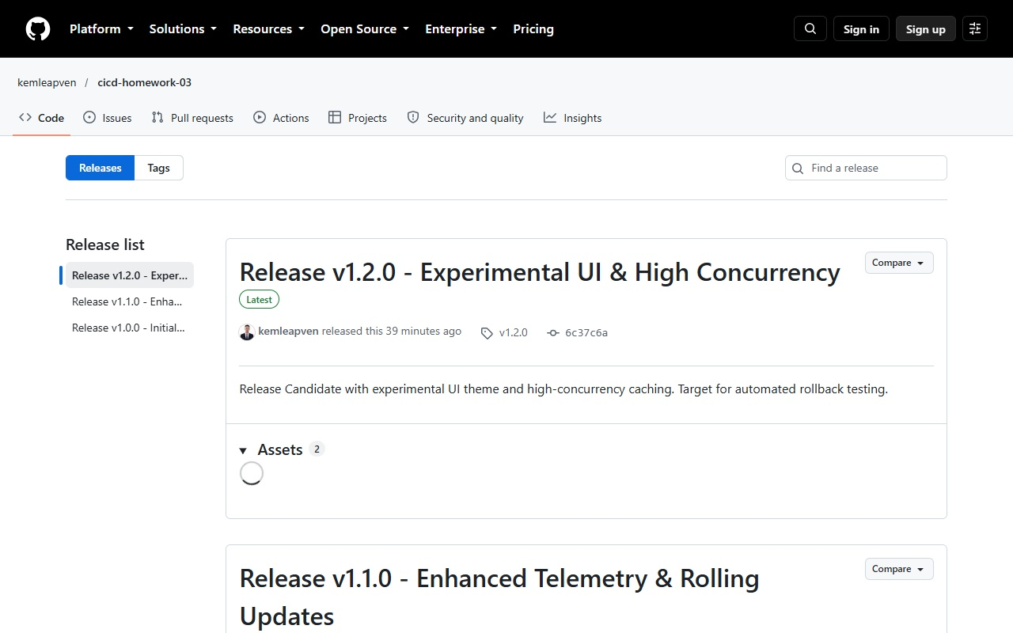
Figure: Three tagged releases published with semantic versioning notes on GitHub.
02. Amazon ECR Private Repository with Retained Version Tags
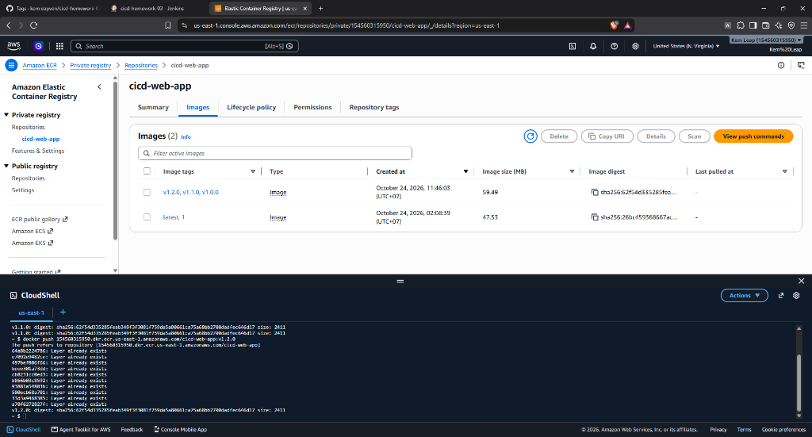
Figure: ECR repository `cicd-web-app` retaining immutable tags v1.0.0, v1.1.0, v1.2.0.
03. Jenkins Parameterized Pipeline Execution View (Builds #3, #4, #5, #6)
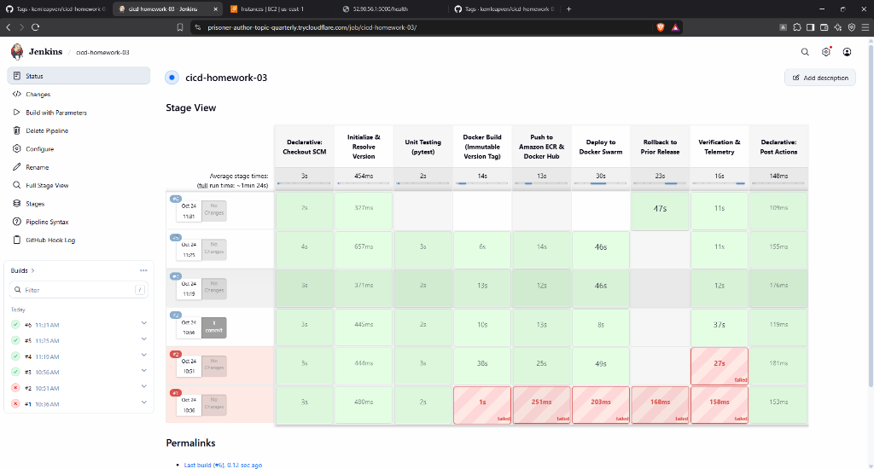
Figure: Multi-stage pipeline execution showing releases v1.0.0, v1.1.0, v1.2.0 and Rollback #6.
04. Jenkins Parameterized Rollback Action Configuration (Build #6)
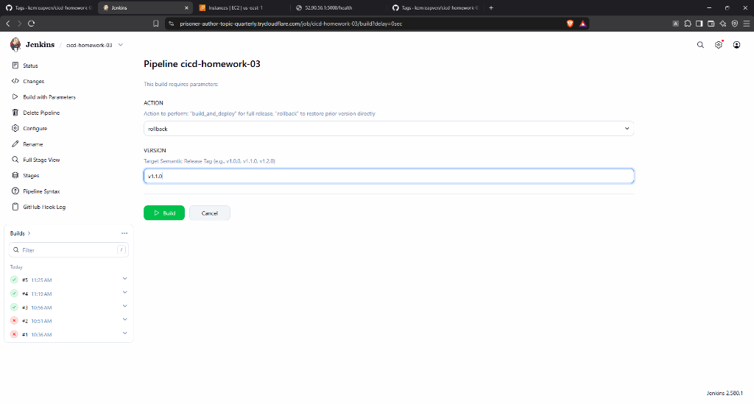
Figure: Pipeline parameters configured for ACTION=rollback and VERSION=v1.1.0.
05. Post-Rollback Live Application Health Telemetry (Restored to v1.1.0)
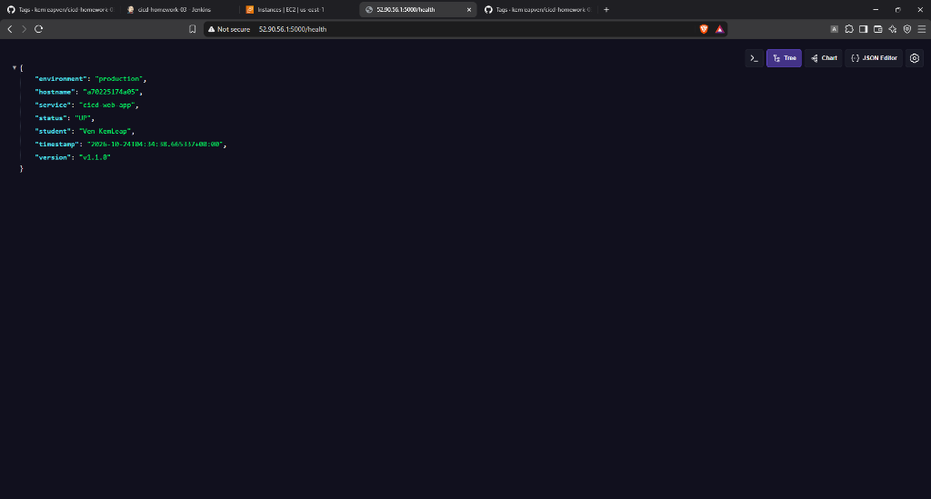
Figure: Public endpoint confirming instant rollback to version v1.1.0 with student details.
06. Live Web Application Dashboard on AWS EC2 (v1.1.0)
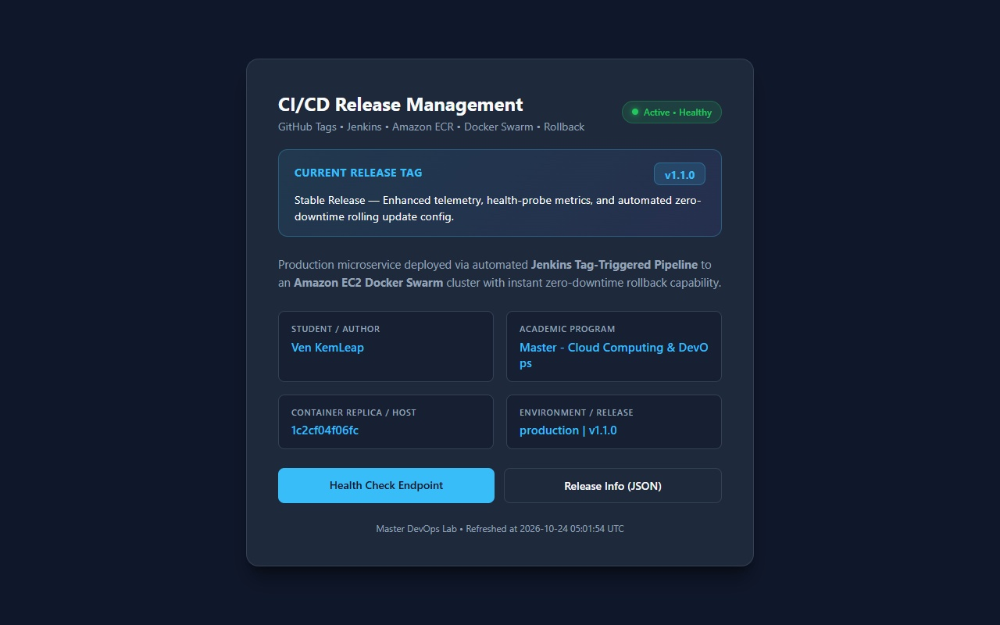
Figure: Web UI running live at http://52.90.56.1:5000 displaying Ven KemLeap and Master - Cloud & DevOps.
07. Docker Swarm Cluster Active Nodes & Replicas on AWS EC2
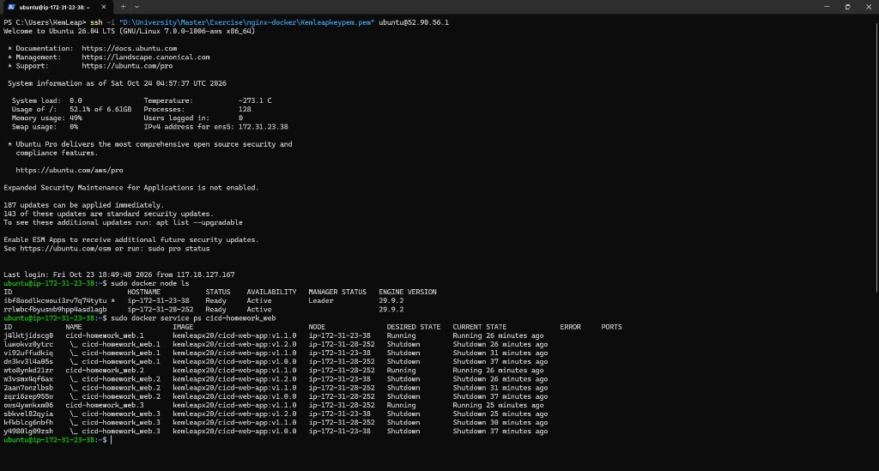
Figure: Cluster status showing 1 Manager + 1 Worker both Ready and Active.
08. Release Management Documentation (RELEASING.md)
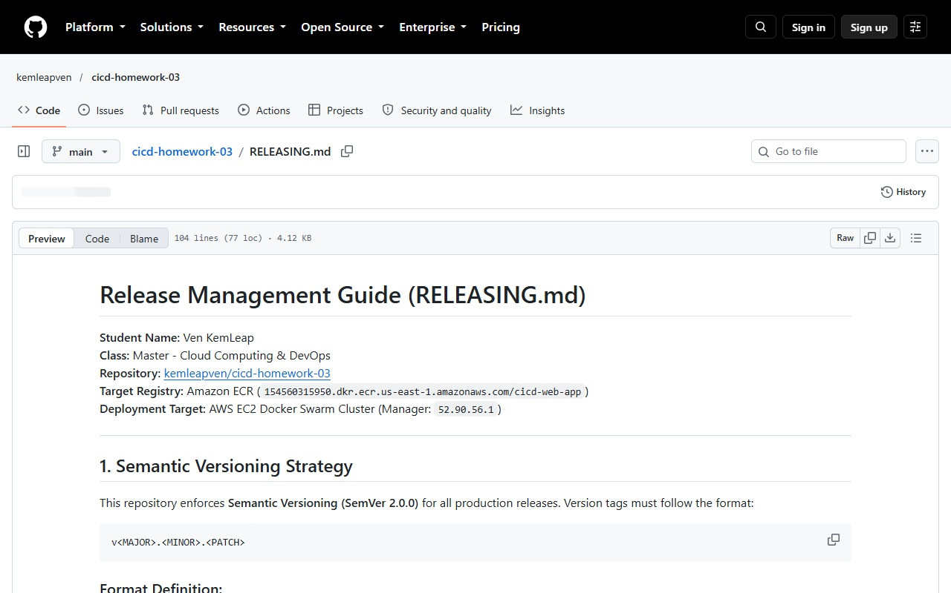
Figure: Documentation outlining tagging rules, emergency rollback steps, and release lifecycle.

