Checkpoint 02: Deploying and Securing a MERN Application
(ITE 314: ADVANCED DATABASE SYSTEMS)
Project Information | Details
Project Title | Panzi — AI Pantry & Recipe Assistant
Group/Team | [FILL IN]
Members | [FILL IN]
Course/Section | [FILL IN]
Instructor | [FILL IN]
Date | September 23, 2026
Frontend Deployment URL | Pending — not yet deployed (see Section 8)
Backend/API Deployment URL | Pending — not yet deployed (see Section 8)
Repository URL | https://github.com/kemoceraldeup-arch/panzi

1. Project Overview
Provide a concise description of your group's application.
Item | Group Response
Project Title | Panzi — AI Pantry & Recipe Assistant
Problem/Need Addressed | Households lose track of groceries they already own, leading to food waste from forgotten or expired items. Manually logging pantry contents and expiry dates is tedious enough that most people skip it.
Target Users | General consumers/households who want to reduce food waste by tracking what they have on hand and getting recipe ideas based on items nearing expiry.
Main Purpose | Panzi lets a user photograph their groceries; an AI vision call reads the items and use-by dates off the photo and turns them into pantry entries automatically, removing the friction of manual data entry. It then recommends recipes that prioritize ingredients closest to spoiling.
Major Features | • Camera-based pantry scanning with AI-assisted item/date recognition• Pantry inventory tracking (quantity, category, storage location, expiry date, freshness/ripeness)• Recipe suggestions generated from current pantry contents, prioritizing soon-to-expire items• Diet- and allergy-aware recipe filtering• Per-item and per-recipe nutrition lookup (calories, protein, carbs, fat)• Conversational chat assistant for food/recipe questions• Saved recipes, recipe ratings, and scan history• User profile with photo, dietary preferences, and account data export/deletion

2. MERN Architecture
How the React (Expo/React Native) frontend communicates with the Express/Node.js backend, and how the backend interacts with MongoDB through Mongoose.
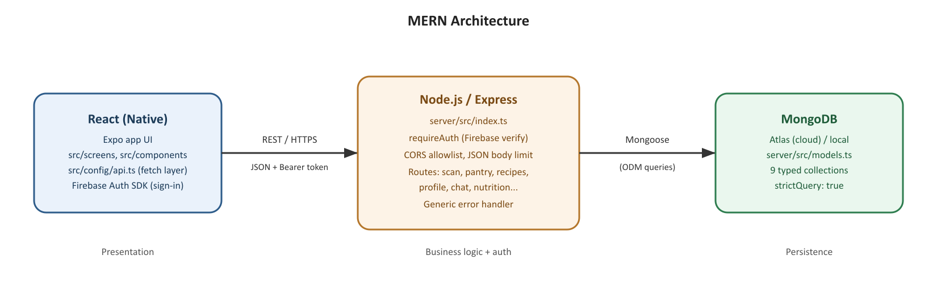
Component | Technology Used | Role in Our Project
Frontend | React Native + Expo (~57.0.24), React 19 | Renders the mobile UI (scanning, pantry list, recipes, chat, profile) and calls the API using a fresh Firebase ID token on every request.
Backend | Node.js / Express 5 | Exposes the REST API, verifies Firebase auth tokens, applies CORS and body-size limits, calls external services (OpenAI for vision/recipes, FatSecret for nutrition, Supabase for photo storage), and performs all MongoDB reads/writes.
ODM | Mongoose 9 | Defines strict, typed schemas for every collection (enums, required fields, numeric bounds) and provides the query layer used by all routes.
Database | MongoDB (Atlas in production, local MongoDB in development) | Stores users, pantry items, scans, saved recipes, recipe ratings, chat conversations/messages, feedback, and email-verification records.
API Communication | REST over HTTP(S), JSON payloads, Bearer-token auth | The Expo app calls the Express API directly (no GraphQL layer); the server never talks back to the app except in the HTTP response.

2.1 Request-Response Flow
Trace of one important user action — scanning a grocery photo and having it appear in the pantry — through the complete MERN request-response cycle.
Step | What Happens in Our Application
1. React/UI Event | User taps the camera button and photographs their groceries; the app captures the image and shows a loading state.
2. HTTP Request | The app sends POST /api/scan with the photo (base64) and an Authorization: Bearer <Firebase ID token> header.
3. Express Route | The request hits the /api/scan router (server/src/routes/scan.ts), which sits behind the requireAuth middleware mounted in server/src/index.ts.
4. Controller/Logic | requireAuth verifies the token against Google's public keys and sets req.uid. The route handler then sends the image to the AI vision model, parses the returned item list and use-by dates, and validates the shape of the response.
5. MongoDB Operation | Candidate items are returned to the client for review first (no write yet). Once the user approves them, POST /api/pantry/add writes the batch via Mongoose to the pantry_items collection, scoped to { userId: req.uid }.
6. API Response | The server responds with the created pantry item documents (or, for /api/scan, the candidate list) as JSON, or a generic error object if something failed.
7. UI Update | The app updates the pantry list in place and shows an “N items added · Undo” confirmation, using the client-generated IDs so the UI does not have to wait on a round trip to render.

3. Project Features and REST API
Major resources and endpoints implemented, from server/src/index.ts and server/src/routes/*.ts. Every route is protected by Firebase-token authentication (requireAuth) except /health, which is intentionally public for uptime checks.
Resource | Method | Endpoint | Purpose | Protected?
Health | GET | /health | Liveness check for the host | No
Scan | POST | /api/scan | Reads a grocery photo, returns candidate pantry items with names/dates | Yes
Recipes | POST | /api/recipes/featured | Suggests dishes from the current pantry | Yes
Recipes | POST | /api/recipes/alternates | Alternate recipe suggestions | Yes
Recipes | POST | /api/recipes/browse | Browse/search recipes | Yes
Pantry | GET | /api/pantry | Lists pantry items, soonest-expiring first | Yes
Pantry | POST | /api/pantry/add | Writes an approved scan batch to the pantry | Yes
Pantry | POST | /api/pantry/update | Applies a correction to one item | Yes
Pantry | POST | /api/pantry/patch-many | Batch-patches different fields on different items | Yes
Pantry | POST | /api/pantry/delete | Removes items (also used by Undo) | Yes
Pantry | POST | /api/pantry/clear | Clears the pantry | Yes
Pantry | POST | /api/pantry/move | Changes an item's storage location | Yes
Pantry | POST | /api/pantry/scan-photo | Attaches an uploaded photo to scanned items | Yes
Nutrition | POST | /api/nutrition/lookup | Per-item macro lookup via FatSecret | Yes
Nutrition | POST | /api/nutrition/recipe | Recipe-level nutrition estimate | Yes
Profile | GET | /api/profile | Fetches the user document | Yes
Profile | POST | /api/profile/create | Creates a profile | Yes
Profile | POST | /api/profile/save | Merges diets, allergies, photo URL | Yes
Profile | POST | /api/profile/survey | Records onboarding answers | Yes
Profile | POST | /api/profile/name | Updates display name | Yes
Profile | GET | /api/profile/export | Exports the user's data | Yes
Profile | POST | /api/profile/delete | Deletes the account; logs a deletion audit record | Yes
Profile | POST | /api/profile/photo | Uploads an avatar to Supabase Storage | Yes
Profile | POST | /api/profile/photo/remove | Removes the avatar | Yes
Saved Recipes | GET | /api/saved-recipes | Lists dishes the user saved | Yes
Saved Recipes | POST | /api/saved-recipes/save | Saves a dish (overwrites on duplicate) | Yes
Saved Recipes | POST | /api/saved-recipes/unsave | Removes a saved dish | Yes
Recipe Ratings | POST | /api/recipe-ratings | Rates a dish (1–5 stars) | Yes
Scans | GET | /api/scans | Scan history, newest first, capped at 30 | Yes
Scans | POST | /api/scans/save | Records a finished scan | Yes
Scans | POST | /api/scans/update | Corrects a scan later | Yes
Scans | POST | /api/scans/photo | Repoints a scan at its uploaded photo | Yes
Dish Photo | GET | /api/dish-photo | Returns an AI-generated/fetched dish photo | Yes
Feedback | POST | /api/feedback | Submits user feedback | Yes
Chat | GET | /api/chat/conversations | Lists chat conversations | Yes
Chat | POST | /api/chat/conversations | Creates a conversation | Yes
Chat | POST | /api/chat/conversations/:id/delete | Deletes a conversation | Yes
Chat | GET | /api/chat/conversations/:id/messages | Lists messages in a conversation | Yes
Chat | POST | /api/chat/conversations/:id/messages | Sends a chat message | Yes
Email Verification | POST | /api/verify-email/send | Sends a verification code by email | Yes
Email Verification | POST | /api/verify-email/confirm | Confirms a verification code | Yes

4. Security Analysis of Our Project
Security risks selected for relevance to this project's features and data (photo uploads, health-adjacent diet/allergy data, AI/third-party API calls).
Area | Potential Risk in Our Project | Impact | Planned Control
Authentication | Stolen or replayed Firebase ID token used to call the API as another user. | Unauthorized read/write of that user's pantry, profile, and chat data. | Tokens are short-lived and re-verified on every request via firebase-admin (requireAuth); the app fetches a fresh token per call rather than storing one long-term.
Authorization/RBAC | A route forgets to scope a Mongo query by the caller's userId and returns/modifies another user's data. | Cross-account data leakage or tampering (pantry, chat, profile). | Every read/write is written as {_id, userId} using req.uid from the verified token, never a client-supplied id; a dormant requireAdmin/custom-claim mechanism exists for future admin routes but is not wired to any endpoint yet.
Input Validation | Malformed or oversized payloads (e.g., bad photo data, invalid ids, unexpected types) sent to routes that do manual validation instead of a schema library. | Server errors, corrupted pantry records, or wasted AI-API spend on garbage input. | Shared helpers (isValidId, badRequest) plus per-route typeof/Array.isArray checks reject malformed requests before they reach the database or an external API call.
Database | NoSQL operator injection if a client-controlled value were passed unsanitized into a Mongo filter. | Could bypass the userId ownership check and expose other users' documents. | mongoose.set('strictQuery', true) plus typed/enum Mongoose schemas; ownership filters are built server-side from req.uid, never from request body content.
API | Overly permissive CORS or an unbounded request body size on a public-facing API. | Cross-origin abuse, or large-payload denial-of-service against the single server instance. | CORS is restricted via an ALLOWED_ORIGINS allowlist; JSON body size is capped at 10mb (raised only enough for base64 photo uploads, not unbounded).
Passwords | N/A directly — this server never stores or hashes passwords itself. | If mishandled, would be the single highest-impact account-takeover risk. | Credential storage and verification is delegated entirely to Firebase Authentication; the Express server only verifies the resulting ID token and never sees a password.
Deployment | Backend is not yet deployed to a persistent host; free-tier hosts cold-start slowly or sleep, which could look like an outage during grading/demo. | Availability risk during evaluation; not yet a live attack surface. | Deploy to an always-on Node host (Render/Fly/Railway) before demo, with the same environment variables as local .env, and MongoDB Atlas network access restricted to that host.
Other | Health-adjacent fields (allergies, dietaryPreferences) are stored without field-level encryption. | If the database were compromised, this data would be readable in plaintext alongside everything else. | Accepted as a documented design tradeoff for a single-tenant, ownership-scoped app; flagged here as an area for improvement (see Section 11 reflection).

5. Authentication and Authorization
Users authenticate with Firebase Authentication on the client (email/password or anonymous sign-in via the Firebase SDK). The app attaches the resulting ID token to every API call as Authorization: Bearer <token>. The Express server verifies that token on each request using firebase-admin and never issues or stores its own session/JWT. There is currently one effective role (authenticated user); an admin capability exists in the code as a Firebase custom claim (requireAdmin) but is not yet attached to any route.
Role | Description | Allowed Functions | Restricted Functions
Authenticated User | Any user signed in through Firebase whose ID token verifies successfully. | Full CRUD on their own pantry, scans, saved recipes, ratings, chat conversations, profile, and feedback. | Cannot read or modify another user's documents; queries are always scoped to their own uid.
Unauthenticated Request | Any caller with no token, an invalid token, or an expired token. | Only GET /health. | Every /api/* route; requireAuth returns a generic 401 without revealing which condition failed.
Admin (scaffolded, not active) | A user whose Firebase custom claim admin is set to true, intended for a future admin panel. | Defined in middleware (requireAdmin) but not currently attached to any route. | No admin-only endpoints exist yet; this role has no additional access in the running system today.

5.1 RBAC Matrix
System Function | Authenticated User (own data) | Unauthenticated
View | ✓ | ✗
Create | ✓ | ✗
Update | ✓ | ✗
Delete | ✓ | ✗
Manage Users | ✗ (self-service only: own profile/account deletion) | ✗
Reports/Admin Functions | ✗ (scaffolded, not implemented) | ✗
Note: this project does not (yet) have a multi-tier role system (e.g., user vs. moderator vs. admin) with distinct permissions in active use — access control today is ownership-based (a user may only act on documents where userId matches their verified uid), which the RBAC matrix above reflects.

6. Secure Development Practices
Security Control | Implementation in Our Project | Evidence/Screenshot
Input Validation | Manual per-route checks (typeof, Array.isArray) plus shared isValidId()/badRequest() helpers in server/src/routes/helpers.ts; no third-party schema library (zod/joi) is used yet. | [Insert code screenshot of helpers.ts]
Parameterized/Safe Database Queries | All access goes through Mongoose's query builder (no raw/string-concatenated queries); strictQuery is enabled so unrecognized filter keys are rejected rather than silently matched. | [Insert code screenshot of mongo.ts]
Password Hashing | Not applicable on this server — password storage/verification is fully delegated to Firebase Authentication, which handles hashing on Google's infrastructure. | [Insert Firebase Auth console screenshot]
Authentication | Firebase ID tokens verified per-request via firebase-admin (requireAuth middleware); no custom session or JWT issuance. | [Insert code screenshot of middleware/auth.ts]
Authorization/RBAC | Ownership-based: every query is scoped to { userId: req.uid } derived from the verified token, never from the request body. | [Insert code screenshot of a route showing userId scoping]
Least Privilege | Routes only request the fields/collections they need; the admin custom claim exists but grants no extra route access today, so no account currently holds elevated privileges. | [Insert screenshot]
Secure Error Handling | A catch-all Express error handler returns a generic { error, message } response and logs only err.message server-side; a withDb() wrapper applies the same pattern to database errors so raw Mongo error text never reaches the client. | [Insert code screenshot of index.ts error handler]
Security Headers | Not yet implemented — helmet is not currently a dependency. Planned improvement (see Section 11). | N/A — gap
Rate Limiting | General API rate limiting is not yet implemented. A narrow, purpose-specific guess-limit exists for email verification codes (attempts counter + lockedUntil field). Planned improvement (see Section 11). | [Insert code screenshot of verifyEmail.ts attempts/lockedUntil]
Environment Variables | All secrets (OpenAI/API keys, Firebase service account, MongoDB URI, Supabase keys, SMTP credentials) live in server/.env, which is gitignored; a server/.env.example documents the required keys without real values. The Expo app's .env only ever contains public, non-secret values because Expo inlines EXPO_PUBLIC_* variables into the client bundle. | [Insert screenshot of .env.example]
HTTPS/TLS | Not yet configured — the API currently runs over plain HTTP on the local network for development. Will be enabled automatically by the chosen host (Render/Fly/Railway all terminate TLS) once deployed. | N/A — pending deployment
Database Security | MongoDB Atlas (planned production target) with network access restricted to the deployed host, credentialed connection string stored only in server/.env, and strict Mongoose schemas (required fields, enums, numeric bounds) to constrain what can be written. | [Insert Atlas network access screenshot]

7. Database Design and Security
Collection | Purpose | Important Fields | Embedded/Referenced | Security Consideration
users | One document per account. | _id (Firebase uid), name, dietaryPreferences, allergies, mealPlanOptIn, photoURL | Referenced by userId from every other collection | _id is the caller's own verified uid, so a user can only ever address their own document.
pantry_items | Tracks what a user currently has on hand. | userId (indexed), name, quantity, category, location, expiryDate, nutrition (embedded), packageStatus | nutrition and scanPhoto embedded as sub-documents; userId is a reference | Compound index on {userId, expiryDate}; every query filtered by userId from the token.
scans | History of AI photo-scan results. | userId (indexed), sceneLabel, candidates, addedItemIds, accuracy | candidates/original stored as embedded Mixed data | Indexed on {userId, createdAt} so history is always fetched pre-scoped to the caller.
saved_recipes | Recipes the user bookmarked. | userId (indexed), key, recipe (embedded) | recipe embedded as Mixed | _id derived from uid+slug, preventing one user's save from colliding with or overwriting another's.
recipe_ratings | Star ratings a user gave a dish. | userId (indexed), title, stars (1–5) | Referenced by userId | Schema-level min/max validation (1–5) rejects out-of-range values before they're persisted.
chat_conversations / chat_messages | The chat assistant's conversation history. | userId, title / conversationId, role (user|assistant), content | messages reference their parent conversation by id | role is enum-constrained; all conversation and message reads are scoped by userId.
email_verifications | Short-lived codes for email verification. | _id (uid), code, attempts, expiresAt, lockedUntil, reapAt | N/A | TTL index on reapAt auto-deletes stale rows; attempts/lockedUntil throttle code-guessing.
feedback / deletion_audit_log | User-submitted feedback; audit trail of account deletions. | userId, email, message / uid, requestedAt, requestedVia | N/A | deletion_audit_log intentionally survives account deletion as an accountability record.
All collections use a client-generated String _id rather than a Mongoose ObjectId so the UI can render optimistically (e.g., an "Undo" action) without waiting on a database round trip; every write pairs that _id with the caller's userId.

8. Deployment Plan
As of this checkpoint the application runs in local development only; the table below records the intended production setup and current status.
Component | Local Environment | Production Environment | Deployment Status
React Native Frontend | Expo Go / dev client on a phone, pointed at a LAN IP via EXPO_PUBLIC_API_URL | EAS Build (eas.json defines development/preview/production profiles) → app store or internal distribution | Pending
Node/Express API | tsx watch src/index.ts on localhost:8080 (or similar), reachable over LAN | Always-on Node host (Render, Fly, or Railway) so free-tier cold starts don't look like an outage | Pending
MongoDB | Local MongoDB or a dev MongoDB Atlas cluster | MongoDB Atlas, network access restricted to the API host's IP | Pending (Atlas cluster to be provisioned/locked down before go-live)
Environment Variables | server/.env (gitignored) with OpenAI/Firebase/Mongo/Supabase/FatSecret/Serper keys; root .env with only public EXPO_PUBLIC_* values | Same variables set as host-level secrets/config, never committed | Pending
HTTPS | None — plain HTTP on the local network | Provided automatically by the chosen host's TLS termination | Pending

8.1 Deployment Architecture
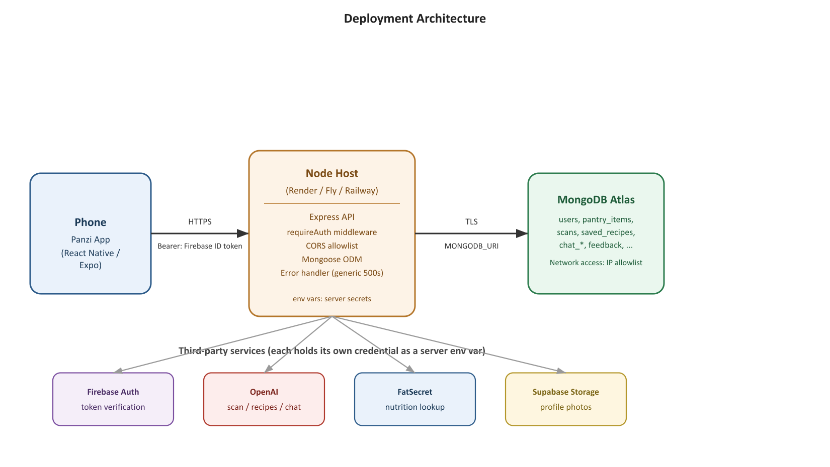

9. Security Testing
Planned tests against our own local/deployed instance. Actual/Status columns are to be completed after each test is run (mark PASS/FAIL and fill in the observed result).
Test Case | Procedure | Expected Result | Actual Result | Status
Invalid Login | Attempt to sign in with a wrong password / malformed credential via the Firebase Auth client. | Sign-in is rejected with a generic error; no session is created. | [Fill in after test] | [PASS/FAIL]
Unauthorized Route | Call a protected endpoint (e.g., GET /api/pantry) with no Authorization header. | 401 response; no data returned. | [Fill in after test] | [PASS/FAIL]
Role Restriction | Call an admin-scaffolded action (if/when wired) with a non-admin token. | 403/404 — request refused; currently no admin routes exist to test against. | [Fill in after test] | [PASS/FAIL]
Invalid Input | Send a pantry update with a missing/oversized/wrong-typed field. | 400 Bad Request from the manual validation helpers; no document written. | [Fill in after test] | [PASS/FAIL]
Protected API Without Token | Call POST /api/scan with an expired or garbage Bearer token. | 401 response; verifyIdToken() rejects the token before the handler runs. | [Fill in after test] | [PASS/FAIL]
Password Storage Check | Inspect the Firebase Authentication console/user record for the test account. | No plaintext password is visible or stored; this server has no password field at all. | [Fill in after test] | [PASS/FAIL]
Secure Error Response | Trigger a server-side error (e.g., malformed payload causing a DB error). | Client receives a generic { error: 'internal', message: 'Something went wrong.' } with no stack trace or Mongo details. | [Fill in after test] | [PASS/FAIL]
HTTPS Check | Inspect the deployed URL's scheme/certificate once hosted. | URL resolves over https:// with a valid certificate. | [Fill in after deployment] | [PENDING]
Rate Limit Test | Rapidly repeat email-verification code attempts on one account. | Further attempts are refused once attempts/lockedUntil threshold is hit. | [Fill in after test] | [PASS/FAIL]
Database Access Check | Attempt to connect to the MongoDB Atlas cluster from an IP outside the allowlist. | Connection refused by Atlas network access rules. | [Fill in after deployment] | [PENDING]

10. Deployment Verification Checklist
Item | Status
Frontend is accessible through the deployed URL. | ☐ Pending
Backend/API is accessible through the deployed environment. | ☐ Pending
MongoDB is connected successfully. | ☑ Yes — verified locally
CRUD operations work in production. | ☐ Pending deployment
Authentication works in production. | ☑ Yes — verified locally via Firebase Auth
Passwords are hashed and not stored as plain text. | ☑ Yes — handled entirely by Firebase Authentication; this server never sees or stores a password
Protected routes require authentication. | ☑ Yes — requireAuth on every route except /health
Role-based restrictions work. | △ Partial — ownership-based access control works; no multi-role admin routes exist yet to test
Input validation works. | ☑ Yes — manual validation helpers reject malformed requests
Sensitive configuration is stored using environment variables. | ☑ Yes — server/.env, gitignored
Production secrets are not committed to the repository. | ☑ Yes — only .env.example files are tracked
HTTPS is enabled for the deployed application. | ☐ Pending deployment
Secure error handling is implemented. | ☑ Yes — generic error responses, server-side-only logging
Security headers are configured where appropriate. | ✗ Not yet — helmet not implemented (see Section 11)
Rate limiting or an equivalent control is implemented where appropriate. | △ Partial — only on email-verification attempts; no general API rate limiting yet
MongoDB access is appropriately restricted. | △ Planned — Atlas network allowlist to be configured on deployment
Security tests were completed and documented. | △ In progress — see Section 9

11. Evidence and Screenshots
Insert screenshots showing the implementation and deployment of your project below each caption.
[INSERT SCREENSHOT HERE]
Figure 1. Project Homepage
[INSERT SCREENSHOT HERE]
Figure 2. Authentication/Login
[INSERT SCREENSHOT HERE]
Figure 3. Authorized User Function
[INSERT SCREENSHOT HERE]
Figure 4. Restricted/Unauthorized Function
[INSERT SCREENSHOT HERE]
Figure 5. Input Validation
[INSERT SCREENSHOT HERE]
Figure 6. MongoDB Data
[INSERT SCREENSHOT HERE]
Figure 7. Deployed Frontend
[INSERT SCREENSHOT HERE]
Figure 8. Deployed Backend/API
[INSERT SCREENSHOT HERE]
Figure 9. HTTPS
[INSERT SCREENSHOT HERE]
Figure 10. Security Testing Result

Reflection
1. What changed when your application moved from local development to deployment?
[FILL IN] — to be completed once deployed (expected: the API URL moves from a LAN IP to a public HTTPS host; environment variables move from local .env files to host-level secrets; MongoDB moves from local/dev Atlas to a network-restricted production Atlas cluster; the app must reach the server without both devices being on the same Wi-Fi network).
2. What security weakness did your testing reveal?
Two gaps are already visible from the code review itself, ahead of formal testing: (1) no general-purpose rate limiting on the API, so an attacker with a valid token could hammer any endpoint (e.g., /api/scan, which calls a paid AI service) with no throttling beyond the narrow email-verification attempt counter; (2) no helmet/security-headers middleware, so the API is not setting standard protective headers (HSTS, X-Content-Type-Options, etc.).
3. How did your group address the identified weakness?
[FILL IN] — describe the fix once implemented (planned: add express-rate-limit globally and helmet in server/src/index.ts before deployment).
4. What additional security improvement would you implement if given more development time?
Add field-level encryption or stricter access controls around health-adjacent data (allergies, dietaryPreferences); introduce a schema-validation library (zod) to replace the hand-rolled per-route checks; wire the existing requireAdmin scaffolding to real admin-only routes with tests; and add automated security regression tests (e.g., a script that asserts every route 401s without a token) to CI.

12. Final Project Information
Required Item | Submission / Link
Source Code Repository | https://github.com/kemoceraldeup-arch/panzi
Live Frontend | Pending — not yet deployed
Live Backend/API | Pending — not yet deployed
Database Configuration Evidence | [Insert Atlas/local MongoDB screenshot]
.env.example | Included in repository (root .env.example and server/.env.example)
Architecture Diagram | Section 2 / Section 8.1 of this document
RBAC Matrix | Section 5.1 of this document
Security Testing Results | Section 9 of this document
Documentation | This document; see also HANDOFF.md and server/README.md in the repository
Demo Video (if required) | [FILL IN]

13. Suggested Evaluation Rubric
Criterion | Points
MERN Architecture & Integration | 15
Project Functionality / CRUD | 15
Authentication & Password Security | 10
Authorization & RBAC | 10
Input Validation & Secure API | 10
Database Security & Least Privilege | 10
Deployment & HTTPS | 15
Security Testing & Evidence | 10
Documentation & Presentation | 5
TOTAL | 100

