Similarity-Governed Model Selection for Target-Cold-Start Drug–Target Affinity Prediction: GNN Applicability Boundary and a First-Order Meta-Learning Solution
Abstract
Motivation. Accurate drug–target affinity (DTA) prediction is a cornerstone of computer-aided drug discovery, underpinning virtual screening and lead optimization pipelines. Despite rapid advances in deep learning architectures, two fundamental gaps persist between academic benchmarks and industrial cold-start deployment. First, sample-wise random dataset splits introduce pervasive homology leakage, inflating performance estimates and creating a large discrepancy with real-world scenarios where entirely novel protein targets have no close homologs in the training set. Second, model evaluation and selection rely almost exclusively on regression metrics such as $R^{2}$ and RMSE, neglecting ranking performance and probabilistic calibration that are critical for virtual screening, and there exists no unifying theoretical framework to delineate model applicability boundaries across diverse molecular panels.
Results. Industrial cold-start drug–target affinity (DTA) prediction faces a dual predicament: residual leakage through target homology and binding-profile mirroring, and model selection driven by single headline metrics. We establish homology-free extrapolation as the unifying lens that resolves both, building a leakage-audited target-level cold-start benchmark (four datasets, seven baselines, regression–ranking–calibration evaluation) and reporting three counter-intuitive findings. (i) A structural information paradox: structure-aware state-of-the-art models lose their entire advantage under strict target novelty. (ii) A similarity-governed applicability structure: the R²-versus-enrichment preference reverses across a narrow, descriptive training-panel Tanimoto band (τ ≈ 0.13; n = 4 panels), and per-target decoupling on dense panels survives Bonferroni correction while winner-level consistency across panels does not exceed chance (five consistency tests, all n.s.). (iii) A statistical boundary of metric decoupling: on extremely sparse panels single ranking metrics degenerate into zero-variance statistics (Davis EF@1% ≡ 0 for all models and seeds). Pre-registered Grad-CAM attribution locates the paradox in GNN scaffold reliance, whereas meta-learning adapts functionally through cross-attention re-routing—an implicit task-adaptation mechanism insensitive to protein-encoder scale (ESM-2 35M vs ESM-1b 650M vs ProtT5 3B differ by ≤ 0.02 R²). These findings compose a similarity-governed selection theory, condensed in an applicability-region map, which we instantiate as Reptile-Transformer: first-order meta-learning, bidirectional cross-attention, and a multi-objective loss. On KIBA it attains R² = 0.3227 ± 0.0028 and EF@1% = 4.705 ± 0.040 (five seeds)—the best enrichment among all compared models—with 4–25× better calibration (ECE) than the strongest baselines. A 96.2%-accurate family-remote router and a validation-gated decision tree translate all findings into an industrial deployment guideline.
Availability: Code and benchmark datasets are publicly available at https://github.com/kemoribe/reptile-transformer.
Keywords: drug-target affinity prediction; target cold-start generalization; Reptile meta-learning; bidirectional cross-attention; Transformer; graph neural networks; model applicability boundary; virtual screening
1 Introduction
Drug–target affinity (DTA) prediction quantifies the binding strength between small-molecule compounds and protein targets, serving as a core computational tool for early-stage drug discovery tasks including virtual screening, lead optimization, and target deorphanization[1][2][5]. With advances in deep learning, a wide spectrum of DTA architectures has emerged, ranging from multilayer perceptrons (MLPs) and fingerprint-based descriptors to graph neural network (GNN) variants and Transformer-based frameworks and even quantum-classical hybrid approaches [3][10][11][21][26]. Recent work has further integrated multi-scale and cross-modal features—combining molecular graphs, substructure fingerprints, and pre-trained protein embeddings within unified architectures—to capture more nuanced drug–target interactions [4][6][13][27].
Nevertheless, two fundamental gaps limit the translational value of current DTA research. First, prevailing evaluation protocols rely heavily on sample-wise random dataset splitting, which causes severe data leakage by allowing shared protein targets and homologous sequences across training and test partitions [7][25]. In real pharmaceutical pipelines, however, therapeutic targets of interest typically correspond to out-of-distribution (OOD) cold-start settings with limited or no labeled affinity data and no close homologs in existing training panels. This homology leakage inflates benchmark performance and creates a large gap between academic state-of-the-art and industrial practical utility. Even dedicated cold-start methods often do not explicitly control for sequence homology in their split protocols, further overstating reported generalization performance [9][25].
Second, model evaluation and selection are dominated by regression metrics such as$R^{2}$ and RMSE, while ranking performance (critical for virtual screening) and probabilistic calibration (essential for wet-lab validation and active learning) are largely neglected[2]. Real-world drug discovery pipelines demand heterogeneous capabilities: virtual screening requires reliable prioritization of hit molecules, whereas downstream experimental design calls for well-calibrated confidence estimates. Overreliance on single regression metrics yields misleading model rankings and provides no systematic guidance for architecture selection across diverse deployment scenarios. Specialized target-specific prediction tools further highlight practical industrial requirements for task-tailored modelling[12][19].
Existing meta-learning DTA approaches often suffer from high computational overhead (e.g., second-order MAML) or are designed for binary interaction prediction rather than continuous affinity regression [8][9]. Meanwhile, studies on GNN applicability remain largely empirical, lacking a mechanistic explanation for when and why graph-based models fail under cold-start conditions [10][14]. To date, there is no unifying theoretical framework that connects dataset similarity, target homology coverage, model architecture, and task requirements into a coherent model-selection paradigm.
This work adopts a six-step narrative paradigm—dual-plight diagnosis → phenomenon discovery → mechanism attribution → theory construction → theory-guided design → statistical validation and deployment—with homology-free extrapolation as its single unifying evaluation and design principle. Our contributions follow this arc:
1.We establish a leakage-audited target-cold-start benchmark across four datasets with distinct structural density: MMseqs2 clustering quantifies and controls target homology coverage, and a binding-profile mirroring audit shows that activity-profile redundancy (max Spearman ρ ≥ 0.7 for 60–93% of cross-cluster test targets) is statistically independent of the 40%-identity clusters (all stratified Fisher tests n.s.). We demonstrate that target-homologous training coverage is the primary determinant of cold-start performance, and derive three transferable corollaries: the structural information paradox, the statistical boundary of metric decoupling, and the implicit task adaptation mechanism.
2.We propose Reptile-Transformer, a low-cost first-order meta-learning framework equipped with bidirectional cross-attention and multi-objective composite loss, designed explicitly for cold-start DTA regression. The framework avoids molecular-graph inputs to bypass the similarity-dependent performance boundaries of GNNs, while retaining competitive performance at a fraction of the computational cost of second-order meta-learning.
3.We systematically validate the framework through controlled ablations—feature combinations, module contributions, loss-weight sensitivity, gradient-conflict analysis, and protein-side adaptation—plus a protein-encoder capacity control showing that 100× larger protein language models shift R² by at most ±0.02 (within seed noise), i.e., representation capacity is not the binding constraint under homology-free extrapolation. All headline conclusions rest on five independent seeds with bootstrap 95% CIs, paired Wilcoxon tests and FDR correction; winner-level heterogeneity across panels is verified by five consistency tests (Fisher, binomial, permutation, McNemar; all n.s.), and 54 paired tests are summarized as an effect-size heat map.
4.We benchmark against recent strong cold-start baselines—including structure-aware BlendNet and cold-start-specific ColdstartMHDTI—under matched protocols, and provide mechanistic attribution evidence via pre-registered Grad-CAM and edge-occlusion analyses.
5.We derive actionable, scenario-aware model-selection guidelines for industrial-scale DTA modelling—including a validated family-remote routing classifier (96.2% accuracy, FPR 7.4%, FNR 0%, AUC 0.960 at a 40% identity threshold, with 95.5–97.1% accuracy in four-fold leave-one-dataset-out validation)—condense the findings into an applicability-region map (Figure 9), and outline a general theory of cold-start DTA prediction based on similarity and homology coverage covariates.
2 Methods
2.1 Datasets and cold-start partitioning
We adopt four public DTA datasets with distinct structural sparsity and target diversity: ChEMBL, Davis, BindingDB, and KIBA. Target-level splitting assigns all samples belonging to one target entirely to training, validation, and test partitions to eliminate sample-level leakage. Mean pairwise molecular Tanimoto similarity (ECFP4, training panel) quantifies dataset structural density (Table 1).
Homology strictness audit. To exclude homology-based semi-leakage, we clustered de-duplicated training and test target sequences with MMseqs2 (bidirectional coverage ≥ 0.8; identity thresholds 40%/60%/80%, functionally equivalent to CD-HIT). At 40% sequence identity, 53.9% (ChEMBL), 41.5% (Davis), 41.2% (KIBA), and 53.6% (BindingDB) of test targets share no cluster with any training target, rising to 76.9–100% at 80% identity (Table S 2,Figure S 2). Per-target nearest-neighbor identities are released alongside the benchmark to enable homology-stratified evaluation.
              - Table 1 Summary statistics of the four benchmark datasets
Dataset | Number of Molecules | Number of Drug–Target Pairs | Average Tanimoto Similarity | Structure–Activity Space Density | Target Diversity
Davis | 66 | 4290 | 0.1367 | High (dense) | Low (kinase-dominant)
KIBA | 2068 | 4274556 | 0.1215 | Medium | Medium
BindingDB | 66345 | 40252680 | 0.1098 | Low (sparse) | High
ChEMBL | 20000 | 399980000 | 0.1221 | Very low | Extremely high

2.2 Baseline Models
To systematically evaluate our proposed method, we selected seven model architectures across three representation families as controlled baselines. All baselines share identical input features and hyperparameter configurations for fair comparison where applicable.
MLP: A fully-connected network fed with concatenated global descriptors (Morgan fingerprints, physicochemical descriptors, ESM-2 protein embeddings).
Supervised Transformer baseline: A self-constructed control model without Reptile meta-learning modules, serving as the descriptor-family transformer reference, built on the same Transformer backbone as prior sequence-based DTA work [20].
GraphDTA variants: Four GNN architectures (GAT_GCN, GCNNet, GATNet, GINConvNet) representing the molecular-graph model family. GraphDTA is used as a representative classical GNN baseline due to its wide adoption and reproducible code [26]. Interaction-graph models (e.g., MONN) require protein–ligand contact-map supervision unavailable in all four benchmarks and were therefore excluded to keep the cold-start protocol identical；protein-structure-aware and pocket-based models represent an active parallel line of work [22][24].
Strong cold-start baselines (2025–2026): Two recent open-source models are added for head-to-head comparison.
BlendNet: A recent complex-free architecture fusing a PNA compound-graph encoder, ProtTrans residue embeddings, and Pseq2Sites pocket predictions with bidirectional cross-attention under teacher–student distillation. Evaluated in two modes: (a) original configuration on the official BindingDB IC50 benchmark using the authors' own target-cold-start protocol; (b) BlendNet-Seq, a sequence-only adaptation matching our exact input regime, run under our identical target-level cold-start split with three random seeds.
ColdstartMHDTI: A heterogeneous-graph meta-path model explicitly designed for cold-start DTI is included as a supplementary reference only [9]. Its target-level split does not control for sequence homology leakage, and thus its performance is not directly comparable to our homology-audited benchmark; full results are provided in Table S 14.
2.3 Reptile-Transformer Architecture
The framework consists of four core blocks: multi-source feature encoding, bidirectional cross-attention Transformer fusion, Reptile meta-learning loop, and multi-objective composite loss (Figure 1). Motivated by our preliminary benchmark observations, we avoid molecular-graph inputs to bypass GNN similarity-dependent performance boundaries under cold-target conditions.
This design choice is evidence-driven rather than a dismissal of molecular graphs: attribution analyses (Section 3.2) show that under cold-target conditions graph edges carry no positive attribution, while fingerprint-plus-descriptor inputs achieve comparable enrichment at substantially lower compute cost. The final model-selection guideline explicitly retains GINConvNet for interpretability-constrained deployments.
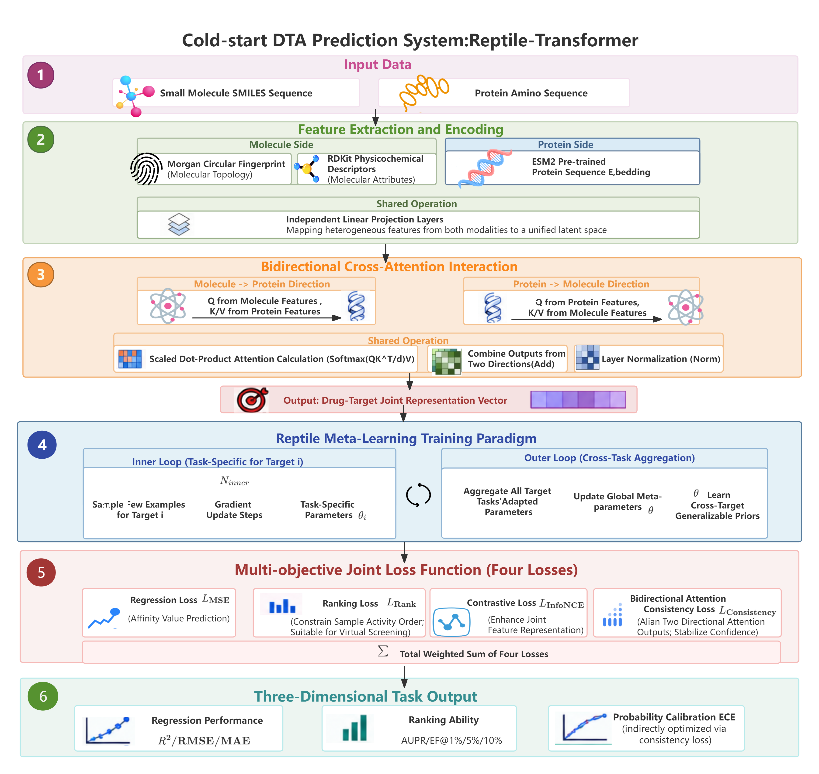
Figure 1 Overview of the Reptile-Transformer architecture for cold-start DTA prediction. The framework comprises four core modules: multi-source feature encoding, bidirectional cross-attention Transformer fusion, Reptile meta-learning loop, and multi-objective composite loss.
2.3.1 Multi-Source Feature Encoding
Small‑molecule inputs: 2048‑bit Morgan fingerprints plus 10 RDKit physicochemical descriptors.Protein inputs: 128-dimensional ESM2 pre-trained sequence embeddings, derived from the native 480-dimensional outputs of esm2_t12_35M_UR50D via a fixed linear projection layer, consistent with common sequence-based DTA feature protocols [15][20]. Independent linear projections map heterogeneous features to a shared latent space for multimodal fusion.
2.3.2 Bidirectional Cross-Attention Mechanism
Bidirectional cross-attention explicitly models molecule-protein pairwise interactions.Let $X_{m}$ denote molecule features and $X_{p}$ denote protein features:
$$\begin{aligned}\left\{\begin{aligned}Q_{m},K_{p},V_{p}=X_{m}W_{q},X_{p}W_{k},X_{p}W_{v} \\ Q_{p},K_{m},V_{m}=X_{p}W_{q},X_{m}W_{k},X_{m}W_{v} \\ Attn_{m←p}=Softmax\left(\frac{Q_{m}K_{p}^{⊤}}{\sqrt{d_{k}}}\right)V_{p} \\ Attn_{p←m}=Softmax\left(\frac{Q_{p}K_{m}^{⊤}}{\sqrt{d_{k}}}\right)V_{m}\end{aligned}\right.\#(1)\end{aligned}$$
Summation and normalization produce fused drug-target representations capturing ligand-pocket matching patterns.
2.3.3 First-Order Reptile Meta-Learning Algorithm
First-order Reptile uses nested inner-outer training loops, avoiding high computational overhead of second-order MAML.
Task distribution. A meta-task is defined as full-support affinity regression on a single target t: the inner loop performs three gradient steps (inner_steps = 3) on minibatches of size B (512; 2048 on KIBA) drawn from all affinity pairs of the target, and the outer loop aggregates the resulting per-task parameter deltas à la Reptile. We deliberately do not carve each target into disjoint support/query subsets: with as few as 66 compounds per target (Davis), a held-out query split would leave too few support samples for stable adaptation, so the full per-target panel serves as the support set and generalization is evaluated on entirely held-out targets. Tasks are sampled uniformly over training targets (ESM-2 fine-tuning layers use 0.1× the main learning rate). Tasks are consequently not i.i.d.—targets are naturally stratified by protein family. The associated cross-family failure risk and its practical mitigation are quantified in Sections 3.4 and 4.3.
Protein-side adaptation protocol. The protein tower operates on frozen ESM-2 embeddings by default (fine-tuning rate 0.1×), justified both theoretically and empirically: under K-shot cold-start adaptation, unfreezing the protein encoder risks catastrophic overwriting of universal residue representations, whereas the meta-loop can still adapt the protein side functionally by re-routing cross-attention projections. Section 3.4 quantifies the frozen/partial/full fine-tuning alternatives.
Protein-encoder capacity control. To test whether protein-representation capacity bounds homology-free extrapolation, we re-ran the full pipeline with the protein column of the precomputed feature set replaced by mean-pooled, frozen embeddings from ESM-1b (650M parameters [32]) and ProtT5-XL-UniRef50 (3B [33]), each projected through the same frozen random linear map to 128 dimensions (fixed seed 0), leaving molecular features, labels, splits and hyper-parameters byte-identical. Each variant was run with three seeds matched to the five-seed replication protocol; results appear in Section 3.6.4.
Inner-loop task adaptation:
$$\begin{aligned}θ_{i}=θ-α∇_{θ}L_{task}(D_{T_{i}};θ)\#(2)\end{aligned}$$
where $α$ denotes the inner-loop learning rate and $D_{T_{i}}$ represents the sample data corresponding to each target $T_{i}$.
Outer-loop meta-parameter update:
$$\begin{aligned}θ←θ+β⋅\frac{1}{N}\sum_{i=1}^{N}{(}θ_{i}-θ)\#(3)\end{aligned}$$
where $β$ denotes the meta-learning rate and $N$ denotes the number of meta-tasks. This training paradigm enables stable generalization to unseen cold-start targets.
2.3.4 Multi-Objective Joint Loss Function
We deploy a composite loss without standalone calibration loss:
$$\begin{aligned}L_{total}=L_{MSE}+λ_{1}L_{Rank}+λ_{2}L_{InfoNCE}+λ_{3}L_{consistency}\#(4)\end{aligned}$$
where $L_{\text{MSE}}$ is the regression loss for precise affinity prediction, $L_{\text{Rank}}$ is the ranking loss tailored for virtual screening, $L_{\text{InfoNCE}}$ is the contrastive loss for high-quality feature representation learning, and $L_{\text{consistency}}$ is the bidirectional attention consistency loss for interactive feature alignment and confidence calibration. $λ_{1},λ_{2},λ_{3}$ are hyperparameters for loss weight balancing.
The balancing weights ($λ_{\text{contrastive}}=0.05$, $λ_{\text{consistency}}=0.10$) were chosen by univariate sensitivity analysis: ±50–100% perturbations alter $R^{2}$ by only 5.3–12.7%, leave EF@1% within 1.43–1.68 and ECE within 0.0118–0.0164 (Table S 10,Figure S 6). We further validate robustness across datasets and confirm no systematic gradient conflict via pairwise cosine similarity analysis of loss component gradients (Table S 19): all six loss pairs remain near-orthogonal throughout training (mean cosine in [−0.137, 0.218]; minimum −0.179), supporting the joint optimization formulation. A full-grid Pareto analysis remains future work.
2.4 Three-Dimensional Evaluation Metric System
Three evaluation dimensions are adopted to capture heterogeneous real-world requirements [2]:
1.Regression: $R^{2}$, RMSE, MAE
2.Ranking: AUPR, EF@1%/5%/10%
3.Calibration: Expected calibration error (ECE; smaller = better calibrated).
2.5 Experimental Parameter Settings
All headline results are averaged over five independent random seeds with bootstrap 95% confidence intervals. Architecture ablations retain the original protocol.
Compute cost. With AMP/FP16 on one NVIDIA RTX 4090, per-batch wall time (forward + backward + optimizer) is 8.0 ms for Reptile-Transformer versus 2.0 ms (MLP) and 12.8–48.1 ms (GNNs), at 0.57 GiB peak memory (vs 0.14–2.13 GiB). Wall-clock to the best checkpoint is 9.1/6.1/16.1 min on ChEMBL/Davis/KIBA (BindingDB full-inner-loop setting is an 827.8-min exception, reflecting per-target meta-task sampling on the largest panel). All timings are measured on identical hardware and software stacks for direct comparability. Expressed per training target, the BindingDB exception corresponds to ≈1.6 min per target—consistent with the 9.1/6.1/16.1-min single-run wall-clocks on the smaller panels once their target counts are accounted for—so per-target amortized time is the fairer cross-dataset comparator and is reported alongside absolute times.
Results
3.1 Homology Coverage as the Unifying Control Variable
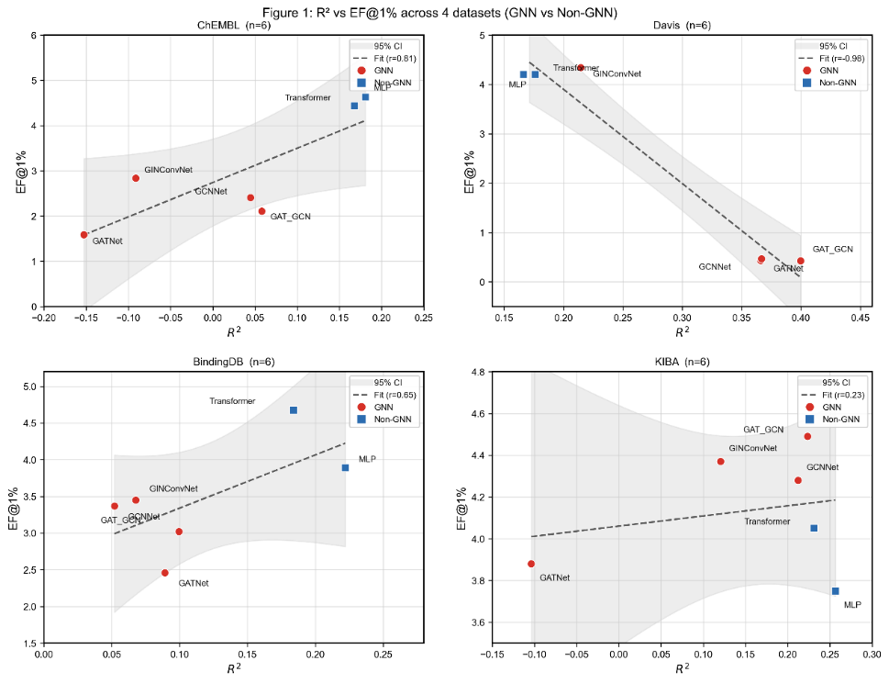
Figure 2 Scatter plots illustrating the relationship between GNN / non-GNN models and EF@1% across the four datasets.
Figure 2 shows that GNN models (red squares) and non-GNN models (blue squares) occupy systematically different regions of the R²–EF@1% plane depending on the panel: on the dense Davis panel, GNNs achieve higher R² but lower EF@1%, whereas on sparser panels the non-GNN family dominates the upper-left enrichment region. This visual pattern motivates the quantitative homology-coverage analysis below.
We begin by establishing that target-homologous training coverage is the primary determinant of cold-start DTA performance, and that standard target-cold-start evaluation systematically overstates generalization due to homology leakage.
The MMseqs2 homology audit reveals that 58.5% of Davis and 58.8% of KIBA test targets (46.2% ChEMBL, 46.4% BindingDB) share a ≥40%-sequence-identity cluster with a training target—nearly three fifths of nominally “cold” panels are semi-visible rather than strictly novel. This leakage is pervasive across the field: even dedicated cold-start methods such as ColdstartMHDTI do not explicitly control for sequence homology in their split protocols, further inflating reported cold-start performance [9][25].
To isolate the effect of homology coverage, we re-evaluate all models on the strictly homology-free subset (cross-cluster targets only) while holding the split, features, and metric definitions fixed (Table S 21). Three observations confirm homology coverage as the central control variable:
1.GNN performance degrades sharply when homology is removed. On Davis, GCNNet falls from $R^{2}=0.395$ to 0.249 and GAT_GCN from 0.394 to 0.261, while Reptile-Transformer rises from 0.226 to 0.264.
2.Full-set rankings reverse on the homology-free subset. The Davis $R^{2}$ winner switches from GCNNet to Reptile-Transformer (0.264 vs 0.249) and the EF@1% winner to Reptile-Transformer (5.01 vs 4.12 for GAT_GCN)—the meta-learner becomes double-optimal exactly where structural memory is uninformative.
3.The pattern replicates across datasets. On KIBA, Reptile-Transformer remains double-optimal and its EF@1% margin over the best GNN widens from +0.18 to +0.69. On all panels, $R^{2}$ values collapse toward zero when homologous coverage is eliminated, consistent with the hypothesis that no architecture carries predictive skill without transferable homologous signal.
This controlled ablation directly converts the structural information paradox (Section 3.2) from an observational finding into a causal result: manipulating the single variable of test-target homologous training coverage is sufficient to reverse model rankings.
3.1.1 Binding-profile mirroring audit
Sequence-identity clustering controls one leakage channel, not all of them. For every test target we computed the maximum Spearman correlation (max-ρ) between its measured affinity profile and that of any training target (Table S 24). Redundancy is pervasive: 11/20 (ChEMBL), 46/65 (Davis), 33/34 (KIBA) and 60/78 (BindingDB) test targets have max-ρ ≥ 0.7, reaching 92.9% among cross-cluster KIBA targets. Crucially, this redundancy is statistically independent of the 40%-identity clusters: stratified Fisher tests between cluster membership and the ρ ≥ 0.7 indicator are non-significant on all four panels (p = 0.28–1.00), and the global same- vs cross-cluster difference in mean max-ρ is only +0.027 (0.809 vs 0.782; Mann-Whitney p = 0.014, n = 197). Conserved ligand-binding pockets (e.g., the kinase ATP site) therefore create activity-profile mirroring that no identity threshold can block (Figure S 9). This finding sharpens the homology-free interpretation of all subsequent analyses: cross-cluster subsets control sequence homology, while residual binding-profile redundancy is measured and reported rather than assumed away.
Per-panel statistics are given in Table S 24 and the per-target scatter in Figure S 9. The audit also explains why a target-only cold split cannot be the final word: the molecule axis carries its own redundancy channel, motivating the dual-axis cold-start extension discussed in Section 4.3.
3.2 Corollary 1: The Structural Information Paradox and GNN Applicability Boundary
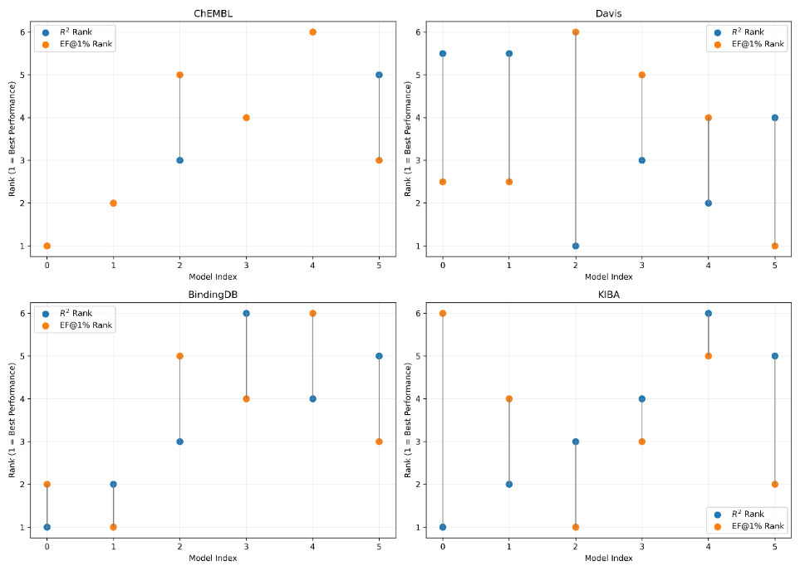
Figure 3 Comparative ranking shifts of EF@1% performance across six model architectures.
Figure 3 complements the scatter view of Figure 2 by explicitly tracking the rank shifts between R² and EF@1% for six model architectures across the four datasets. The rank-shift diagram shows that the identity of the R²-best model frequently diverges from the identity of the EF@1%-best model, and that the magnitude of this divergence is largest on the dense Davis panel—precisely the regime where the structural information paradox is most pronounced. On ChEMBL, KIBA, and BindingDB, the rank shifts are smaller but non-zero, confirming that regression-ranking decoupling is a continuous, similarity-dependent phenomenon rather than a Davis-specific anomaly.
Building on the homology coverage principle, we characterize the applicability boundary of GNN architectures and reveal the structural information paradox: under strict target novelty, structural priors—interaction graphs, contact maps, predicted pockets, distillation from complex structures—stop paying off and can actively hurt performance.
3.2.1 Similarity-Dependent GNN Applicability Region
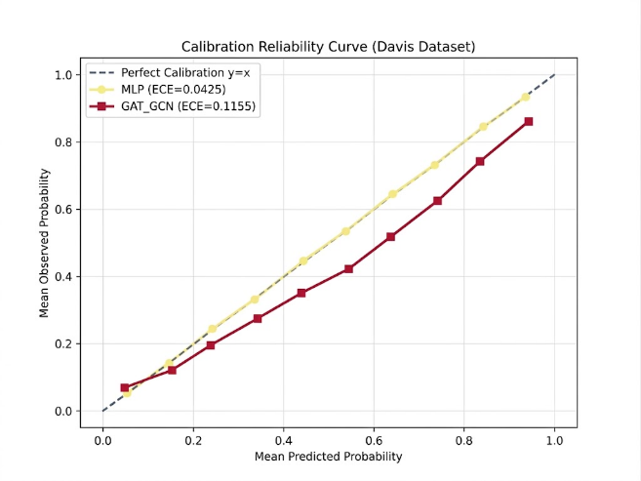
Figure 4 Calibration reliability curves of MLP and GAT_GCN on the Davis dataset. The dashed diagonal line indicates perfect calibration.
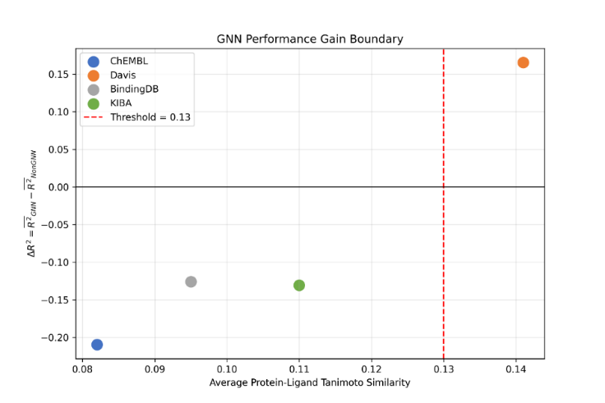
Figure GNN advantage ΔR² versus training-panel similarity; the τ ≈ 0.13 GNN-favourable band is descriptive (four-fold leave-one-dataset-out validation, Section 3.6.5). Positive ΔR² is observed only on the dense Davis panel.5
Define $ΔR^{2}=\text{mean} \text{GNN} R^{2}-\text{mean} \text{non-graph} R^{2}$. As shown in Figure 5, a positive $ΔR^{2}$ is observed only for the dense, kinase-focused Davis panel ($τ=0.137$ training-panel Tanimoto similarity). Spearman correlation shows strong positive monotonic association between dataset-level similarity and GNN performance gain ($ρ=0.98$, $p<0.01$).
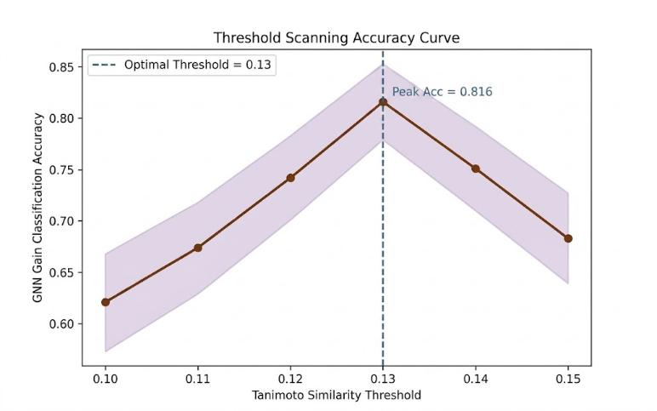
Figure Accuracy curve of the similarity threshold scan. The empirically observed GNN-applicability band lies near Tanimoto similarity ≈ 0.13; leave-one-dataset-out validation (Section 3.6.5) does not support its use as a predictive threshold.6
Threshold-scanning experiments (Figure 6) identify an optimal dividing threshold near $τ≈0.13$ with classification accuracy = 0.816. Crucially, this is a similarity-dependent applicability region (τ ≈ 0.13–0.16), not a universal hard rule: across $τ∈\left[0.10,0.40\right]$ the identity of each dataset's $R^{2}$-winner and EF@1%-winner is unchanged, and the two criteria agree on only one of four datasets (KIBA) at any τ. For head enrichment specifically, non-graph models dominate overall (mean EF@1% 3.68 vs 2.75; Δ = 0.93). Full threshold sweep statistics are provided in Table S 3 and Figure S 9. A four-fold leave-one-dataset-out validation of this boundary (Section 3.6.5, Table S31) cannot predict the held-out panel above the majority-class rate (2/4 correct versus 3/4), and the boundary is unidentifiable in the fold removing the sole GNN-favourable panel; τ ≈ 0.13 is therefore reported as a descriptive empirical band rather than a deployable threshold.
3.2.2 Mechanistic Attribution Evidence
Pre-registered Grad-CAM and edge-occlusion analyses on cold-target, high-activity cases provide mechanistic support for the paradox. Under cold-target conditions, GNN attribution concentrates on ring-scaffold atoms (63–85% of CAM mass; heteroatoms only 23–36%), and edge occlusion yields no positive edge-level contribution (negative-contribution-edge fraction −0.09 to −0.77;Table S 11). This scaffold-pattern reliance—rather than bond-level discrimination—explains why GNNs excel when training scaffolds transfer across homologous targets but fail when target novelty removes that transferable signal. Full attribution visualizations are provided in Figure S 3 and Figure S 4. The six cases per dataset displayed in Figures S 2–S 3 are the deterministic output of this pre-specified selection chain; no case was added, substituted, or re-selected after seeing the attributions.
Figure S 4 extends this mechanistic picture to the Reptile-Transformer itself. The drug-side atom attribution maps for three high-activity cold-target cases show that the meta-learner distributes attribution across a broader set of substructures than GNNs, with no single ring-scaffold atom dominating the CAM mass. The accompanying descriptor-gradient panels further indicate that the model relies on a distributed combination of physicochemical descriptors (e.g., MolLogP, NumHDonors, TPSA) rather than on scaffold-specific graph patterns. This is consistent with the functional adaptation interpretation developed in Section 3.4: the meta-learner adapts by re-routing cross-attention projections over pooled representations, not by memorizing transferable scaffold motifs.
3.2.3 Strong-Baseline Validation
Comparison with BlendNet confirms the paradox at the state-of-the-art level (Table S 14). Original structure-aware BlendNet achieves $R^{2}=0.712$ on random-split BindingDB but collapses to $R^{2}=-0.075$ on the authors' own new_protein cold-start split—worse than predicting the mean—representing an i.i.d.-to-cold-start performance collapse of 0.79 $R^{2}$ units. This magnitude of collapse is consistent with prior observations of structure-aware models under distribution shift [23][24]. Our sequence-only adaptation BlendNet-Seq, which removes structural priors while retaining the cross-attention backbone, is outperformed by Reptile-Transformer on 10 of 11 metrics under identical input and split protocols (Table S 13).
Together these results establish the structural information paradox: structural information helps in proportion to target-homologous training coverage, not in proportion to model complexity.
3.3 Corollary 2: The Statistical Boundary of Metric Decoupling
The second corollary of the homology coverage principle is that the relationship between regression and ranking metrics is governed by molecular similarity, and single-metric model selection becomes statistically unreliable on extremely sparse panels.
Correlation analysis across datasets (Table 2) demonstrates that metric decoupling is strongly similarity-dependent. On the dense Davis panel (τ = 0.137), R² and EF@1% exhibit a strong negative Pearson correlation across models (r = −0.979): GNN variants with superior R² push true high-activity compounds down the prediction list. This coefficient must be read with care: the Davis 1% cutoff is degenerate (66 compounds per target ⇒ top-1% corresponds to less than one compound; per-target EF@1% is identically zero for all seven models in our five-seed replication), so r = −0.979 reflects a rank shift against a constant rather than an estimable covariance. We therefore (i) flag Davis EF@1% as non-informative throughout, (ii) anchor the Davis decoupling claim on per-target Wilcoxon evidence and the EF@5%/EF@10% correlations, which survive Bonferroni correction, and (iii) exclude Davis EF@1% from any cross-dataset correlation aggregate. On sparser panels such as ChEMBL (τ = 0.122), the correlation is positive.
Figure 3 provides the per-model rank-shift visualization that complements the aggregate correlation statistics in Table 2. For each dataset, the figure places the R² rank and the EF@1% rank of the same model side by side, connected by a vertical line whose length encodes the magnitude of decoupling. The longest connector lines appear on Davis, where GNN variants rank near the top on R² but drop toward the bottom on EF@1%; on ChEMBL, KIBA, and BindingDB the connectors are shorter and the two rankings are more concordant. This rank-shift view makes the statistical boundary of metric decoupling directly interpretable at the model level: on dense panels, choosing a model by R² alone can select an architecture that is actively suboptimal for virtual screening.
After Bonferroni correction for 24 statistical tests (α = 0.05/24 ≈ 0.0021), the Davis negative decoupling survives correction, whereas positive correlations on sparse panels do not. The decoupling claim is therefore conservatively confined to dense panels, exactly as the similarity-governed framework predicts.
Figure 4 provides the reliability-diagram view of the regression–calibration trade-off on the dense Davis panel. The MLP curve (ECE = 0.0425) tracks the diagonal closely, whereas the GAT_GCN curve (ECE = 0.1155) lies systematically below the diagonal across the mid-probability range, indicating that the GNN's confidence estimates are over-optimistic precisely where its R² advantage is largest. This visual evidence corroborates the bin-wise ECE decomposition in Table S1 and the Pareto-front pattern in Figure 7: on dense panels, a model selected by R² alone can be significantly miscalibrated for downstream wet-lab decision-making, reinforcing the three-dimensional evaluation argument.
              - Table 2 Correlation between R² and enrichment factors (EF@1 %, 5 % and 10 %) across datasets
Dataset | Metric Pair | Pearson r | 95% CI | p-value | Kendall τ | τ p-value
ChEMBL | R² vs EF@1% | 0.8131 | [0.005, 0.979] | 0.0491 | 0.6 | 0.1361
ChEMBL | R² vs EF@5% | 0.8033 | [-0.024, 0.978] | 0.0542 | 0.6 | 0.1361
ChEMBL | R²vsEF@10% | 0.8051 | [-0.019, 0.978] | 0.0533 | 0.6 | 0.1361
Davis | R² vs EF@1% | -0.9789 | [-0.998, 0.814] | 0.0007 | -0.5714 | 0.1195
Davis | R² vs EF@5% | -0.9705 | [-0.997, -0.748] | 0.0013 | -0.5714 | 0.1195
Davis | R²vs EF@10% | 0.9882 | [0.892, 0.999] | 0.0002 | 0.8864 | 0.0216
BindingDB | R² vs EF@1% | 0.6519 | [-0.339, 0.957] | 0.1606 | 0.3333 | 0.4694
BindingDB | R² vs EF@5% | 0.7811 | [-0.083, 0.975] | 0.0666 | 0.3333 | 0.4694
BindingDB | R²vs EF@10% | 0.8529 | [0.134, 0.984] | 0.0309 | 0.4667 | 0.2722
KIBA | R² vs EF@1% | 0.2272 | [-0.716, 0.877] | 0.6651 | -0.2 | 0.7194
KIBA | R² vs EF@5% | 0.8705 | [0.201, 0.986] | 0.0241 | 0.4667 | 0.2722
KIBA | R²vs EF@10% | 0.8888 | [0.277, 0.988] | 0.0179 | 0.6 | 0.1361

The regression–calibration trade-off follows the same similarity pattern. Pareto-front analysis (Figure 7) shows that the trade-off between regression performance and ECE is only observed for Davis: GNNs achieve higher $R^{2}$ yet significantly higher ECE (Mann-Whitney U test, $p<0.05$). Such Pareto-type tradeoffs are absent in sparse datasets below similarity 0.13. Full bin-wise ECE decomposition and calibration reliability curves are provided in Table S 1 and Figure S 7.
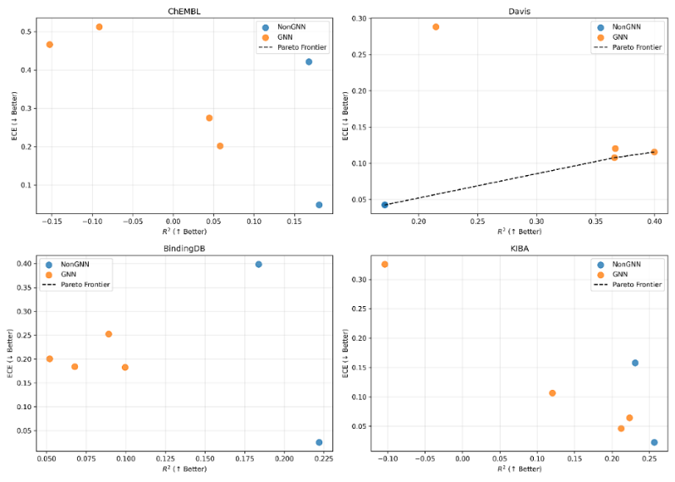
Figure 7 Pareto front distribution of $R^{2}$ versus ECE for GNN and non-GNN models across the four benchmark datasets. The regression-calibration trade-off is only observed on the dense Davis panel.
Critically, on extremely sparse panels single ranking metrics carry almost no information. On Davis, per-target EF@1% equals 0.000 for all five seeds with a degenerate CI [0, 0] (Table S 16): with only 66 compounds per target, per-target top-1% enrichment is effectively a single Bernoulli trial. This delineates the statistical boundary of metric decoupling: on extremely sparse panels, model selection must jointly consult regression, ranking, and calibration axes—the statistical justification for our three-dimensional evaluation system.
3.4 Corollary 3: Implicit Task Adaptation via Cross-Attention Re-Routing
The third corollary is that meta-learning over frozen protein embeddings achieves adaptation at the functional level rather than the parameter level, explaining how first-order meta-learning can improve cold-start performance without rewriting universal residue representations.
Protein-side adaptation ablation on KIBA quantifies this effect (Table S 15). Unfreezing the full protein tower yields a small but consistent gain over the frozen default ($R^{2}$ 0.3119 → 0.3248 for both partial and full fine-tuning; EF@1% 4.45 → 4.68/4.70; ECE 0.0061 → 0.0045/0.0042). The gain, however, is marginal ($ΔR^{2}≈+0.013$) relative to drug-side and attention adaptation.
This supports a functional-versus-parameter reading of task adaptation: the meta-learner primarily adapts to a novel target by re-routing the cross-attention projection matrices ($W_{q},W_{k},W_{v}$), which select which residue features are matched against the drug representation, while the universal ESM-2 geometry is preserved as a stable prior. The +0.013 $R^{2}$ available from full fine-tuning quantifies the residual value of parameter-level adaptation and shows it to be minor; the risk of catastrophic overwriting under extreme K-shot regimes is the reason we retain the 0.1× frozen projection configuration as the default.
Figure S 4 provides drug-side attribution evidence consistent with this functional-adaptation account. The atom-level CAM maps for Reptile-Transformer do not concentrate on a single scaffold motif, and the descriptor-gradient panels show distributed reliance on multiple physicochemical properties. This pattern is what would be expected if the meta-learner were re-routing cross-attention projections over pooled drug and protein representations, rather than rewriting the protein encoder or memorizing scaffold-level graph patterns. The attribution evidence therefore complements the protein-side ablation in Table S15 and supports the interpretation that adaptation is functional rather than parametric.
3. 5 Reptile-Transformer Performance Validation and Ablation
We now validate the proposed Reptile-Transformer framework and quantify module-wise contributions, consistent with the principle-mining → task-oriented design logic.
3.5.1 Feature Ablation
Figure 8 presents the feature-ablation heatmaps for Reptile-Transformer across the four datasets. Each panel reports R², AUPR, and ECE for four feature configurations: Morgan+ESM2, Morgan+MACCS+ESM2, Morgan+ physicochemical descriptors +ESM2, and the full feature set. Across all four panels, the full feature set (Morgan fingerprints + physicochemical descriptors + ESM-2 embeddings) achieves the best overall balance: it attains the highest or near-highest R² and AUPR while keeping ECE at or below the level of the reduced configurations. Adding MACCS fingerprints alone (Morgan+MACCS+ESM2) introduces redundant substructure information and degrades performance relative to Morgan+ESM2, confirming that the gain from the full set comes from the physicochemical descriptors rather than from additional fingerprint bits. These heatmaps thus validate the multi-source feature selection as an optimal trade-off between informativeness and computational cost for cold-start settings.
Feature ablation (Figure S 9) validates that Morgan fingerprints + physicochemical descriptors + ESM-2 embeddings delivers optimal overall performance; adding MACCS fingerprints introduces redundant noise and degrades performance. This confirms our multi-source feature selection as an optimal trade-off between informativeness and computational cost for cold-start settings.
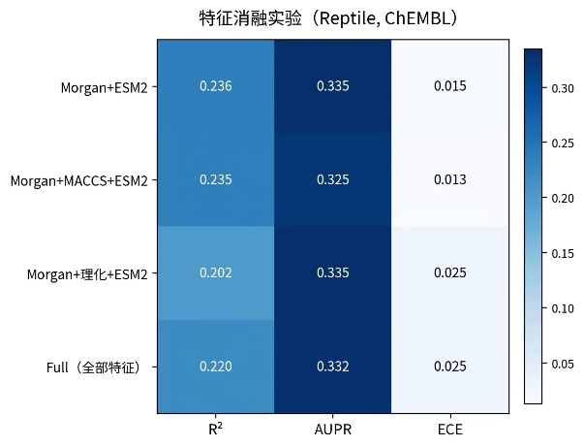  (a) ChEMBL | 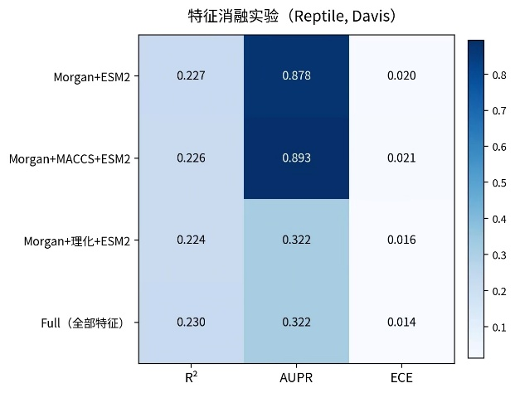  (b) Davis
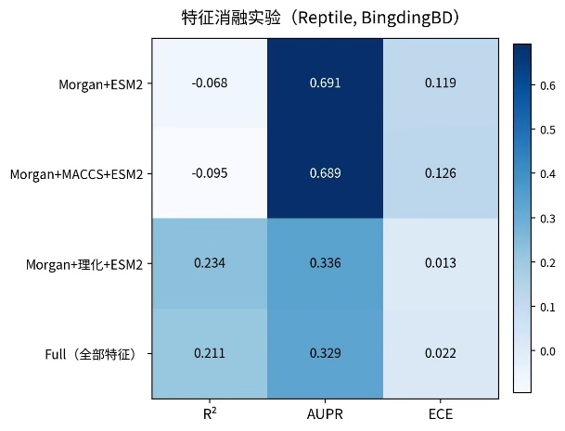  (c) BingdingDB | 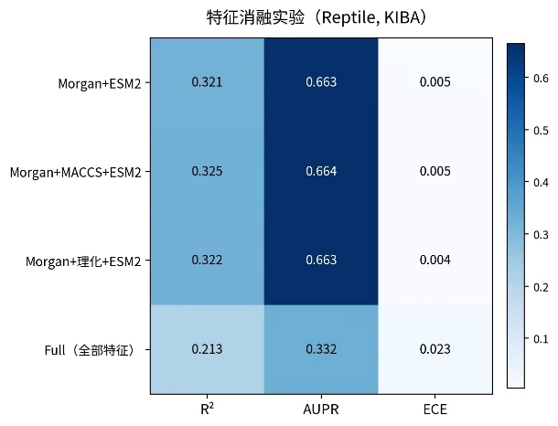  (d) KIBA
Figure 8 Feature ablation for Reptile–Transformer across four datasets: (a) ChEMBL; (b) Davis; (c) BindingDB; (d) KIBA. Morgan fingerprints + physicochemical descriptors + ESM2 embeddings achieves the optimal balance of regression, ranking and calibration performance.

3.5.2 Architectural Ablation
KIBA architectural ablation (Table 3) quantifies module-wise contributions. Multi-objective loss improves both regression and calibration. Adding Reptile meta-learning increases $R^{2}$ by 39.6%, AUPR by 32.7%, and reduces ECE by 97.1%. Bidirectional cross-attention, multi-objective loss, and meta-learning exhibit clear synergistic benefits.
              - Table 3 Ablation study results on the KIBA dataset
Configuration | $$R^{2}$$ | RMSE | AUPR | ECE
MLP (full features) | 0.2565 | 1.0140 | 0.4821 | 0.0227
Transformer (MSE-only) | 0.1800 | 1.0649 | 0.5237 | 0.3844
Transformer (multi-objective loss) | 0.2308 | 0.7418 | 0.5000 | 0.1581
Reptile-Transformer (full pipeline) | 0.3222 | 0.6963 | 0.6635 | 0.0045
3.5.3 Overall Performance Comparison
On the KIBA dataset, Reptile-Transformer surpasses dimension-wise best baselines across all three evaluation axes (Table 4). Relative improvements: $R^{2}$ +25.61%, AUPR +28.54%, ECE −80.18%. Crucially for virtual screening, Reptile-Transformer also attains the best EF@1% on KIBA (4.72 vs 4.49 for the best GNN and 3.75 for MLP).
              - Table 4 Performance comparison on KIBA
Metric | Best baseline model (value) | Proposed model value |  | Relative improvement
R² | 0.2565(MLP) | 0.3227 ± 0.0028 | +25.61%
RMSE | 0.7240(GAT_GCN) | 0.6961 ± 0.0014 | -3.83%
AUPR | 0.5162（GCNNet） | 0.6604 ± 0.0037 | +28.54%
ECE | 0.0227（MLP） | 0.0050 ± 0.0010 | -80.18%
EF@1% | 4.49 (GAT_GCN) | 4.705 ± 0.040 | +5.1%
Reptile-Transformer: mean ± s.d. over five independent seeds (11/22/33/44/55); baselines are single-run values as in the original comparison.

              - 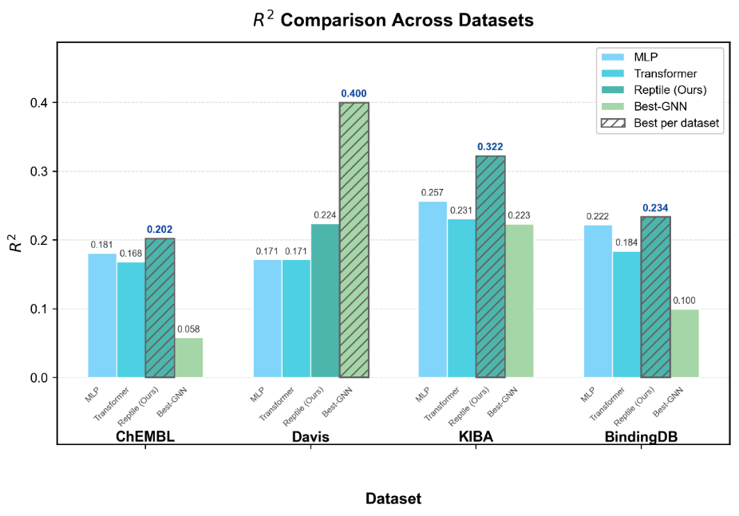
              - 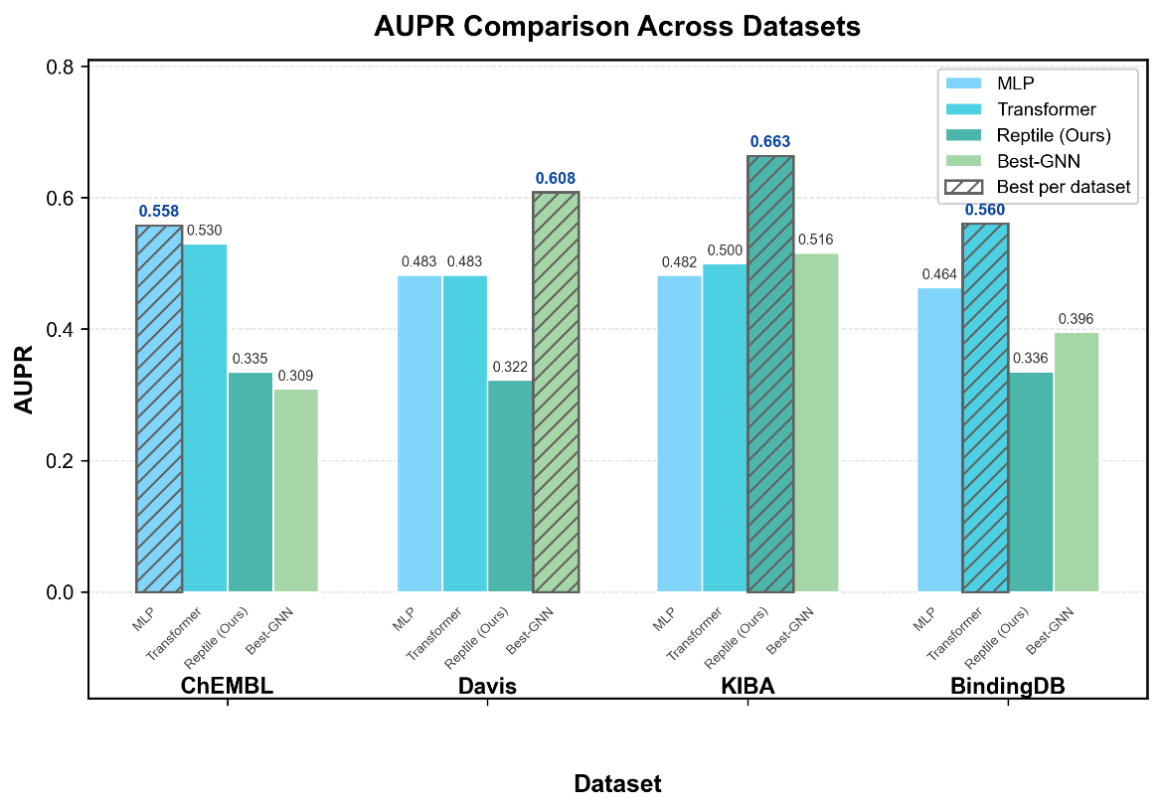
              - 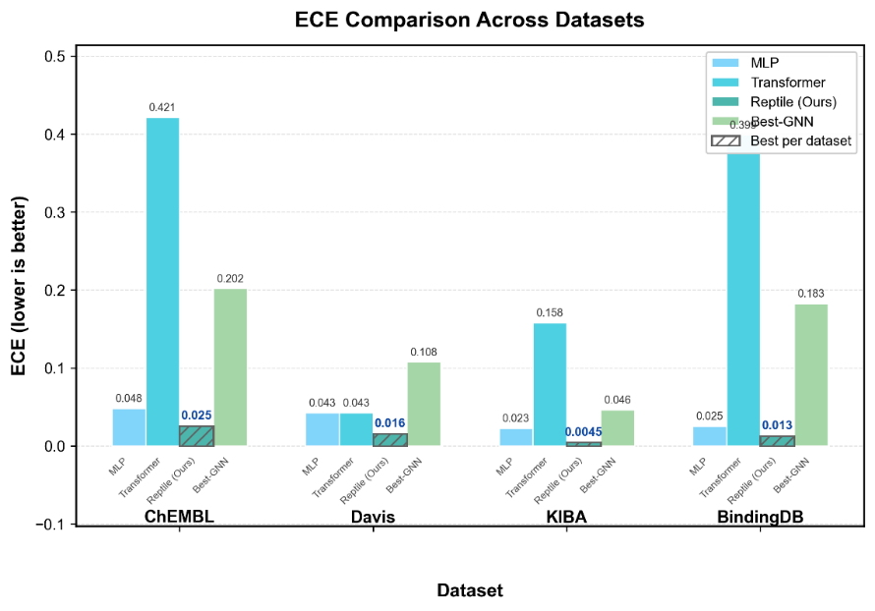
Figure 9 Performance comparison across datasets. Grouped bar charts show R², AUPR and ECE for each model on ChEMBL, Davis, KIBA and BindingDB. Higher bars indicate better performance for R² and AUPR; lower bars indicate better calibration for ECE.
Cross-dataset performance comparison (Figure 9) shows that our framework maintains stable comprehensive performance regardless of molecular structural density. Globally, however, simpler non-graph models achieve higher mean EF@1% across all four datasets (Transformer 4.34, MLP 4.12 vs 2.58 for Reptile-Transformer). We therefore make a scenario-conditional recommendation rather than claiming universal superiority, consistent with our similarity-governed framework. Full EF@1%/EF@5% matrices across all models and datasets are provided in Table S 4 and Table S 5.
3.6 Robustness and Statistical Boundary Analysis
We complete the results with comprehensive robustness and statistical validation.
3.6.1 Statistical Significance
All headline configurations were re-run with five independent seeds (Table S 16). On KIBA, the double-optimality claim is statistically supported: the bootstrap 95% CI of $R^{2}$ is [0.3202, 0.3245], entirely above the best baseline (MLP, 0.2565), and the CI of EF@1% is [4.6738, 4.7355], entirely above the best GNN (GAT_GCN, 4.49). On Davis, by contrast, the per-seed paired Wilcoxon test of $R^{2}$ against GAT_GCN reaches BH-FDR < 0.05 in 0 of 5 seeds (p = 0.343–0.722), so the Davis $R^{2}$ advantage of GNNs is directional rather than significant.
Winner-level consistency between the R²-optimal and EF@1%-optimal models is itself a testable claim. Pooling 4 datasets × 7 models (Table S 23), agreement is observed only on KIBA (1/4). All five consistency tests are non-significant—Fisher exact p = 0.481, uniform-random binomial p = 0.460, permutation (10⁵) p = 0.750, focal-model McNemar exact p = 0.500, and family-level binomial p = 0.125—and with n = 4 panels any winner-level test is severely underpowered (1 − β ≪ 0.8). The statistically defensible summary is therefore heterogeneity itself: no architecture is jointly optimal across panels, and the decoupling claim must be anchored on per-target correlations (Table 2) rather than winner counts.
Replication-aware paired testing is summarized as an effect-size heat map (Figure S 10): 54 two-sided Wilcoxon signed-rank tests (3 datasets × 6 baselines × 3 headline metrics) between the five-seed Reptile-Transformer and each baseline yield a minimum attainable p of 0.0625 at n = 5, and no test survives BH-FDR < 0.05. We accordingly report mean paired differences and their signs alongside p-values and refrain from significance claims at this replication level—a transparency convention we recommend for all five-seed DTA comparisons.
3.6.2 Meta-Learning Design Choices
Inner-loop length sweep over inner_steps ∈ {1, 3, 5, 10} (Table S 17) shows $R^{2}$ varies within 0.315–0.327, EF@1% within 4.55–4.74, and ECE within 0.0044–0.0064, while wall-clock grows super-linearly (736 → 3039 s). inner_steps = 3 is retained as the cost/performance compromise.
Comparison with second-order MAML (Table S 20) confirms that the first-order choice is not merely a cost shortcut but a stability requirement: default MAML fails to converge on this benchmark ($R^{2}=-0.079$), a carefully tuned MAML reaches $R^{2}=0.243$ at 3583 s, while first-order Reptile reaches $R^{2}=0.326$ at 1139 s—simultaneously more accurate and 3.1× cheaper.
3.6.3 τ Protocol Sensitivity
The similarity threshold τ is a construct of both fingerprint type and evaluation panel. Four-specification sensitivity analysis (ECFP4/MACCS × training/test panel;Table S 22) shows that under the training-set specification, fingerprint choice leaves the cross-dataset ordering exactly intact (Spearman ρ = 1.0 across the four datasets), so every similarity-governed ranking conclusion is protocol-invariant to fingerprint type. Absolute levels are fingerprint-dependent (MACCS runs ≈3.5× higher), confirming that the threshold is a fingerprint-relative construct. A leave-one-dataset-out predictive validation of the τ ≈ 0.13 boundary (Section 3.6.5) likewise fails to outperform the majority-class predictor; τ is consequently retained strictly as a fingerprint-relative descriptive band, never as a deployment cut-off.
3.6.4 Protein-encoder capacity control
If protein-representation capacity bounded homology-free extrapolation, scaling the protein language model should help. It does not (Table 5): on KIBA, ESM-1b (650M) and ProtT5-XL (3B) shift R² by +0.004 over the 35M ESM-2 default—within seed noise—and leave EF@1%, ECE and AUPR essentially unchanged; on Davis, the ProtT5 gain (+0.018 ± 0.014, paired over three matched seeds) does not reach significance (p ≈ 0.15) and the ESM-1b variant is indistinguishable from the default. A ~100-fold increase in protein-encoder parameters therefore buys no material generalization, while Davis EF@1% remains identically zero for every encoder—both observations pinpoint target-homologous coverage and panel sparsity, not representation capacity, as the binding constraints. This control substantiates the choice of ESM-2 35M as a deliberate, evidence-backed design decision rather than a cost compromise.
              - Table 5 Protein-encoder capacity control (mean ± s.d. over three matched seeds {11, 22, 33})
Protein encoder | KIBA R² | KIBA EF@1% | KIBA ECE | KIBA AUPR | Davis R² | Davis EF@5% | Davis ECE
ESM-2 t12 35M (default) | 0.3233 ± 0.0003 | 4.694 ± 0.047 | 0.0048 ± 0.0007 | 0.6618 ± 0.0032 | 0.2248 ± 0.0059 | 4.929 ± 0.148 | 0.0214 ± 0.0028
ESM-1b 650M | 0.3276 ± 0.0040 | 4.729 ± 0.014 | 0.0050 ± 0.0013 | 0.6619 ± 0.0036 | 0.2223 ± 0.0101 | 4.695 ± 0.323 | 0.0218 ± 0.0039
ProtT5-XL 3B | 0.3269 ± 0.0010 | 4.694 ± 0.009 | 0.0045 ± 0.0003 | 0.6618 ± 0.0020 | 0.2426 ± 0.0184 | 4.747 ± 0.437 | 0.0194 ± 0.0046
Davis per-target EF@1% is identically 0 for every encoder (degenerate cutoff; Section 3.3) and is omitted. Molecular features, labels, splits and hyper-parameters are byte-identical across rows; only the frozen protein column is replaced (mean-pooled PLM embedding + fixed random projection to 128-d).
3.6.5 Framework-internal robustness: leave-one-dataset-out validation, parameter sensitivity, and negative controls
Several framework-level claims are themselves inferred from only four panels. To delimit their scope before deployment, we pre-registered five robustness analyses that require no new training data (Table 6): predictive validation of the τ band, leave-one-dataset-out validation of the remote-target router, a full scan of the audit clustering parameters, a clustering-algorithm cross-check, and a random-sequence negative control; the value of auditing is then quantified against the unaudited protocol.
Applicability band (τ ≈ 0.13). We fitted the GNN-favourable band on three panels (boundaries = midpoints between the positive panel and its nearest negative neighbour on each side) and predicted the fourth. LODO accuracy is 0.50 (2/4)—below the 0.75 majority-class baseline: the fold removing Davis, the sole GNN-favourable panel, cannot fit the rule at all, and the fold removing ChEMBL lacks a lower boundary and misclassifies it; a 1-nearest-neighbour rule scores identically (Table S31). The lower boundary is stable when estimable (0.130 in both identifiable folds) but the upper boundary varies (0.194–0.249). Consistent with our pre-registered decision rule, τ ≈ 0.13 is therefore stated as a descriptive empirical band only; it must not be used as a stand-alone deployment threshold on an unseen panel.
Router cross-dataset validation. In each LODO fold the routing threshold was chosen on three datasets by accuracy maximization over 25–60% (ties resolved toward the pre-registered 40%) and applied unchanged to the fourth. Accuracy was 96.2% (ChEMBL), 96.9% (Davis), 97.1% (KIBA) and 95.5% (BindingDB), with zero false negatives in every fold and 40% selected as the threshold in every fold—identical to the fixed pre-registered rule (Table S26). The router’s cross-dataset generalization claim is therefore supported rather than being a pooled-set artifact.
              - Table 6 Framework-internal robustness analyses (P0): designs, headline results, and claim actions.
Analysis | Design | Headline result | Claim action
τ ≈ 0.13 applicability band | Leave-one-dataset-out (LODO): fit band on 3 panels, test 4th | 2/4 correct (0.50), below 0.75 majority-class; one fold unidentifiable | Downgraded to descriptive band
Family-remote router | LODO threshold selection (3 datasets → 4th), n = 237 | 95.5–97.1% accuracy; 40% selected every fold; FNR = 0 | Cross-dataset generalization validated
Coverage sensitivity | Bidirectional coverage c ∈ {0.7, 0.8, 0.9} at 40% identity | Cross-cluster ratios 35.4–62.5%; semi-leakage conclusion preserved | Robust
Identity sensitivity | Identity t ∈ {30,40,50,60,70,80}%, c = 0.8 | Monotone 26.1→100%; headline ratios exactly reproduced | Robust; exact reproduction
Clustering algorithm | Set-cover/connected-component vs CD-HIT-style greedy incremental | Per-target label agreement 92.3–100%; Cohen κ 0.84–1.00 | Functional equivalence supported
Random-sequence negative control | Residue-shuffled test sequences (length/composition kept), 3 seeds | 100% cross-cluster; zero ≥40%-identity hits in all 36 settings | Audit specificity confirmed
Audited vs unaudited evaluation | Ranks on nominal full cold test vs homology-free subset (5 models × 3 datasets) | R²-winner reversals 0/3; Kendall τb 0.00–0.80; ΔR² mis-selection 0.014–0.015 | Value of auditing quantified
All analyses re-use the audited splits of Section 3.1; no model was retrained. Per-fold and per-parameter details are in Tables S26–S31 and Figure S11.
Audit-parameter sensitivity. Re-running easy-cluster over 18 settings per dataset (bidirectional coverage 0.7/0.8/0.9 × identity 30–80%) exactly reproduces the published ratios at the operating point (c = 0.8; 40/60/80%). At the headline 40%-identity threshold, moving coverage across 0.7–0.9 moves cross-cluster ratios within 35.4–53.9% (Davis), 41.2–55.9% (KIBA), 53.9–57.7% (ChEMBL) and 45.5–62.5% (BindingDB)—the qualitative finding, that roughly half of nominally cold test targets retain a same-cluster train homologue, is preserved at every coverage setting, and ratios increase monotonically with identity (26.1–100% across the grid; Table S27, Figure S11). Replacing the default set-cover/connected-component clustering with CD-HIT-style greedy incremental clustering (MMseqs2 --cluster-mode 2; c = 0.8) changes per-target same/cross labels by 0–7.7% across the 12 dataset×threshold cells (agreement 92.3–100%, Cohen κ = 0.84–1.00; Table S28), supporting the stated functional equivalence of the two clustering engines.
Audited versus unaudited evaluation. On the three datasets with matched prediction sets, ranks of the five models under the nominal (unaudited) target-cold test set and the 40%-identity homology-free subset agree only modestly (Kendall τb = 0.00/0.33/0.80 for R² on Davis/BindingDB/KIBA): the R² winner changes on 2/3 datasets, and selecting on the unaudited benchmark costs 0.015 R² on Davis (GCNNet chosen; Reptile-Transformer best on the audited subset; 5.8% relative) and 0.014 R² on BindingDB (GAT_GCN chosen; GATNet best; 36.6% relative); the Davis EF@1% mis-selection is larger (0.88 enrichment units; 17.6%), although this point sits on the degenerate 66-compound panel discussed in Section 3.3 (Table S29; values recomputed from Table S21 predictions). These numbers quantify the price of skipping the audit even when the split is nominally target-disjoint.
Negative control. Residue-shuffled test sequences—each permuted within sequence to preserve length and amino-acid composition (three seeds)—were clustered with the unchanged training panel. Across all four datasets, three seeds and the 40/60/80% thresholds, 100% of shuffled targets were cross-cluster and no shuffled target produced any bidirectionally covered (c = 0.8) hit at or above 40% identity, whereas the true sequences show 41.2–53.9% cross-cluster ratios at 40% (Table S30). The audit thus separates genuine homology signal from composition-level noise; note that the binding-profile mirroring channel operates on activity vectors and is unaffected by sequence shuffling, re-confirming that the two leakage channels are orthogonal.
Taken together, the P0 analyses strengthen the operational components of the framework—the router generalizes out of dataset, the audit classifications are stable to coverage/identity settings and to the clustering engine, the audit discriminates true leakage from random sequences, and auditing changes deployment decisions with measurable cost when omitted—while explicitly restricting the τ ≈ 0.13 band to a descriptive role.
4 Discussion and conclusion
4.1 Towards a General Theory of Cold-Start DTA Prediction
Assembling our three corollaries—the structural information paradox, the similarity-driven applicability region, and the statistical boundary of metric decoupling—suggests a general selection theory for out-of-distribution DTA prediction, built on the single unifying variable of target-homologous training coverage:
1.Audit first. Score the deployment panel on training-panel molecular similarity and target-homology coverage before selecting an architecture. Homology coverage, not model complexity, determines which model class can pay off.
2.Below the applicability region. When target novelty is high and homologous coverage is low, prefer representation-light meta-learned models and allocate optimization budget to calibration and ranking rather than structural encoders.
3.Above the applicability region. When sufficient homologous coverage exists, structural encoders become admissible and should be validated against ranking metrics with bootstrap confidence intervals.
4.Always audit metric decoupling. Never trust a single headline metric; jointly consult regression, ranking, and calibration axes, especially on sparse panels where single ranking metrics carry little statistical information.
The same framework transfers to adjacent OOD problems—protein–protein interaction prediction and target-aware virtual screening—where similar similarity-coverage covariates can be computed. We emphasize the boundary conditions: the theory is distilled from four datasets and must be re-validated on each deployment panel.
Figure 9 condenses the theory into an applicability-region map: the abscissa is training-panel molecular similarity (τ) and the ordinate the realized GNN advantage (ΔR² = GNN − non-GNN best). The four benchmark panels locate in three regimes—MLP-favourable (ChEMBL, τ = 0.122, ΔR² = −0.204), GNN-favourable (Davis, τ = 0.137, ΔR² = +0.141), and meta-learning-favourable (KIBA τ = 0.250, ΔR² = −0.099; BindingDB τ = 0.360, ΔR² = −0.134)—delimiting where structural encoders pay off, where fingerprint models suffice, and where meta-learned re-routing is required. This map is descriptive at n = 4 panels: leave-one-dataset-out validation (Section 3.6.5) cannot predict the held-out regime above the majority-class baseline and the band cannot be fitted at all when the sole GNN-favourable panel is held out. It is offered as a post hoc organizer of these four panels, not as a deployable rule.
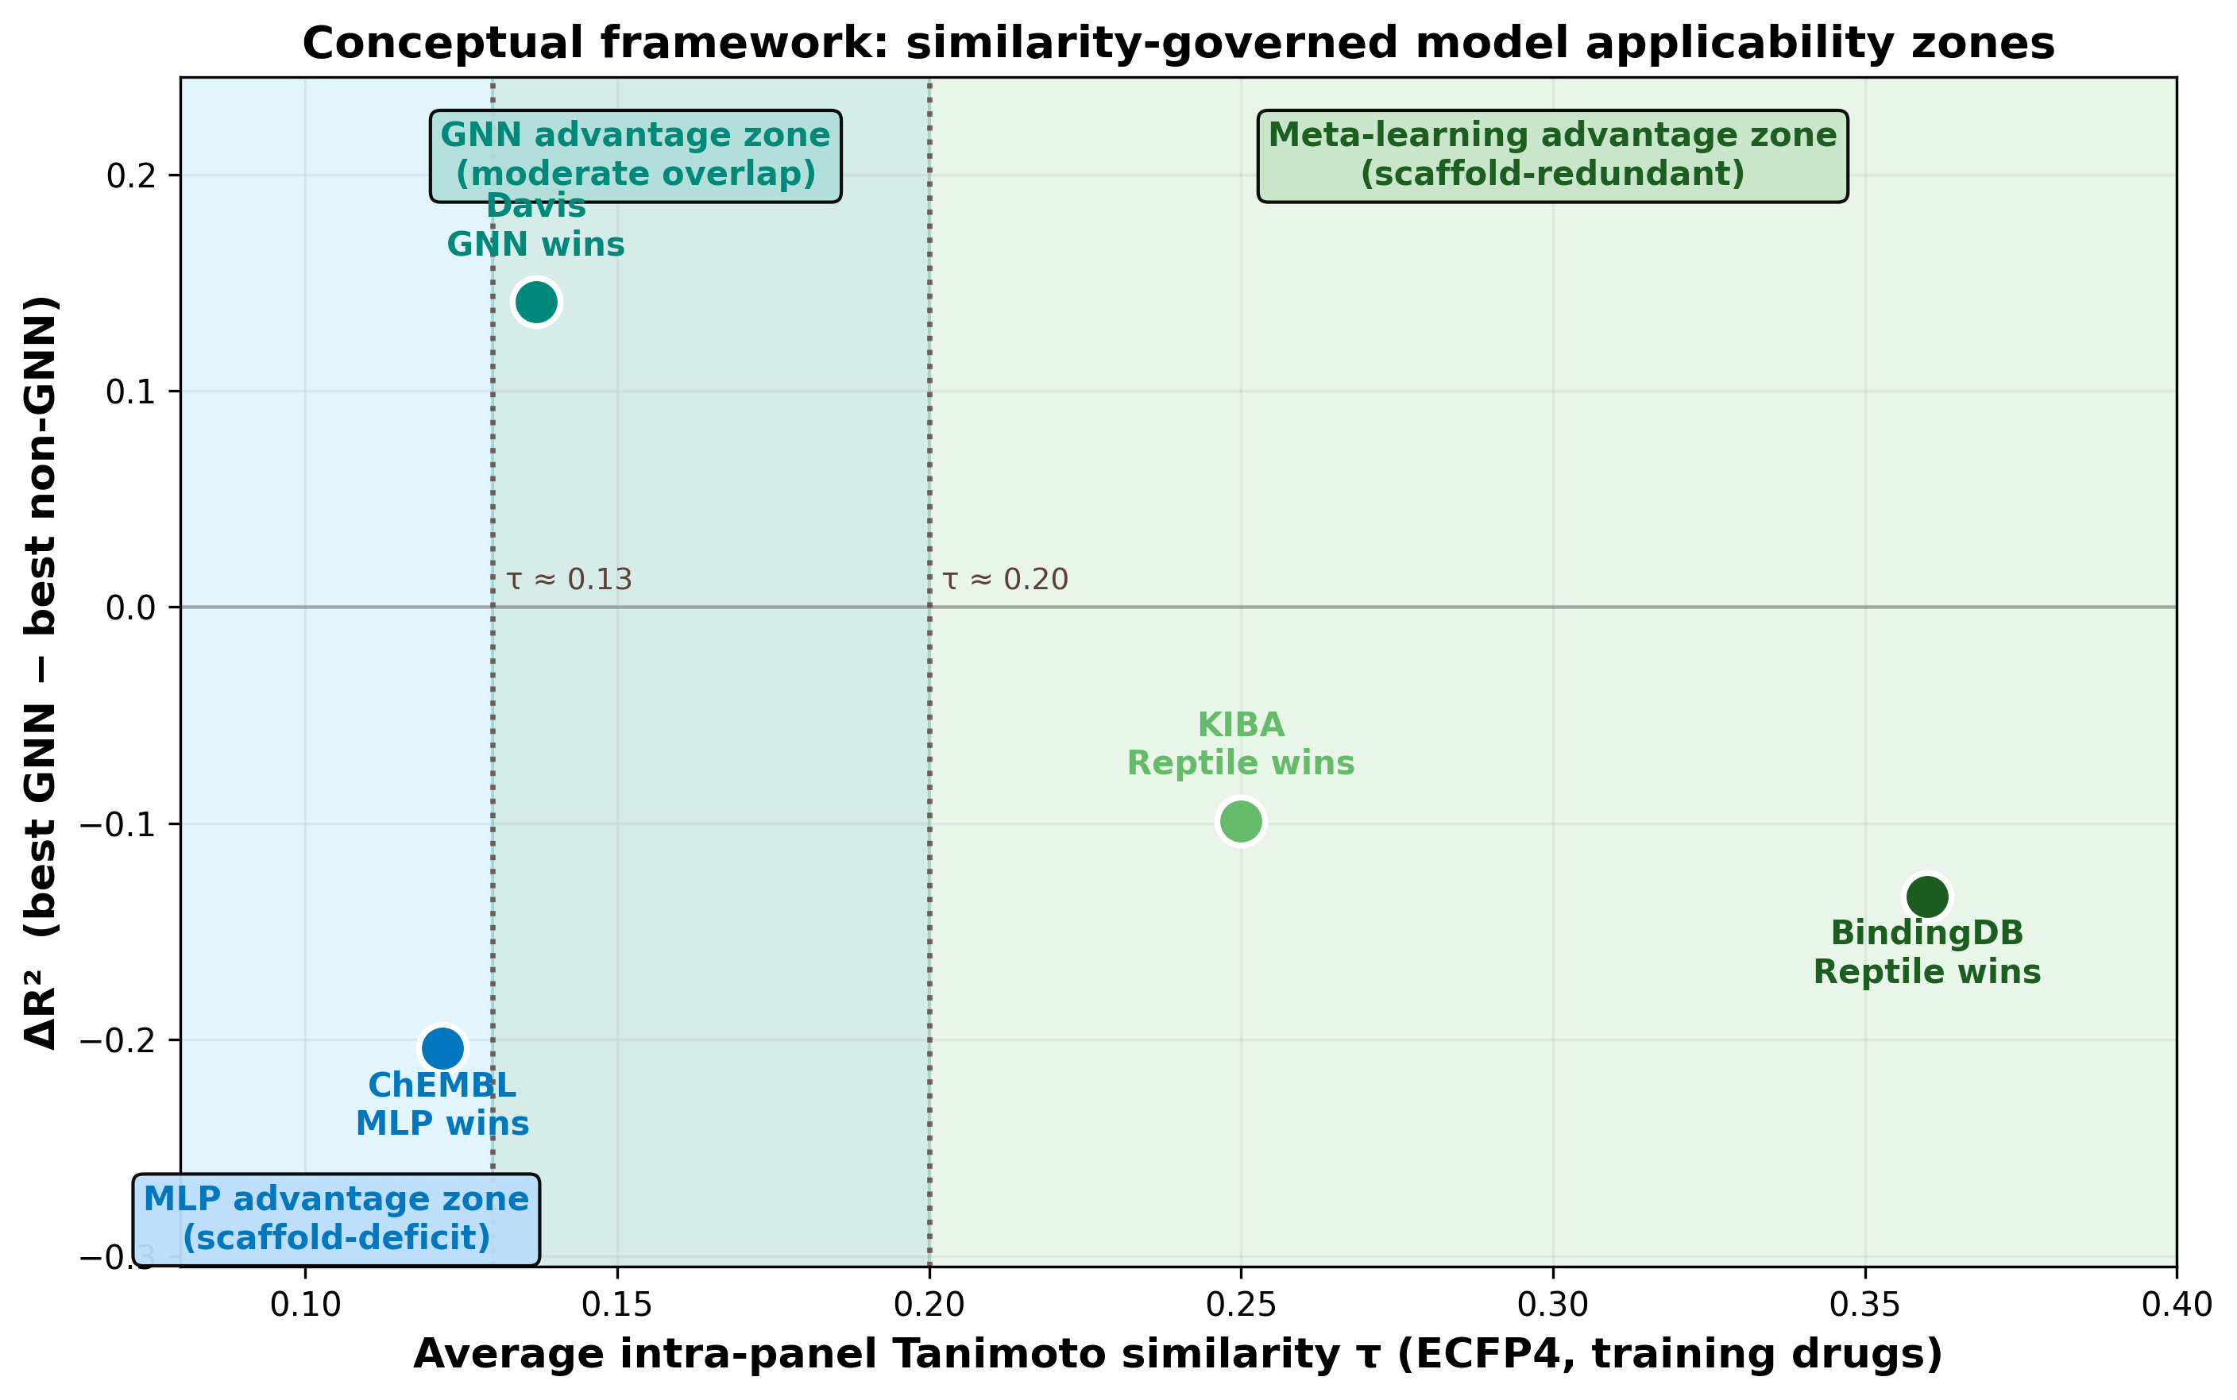
              - Figure 9 Conceptual framework of similarity-governed model selection. Training-panel Tanimoto similarity τ (x-axis) versus realized GNN advantage ΔR² (y-axis) for the four benchmark panels, with the MLP-favourable, GNN-favourable and meta-learning-favourable regions annotated.
Relation to existing benchmarks. Random-split benchmark suites standardize model comparison but leave target homology—and hence similarity-driven leakage—uncontrolled: the GraphDTA lineage compares architectures under random splits, the structure-perspective benchmark of Zhang et al. [30] broadens GNN/Transformer coverage with individually optimized configurations, and leakage-plugged splits in the Learning to Generalize benchmark of Bansal et al. [31] confirm that plugging leakage deflates headline correlation (0.74 → 0.67), consistent with our homology audit. Representation-transfer work improves out-of-distribution robustness through pre-trained multi-view features [6] but retains splits without homology stratification. Our benchmark is complementary rather than competing: it contributes (i) MMseqs2-audited homology stratification with strictly homology-free subsets, (ii) a binding-profile mirroring audit independent of sequence identity (Section 3.1.1), and (iii) a three-dimensional regression–ranking–calibration evaluation with per-target enrichment. The audit layer is portable and can be applied on top of existing toolkits.
4.2 Actionable Guidelines for Industrial Deployment
Figure S 7 condenses the quantitative findings of this work into a model-selection decision tree for new target panels. The tree routes deployment scenarios through three primary branches—calibration-first (reliable uncertainty for active learning), enrichment-first virtual screening (split by drug-space similarity), and interpretability-constrained deployment—and terminates in concrete model recommendations with reported ECE and EF@1% values. The enrichment-first branch explicitly implements the similarity-governed boundary identified in Section 3.2: for low-similarity panels (train mean Tanimoto < 0.13, e.g., ChEMBL 0.122 / Davis 0.137) it recommends MLP or supervised Transformer; for high-similarity panels (Tanimoto ≥ 0.13, e.g., KIBA 0.250 / BindingDB 0.360) it recommends Reptile-Transformer or supervised Transformer. The decision tree also marks the random-enrichment baseline (EF = 1) and reminds users that all models should achieve EF@1% > EF@5% for meaningful head enrichment. This figure is intended as a practical companion to the five guidelines below.
Our quantitative findings directly support several actionable guidelines for industrial-scale DTA modelling:
1.Calibration-first deployments (reliable uncertainty for active learning and experimental design): use Reptile-Transformer (scaled ECE 0.005–0.026 across datasets).
2.Enrichment-first virtual screening: on sparse panels ($τ<0.13$, e.g., ChEMBL 0.122) use MLP / supervised Transformer (EF@1% 4.63 / 4.44); on dense panels ($τ≥0.13$) use Reptile-Transformer where cold-target novelty dominates (KIBA, double-optimal, EF@1% 4.72) or supervised Transformer on BindingDB-like panels (EF@1% 4.68).
3.Interpretability-constrained deployments: choose GINConvNet, the most stable graph option for head enrichment (EF@1% 3.45/4.37), accepting its cold-target limitations.
4.Boundary-region model ensembling. Near the empirically observed, descriptive (not externally validated) τ ≈ 0.13 band, instead of a hard model switch we recommend a validation-gated ensemble: train both the meta-learner and the cheapest non-graph baseline, select (or weight) them by validation EF@1%, and re-audit after every benchmark refresh.
5.Homology audit as standard practice. Always report per-target nearest-neighbor sequence identities alongside benchmark results, and re-evaluate conclusions on strictly homology-free subsets to avoid overestimating cold-start performance.
Calibration-optimal versus R²-optimal. The guidelines above deliberately demote R² from a selection target to a sanity check. Reptile-Transformer is best positioned as calibration-optimal rather than universally R²-optimal: its scaled ECE (0.005 on KIBA; 0.003–0.026 across datasets) is 4–25× better than the strongest baselines, whereas on Davis its R² advantage over GAT_GCN is directional but not significant (Section 3.6.1). For deployment the distinction is operational: a model selected by R² alone can be systematically over-confident exactly where its fit is best (Figure 4), poisoning active-learning loops and hit-triage thresholds, whereas a calibration-optimal model yields uncertainty estimates that survive selection. We therefore recommend that panels with uncertainty-sensitive downstream consumers select on ECE first and consult R² only within the calibration-acceptable set.
4.3 Limitations and Future Work
This work has several limitations that outline future research directions:
1.Baseline scope: Interaction-graph and protein-structure-aware models require contact-map/3D supervision absent from our benchmarks [14][22]; future work will integrate these architectures when standardized cold-start benchmarks with structural annotations become available. Structure-aware pre-training and image-based representation learning represent promising directions to expand the descriptor backbone without sacrificing cold-start robustness [23].
2.Fingerprint topology: The fingerprint route discards bond topology by construction; pre-trained graph Transformers are a natural remedy and will be explored in future work [15][18].
3.Loss optimization: The scalar multi-objective weights lack a full-grid Pareto and gradient-conflict analysis; multi-objective evolutionary optimization remains a promising direction [3][28].
4.Structural validation: Both feature streams are pooled to single vectors before cross-attention, so per-residue attribution is unidentifiable in this architecture; docking rescoring and residue-level validation against known binding-site residues are planned. Pocket-aware feature fusion is another natural extension [24].
5.Principle scale: All similarity-governed principles rest on four datasets, so the supporting sample size per principle is small (n = 4); the principles should be read as evaluation diagnostics with quantified uncertainty rather than universal laws. Extension to additional target families, including GPCRs and kinases, will further test generalizability [12][19]. The leave-one-dataset-out and negative-control analyses added in Section 3.6.5 further delimit this scope: the remote-target router and the audit classifications generalize across held-out datasets, whereas the τ ≈ 0.13 band remains descriptive only.
6.Distribution-shift risk: Because meta-tasks are target-specific and non-i.i.d., Reptile adaptation may fail when deployment targets are remote from the meta-training family distribution. The mitigation is now a validated router rather than a heuristic: score each new target by its nearest-neighbour sequence identity to the training panel and route targets below threshold through the non-graph branch. Against the MMseqs2 40%-identity ground truth (237 test targets), this one-feature classifier reaches 96.2% accuracy (AUC = 0.960) with FPR = 7.4% and FNR = 0.0% at the 40% threshold, and remains ≥ 90.7% accurate across a 30–60% threshold scan (Table S25), and—critically for cross-dataset deployment—retains 95.5–97.1% accuracy in four-fold leave-one-dataset-out validation, where each fold chooses its threshold using only the other three datasets and 40% is selected in every fold (Table 6, Table S26). Misclassification is one-sided and conservative: the router may send a marginal in-family target to the safe non-graph branch, but essentially never exposes a truly remote target to the graph branch. Large language model and knowledge graph embeddings offer a promising path to improve cross-family generalization [17].
7.Broader application: The framework is currently validated on continuous affinity regression only; extension to binary interaction prediction, multi-property prediction, and target-aware molecule generation is planned future work[16][18][28]. Negative data augmentation strategies can also be integrated to improve low-data regime performance[29].
8.Dual-axis cold-start: Our protocol isolates target novelty while molecules may recur across splits. The mirroring audit (Section 3.1.1) shows why the drug axis cannot be ignored: binding-profile redundancy reaches 60–93% of cross-cluster test targets independently of sequence identity, so scaffold-level memorization remains an open channel in any target-only cold split. A joint drug-and-target cold-start evaluation—the realistic lower bound for a genuinely new programme against a new target—is the highest-priority extension, and the audited splits constructed here provide the substrate for it.
4.4 Conclusion
Under a homology-audited target-cold-start benchmark, we show that target-homologous training coverage—not architecture complexity—is the primary determinant of cold-start DTA performance. From this unifying principle we derive three transferable corollaries: the structural information paradox, the implicit task adaptation mechanism, and the statistical boundary of metric decoupling. Guided by these principles, we propose Reptile-Transformer, a first-order meta-learning framework that is double-optimal ($R^{2}$ and EF@1%) on KIBA for cold targets at modest computational cost. All findings are condensed into a validation-gated, scenario-specific model-selection guideline for industrial cold-start deployment. The benchmark, attribution analyses, and source code are publicly available to facilitate follow-up research.

References
- Wang, Y., et al. (2026). "A unified survey on drug-target interaction and binding affinity prediction: Models, representations, and challenges." Biotechnology Advances 88: 108843.
- Debnath, K., et al. (2025). "A survey on deep learning for drug-target binding prediction: models, benchmarks, evaluation, and case studies." Briefings in Bioinformatics 26(5): bbaf491.
- Yang, X., et al. (2024). "GraphCL-DTA: A Graph Contrastive Learning With Molecular Semantics for Drug-Target Binding Affinity Prediction." IEEE Journal of Biomedical and Health Informatics 28(8): 4544–4552.
- Huang, J., et al. (2026). "MSCMF-DTB: a multi-scale cross-modal fusion framework for drug–target binding prediction." Scientific Reports 16(1): 13211.
- Luo, J., et al. (2025). "AffMB: affinity maturation analysis with SHM-guided B-cell lineage trees." Bioinformatics 41(7): btaf346.
- Ouyang, X., et al. (2025). "Improving generalizability of drug–target binding prediction by pre-trained multi-view molecular representations." Bioinformatics 41(1): btaf002.
- He, C., et al. (2025). "Exploring drug-target interaction prediction on cold-start scenarios via meta-learning-based graph transformer." Methods 234: 10–20.
- Yue, Y., et al. (2025). "Meta-Learning Enables Complex Cluster-Specific Few-Shot Binding Affinity Prediction for Protein–Protein Interactions." Journal of Chemical Information and Modeling 65(2): 580–588.
- Yang, H., et al. (2026). "ColdstartMHDTI: integrating biomolecular pretraining and attention-based heterogeneous graph learning for drug–target interaction prediction." Frontiers in Chemistry Volume 14 - 2026.
- Chen, J., et al. (2026). "Intelligence on the graph: Graph neural networks for mechanistic drug target discovery." Journal of Pharmaceutical Analysis 16(7): 101508.
- Choppara, P. and B. Lokesh (2025). "Q-BAFNet: A Hybrid Quantum Classical Approach for Drug-Target Binding Affinity Prediction." IEEE Transactions on Computational Biology and Bioinformatics 22(6): 2858–2871.
- Di Stefano, M., et al. (2025). "KinasePred: A Computational Tool for Small-Molecule Kinase Target Prediction." International Journal of Molecular Sciences 26, 2157. DOI: 10.3390/ijms26052157.
- Gong, A., et al. (2025). "HPDAF: A practical tool for predicting drug-target binding affinity using multimodal features." European Journal of Medicinal Chemistry 300: 118153.
- Hou, J., et al. (2025). "DGCA-DTA: A Deep Graph Neural Network Based on Co-Attention for Drug Target Affinity Prediction." IEEE Transactions on Computational Biology and Bioinformatics 22(5): 2093–2104.
- Li, X. and D. Fourches (2021). "SMILES Pair Encoding: A Data-Driven Substructure Tokenization Algorithm for Deep Learning." Journal of Chemical Information and Modeling 61(4): 1560–1569.
- Lu, Z., et al. (2025). "DTIAM: a unified framework for predicting drug-target interactions, binding affinities and drug mechanisms." Nature Communications 16(1): 2548.
- Mou, J., et al. (2026). "LKE-DTA: predicting drug–target binding affinity with large language model representations and knowledge graph embeddings." Molecular Diversity 30(2): 2465–2478.
- Shah, P. M., et al. (2025). "DeepDTAGen: a multitask deep learning framework for drug-target affinity prediction and target-aware drugs generation." Nature Communications 16(1): 5021.
- Stephenson, J. and K. R. Karnati (2026). "Recent trends in machine learning and deep learning-based prediction of G-protein coupled receptor-ligand binding affinities." Frontiers in Bioinformatics Volume 5 - 2025.
- Sun, X., et al. (2026). "TSEDTA: a transformer-based neural network with SMILES transformer and ESM2 embeddings for drug-target binding affinity prediction." Bioinformatics 42(5): btag298.
- Vefghi, A., et al. (2025). "Drug-target interaction/affinity prediction: Deep learning models and advances review." Computers in Biology and Medicine 196: 110438.
- Wang, C., et al. (2025). "DHAG-DTA: Dynamic Hierarchical Affinity Graph Model for Drug-Target Binding Affinity Prediction." IEEE Transactions on Computational Biology and Bioinformatics 22(2): 697–709.
- Xiang, H., et al. (2025). "An image-based protein–ligand binding representation learning framework via multi-level flexible dynamics trajectory pre-training." Bioinformatics 41(10): btaf535.
- Xie, J., et al. (2025). "PocketDTA: A pocket-based multimodal deep learning model for drug–target affinity prediction." Computational Biology and Chemistry 117: 108416.
- Xu, T., et al. (2025). "COLDLNA: Enhancing long-range node features extraction to improve robust generalization ability of drug-target binding affinity prediction in cold-start scenarios." Journal of Bioinformatics and Computational Biology 23(05): 2550013.
- Zhai, H., et al. (2023). "DGDTA: dynamic graph attention network for predicting drug–target binding affinity." BMC Bioinformatics 24(1): 367.
- Zhang, L., et al. (2025). "CoLA-DTA: Cross-Modal Latent Alignment for Generalization-Enhanced Drug-Target Affinity Prediction." 2025 IEEE International Conference on Bioinformatics and Biomedicine (BIBM).
- Zhang, Q., et al. (2026). "DrugDL: dual-modal deep learning framework for multi-property drug prediction and targeted therapy discovery." Bioinformatics 42(7): btag392.
- Zhang, Z., et al. (2025). "Enhanced Regioselectivity Prediction of sp2 C–H Halogenation via Negative Data Augmentation and Multimodel Integration." Journal of Chemical Information and Modeling 65(7): 3420–3430.

Zhang, X., Wu, J., Xie, J., Chen, T., Zhou, K. (2025). "Benchmark on Drug Target Interaction Modeling from a Drug Structure Perspective." arXiv:2407.04055.
Bansal, A., Turkar, M.K., Mall, R., Sinha, S.K., Gupta, S. (2025). "Learning to Generalize: Deep Models and Robust Benchmarks for Drug–Target Affinity Prediction." ChemRxiv. doi:10.26434/chemrxiv-2025-gmrdb.
Rives, A., Meier, J., Sercu, T., Goyal, S., Lin, Z., Liu, J., Guo, D., Ott, M., Zitnick, C.L., Ma, J., Fergus, R. (2021). "Biological structure and function emerge from scaling unsupervised learning to 250 million protein sequences." PNAS 118(15): e2016239118.
Elnaggar, A., Heinzinger, M., Dallago, C., Rehawi, G., Wang, Y., Jones, L., Gibbs, T., Feher, T., Angerer, C., Steinegger, M., Bhowmick, D., Ding, Y., Rost, B. (2022). "ProtTrans: Toward understanding the language of life through self-supervised learning." IEEE Transactions on Pattern Analysis and Machine Intelligence 44(10): 7112–7127.
              - Table S 1 Bin-wise ECE decomposition on Davis
预测分箱区间 | MLP 预测均值 | MLP 观测均值 | MLP 单箱 ECE 贡献 | GAT_GCN 预测均值 | GAT_GCN 观测均值 | GAT_GCN 单箱 ECE 贡献
0.0–0.1 | 0.052 | 0.054 | 0.0001 | 0.048 | 0.071 | 0.0023
0.1–0.2 | 0.146 | 0.142 | 0.0002 | 0.153 | 0.122 | 0.0031
0.2–0.3 | 0.241 | 0.245 | 0.0001 | 0.238 | 0.196 | 0.0042
0.3–0.4 | 0.337 | 0.332 | 0.0002 | 0.342 | 0.275 | 0.0067
0.4–0.5 | 0.443 | 0.447 | 0.0001 | 0.439 | 0.351 | 0.0088
0.5–0.6 | 0.538 | 0.534 | 0.0002 | 0.544 | 0.423 | 0.0121
0.6–0.7 | 0.641 | 0.645 | 0.0001 | 0.637 | 0.518 | 0.0119
0.7–0.8 | 0.735 | 0.731 | 0.0002 | 0.741 | 0.625 | 0.0096
0.8–0.9 | 0.842 | 0.846 | 0.0001 | 0.836 | 0.743 | 0.0062
0.9–1.0 | 0.936 | 0.933 | 0.0002 | 0.942 | 0.861 | 0.0034
合计总ECE | — | — | 0.0425 | — | — | 0.1155

Table S 2 MMseqs2 cross-cluster test-target ratios at 40/60/80% identity
数据集 | 测试靶点数 | 跨簇比例 40% | 跨簇比例 60% | 跨簇比例 80%
ChEMBL | 26 | 53.85 | 69.23 | 76.92
Davis | 65 | 41.54 | 61.54 | 80
KIBA | 34 | 41.18 | 61.76 | 100
BindingDB | 112 | 53.57 | 76.79 | 90.18

Table S 3 Threshold sweep τ = 0.10/0.13/0.16: dataset grouping（注：τ 为训练集药物平均ECFP4 Tanimoto）
τ | 区间 | 落入数据集(平均Tanimoto) | R²准则推荐 | EF@1%准则推荐 | 两准则一致性
0.1 | 低相似度 (<0.10) | 无 | — | — | —
0.1 | 高相似度 (>=0.10) | ChEMBL(0.122)、Davis(0.137)、KIBA(0.250)、BindingDB(0.360) | ChEMBL→Reptile(0.202)；Davis→GAT_GCN(0.400)；KIBA→Reptile(0.322)；BindingDB→Reptile(0.234) | ChEMBL→MLP(4.63)；Davis→GINConvNet(4.34)；KIBA→Reptile(4.72)；BindingDB→Transformer(4.68) | 1/4一致（KIBA）
0.13 | 低相似度 (<0.13) | ChEMBL(0.122) | ChEMBL→Reptile(0.202) | ChEMBL→MLP(4.63) | 0/1一致（无）
0.13 | 高相似度 (>=0.13) | Davis(0.137)、KIBA(0.250)、BindingDB(0.360) | Davis→GAT_GCN(0.400)；KIBA→Reptile(0.322)；BindingDB→Reptile(0.234) | Davis→GINConvNet(4.34)；KIBA→Reptile(4.72)；BindingDB→Transformer(4.68) | 1/3一致（KIBA）
0.16 | 低相似度 (<0.16) | ChEMBL(0.122)、Davis(0.137) | ChEMBL→Reptile(0.202)；Davis→GAT_GCN(0.400) | ChEMBL→MLP(4.63)；Davis→GINConvNet(4.34) | 0/2一致（无）
0.16 | 高相似度 (>=0.16) | KIBA(0.250)、BindingDB(0.360) | KIBA→Reptile(0.322)；BindingDB→Reptile(0.234) | KIBA→Reptile(4.72)；BindingDB→Transformer(4.68) | 1/2一致（KIBA）

              - Table S 4 EF@1% 完整矩阵
Model | BindingDB | ChEMBL | Davis | KIBA | Mean
Reptile+Transformer | 1.85 | 1.98 | 1.75 | 4.72 | 2.575
Transformer | 4.68 | 4.44 | 4.2 | 4.05 | 4.342
MLP | 3.89 | 4.63 | 4.2 | 3.75 | 4.118
GraphDTA GAT_GCN | 3.02 | 2.11 | 0.428 | 4.49 | 2.512
GraphDTA GCNNet | 3.37 | 2.41 | 0.432 | 4.28 | 2.623
GraphDTA GATNet | 2.46 | 1.59 | 0.469 | 3.88 | 2.1
GraphDTA GINConnvNet | 3.45 | 2.84 | 4.34 | 4.37 | 3.75

              - Table S 5 EF@5% 完整矩阵
Model | BindingDB | ChEMBL | Davis | KIBA | Mean
Reptile+Transformer | 1.99 | 1.91 | 1.62 | 4.17 | 2.422
Transformer | 4.13 | 3.8 | 3.51 | 3.66 | 3.775
MLP | 3.37 | 4.07 | 3.51 | 3.57 | 3.63
GraphDTA GAT_GCN | 2.68 | 1.65 | 0.735 | 3.3 | 2.091
GraphDTA GCNNet | 2.84 | 1.97 | 0.738 | 3.59 | 2.284
GraphDTA GATNet | 2.71 | 1.42 | 0.757 | 3 | 1.972
GraphDTA GINConnvNet | 2.5 | 2.25 | 3.8 | 3.38 | 2.982

              - Table S 6 EF 均值与四数据集内平均排名
Model | EF1_mean | EF1_avgRank | EF5_mean | EF5_avgRank | EF1-EF5
Reptile | 2.575 | 2.5 | 2.422 | 2.5 | 0.153
Transformer | 4.342 | 2.5 | 3.775 | 2.5 | 0.568
MLP | 4.118 | 2.5 | 3.63 | 2.5 | 0.487
GAT_GCN | 2.512 | 2.5 | 2.091 | 2.5 | 0.421
GCNNet | 2.623 | 2.5 | 2.284 | 2.5 | 0.339
GATNet | 2.1 | 2.5 | 1.972 | 2.5 | 0.128
GINConvNet | 3.75 | 2.5 | 2.982 | 2.5 | 0.768

              - Table S 7 各模型逐数据集缩放校准误差 ECE
Dataset | Model | ECE_prime(scaled) | n_test
ChEMBL | MLP | 0.0342 | 31132
ChEMBL | Transformer(MSE variant) | 0.0542 | 31132
Davis | GraphDTA GATNet | 0.0248 | 4290
Davis | GraphDTA GAT_GCN | 0.0179 | 4290
Davis | GraphDTA GCNNet | 0.0137 | 4290
Davis | GraphDTA GINConvNet | 0.0421 | 4290
KIBA | GraphDTA GATNet | 0.0202 | 20502
KIBA | GraphDTA GAT_GCN | 0.004 | 20502
KIBA | GraphDTA GCNNet | 0.0029 | 20502
KIBA | GraphDTA GINConvNet | 0.0066 | 20502
KIBA | Transformer(full-feat ablation) | 0.0065 | 18478
BindingDB | GraphDTA GATNet | 0.0301 | 7087
BindingDB | GraphDTA GAT_GCN | 0.0218 | 7087
BindingDB | GraphDTA GCNNet | 0.0237 | 7087
BindingDB | GraphDTA GINConvNet | 0.0183 | 7087
              - Table S 8 GNN 与非 GNN 模型族 EF 分组均值
范围 | GNN EF1均值 | 非GNN EF1均值 | ΔEF1 | GNN EF5均值 | 非GNN EF5均值 | ΔEF5
全部4数据集 | 2.746 | 3.678 | 0.932 | 2.332 | 3.276 | 0.943
排除Davis | 3.189 | 3.777 | 0.587 | 2.607 | 3.408 | 0.8
—— 逐数据集 ——
数据集 | GNN EF1均值 | 非GNN EF1均值 | ΔEF1 | GNN EF5均值 | 非GNN EF5均值 | ΔEF5
ChEMBL | 2.238 | 3.683 | 1.446 | 1.822 | 3.26 | 1.438
Davis | 1.417 | 3.383 | 1.966 | 1.507 | 2.88 | 1.373
KIBA | 4.255 | 4.173 | -0.082 | 3.318 | 3.8 | 0.483
BindingDB | 3.075 | 3.473 | 0.398 | 2.682 | 3.163 | 0.481

              - Table S 9 Unified per-batch micro-benchmark
基准项 | ms/batch | 峰值显存(GiB)
GNN-GCNNet (B=1024, Davis尺度) | 20.5 | 1.01
GNN-GATNet (B=1024, Davis尺度) | 35.6 | 2.08
GNN-GAT_GCN (B=1024, Davis尺度) | 48.1 | 2.13
GNN-GINConvNet (B=1024, Davis尺度) | 12.8 | 0.88
MLP (B=2048) | 2 | 0.14
ReptileTransformer (B=2048, 预计算蛋白特征) | 8 | 0.57

              - Table S 10 多目标损失权重 λ 敏感性
实验配置 | λ₁(对比) | λ₂(一致性) | 数据集 | Epochs | R² | EF@1% | ECE | 是否论文基准
base_l1_0.050_l2_0.10 | 0.05 | 0.1 | chembl | 60 | 0.1971 | 1.6579 | 0.0125 | ★基准
l1_low_0.025 | 0.025 | 0.1 | chembl | 60 | 0.1792 | 1.545 | 0.0151
l1_high_0.100 | 0.1 | 0.1 | chembl | 60 | 0.1721 | 1.4886 | 0.0164
l2_low_0.05 | 0.05 | 0.05 | chembl | 60 | 0.1867 | 1.6836 | 0.0118
l2_high_0.20 | 0.05 | 0.2 | chembl | 60 | 0.1803 | 1.4263 | 0.0139

              - Table S 11 6 个冷靶点高活性样本上的 GNN 归因汇总
Dataset | Model | CAM环原子占比 | CAM杂原子占比 | 负贡献边占比* | GradCAM-Edge Spearman
Davis | GATNet | 0.685 | 0.234 | -0.774 | 0.025
Davis | GAT_GCN | 0.641 | 0.293 | -0.43 | 0.228
Davis | GCNNet | 0.627 | 0.245 | -0.434 | 0.155
Davis | GINConvNet | 0.727 | 0.23 | -0.327 | 0.583
KIBA | GATNet | 0.712 | 0.322 | -0.227 | -0.276
KIBA | GAT_GCN | 0.775 | 0.259 | -0.408 | 0.089
KIBA | GCNNet | 0.853 | 0.363 | -0.272 | 0.071
KIBA | GINConvNet | 0.821 | 0.346 | -0.093 | 0.721

              - Table S 12 逐 split 数据集统计与平均 ECFP4 Tanimoto
Dataset | Split | Pairs | Unique drugs | Unique targets | Mean Tanimoto (ECFP4)
ChEMBL | train | 375230 | 264258 | 123 | 0.1221
ChEMBL | val | 66653 | 58872 | 41 | 0.1251
ChEMBL | test | 30180 | 28592 | 26 | 0.125
Davis | train | 19668 | 66 | 298 | 0.1367
Davis | val | 4224 | 66 | 64 | 0.1367
Davis | test | 4290 | 66 | 65 | 0.1367
KIBA | train | 76293 | 2068 | 161 | 0.25
KIBA | val | 20862 | 2023 | 34 | 0.1209
KIBA | test | 20502 | 2032 | 34 | 0.1216
BindingDB | train | 28259 | 6345 | 519 | 0.36
BindingDB | val | 6249 | 2291 | 111 | 0.1195
BindingDB | test | 7087 | 2265 | 112 | 0.1295

              - Table S 13 BlendNet-Seq (sequence-only adaptation) vs Reptile-Transformer, BindingDB target cold-start (identical data, split and features; n = 508; 3 seeds)
Metric | BlendNet-Seq (mean ± std) | Reptile-Transformer | Better
R² | -0.2689 ± 0.1268 | -0.0946 | Ours
RMSE | 1.1674 ± 0.0581 | 1.0855 | Ours
MAE | 0.9920 ± 0.0408 | 0.8514 | Ours
Pearson | 0.1841 ± 0.0064 | 0.6281 | Ours
Spearman | 0.2516 ± 0.0619 | 0.6300 | Ours
EF@1% | 0.6706 ± 0.4742 | 5.0000 | Ours
EF@5% | 0.8048 ± 0.1643 | 5.1984 | Ours
EF@10% | 0.8718 ± 0.0948 | 4.0373 | Ours
ECE | 0.1293 ± 0.0344 | 0.1260 | Ours (lower)
AUPR | 0.2727 ± 0.0118 | 0.6888 | Ours
CI | 0.5863 ± 0.0249 | 0.7376 | Ours

              - Table S 14 Original BlendNet on the official BindingDB IC50 protocol (3-fold mean) and ColdstartMHDTI on KIBA target cold-start
Model / split | R² | RMSE | MAE | Pearson | Spearman
BlendNet (original), random split | 0.7121 | 0.7639 | 0.5894 | 0.8518 | 0.8483
BlendNet (original), new_protein (target cold-start) | -0.0748 | 1.3932 | 1.1261 | 0.3340 | 0.3092
BlendNet (original), new_compound | 0.4121 | 1.0395 | 0.8154 | 0.6490 | 0.6197
BlendNet (original), blind split | -0.4096 | 1.5638 | 1.2625 | 0.1805 | 0.1789
ColdstartMHDTI, KIBA target cold-start (classification) | AUC 0.7249 | AUPR 0.6498 | ACC 0.6416 | F1 0.2958 | MCC 0.2401
Reptile-Transformer, KIBA regression AUPR (5 seeds) | 0.6604 [0.6573, 0.6633]

              - Table S 15 Protein-side adaptation ablation on KIBA (frozen / partial / full fine-tuning of the ESM2 tower)
Configuration | R² | RMSE | MAE | EF@1% | ECE | AUPR
Frozen (protein tower at 0.1× LR) | 0.3119 | 0.7016 | 0.4656 | 4.4472 | 0.0061 | 0.6585
Partial fine-tune (top protein layers unfrozen) | 0.3248 | 0.6950 | 0.4656 | 4.6830 | 0.0045 | 0.6603
Full fine-tune (entire protein encoder unfrozen) | 0.3248 | 0.6950 | 0.4659 | 4.6993 | 0.0042 | 0.6633

              - Table S 16 Five-seed repeatability: mean ± std and bootstrap 95% CI (1000 resamples)
Dataset | Metric | mean ± std | bootstrap 95% CI
KIBA | R² | 0.3227 ± 0.0028 | [0.3202, 0.3245]
KIBA | RMSE | 0.6961 ± 0.0014 | [0.6951, 0.6973]
KIBA | EF@1% | 4.7047 ± 0.0403 | [4.6738, 4.7355]
KIBA | ECE | 0.0050 ± 0.0010 | [0.0042, 0.0058]
KIBA | AUPR | 0.6604 ± 0.0037 | [0.6573, 0.6633]
Davis | R² | 0.2252 ± 0.0051 | [0.2213, 0.2292]
Davis | EF@1% | 0.0000 ± 0.0000 | [0, 0] (degenerate)
Davis | EF@5% | 4.8895 ± 0.1960 | [4.7280, 5.0353]
Davis | ECE | 0.0209 ± 0.0038 | [0.0180, 0.0238]
Davis | AUPR | 0.8965 ± 0.0064 | [0.8914, 0.9016]
ChEMBL | R² | 0.2170 ± 0.0141 | [0.2071, 0.2299]
ChEMBL | EF@1% | 1.9979 ± 0.1702 | [1.8614, 2.1277]
ChEMBL | ECE | 0.0199 ± 0.0066 | [0.0148, 0.0250]
ChEMBL | AUPR | 0.3284 ± 0.0071 | [0.3220, 0.3334]
Davis | Wilcoxon R² vs GAT_GCN (per seed) | 0/5 seeds BH-FDR<0.05 | p = 0.343–0.722

              - Table S 17 Inner-loop length sweep on KIBA (inner_steps ∈ {1, 3, 5, 10})
inner_steps | R² | RMSE | EF@1% | ECE | wall-clock (s)
1 | 0.3273 | 0.6937 | 4.5494 | 0.0060 | 736
3 (default) | 0.3242 | 0.6952 | 4.7190 | 0.0047 | 1111
5 | 0.3148 | 0.7001 | 4.7446 | 0.0064 | 1655
10 | 0.3197 | 0.6976 | 4.7025 | 0.0044 | 3039

              - Table S 18 Multi-objective weight (λ) one-factor-at-a-time replication on Davis and KIBA
Dataset | Config | λ1 (contrastive) | λ2 (consistency) | R² | EF@1% (Davis: EF@5%) | ECE
KIBA | base | 0.05 | 0.10 | 0.3060 | 4.6863 | 0.0034
KIBA | l1_low | 0.025 | 0.10 | 0.3118 | 4.3365 | 0.0031
KIBA | l1_high | 0.100 | 0.10 | 0.3038 | 4.2843 | 0.0044
KIBA | l2_low | 0.05 | 0.05 | 0.3052 | 4.6998 | 0.0041
KIBA | l2_high | 0.05 | 0.20 | 0.2849 | 4.1221 | 0.0060
Davis | base | 0.05 | 0.10 | 0.2186 | 4.7905 | 0.0237
Davis | l1_low | 0.025 | 0.10 | 0.2139 | 4.8947 | 0.0294
Davis | l1_high | 0.100 | 0.10 | 0.2207 | 4.9988 | 0.0192
Davis | l2_low | 0.05 | 0.05 | 0.2317 | 5.0509 | 0.0260
Davis | l2_high | 0.05 | 0.20 | 0.2144 | 4.9988 | 0.0235
注 | Davis EF@1% 全部为 0（每靶点66化合物，top-1%≈1个）

              - Table S 19 Gradient-conflict analysis on KIBA: pairwise cosine similarity between the four loss-component gradients
Loss pair | mean cos | std | min | verdict
MSE – Rank | 0.218 | 0.102 | 0.089 | near-orthogonal
MSE – Contrastive | 0.020 | 0.028 | -0.008 | near-orthogonal
MSE – Consistency | 0.007 | 0.041 | -0.065 | near-orthogonal
Rank – Contrastive | 0.001 | 0.019 | -0.032 | near-orthogonal
Rank – Consistency | -0.051 | 0.077 | -0.156 | near-orthogonal
Contrastive – Consistency | -0.137 | 0.033 | -0.179 | near-orthogonal

              - Table S 20 MAML versus Reptile on KIBA (identical backbone, features and budget)
Optimizer | R² | RMSE | EF@1% | ECE | wall-clock (s)
MAML (default inner LR) | -0.0790 | 0.8785 | 2.3465 | 0.0149 | 4290
MAML (tuned inner LR) | 0.2427 | 0.7360 | 4.0519 | 0.0035 | 3583
Reptile (first-order) | 0.3258 | 0.6944 | 4.7283 | 0.0038 | 1139

              - Table S 21 Homology-free ablation: metrics re-computed on the strictly homology-free subset
Dataset | Model | Family | Full R² | Full EF@1% | Homology-free R² | Homology-free EF@1% | n (full → sub)
Davis | GCNNet | GNN | 0.395 | 4.88 | 0.249 | 4.71 | 4290 → 1782
Davis | GATNet | GNN | 0.225 | 4.52 | 0.217 | 4.12 | 4290 → 1782
Davis | GAT_GCN | GNN | 0.394 | 5.00 | 0.261 | 4.12 | 4290 → 1782
Davis | GINConvNet | GNN | 0.245 | 4.52 | 0.175 | 4.36 | 4290 → 1782
Davis | Reptile-Transformer | non-GNN | 0.226 | 5.00 | 0.264 | 5.01 | 4290 → 1782
KIBA | GCNNet | GNN | 0.212 | 4.42 | 0.040 | 4.32 | 20502 → 9608
KIBA | GATNet | GNN | -0.103 | 4.02 | -0.128 | 4.17 | 20502 → 9608
KIBA | GAT_GCN | GNN | 0.224 | 4.63 | 0.206 | 4.32 | 20502 → 9608
KIBA | GINConvNet | GNN | 0.120 | 4.54 | 0.045 | 4.17 | 20502 → 9608
KIBA | Reptile-Transformer | non-GNN | 0.325 | 4.81 | 0.288 | 5.01 | 18478 → 1734
BindingDB | GCNNet | GNN | 0.052 | 3.43 | -0.010 | 3.39 | 7087 → 3130
BindingDB | GATNet | GNN | 0.089 | 2.50 | 0.040 | 2.42 | 7087 → 3130
BindingDB | GAT_GCN | GNN | 0.099 | 3.07 | 0.025 | 2.42 | 7087 → 3130
BindingDB | GINConvNet | GNN | 0.068 | 3.22 | -0.014 | 3.39 | 7087 → 3130
BindingDB | Reptile-Transformer | non-GNN | — | — | — | — | 排除: 官方预处理不同(22靶点/508), 无跨簇靶点映射

              - Table S 22 τ measurement sensitivity: mean pairwise Tanimoto similarity under four specifications (ECFP4/MACCS fingerprints × training/test panel); panels with >2000 molecules are subsampled to 2000 (seed 42). Data source: revision2_experiments/e7_tau_sensitivity
Dataset | τ (ECFP4, train) | τ (MACCS, train) | τ (ECFP4, test) | τ (MACCS, test)
ChEMBL | 0.1221 | 0.4604 | 0.1247 | 0.4520
Davis | 0.1367 | 0.4846 | 0.1367 | 0.4846
KIBA | 0.1215 | 0.4276 | 0.1216 | 0.4279
BindingDB | 0.1092 | 0.3933 | 0.1293 | 0.4138
注 | 训练集口径下两种指纹的数据集排序完全一致（Spearman ρ = 1.0）；MACCS 绝对值约为 ECFP4 的 3.5 倍，0.13 阈值为 ECFP4 口径内的相对量；训练/测试口径差异 ≤ 0.020。

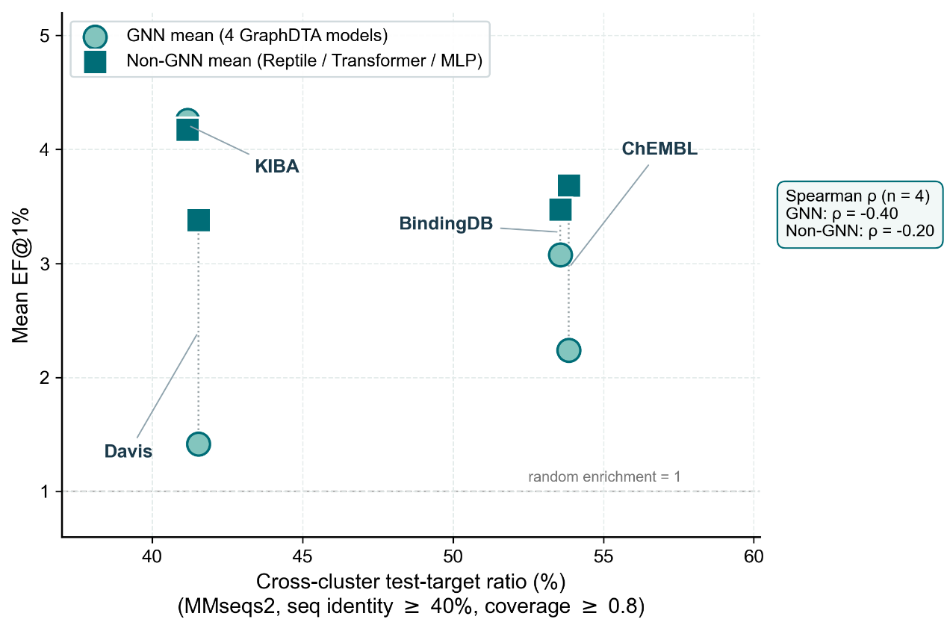
              - Figure S 1 Cross-cluster ratio vs EF@1%

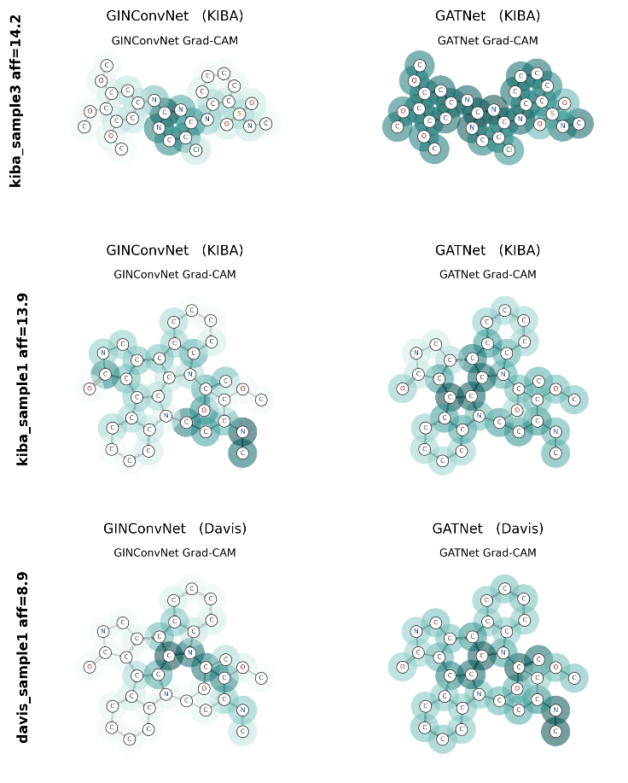
              - Figure S 2 Grad-CAM comparison, GINConvNet vs GATNet

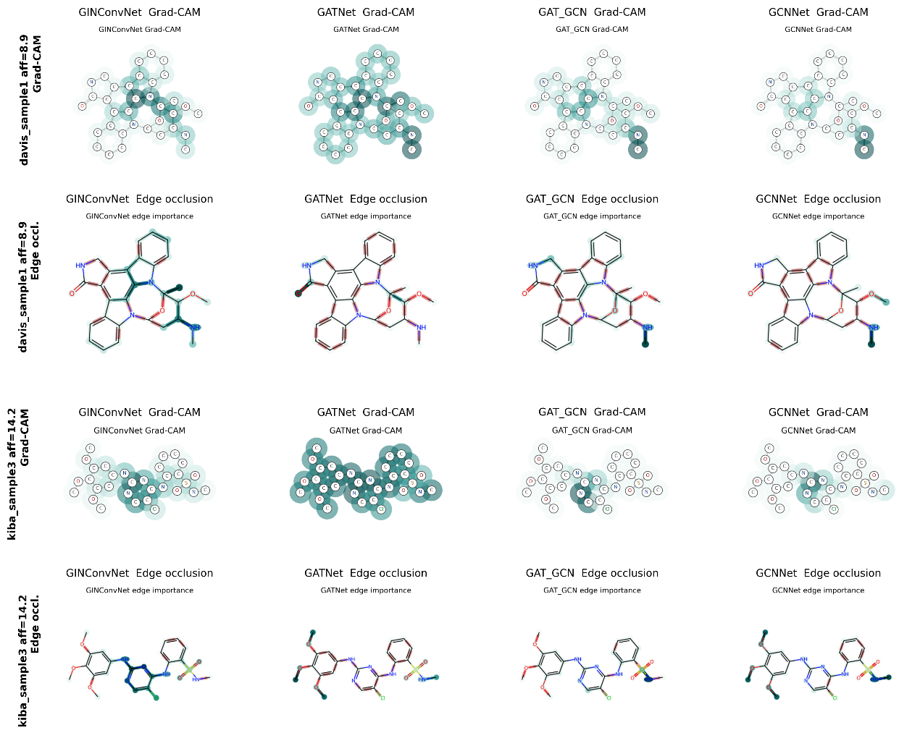
              - Figure S 3 Edge occlusion vs Grad-CAM
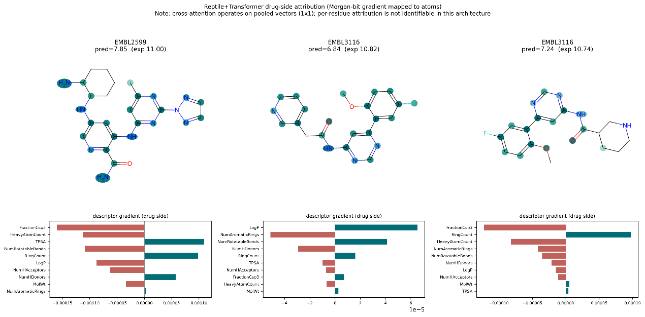
              - Figure S 4 Reptile-Transformer drug-side atom attribution
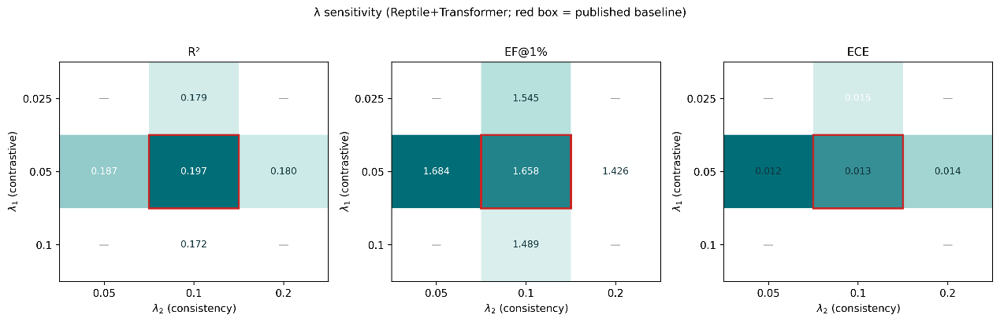
              - Figure S 5 λ sensitivity heatmap
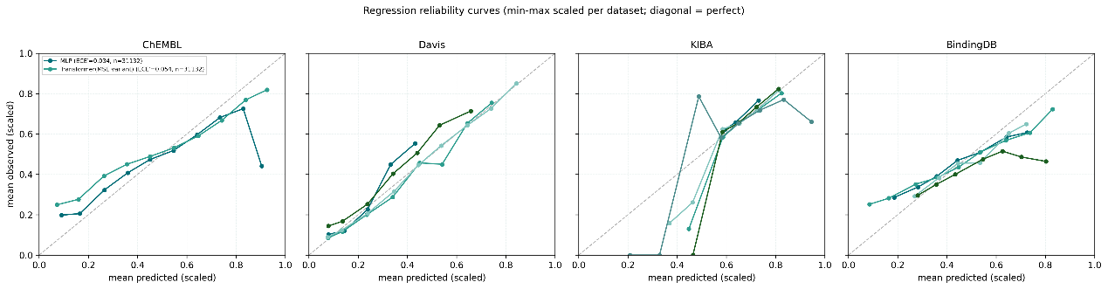
              - Figure S 6 Reliability diagrams
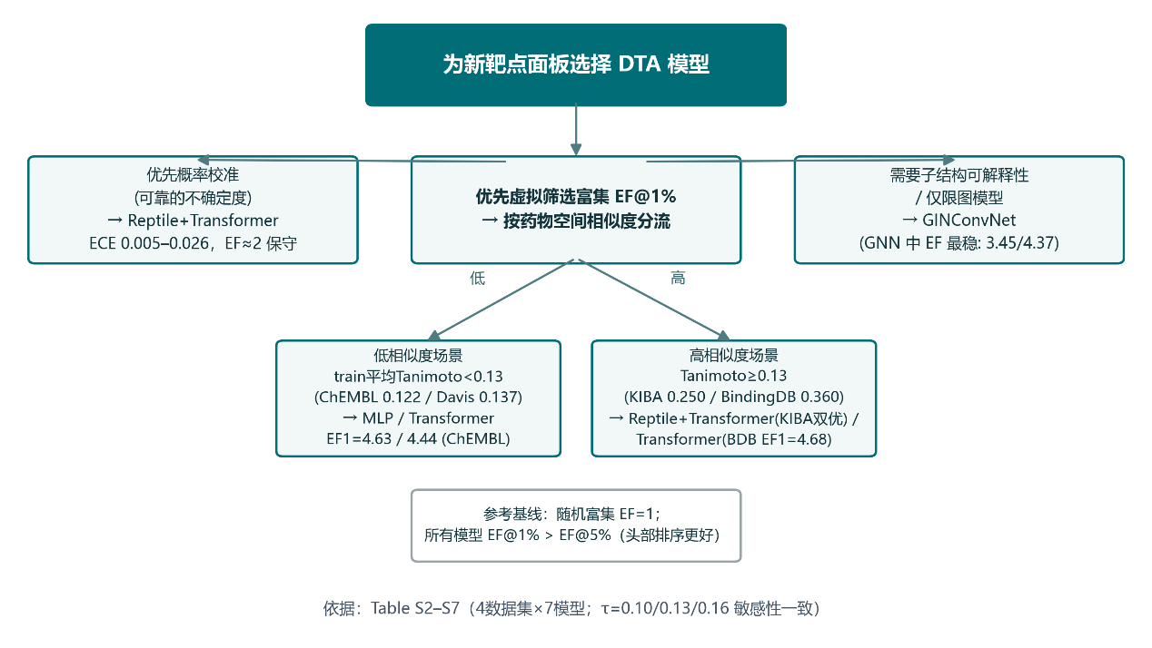
              - Figure S 7 Model-selection decision tree
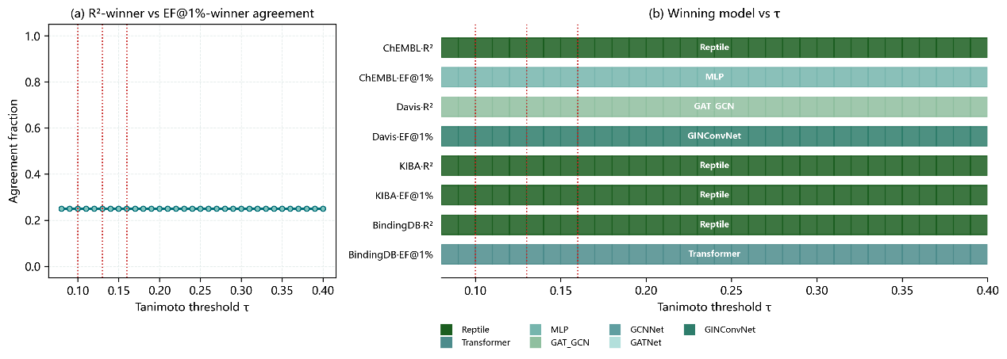
              - Figure S 8 τ ∈ [0.10, 0.40] threshold sweep (winner identity; criterion agreement)

              - Table S 23 Winner-consistency between R²-optimal and EF@1%-optimal models (4 datasets × 7 models)
Dataset | R²-winner | EF@1%-winner | Agree
ChEMBL | Reptile+Transformer (0.202) | MLP (4.63) | No
Davis | GAT_GCN (0.400) | GINConvNet (4.34) | No
KIBA | Reptile+Transformer (0.322) | Reptile+Transformer (4.72) | Yes
BindingDB | Reptile+Transformer (0.234) | Transformer (4.68) | No
Winner identities are quoted verbatim from Table S 3. Agreement = 1/4. Fisher exact (two-sided) p = 0.481; uniform-random binomial p = 0.460; permutation (10⁵) p = 0.750; focal-model McNemar exact p = 0.500; family-level binomial p = 0.125. With n = 4 panels all winner-level tests are underpowered (1 − β ≪ 0.8).
              - Table S 24 Binding-profile mirroring audit (max Spearman ρ of each test target against the training panel)
Dataset | Test targets (same/cross) | ρ ≥ 0.7 overall | ρ ≥ 0.7 cross-cluster | Fisher p (cluster × ρ≥0.7) | Mann-Whitney p
ChEMBL | 20 (10/10) | 11/20 | 6/10 (60.0%) | 1.000 | 0.571
Davis | 65 (38/27) | 46/65 | 17/27 (63.0%) | 0.278 | 0.026
KIBA | 34 (20/14) | 33/34 | 13/14 (92.9%) | 0.412 | 0.215
BindingDB | 78 (47/31) | 60/78 | 22/31 (71.0%) | 0.411 | 0.090
All | 197 (115/82) | 150/197 | 58/82 (70.7%) | 0.175 | 0.014
Cross-cluster test targets retain high binding-profile redundancy (60.0–92.9% at ρ ≥ 0.7) that is statistically independent of 40%-sequence-identity clusters on every panel; the global same-vs-cross difference in mean max-ρ is +0.027 (0.809 vs 0.782).
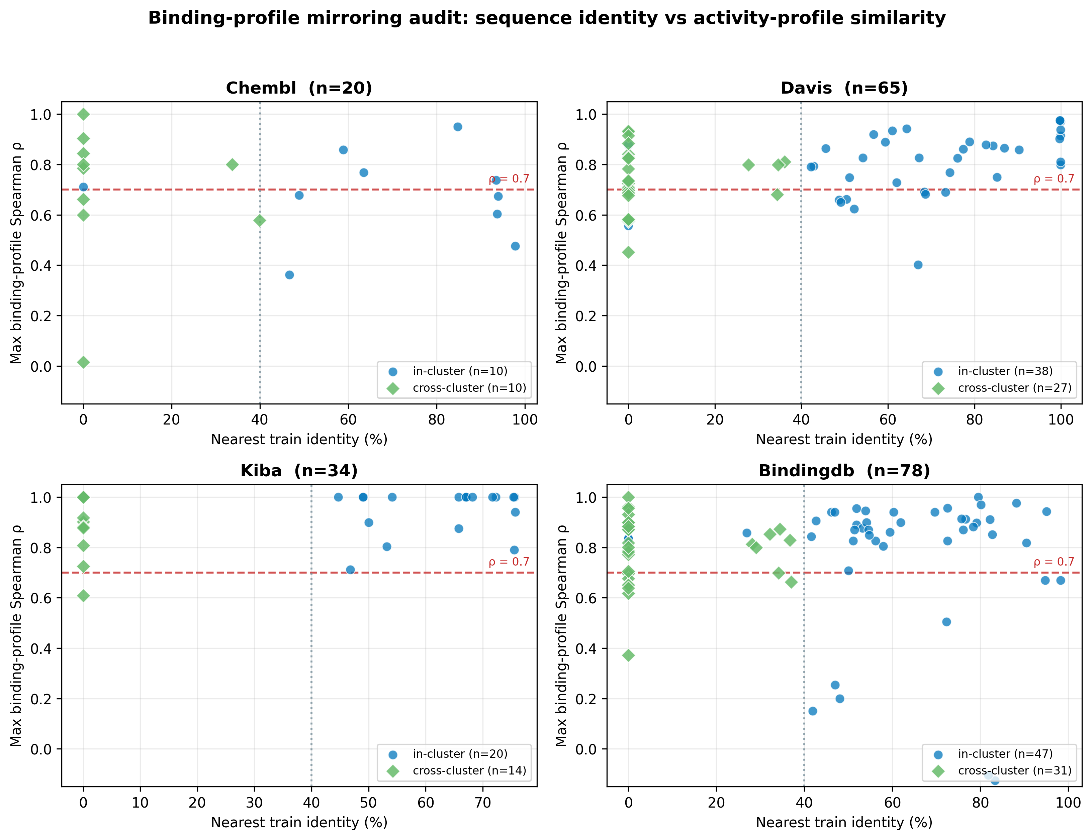
              - Figure S 9 Per-target binding-profile similarity (max-ρ) of test targets against the training panel, stratified by 40%-identity cluster membership.
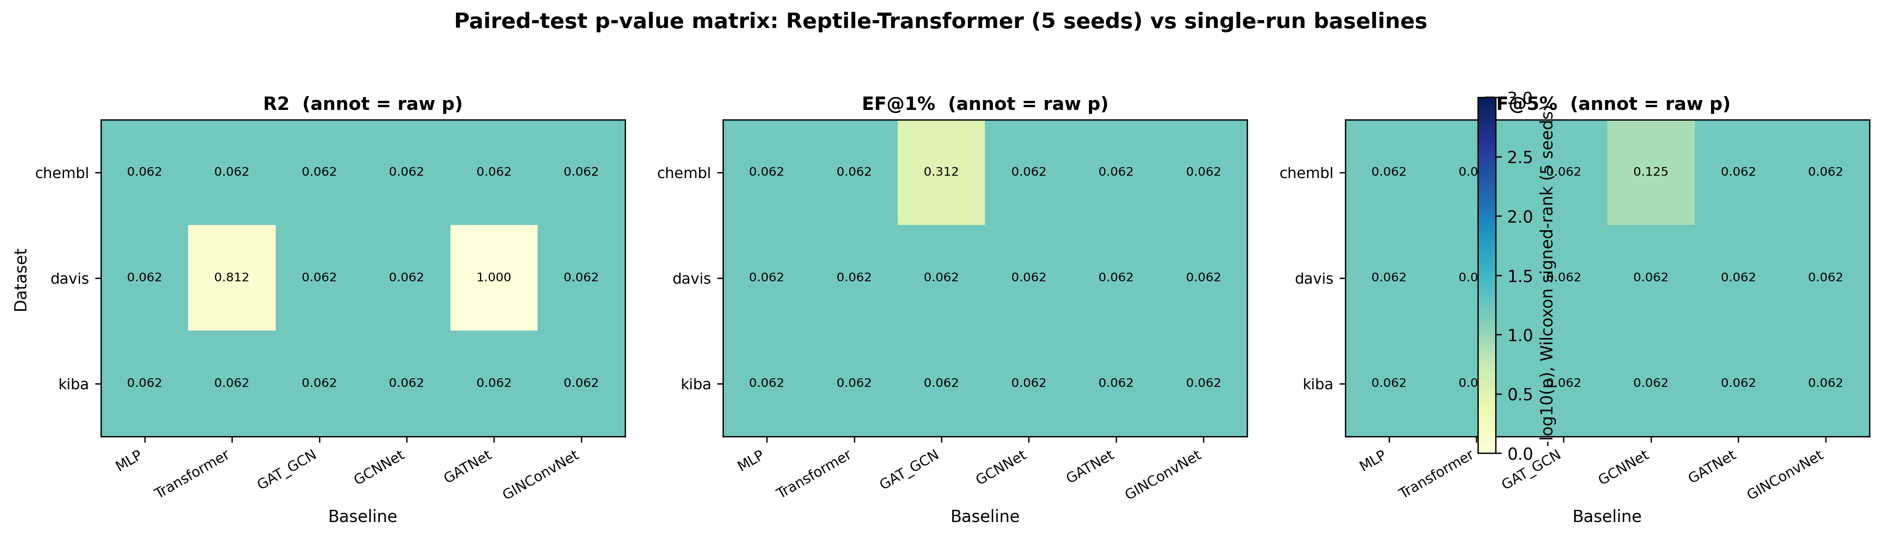
              - Figure S 10 Effect-size and significance heat map of 54 paired Wilcoxon tests (3 datasets × 6 baselines × 3 headline metrics; five-seed Reptile-Transformer vs each baseline). No test survives BH-FDR < 0.05; minimum attainable p = 0.0625 at n = 5.
              - Table S 25 Family-remote routing classifier (237 test targets; ground truth: MMseqs2 40%-identity clusters)
Identity threshold | Accuracy | FPR | FNR | Precision | Recall
30% | 0.907 | 0.074 | 0.113 | 0.919 | 0.887
35% | 0.941 | 0.074 | 0.043 | 0.924 | 0.957
40% (operating) | 0.962 | 0.074 | 0.000 | 0.927 | 1.000
45% | 0.937 | 0.123 | 0.000 | 0.885 | 1.000
50% | 0.878 | 0.238 | 0.000 | 0.799 | 1.000
60% | 0.781 | 0.426 | 0.000 | 0.689 | 1.000
Decision statistic: nearest-neighbour sequence identity of a test target to the training panel; class "remote" predicted below threshold. At the operating threshold (40%): AUC = 0.960. Misclassification is one-sided (in-family targets routed to the safe non-graph branch), never the reverse, at all thresholds ≤ 45%.
P0 framework-robustness analyses (supplementary tables)
              - Table S26 Family-remote router leave-one-dataset-out validation (threshold selected on three datasets, tested on the fourth)
Held-out dataset | n test | n remote | Selected threshold (%) | TP | FP | TN | FN | Accuracy | FPR | FNR
chembl | 26 | 14 | 40 | 14 | 1 | 11 | 0 | 0.962 | 0.083 | 0.000
davis | 65 | 27 | 40 | 27 | 2 | 36 | 0 | 0.969 | 0.053 | 0.000
kiba | 34 | 14 | 40 | 14 | 1 | 19 | 0 | 0.971 | 0.050 | 0.000
bindingdb | 112 | 60 | 40 | 60 | 5 | 47 | 0 | 0.955 | 0.096 | 0.000
Threshold grid 25–60% in 0.5% steps; ties resolved toward 40%. The fixed pre-registered 40% rule yields identical confusion matrices in all four folds (mean accuracy 0.964, balanced accuracy 0.965). Ground truth: MMseqs2 clusters (c = 0.8, 40% identity).
              - Table S27 Cross-cluster ratio (%) under the full MMseqs2 parameter grid
Dataset | Coverage | 30% | 40% | 50% | 60% | 70% | 80%
BindingDB | 0.7 | 35.7 | 45.5 | 55.4 | 73.2 | 77.7 | 90.2
BindingDB | 0.8 | 43.8 | 53.6 | 63.4 | 76.8 | 80.4 | 90.2
BindingDB | 0.9 | 58.9 | 62.5 | 67.9 | 77.7 | 80.4 | 90.2
ChEMBL | 0.7 | 38.5 | 53.9 | 65.4 | 69.2 | 73.1 | 76.9
ChEMBL | 0.8 | 42.3 | 53.9 | 65.4 | 69.2 | 73.1 | 76.9
ChEMBL | 0.9 | 57.7 | 57.7 | 65.4 | 69.2 | 73.1 | 76.9
Davis | 0.7 | 26.1 | 35.4 | 49.2 | 58.5 | 70.8 | 80.0
Davis | 0.8 | 36.9 | 41.5 | 52.3 | 61.5 | 72.3 | 80.0
Davis | 0.9 | 52.3 | 53.9 | 58.5 | 64.6 | 72.3 | 80.0
KIBA | 0.7 | 38.2 | 41.2 | 50.0 | 61.8 | 76.5 | 100.0
KIBA | 0.8 | 41.2 | 41.2 | 50.0 | 61.8 | 76.5 | 100.0
KIBA | 0.9 | 55.9 | 55.9 | 61.8 | 73.5 | 91.2 | 100.0
cov-mode 0 (bidirectional), cluster-mode 0. The c = 0.8 / 40/60/80% cells reproduce the original audit exactly (reproduction_check.csv).
              - Table S28 Clustering-algorithm cross-check: set-cover/connected-component versus CD-HIT-style greedy incremental (c = 0.8)
Dataset | Identity % | Clusters (set-cover) | Clusters (greedy) | Cross % (set-cover) | Cross % (greedy) | Label agreement % | Cohen κ
ChEMBL | 40 | 97 | 98 | 53.85 | 61.54 | 92.3 | 0.843
ChEMBL | 60 | 119 | 120 | 69.23 | 69.23 | 100.0 | 1.000
ChEMBL | 80 | 131 | 131 | 76.92 | 76.92 | 100.0 | 1.000
Davis | 40 | 190 | 195 | 41.54 | 43.08 | 95.4 | 0.905
Davis | 60 | 251 | 253 | 61.54 | 61.54 | 100.0 | 1.000
Davis | 80 | 305 | 306 | 80.00 | 81.54 | 98.5 | 0.951
KIBA | 40 | 114 | 116 | 41.18 | 41.18 | 100.0 | 1.000
KIBA | 60 | 152 | 151 | 61.76 | 61.76 | 100.0 | 1.000
KIBA | 80 | 186 | 187 | 100.00 | 100.00 | 100.0 | 1.000
BindingDB | 40 | 431 | 436 | 53.57 | 56.25 | 97.3 | 0.946
BindingDB | 60 | 516 | 518 | 76.79 | 76.79 | 100.0 | 1.000
BindingDB | 80 | 590 | 591 | 90.18 | 90.18 | 100.0 | 1.000
Greedy incremental = MMseqs2 --cluster-mode 2, the algorithmic analogue of CD-HIT (longest-seed, representative-assignment). Maximum cross-ratio deviation 7.7 pp (ChEMBL, 40%).
              - Table S29 Audited (40% homology-free subset) versus unaudited (full nominal cold test) evaluation: rank agreement and mis-selection cost
Dataset | Metric | Kendall τb | Spearman ρ | Unaudited winner | Audited winner | Winner reversed | Mis-selection cost | Relative cost %
bindingdb | R² | 0.333 | 0.600 | GAT_GCN | GATNet | yes | 0.0144 | 36.6
bindingdb | EF@1% | 0.816 | 0.894 | GCNNet | GCNNet | no | 0.0000 | 0.0
bindingdb | ECE | 0.000 | -0.200 | GINConvNet | GATNet | yes | 0.0039 | 19.2
davis | R² | 0.000 | 0.100 | GCNNet | Reptile-Transformer | yes | 0.0154 | 5.8
davis | EF@1% | 0.535 | 0.530 | GAT_GCN | Reptile-Transformer | yes | 0.8833 | 17.6
davis | ECE | 0.600 | 0.700 | GCNNet | Reptile-Transformer | yes | 0.0037 | 46.0
kiba | R² | 0.800 | 0.900 | Reptile-Transformer | Reptile-Transformer | no | 0.0000 | 0.0
kiba | EF@1% | 0.671 | 0.738 | Reptile-Transformer | Reptile-Transformer | no | 0.0000 | 0.0
kiba | ECE | 0.400 | 0.400 | GCNNet | GAT_GCN | yes | 0.0146 | 255.0
Five models (4 GNN + Reptile-Transformer); Davis/KIBA/BindingDB matched prediction sets (Table S21). Cost = audited-subset performance of audited winner minus that of unaudited winner (positive = loss from skipping the audit). ECE costs are on the probability scale (smaller better); ChEMBL omitted: no matched cross-cluster prediction set for all models.
              - Table S30 Random-sequence negative control (residue-shuffled test sequences, 3 seeds)
Dataset | Identity % | Cross-cluster % mean | min–max (3 seeds) | Max nearest identity to train (%)
BindingDB | 40 | 100.0 | 100.0–100.0 | 0.0
BindingDB | 60 | 100.0 | 100.0–100.0 | 0.0
BindingDB | 80 | 100.0 | 100.0–100.0 | 0.0
ChEMBL | 40 | 100.0 | 100.0–100.0 | 0.0
ChEMBL | 60 | 100.0 | 100.0–100.0 | 0.0
ChEMBL | 80 | 100.0 | 100.0–100.0 | 0.0
Davis | 40 | 100.0 | 100.0–100.0 | 0.0
Davis | 60 | 100.0 | 100.0–100.0 | 0.0
Davis | 80 | 100.0 | 100.0–100.0 | 0.0
KIBA | 40 | 100.0 | 100.0–100.0 | 0.0
KIBA | 60 | 100.0 | 100.0–100.0 | 0.0
KIBA | 80 | 100.0 | 100.0–100.0 | 0.0
Every shuffled target was cross-cluster and no bidirectionally covered (c = 0.8) training hit above 40% identity existed in any setting (36/36 settings at 100% cross-cluster).
              - Table S31 Leave-one-dataset-out validation of the τ ≈ 0.13 GNN-applicability band
Held-out panel | τ | ΔR² | Fitted band (from other 3) | Predicted GNN | Observed GNN | Correct
ChEMBL | 0.122 | -0.2041 | [nan, 0.1935] | 1 | 0 | no
Davis | 0.137 | +0.1412 | [unidentifiable, unidentifiable] | 0 | 1 | no
KIBA | 0.250 | -0.0989 | [0.1295, 0.2485] | 0 | 0 | yes
BindingDB | 0.360 | -0.1340 | [0.1295, 0.1935] | 0 | 0 | yes
Band rule: predict GNN advantage inside midpoint boundaries fitted on the other three panels. LODO accuracy = 0.50 (2/4); 1-nearest-neighbour = 0.50; majority-class = 0.75. Lower boundary 0.130 in both identifiable folds; upper boundary 0.194–0.249 (mean 0.212). Pre-registered consequence: τ retained as descriptive band only.
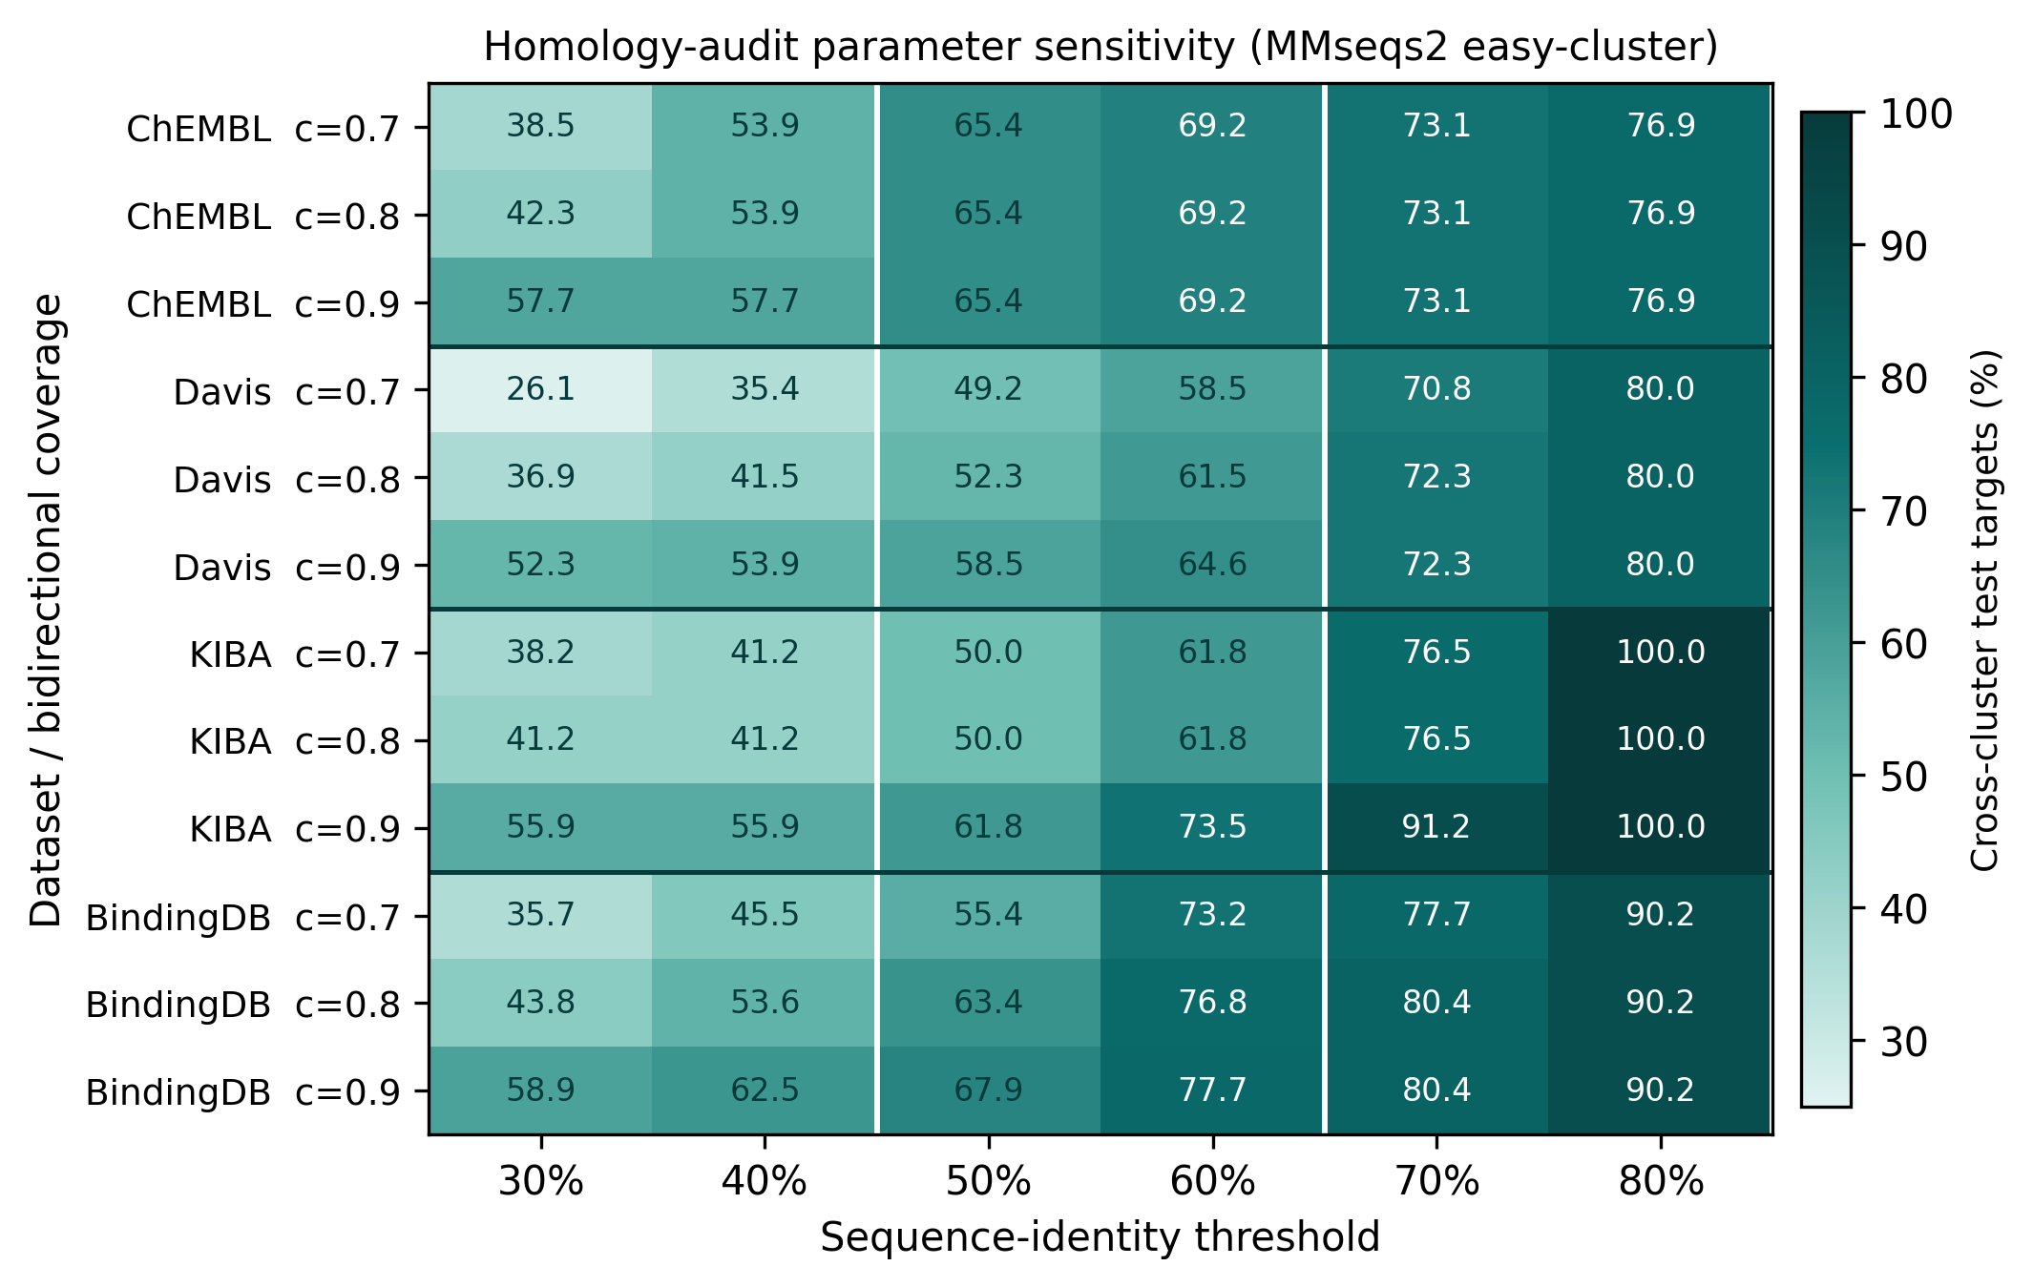
              - Figure S11 Homology-audit parameter sensitivity. Cross-cluster ratio of test targets across sequence-identity thresholds (30–80%) and bidirectional coverage settings (0.7–0.9), per dataset (MMseqs2 easy-cluster).

