26 September 2020
The Block Pi charges the battery very often from AC during the night. The only difference in the settings is the “device grid working range” is set to “Applicance” at The Block and “UPS” for Pa.
Pa Pi ratings:
['230.0', '21.7', '230.0', '50.0', '21.7', '5000', '5000', '48.0', '49.0', '42.0', '56.4', '54.0', '0', '30', '030', '1', '2', '1', '9', '01', '0', '0', '56.0', '0', '0', '000']"
The Block ratings:
['230.0', '21.7', '230.0', '50.0', '21.7', '5000', '5000', '48.0', '49.0', '42.0', '56.4', '54.0', '0', '30', '030', '0', '2', '1', '9', '01', '0', '0', '56.0', '0', '0', '000']
Pa graph:
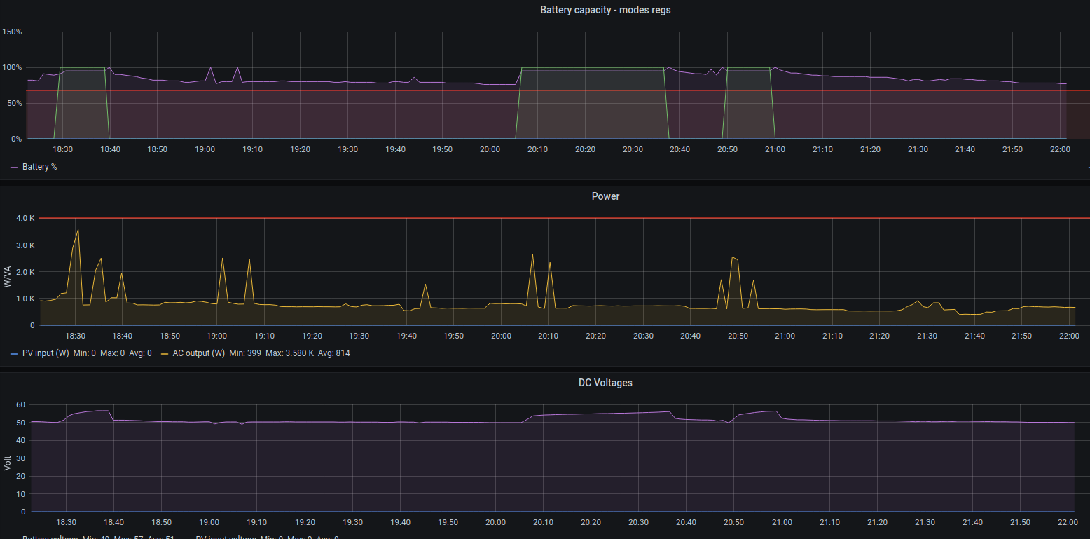
The Block graph:
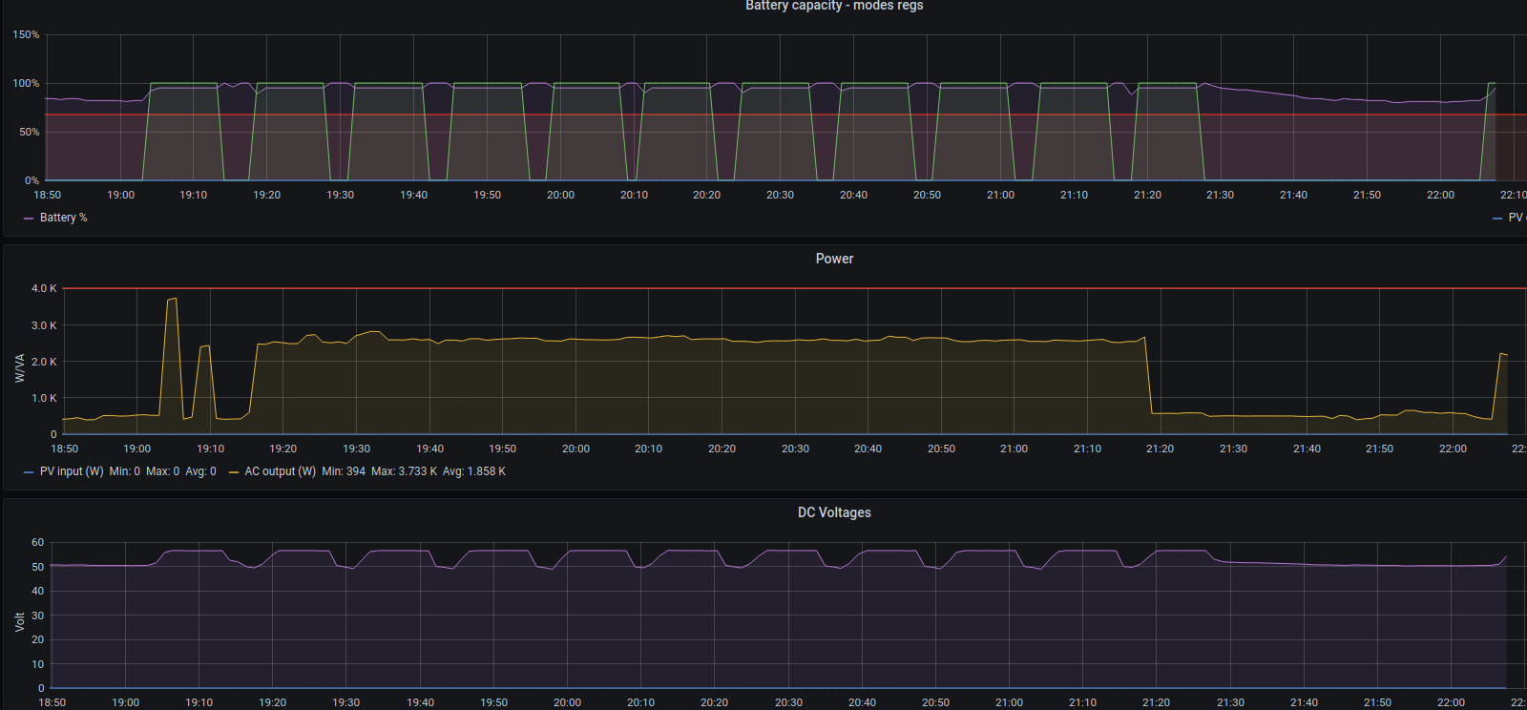

15 September 2020
The Block Pi lost connection. The TP-link network to the guardhouse was dead (middle LED off).
Fixed by re-Pair of the TP-Link devices on 26 September (press pair button for just more than 1 second, then go to the other). If it does not want to pair, one has to press longer than 10 seconds. Had to restart the Pi as well, for some reason it did not want to connect via remote.it
The data was all there so the Pi was running.

12 August 2020
Cycled Pi’s power at The Block, now running OK. Raspbian is new version.

11 August 2020

Versions
The Block uptime was 76 days, 18 hours
App | Pa | The Block
Nginx | 1.14.2 | 1.14.2
Python | 3.7.3 | 3.7.3
Grafana | 7.0.6 | 6.6.2
InfluxDB | 1.6.4 | 1.6.4
python_solar | 0.1.3 | 0.0.5
Raspbian | 5.4.51-v7+ | 4.19.97-v7l+
Remote.it | 1.2.26 | Connectd version 4.6
Postgres | 11.7 | 11.7

Updated:

App | Pa | The Block
Nginx | 1.14.2 | 1.14.2
Python | 3.7.3 | 3.7.3
Grafana | 7.0.6 | 7.0.6
InfluxDB | 1.6.4 | 1.6.4
python_solar | 0.1.3 | 0.1.3
Raspbian | 5.4.51-v7+ | 5.4.51-v7l+
Remote.it | 1.2.26 | Connectd version 4.6
Postgres | 11.7 | 11.7

Rebooted Pi after SW update, forgot connectd updated and now Pi connection is unavailable...

