Thank you for playing our game! We hope you enjoy.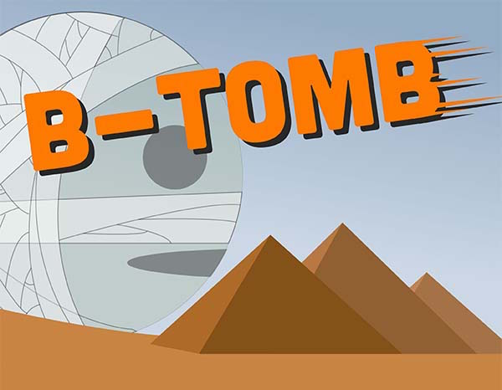

Developed by: Tomy Callanta and Kemp Po

**Description**

The game is very much inspired by the Hudson Soft made franchise, “Bomberman.” The goal of the game is to be the last one standing. Blow up blocks to get items and to be able to move towards other players. Plant bombs to catch other players with your bomb fire and destroy them. Avoid other players’ bomb fire to stay alive.

**Mechanics**

At the start of each game both players are spawned at opposite parts of the map. Each player can plant one bomb at the start and tries to gain as much items to be able to outlast and kill their opponents. Every time a bomb explodes adjacent bricks will be destroyed and will possibly drop items. Items can vary from BombUp, FireUp, or the dreaded Skull. BombUp allows the player to plant an additional bomb with a maximum of 10 bombs, while FireUp increases the range of the player’s bomb explosion range. Meanwhile, the Skull gives the player a penalty. Penalties can vary from a decrease in the maximum bombs of the player by one as long as the player can still plant one bomb, or it can make the bomb fire weaker in range. The last player alive wins the game.

**Controls**

W - Moves character up

S - Moves character down

A - Moves character left

D - Moves character right

Spacebar - Plants bomb at current position of character

Enter - Pauses the game

AVOID THE FIRE!

**Items**

|  |  |  |
| --- | --- | --- |
| Image | Name | Description |
|  | BombUp | Increases maximum number of bombs that can be planted at once by one. Maximum of 10. |
|  | FireUp | Increases the range of bomb fire |
|  | Skull | Decreases character’s power. Either decreases maximum number of bombs, or makes bomb fire weaker. |