Laser Powder Bed Fusion with high layer thickness: sustainability oriented multi-objective optimization
Bg^{d}
ª Department of Mechanical Engineering, Shantou University, Shantou 515063, China
^{d} Department of Industrial, Manufacturing, & Systems Engineering, Texas Tech University, Lubbock, Texas 79409, United States
* Corresponding author. Tel.: + 86 18018985971; E-mail address: shtpeng@stu.edu.cn
Abstract
H.

Keywords: Additive manufacturing; energy consumption; carbon emission; production cost; parameters optimization, machine learning.

- Introduction
Additive manufacturing (AM) involves joining materials to create parts directly from 3D CAD model data, typically by building layer upon layer, in contrast to traditional subtractive and formative manufacturing methods. It is widely used in cutting-edge fields such as aerospace, military, automotive, electronics, mold-making, energy, and biomedical (Gong et al., 2021). Compared with traditional subtractive manufacturing methods such as drilling, electrical discharge machining, and milling, AM offers near-perfect design freedom and fabricates structures with customized properties for parts (Bandyopadhyay et al., 2020). However, its large-scale industrial application is still constrained by factors such as low production efficiency, high energy consumption, and high costs. From a process perspective, the layer-by-layer melting, solidification, and stacking in AM lead to low manufacturing efficiency. For instance, using AM to manufacture a central flange strip takes approximately one month, which is more than twice the manufacturing cycle of traditional technology (Gao et al., 2022). Due to the use of high-energy beams (e.g., laser, electron beams, and plasma), the specific energy consumption (SEC) of the covered AM unit processes is 1 to 2 orders of magnitude higher compared to conventional machining or injection molding processes (Elduque et al., 2015). Additionally, AM has higher energy cost (Balogun et al., 2015) and consumes approximately 3 GJ more energy than CNC milling in the production of the insert (Morrow et al., 2007).【generates about three times more energy-induced CO₂ emissions per part compared with traditional subtractive processes (Baumers et al., 2011).】 Therefore, a trade-off between efficiency, carbon emissions, and economic cost is urgent to realize a sustainable next-generation AM technology.
Laser powder bed fusion (LPBF) is one of the AM processes that have revolutionized the manufacturing industry (Chowdhury et al., 2022). Impact of production efficiency on sustainability of LPBF must not be neglected (Gao et al., 2024). Currently, for LPBF process, the main strategies to enhance production efficiency include multi-laser simultaneous printing, increasing printing speed, and accelerating powder spreading rates. However, in the multi-laser LPBF process, the residual stress is significantly higher as the number of lasers increases (Zou et al., 2020). Faster print speeds may lead to defects and surface quality issues in the printed parts (Zhai et al., 2023). High-speed powder spreading technology can result in increased height deviations in parts and further reduces dimensional accuracy in the build direction (Chen et al., 2022). At present, the LPBF process predominantly focuses on printing with small layer thicknesses (20 μm-50 μm) (Shi et al., 2016). High layer thickness is regarded as a promising strategy to improve the production efficiency of LPBF. Using a high layer thickness (> 50 μm) in the printing process can reduce the number of layers required for part fabrication, thereby shortening overall build time, boosting production efficiency, and lowering costs. Most importantly, high layer thickness allows relatively coarse powders with the size range of about 53 μm-106 μm and reduces material cost. In the example of Ti6Al4V powder, the price of the coarse powder (53 μm-106 μm) is only about 30 %-50 % of fine powder (10 μm-50 μm) (Shi et al., 2016). (Ma et al., 2015) investigated high-power LPBF of 1Cr18Ni9Ti stainless steel with layer thicknesses ranging from 60 to 150 μm, revealing that the build rate increases by 10-20 times compared to other laser additive manufacturing technologies. Therefore, fabrication via high layer thicknesses with low-cost coarse powders can achieve higher production efficiency and cost-effectiveness.
However, most existing research indicates the portion of research publications on the theme of AM sustainability is no more than 10 % (Li and Yeo, 2021), and even less on those with high layer thickness. The AM community pays overwhelmingly more attention to practical issues, such as improving mechanical properties, characterizing microstructures and properties, and refining structural imperfections of AM parts (Li and Yeo, 2021). (Bakhtiarian et al., 2024) discovered that process parameters have a significant impact on the microstructure and mechanical properties of the final part, and established a correlation between process parameters, relative density, and hardness of the part. (Liu et al., 2021) investigated the phase constituents, densification behavior, microstructural evolution, and mechanical properties of the specimens produced using 400 W laser power and 200 μm aerosolized 316L stainless steel powder by the LPBF. (Wang et al., 2017)discussed LPBF with high layer thickness and fine powder, analyzing how process parameters affect the relative density, microstructure, and mechanical properties of the parts. Thus, there is insufficient research on the contribution of high layer thickness processes to the sustainability of AM.
To fill the research gap, based on LPBF with high layer thickness experiments, this study proposed a two-stage optimization model to realize the sustainability of LPBF without compromising the fabrication quality. Specifically, we conducted LPBF with 84 sets of process parameters obtained by Doehlert Design (Doehlert, 1970). Four key process parameters of P, V, H, and LT are considered in the energy efficiency, carbon emissions, and cost-effectiveness model creation, with constraint of relative density. We developed a two-stage multi-objective model combined with Augmecon-R algorithm to solve the multi-objective optimization problem of maximizing energy efficiency, minimizing carbon emissions, and maximizing cost-effectiveness for different process conditions for LPBF-ed SS-CX, and the optimal key process parameters are obtained. To the best of our knowledge, this is the first attempt to evaluate the sustainability of AM with high layer thickness and expects to provide new insights to promote environmentally friendly and cost-effective.

Fig. 1Fig. 1 Overview of prediction and optimization for L-DED
- Experimental conditions and methods

2.1 Equipment and materials
Fig. 2 illustrates the flow of the LPBF experiment. Modeling, slicing, until the final print is well-formed. A R250M2 device in Fig. 2(c) (Suzhou Rongzhi 3D Printing Tehnology Co.,Ltd.) with an IPG fiber laser（1070 nm）with a maximum power of 500 W and a spot size of 100 μm is used for LPBF-ed SS-CX. The 304 stainless steel substrate with size of 255 mm ×255 mm ×30 mm is preheated to 80 ℃ after leveling. During printing, as in Fig. 2(e), the residual oxygen is controlled within 100 ppm under the protection of argon atmosphere. The scanning strategy is a zigzag pattern with a rotation angle of 67° between adjacent layers and the laser scanning direction is parallel to each track in each layer. The cube specimens of 10 mm ×10 mm ×15 mm are built on the same substrate with different process parameters, as given in Table 1.
Fig. 2 Experimental process: (a) create sample model; (b) generate slice file; (c) experimental device; (d) level the substrate; (e) print procedure; and (f) take out of sample for testing

Table 1
LPBF processing conditions used in this work
Processing parameters | Value | Unit
Laser power | 385 - 460 | W
Laser scanning speed | 700 - 1150 | mm/s
Hatching space | 90 - 115 | μm
Laser beam spot size | 100 | μm
Layer thickness | 80, 100, 120 | μm
Powder size distribution | 15 - 80 | μm
Shielding gas | Argon | /
Oxygen content | ≤ 100 | ppm
Gas pressure | 0 - 1500 | Pa

Gas-atomized SS-CX powder is used as raw material, which is provided by Vlory with particle sizes in range of 15 - 80 μm and its chemical composition is given in Table 2. According to the scanning electron microscope (SEM) in Fig. 3(a), it is seen that the powder particles are mainly spherical with smooth surface, and only a small amount of irregular satellite particles is adhered. In addition, the particle size distribution of the powder is characterized using a laser diffraction particle size analyzer (Mastersizer 3000 + Ultra). As shown in Fig. 3(b), the powder has a particles size of D_{r} = 15 - 80 μm and an average diameter of D_{mean} = 45.5 μm (D₁₀ = 22.2 μm, D₅₀ = 45 μm, and D₉₀ = 85.4 μm).
Table 2
Chemical composition of SS-CX coarse powder
Element | Fe | Cr | Ni | Mo | Si | Al | Mn
Content (wt.%) | Bal | 12.00 | 9.20 | 1.40 | 0.25 | 1.65 | 0.22

LPBF process involves multiple process parameters, such as manufacturing strategy, layer thickness, laser offset, laser type and scanning strategy. The relative density model is constructed by preparing cube samples (10 mm × 10 mm × 15 mm) with layer thickness (LT) of 80 μm, 100 μm and 120 μm. Optimization of process parameters for high layer thicknesses of SS-CX is performed by using large powder particle sizes of 15 - 80 μm. The effects of laser power (P), laser scanning speed (V) and hatching space (H) on the final microstructure of as-built parts are studied in this paper. These four main process parameters interact with each other and play a vital role in determining the densification of parts referred to as the laser energy density (ED).
Fig. 3 Powder morphology and particle size distribution: (a) SEM image of SS-CX powder; (b) SS-CX powder particle size distribution

2.2 Design of Experiment
To reduce the number of experiments and the time, this paper proposes to develop the process parameters of high layer thickness through the Doehlert design method. The experimental approach uses Doehlert design method to develop a series of experiments to optimize theoretically the three processing parameters (laser power, laser scanning speed and hatching space). Typically, the Doehlert design allows the description of a region around an optimal response and contains k²+k+1 point for k variables as shown in Table 3. For three variables, thus, a set of 13 experiments is required, and the uniform distribution of the experiments can be mapped in a three-dimensional space. Fig. 4 presented the 14th experiment is coming from the difference between experimental design and developing method based on a global maximum search which is the search for highest relative density in the present case.
Table 3
Experimental matrix created by the Doehlert design method for three-variables
Experiment | Experimental variables
Experiment | X₁ | X₂ | X₃
Experiment | P (W) | V (mm/s) | H (μm）
1 | 0 | 0 | 0
2 | 1 | 0 | 0
3 | 0.5 | 0.866 | 0
4 | -0.5 | 0.866 | 0
5 | -1 | 0 | 0
6 | -0.5 | -0.866 | 0
7 | 0.5 | -0.866 | 0
8 | -0.5 | 0.289 | 0.816
9 | -0.5 | 0.289 | 0.816
10 | 0 | -0.577 | 0.186
11 | 0.5 | -0.289 | -0.816
12 | 0 | 0.577 | -0816
13 | -0.5 | -0.289 | -0.816
14 | -1 | -0.577 | -0816

Fig. 4 Spatial distribution of the experimental points in a Doehlert design: (a) the Doehlert design for three variables by passing a central point generating a 14-hedron; (b) plane projections based on the triangular face generating different Doehlert experimental matrices for optimization of three variables
As such, in order to find the optimal process window for different layer thicknesses and achieve the optimal relative density, two rounds of Doehlert design are carried out for each layer thickness of 80 μm, 100 μm and 120 μm, and each round contained 14 experiments. A total of 84 experiment settings of different process parameter combinations are provided in Appendix Table XX, and their corresponding designs and calculated ED values are also displayed. The summary of the ranges and setting of P, V, H, LT are displayed in Table 1.

2.3 Multiple Linear Regression (MLR) model
During LPBF process, the laser energy density (ED) can be calculated by using the following equation:
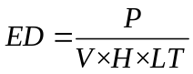
Where ED is the laser energy density (J/mm³), P is the laser power (W), V is the laser scanning speed (mm/s), H is the hatching space between scan passes (μm), and LT is the layer thickness (μm).
Scatter plot of RD and ED is displayed in Fig. 5, and LT of 80,100,120μm are labelled. The RD results in Appendix Table XX show that most SS-CX samples achieved a high density, with the highest relative density of 99.98%. Only three samples are below 99% relative density. As shown in Fig. 5, the relative density is correlated to laser energy density, where the lowest energy density of 30.43 J/mm³ resulted in the second lowest relative density (98.78%) and the second highest energy density of 67.22 J/mm³ resulted in the highest relative density.
Fig. 5 Scatter plot of relative density (RD) and energy density (ED)
The effect of P, V, H, LT and ED on the as-built part characteristics are evaluated with regression analysis. The complete parametric analysis of SS-CX density data is carried out using Design-Expert® 13. To create a RD predictive model with high accuracy, the model coefficients are estimated using the least-squares method, direct process parameters of P, V, H, LT and ED are used as input variables and the sample density is modeled as a second order polynomial with respect to input variables. Eq. represents the polynomial regression model for as-built SS-CX density.
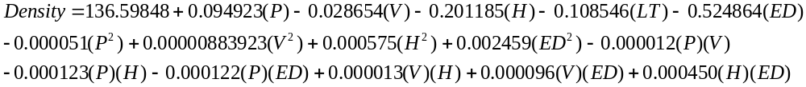
To infer about the cause-effect relationships between the independent variables (the process parameters), and the dependent variable (namely the relative density), the statistical significance of such interactions and the model itself have been assessed by a proper analysis of variance. Table 4 reports the numerical results from the ANOVA, in which P-values and F-values reveal the significance of the obtained model and associated factors. In other words, if the P-value is lower than 0.05 it means that such a factor or combinations of factors influence the response variable in a statistically significant manner. Conversely, the higher the F-value the greater is the impact of a factor or a combination of factors on the model and on the relative density as well. Almost all the input model terms have significant effects on RD as their P-values are smaller than 0.05. In particular, process parameters P, V, H, LT, and ED have very significant effects on RD due to their P-values of less than 0.0001.
Table 4
ANOVA results of RD multiple linear regression model
Source | Degree of freedom | Sum of square | Mean square | F-value | P-value | result
Model | 15 | 4.76 | 0.3173 | 28.74 | < 0.0001 | signification
P | 1 | 0.2108 | 0.2108 | 19.10 | < 0.0001
V | 1 | 0.2640 | 0.2640 | 23.91 | < 0.0001
H | 1 | 0.2918 | 0.2918 | 26.43 | < 0.0001
LT | 1 | 0.2536 | 0.2536 | 22.97 | < 0.0001
ED | 1 | 0.2213 | 0.2213 | 20.05 | < 0.0001
P² | 1 | 0.0161 | 0.0161 | 1.46 | 0.2318
V² | 1 | 0.1054 | 0.1054 | 9.55 | 0.0029
H² | 1 | 0.0318 | 0.0318 | 2.88 | 0.0944
ED² | 1 | 0.0842 | 0.0842 | 7.63 | 0.0074
PV | 1 | 0.0133 | 0.0133 | 1.21 | 0.2756
PH | 1 | 0.0078 | 0.0078 | 0.7044 | 0.4042
PED | 1 | 0.0053 | 0.0053 | 0.4816 | 0.4901
VH | 1 | 0.0012 | 0.0012 | 0.1071 | 0.7444
VED | 1 | 0.0312 | 0.0312 | 2.83 | 0.0974
HED | 1 | 0.0070 | 0.0070 | 0.6325 | 0.4292
Residual | 68 | 0.7506 | 0.0110
Lack of Fit | 67 | 0.7505 | 0.0112 | 224.04 | 0.0531 | Not signification
Pure Error | 15 | 4.76 | 0.3173 | 28.74 | < 0.0001 | signification
Cor Total | 1 | 0.2108 | 0.2108 | 19.10 | < 0.0001

The coefficients of determination for the relative density, summarized in Table 5, reveal that R² is 86.38%, adjusted, R²( adj.), is 83.37% and predicted, R²( pred.) is 78.24%. The R² value means that the regression model explains 86.38% of the variation in relative density. The predicted R² determines how accurately the model predicts the relative density for new observations. The agreement between R², adjusted R², and predicted R² demonstrates that the obtained model can effectively predict relative density. As show in Fig. 6, the data points are distributed closely along the diagonal line.

Fig. 6 Prediction accuracy of the relative density model

Table 5
Model summary for relative density
Std.Dev | R² | R²(adj.) | R²(pred.)
0.1051 | 86.38% | 83.37% | 78.24%

2.4 Density measurement
The most economic way to get information about the quality of a LPBF-ed sample is the measurement of relative density. The relative densities of as-built samples are measured using the Archimedes method. The sample density test process is shown in Fig. 7, the lower weighing pan is immersed in the medium (water) and the upper weighing pan is still in the air as shown in Fig. 7(b). The mass of the test sample in air is obtained by placing it on the upper weighing pan, as shown in Fig. 7(c). Then gently remove the sample and carefully place it on the lower weighing pan submerged in water to ensure that the sample is completely submerged in water and obtain its mass in water, as shown in Fig. 7(d). Each sample is measured three times repeatedly to ensure the reliability of results. According to Eq., the relative densities of each part can be calculated.
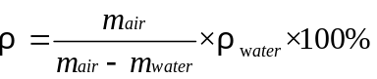
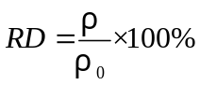
Where ρ is the measure density, g/cm³; m_{air} represents the mass of sample in air, g; m_{water} is the mass of sample when suspended in water, g; ρ_{water} is the density of water, 0.997 g/cm³; ρ₀ is the nominal density of SS-CX (7.70 g/cm³). The averaged RD measurement of three times for each setting is presented in Table A 1.
Fig. 7 Schematic of Archimedes method: (a) ZMD-2 electronic densitometer; (b-d) Sample density test diagram

- Multi-objective optimization based on AUGMECON-R

3.1 AUGMECON-R
AUGMECON-R, a robust variant of the augmented ε-constraint algorithm, demonstrates superior performance in addressing multi-objective linear programming problems and is an improved algorithm developed on the basis of the classic AUGMECON method. The fundamental procedure of AUGMECON-R primarily comprises five steps. (1) select one objective as the main objective and reformulate the remaining objectives as constraints, (2) grid the value range of the constraint objective, with each grid point corresponding to a single-objective optimization problem, (3) introduce enhancements (e.g., slack variables) into the primary objective function to ensure solution uniqueness and feasibility, (4) by leveraging the flag mechanism and parallel processing, redundant solutions can be skipped and the solution process accelerated, (5) Collect all Pareto optimal solutions to form a complete Pareto front. The process of AUGMECON-R is shown in Fig. 8, while comprehensive descriptions of the method are available in (Nikas et al., 2022).
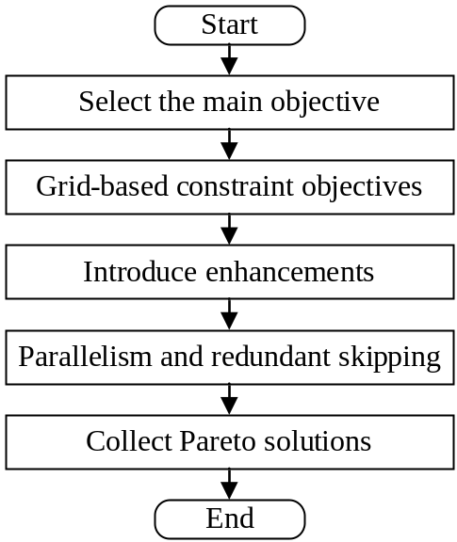
Fig. 8 The fundamental procedure of AUGMECON-R

3.2 Problem description

3.2.1 Objective functions
In this paper, the optimization results are directly determined by the mathematical formulations of the objective functions and constraints. Specifically, the values of the decision variables P, V, H , and ED are optimized to achieve the best trade-off among the multiple objectives, such as minimizing carbon emission, minimizing cost, and maximizing production efficiency. Fig. 9 shows the framework of multi-objective optimization model.
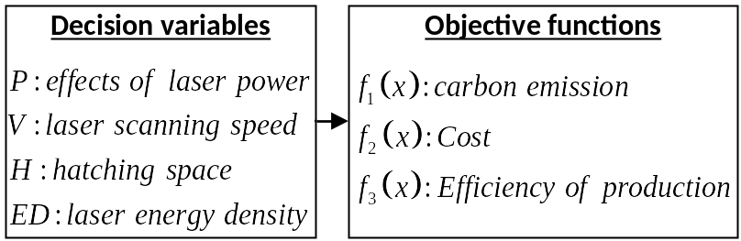
Fig. 9 Framework of multi-objective optimization modeling for high layer thickness of die steel

In this carbon emission optimization, we mainly consider the carbon emissions from powder production and printing energy consumption. The carbon emission objective function using Eq. (5).
where $m_{powder}$ is the actual amount of powder consumed, ${EF}_{powder}$ represents the carbon emission factor of powder production, ED donates the laser energy density and ${EF}_{electricity}$ is the electronic carbon emission factor. Carbon emission factors of various common metal powder production are summarized in Table 6, and carbon emission factors of electronic production of various common laser powder bed melting equipment are summarized in Table 7.
For a fair comparison of each parameter combination, the functional unit was set to produce ${1mm}^{3}$ parts of the same specification. Therefore, according to Eq.(1), the actual amount of powder consumed is shown in Eq. (6) (7).
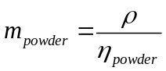
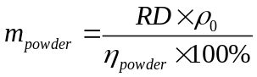
where $η_{powder}$ donates the utilization rate (recycling rate) of the mental powder. ρ is the measure density, ρ₀ is the nominal density of SS-CX (7.70 g/cm³). As a result, Eq. (5) can also be written as Eq. (8) in specific. The coefficients of utilization (recycling) of the mental powder, summarized in Table x
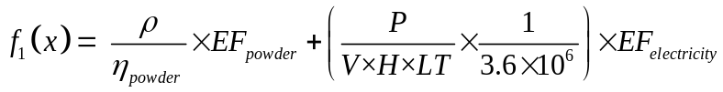

In this cost optimization, we mainly consider the processing cost and the investment cost. All these components are related to the process parameters P, V, H. The cost objective function in this study is formulated based on the cost analysis framework proposed by (Peng et al., 2019), as shown in Eq. (9)(10).
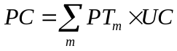
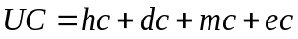
where PC represents the processing cost, UC represents the unit processing cost, and the index m represent the set of manufacturing processes. ${PT}_{m}$ is the processing time of the mth program. hc, dc, mc and ec respectively represent the human cost, depreciation cost, mental powder cost and energy costs.
Therefore, Given the uncertainty of equipment, maintenance costs are ignored in this paper. The ${1mm}^{3}$parts are produced by single-layer scanning, and the processing time is shown in Eq. (11). The equipment depreciation cost is calculated using Eq. (12).
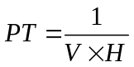
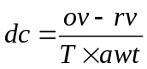
where, the ov and rv represent the original value (also refers to the investment cost) and the residual value of the equipment, respectively; T means the expected useful life, awt is the annual working time. According to the provisions regarding depreciation periods specified in the income tax law, the depreciation period for production equipment is set at ten years, with an assumed residual value of 5% of the original cost.
The costs of metal powder and energy consumption are respectively shown in Eq. (13) and Eq. (14).
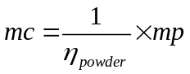
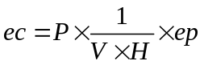
where, mp donates the unit price of mental powder, ep is the electricity price. Relevant prices or cost figures related to LPBF processes are summarized in Table 8. Auxiliary materials cost (e.g., shielding gas, purification solution, activation soulution, deposition solution) can be optionally included depending on the actual process. Therefore, the cost objective function using Eq. (15).
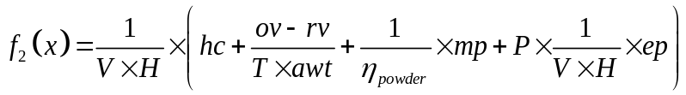
Human cost data were primarily collected through a survey conducted at SINOTRUK Jinan Fuqiang Power Corp., Ltd., a leading engine remanufacturing enterprise with more than two decades of operational history. Meanwhile, material costs, including those for powder and shielding gas, were obtained from the official website of Alibaba, China's largest e-commerce platform.

Table 8
The relevant prices or costs related to LPBF processes
 | Items | Values
 | Commercial power | 1.336 Yuan/kWh
 | Metal powder | 210 Yuan/kg
 | Shielding gas | 53 Yuan/$m^{3}$
 | Purification solution | 25 Yuan/L
 | Activation solution | 30 Yuan/L
 | Deposition solution | 55 Yuan/L

Note：Yuan refers to China Yuan (CNY), the chinese currency.
The processing cost allocated per restoration process for each functional unit is detailed in Table 9. Investment cost, as also presented in Table 9, refers to the capital required for acquiring machinery and facilities necessary for production or reprocessing activities. As shown in the table, laser cladding equipment entails a high initial investment, which contributes to its relatively high processing cost. In contrast, plasma spray technology exhibits the lowest cost among beam deposition methods due to its higher processing efficiency.
In metal additive manufacturing such as laser selective melting (LPBF), efficiency is often measured by time required to form per unit volume or volume formed per unit time. In this efficiency of production optimization, we choose the former. Therefore, the efficiency of production objective function using Eq. (16).
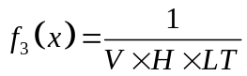
where V is the laser scanning speed, H is the hatch spacing, and LT is the layer thickness.

Table 9
The investment cost and the processing cost for one functional unit.
Cost (Yuan) | Laser cladding | Plasma arc surfacing | Brushing electroplating | Plasma spray
Equipment model | RS-LCD-4000-D-R | LU-F500-D800-CNC | NBD-200 | PPI-500 A-P
Processing cost | 12.52 | 7.15 | 4.11 | 4.36
Investment cost | 2,600,000 | 600,000 | 9300 | 500,000

3.2.2 constraint and uncertain

Appendix
Table A 1
Settings of LPBF experiments
Run | P (W) | V (mm/s) | H (μm) | LT (μm) | ED (J/mm³) | RD (%) | Design
1 | 415 | 950 | 100 | 80 | 54.61 | 99.68 | Doehlert
2 | 440 | 950 | 100 | 80 | 57.89 | 99.76
3 | 428 | 1150 | 100 | 80 | 46.47 | 99.79
4 | 403 | 1150 | 100 | 80 | 43.75 | 99.80
5 | 390 | 950 | 100 | 80 | 51.32 | 99.89
6 | 403 | 750 | 100 | 80 | 67.08 | 99.94
7 | 428 | 750 | 100 | 80 | 71.25 | 99.91 | High ED
8 | 428 | 1017 | 110 | 80 | 47.78 | 99.81
9 | 403 | 1017 | 110 | 80 | 44.99 | 99.67
10 | 415 | 817 | 110 | 80 | 57.74 | 99.94
11 | 428 | 883 | 90 | 80 | 67.22 | 99.98 | High ED
12 | 415 | 1083 | 90 | 80 | 53.21 | 99.84
13 | 403 | 883 | 90 | 80 | 63.29 | 99.80
14 | 390 | 817 | 90 | 80 | 66.32 | 99.87
15 | 415 | 875 | 110 | 80 | 53.9 | 99.75 | Doehlert
16 | 430 | 875 | 110 | 80 | 55.84 | 99.75
17 | 423 | 925 | 110 | 80 | 51.9 | 99.66
18 | 408 | 925 | 110 | 80 | 50.06 | 99.64
19 | 400 | 875 | 110 | 80 | 51.95 | 99.68
20 | 408 | 825 | 110 | 80 | 56.13 | 99.78
21 | 423 | 825 | 110 | 80 | 58.2 | 99.79
22 | 423 | 892 | 115 | 80 | 51.5 | 99.71
23 | 408 | 892 | 115 | 80 | 49.67 | 99.74
24 | 415 | 842 | 115 | 80 | 53.59 | 99.70
25 | 423 | 858 | 105 | 80 | 58.6 | 99.76
26 | 415 | 908 | 105 | 80 | 54.39 | 99.79
27 | 408 | 858 | 105 | 80 | 56.52 | 99.77
28 | 400 | 842 | 105 | 80 | 56.58 | 99.68
29 | 405 | 850 | 100 | 100 | 47.65 | 99.82 | Doehlert
30 | 425 | 850 | 100 | 100 | 50 | 99.87
31 | 415 | 1000 | 100 | 100 | 41.5 | 99.63
32 | 395 | 1000 | 100 | 100 | 39.5 | 99.68
33 | 385 | 850 | 100 | 100 | 45.29 | 99.81
34 | 395 | 700 | 100 | 100 | 56.43 | 99.86
35 | 415 | 700 | 100 | 100 | 59.29 | 99.84
36 | 415 | 900 | 110 | 100 | 41.92 | 99.67
37 | 395 | 900 | 110 | 100 | 39.9 | 99.71
38 | 405 | 750 | 110 | 100 | 49.09 | 99.81
39 | 415 | 800 | 90 | 100 | 57.64 | 99.79
40 | 405 | 950 | 90 | 100 | 47.37 | 99.81
41 | 395 | 800 | 90 | 100 | 54.87 | 99.83
42 | 385 | 750 | 90 | 100 | 57.03 | 99.85
43 | 410 | 850 | 100 | 100 | 48.24 | 99.80 | Doehlert
44 | 420 | 850 | 100 | 100 | 49.41 | 99.82
45 | 415 | 950 | 100 | 100 | 43.68 | 99.77
46 | 405 | 950 | 100 | 100 | 42.63 | 99.70
47 | 400 | 850 | 100 | 100 | 47.06 | 99.82
48 | 405 | 750 | 100 | 100 | 54 | 99.86
49 | 415 | 750 | 100 | 100 | 55.33 | 99.88
50 | 415 | 883 | 105 | 100 | 44.74 | 99.79
51 | 405 | 883 | 105 | 100 | 43.66 | 99.78
52 | 410 | 783 | 105 | 100 | 49.85 | 99.86
53 | 415 | 817 | 95 | 100 | 53.49 | 99.90
54 | 410 | 917 | 95 | 100 | 47.08 | 99.83
55 | 405 | 817 | 95 | 100 | 52.2 | 99.83
56 | 400 | 783 | 95 | 100 | 53.75 | 99.89
57 | 430 | 950 | 100 | 120 | 37.72 | 99.43 | Doehlert
58 | 450 | 950 | 100 | 120 | 39.47 | 99.42
59 | 440 | 1150 | 100 | 120 | 31.88 | 99.17
60 | 420 | 1150 | 100 | 120 | 30.43 | 98.78 | Low ED
61 | 410 | 950 | 100 | 120 | 35.96 | 99.37
62 | 420 | 750 | 100 | 120 | 46.67 | 99.49
63 | 440 | 750 | 100 | 120 | 48.89 | 99.44
64 | 440 | 1017 | 110 | 120 | 32.78 | 99.20
65 | 420 | 1017 | 110 | 120 | 31.29 | 99.14 | Low ED
66 | 430 | 817 | 110 | 120 | 39.88 | 99.53
67 | 440 | 883 | 90 | 120 | 46.13 | 99.45
68 | 430 | 1083 | 90 | 120 | 36.75 | 99.43
69 | 420 | 883 | 90 | 120 | 44.03 | 99.49
70 | 410 | 817 | 90 | 120 | 46.48 | 99.49
71 | 450 | 950 | 100 | 120 | 39.47 | 99.43 | Doehlert
72 | 460 | 950 | 100 | 120 | 40.35 | 99.47
73 | 455 | 1050 | 100 | 120 | 36.11 | 98.95
74 | 445 | 1050 | 100 | 120 | 35.32 | 99.01
75 | 440 | 950 | 100 | 120 | 38.6 | 99.42
76 | 445 | 850 | 100 | 120 | 43.63 | 99.53
77 | 455 | 850 | 100 | 120 | 44.61 | 99.52
78 | 455 | 983 | 105 | 120 | 36.72 | 98.71
79 | 445 | 983 | 105 | 120 | 35.91 | 99.35
80 | 450 | 883 | 105 | 120 | 40.43 | 99.52
81 | 455 | 917 | 95 | 120 | 43.54 | 99.58
82 | 450 | 1017 | 95 | 120 | 38.83 | 99.38
83 | 445 | 917 | 95 | 120 | 42.59 | 99.52
84 | 440 | 883 | 95 | 120 | 43.69 | 99.56

