ADVANCED SYSTEMS DESIGN AND IMPLEMENTATION

IPTAS – Integrated Automated Payroll & Time Tracking Management System
System Design Document
Harold A. Sarmiento · MIT421 – Systems Design and Implementation · November 2026

Overview
The Document describes the system requirements, operating environment, system and subsystem architecture, files and database design, input formats, output layouts, human-machine interfaces, detailed design, processing logic, and external interfaces.

1. INTRODUCTION AND ITS BACKGROUND

Purpose and Scope
This System Design Document (SDD) describes how the Integrated Automated Payroll & Time Tracking Management System (IPTAS) is built: its architecture, database, screens, modules, external interfaces and controls. It is written for the developer who maintains the system, the instructor and panel who evaluate it, and the business owner who runs it.
Scope. IPTAS is a web application for a Canadian Shopify business with remote employees. It covers six modules: (1) Time Tracker API Integration with Clockify, (2) Employee Records, (3) Salary Computation, (4) Hours & Payroll Dashboard, (5) Payroll Reports, and (6) User Management & Security. It also pays employees through PayPal Payouts and emails each employee a payment notice with a Received button that marks the payment as Paid.
Limitations.
- CPP and EI are computed at flat general rates; annual maximums, basic exemptions and income-tax withholding are not included.
- Employees do not log in; they receive payments and payslip details by email.
- Hours come only from Clockify; there is no manual time entry.
- Unclaimed PayPal payouts cannot be cancelled from IPTAS (PayPal returns them after 30 days).
- Emails sent from a free or school address (not an authenticated company domain) may be filtered as spam.
- The free hosting plan sleeps when idle, so the 30-minute automatic sync runs only while the service is awake.

Project Executive Summary
The business pays a small remote team in Canada and abroad. Before IPTAS, hours were copied from the time tracker into spreadsheets, overtime and deductions were calculated by hand, and payments were sent one by one. This was slow and error-prone.
IPTAS automates the whole cycle: hours are pulled from Clockify automatically, pay is computed from versioned pay rules, the Business Owner reviews and approves the payroll (which locks it), payments are sent to each employee's email through PayPal, and the employee confirms receipt from the email. Every step is recorded in an audit trail, and reports are exported to PDF and Excel. The system is deployed at https://iptas.onrender.com on Render with a Neon PostgreSQL database.

System Overview
In everyday terms: employees track their working time in Clockify. The Administrator opens IPTAS, which brings in those hours and shows them per day. When the pay period ends, the Administrator clicks Compute payroll; IPTAS works out regular hours, overtime, deductions and net pay for everyone. The Business Owner checks the numbers and approves them. The Owner then clicks Pay with PayPal: each employee receives the money in PayPal and an email with their pay details. When the employee clicks Received in the email, IPTAS marks them as Paid.
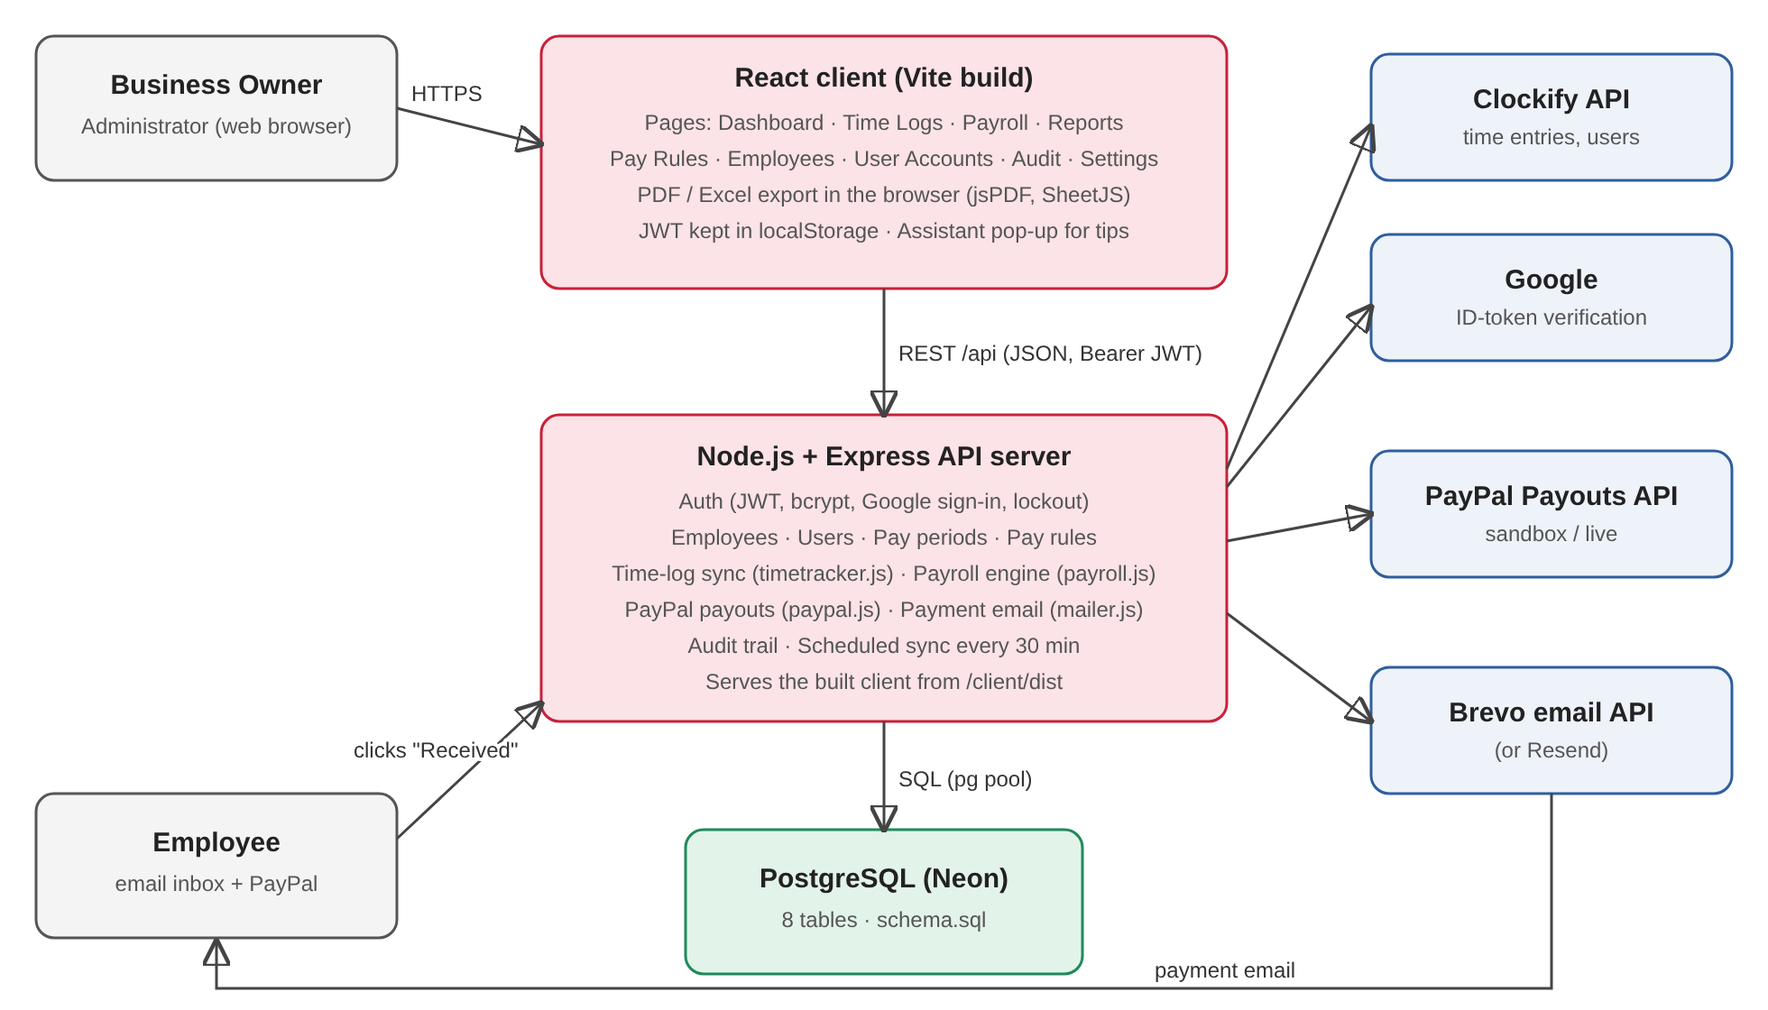
Figure 1. High-level system architecture and context diagram
Subsystems: the React web client (screens), the Express API server (business logic), the PostgreSQL database, and four external systems: Clockify (hours), Google (sign-in), PayPal (payments) and Brevo (email).
Requirements Traceability Matrix (RTM)
ID | Functional requirement | Design element (this document)
FR-1 | Sync employees' time logs from the time tracker | Module M1 timetracker.js; /api/timelogs/sync; scheduled sync (5.2)
FR-2 | Maintain employee records (pay type, rate, currency, OT eligibility) | Employees screen; employees table; /api/employees (4.1, 3.1)
FR-3 | Compute regular/overtime pay, CPP, EI and net pay | Module M3 payroll.js; /api/payroll/:id/compute (5.2)
FR-4 | Owner approval locks the payroll | Pay period states; /api/payroll/:id/approve (5.2)
FR-5 | Dashboard of hours, overtime and projected cost | Dashboard screen; /api/dashboard (4.2)
FR-6 | Payroll Summary and Payslip reports in PDF/Excel | Reports screen; payroll_reports table (4.2, 3.2)
FR-7 | Secure login, roles, lockout, audit trail | Auth module; audit_log; Section 7
FR-8 | Pay employees by email and confirm receipt | paypal.js, mailer.js; /api/payroll/:id/paypal; /api/receipt (6.2)

Design Constraints
- Budget: free tiers only – Render free web service, Neon free PostgreSQL, PayPal sandbox, Brevo free plan (300 emails/day).
- Database: must match the Laboratory Exercise 005 ERD (8 entities); payment columns were added to payroll only where required by the payment feature.
- No settings table: configuration and secrets are environment variables on the server.
- Time tracker: Clockify's API rate limits and paging; the API key must belong to a workspace admin to read everyone's hours.
- Payments: PayPal Payouts needs a business account balance in the payout currency (CAD); sandbox payouts only reach sandbox accounts.
- Email: Render's free plan generally blocks SMTP ports, so email is sent through Brevo's HTTPS API; the sender must be verified in Brevo.
- Trade-off: reports are generated in the browser (jsPDF, SheetJS) instead of on the server, which keeps the free server light but means report files are not stored on the server; only a log of each report is kept.
- Assumptions: one business (single tenant); business time zone America/Toronto; semi-monthly pay periods (1st–15th, 16th–end of month) paid 6 days after the period ends.

Future Contingencies
- Free hosting limits (sleep, outbound IP changes): upgrade the Render plan if the 30-minute sync must run around the clock; authorise Render's outbound IPs in Brevo.
- Email deliverability: if emails are rejected or go to spam, move the sender to a company domain authenticated with DKIM/DMARC in Brevo, or switch to another provider (the mailer also supports Resend).
- PayPal currency or account issues: use a Canadian business account holding CAD; if PayPal is unavailable, payroll can still be approved and paid manually – IPTAS keeps working without payouts.
- Clockify changes or outage: sync errors are logged (SYNC_FAILED) and the last synced hours remain; the payroll is not computed with missing hours.
- Legal changes (CPP/EI rates): new rates are added as a new pay-rule version with an effective date, without code changes.

Document Organization
Section 1 introduces the system, its scope, constraints, contacts and glossary. Section 2 describes the hardware, software and communications architecture. Section 3 presents the database and non-database files. Section 4 shows the screens (inputs) and reports/screens (outputs). Section 5 gives the detailed design of the hardware, software modules and internal communications. Section 6 describes the external interfaces (Clockify, Google, PayPal, Brevo). Section 7 describes the system integrity controls.

Points of Contact
Role | Name | Responsibility
Project Manager / Developer | Harold A. Sarmiento | Design, development, testing, deployment
System Proponent / Business Owner | Store Owner – Northern Goods Co. | Requirements, payroll approval, payments
User Organization | Payroll Administrator | Daily use: employees, time logs, payroll computation, reports
Quality Assurance | Course instructor / panel – MIT421 | Review and evaluation
Security & Configuration Manager | Harold A. Sarmiento | Accounts, environment variables, API keys, GitHub repository

Project References
- IPTAS Laboratory Exercise 005 – Entity Relationship Diagram (docs/erd.png, docs/DATABASE.md).
- IPTAS source code and README – GitHub repository ken-404-io/IPTAS-.
- Clockify REST API documentation – docs.clockify.me.
- PayPal Payouts API v1 documentation – developer.paypal.com.
- Brevo Transactional Email API documentation – developers.brevo.com.
- Canada Revenue Agency – CPP contribution and EI premium rates.
- Systems Design Document template adapted from Office of Information Systems, PDM (2012).

Glossary
Term | Definition
API | Application Programming Interface – how IPTAS exchanges data with other systems
Audit trail | Log of who did what and when (audit_log table)
bcrypt | One-way password hashing method
Clockify | Online time tracker used by the employees
CPP / EI | Canada Pension Plan contribution / Employment Insurance premium deducted from CAD pay
FX rate | USD→CAD exchange rate saved with each payroll
Gross / Net pay | Pay before deductions / pay after CPP and EI
JWT | JSON Web Token – signed login token valid for 8 hours
Overtime threshold | Hours per day paid at the regular rate (default 6); hours above it are overtime
Pay period | Semi-monthly period: 1st–15th or 16th–end of month
Payout | PayPal transfer of an employee's net pay to their email address
Received link | One-time link in the payment email that confirms the employee got the money
REST | Web API style using HTTP methods (GET, POST, PUT) and JSON
Sandbox | PayPal test environment with fake money
SPA | Single-page application (the React client)

SYSTEM ARCHITECTURE
IPTAS is a three-tier, cloud-hosted web application: a browser client (presentation), a Node.js/Express API server (application logic) and a PostgreSQL database (data). External systems are described in Section 6.

System Hardware Architecture
IPTAS has no on-premise hardware. All server components run on managed cloud infrastructure; users need only a device with a modern web browser and internet access.
Component | Description
Application server | Render web service (free plan): shared virtual CPU, 512 MB RAM, Linux, Node.js 22; HTTPS provided by Render
Database server | Neon serverless PostgreSQL (free plan), 0.5 GB storage, SSL connections, point-in-time restore
Client devices | Owner/Administrator laptop or desktop (Windows/macOS) with Chrome, Edge or Firefox; responsive layout also works on tablets and phones
Employee devices | Any device with email and PayPal access (phone or computer)
Network | Public internet; all traffic over HTTPS (TLS)

System Software Architecture
The software is organised in layers. The client (React) calls the server's REST API; the server modules contain the business rules and call the database and the external systems.
Ref | Module (file) | Language / tool | Function
M1 | Time Tracker Integration (server/timetracker.js) | JavaScript (Node.js) | Reads Clockify users and time entries, matches employees, stores time logs
M2 | Employee Records (routes in server/index.js) | JavaScript | Create, read and update employees
M3 | Salary Computation (server/payroll.js) | JavaScript | Daily overtime split, gross, CPP, EI, net pay
M4 | Dashboard (/api/dashboard, Dashboard.jsx) | JavaScript, React | Current-period hours, overtime and projected cost
M5 | Payroll Reports (Reports.jsx, exports.js) | React, jsPDF, SheetJS | PDF/Excel Payroll Summary and Payslips; report log
M6 | User Management & Security (auth, users, audit) | JavaScript, JWT, bcrypt | Login, Google sign-in, roles, lockout, audit trail
M7 | Payments (server/paypal.js) | JavaScript | PayPal Payouts: send, read status
M8 | Payment Email (server/mailer.js) | JavaScript | Payment email and Received confirmation
M9 | Pay Periods & Setup (server/seed.js) | JavaScript, SQL | Schema migration, starter data, semi-monthly periods

Languages and tools: JavaScript (ES2022) on Node.js 22 and in the browser; SQL (PostgreSQL 16); React 18, React Router 6 and Vite for the client; Express 4, node-postgres, jsonwebtoken, bcryptjs and express-rate-limit on the server; Git and GitHub for version control; Render for continuous deployment; Visual Studio Code as the editor.
Mapping to the DFD: process 1.0 Login → M6; 2.0 Manage Employees → M2; 3.0 Retrieve & Sync Time Logs → M1; 4.0 Compute Payroll → M3; 5.0 Generate Reports → M5; data stores D1 users, D2 employees, D3 time_logs, D4 pay_rules, D5 payroll, D6 audit_log.

Internal Communications Architecture
The browser loads the client from the same Render service and talks to the API over HTTPS using JSON (REST). Every request after login carries the JWT in the Authorization: Bearer header. The API server connects to PostgreSQL through a connection pool (5 connections) over SSL. The server calls the external systems over HTTPS (Section 6).
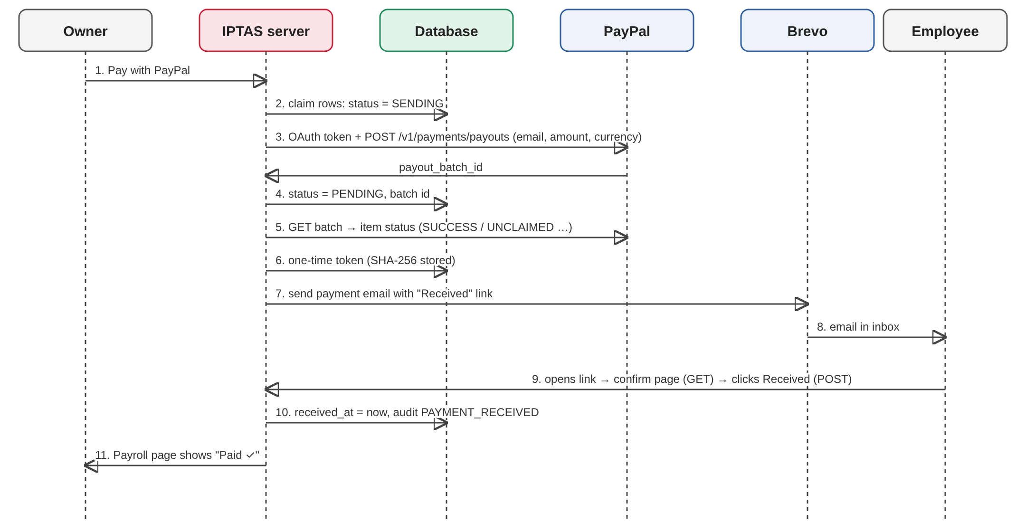
Figure 2. Communication path for paying an employee and confirming receipt

FILE AND DATABASE DESIGN
All persistent data is stored in one PostgreSQL database created from server/schema.sql, which runs on every server start and upgrades older databases safely (IF NOT EXISTS). Configuration is kept in environment variables, not in files or tables.

Database Management System Files
Logical model (ERD)
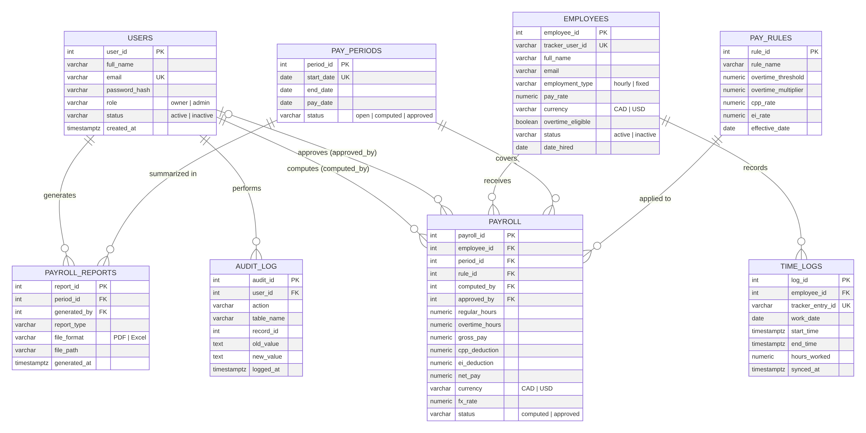
Figure 3. Entity Relationship Diagram
The model is in third normal form: employee data, pay rules and pay periods are stored once and referenced by foreign keys; payroll rows store the computed amounts and the rule and FX rate used, so approved payroll never changes when rules change later.
Physical tables and data dictionary
Table | Column (type) | Rules / description
users (D1) | user_id SERIAL PK; full_name VARCHAR(100); email VARCHAR(100) UNIQUE; password_hash VARCHAR(255); role VARCHAR(10); status VARCHAR(10); created_at TIMESTAMPTZ | role owner|admin; status active|inactive; password stored as bcrypt hash. CRUD: Owner (no delete; deactivate)
employees (D2) | employee_id PK; tracker_user_id VARCHAR UNIQUE; full_name; email; employment_type; pay_rate NUMERIC(10,2); currency VARCHAR(3); overtime_eligible BOOLEAN; status; date_hired DATE | employment_type hourly|fixed; pay_rate ≥ 0; currency CAD|USD. CRU: Owner, Admin
time_logs (D3) | log_id PK; employee_id FK; tracker_entry_id VARCHAR(50) UNIQUE; work_date DATE; start_time, end_time TIMESTAMPTZ; hours_worked NUMERIC(5,2); synced_at | Created/updated/deleted only by the Clockify sync; hours ≥ 0
pay_periods | period_id PK; start_date DATE UNIQUE; end_date; pay_date; status VARCHAR(10) | status open|computed|approved; generated automatically (1st–15th, 16th–end)
pay_rules (D4) | rule_id PK; rule_name; overtime_threshold NUMERIC; overtime_multiplier NUMERIC; cpp_rate NUMERIC(5,4); ei_rate NUMERIC(5,4); effective_date DATE | New version added by the Owner; never edited in place
payroll (D5) | payroll_id PK; employee_id FK; period_id FK; rule_id FK; computed_by FK; approved_by FK; regular_hours; overtime_hours; gross_pay; cpp_deduction; ei_deduction; net_pay NUMERIC(10,2); currency; fx_rate NUMERIC(8,4); status | UNIQUE(employee_id, period_id); status computed|approved
payroll (payment) | paypal_batch_id, paypal_item_id VARCHAR(40); payout_status VARCHAR(20); payout_error TEXT; paid_at; receipt_token VARCHAR(64) UNIQUE; emailed_at; email_error; received_at TIMESTAMPTZ | payout_status SENDING|PENDING|SUCCESS|UNCLAIMED|FAILED|RETURNED…; receipt_token = SHA-256 of the emailed link
payroll_reports | report_id PK; period_id FK; generated_by FK; report_type VARCHAR(50); file_format VARCHAR(10); file_path; generated_at | file_format PDF|Excel
audit_log (D6) | audit_id PK; user_id FK; action VARCHAR(50); table_name; record_id; old_value, new_value TEXT; logged_at | Insert only; never updated or deleted by the application

Access methods
Primary keys and UNIQUE columns use B-tree indexes (users.email, employees.tracker_user_id, time_logs.tracker_entry_id, pay_periods.start_date, payroll(employee_id, period_id), payroll.receipt_token). An extra index on time_logs(employee_id, work_date) supports reading hours by period. All access is through parameterised SQL queries.
Estimated size and update frequency
Table | Estimated volume | Update frequency
time_logs | ≈ 10 employees × 3 entries/day × 260 days ≈ 8,000 rows/year (< 2 MB) | Every sync: on demand and every 30 minutes
payroll | 10 employees × 24 periods = 240 rows/year | Each compute/approve/payment (about twice a month)
pay_periods | 24 rows/year | Created automatically
audit_log | ≈ 5,000 rows/year (logins, syncs, payroll actions) | Every audited action
users, employees, pay_rules, payroll_reports | Tens of rows | Occasionally

Total database size is expected to stay well under 50 MB per year, within the Neon free plan.

Non-Database Management System Files
File | Usage | Read/written by
Payroll Summary (PDF / .xlsx) | Output; created in the browser and downloaded by the user; not stored on the server | Reports screen (M5); a row is logged in payroll_reports
Employee Payslips (PDF) | Output; one page per employee | Reports screen (M5)
.env (local) / Render environment | Input; configuration and secrets (database URL, API keys) | server/env.js, config.js at start-up
schema.sql | Input; database definition and upgrades | server/seed.js at start-up
client/dist (HTML, JS, CSS) | Built client files served to browsers | Built by Vite; served by Express

HUMAN-MACHINE INTERFACE
Users interact with IPTAS through a responsive web interface. The left menu groups the screens into Track, Payroll and Manage. Information messages appear in a small assistant pop-up; errors and confirmations appear at the top of each screen. Employees interact only through the payment email and the confirmation page.

Inputs
Login screen
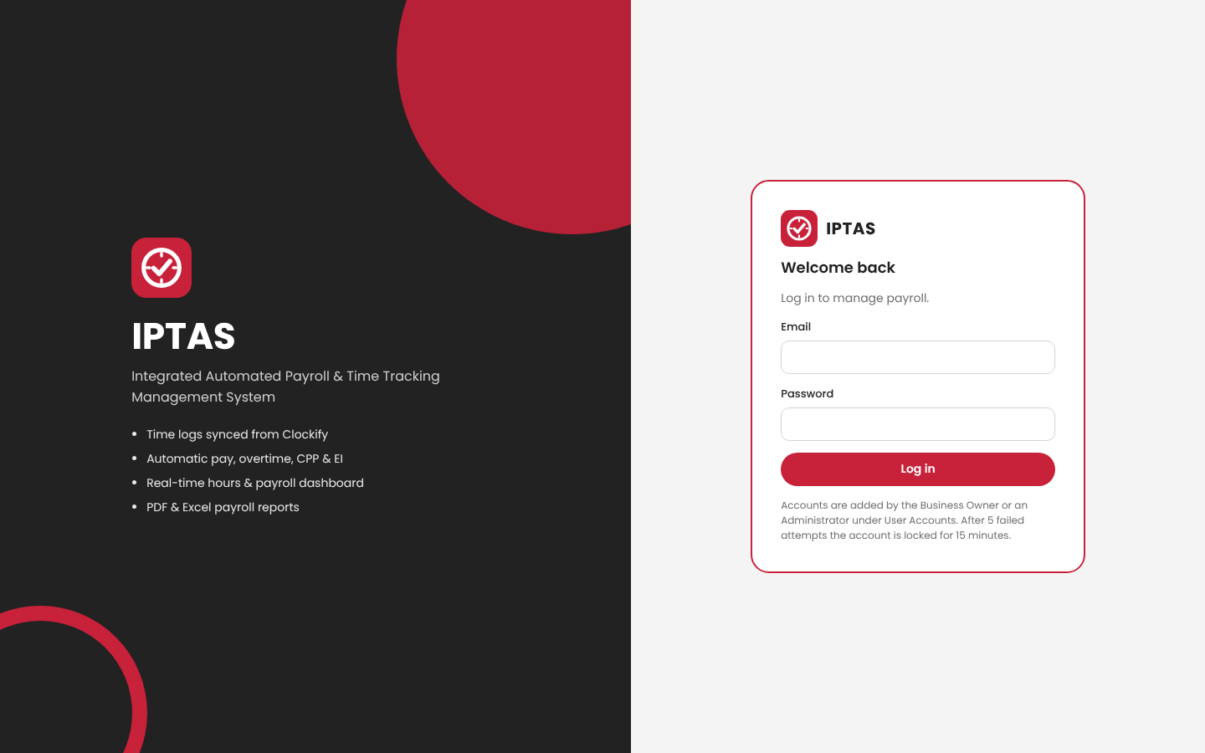
Figure 4. Login screen
Field | Type | Validation
Email | Text | Required; valid email format
Password | Password | Required; 5 wrong attempts lock the account for 15 minutes
Sign in with Google | Button | Only for emails that already have an IPTAS account

Employee Records screen
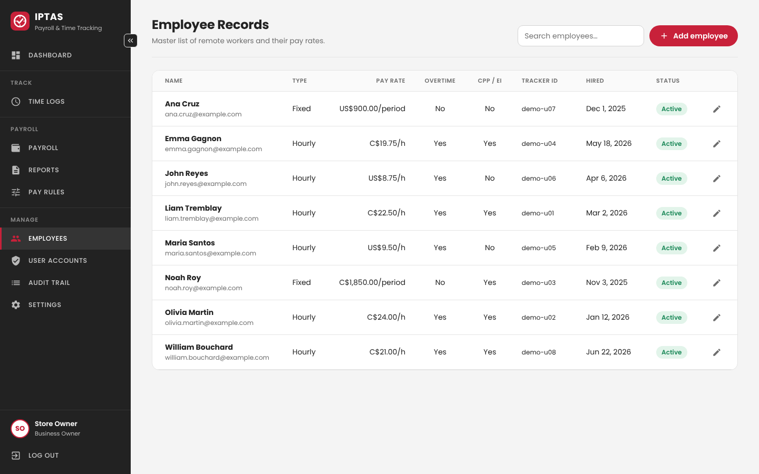
Figure 5. Employee Records screen
Field | Type | Validation
Full name | Text | Required, 2–100 characters
Email | Text | Required, valid email, used to match Clockify and to send payments
Employment type | Select | Hourly or Fixed (per pay period)
Pay rate | Number | Required, > 0; hourly ≤ 500, fixed ≤ 100,000
Currency | Select | CAD or USD
Overtime eligible | Checkbox | Yes/No
Time-tracker user ID | Text | Optional; Clockify user ID
Date hired, Status | Date, Select | Valid date; Active/Inactive

Pay Rules screen
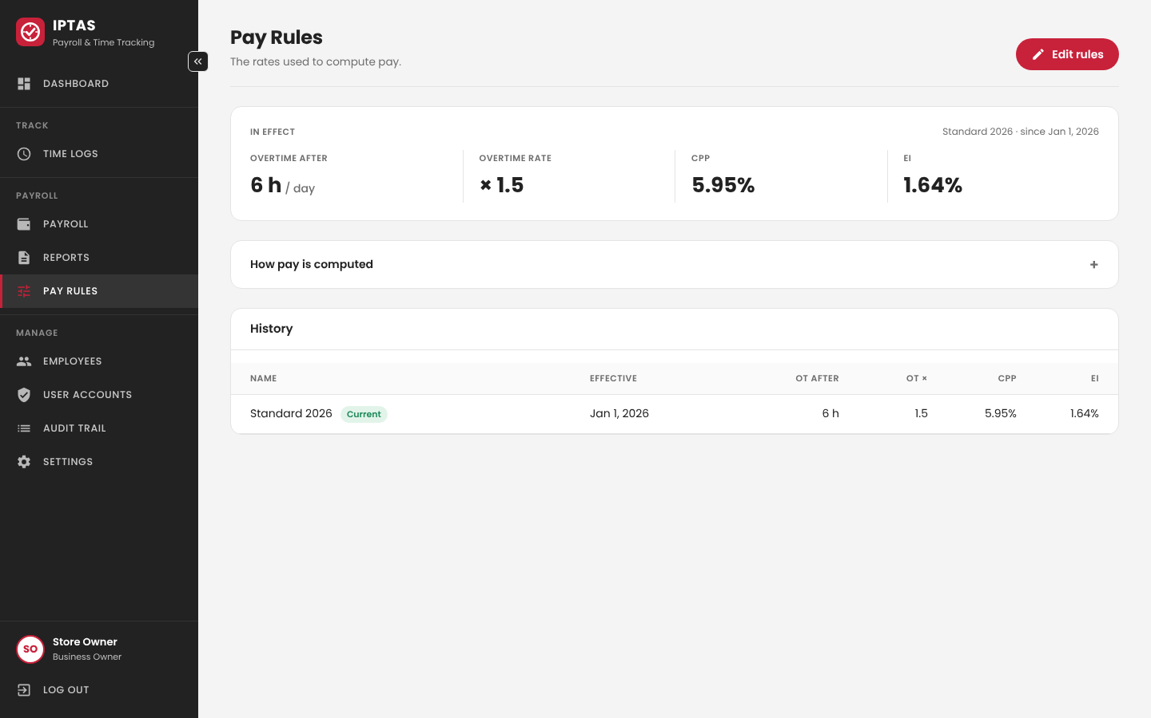
Figure 6. Pay Rules screen (Owner only)
Field | Type | Validation
Rule name | Text | Optional label
Overtime after (hours/day) | Number | 1–24
Overtime rate (multiplier) | Number | 1–3
CPP rate, EI rate | Percent | 0–20%
Effective date | Date | Required

Other operator inputs
- Time Logs: pay-period selector, Sync now button, employee filter and search box.
- Payroll: pay-period selector, USD→CAD rate (0.5–5), Compute payroll, Approve payroll (Owner), Pay with PayPal (Owner), Email employees (Owner), Refresh PayPal status.
- User Accounts (Owner): name, email, role (Owner/Administrator), password (minimum length and complexity), status.
- Employee confirmation page: one button, Received.
Data entry controls: every form is validated while typing and again on the server, so validation cannot be bypassed. Buttons are disabled while an action runs, and confirmation dialogs appear before approving payroll and before sending payments. Owner-only actions are refused by the server for other roles.

Outputs
Code | Output | Contents | Users / frequency
O-1 | Dashboard | Hours and overtime this period, projected payroll cost (CAD), active employees, pay date, hours per employee, payroll cost by period | Owner, Admin – daily
O-2 | Time Logs | Totals per employee, hours per day, entries with start/end times, regular vs overtime | Owner, Admin – daily
O-3 | Payroll | Per employee: regular/OT hours, gross, CPP, EI, net, net in CAD, PayPal status; payslip pop-up | Owner, Admin – twice a month
O-4 | Payroll Summary report (PDF/Excel) | Company, period, pay date, rule, one row per employee with hours, gross, deductions, net, totals | Owner – each pay period
O-5 | Employee Payslips (PDF) | One page per employee with hours, gross, CPP, EI, net pay | Owner, employees – each pay period
O-6 | Payment email | Amount, period, hours, gross, deductions, net; Open PayPal and Received buttons | Employees – each payment
O-7 | Audit Trail | Date, user, action, record, old and new values (latest 300) | Owner – as needed

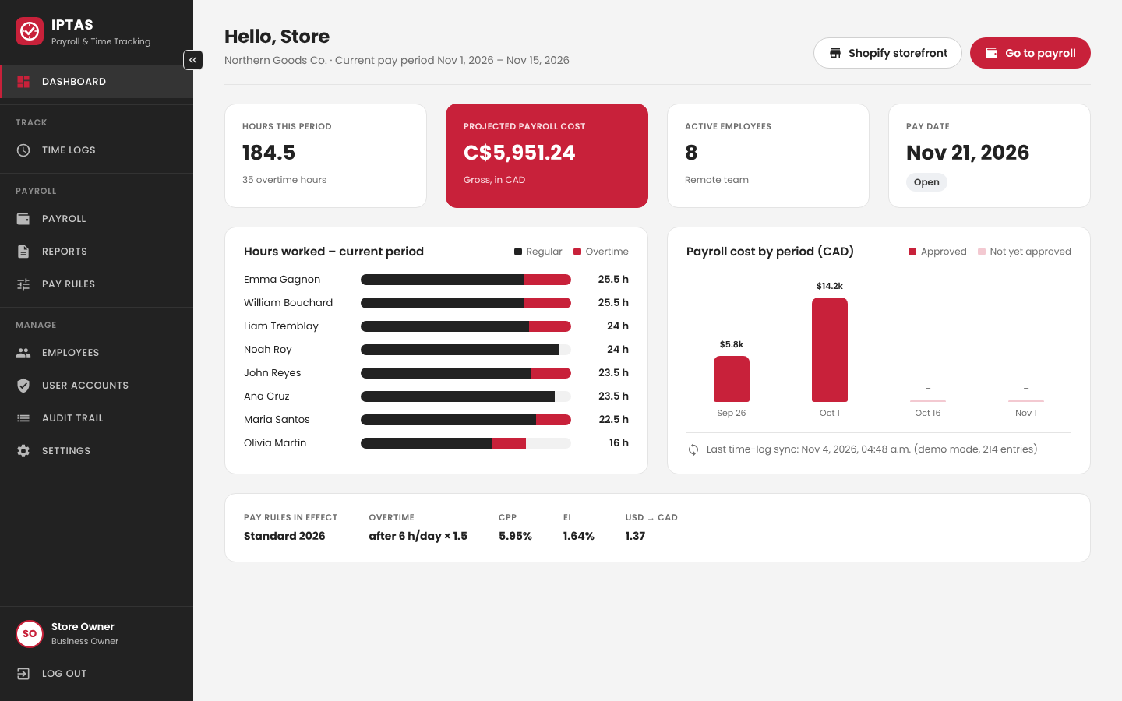
Figure 7. Dashboard (O-1)
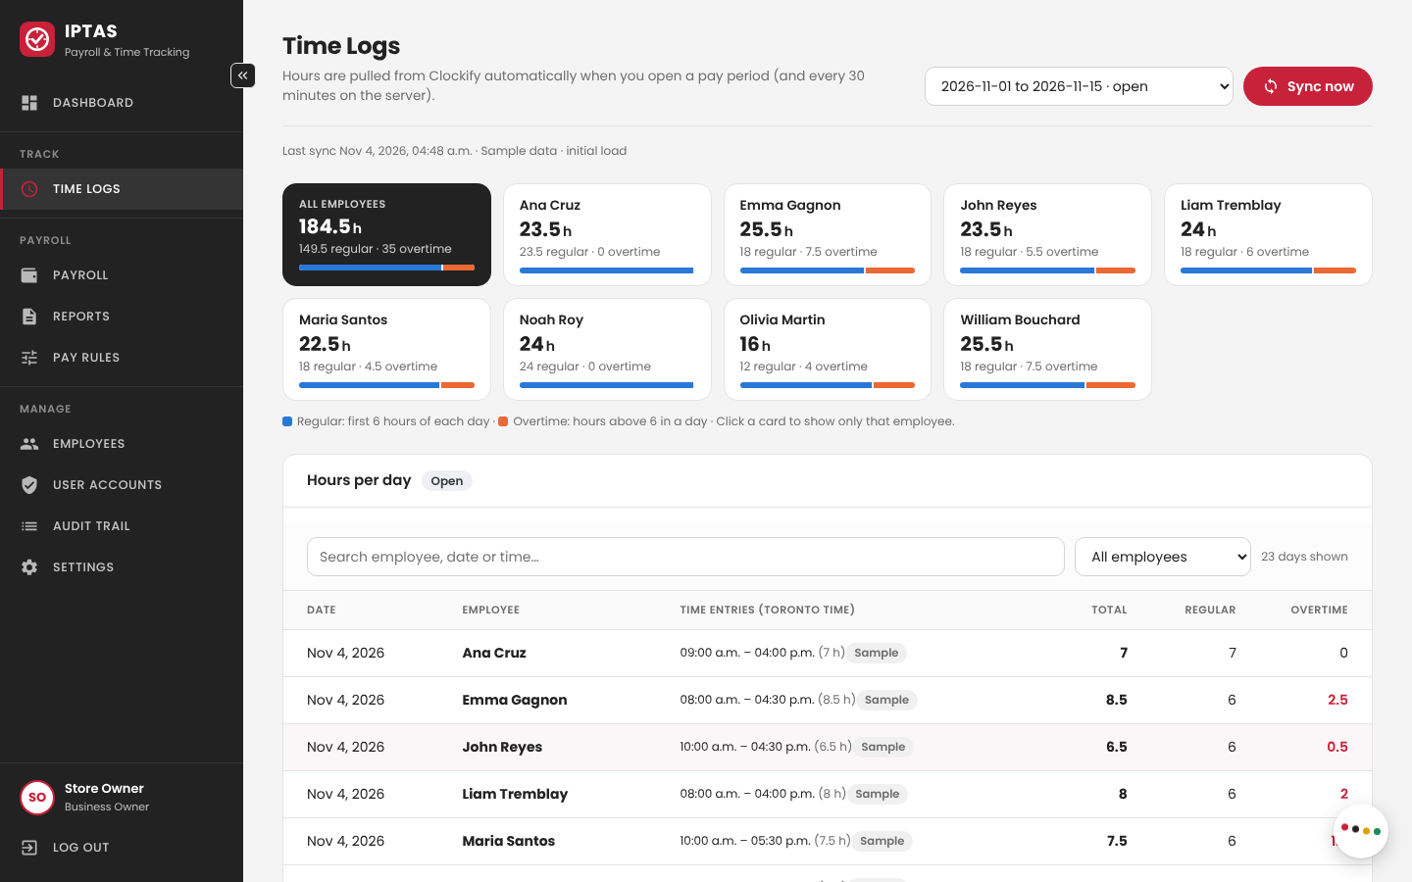
Figure 8. Time Logs (O-2)
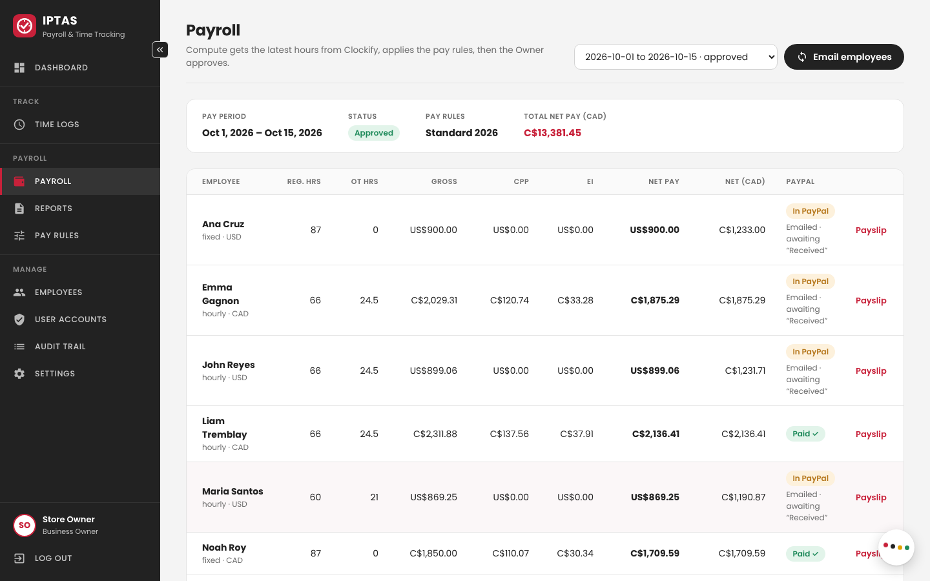
Figure 9. Payroll with PayPal status (O-3)
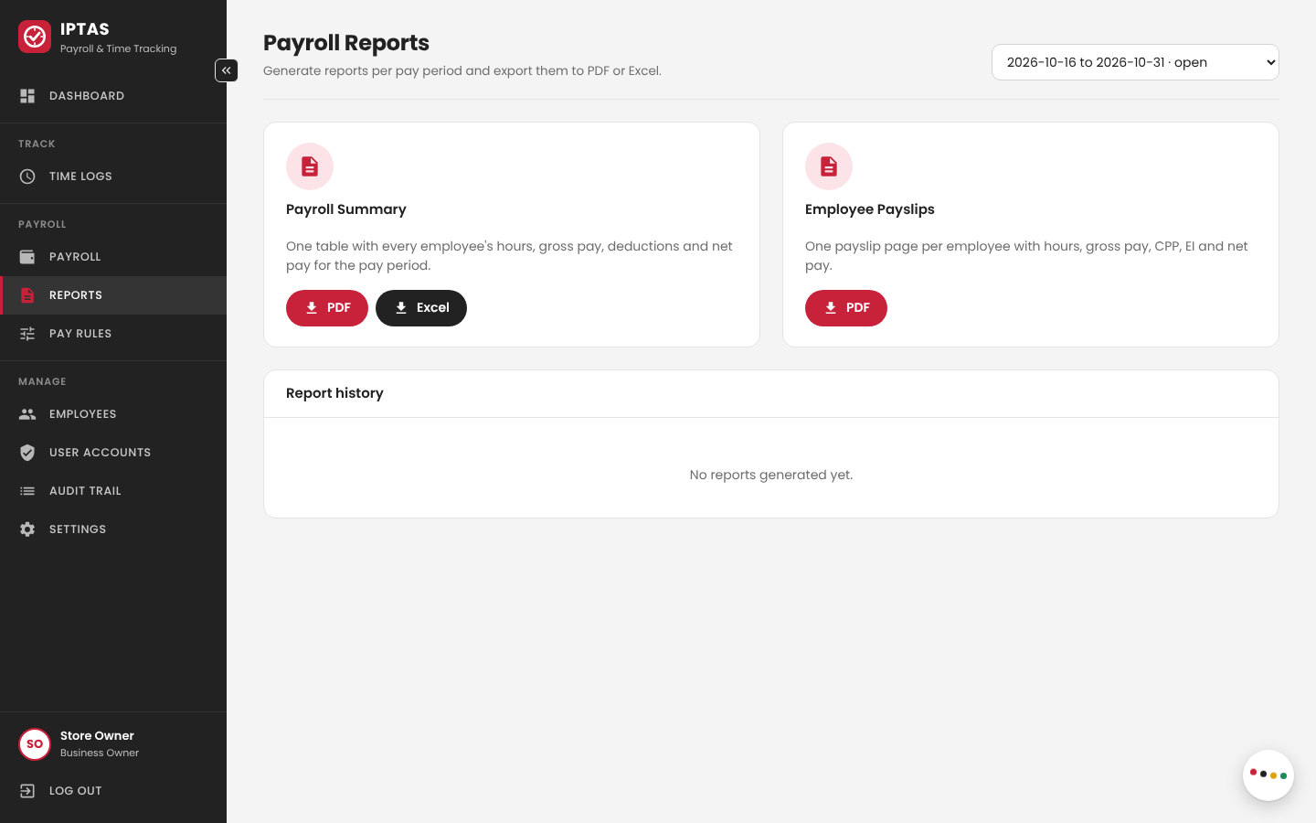
Figure 10. Payroll Reports (O-4, O-5)
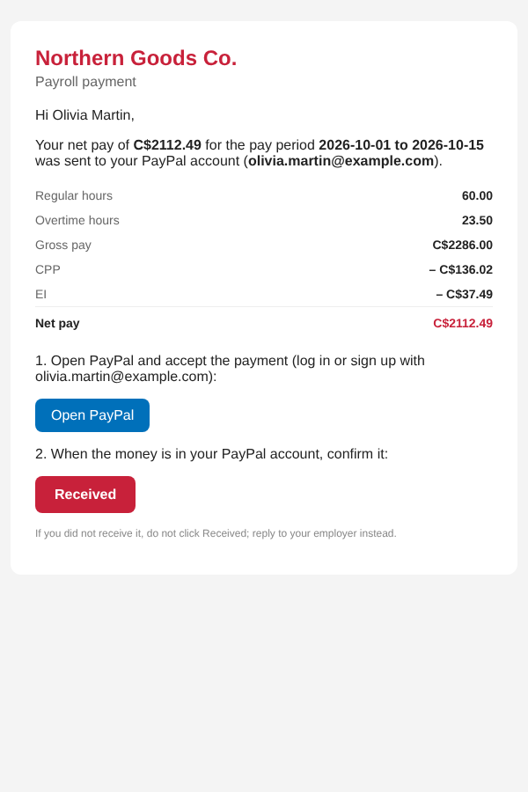
Figure 11. Payment email received by the employee (O-6)
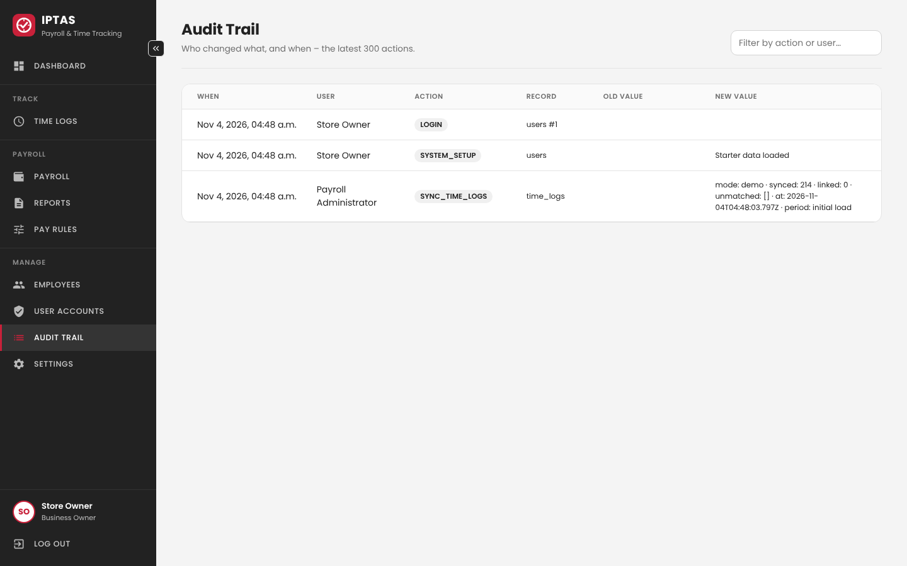
Figure 12. Audit Trail (O-7)
Access restrictions: Audit Trail, User Accounts, Settings, pay-rule changes, approval and payments are Owner-only. Reports show the payroll status (computed or approved) so unapproved figures are not mistaken for final pay.

DETAILED DESIGN
This section gives the information needed to rebuild and run IPTAS: the hosting components, the logic of each software module, and the communication formats.

Hardware Detailed Design
IPTAS uses managed cloud services, so power, cabling and connectors are handled by the providers. The requirements are:
Component | Requirement
Application server (Render) | Node.js ≥ 18 (22 used); ≥ 512 MB RAM; ≥ 0.1 vCPU; outbound HTTPS to Clockify, PayPal, Brevo, Google; health check GET /api/health
Database (Neon) | PostgreSQL 14+ (16 used); ≥ 0.5 GB storage; SSL required
Client computer | Any dual-core PC/Mac, 4 GB RAM, current Chrome/Edge/Firefox/Safari; screen 1280×720 or larger recommended (layout adapts down to phone width)
Network | Broadband internet connection; HTTPS port 443
Printer (optional) | Any printer for the PDF reports and payslips

Software Detailed Design
M1 – Time Tracker Integration (timetracker.js)
Called by Sync now, by opening an open period on Time Logs (if the last sync is older than 5 minutes), by Compute payroll, and by a timer every 30 minutes for open periods that are current or ended in the last 14 days.
1. Read all workspace users and the period's time entries from Clockify, 200 per page, retrying when rate-limited.
2. Match each Clockify user to an employee by tracker_user_id or email; list unmatched users.
3. Convert each entry's start time to a work date in the business time zone; skip running timers.
4. Insert or update entries by tracker_entry_id; delete entries removed in Clockify.
5. If hours changed after payroll was computed (not approved), delete that payroll and reopen the period.
6. Write SYNC_TIME_LOGS (or SYNC_FAILED) to the audit trail.
M3 – Salary Computation (payroll.js)
Step | Formula / rule
Daily split | For each work date: regular = min(hours, threshold); overtime = hours − regular (all regular if not OT-eligible)
Hourly gross | regular × rate + overtime × rate × multiplier
Fixed gross | rate per period + overtime × [rate ÷ (threshold × 10.83 working days)] × multiplier
CPP / EI | gross × cpp_rate and gross × ei_rate – CAD employees only
Net | gross − CPP − EI (rounded to cents); Net CAD = net × fx_rate

Example: hourly CAD employee at C$15/h works 9 h on Monday and 4 h on Tuesday → regular 10 h, overtime 3 h → gross C$217.50, CPP C$12.94, EI C$3.57, net C$200.99.
Compute payroll first syncs the hours, then (in one database transaction) deletes and recreates the period's payroll rows with the rule in effect on the period end date, and sets the period to computed. Approve (Owner) sets the payroll and period to approved, which locks them.
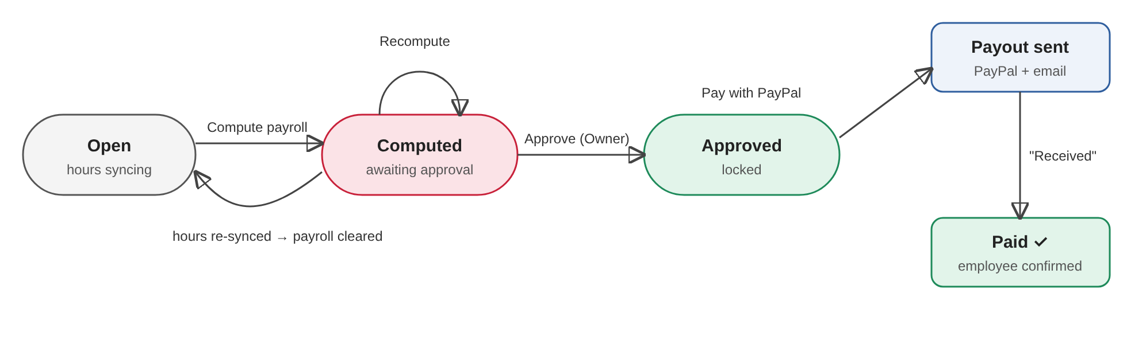
Figure 13. Pay period and payment states
M6 – User Management & Security
Login checks the bcrypt hash and returns a JWT valid for 8 hours. Five wrong passwords lock the account for 15 minutes. Google sign-in verifies the ID token and signs in only existing accounts. Each request re-checks the user's status and role. Actions are written to audit_log.
M7 – Payments (paypal.js) and M8 – Payment Email (mailer.js)
1. Owner clicks Pay with PayPal on an approved period.
2. Rows with net pay > 0 and no payout (or a failed/returned one) are marked SENDING in one SQL statement, which prevents double payment.
3. IPTAS gets an OAuth token and posts one payout batch: one item per employee (receiver = email, amount = net pay, currency).
4. The batch id is saved, status becomes PENDING, and item statuses (SUCCESS, UNCLAIMED, FAILED…) are read back.
5. For each employee a random 32-byte token is created; its SHA-256 hash is saved and the payment email with the Received link is sent through Brevo.
6. The link opens a confirm page (GET); the Received button (POST) sets received_at and logs PAYMENT_RECEIVED. The Payroll screen then shows Paid ✓.
Report layout (M5)
Payroll Summary: header with company, report title, pay period, pay date, status and pay rules; table columns Employee, Type, Reg hrs, OT hrs, Gross, CPP, EI, Net, Currency, Net CAD; totals row; footer with generation date and page numbers. Payslip: one page per employee with employment type, rate, hours, gross, deductions and net pay.

Internal Communications Detailed Design
- Servers and clients: one application server (Render), one database server (Neon), any number of browser clients.
- Data format: JSON over HTTPS; dates as YYYY-MM-DD; amounts as decimal numbers with 2 places; errors as {"error": "message"} with HTTP 400, 401, 403, 404, 423 or 502.
- Authentication: Authorization: Bearer <JWT> on every API call except login, health and the receipt link.
- Database link: node-postgres pool (max 5 connections) over SSL; DATE values returned as plain strings to avoid time-zone shifts.
- Topology: star – all clients connect to the one server over the internet; the server is the only component that talks to the database and the external systems.
Main API endpoints
Endpoint | Access | Purpose
POST /api/auth/login, /api/auth/google | Public (rate-limited) | Sign in, returns JWT
GET/POST/PUT /api/employees | User | Employee records
GET/POST/PUT /api/users | Owner | User accounts
GET /api/periods | User | Pay periods with totals
GET /api/timelogs, POST /api/timelogs/sync | User | Hours and Clockify sync
GET /api/rules, POST /api/rules | User / Owner | Pay rules
GET /api/payroll/:id; POST …/compute | User | View and compute payroll
POST /api/payroll/:id/approve | Owner | Approve and lock
POST /api/payroll/:id/paypal, …/email, …/paypal/refresh | Owner / User | Pay, email employees, refresh status
GET/POST /api/receipt/:token | Public one-time link | Employee confirms receipt
GET /api/dashboard, /api/reports, /api/audit, /api/settings | User / Owner | Dashboard, report log, audit, settings

EXTERNAL INTERFACES
IPTAS exchanges data with four external systems. All interfaces are initiated by the IPTAS server over HTTPS with JSON (except Google sign-in, which starts in the browser). Credentials are stored only in server environment variables.

Interface Architecture
External system | Direction | Method | Purpose
Clockify | Clockify → IPTAS | REST queries (GET), on demand and every 30 min | Workspace users and time entries
Google Identity | Browser → Google → IPTAS | ID token checked with Google's tokeninfo endpoint | Sign in with Google
PayPal Payouts | IPTAS → PayPal → IPTAS | OAuth 2.0 client credentials; POST payout batch; GET batch status | Pay employees by email
Brevo | IPTAS → Brevo → employee | POST transactional email (API key) | Payment email with Received link

The context diagram in Figure 1 (Section 1.2.1) shows these communication paths.

Interface Detailed Design
Clockify
- Header X-Api-Key; GET /user, /workspaces/{id}/users, /workspaces/{id}/user/{userId}/time-entries?start&end&page&page-size=200.
- Durations (ISO 8601, e.g. PT7H30M) and start/end times are converted to hours and work dates in the business time zone.
- Errors: 401 → "Clockify rejected the API key"; 429/5xx → retry with back-off; other errors stop the sync, are shown to the user and logged as SYNC_FAILED.
Google sign-in
- Checks: audience = GOOGLE_CLIENT_ID, issuer accounts.google.com, not expired, email verified. Errors return 401/403 with a message.
PayPal Payouts
- POST /v1/oauth2/token (Basic auth) → access token cached until expiry.
- POST /v1/payments/payouts: sender_batch_header {sender_batch_id, email_subject, email_message}; items [{recipient_type: EMAIL, receiver, amount {value, currency}, note, sender_item_id: iptas-payroll-<id>}].
- GET /v1/payments/payouts/{batch_id} → transaction_status per item, matched by sender_item_id.
- Errors are translated (invalid credentials, INSUFFICIENT_FUNDS, NON_HOLDING_CURRENCY, not authorised) and saved in payout_error; the rows return to "not sent" so they can be paid again.
Brevo
- POST https://api.brevo.com/v3/smtp/email, header api-key; body {sender {email, name}, to [{email, name}], subject, htmlContent, textContent}.
- Errors (unverified sender, unrecognised IP, invalid address) are saved in email_error and shown on the Payroll screen; Email employees resends with a new link.

SYSTEM INTEGRITY CONTROLS
IPTAS handles personal and pay information, so the following controls are built in:
Control | Implementation
Internal security / access | Role-based access (Owner, Administrator) enforced by the server; passwords hashed with bcrypt; JWT sessions expire after 8 hours; deactivated users are blocked immediately; login rate limit and 15-minute lockout after 5 failed attempts
Audit procedures | audit_log records LOGIN, LOGIN_FAILED, CREATE/UPDATE_USER, CREATE/UPDATE_EMPLOYEE, SYNC_TIME_LOGS, SYNC_FAILED, UPDATE_PAY_RULES, COMPUTE_PAYROLL, APPROVE_PAYROLL, PAYPAL_PAYOUT, EMAIL_PAYSLIPS, PAYMENT_RECEIVED, GENERATE_REPORT, CLEAR_SAMPLE_DATA; entries are never edited or deleted by the application
Application audit trail | Each entry stores the user, date and time, action, table, record and old/new values; viewable by the Owner on the Audit Trail screen
Standard tables for validation | Allowed values are enforced with CHECK constraints (role, status, employment type, currency, period status, report format) and in the forms
Verification of critical changes | Payroll must be computed then approved by the Owner; approved periods are locked; confirmation dialogs before approving and paying; payments only for approved payroll and never twice; pay rules are versioned, never overwritten
Identification of audit information | Every audited action is tied to the signed-in user ID and timestamp; employee receipts are tied to the payroll record
Data protection | HTTPS for all traffic; SSL to the database; API keys only in environment variables; receipt links stored only as SHA-256 hashes; all SQL parameterised
Backup and recovery | Neon point-in-time restore; source code in GitHub; schema recreated automatically on start-up

Document Template Adapted from: Office of Information Systems, Business Systems Support Office: PDM (2012)

