IPTAS
Integrated Automated Payroll & Time Tracking Management System
System Design Document
Item | Details
Document | System Design Document (SDD)
System | IPTAS – web application for payroll and time tracking of remote employees
Version | 1.0
Date | November 4, 2026
Prepared by | Harold Sarmiento
Live system | https://iptas.onrender.com
Source code | GitHub: ken-404-io/IPTAS-

Table of Contents

(In Word: right-click the table and choose Update Field to refresh page numbers.)

1. Introduction

1.1 Purpose
This document describes the design of IPTAS: its architecture, modules, data, processes, interfaces, security and deployment. It is the reference for developers maintaining the system and for reviewers checking how the requirements were met.

1.2 Scope
IPTAS automates the payroll of a small business with remote employees in Canada and abroad. It:
- pulls working hours from Clockify automatically (on demand and every 30 minutes);
- splits each day into regular hours and overtime using the pay rules;
- computes gross pay, CPP and EI deductions and net pay in CAD or USD;
- lets the Business Owner review and approve the payroll, which locks it;
- pays employees by email through PayPal Payouts, and emails them a payment notice with a Received button that marks the payment Paid;
- produces Payroll Summary and Payslip reports in PDF and Excel;
- keeps an audit trail of every important action.

1.3 Users and roles
Role | Who | Can do
Business Owner (owner) | Store owner | Everything: approve payroll, pay with PayPal, email employees, change pay rules, manage user accounts, view audit trail and settings
Administrator (admin) | Payroll / HR staff | Manage employees, sync time logs, compute payroll, generate reports. Cannot approve, pay or change pay rules
Employee | Remote worker (no login) | Receives PayPal payment and the payment email; clicks Received to confirm

1.4 Definitions
Term | Meaning
Pay period | Semi-monthly: the 1st–15th and the 16th–last day of the month. Paid 6 days after the period ends.
Overtime threshold | Hours per day that are regular pay (default 6). Hours above it on the same day are overtime.
CPP / EI | Canada Pension Plan and Employment Insurance deductions (CAD employees only).
FX rate | USD→CAD rate saved with each payroll so totals can be shown in CAD.
Payout | A PayPal Payouts transfer of an employee's net pay to their email address.
JWT | JSON Web Token used to keep a user signed in (8 hours).

2. System Architecture
IPTAS is a three-tier web application: a single-page React client, a Node.js/Express REST API, and a PostgreSQL database. The API server also serves the built client, so the whole system runs as one web service on Render. External services are called only from the server, never from the browser (except Google sign-in).
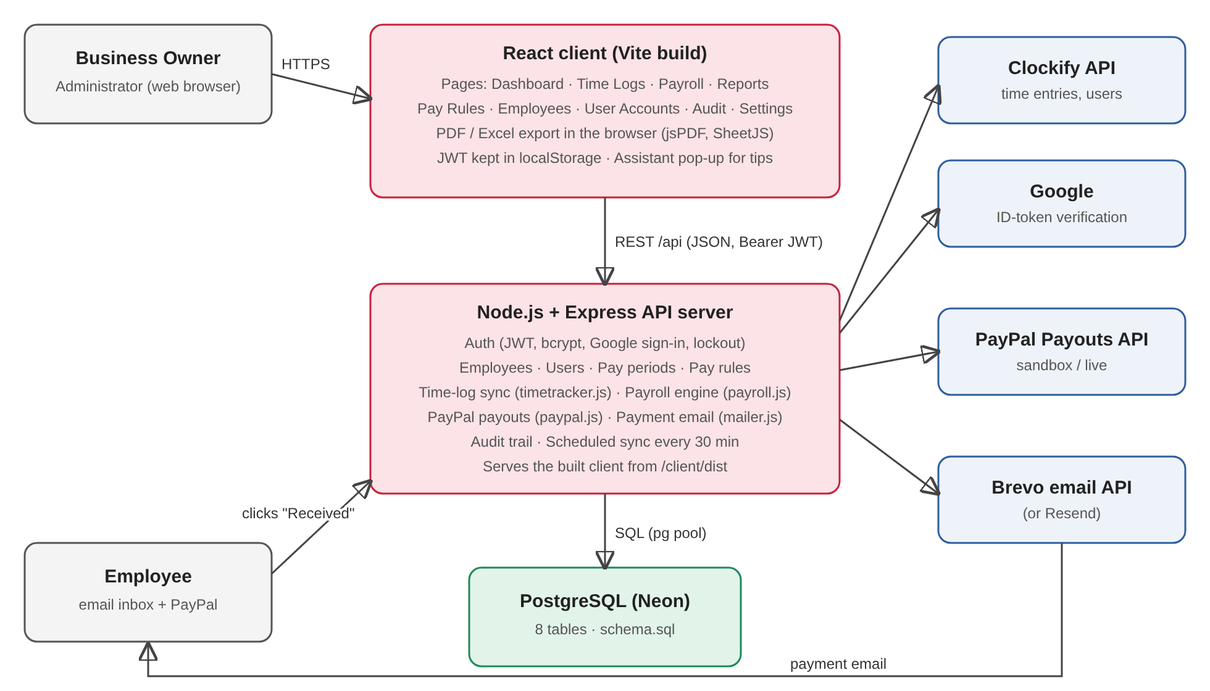
Figure 1. High-level architecture

2.1 Technology stack
Layer | Technology | Notes
Client | React 18, React Router 6, Vite | Single-page app in client/src; built to client/dist
Reports | jsPDF + autoTable, SheetJS (xlsx) | PDF and Excel files are generated in the browser
Server | Node.js 22, Express 4 | server/index.js (routes), one module per concern
Auth | jsonwebtoken, bcryptjs, express-rate-limit | JWT bearer tokens, hashed passwords, login rate limit
Database | PostgreSQL (Neon), node-postgres (pg) | Schema in server/schema.sql, applied on every start
Time tracking | Clockify REST API | server/timetracker.js
Payments | PayPal Payouts API v1 | server/paypal.js (sandbox or live)
Email | Brevo transactional email API (or Resend) | server/mailer.js
Hosting | Render web service (free plan), Neon Postgres | render.yaml blueprint

2.2 Server modules
File | Responsibility
server/index.js | Express app: authentication middleware, all /api routes, audit helper, scheduled sync, static client
server/payroll.js | Pure salary engine: daily regular/overtime split, gross, CPP, EI, net (unit-tested)
server/timetracker.js | Clockify client: paging, retries, time-zone work dates, employee matching, demo data
server/paypal.js | PayPal OAuth token cache, create payout batch, read item statuses, error messages
server/mailer.js | Brevo/Resend email sending and the HTML payment email template
server/seed.js | Schema migration, starter data, semi-monthly pay-period generation
server/google.js | Verifies Google sign-in ID tokens
server/config.js, env.js, db.js | Environment variables, .env loader, PostgreSQL pool

2.3 Client pages
Page | Purpose
Login | Email + password, or Sign in with Google
Dashboard | Current period, hours, overtime and projected payroll per employee
Time Logs | Hours per day per employee from Clockify, regular vs overtime, Sync now
Payroll | Compute, approve, Pay with PayPal, Email employees, payout status, payslips
Reports | Payroll Summary and Employee Payslips in PDF/Excel, report history
Pay Rules | Overtime threshold and multiplier, CPP and EI rates by effective date
Employees | Add/edit employees: pay type, rate, currency, overtime eligibility, Clockify link
User Accounts | Owner manages system users and roles
Audit Trail | Owner views the last 300 audited actions
Settings | Shows server configuration, tests Clockify, removes sample data

3. Data Design
The database has 8 tables matching the Laboratory Exercise 005 ERD, plus payout and email columns added to payroll. The schema is created and upgraded automatically on every server start (server/schema.sql); all upgrades are idempotent (IF NOT EXISTS).
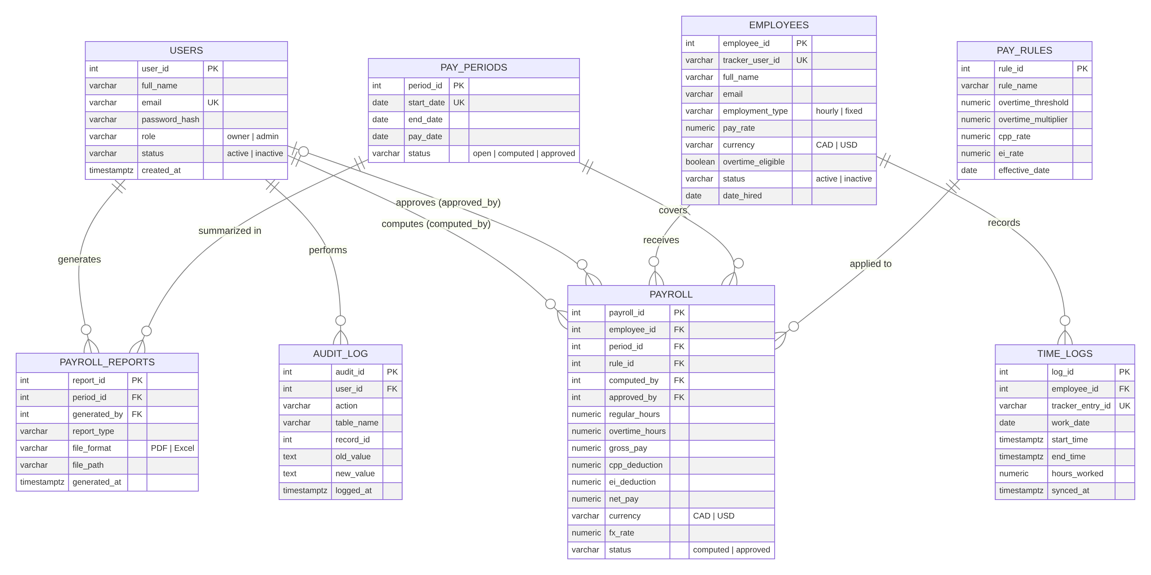
Figure 2. Entity Relationship Diagram (ERD)

3.1 Tables
Table | Purpose | Key fields
users | System accounts (D1) | email (unique), password_hash (bcrypt), role owner|admin, status
employees | People being paid (D2) | tracker_user_id (Clockify), employment_type hourly|fixed, pay_rate, currency CAD|USD, overtime_eligible
time_logs | One Clockify time entry (D3) | tracker_entry_id (unique), work_date, start/end, hours_worked
pay_periods | Semi-monthly periods | start_date (unique), end_date, pay_date, status open|computed|approved
pay_rules | Versioned pay rules (D4) | overtime_threshold, overtime_multiplier, cpp_rate, ei_rate, effective_date
payroll | Pay of one employee for one period (D5) | hours, gross, CPP, EI, net, currency, fx_rate, status; PayPal and email columns (3.2)
payroll_reports | Log of generated reports | report_type, file_format PDF|Excel, generated_by
audit_log | Audit trail (D6) | user_id, action, table_name, record_id, old_value, new_value, logged_at

3.2 Payment columns on payroll
Column | Meaning
paypal_batch_id / paypal_item_id | PayPal payout batch and item identifiers
payout_status | SENDING, PENDING, SUCCESS, UNCLAIMED, ONHOLD, FAILED, RETURNED, BLOCKED, DENIED, REFUNDED
payout_error | Last PayPal error message for this row
paid_at | When the payout was sent
receipt_token | SHA-256 hash of the one-time Received link (the link itself is never stored)
emailed_at / email_error | When the payment email was sent, or why it failed
received_at | When the employee clicked Received; the row then shows Paid

3.3 Integrity rules
- payroll is unique per (employee_id, period_id); recomputing replaces the rows in one transaction.
- An approved pay period is locked: sync, compute and approve are refused by the server.
- Pay periods that are computed, approved, or have payroll or reports never change dates.
- Time logs are stored by date, not by period, so changing the period calendar never loses hours.
- Money is stored as NUMERIC(10,2) and rounded to cents at every step.

4. Process Design

4.1 Payroll lifecycle
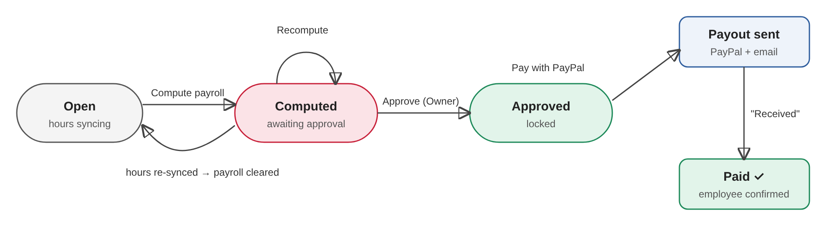
Figure 3. Pay period and payment states

4.2 Time-log sync (Clockify)
- Triggered by Sync now, by opening an open period on Time Logs (if the last sync is older than 5 minutes), by Compute payroll, and by a server timer every 30 minutes for open periods that are current or ended in the last 14 days.
- The server reads all Clockify users and time entries of the period, page by page (200 per page, retries on rate limits).
- Clockify users are matched to employees by tracker_user_id or by email; unmatched users are reported.
- Each entry's work date is computed in the business time zone (default America/Toronto). Running timers are skipped.
- Entries are upserted by tracker_entry_id; entries deleted in Clockify are removed.
- If hours change after payroll was computed (not approved), that payroll is cleared and the period returns to open.
- The result is written to the audit trail (SYNC_TIME_LOGS or SYNC_FAILED).

4.3 Pay periods
Periods are generated automatically up to one period after today: the 1st–15th and the 16th–end of each month, pay date = end date + 6 days. When the calendar changed from two-week periods, open unused periods were realigned and the first one runs to the end of its half-month (for example Oct 24–31) so the next one starts on the 1st.

4.4 Payment and confirmation
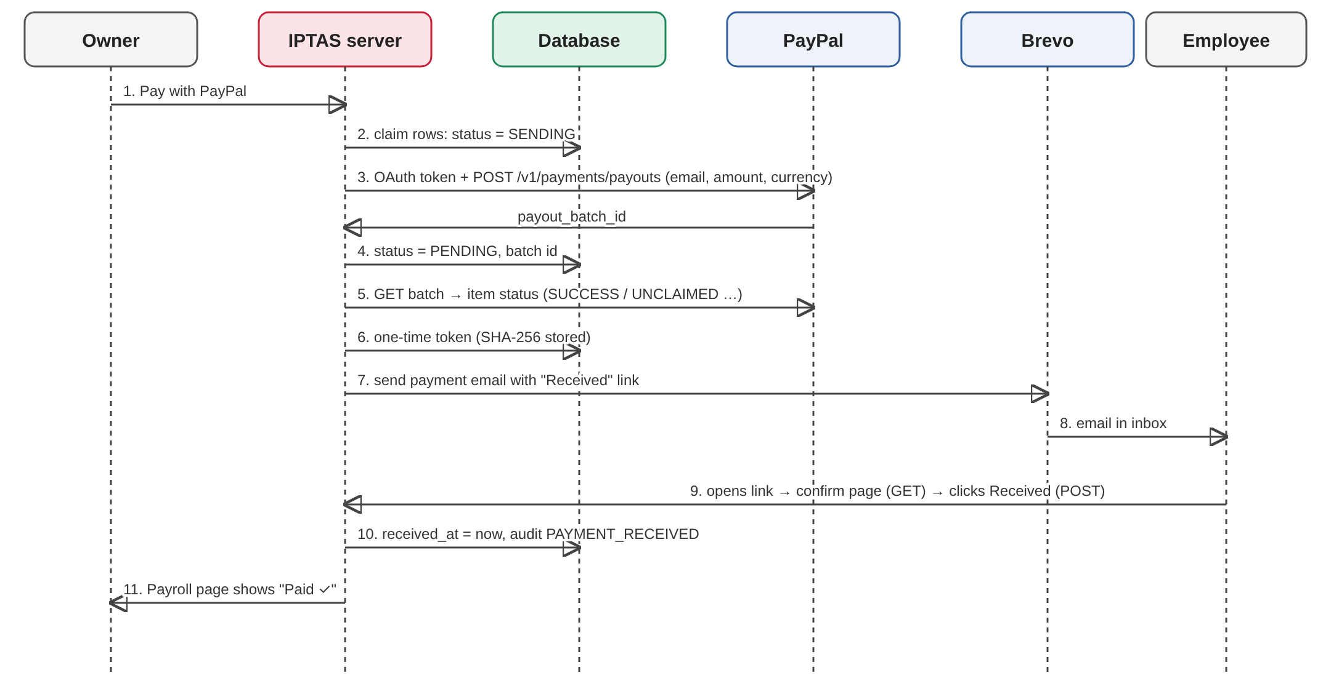
Figure 4. Pay with PayPal and the Received email
- Rows are claimed (status SENDING) before PayPal is called, so a double click cannot pay anyone twice.
- Only rows with no payout, or whose payout FAILED/RETURNED/BLOCKED/DENIED/REFUNDED, can be paid again.
- Pending payouts refresh automatically when the period is opened, or with Refresh PayPal status.
- Email employees re-sends the email (with a new link) to everyone who has not confirmed; old links stop working.
- The Received link first shows a confirm page (GET); only the button (POST) records the receipt, so email link scanners cannot confirm by accident.

5. Payroll Computation Rules
The engine in server/payroll.js is a set of pure functions, covered by unit tests. Default rule "Standard 2026": overtime after 6 hours per day, multiplier 1.5, CPP 5.95%, EI 1.64%.
Step | Rule
Daily split | Hours are summed per work date. Regular = min(hours, threshold); overtime = the rest. Not overtime-eligible → all hours regular.
Hourly gross | regular × rate + overtime × rate × multiplier
Fixed gross | pay_rate per period + overtime × (pay_rate ÷ (threshold × 10.83 working days)) × multiplier
CPP, EI | gross × cpp_rate and gross × ei_rate, for CAD employees only (USD workers are foreign contractors)
Net pay | gross − CPP − EI, in the employee's currency
Net (CAD) | net × fx_rate (1 for CAD). The USD→CAD rate is entered when computing and saved with the payroll
Rounding | Every amount is rounded to 2 decimals
Pay rule used | The latest rule whose effective_date is on or before the period end date; saved on each payroll row

Example
An hourly CAD employee at C$15/h works 9 h on Monday and 4 h on Tuesday. Regular = 6 + 4 = 10 h, overtime = 3 h. Gross = 10 × 15 + 3 × 15 × 1.5 = C$217.50; CPP = C$12.94; EI = C$3.57; net = C$200.99.

6. API Design
All endpoints are under /api, use JSON, and (except the ones marked public) need the header Authorization: Bearer <JWT>. Errors return { "error": "message" } with status 400 (validation), 401/403 (auth), 404, 423 (locked account), 502 (external service failed).
Method & path | Access | Purpose
GET /auth/config | Public | Login options (Google client id)
POST /auth/login | Public, rate-limited | Email + password sign-in → JWT
POST /auth/google | Public, rate-limited | Google sign-in for existing accounts → JWT
GET /auth/me | User | Current user
GET, POST /users · PUT /users/:id | Owner | List, create, update system accounts
GET, POST /employees · PUT /employees/:id | User | List, create, update employees
GET /periods | User | Pay periods with totals (creates missing periods)
GET /timelogs?period_id= | User | Time entries and daily regular/overtime split
POST /timelogs/sync | User | Sync the period from Clockify
GET /rules · POST /rules | User · Owner | Read pay rules · add a new version
GET /payroll/:periodId | User | Payroll rows, rule, PayPal/email status
POST /payroll/:periodId/compute | User | Sync hours and compute payroll
POST /payroll/:periodId/approve | Owner | Approve and lock
POST /payroll/:periodId/paypal | Owner | Send PayPal payouts and payment emails
POST /payroll/:periodId/paypal/refresh | User | Update payout statuses from PayPal
POST /payroll/:periodId/email | Owner | Email everyone who has not confirmed
GET, POST /receipt/:token | Public (one-time token), rate-limited | Confirm page and Received action
GET /dashboard | User | Current-period summary
GET, POST /reports | User | Report history · record a generated report
GET /audit | Owner | Last 300 audit entries
GET /settings · POST /settings/clockify-test · POST /settings/clear-sample-data | Owner | Configuration, Clockify test, remove sample data
GET /health | Public | Health check for Render

7. Security Design
Area | Design
Passwords | bcrypt hashes; never returned by the API
Sessions | JWT signed with JWT_SECRET, 8-hour expiry; the account's status and role are re-checked on every request, so deactivation takes effect immediately
Brute force | Login rate limit (30 per 15 min per IP); account locked 15 minutes after 5 wrong passwords
Google sign-in | ID token verified (audience, issuer, expiry, verified email); only existing accounts may sign in
Authorization | Role checks on the server (ownerOnly) – hiding buttons in the client is not relied on
SQL injection | All queries are parameterized ($1, $2 …)
Input validation | Every form is validated in the browser and again on the server
Payments | Only the Owner can pay; only approved payroll; rows claimed before calling PayPal (no double pay); every payout audited
Receipt links | 32 random bytes; only the SHA-256 is stored; new email replaces the old link; confirm needs a POST; rate-limited
Secrets | API keys only in environment variables on Render (never in code or the database); Settings shows only the last 4 characters
Audit trail | LOGIN, LOGIN_FAILED, CREATE/UPDATE_USER, CREATE/UPDATE_EMPLOYEE, SYNC_TIME_LOGS, SYNC_FAILED, UPDATE_PAY_RULES, COMPUTE_PAYROLL, APPROVE_PAYROLL, PAYPAL_PAYOUT, EMAIL_PAYSLIPS, PAYMENT_RECEIVED, GENERATE_REPORT, CLEAR_SAMPLE_DATA
Transport | HTTPS provided by Render; Postgres connection uses SSL

8. External Integrations and Configuration
All settings are environment variables (Render → service → Environment, or a local .env file). There is no settings table.
Variable | Required | Purpose
DATABASE_URL | Yes | PostgreSQL connection string (Neon)
JWT_SECRET | Yes | Signs login tokens (Render generates it)
CLOCKIFY_API_KEY | For real hours | Clockify workspace admin API key
CLOCKIFY_WORKSPACE_ID, CLOCKIFY_API_URL | Optional | Specific workspace / regional Clockify server
TIMEZONE | Optional | Business time zone for work dates (default America/Toronto)
COMPANY_NAME, STOREFRONT_URL | Optional | Shown in the app, reports and emails
FX_USD_TO_CAD | Optional | Default USD→CAD rate (1.37)
GOOGLE_CLIENT_ID | Optional | Enables Sign in with Google
PAYPAL_CLIENT_ID, PAYPAL_CLIENT_SECRET | For payouts | PayPal REST app credentials
PAYPAL_ENV | Optional | sandbox (default) or live
BREVO_API_KEY (or RESEND_API_KEY) | For emails | Transactional email API key
EMAIL_FROM | For emails | Sender address verified in Brevo
APP_URL | Optional | Public URL used in email links (https://iptas.onrender.com)

Integration notes
- Clockify: the key must belong to a workspace admin to read everyone's hours; otherwise only the key owner's hours are synced.
- PayPal: the sending business account must hold a balance in the payout currency (CAD for Canadian employees), otherwise PayPal returns NON_HOLDING_CURRENCY. Sandbox payouts reach only sandbox accounts; other emails show UNCLAIMED. PayPal returns unclaimed money after 30 days.
- Brevo: EMAIL_FROM must be a verified sender; IP blocking for API keys must be off or Render's outbound IPs authorized. A sender domain authenticated with DKIM/DMARC is recommended for inbox delivery.

9. Deployment and Operations
Item | Design
Hosting | One Render web service (render.yaml): build = npm install && npm run build (client), start = npm start
Database | Neon serverless PostgreSQL; connection pool of 5
Release | Push to main on GitHub → Render deploys automatically; work is done on feature branches and merged by pull request
Start-up | Apply schema.sql → load starter data on an empty database → generate pay periods → start the 30-minute sync timer
Health | GET /api/health used by Render
Free-plan behaviour | The service sleeps when idle; the first request after sleep is slow, and the 30-minute sync only runs while it is awake
Backups | Neon point-in-time restore

10. Testing
- Unit tests (npm test, Node test runner): payroll engine (daily overtime, fixed pay, CPP/EI, USD), Clockify parsing and time zones, Google token checks, PayPal payout request and error messages, payment email content.
- End-to-end checks against a local PostgreSQL with mock PayPal and email services: pay, double-pay protection, retry of failed payouts, email failures, Received link (confirm page, one-time use, invalid link).
- Manual testing on the deployed system with the PayPal sandbox and Brevo.

11. Limitations and Future Work
- Sending emails from a Gmail or school address may land in spam or be rejected; use a company domain authenticated in Brevo.
- Login lockout counters are kept in memory and reset when the server restarts.
- CPP/EI use flat rates without annual maximums or basic exemptions; income tax is not withheld.
- Unclaimed PayPal payouts cannot be cancelled from IPTAS yet (PayPal returns them after 30 days).
- Employees have no login of their own; payslips are delivered by email and reports.
- Possible next steps: Cancel unclaimed payout, employee self-service portal, tax tables, PayPal webhooks instead of polling.

