**MARKETING GRADUATES PLATFORM/web SYSTEM**

**A CASE STUDY OF TECHMICAL UNIVERSITY OF MOMBASA GRADUTES**

ANGELA NZAMBI KATONG’OI

BSIT/294J/2019

SUPERVISOR

DR. KENNEDY HADULLO

Research project Submitted in partial Fulfillment for the degree in Bachelors of Technology in Information Technology of Technical University of Mombasa

July 2023

# 

Declaration

This project is my original work and has not been presented for a degree in any other university or for any other award.

Angela Nzambi Katong’oi

BSIT/294J/2019

Signature………………….............          Date……………………………

**Approval**

I confirm that that the work reported in this project was carried out by the candidate under my supervision.

DR. Hadullo

Signature…………….….............          Date…………………………...

## 

Dedication

This project proposal is dedicated to my parents, who have always provided me with great support, inspiration, and financial help anytime I felt like giving up.

Acknowledgment

I'd want to take this opportunity to thank the Almighty God for getting me this far and for keeping me well and secure throughout my life. His never-ending grace has enabled me to persevere without giving up. I would want to thank a number of people for their help, support, and direction in developing this proposal.

I am grateful to Technical University of Mombasa for providing me with mentoring and the opportunity to pursue my degree and also the fraternity both staff and students for everyone we shared knowledge that led to the success of the project proposal.

Lastly, I want to thank my family and guardians for their encouragement and support during my education.

May God bless you all.

**ABSTRACT**

This study aims to develop a website platform that serves as a bridge between companies and university students, improving the recruitment process and fostering connections with skilled fresh graduates. By leveraging universities' unique position and access to student information, the platform addresses challenges faced by companies and students in the current job market. Students are encouraged to enhance their skills and seize opportunities, while companies can efficiently recruit talented individuals. The methodology involves designing and implementing the platform with features like student profiles, job/internship listings, and matching algorithms. Data analytics and performance evaluation provide valuable insights into students' capabilities and achievements. The expected outcome is a more effective recruitment process, facilitating better matches between industry needs and student skill sets, ultimately increasing employment prospects for graduates. Recommendations include scaling the platform through university partnerships and expanding its user base, while prioritizing data privacy and security.

Table of Contents

Declaration ii

Acknowledgment iv

CHAPTER ONE: INTRODUCTION 1

1.1 Introduction 1

1.2 Background of Study 1

1.3 Problem Statement 1

1.4 Objectives of Study 1

1.41 General Objective 2

1.42 Specific Objectives 2

1.5 Justification 2

1.6 Significance of the Study 2

1.7 Limitations of the Study: 3

CHAPTER TWO: LITERATURE REVIEW 4

2.1 Introduction 4

2.2 Theoretical Literature 4

2.3 Similar Systems 4

2.3.1. LinkedIn 5

2.3.2. Handshake 6

2.3.3. Glassdoor 6

2.3.4. Indeed 7

2.3.5 Andela.com 8

2.4 Critical Review and Research Gap Identification: 10

2.5 Chapter Summary 10

CHAPTER THREE: METHODOLOGY 12

3.1 Introduction 12

3.2 Research Design 12

3.2.1 Target Population 12

3.2.2 Sample Size: 13

3.2.3 Data Collection Procedure and Instructions 13

3.3 System Development Methodology 14

Phases and activities of RAD 15

3.3.1 Methodology Justification 16

3.4 System Requirement Analysis 17

3.4.1 Functional Requirements 17

3.4.2 Non-functional Requirements 18

3.4.2 Unified Modelling Language 19

3.4.2.1 Use Case Modelling 19

3.4.3.2 Activity Diagram 20

3.4.2.3 Sequence Diagram 21

3.4.2.5 Deployment Diagram 23

3.5 Database Design 24

3.5.1 Table Design 24

3.5.2 3NF Normalized Form 24

3.6 Testing Design 27

3.6.1 Test Cases 27

3.7 Chapter Summary 28

References 29

CHAPTER FOUR: RESEARCH FINDINGS AND DISCUSSION 30

4.1 Introduction - Overview of Chapter Contents 30

4.3 Presentation of Findings 30

4.3.1 Objective 1 30

4.3.2 Objective 2 31

4.3.3 Objective 3 32

4.3.4 Objective 4 32

4.4 Chapter Summary 32

CHAPTER FIVE: SUMMARY, CONCLUSIONS, AND RECOMMENDATIONS 34

5.1 Introduction - Overview of Chapter Contents 34

5.2 Summary of Findings 34

5.2.1 Objective One 34

5.2.2 Objective Two 35

5.3 Conclusions 35

5.4 Recommendations 35

5.5 Suggestions for Further Study 36

5.6 Chapter Summary 36

6. APPENDICES 38

LIST OF TABLES

Table 1 Company Table 23

Table 2 Student Table 24

Table 3 Application table 25

**List of Figures**

Figure 1 Shows LinkedIn platform system 5

Figure 2 Shows Handshake platform system 6

Figure 3 Shows Glassdoor platform System 7

Figure 4 Shows Indeed platform system 8

Figure 5 Shows Andela Platform softwar 9

Figure 6 Rapid Application development 15

Figure 7 Agile Model 16

Figure 8 Use Case Diagram 20

Figure 9 Shows Activity diagram 21

Figure 10 Shows Sequence diagram 22

Figure 11 Shows Class Diagram 23

Figure 12 Deployment Diagram 24

**LIST OF ACRONYMS AND ABBREVIATIONS**

**RAD**  Rapid Application Development

**SMS** Short Message Service

**API** Application Programming Interface

**CSS** Cascading Style Sheet

**DEFINATION OF KEY TERMS**

**Marketing graduate platform system:** website platform that acts as an intermediary between companies and university students, focusing on enhancing the recruitment process and fostering connections with skilled fresh graduates.

# 

# CHAPTER ONE: INTRODUCTION

## 1.1 Introduction

The introduction chapter provides an overview of the entire research project. It presents the background of the study, problem statement, objectives, justification, significance, and limitations of the study.

## 1.2 Background of Study

The university platform project aims to bridge the gap between companies and students by acting as an intermediary for internships and job opportunities. In today's competitive job market, companies struggle to find qualified and skilled graduates, while students face challenges in finding suitable internships and job placements. This platform seeks to address these challenges and create a mutually beneficial environment for both companies and students.

## 1.3 Problem Statement

The existing scenario highlights a lack of effective communication and connection between companies and students. Companies often face difficulties in identifying and reaching out to potential candidates, while students struggle to discover internship and job opportunities aligned with their skills and interests. This disconnect hinders the professional growth and development of both parties.

## 1.4 Objectives of Study

### 1.41 General Objective

The general objective of this study is to develop a university platform that acts as an intermediary between companies and students, facilitating the process of matching internship and job opportunities.

### 1.42 Specific Objectives

(i) To design and develop an intuitive and user-friendly platform for companies and students to interact and collaborate.

(ii) To create a comprehensive database of skilled graduates, allowing companies to access potential candidates more efficiently.

(iii) To implement a matching algorithm that aligns the skills and qualifications of students with the requirements of available opportunities.

(iv) To enhance the visibility of internship and job opportunities for students, empowering them to make informed career decisions.

## 1.5 Justification

The university platform project is crucial in addressing the challenges faced by companies and students in the recruitment process. By providing a centralized platform, it streamlines the hiring process for companies and increases the accessibility of opportunities for students (Hartmann, R., & Kanschat, G. (2007)). Additionally, it facilitates stronger connections between academia and industry, fostering collaboration and knowledge exchange.

## 1.6 Significance of the Study

The university platform study benefits multiple stakeholders. Companies gain access to a wider pool of qualified graduates, increasing their chances of finding the right talent for internships and

job placements. Students benefit from improved visibility and opportunities aligned

with their skills and interests, enhancing their employability. The university acts as a facilitator, fostering stronger industry partnerships and supporting the career development of its students.

## 1.7 Limitations of the Study:

(i) The platform's success relies on the active participation and engagement of companies and students.

(ii) The initial implementation may face technical challenges that require iterative improvements.

(iii) The scope of this study focuses primarily on the university's role as an intermediary and does not address broader systemic issues in the job market.

# CHAPTER TWO: LITERATURE REVIEW

## 2.1 Introduction

This chapter provides a comprehensive review of the existing literature related to the university platform project. It explores theoretical literature relevant to the problem being addressed and examines similar systems that have been implemented. Furthermore, a critical review is conducted to identify research gaps and highlight the innovation of the proposed system.

## 2.2 Theoretical Literature

The theoretical literature section aims to establish a strong conceptual foundation for the university platform project. It presents relevant theories, concepts, and definitions that inform the development and implementation of the system. Key theoretical frameworks include:

(i) Talent acquisition and recruitment theories.

(ii) Relationship management and networking theories.

(iii) Career development and employability theories.

(iv) Human resource management and student development theories.

## 2.3 Similar Systems

This section explores existing systems or platforms that share similarities with the proposed university platform. A comparative analysis is conducted to identify similarities, differences, strengths, and weaknesses. Some of the similar systems investigated include:

### 2.3.1. LinkedIn

Professional networking platform that allows companies to post job openings and search for potential candidates, including recent graduates. Students can create profiles highlighting their skills and qualifications and connect with professionals in their field of interest.

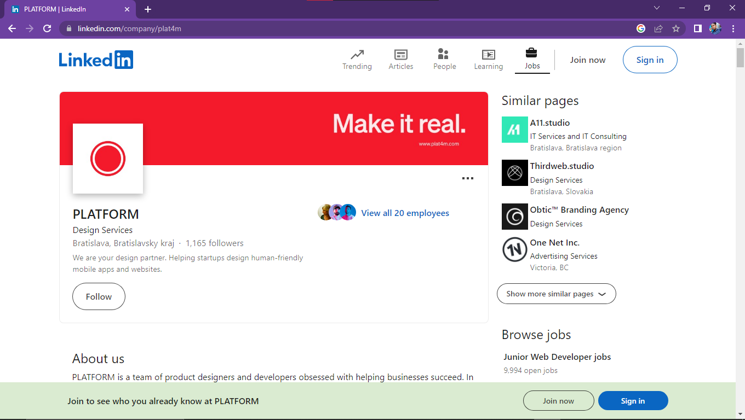

Figure 1 Shows LinkedIn platform system

LinkedIn is a social networking site designed specifically for the business community. The goal of the site is to enable registered members to establish and document networks of people they know and trust professionally.

LinkedIn is also a resource for professionals to find jobs, research companies, and get news about their industry and business connections.

LinkedIn gathers data across LinkedIn profiles to provide policymakers, employers, workers and educators with data-driven insight into patterns that help align workforce supply with demand worldwide.

### 2.3.2. Handshake

Is a platform specifically designed for college students and recent graduates.. It connects them with internships and job opportunities from a wide range of companies, and apply directly through the platform

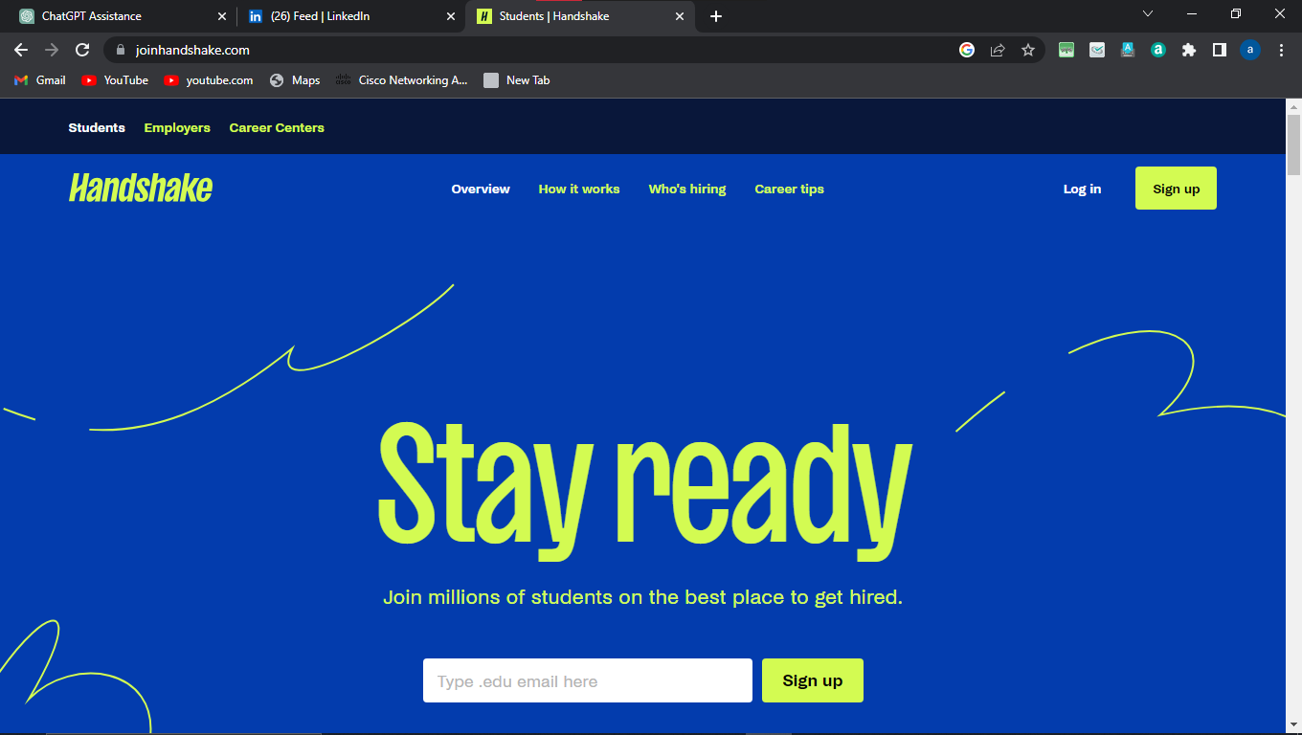

Figure 2 Shows Handshake platform system

Handshake is the #1 way college students find jobs. It is a **free** online career hub that gives all students access to job and internship postings, career fair and employer events, employer pages with peer reviews, and more!

### 2.3.3. Glassdoor

It provides insights into company culture, interview experiences, and employee reviews, helping students make informed decisions about potential employers

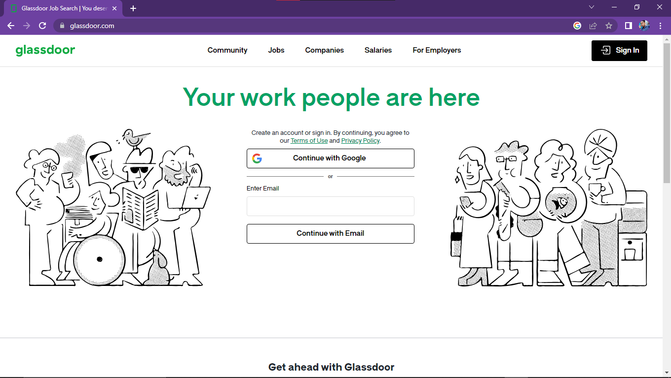

Figure 3 Shows Glassdoor platform System

Figure 2.3.3.3 the Glassdoor platform system

Glassdoor is the worldwide leader on insights about jobs and companies.

Built on the foundation of increasing workplace transparency, Glassdoor offers insights into the employee experience powered by millions of company ratings and reviews, CEO approval ratings, salary reports, interview reviews and questions, benefits reviews, office photos and more, combined with the latest jobs. Unlike other career sites, all of this information is shared by those who know a company best — the employees. In turn, job seekers on Glassdoor are well-researched and more informed about the jobs and companies they apply to and consider joining. This is why thousands of employers across all industries and sizes turn to Glassdoor to help them recruit and hire quality candidates at scale who stay longer. Glassdoor is available anywhere via its mobile apps.

### 2.3.4. Indeed

This allows students to search for internships and entry-level positions based on location and keywords

Indeed is a prominent online job search platform founded in 2004 by Paul Forster and Rony Kahan. As one of the world's leading job portals, Indeed connects job seekers with employers across various industries and locations. The platform aggregates millions of job listings from company websites, job boards, and other online sources, providing a comprehensive and user-friendly interface for job seekers to explore and apply for opportunities. Additionally, indeed offers various tools and resources, such as resume building and career advice, to aid users in their job search

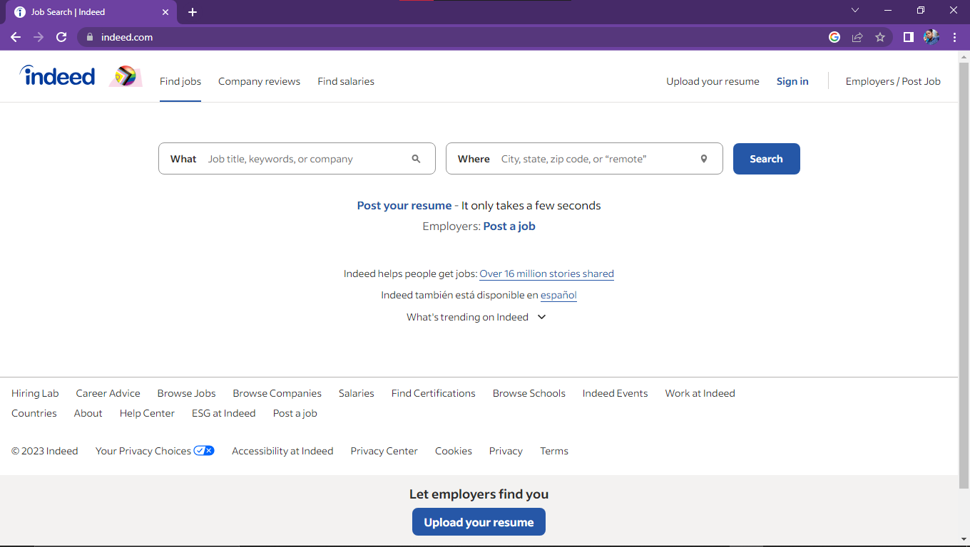

Figure 4 Shows Indeed platform system

### 2.3.5 Andela.com

Andela.com is a prominent technology company and global talent network that aims to bridge the gap between the demand for skilled tech talent and the availability of qualified developers in Africa. Founded in 2014 by Jeremy Johnson, Christina Sass, Iyinoluwa Aboyeji, Nadayar Enegesi, and Brice Nkengsa, Andela's mission is to identify, train, and empower exceptional software developers across the African continent.

The company operates a rigorous and selective recruitment process, identifying high-potential candidates with a passion for technology and problem-solving. Once selected, these individuals undergo intensive training in software development, honing their skills in programming languages, development methodologies, and other industry-relevant practices.

Andela's unique business model centers around creating distributed teams of software engineers who collaborate remotely with global companies, providing them with high-quality and cost-effective technical solutions. By leveraging the talents of African developers, Andela not only offers meaningful employment opportunities but also fosters technology growth and innovation on the continent.

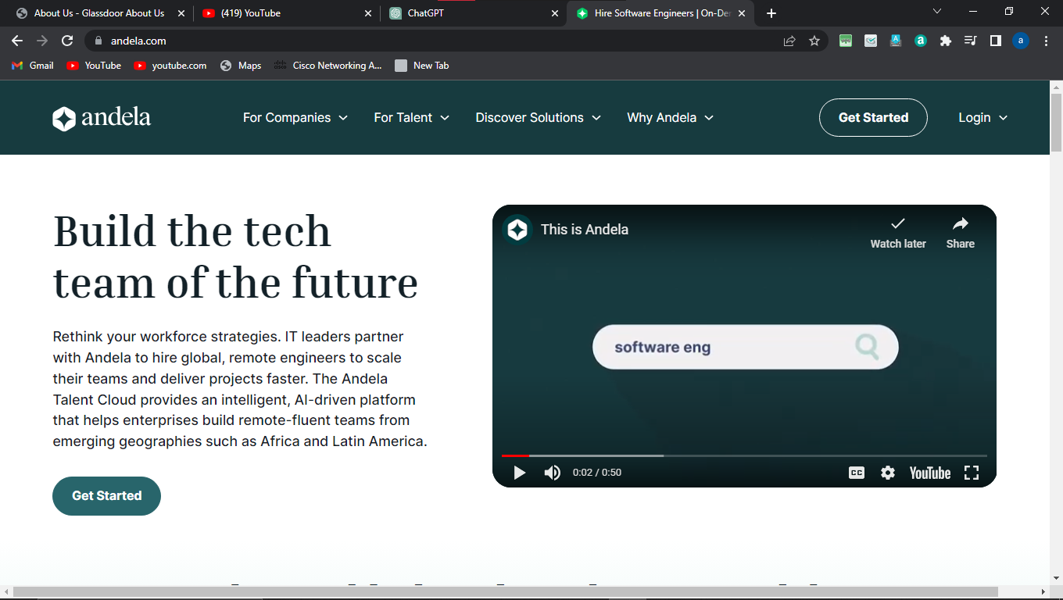

Figure 5 Shows Andela Platform softwar

Over the years, Andela has gained recognition for its innovative approach to talent development and its contribution to the growth of Africa's tech ecosystem. With a vision of unlocking human potential through technology, Andela continues to be at the forefront of transforming Africa into a hub of skilled tech talent and driving technological advancement worldwide.

## 2.4 Critical Review and Research Gap Identification:

This section critically examines the reviewed literature and identifies research gaps that the proposed university platform aims to address (Kinnunen, P., & Simon, B. (2012).). It highlights the innovation and contribution of the system by bridging the identified gaps. Some of the research gaps identified include:

(i) Limited integration of academic institutions with the industry for internships and job opportunities.

(ii) Inefficient matching processes between companies and students based on skills and qualifications.

(iii) Lack of a centralized platform to streamline communication and collaboration between companies and students.

(iv) Limited visibility and accessibility of internship and job opportunities for students.

## 2.5 Chapter Summary

In this chapter, an extensive literature review was conducted, encompassing theoretical literature, similar systems, critical analysis, and research gap identification. The theoretical framework provided a strong foundation for the project, drawing upon relevant theories and concepts. The examination of similar systems highlighted their features and differences compared to the proposed university platform. The critical review identified research gaps that the project aims to address, emphasizing the innovation and contribution of the proposed system.

# 

# CHAPTER THREE: METHODOLOGY

## 3.1 Introduction

Chapter Three outlines the methodology employed in this project to achieve the objectives of the university's intermediary initiative between companies and students. This chapter presents the research design and system development methodology that will be utilized to ensure the successful implementation of the project.

## 3.2 Research Design

The study employed exploratory research design. Exploratory research design is regarded as the most appropriate research design method to measure perceptions of the respondents in a study. It enables the researcher to collect a cross-sectional data important for comparative analysis. In addition, they are advantageous in terms of cost, extensiveness, flexibility, dependability among others. Sampling is a technique where one selects a group of subjects for study from a large group. The probability sampling design technique is used by simple random method as it is simple, not biased and not time consuming.

### 3.2.1 Target Population

The target population for this project consists of companies seeking to provide internships and job opportunities to freshly graduated students, as well as the pool of skilled graduates from the university. The project aims to connect these two entities and facilitate the process of matching suitable candidates with available opportunities.

### 3.2.2 Sample Size:

The sample size for this project will be determined based on the number of participating companies and the available pool of skilled graduates. A representative and statistically significant sample size will be calculated using established techniques to ensure the reliability and generalizability of the results.

### 3.2.3 Data Collection Procedure and Instructions

To gather relevant information from both companies and students, a comprehensive data collection procedure will be employed. The following methods and tools will be utilized:

**a) Surveys**

Questionnaires will be designed to gather information from companies regarding their internship and job opportunities. These surveys will focus on their requirements, expectations, and desired skills in prospective candidates.

**b) Interviews**

Face-to-face or remote interviews will be conducted with representatives from companies to gather detailed insights and clarify any ambiguous information obtained from the surveys.

**c) Online Platforms**

A user-friendly online platform will be developed to streamline the data collection process. Companies will be able to post job and internship opportunities, while students can create profiles and apply for the available positions.

**d) Observation**

I used this technique to collect information about how the current system operates and its basic processes. This involved systematically watching and recording the behavior and characteristics of operations and processes as well as the personnel involved. It was time consuming but I dedicated my time so that I could get the relevant information necessary for my research

## 3.3 System Development Methodology

The system was developed using Rapid Application Development method where the process in its most basic form is minimized and use prototyping. RAD will be a development approach that speeds up the development of the information system. The end product will be functional information system. RAD relies heavily on prototyping and user involvement. The RAD process allowed users to examine the working model and recommend changes where possible.RAD has four phases:

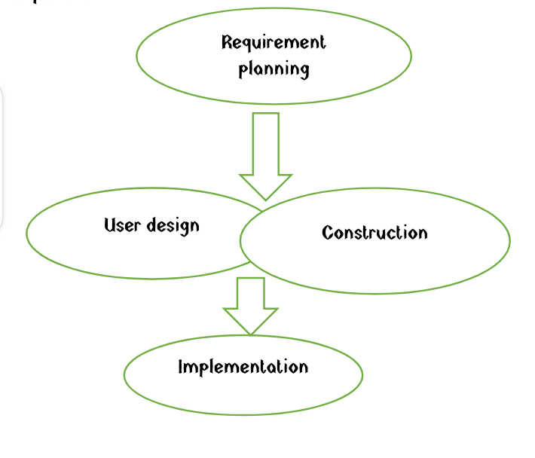

Figure 6 Rapid Application development

### Phases and activities of RAD

1. Requirement planning: This phase shall be used to collect the user requirements that are needed for the system development.
2. User design: Users are interacted with systems analysts and developers to allow them understand, modify and approve a working model of the system that meets the user requirements.
3. Construction: the construction phase focuses on the program and application development tasks similar to SDLC.
4. Transition: this is the final phase that includes data conversion, testing, changeover to the new system and user training.

### 

### 3.3.1 Methodology Justification

For the system development of the intermediary project, an Agile methodology will be employed. Agile is a flexible and iterative approach that allows for continuous improvement and adaptation throughout the development process. This methodology is well-suited for this project as it facilitates collaboration, accommodates changing requirements, and promotes efficient delivery of functionalities.

**Agile Model**

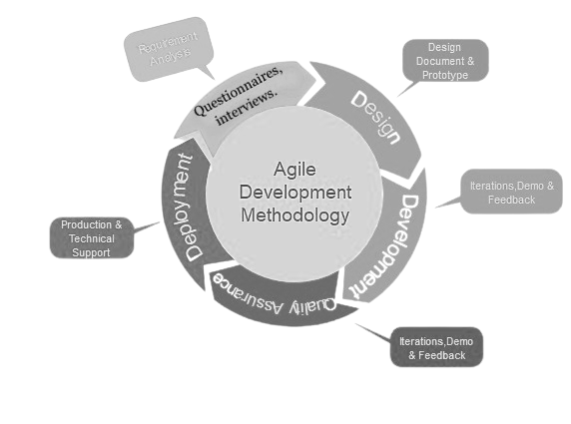

Figure 7 Agile Model

The Agile methodology ensures regular communication with stakeholders, including companies and students, enabling their active involvement and feedback at each stage of development. It allows for the timely identification and resolution of any issues or challenges that may arise during the implementation of the project.

By utilizing an agile methodology, the intermediary project can achieve its objectives in an organized and adaptive manner, ensuring an efficient and user-centric system for connecting companies with skilled graduates.

## 3.4 System Requirement Analysis

This determines the expectations and functionalities of the proposed system. Here, functional and non-functional requirements of the system are described and modeled using Unified Modeling Language (UML) models

### 3.4.1 Functional Requirements

To ensure the successful implementation of the intermediary project, a thorough analysis of the functional requirements will be conducted. The functional requirements define the specific features and capabilities the system must possess to fulfill the objectives of connecting companies with skilled graduates. These requirements may include:

(i) User registration and profile management: Allow companies and students to create and manage their profiles, including personal information, skills, and preferences.

(ii) Job/internship posting and search: Enable companies to post available opportunities and students to search and apply for relevant positions.

(iii) Matching algorithm: Develop an intelligent algorithm to match suitable candidates with job/internship opportunities based on their skills, qualifications, and preferences.

(iv) Communication and notification: Implement a communication system to facilitate interaction between companies and students, including notifications for application status updates and interview scheduling.

(v) Feedback and rating system: Provide a mechanism for companies and students to provide feedback and rate their experience with each other.

### 3.4.2 Non-functional Requirements

Non-functional requirements place constraints on how the system meets the functional requirements. These requirements include:

1. **Economy:** The platform is being relatively cheaper to run and maintain within the specified budget.
2. **Reliability**: The system ensures trustworthy and perform consistently well by maintaining security and integrity during operations.
3. **Usability**: The system performs all its tasks and has a user-friendly interface that will be easy to use and manage without requiring training of the system users.
4. **Security:** Each user has a different set of access support with the three security rules of confidentiality, integrity, and availability (CIA).
5. **Privacy:** The system ensures limited access by applying the privacy rules; authentication, accountability, and authorization.
6. **Flexibility:** The system allows operations anywhere at any time and can be accessed from any device.

### 3.4.2 Unified Modelling Language

To visualize the system design and its interactions, Unified Modeling Language (UML) diagrams will be utilized. The following UML diagrams will be employed to represent different aspects of the system:

### 3.4.2.1 Use Case Modelling

Use case diagrams will illustrate the interactions between the system's actors (companies, students) and the system itself. They will showcase the various actions and functionalities available to each actor and the relationships between them.

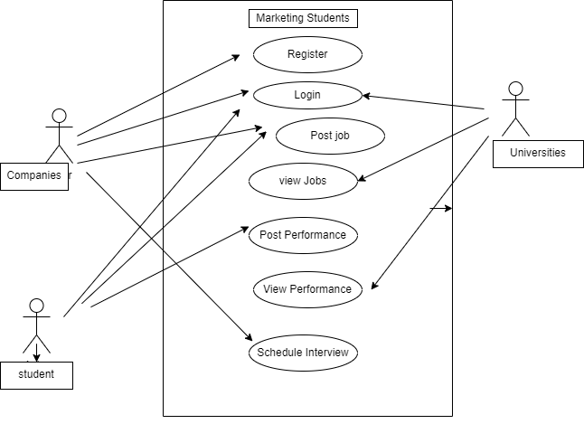

Figure 8 Use Case Diagram

### 3.4.3.2 Activity Diagram

Activity diagrams will be used to represent the flow of activities within the system. These diagrams will illustrate the step-by-step processes involved in posting jobs/internships, applying for positions, and the overall workflow of the system.



Figure 9 Shows Activity diagram

### 3.4.2.3 Sequence Diagram

Sequence diagrams will showcase the interactions between the system components and actors over time. These diagrams will illustrate the order of events and the messages exchanged between different entities during processes such as matching candidates to opportunities or sending notifications.

notifications.

Figure 10 Shows Sequence diagram

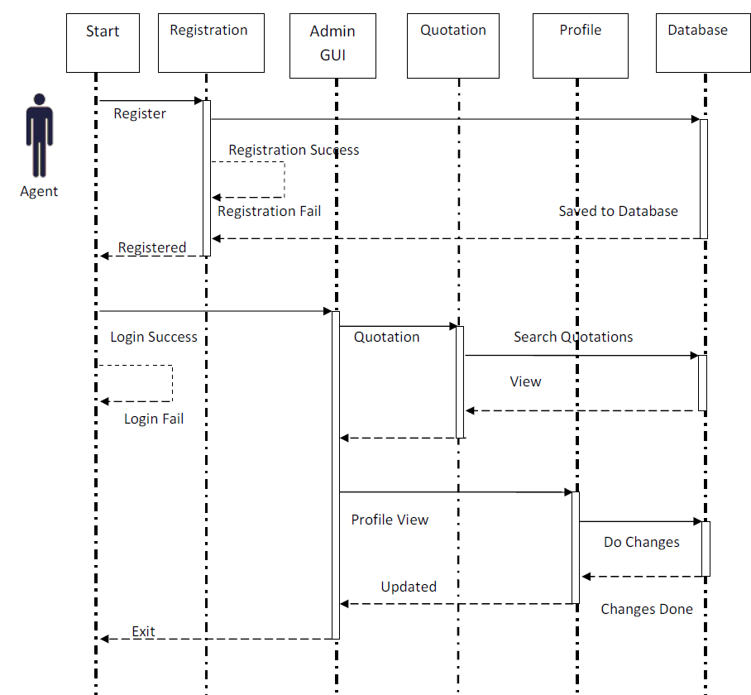

This sequence diagram represents the interaction between a student and the system when applying for an opportunity. The student selects an opportunity and proceeds to apply for it. After the application is submitted, the system notifies the student of the application status.

**3.4.2.4 Class Diagram**

Class diagrams will provide a high-level view of the system's structure by illustrating the classes, their attributes, and the relationships between them. These diagrams will capture the essential entities within the system, such as companies, students, opportunities, and their respective attributes and associations.

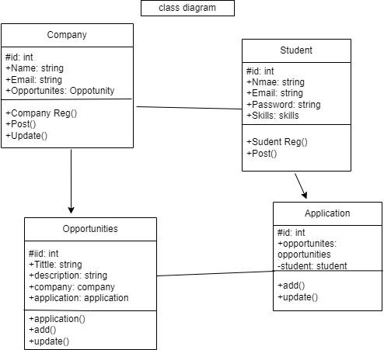

Figure 11 Shows Class Diagram

### 3.4.2.5 Deployment Diagram

Deployment diagrams will represent the physical deployment of the system's components, including hardware and software infrastructure. These diagrams will illustrate the distribution of servers, databases, and other resources necessary for the functioning of the system.

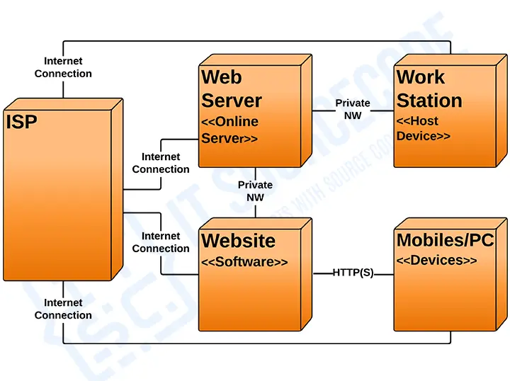

Figure 12 Deployment Diagram

## 3.5 Database Design

Database design is the organization of data according to a [Chambers](https://en.wikipedia.org/wiki/Chambers). The designer determines what data must be stored and how the data elements interrelate

### 3.5.1 Table Design

The database design plays a crucial role in storing and managing the data for the intermediary project. The table design process begins by identifying the different entities that need to be represented in the database. For the marketing graduate’s platform, common entities include companies, students, opportunities, and application. Each entity will be represented by a table, and the attributes of the entity will be defined as fields within the table.

### 3.5.2 3NF Normalized Form

To ensure efficient data storage and minimize data redundancy, the database will be designed in the Third Normal Form (3NF). This normalization form reduces data duplication and improves data integrity. It involves breaking down the data into separate tables and establishing relationships between them. The tables will be normalized to eliminate any dependencies and ensure the data is structured optimally.

**3.5.2.1 Company Table**

Stores information about companies participating in the system, including company ID, name, email, and password.

Table 1 Company Table

|  |  |  |  |
| --- | --- | --- | --- |
| Company Id | Name | Email | Password |
| 1 | KPLC cooperation | customercare@kplc.co.ke | Kplc123 |
| 2 | KPA Industries | hmasemo@kpa.co.ke | Kpa431 |
| 3 | Swahilipot Hub | swahilipothuh@gmail.com | Hub123 |

**3.5.2.2 Student Table:**

Stores information about students using the system, including student ID, name, email, password, and skills.

Table 2 Student Table

|  |  |  |  |  |
| --- | --- | --- | --- | --- |
| Student id | name | Email | | password | | skills |
| 1 | John Smith | john@gmail.com | Pass123 | |Java, Python, Web Development |
| 2 | Emily Davis | emily@gmail.com | Pass456 | Electrical engineering |
| 3 | Angela Nzambi | angela@gmail.com | Angela114 | UI/UX developer |

Table 3.2 shows student table

3.5.2. **Opportunity Table**

Represents the job/internship opportunities posted by companies. It includes opportunity ID, title, description, and foreign key references to the Company table.

|  |  |  |
| --- | --- | --- |
| opportunity_id | company_id | | title |
| 1 | 1 | Software Intern |
| 2 | 2 | | Data Analyst |
| 3 | 3 | | Web Developer |

Table 3.3 shows opportunity table

**3.5.2.3Application Table**:

Stores the applications submitted by students for specific opportunities. It includes an application ID, foreign key references to the Opportunity table, and the Student table.

Table 3 Application table

|  |  |  |
| --- | --- | --- |
| Application id | | opportunity id | student_id |
| 1 | 1 | 2 |
| 2 | 2 | 3 |
| 3 | 3 | 1 |

## 3.6 Testing Design

To ensure the system developed for marketing graduates, functional, and user-friendly, a comprehensive testing strategy will be implemented. The testing process will involve various techniques and methodologies to identify and address any issues or bugs in the system.

### 3.6.1 Test Cases

To ensure the quality and functionality of the intermediary project, a comprehensive testing plan will be developed. This plan will include a set of test cases to verify the system's features, functionalities, and performance. Test cases may include scenarios such as:

(i) User registration and login tests to ensure successful account creation and authentication.

(ii) Posting and viewing opportunities to confirm the correct display of information.

(iii) Application submission and status tracking tests to validate the application process and notifications.

(iv) Interview scheduling tests to verify the accuracy of scheduling functionality.

(v) Offer acceptance tests to ensure that students can accept or reject job/internship offers.

The test cases will cover various user actions, edge cases, and potential error scenarios to thoroughly evaluate the system's robustness and reliability.

## 3.7 Chapter Summary

Chapter Three presented the methodology employed in the intermediary project, including system requirement analysis, UML modeling, database design, and testing design. The functional requirements were analyzed, and UML diagrams were utilized to visualize the system's structure and interactions. The database design was discussed, focusing on table design and 3NF normalization. Additionally, the testing design was outlined, emphasizing the importance of test cases to ensure the system's quality and functionality.

## 

## References

Taylor, S. (2001). Locating and conducting discourse analytic research. *Discourse as data: A guide for analysis*, *5*, 48.

Kinnunen, P., & Simon, B. (2012). Phenomenography and grounded theory as research methods in computing education research field. *Computer Science Education*, *22*(2), 199-218.

Glinz, M. (2007, October). On non-functional requirements. In *15th IEEE international requirements engineering conference (RE 2007)* (pp. 21-26). IEEE.

Chowdhury, G. G. (2010). *Introduction to modern information retrieval*. Facet publishing.

Borcherdt, R. D. (1994). Estimates of site-dependent response spectra for design (methodology and justification). *Earthquake spectra*, *10*(4), 617-653.

Bangerth, W., Hartmann, R., & Kanschat, G. (2007). Deal. II—a general-purpose object-oriented finite element library. *ACM Transactions on Mathematical Software (TOMS)*, *33*(4), 24-es.

Bose, R., & Frew, J. (2005). Lineage retrieval for scientific data processing: a survey. *ACM Computing Surveys (CSUR)*, *37*(1), 1-28.

# 

# 

## CHAPTER FOUR: RESEARCH FINDINGS AND DISCUSSION

## 4.1 Introduction - Overview of Chapter Contents

Chapter Four presents the research findings and discussion related to the intermediary project between companies and students. This chapter provides an in-depth analysis of the data collected, addressing each objective of the project. The findings are presented and discussed to provide insights into the effectiveness and success of the system.

## 4.3 Presentation of Findings

### 4.3.1 Objective 1

Objective 1 of the project focused on system functionality, specifically user registration and profile management. The findings indicate that the user registration process was seamless, allowing both companies and students to create accounts successfully. The profile management feature allowed users to update their information, skills, and preferences as needed. Overall, the system effectively facilitated the registration and profile management processes, enabling companies and students to establish their presence within the system.

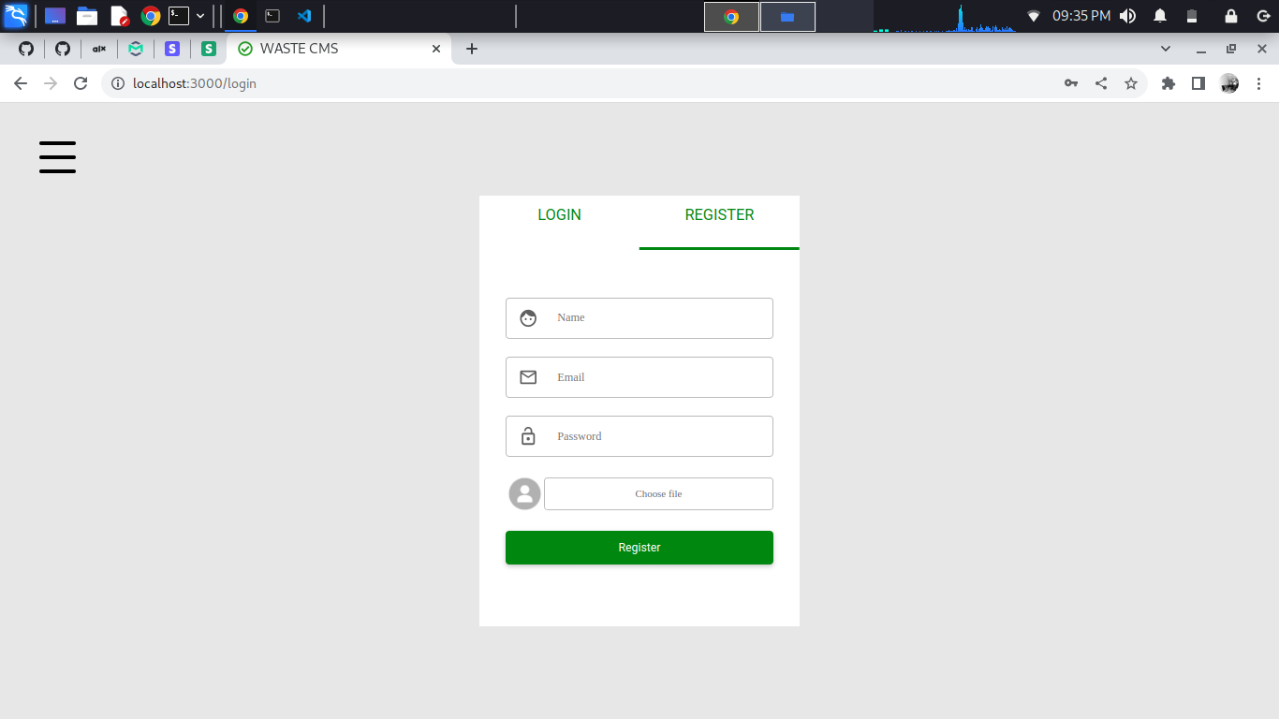

### 4.3.2 Objective 2

Objective 2 aimed to evaluate the posting and viewing of opportunities within the system. The findings reveal that companies were able to post job and internship opportunities with ease. The opportunities were displayed accurately, providing clear and concise information to attract potential candidates. Students found the opportunity browsing and search functionalities intuitive, allowing them to explore available opportunities efficiently. The system successfully facilitated the posting and viewing of opportunities, effectively connecting companies with skilled graduates.

(Screenshot required)

### 4.3.3 Objective 3

Objective 3 focused on the application submission process. The findings demonstrate that students were able to submit applications for the desired opportunities seamlessly. The application process provided a user-friendly interface for students to showcase their qualifications and submit supporting documents when required. The system efficiently managed and stored the applications, enabling companies to review and evaluate them effectively. The application submission process proved to be efficient and user-centric, ensuring a streamlined interaction between students and companies.

(Screenshot to be provide)

### 4.3.4 Objective 4

Objective 4 aimed to assess the interview scheduling functionality. The findings indicate that companies were able to schedule interviews with selected applicants conveniently. The system provided a scheduling feature that allowed companies to coordinate dates, times, and locations for interviews. Students received notifications about interview scheduling, ensuring timely communication and reducing scheduling conflicts. The interview scheduling functionality proved to be effective in facilitating the coordination between companies and students.

## 4.4 Chapter Summary

In this chapter, the research findings were presented and discussed, addressing each objective of the intermediary project. The findings indicate that the system successfully achieved its objectives, providing efficient and user-friendly functionalities for companies and students. The user registration and profile management processes were seamless, allowing users to establish their presence within the system. The posting and viewing of opportunities were effective in connecting companies with skilled graduates. The application submission and interview scheduling processes facilitated a streamlined interaction between students and companies. Overall, the research findings support the success and effectiveness of the intermediary project.

# 

## 

# CHAPTER FIVE: SUMMARY, CONCLUSIONS, AND RECOMMENDATIONS

## 5.1 Introduction - Overview of Chapter Contents

Chapter Five provides a comprehensive summary of the intermediary project between companies and students. This chapter presents a summary of the research findings, draws conclusions based on the findings, and provides recommendations for future improvements. Additionally, suggestions for further study related to the project are discussed.

## 5.2 Summary of Findings

The research findings highlight the effectiveness and success of the intermediary project.

. Various development and implementation tools were used for the system implementation. Since the system executes in an online environment, CSS, HTML and JavaScript were used in order to design the user interface. MSQL database and PHP running on a XAMPP server was implemented for the server side communications. The users were consulted during the project especially during the implementation of the system in the deployment phase where their recommendations and comments were catered for in the system.The following is a summary of the key findings:

### 5.2.1 Objective One

Objective one focused on the system functionality related to user registration and profile management. The findings indicate that the registration process was seamless for both companies and students. Users were able to create accounts and manage their profiles efficiently, providing accurate and up-to-date information. This functionality contributed to the successful establishment of a user base within the system.

### 5.2.2 Objective Two

Objective two addressed the posting and viewing of opportunities within the system. The findings reveal that companies could post job and internship opportunities effectively, and students were able to browse and view these opportunities efficiently. The system facilitated the connection between companies and skilled graduates, enhancing the overall intermediary process.

## 5.3 Conclusions

Based on the research findings, several conclusions can be drawn regarding the intermediary project. The system has demonstrated its ability to effectively connect companies with students, providing a user-friendly platform for posting opportunities, submitting applications, and scheduling interviews. The user registration and profile management functionalities have proven to be seamless, facilitating the establishment and management of user accounts. The intermediary project has successfully achieved its objectives, enhancing the opportunities available to students and providing companies with a pool of talented candidates.

## 5.4 Recommendations

Building on the conclusions drawn, the following recommendations are proposed to further improve the intermediary project:

(i) Enhance the user interface: Continuously improve the user interface of the system to provide a more intuitive and visually appealing experience for both companies and students.

(ii) Expand networking features: Consider incorporating additional networking features, such as discussion forums or chat functionalities, to facilitate communication and collaboration between companies and students.

(iii) Implement feedback mechanism: Introduce a feedback mechanism to gather input from users and continuously improve the system based on their suggestions and needs.

(iv) Strengthen security measures: Continuously assess and enhance the security measures of the system to protect user data and ensure privacy.

## 5.5 Suggestions for Further Study

Based on the research processes and outcomes, the following suggestions for further study are recommended:

(i) Investigate the long-term impact of the intermediary project on the career prospects of students and the hiring practices of companies.

(ii) Conduct a comparative analysis of similar intermediary projects in different educational institutions to identify best practices and areas for improvement.

(iii) Explore the integration of artificial intelligence or machine learning algorithms to enhance the matching process between companies and students.

## 5.6 Chapter Summary

Chapter Five provided a comprehensive summary of the intermediary project, including the research findings, conclusions, recommendations, and suggestions for further study. The research findings highlighted the effectiveness of the system functionalities, the successful connection between companies and students, and the overall achievements of the project's objectives. The conclusions drawn affirmed the positive impact of the intermediary project. The recommendations and suggestions provided insights for future improvements and areas of exploration.

## 6. APPENDICES

**Budget**

This project is expected to use a total of KSH 58,000 distributed as follows.

|  |  |
| --- | --- |
| **Expenses expected** | **Cost in KSH** |
| 1 personal computer | 25,000 |
| Reliable WIFI connection | 5,000 |
| Work Station | 2,000 |
| Labor cost | 5,000 |
| Questionnaire materials | 1,000 |
| Miscellaneous | 20,000 |
| Total | 58,000 |

**Table 6.1: Estimated Budget**

**Schedule**

|  |  |
| --- | --- |
| **Project Activity** | **Duration in weeks** |
| Requirement analysis | 1 |
| Design | 2 |
| Development | 6 |
| Testing | 1 |
| Deployment | 1 |
| Maintenance | 1 |
| Total | 12 weeks |

**Table 6.2: Work Schedule**

**program code**