**Event Used**

1. **Page Load Event**

* DOMContentLoaded – Shows the Introduction Modal when the game starts.

1. **Mouse Click Events (** click **)**

* Game Choices (#rock, #paper, #scissor) – Picks the player’s move.
* Reset Button (#reset) – Resets the scores and restarts the game.
* Instructions Button (#instructionsBtn) – Opens Instructions modal.
* Close Instructions (#closeModal) – Closes Instructions modal.
* Close Introduction (#closeIntro) – Closes Introduction modal.
* Theme Button (#themeBtn) – Switches between arcade skins.
* Music Button (#toggle-music) – Plays/pauses background music.

1. **Change Event (** change **)**

* Game Level Selector (#game_level) – Adjusts “First to N” winning condition.

1. **API Events (** Promise handling **)**

* .then() – Handles successful API response (Advice Tip).
* .catch() – Handles errors when fetching advice.

**Event Codes**

* **Game Level Selector (** change **)**

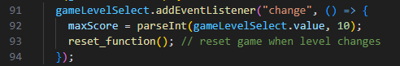

* **Reset Button (** click **)**
* **Game Choices (** Rock, Paper, Scissors –click **)**
* 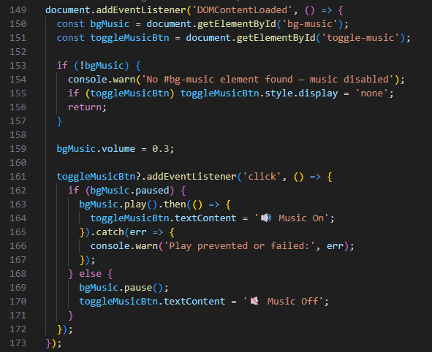**Background Music Toggle (** DOMContentLoaded +click **)**
* 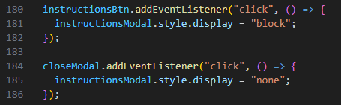**Instructions Modal (** click events **)**
* **Instructions Modal – Close by Clicking Outside (** click on window **)**

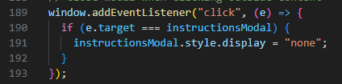

* **Intro Modal (** load + click **)**

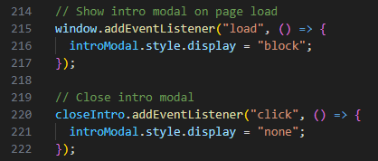

* **Arcade Tip Modal – Close (** click **)**

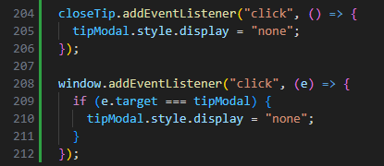

* **Theme Switcher (** click **)**

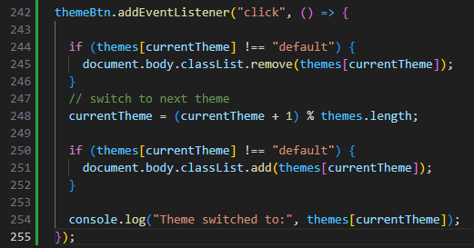

**APIs Used**

**Advice Slip JSON API**

* **Endpoint:** https://api.adviceslip.com/advice
* **Purpose:** Provides a random piece of advice. Used to display **Arcade Tips** when the game ends.
* **Format:** JSON response containing an **id** and **advice** string.
* **Why Used:** Adds uniqueness to the game by giving players motivational/funny tips after finishing a round.

**API Codes**

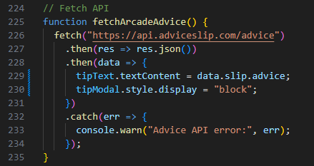**Advice API Fetch**

**Explanation:**

* fetch() calls the Advice API.
* .then(response => response.json()) parses the JSON result.
* .then(data => {...}) inserts the advice into the game’s Advice Tip modal.
* .catch(error => {...}) logs errors if the API request fails.