Name: Adding a new product into the system
Steps:

ACTOR | SYSTEM
1. Choose command “Add Product”  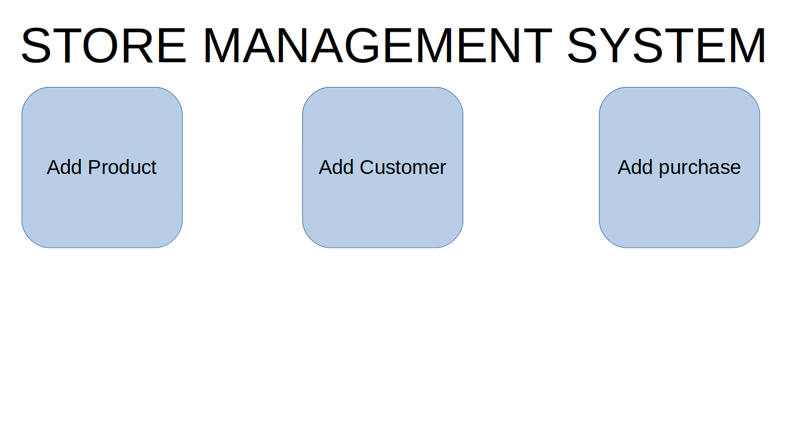  Main Screen: | 2. Display “Add Product” screen  “Add Product” screen:  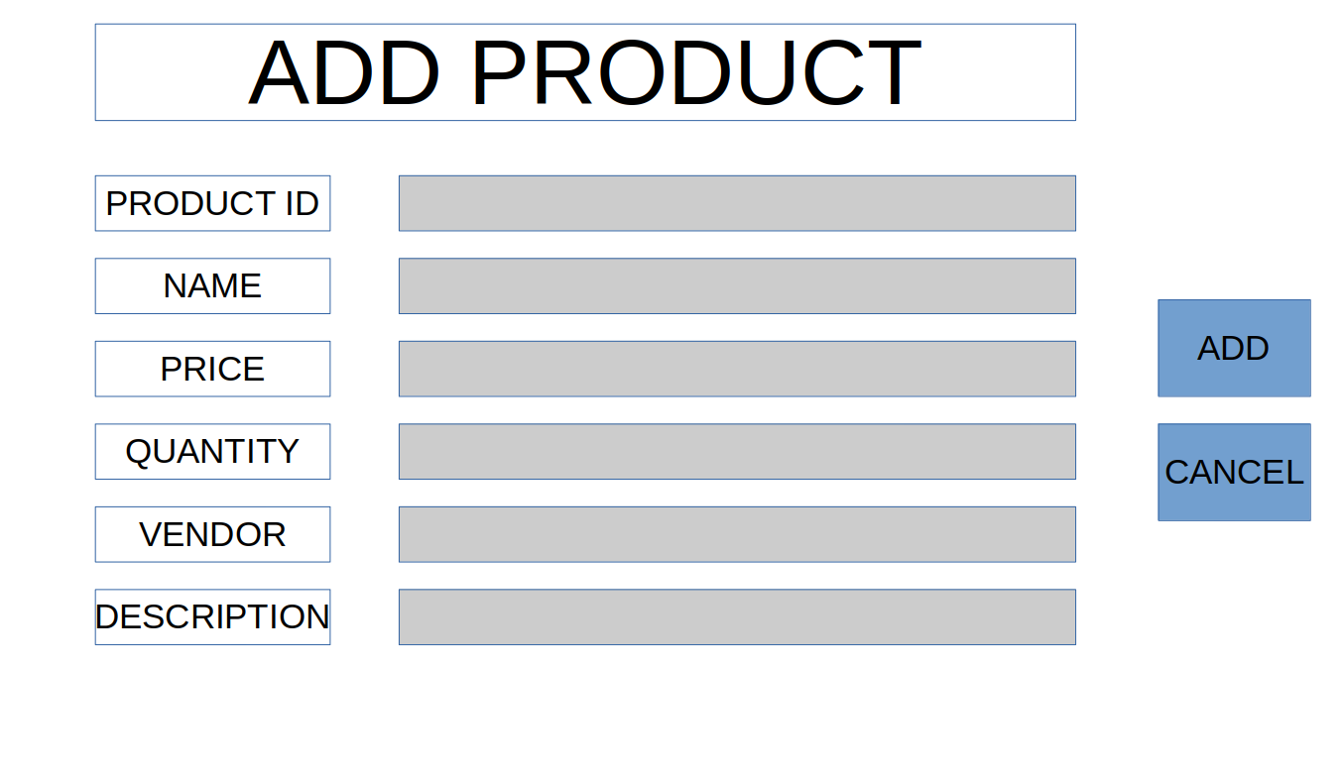
3. Input data, and click “Add” button  “Add Product” screen with data:  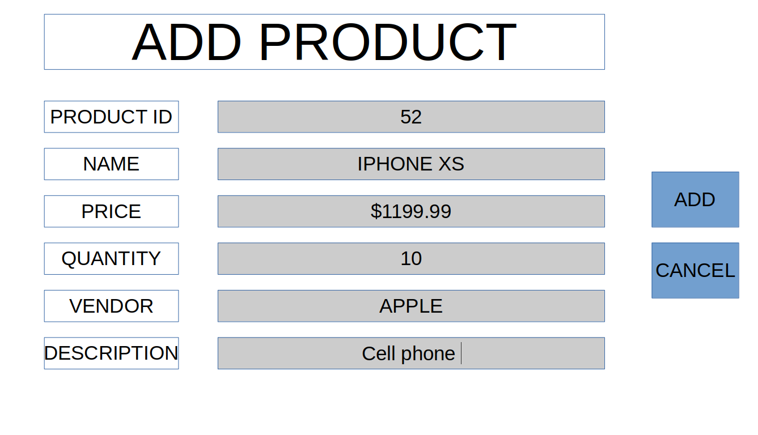 | 4. Hide “Add product” screen and display “Add Product Successfully” screen”  “Add Product Successfully” screen:  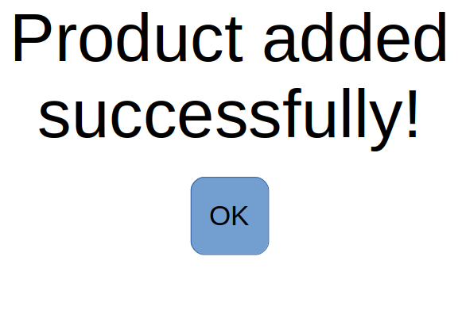
5. Click on “OK” button: | Display “Main” screen:  Main Screen:

Name: Adding a new customer into the system
Steps:

ACTOR | SYSTEM
1. Choose command “Add Customer”  Main Screen: | 2. Display “Add Customer” screen  “Add Customer” screen:  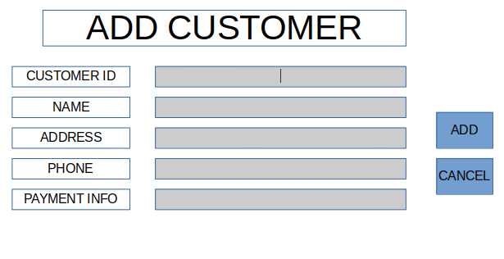
3. Input data, and click “Add” button  “Add Customer” screen with data:  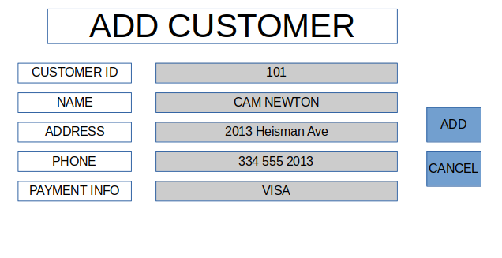 | 4. Hide “Add Customer” screen and display “Add Customer Successfully” screen”  “Add Customer Successfully” screen:  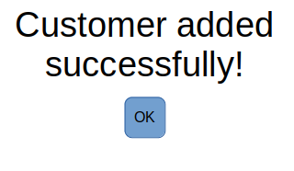
5. Click on “OK” button: | Display “Main” screen:  Main Screen:

Name: Adding a new purchase into the system
Steps:

ACTOR | SYSTEM
1. Choose command “Add Purchase”  Main Screen: | 2. Display “Add Purchase” screen  “Add Purchase” screen:  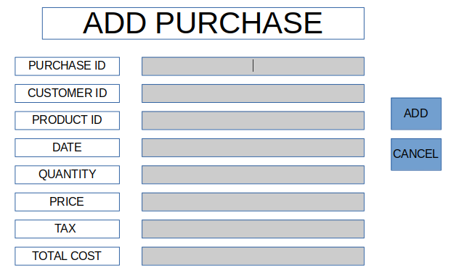
3. Input data, and click “Add” button  “Add Purchase” screen with data:  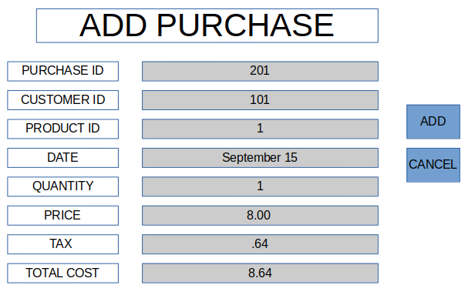 | 4. Hide “Add purchase” screen and display “Add Purchase Successfully” screen”  “Add Purchase Successfully” screen:  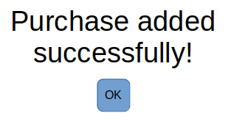
5. Click on “OK” button: | Display “Main” screen:  Main Screen:

Name: Adding a new product into the system, exception
Steps:

ACTOR  Product Duplicate Error  OK | SYSTEM
1. Choose command “Add Product”  Main Screen: | 2. Display “Add Product” screen  “Add Product” screen:
3. Input data, and click “Add” button  “Add Product” screen with data: | 4. Hide “Add product” screen and display “Product Duplicate Error” screen”  “Product Duplicate Error” screen:
5. Click on “OK” button: | Display “Main” screen:  Main Screen:

Name: Adding a new customer into the system, exception
Steps:

ACTOR | SYSTEM
1. Choose command “Add Customer”  Main Screen: | 2. Display “Add Customer” screen  “Add Customer” screen:
3. Input data, and click “Add” button  “Add Customer” screen with data: | 4. Hide “Add Customer” screen and display Customer Duplicate Error” screen  “Customer Duplicate Error” screen:  Customer Duplicate Error  OK
5. Click on “OK” button: | Display “Main” screen:  Main Screen:

Name: Adding a new purchase into the system, exception
Steps:

ACTOR | SYSTEM
1. Choose command “Add Purchase”  Main Screen: | 2. Display “Add Purchase” screen  “Add Purchase” screen:
3. Input data, and click “Add” button  “Add Purchase” screen with data: | 4. Hide “Add purchase” screen and display “Purchase Duplicate Error” screen”  “Purchase Duplicate Error” screen:  Purchase Duplicate Error  OK
5. Click on “OK” button: | Display “Main” screen:  Main Screen:

Name: Updating a product into the system
Steps:

ACTOR | SYSTEM
1. Choose command “Update Product”  Main Screen: | 2. Display “Add Product” screen  “Add Product” screen:
3. Input data, and click “Add” button  “Add Product” screen with data: | 4. Hide “Add product” screen and display “Add Product Successfully” screen”  “Add Product Successfully” screen:
5. Click on “OK” button: | Display “Main” screen:  Main Screen:

Name: Updating a customer into the system
Steps:

ACTOR | SYSTEM
1. Choose command “Update Customer”  Main Screen: | 2. Display “Add Customer” screen  “Add Customer” screen:
3. Input data, and click “Add” button  “Add Customer” screen with data: | 4. Hide “Add Customer” screen and display “Add Customer Successfully” screen”  “Add Customer Successfully” screen:
5. Click on “OK” button: | Display “Main” screen:  Main Screen:

Name: Updating purchase into the system
Steps:

ACTOR | SYSTEM
1. Choose command “Update Purchase”  Main Screen: | 2. Display “Add Purchase” screen  “Add Purchase” screen:
3. Input data, and click “Add” button  “Add Purchase” screen with data: | 4. Hide “Add purchase” screen and display “Add Purchase Successfully” screen”  “Add Purchase Successfully” screen:
5. Click on “OK” button: | Display “Main” screen:  Main Screen:

Name: Updating a product into the system, exception
Steps:

ACTOR  Product Duplicate Error  OK | SYSTEM
1. Choose command “Update Product”  Main Screen: | 2. Display “Add Product” screen  “Add Product” screen:
3. Input data, and click “Add” button  “Add Product” screen with data: | 4. Hide “Add product” screen and display “Product Duplicate Error” screen”  “Product Duplicate Error” screen:
5. Click on “OK” button: | Display “Main” screen:  Main Screen:

Name: Updating a customer into the system, exception
Steps:

ACTOR | SYSTEM
1. Choose command “Update Customer”  Main Screen: | 2. Display “Add Customer” screen  “Add Customer” screen:
3. Input data, and click “Add” button  “Add Customer” screen with data: | 4. Hide “Add Customer” screen and display Customer Duplicate Error” screen  “Customer Duplicate Error” screen:  Customer Duplicate Error  OK
5. Click on “OK” button: | Display “Main” screen:  Main Screen:

Name: Updating a purchase into the system, exception
Steps:

ACTOR | SYSTEM
1. Choose command “Update Purchase”  Main Screen: | 2. Display “Add Purchase” screen  “Add Purchase” screen:
3. Input data, and click “Add” button  “Add Purchase” screen with data: | 4. Hide “Add purchase” screen and display “Purchase Duplicate Error” screen”  “Purchase Duplicate Error” screen:  Purchase Duplicate Error  OK
5. Click on “OK” button: | Display “Main” screen:  Main Screen:

