SOC Design

Lab4-1 Execute Code in User Memory

112061611陳伯丞, 112061524葉又菘, 110063553 張傑閔

* 1. How does it execute a multiplication in assembly code?

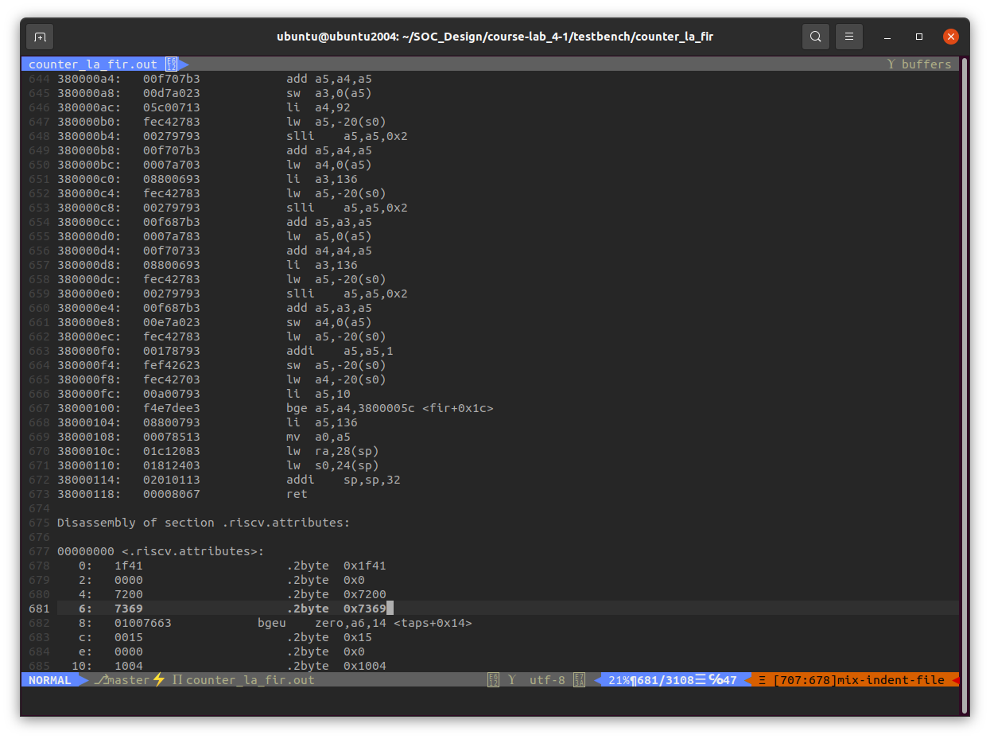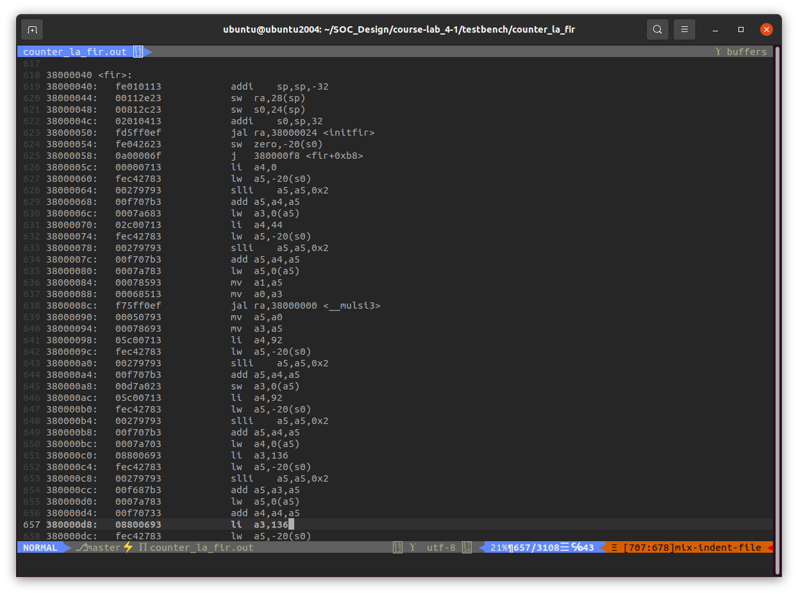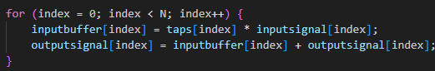

* 1. According to the screenshot in part1.1, user project is allocated in . And the space requirement of firmware code is 7188 Bytes.

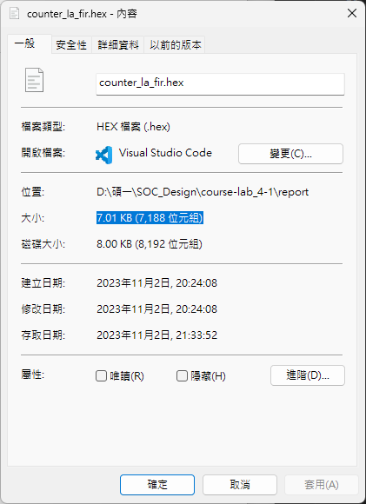

1. Waveform from XSIM

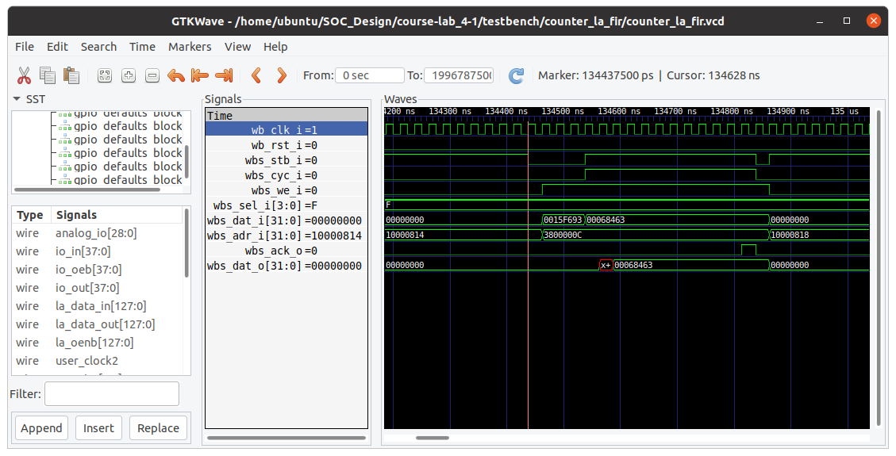

Delay between and is 10 clock cycle.

1. Synthesis report

