**SOC Design Laboratory**

**Lab5** **- Caravel SoC FPGA Integration**

Group 6: 112061611 陳伯丞

112061524 葉又菘

110063553 張傑閔

1. **Block Diagram**
2. **FPGA utilization**

Counter utilization:

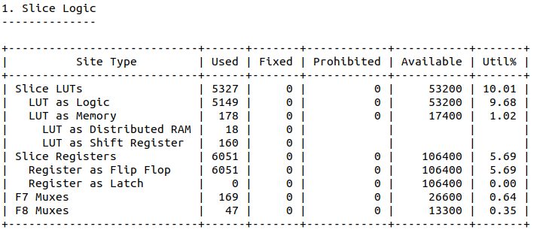

GCD utilization:

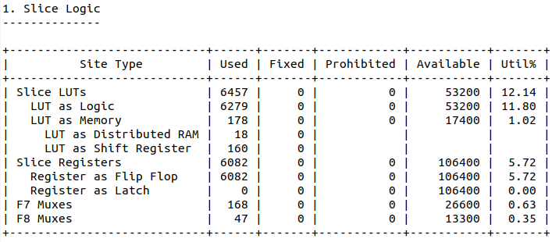

1. **IP Functions**
2. **FPGA Running result**

In the first run, select file $“counter_wb.hex”$.

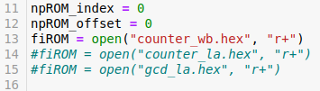

And the result is the following, the value at address 0x1c is 0xab61.

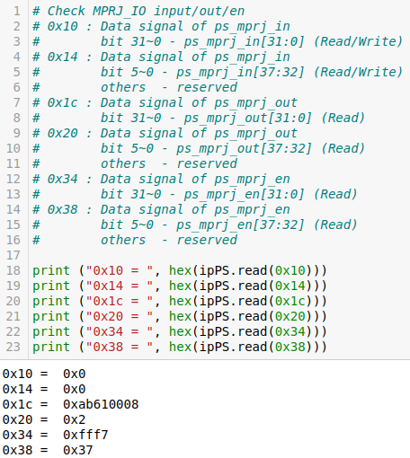

In the second run, we select the file $“counter_la.hex”$.

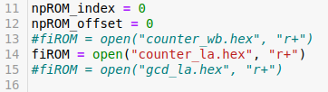

The value at address 0x1c is 0xab51.

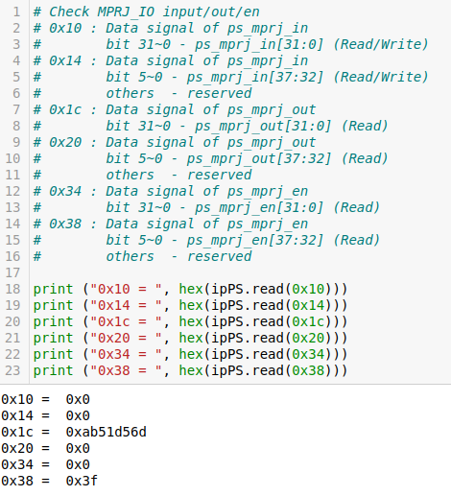

Last, select the file $“gcd_la.hex”$.

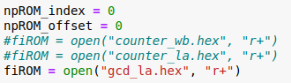

The value at address 0x1c is 0xab51.

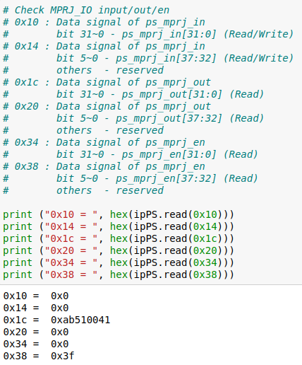

1. **caravel_fpga.ipynb**