SOC lab3

112061611 陳伯丞

1. Block Diagram

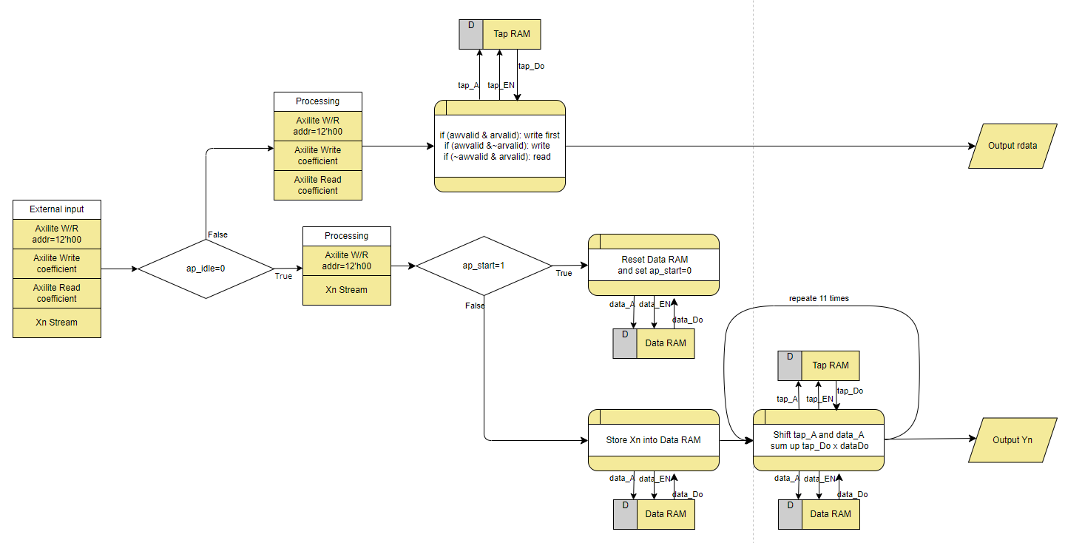

1. Describe operation

* : can only be write before turn on.

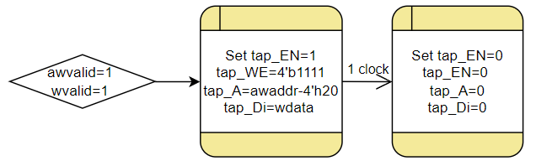

* : can only be write after turn on. And there is a FIFO to store the address of .

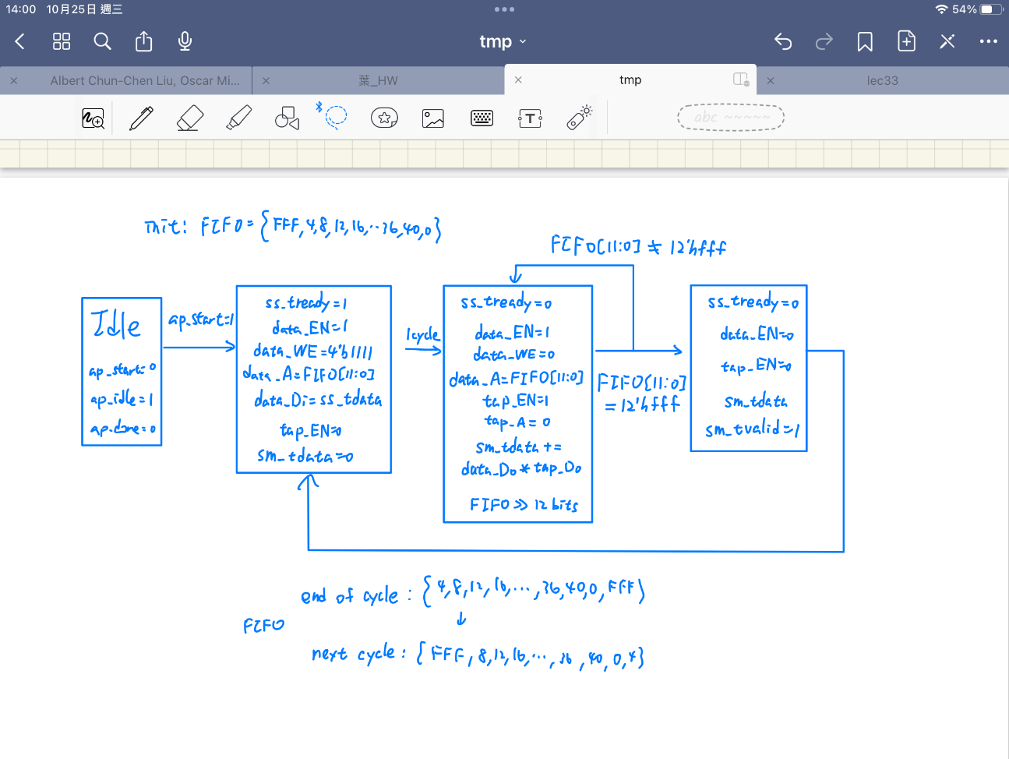

* is generated when

1. Resource usage: including FF, LUT, BRAM

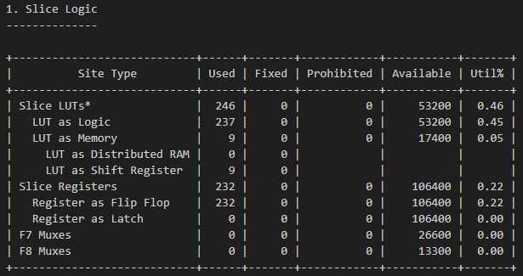

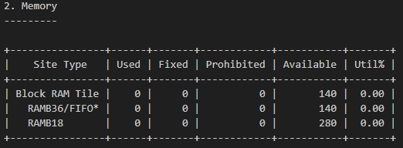

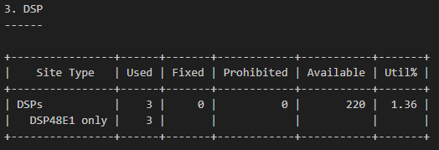

1. Timing Report

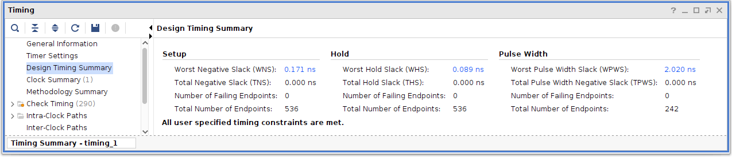

Fig. Design Timing Summary as clock cycle time 6ns

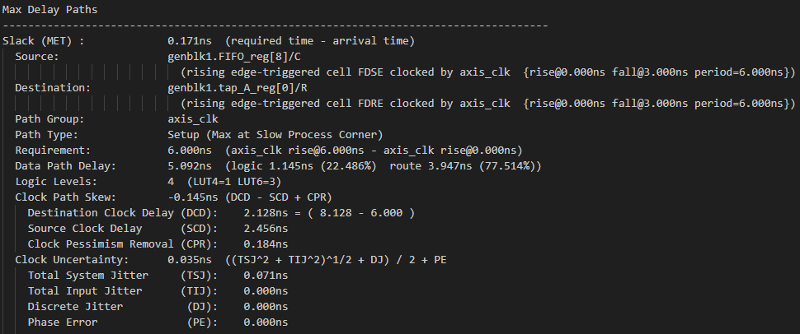

Fig. Max Delay Paths

1. Simulation Waveform, show

* Coefficient program, and read back
* Data-in stream-in
* Data-out stream-out
* RAM access control
* FSM