Topic: Library Management System

Goal:

1. basic inquiry system
2. deal with the error when the books have been returned to the library, but haven’t been put back to the bookshelves.

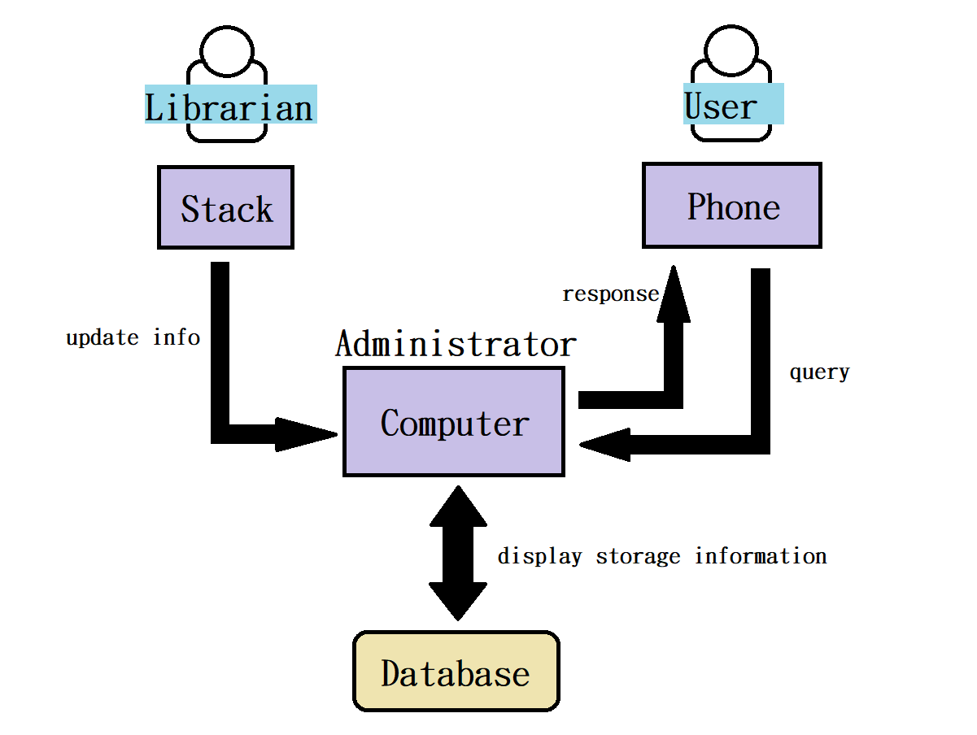

User can register account, login, query and check the status of books, if they are (1)borrowed (2)return but not yet on bookshelves (3)borrowable from computer.

Librarian can type in the code of the book into stack, and upload it to the computer to change the status of the book.

Administrator can use various functions of the library management system interface to display information such as book status and inventory.

JSON format:

{

"id": 0123456789,

"user_id": 00001111,

"book_id": 00000101,

"book_name": "java program",

"borrowed_time": "yyyy-mm-dd",

"return_time": "yyyy-mm-dd",

"available": [true, false],

"position": "A-1-2"

}

Done:

1. Complete the assignment of team members.

Problem:

1. We have changed the topic from a shooting game to this one, but we can’t retake the video due to pandemic.