Topic: Library Management System

Goal:

1. basic inquiry system
2. librarian can scan the code of book and get the information such as where to return the book or whether the it is booked from desktop.
3. computer can be used as a central processing system to connect iot and web.

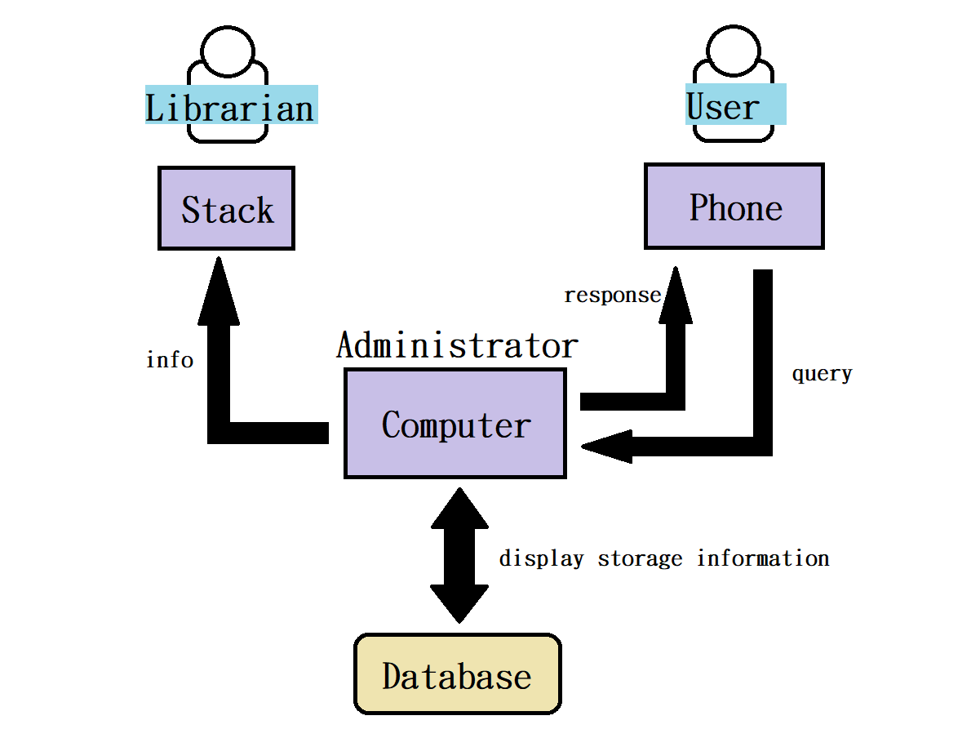

User can register account, login, query and check the status of books, if they are (1)borrowed (2)return but not yet on bookshelves (3)borrowable from computer.

Librarian can receive the message from administrator by stack, and return the book to the right bookshelf or “already booked shelf”.

Administrator can send message to stack, and use various functions of the library management system interface to display information such as book status and inventory.

JSON format:

{

"id": 012345678,

"user_id": 012345678,

"book_id": 012345678,

"book_name": "java program",

"borrowed_time": "yyyy-mm-dd",

"return_time": "yyyy-mm-dd",

"booked": [true, false],

"position": "A-1-2"}

Done:

1. Complete the assignment of each team members.

Problem:

1. We have changed the topic from a shooting game to this one, but we can’t retake the video due to pandemic. (solve, no need to retake)
2. Stack can only receive message. (solve, change or goal from send message to desktop to get book information from desktop)