SOFTWARE REQUIREMENTS SPECIFICATION

For

ATTENDLY: Student Event Attendance and Sanctions System

Prepared by:

THE CODEX GUILD

KIRT DELA TORRE
NICOLE JANSOL

Submitted in fulfillment requirements for Integrative Programming and Technologies 2 (IT305)

September 07, 2026
Table of Contents
Table of Contents
1. Introduction
1.1 Purpose
1.2 Intended Audience
1.3 Product Scope
1.4 Definitions, Acronyms, and Abbreviations
1.5 Document Conventions
1.6 REFERENCES
2. Project Proposal and Team Formation
2.1 Approved Project Concept
2.2 Team Formation
2.3 Problem Statement
2.4 Project Objectives
2.5 Target Users
2.6 Core Features
2.7 Scope Boundaries
2.8 Comparison with Similar or Existing Systems
2.9 Proposal Approval and Supporting Documents
3. Overall Description
3.1 Product Perspective
3.2 User Classes and Characteristics
3.3 Operating Environment
3.4 Design and Implementation Constraints
3.5 Assumptions and Dependencies
4. Requirements Analysis
4.1 Functional Requirements
4.2 Non-Functional Requirements
4.3 Requirements Priorization and Traceability
4.4 Business Rules
4.5 External Interface Requirements
5. Systems Models and Architectures
5.1 Use Case Diagram
5.2 User Flow Diagram
5.3 Architecture Diagram
5.4 Entity Relational Diagram
5.5 Data Flow Diagram
5.6 Module Interaction Diagram
5.7 Priority Workflow Models

1. INTRODUCTION
ATTENDLY: Student Event Attendance and Sanctions System is a web-based information system designed to automate student attendance tracking during institutional events through fingerprint biometric verification. The system supports the Supreme Student Council (SSC) in managing events, monitoring student attendance, identifying absences from mandatory events, and administering attendance-related sanctions.
The system will initially be piloted among Bachelor of Science in Information Technology (BSIT) students of JHCSC Pagadian Annex Campus. The initial implementation is intended to establish and evaluate the effectiveness of the system before potential expansion to other academic programs.
  - PURPOSE
The purpose of ATTENDLY is to provide an accurate, efficient, and centralized method of recording and monitoring student attendance during institutional events using fingerprint biometric verification.
The system is intended to reduce the limitations of manual attendance recording by automatically capturing attendance information, including the date and time of check-in. It will also monitor absences from mandatory events, determine student attendance standing based on configurable thresholds, and assist SSC officers in reviewing and recording appropriate sanction actions.
  - INTENDED AUDIENCE
This document is intended for the individuals and stakeholders involved in the development, use, testing, and evaluation of ATTENDLY. Students will use the system to view event schedules, check in to events, and monitor their attendance records and standing. SSC Officers will manage events, attendance, and reports within their own scope, and recommend sanctions for Administrator review. Administrators will manage student accounts, SSC Officer accounts, fingerprint enrollment, and system-wide reports. System Developers and Testers will use this document as a guide for system development and testing.
  - PRODUCT SCOPE
ATTENDLY addresses the challenges of manually recording and monitoring student attendance during institutional events, including inaccurate records, delayed monitoring, and difficulty tracking mandatory-event absences and sanctions. The system aims to provide an accurate and efficient attendance management process through fingerprint biometric verification, centralized attendance records, and automated sanction monitoring.
The system is intended for JHCSC students and SSC officers. Students will use the system to check in to events and view their attendance information, while SSC officers will manage events and attendance records within their own scope, notifications, and recommend sanctions for Administrator review. Administrators will manage student accounts, SSC Officer accounts, fingerprint enrollment, and system-wide reports.
The initial implementation will be limited to BSIT students of JHCSC Pagadian Annex Campus. It will exclude other academic programs, integration with the school's grading or registrar system, non-fingerprint biometric technologies, payment processing, and parent or guardian access. Future enhancements may include expansion to other academic programs, multi-campus deployment, mobile application support, and integration with other school systems.
  - DEFINITIONS, ACRONYMS, AND ABBREVIATIONS
- SSC (Supreme Student Council) - is a group of student leaders who represent 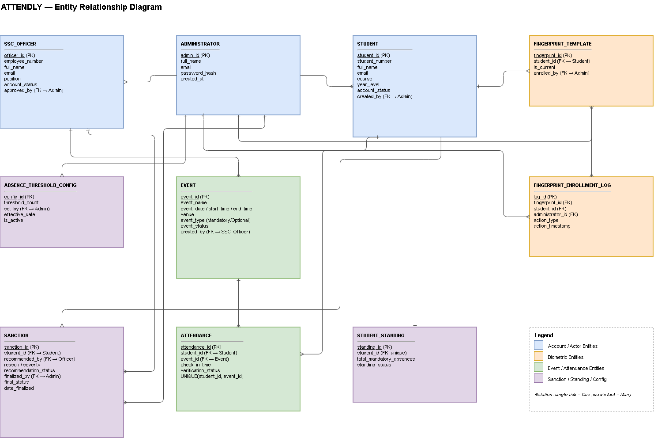and serve the students in the school.
- Biometric - Technology used to identify a person through unique physical characteristics.
- Fingerprint Template - Digitally stored representation of a fingerprint used for verification.
- Mandatory Event - An event that students are required to attend.
- Optional Event - An event that students may attend but does not affect sanctions.
- Sanction - An action or penalty given for violating attendance policies.
- ATTENDLY - The Student Event Attendance and Sanctions System developed for managing student event attendance and sanctions.
- Fingerprint Enrollment - The process of registering a student's fingerprint template in the system for future verification.
- Attendance Record - A stored record indicating a student's attendance or absence from an event.
- Fingerprint Verification - The process of comparing a captured fingerprint against a registered fingerprint template to verify a student's identity.
  - DOCUMENT CONVENTIONS
This section defines the labeling, formatting, and documentation conventions used throughout this SRS to ensure consistency and clarity.
- Requirement Identification - Each requirement in this document is assigned a unique identifier consisting of a prefix and a three-digit sequence number: FR-XXX for Functional Requirements, NFR-XXX for Non-Functional Requirements, BR-XXX for Business Rules, and TC-XXX (or TC-NFR-XXX for non-functional test cases) for Test Cases.
- Priority Levels - Each functional requirement is assigned a priority of High, Medium, or Low, as defined in Section 4.3.1, to indicate its relative importance to system development.
- Formatting Conventions - Statements containing “shall” indicate mandatory requirements. Defined terms such as Mandatory Event and Optional Event are capitalized when referenced. Section and sub-section headings follow a numbered outline format (e.g., 1.1, 1.2), and structured requirement data is presented in tables for clarity.
Acceptance Criteria Format - Each functional requirement in Section 4.1 is paired with an acceptance criteria entry presented in a five-column format — Input, Process, Output, Expected System Behavior, and Acceptance Criteria — describing the condition under which the requirement is considered satisfied.
  - REFERENCES
The following sources were reviewed and used as a basis for this SRS, including related studies on biometric and fingerprint-based attendance systems.

Adedoyin, M. A., Shoewu, O. O., Yussuff, A. I. O., Adenowo, A. A., Shitta, A. H., & Okedokun, O. (2024). Development of an IoT-Based Biometric Attendance Management System. FUOYE Journal of Engineering and Technology.

Bolasco, M. A. N., Costales, G. L., Saldivar, P. B. E., Valdez, C. D. C., & Cruz, R. D. L. (2025). Labtrack: A Comprehensive Approach to Attendance Tracking Computer Usage Monitoring – The Great Plebeian College. International Journal of Research and Innovation in Applied Science, 10(7), 257–260.

Gabuya, A. Q., Zosa, L. T., & Minoza, J. T. (2022). The Performance of Biometric Attendance System (BAS): CTU-Tuburan Campus as case study. International Journal of Scientific and Research Publications, 12(7), 419–426.

Obiora, G. N., Aladejare, I. O., Igbinosa, G. O., Fiemobebefa, C. B., & Bamido, O. A. (2025). Development of a Fingerprint-Based Attendance Monitoring System. ABUAD Journal of Engineering Research and Development (AJERD).

Patel, D., & Patel, M. (2025). A Study on the Importance of Attendance and Leave Management System in Employee Performance Tracking. International Journal of Research Publication and Reviews, 6(11).

Perez, J. D. L. (2025). Web-Integrated Fingerprint Attendance Monitoring System with Excuse Management for Educational Institutions. Figshare.
Rivera, R. B. (n.d.). Enhanced Attendance Monitoring System using Biometric Fingerprint Recognition. International Journal of Scientific & Technology Research.

Saul, K. B. S., Saul, J. B., & Soberano, K. T. (2023). Utilizing Convolutional Neural Networks for Fingerprint-Based Attendance Monitoring. Index Copernicus International.

Selvi, S., et al. (2017). Implementation of Fingerprint-Based Biometric System and Its Integration with HRMS Application at RDCIS, SAIL. In Proceedings of the International Conference on Data Engineering and Communication Technology. Springer.

2. PROJECT PROPOSAL AND TEAM FORMATION
2.1 APPROVED PROJECT CONCEPT
ATTENDLY: Student Event Attendance and Sanctions System is a proposed web-based system designed to automate student attendance monitoring during institutional events through fingerprint biometric verification. The project was selected to address the limitations of manual attendance recording, particularly inaccurate records, delayed monitoring, and difficulty in tracking mandatory-event absences and attendance-related sanctions. The system aims to provide a centralized and efficient solution for managing attendance and sanctions.
2.2 TEAM FORMATION
The project will be developed by a two-member team, with responsibilities divided according to the major activities required for system development. Both members will collaborate throughout the planning, design, development, testing, documentation, and presentation of ATTENDLY.
Team Member | Role | Responsibilities
Kirt M. Dela Torre | Project Leader / System Developer / Database Designer | Leads and coordinates the project, oversees system development, designs and manages the database, develops core system functions, assists with system integration, participates in testing, and leads the project presentation.
Nicole P. Jansol | System Analyst / UI Designer / Documentation Lead | Analyzes and documents system requirements, designs and develops the user interface, prepares project documentation, assists in system development and testing, and participates in project presentation.

2.3 PROBLEM STATEMENT
The project addresses the challenges associated with manual attendance monitoring during institutional events. Traditional methods may result in inaccurate or incomplete attendance records, delayed monitoring, difficulty identifying students who are absent from mandatory events, and inefficient tracking of sanctions. ATTENDLY aims to address these issues by providing automated fingerprint-based attendance recording and centralized monitoring of attendance and sanction information.
2.4 PROJECT OBJECTIVES
The project aims to develop a system that:
- Automates student attendance recording during institutional events.
- Uses fingerprint biometric verification for student identification.
- Centralizes event, attendance, and sanction records.
- Allows SSC officers to efficiently manage events and attendance.
- Improves the accuracy and accessibility of attendance information.
- Supports systematic monitoring and recording of sanctions.
- Generates attendance and sanction reports for authorized users.
- Provides notifications related to attendance and sanctions.
- Protects system information through role-based access control.
2.5 TARGET USERS
The primary users of ATTENDLY are BSIT students, SSC officers, and Administrators. Students will use the system to check in to institutional events through fingerprint verification and view their attendance records and current standing. SSC officers will serve as event organizers within their own scope, managing their own events and attendance records, and recommending sanction actions for Administrator review. Administrators will serve as the authorized administrators of the system, managing student accounts, SSC Officer accounts, fingerprint enrollment, and system-wide reports.
2.6 CORE FEATURES
The proposed system will include user and account management, authentication and role-based access, fingerprint registration and verification, biometric attendance recording, event management, attendance monitoring and reporting, sanction management, notifications, and centralized data storage.
2.7 SCOPE BOUNDARIES
The initial implementation of ATTENDLY will focus on BSIT students of JHCSC Pagadian Annex Campus. The system will cover institutional event attendance and attendance-related sanctions. It will exclude online payment processing, academic grading, payroll or employee management, multi-campus deployment, a dedicated mobile application, and advanced analytics. These features may be considered for future enhancement based on institutional requirements, available resources, and project evaluation.
2.8 COMPARISON WITH SIMILAR OR EXISTING SYSTEMS
Existing attendance systems use various methods such as manual attendance sheets, QR codes, RFID, and biometric technologies. Manual systems are simple but may require more time and can make attendance monitoring and record management difficult. QR-based systems provide faster recording but may allow attendance codes to be shared. RFID systems can automate identification but require compatible RFID equipment. Biometric systems provide identity-based verification but require specialized hardware and proper management of biometric data.
ATTENDLY is a web-based attendance management system specifically designed for institutional events and attendance-related sanctions. It combines fingerprint verification with event management, centralized attendance records, automatic absence monitoring, sanction tracking, notifications, and reporting. Unlike basic attendance systems that primarily focus on recording check-ins, ATTENDLY provides a centralized web-based platform for both attendance monitoring and sanction management.
2.9 PROPOSAL APPROVAL AND SUPPORTING DOCUMENTS
The project proposal, including the approved concept, objectives, scope, and system features, shall be supported by the team's project proposal document, adviser feedback, presentation materials, and approval evidence, where applicable. These documents shall serve as references for confirming that the development of ATTENDLY follows the approved project direction and requirements.
3. OVERALL DESCRIPTION
3.1 PRODUCT PERSPECTIVE
ATTENDLY is a new web-based student event attendance management system developed to replace the manual process of recording and monitoring attendance during institutional events. The system will integrate fingerprint biometric verification with event management, attendance monitoring, sanction management, notifications, and reporting. It will operate as a standalone system during its initial implementation and will not be integrated with the school's existing grading or registrar systems.
3.2 USER CLASSES AND CHARACTERISTICS
ATTENDLY will serve three primary user groups: BSIT Students, SSC Officers, and Administrators. BSIT Students will use the system to check in to events through fingerprint verification, view upcoming events, access their attendance history, and monitor their attendance standing. SSC Officers will serve as event organizers within their own scope, managing their own events and attendance records, monitoring attendance, and recommending sanction actions for Administrator review. Administrators will serve as the authorized administrators of the system and will manage student accounts, SSC Officer accounts, fingerprint enrollment, sanction finalization, and system-wide reports. All user groups are expected to have basic computer and web browsing skills, while SSC Officers and Administrators should have additional knowledge of event and attendance management.
3.3 OPERATING ENVIRONMENTS
ATTENDLY shall operate in a web-based environment using the following:
- Devices: Desktop computers and laptops
- Operating Systems: Windows 10 or later, or other operating systems capable of running supported web browsers
- Web Browsers: Google Chrome, Microsoft Edge, or Mozilla Firefox
- Network: Stable local network or Internet connection
- Database: A relational database management system such as MySQL
- Server: Web server connected to the centralized database
- Biometric Device: Compatible fingerprint scanner
3.4 DESIGN AND IMPLEMENTATION CONSTRAINTS
The development of ATTENDLY is subject to hardware, software, security, and data privacy constraints. As a web-based system, it requires a supported web browser and a stable internet or school network connection to access the system. The system must also be compatible with the fingerprint scanner and its required SDK or driver for biometric verification. Offline attendance processing will not be supported in the initial version. Access to system functions shall be controlled through role-based access, while personal and biometric information shall be protected using appropriate security measures. The system shall comply with applicable data privacy requirements, particularly the Data Privacy Act of 2012 (Republic Act No. 10173).
3.5 ASSUMPTIONS AND DEPENDENCIES
The system is assumed to be web-based and initially used on a single campus. SSC officers will serve as the event organizers, so no separate event organizer role is required. The system also depends on a compatible fingerprint device, stable network connection, and database server.

4. REQUIREMENTS ANALYSIS
4.1 FUNCTIONAL REQUIREMENTS
ID | Functional Requirement | Source | Priority | Module
FR-001 | The system shall allow Administrators to create, edit, and deactivate student accounts system-wide. | Administrator | High | Administration
FR-002 | The system shall authenticate Students and SSC Officers using valid login credentials. | Student/SSC Officer | High | Authentication
FR-003 | The system shall allow Administrators to enroll and re-enroll a student's fingerprint template. | Administrator | High | Administration
FR-004 | The system shall verify a student's fingerprint during event check-in. | Student | High | Biometric Attendance
FR-005 | The system shall record attendance after successful fingerprint verification. | SCC Officer | High | Attendance Management
FR-006 | The system shall prevent duplicate attendance records for the same student and event. | Student/SSC Officer | High | Attendance Management
FR-007 | The system shall allow SSC Officers to create, edit, and cancel institutional events. | SSC Officer | High | Event Management
FR-008 | The system shall allow SSC Officers to classify events as mandatory or optional. | SSC Officer | High | Event Management
FR-009 | The system shall allow SSC Officers to monitor attendance and identify students absent from mandatory events. | SSC Officer | High | Attendance Monitoring
FR-010 | The system shall automatically count mandatory-event absences and determine student standing based on configured thresholds. | SSC Officer | High | Sanction Management
FR-011 | The system shall allow SSC Officers to flag a student for a sanction, with a reason and severity, for Administrator review when the applicable threshold is reached. | SSC Officer | High | Sanction Management
FR-012 | The system shall allow students to view attendance records and standing, and SSC Officers to generate attendance and sanction reports for their own events. | Student/SSC Officer | Medium | Dashboard & Reporting
FR-013 | The system shall allow Administrators to create, approve, edit, and deactivate SSC Officer accounts. | Administrator | High | Administration
FR-014 | The system shall allow Administrators to audit fingerprint enrollment activity, including which Administrator enrolled or re-enrolled each record and when. | Administrator | Medium | Administration
FR-015 | The system shall allow Administrators to finalize or override a recommended sanction into an official Warning or Probation status. | Administrator | High | Administration
FR-016 | The system shall allow Administrators to generate system-wide attendance and sanction reports across all SSC Officers and events. | Administrator | Medium | Administration
FR-017 | The system shall allow SSC Officers to view student records relevant to their own scope, without the ability to create, edit, or delete accounts. | SSC Officer | Medium | User Management

ID | Input | Process | Output | Expected System Behavior | Acceptance Criteria
FR-001 | Student information and Administrator credentials | Validate and save, edit, or deactivate account information | Student account | The system creates, updates, or deactivates an account when a valid request is submitted by an Administrator. | A valid student account is successfully created, edited, or deactivated by an Administrator.
FR-002 | Username/email and password | Validate credentials and user role | User dashboard or error message | The system grants access only to authorized users. | Valid credentials allow login, while invalid credentials are rejected.
FR-003 | Student information and fingerprint scan | Capture and enroll or re-enroll fingerprint template | Registered fingerprint template | The system links the enrolled fingerprint template to the correct student account when submitted by an Administrator. | A student's fingerprint is successfully enrolled or re-enrolled by an Administrator and associated with the correct account.
FR-004 | Fingerprint scan and event | Match scanned fingerprint with registered template | Verification result | The system identifies the student when the fingerprint matches. | A valid fingerprint successfully identifies the correct student.
FR-005 | Verified student and event | Create and save attendance record with date and time | Attendance record | The system automatically records attendance after successful verification. | A timestamped attendance record is stored for the correct student and event.
FR-006 | Student ID and event ID | Check existing attendance record | Confirmation or duplicate warning | The system prevents multiple attendance records for the same event. | A second attendance attempt for the same event is rejected.
FR-007 | Event name, date, time, venue, and event type | Validate and save event information | Event record | The system reflects authorized event changes. | An event can be successfully created, edited, or cancelled.
FR-008 | Event classification | Save event type | Mandatory/optional status | The system applies the selected classification to the event. | The correct classification is displayed and stored.
FR-009 | Student and attendance records | Compare expected attendance with recorded attendance | Attendance and absence records | The system identifies students who do not have valid attendance for mandatory events. | Absent students are correctly identified.
FR-010 | Attendance records and thresholds | Calculate absences and compare them with thresholds | Absence count and standing | The system automatically updates the student's standing. | The correct absence count and standing are displayed.
FR-011 | Student information, sanction reason, and severity | Validate and save a recommended sanction for review | Recommended sanction record | The system records the recommended sanction and routes it to an Administrator for review. | A valid sanction recommendation is successfully recorded and routed for Administrator review.
FR-012 | Attendance and sanction data | Retrieve and organize records within the user's assigned scope | Dashboard information and reports | Users can access information according to their assigned role and scope. | Students can view their own records, while SSC Officers can generate reports limited to their own events.
FR-013 | SSC Officer information | Validate and save, approve, edit, or deactivate officer account information | SSC Officer account | The system creates, approves, edits, or deactivates an SSC Officer account only when submitted by an Administrator. | A valid SSC Officer account is successfully created, approved, edited, or deactivated.
FR-014 | Fingerprint enrollment records | Retrieve and display enrollment activity logs | Enrollment audit report | The system displays who enrolled or re-enrolled each fingerprint record and when. | Administrators can successfully view a complete and accurate enrollment audit trail.
FR-015 | Recommended sanction record and Administrator decision | Validate and finalize or override the recommended sanction | Official sanction record (Warning/Probation) | The system updates the sanction status only when finalized or overridden by an Administrator. | A recommended sanction is successfully converted into an official Warning or Probation status.
FR-016 | Attendance and sanction data across all events | Retrieve and organize system-wide records | System-wide report | The system compiles attendance and sanction data across all SSC Officers and events for Administrators. | Administrators can successfully generate accurate cross-event, system-wide reports.
FR-017 | Student records within the SSC Officer's scope | Retrieve and display read-only student information | Scoped student list | The system displays only student records relevant to the SSC Officer's own scope, without edit access. | SSC Officers can view relevant student records but cannot create, edit, or delete them.

4.2 NON-FUNCTIONAL REQUIREMENTS
ID | Category | Requirement | Acceptance Threshold / Standard
NFR-001 | Performance | The system shall verify a fingerprint within 3 seconds under normal operating conditions. | At least 95% of verification attempts shall be completed within 3 seconds during testing.
NFR-002 | Security | The system shall restrict system functions according to the user's assigned role. | Students shall not be able to access SSC Officer functions.
NFR-003 | Data Privacy | The system shall protect personal and fingerprint information in accordance with the Data Privacy Act of 2012 (RA 10173). | Unauthorized users shall not be able to access protected information.
NFR-004 | Reliability | The system shall maintain at least 99% availability during scheduled event hours, subject to network and server availability. | The system shall meet the 99% availability target during the defined testing period.
NFR-005 | Usability | The system shall provide clear navigation, readable information, and understandable system messages. | Representative users shall be able to perform core tasks after a short orientation.
NFR-006 | Compatibility | The web-based system shall function correctly on supported modern web browsers. | Core functions shall operate on Google Chrome, Microsoft Edge, and Brave.
4.3 REQUIREMENTS PRIORIZATION AND TRACEABILITY
4.3.1 REQUIREMENT PRIORITIZATION
Priority | Description
High | Essential requirements necessary for the core operation of the system.
Medium | Important requirements that support system efficiency, monitoring, and reporting.
Low | Optional requirements that may be considered for future enhancement.

4.3.2 REQUIREMENT TRACEABILITY MATRIX
The traceability matrix ensures that each approved requirement is addressed during system design, development, and testing.
ID | Source | Objective | Module
FR-001 | Administrator | Account Management | Administration
FR-002 | Student/SSC Officer | Secure Access | Authentication
FR-003 | Administrator | Fingerprint Registration | Administration
FR-004 | Student | Biometric Attendance | Attendance
FR-005 | Student | Attendance Recording | Attendance
FR-006 | Student/SSC Officer | Data Integrity | Attendance
FR-007 | SSC Officer | Event Management | Event Management
FR-008 | SSC Officer | Event Classification | Event Management
FR-009 | SSC Officer | Attendance Monitoring | Attendance Monitoring
FR-010 | SSC Officer | Sanction Monitoring | Sanction Management
FR-011 | SSC Officer | Sanction Management | Sanction Management
FR-012 | Student/SSC Officer | Reporting | Dashboard & Reporting
FR-013 | Administrator | Officer Account Management | Administration
FR-014 | Administrator | Enrollment Audit | Administration
FR-015 | Administrator | Sanction Finalization | Administration
FR-016 | Administrator | System-Wide Reporting | Administration
FR-017 | SSC Officer | Scoped Student Visibility | User Management
NFR-001 | System Requirement | Performance | Fingerprint Verification
NFR-002 | Security Requirement | Access Control | Authentication
NFR-003 | Privacy Requirement | Data Protection | Security
NFR-004 | System Requirement | Reliability | System
NFR-005 | User Requirement | Usability | User Interface
NFR-006 | System Requirement | Compatibility | Web Interface

ID | Related Design Component | Test Case | Status
FR-001 | Account Interface | TC-001 | Planned
FR-002 | Login Interface | TC-002 | Planned
FR-003 | Fingerprint Interface | TC-003 | Planned
FR-004 | Fingerprint Check-in Interface | TC-004 | Planned
FR-005 | Attendance Database | TC-005 | Planned
FR-006 | Attendance Validation | TC-006 | Planned
FR-007 | Event Interface | TC-007 | Planned
FR-008 | Event Form | TC-008 | Planned
FR-009 | Attendance Dashboard | TC-009 | Planned
FR-010 | Standing Module | TC-010 | Planned
FR-011 | Sanction Interface | TC-011 | Planned
FR-012 | Report Interface | TC-012 | Planned
FR-013 | Officer Account Interface | TC-013 | Planned
FR-014 | Enrollment Audit Interface | TC-014 | Planned
FR-015 | Sanction Finalization Interface | TC-015 | Planned
FR-016 | System-Wide Report Interface | TC-016 | Planned
FR-017 | Scoped Student Interface | TC-017 | Planned
NFR-001 | Verification Process | TC-NFR-001 | Planned
NFR-002 | Role-Based Access | TC-NFR-002 | Planned
NFR-003 | Data Protection Controls | TC-NFR-003 | Planned
NFR-004 | Server/System Availability | TC-NFR-004 | Planned
NFR-005 | Web Interface | TC-NFR-005 | Planned
NFR-006 | Browser Compatibility | TC-NFR-006 | Planned

4.4 BUSINESS RULES
The following business rules define the policies and conditions governing the operation of the web-based ATTENDLY system.
ID | Business Rules
BR-001 | Only authenticated users shall access protected features of the web-based system.
BR-002 | Students shall only view their own attendance records, standing, and notifications.
BR-003 | Only authorized SSC Officers shall manage events and attendance, and recommend sanctions, within their own scope.
BR-004 | A student must have a registered fingerprint before using biometric attendance through the web-based system.
BR-005 | Each event shall be classified as Mandatory or Optional.
BR-006 | Only attendance from mandatory events shall be included in absence and sanction monitoring.
BR-007 | Attendance shall be recorded only after successful fingerprint verification.
BR-008 | The system shall prevent duplicate attendance records for the same student and event.
BR-009 | Students who reach the configured absence threshold shall be flagged for sanction review.
BR-010 | Only authorized SSC Officers shall record and recommend sanction actions for Administrator review.
BR-011 | Cancelled events shall not accept attendance records or count as absences.
BR-012 | Students shall not be allowed to modify or delete their attendance or sanction records.
BR-013 | Only authorized Administrators shall create, edit, or deactivate student and SSC Officer accounts, and manage fingerprint enrollment.
BR-014 | Only authorized Administrators shall finalize or override a recommended sanction into an official Warning or Probation status.

4.5 EXTERNAL INTERFACE REQUIREMENTS
4.5.1 User Interface
ATTENDLY shall provide a web-based user interface accessible through supported web browsers on desktop or laptop computers. The STUDENT INTERFACE shall provide access to login, upcoming events, fingerprint check-in, attendance history, attendance standing, and notifications. The SSC OFFICER INTERFACE shall provide access to event management, attendance monitoring, sanction recommendation, threshold configuration, reporting on their own events, and notifications. The ADMINISTRATOR INTERFACE shall provide access to student and SSC Officer account management, fingerprint enrollment and enrollment audit, sanction finalization, and system-wide reporting. The interface shall provide clear navigation, readable information, input validation, confirmation messages, and appropriate error messages.
4.5.2 Hardware Interface
ATTENDLY shall use a fingerprint biometric device for student identification and attendance verification. The device shall capture and verify registered fingerprints during event check-in and communicate with the web-based system through its required SDK, driver, or asupported integration method.
4.5.3 Software Interface
ATTENDLY shall operate through supported modern web browsers and communicate with the web server and centralized database. The database shall store student accounts, fingerprint templates, event information, attendance records, sanction records, and notifications.
4.5.4 Communication Interface
ATTENDLY shall use standard web-based communication protocols between the user's browser and the web server. A stable Internet or school network connection shall be required to access the system and process fingerprint-based attendance. HTTPS shall be used to protect information transmitted between the user's browser and the server where supported by the deployment environment

5. SYSTEM MODELS AND ARCHITECTURE
This chapter presents the structural, behavioral, and data models of ATTENDLY. Each model traces back to the functional requirements (FR), business rules (BR), and priority levels established in Chapter 4, and reflects the three user roles (Student, SSC Officer, Administrator) and the scope boundaries defined in Chapter 2 and 3.
5.1 Use Case Diagram
Purpose: Shows the interactions between the three actors (Student, SSC Officer, Administrator) and an external hardware actor (Fingerprint Scanner) with the system's functions.
How it supports the approved scope: Every use case is directly traceable to a High or Medium priority FR (e.g., Check-in via Fingerprint → FR-004/FR-005; Finalize/Override Sanction → FR-015). The diagram visually enforces BR-003, BR-010, BR-013, BR-014 by isolating which actor is authorized to trigger which function — SSC Officers only recommend sanctions while only Administrators can finalize them, and only Administrators manage accounts/enrollment.
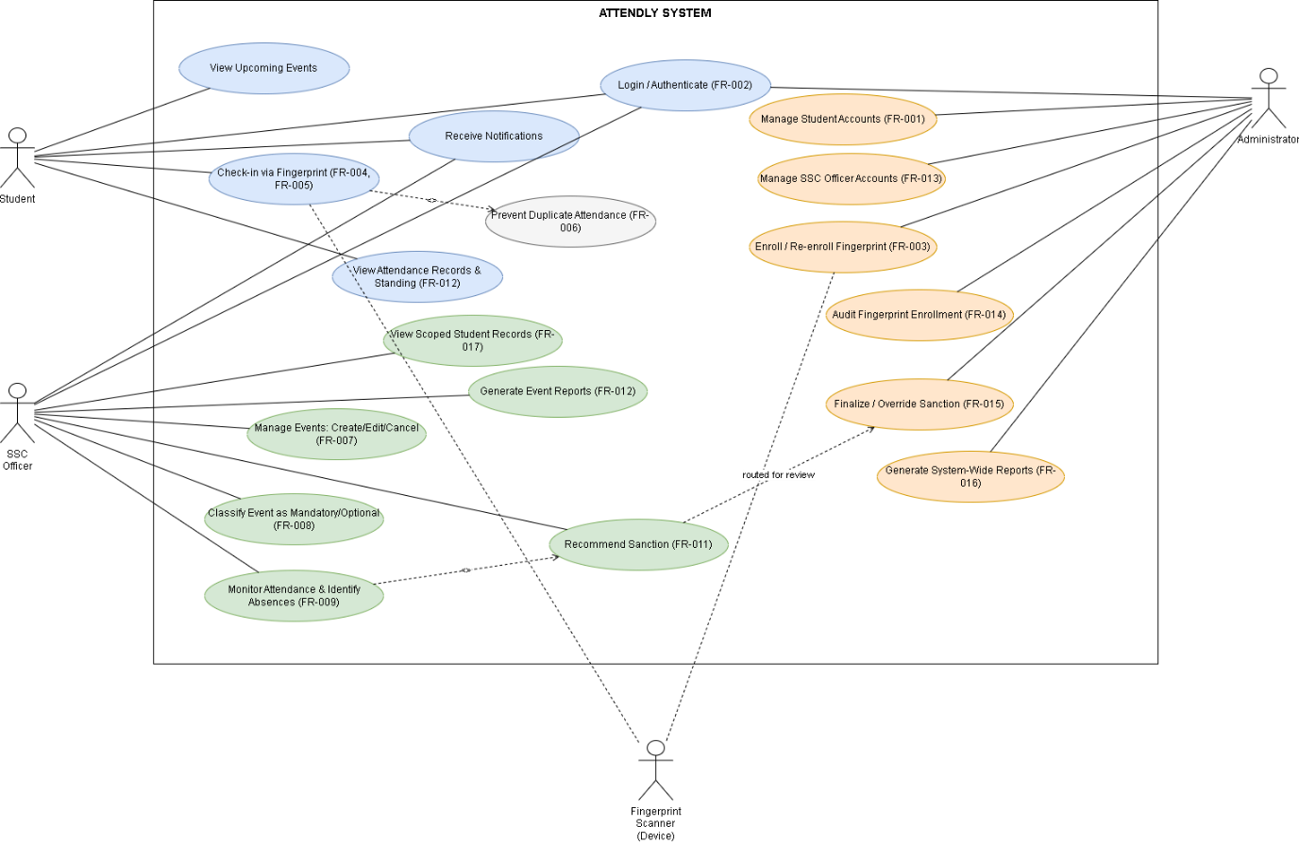

Figure 5.1 Use Case Diagram of the Student Event Attendance & Sanction System
5.2 User Flow Diagram — Student Event Check-In (Core Priority Workflow)
Purpose: Details the single most critical end-to-end workflow in ATTENDLY — the High-priority chain FR-002 → FR-004 → FR-005 → FR-006 → FR-009/FR-010, which is the heart of the system's value proposition (replacing manual attendance).
How it supports the approved scope: The branching logic explicitly enforces BR-007 (attendance recorded only after successful verification) and BR-008 (no duplicate attendance records). It also shows where FR-010 (standing calculation) is triggered only for Mandatory events, consistent with BR-006.
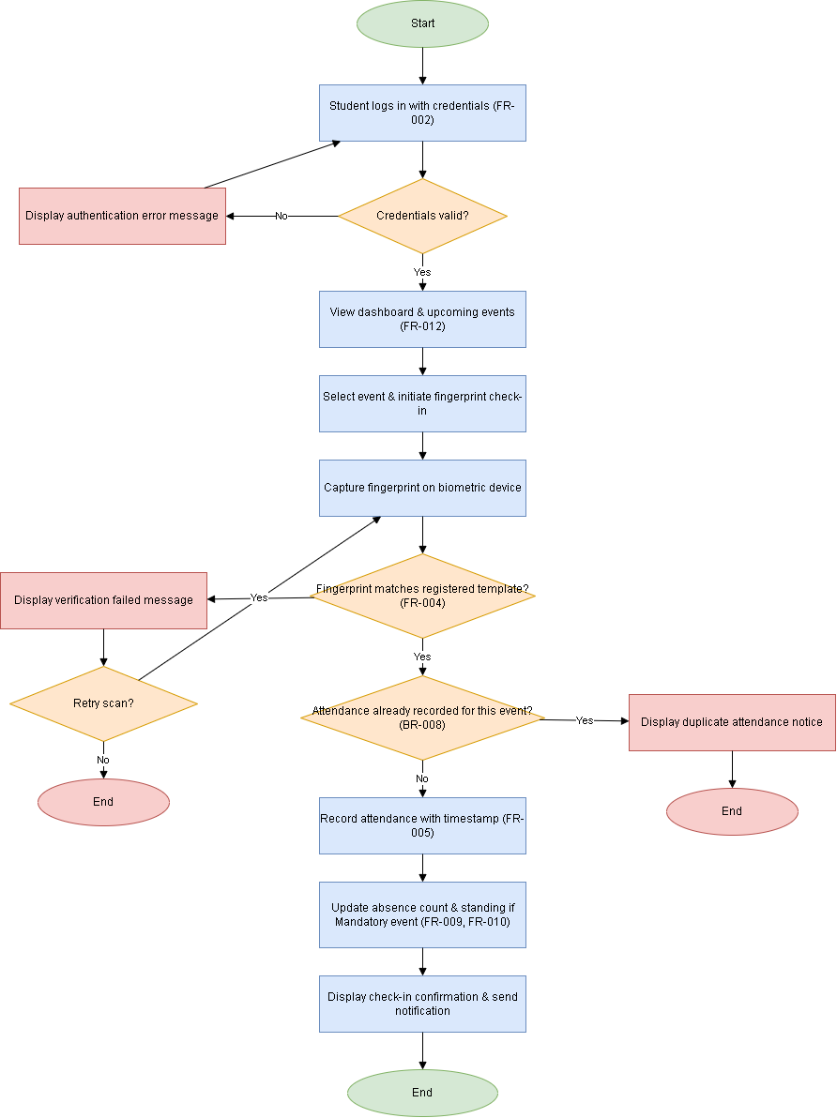

Figure 5.2 User-Flow Diagram of the Student Event Attendance & Sanction System
5.3 System Architecture Diagram
Purpose: Depicts the 3-tier layered architecture — Presentation, Application, and Data layers — plus the external biometric hardware dependency identified in Section 3.3/3.4.
How it supports the approved scope: The diagram visually confirms the constraint that ATTENDLY is a standalone web-based system (Section 3.1) not integrated with grading/registrar systems, that it depends on a compatible fingerprint SDK/driver (Section 3.4), and that all three role-based interfaces (Student/Officer/Admin) connect to the same centralized database (Section 3.3, NFR-002, NFR-003).
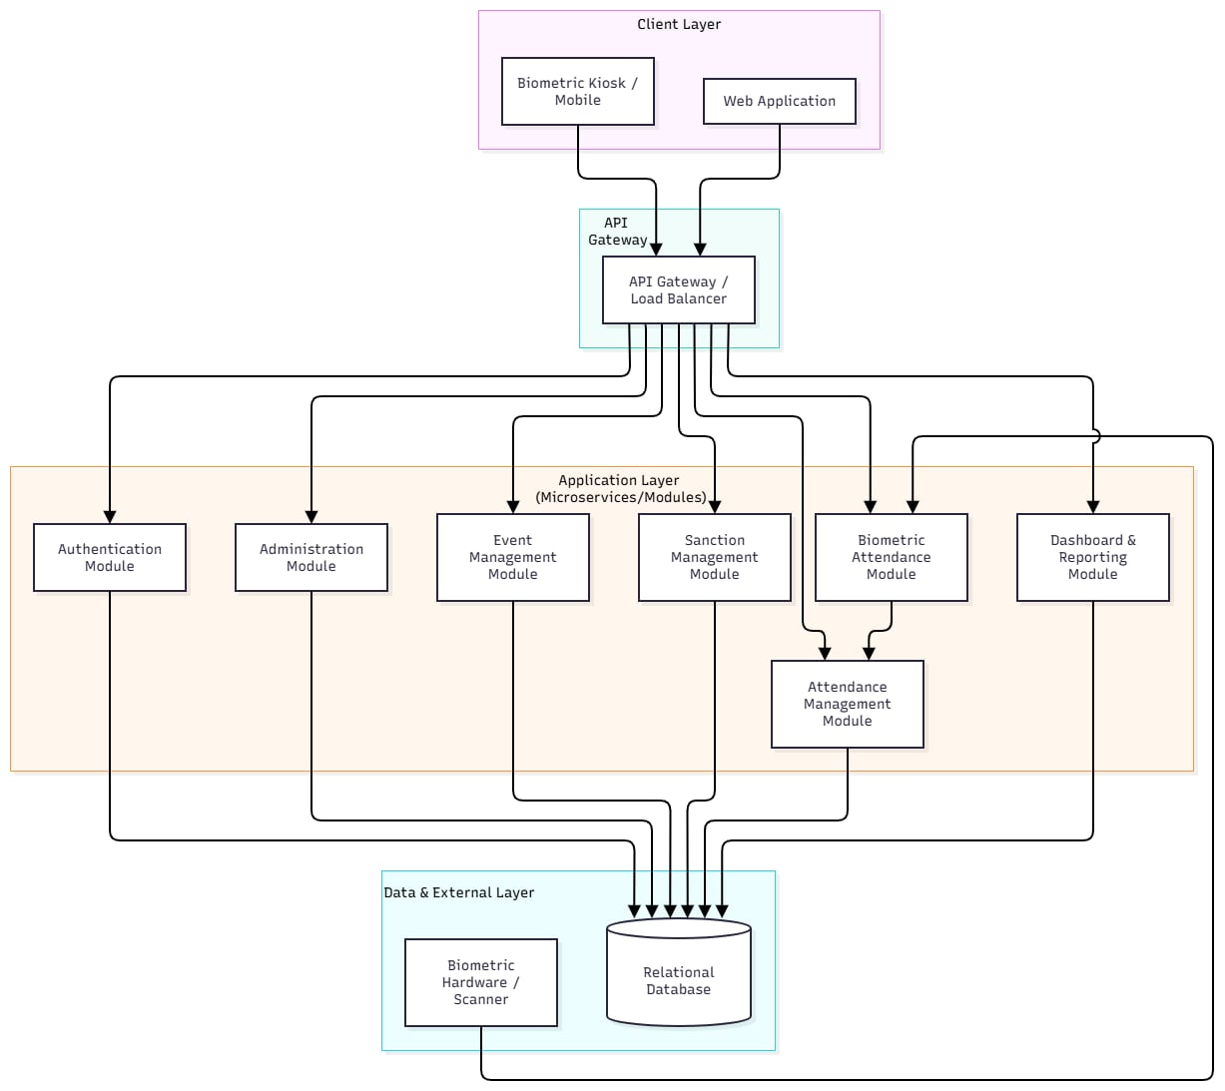

Figure 5.3 System Architecture Diagram Diagram of the Student Event Attendance & Sanction System

5.4 Entity Relationship Diagram (ERD)
Purpose: Models the persistent data entities required to satisfy all 17 functional requirements, from account management to sanction finalization.
How it supports the approved scope: The Attendance entity has a composite unique key (student_id, event_id) directly enforcing FR-006/BR-008. The Fingerprint_Enrollment_Log entity exists solely to satisfy the FR-014 audit requirement. The separation of Sanction.recommendation_status from Sanction.final_status reflects the two-stage sanction workflow mandated by FR-011/FR-015/BR-010/BR-014 (SSC Officer recommends → Administrator finalizes).

Figure 5.4 Entity Relationship Diagram Diagram of the Student Event Attendance & Sanction System

5.6 Data Flow Diagram (DFD – Level 1)
Purpose: Traces how data moves between external entities, system processes, and data stores, independent of implementation.
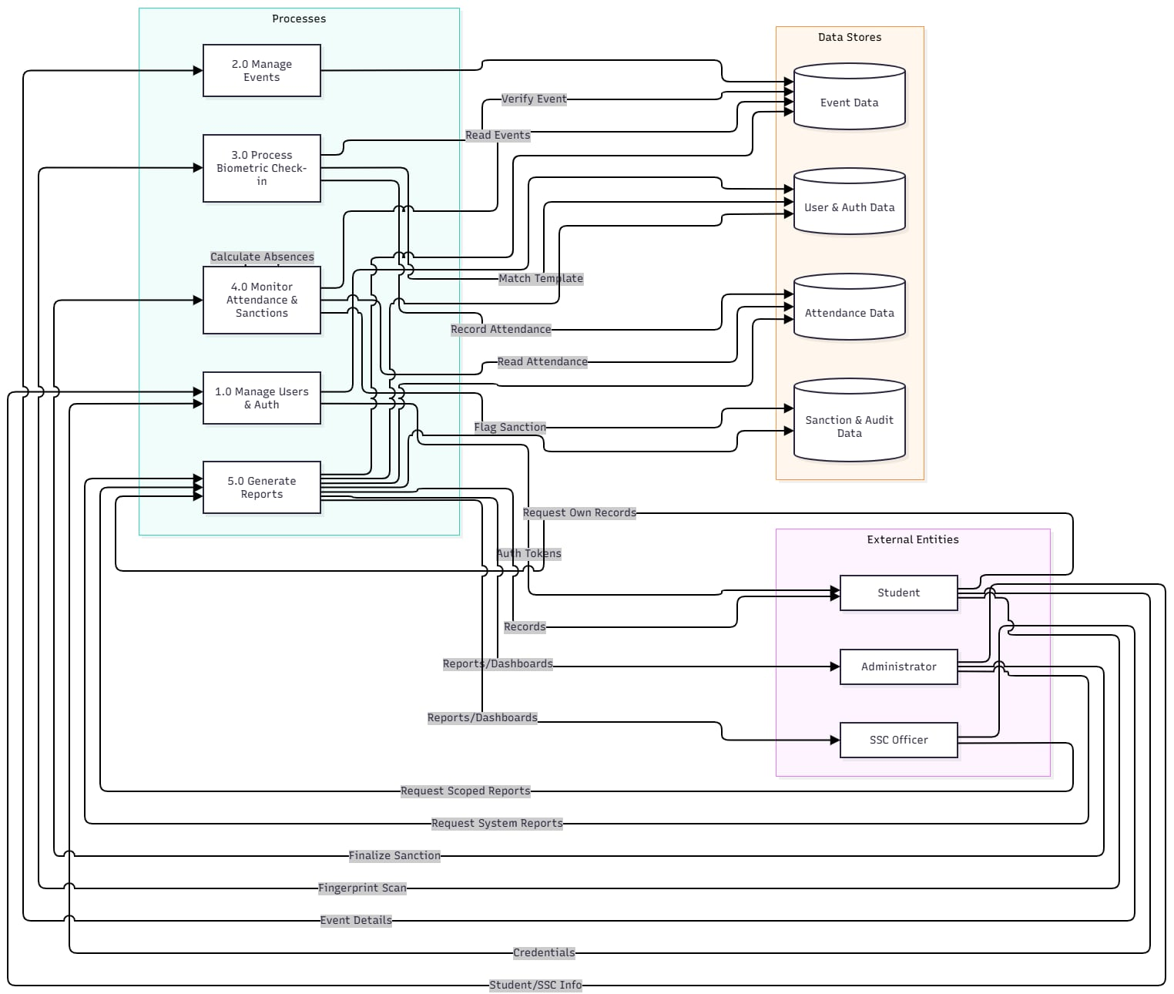
How it supports the approved scope: Processes 1.0–7.0 map one-to-one to the Functional Requirement Modules in Section 4.1 (Authentication, Administration, Biometric Attendance, Event Management, Attendance Monitoring, Sanction Management, Dashboard & Reporting), confirming complete requirement coverage with no orphaned data stores.

Figure 5.5 Data-Flow Diagram of the Student Event Attendance & Sanction System
5.6 Module Interaction Diagram
Purpose: Shows runtime dependencies between the eight business-logic modules and the centralized database at a component level (lower level of detail than the DFD, higher level than class/sequence diagrams).
How it supports the approved scope: The hub-and-spoke pattern around a single database confirms NFR-003/NFR-004 (centralized, secured, reliable data access), while the direct module-to-module arrows (e.g., Attendance Monitoring → Sanction Management → Notification) show the automated trigger chain mandated by FR-009 → FR-010 → FR-011.
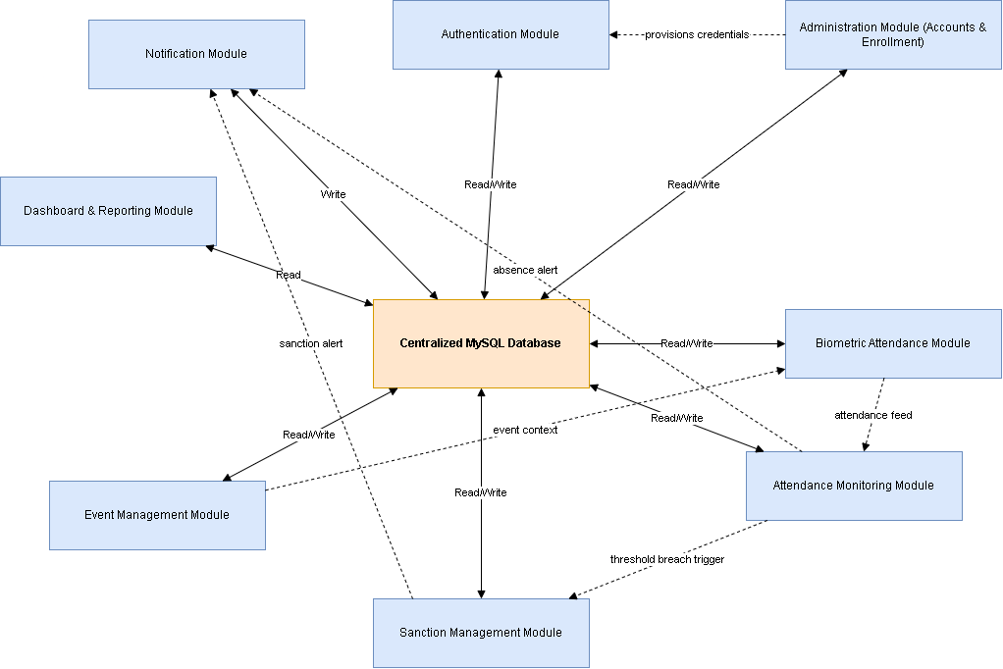

Figure 5.6 Module-Interaction Diagram of the Student Event Attendance & Sanction System

5.7 Priority Workflow Models
The Priority Workflow Models relate the system's major workflows to the models presented in this section. The workflows include student and SSC Officer account registration and fingerprint enrollment, authentication and role-based access, event creation and classification, biometric event check-in and attendance recording, absence monitoring and standing computation, sanction recommendation and administrator finalization, notification delivery, and system-wide and scoped reporting, ensuring that the system design remains aligned with the approved scope and prioritized requirements.

